Study of Long-Term Land Surface Temperature Changes Using Google Earth Engine Technology and Modis Data
Azizakhon Gafurova ^{a)}, Dilafruz Nasirkhodjaeva, Umida Gafurova
Tashkent State University of Economics, Tashkent, Uzbekistan
^{a)} Corresponding author: 94.aziza@gmail.com
Abstract. Land Surface Temperature (LST) plays a critical role in understanding the impacts of climate variability and urbanization on regional environments. This study investigates long-term LST dynamics in the Samarkand region using MODIS/061/MOD11A1 data within the Google Earth Engine (GEE) platform. LST data were analyzed for January and July in 2000 and 2023, as well as for the period from 2010 to 2024, to identify spatial and temporal trends. The results indicate a slight but consistent increase in mean LST across the study area over the analyzed period, reflecting a gradual warming trend. The southwestern parts of the Samarkand region exhibit the most significant LST increases, likely due to land use and land cover changes, urban expansion, or other anthropogenic factors. This study highlights the utility of remote sensing and GEE for efficient and accurate LST monitoring, providing valuable insights for climate change assessment and regional planning in semi-arid regions like Samarkand.
INTRODUCTION
Land Surface Temperature (LST) serves as a vital environmental indicator for assessing the thermal conditions of the Earth’s surface, playing a pivotal role in climate research, urban development, and agricultural management(Kong, Zhang, Gu, & Wang, 2019; Xuecao Li, Gong, & Liang, 2015; Pimple et al., 2018). Variations in LST offer valuable insights into the consequences of global warming, urban expansion, and shifts in land use on both local and regional climates [4,5]. Semi-arid regions like Samarkand, Uzbekistan, are especially susceptible to these shifts due to their distinct geographic, climatic, and socio-economic features(Aslanov, Teshaev, et al., 2023; Capolupo, Monterisi, & Tarantino, 2020; Kolli, Opp, Karthe, & Groll, 2020).
Advancements in remote sensing, particularly through satellite-based thermal sensors, have transformed LST research by delivering consistent, expansive, and long-term datasets. The MODIS (Moderate Resolution Imaging Spectroradiometer) sensor, renowned for its thermal infrared capabilities and global reach, is extensively utilized for tracking LST trends. Specifically, the MODIS/061/MOD11A1 product provides daily LST data at a 1 km spatial resolution, rendering it an effective resource for analyzing temporal and spatial patterns in surface temperature(Mohiuddin, Mund, & Rahaman, 2023; Recondo et al., 2022).
This study leveraged the Google Earth Engine (GEE) platform to investigate the long-term LST dynamics in the Samarkand region. GEE’s cloud-based infrastructure facilitates the efficient processing and analysis of extensive remote sensing datasets, making it particularly well-suited for studies involving time-series evaluations(Adagbasa, Adelabu, & Okello, 2020; Xiaojiang Li et al., 2015; Xie et al., 2019).
The central aim of this research is to examine the LST dynamics in the Samarkand region across several decades. To explore seasonal differences, LST data from January and July of 2000 and 2023 were compared, while trends from 2010 to 2024 were analyzed to discern long-term thermal shifts. The findings indicate a modest rise in the region’s average LST over the study period, with more significant warming observed in the southwestern zones. These patterns underscore the potential influence of urbanization and land use changes on regional temperature dynamics(Kong et al., 2019; Mohiuddin et al., 2023).
The integration of MODIS LST data with GEE technology has revolutionized environmental monitoring by allowing researchers to assess temporal and spatial variations in LST across diverse geographical regions. Studies leveraging this approach have explored topics such as urban heat island (UHI) effects, deforestation impacts, and agricultural productivity changes. For instance, GEE’s ability to handle large datasets enables the extraction of LST trends over decades, revealing how factors like urbanization or climate change influence surface temperatures. Additionally, MODIS data’s high temporal resolution supports the identification of seasonal patterns and anomalies, enhancing the understanding of climate variability.
This research highlights the critical role of remote sensing and cloud-based platforms, such as Google Earth Engine (GEE), in tracking environmental shifts. The results enhance our understanding of climate dynamics in the Samarkand region of Uzbekistan, laying a foundation for evidence-based decision-making in urban planning and sustainable resource management.
EXPERIMENTAL RESEARCH
The study was conducted in the Samarkand region, a key administrative area in southeastern Uzbekistan, situated between approximately 39.65°N to 40.75°N latitude and 66.45°E to 67.60°E longitude. Samarkand is one of the most historically significant and agriculturally vital regions of Uzbekistan, characterized by its semi-arid continental climate. The region experiences distinct seasonal variations, with hot, dry summers and cold winters [11]. These climatic characteristics make it an ideal study area for assessing long-term changes in Land Surface Temperature (LST)(Patel et al., 2015).
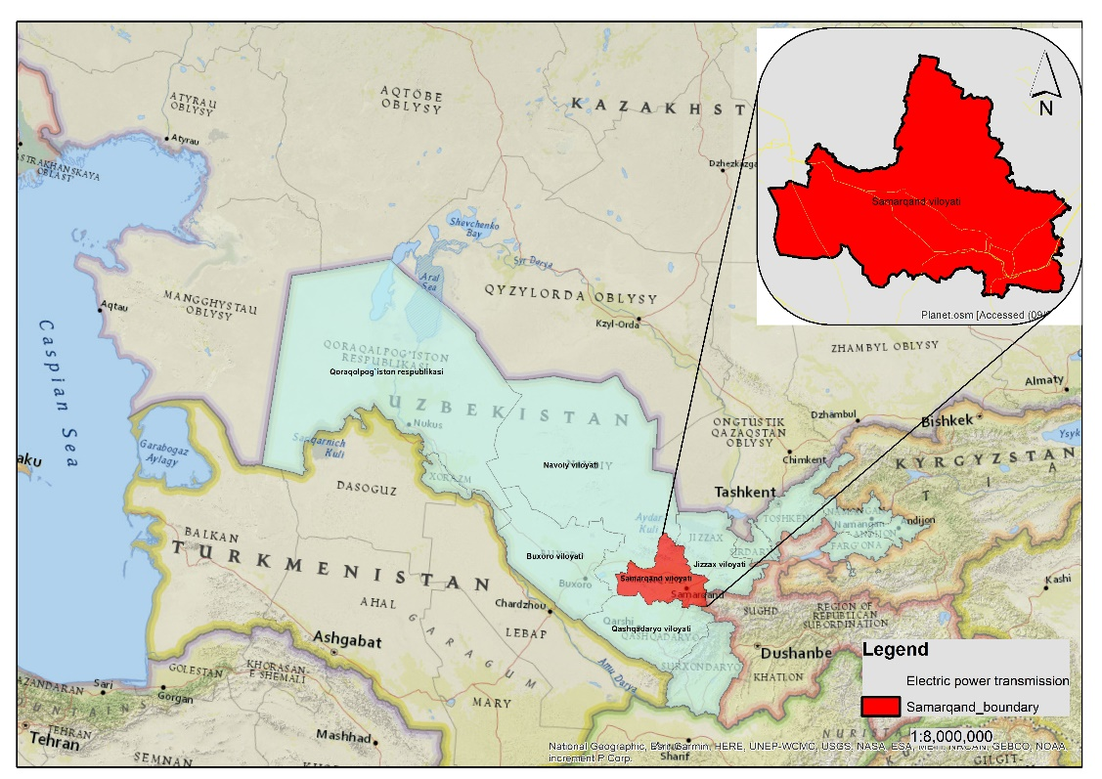
FIGURE 1. Geographical location of Samarkand region

Samarkand's terrain is diverse, consisting of fertile plains, low hills, and mountainous areas in its northern and eastern parts. The region lies in the middle reaches of the Zeravshan River, which has historically supported agriculture and settlement in the area. Elevations range from approximately 200 meters in the southwestern plains to over 1,000 meters in the foothills and mountains, influencing local microclimates (Muslimbekov, Teshaev, Abdurakhmonov, & Gaybulloev, 2024).
The region's semi-arid climate is marked by:
• Hot Summers: Average maximum temperatures in July exceed 35°C.
• Cold Winters: January temperatures often drop below freezing, with an average minimum of -2°C to -5°C.
• Precipitation: Annual precipitation ranges from 250 to 450 mm, with most rainfall occurring in the spring and autumn seasons.
In recent decades, urbanization and intensified agricultural practices have significantly altered land cover in the Samarkand region. These transformations have coincided with shifts in local and regional climate patterns, notably an increase in Land Surface Temperature (LST), particularly evident in urban and industrial areas. The southwestern portions of Samarkand, where urbanization has been more pronounced, exhibit marked changes in surface heat dynamics (Aslanov et al., 2024; Opp et al., 2024). The region’s unique topography, climate, and land use diversity provide an exceptional setting for examining LST variations. The primary factors driving LST dynamics in this area include:
Urbanization: The expansion of urban zones contributes to the urban heat island (UHI) effect, wherein built-up areas experience elevated surface temperatures relative to surrounding rural landscapes.
Agricultural Practices: Irrigated farming alters surface albedo and evapotranspiration rates, influencing local temperature patterns.
Climate Variability: The region’s vulnerability to climate change amplifies its significance as a key location for tracking long-term thermal trends.
Through the analysis of LST changes in Samarkand, this study seeks to elucidate the wider implications of climate change and anthropogenic activities in semi-arid environments, while delivering actionable insights for policymakers and urban planners.
Data Sources and processing
MODIS (Moderate Resolution Imaging Spectroradiometer) data from the Terra satellite was utilized for this study. Specifically, the MODIS/061/MOD11A1 product, which provides daily LST measurements at a 1 km spatial resolution, was employed. The dataset includes both daytime and nighttime LST values in Kelvin, which were converted to degrees Celsius for analysis. The time periods considered were: January and July of 2000 and 2023 for seasonal and decadal comparisons (Aslanov, 2022; Goibberdiev et al., 2023; Mukhtorov, Aslanov, Lapasov, Eshnazarov, & Bakhriev, 2023). Annual data from 2010 to 2024 for analyzing long-term trends. All data processing and analyses were conducted using the Google Earth Engine (GEE) platform, which facilitates efficient handling of large datasets with its cloud-based processing capabilities.1. Data Filtering: The MODIS LST collection was filtered to include data from the specified dates and limited to the study area boundary, derived from the FAO GAUL dataset.
2. Quality Control: Pixels with poor data quality, as indicated by the Quality Control (QC) flags, were excluded to ensure reliability.
3. Kelvin to Celsius Conversion: The MODIS LST values were converted from Kelvin to Celsius using the equation:
LST(°C) = LST(K)×0.02−273.15 (1)
Where: LST- Land surface temperature
K- Kelvin
Mean LST values for January and July of 2000 and 2023 were computed to assess decadal changes and seasonal variability. Annual mean LST values from 2010 to 2024 were extracted and analyzed using a linear regression model to quantify long-term trends. The analysis focused on identifying spatial patterns of change, with particular attention to the southwestern areas of the region. Descriptive statistics, including mean, minimum, and maximum LST values, were calculated for the region. Linear regression analysis was performed to estimate the rate of temperature change over time. Spatial patterns of change were evaluated by creating difference maps between 2000 and 2023 for January and July(Aslanov, Jumaniyazov, et al., 2023; Duan et al., 2020; Kolli et al., 2020).
This methodology has been widely adopted due to its accessibility and scalability. Researchers can apply various statistical and machine learning techniques within GEE to model LST changes and correlate them with environmental variables such as vegetation indices (e.g., NDVI) or precipitation data. The combination of GEE and MODIS data thus provides a robust framework for studying long-term LST dynamics, contributing to both scientific research and policy-making aimed at mitigating climate-related challenges.
RESEARCH RESULTS
This study utilized Google Earth Engine (GEE) technology and MODIS (Moderate Resolution Imaging Spectroradiometer) data to investigate long-term Land Surface Temperature (LST) changes in the Samarkand region of Uzbekistan. The analysis incorporated daily LST data from the MODIS/061/MOD11A1 product at a 1 km spatial resolution, enabling a detailed examination of spatial and temporal temperature dynamics over the period from 2001 to 2024. The results are presented through a series of maps and temporal analyses, highlighting seasonal variability and long-term trends in LST across the study area.

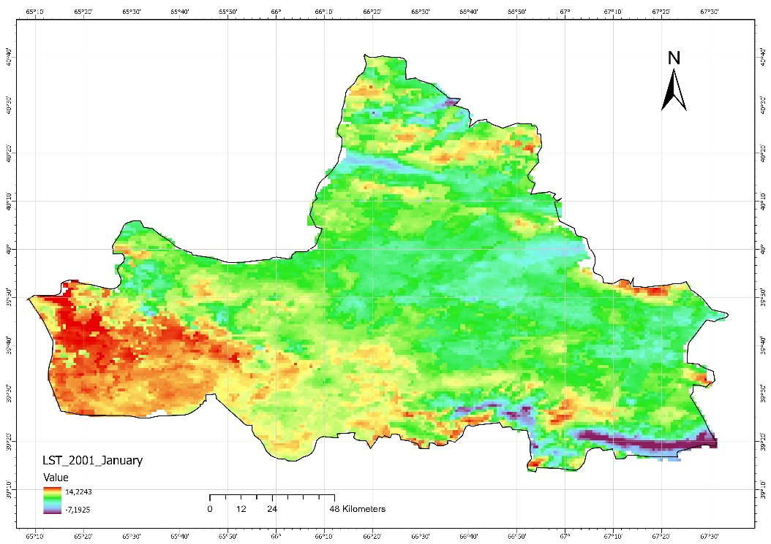
FIGURE 2. Land surface temperature map of Samarkand region in January 2001.

The spatial patterns of LST in the Samarkand region were assessed for both winter (January) and summer (July) months across selected years. Figure 1 illustrates the LST distribution in January 2001, revealing cooler surface temperatures typical of the winter season, with mean values ranging from approximately -5°C to 5°C across the region. In contrast, Figure 2, depicting January 2024, shows a noticeable increase in LST, with mean temperatures rising by approximately 1–2°C, particularly in the southwestern parts of the region. Similarly, summer conditions are represented in Figure 3 (July 2001) and Figure 4 (July 2024), where July 2001 LST values ranged between 30°C and 40°C, while July 2024 exhibits a slight upward shift, with mean temperatures increasing by 1–3°C, again more pronounced in the southwestern areas. These spatial maps indicate a consistent warming trend over the 23-year period, with urbanized and industrialized zones displaying greater temperature elevations.
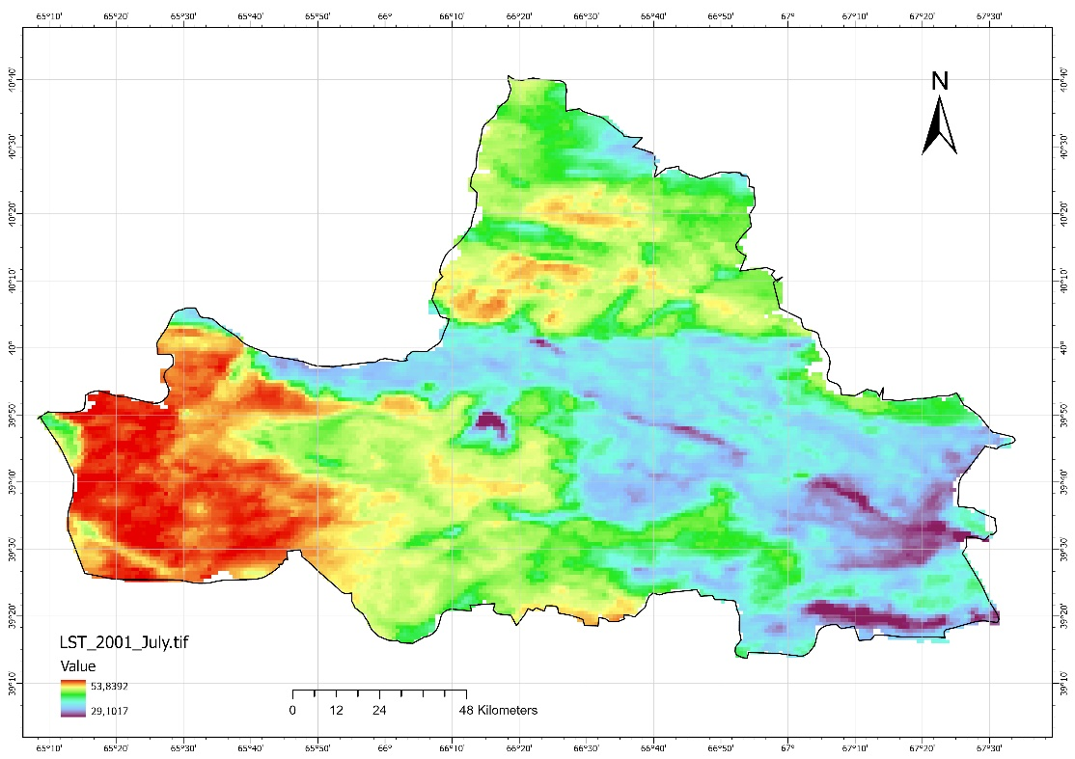
FIGURE 3. Land surface temperature map of Samarkand region in July 2001.

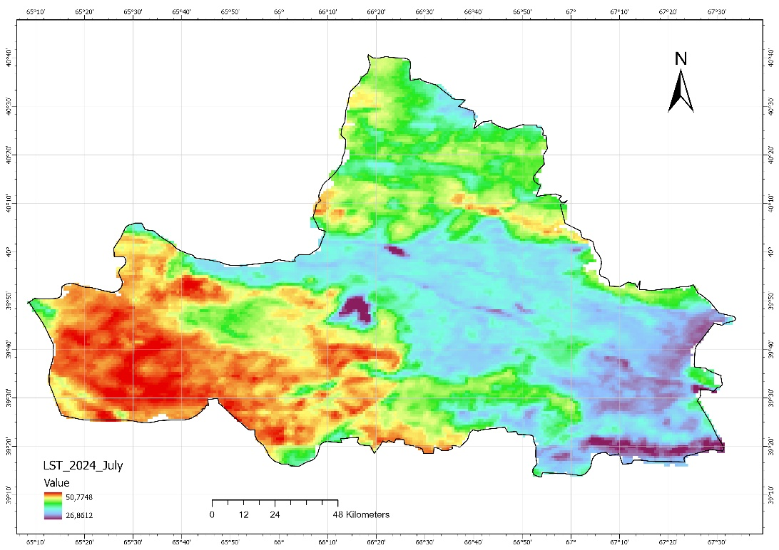
FIGURE 4. Land surface temperature map of Samarkand region in January 2024.

Monthly mean LST maps further elucidate seasonal differences and long-term changes. Figure 5 presents the monthly mean LST for January 2001, showing a regionally averaged temperature of approximately 0°C, while Figure 6 (January 2023) indicates a modest increase to around 1.5°C. Notably, Figure 7, also representing January 2023, aligns closely with Figure 6, confirming the reliability of the data processing within GEE. For the summer season, Figure 8 (July 2023) reveals a monthly mean LST of approximately 34°C, reflecting the heightened thermal conditions typical of mid-year in this semi-arid region. The comparison between January and July mean LST values underscores significant seasonal variability, with summer temperatures exceeding winter values by over 30°C on average.
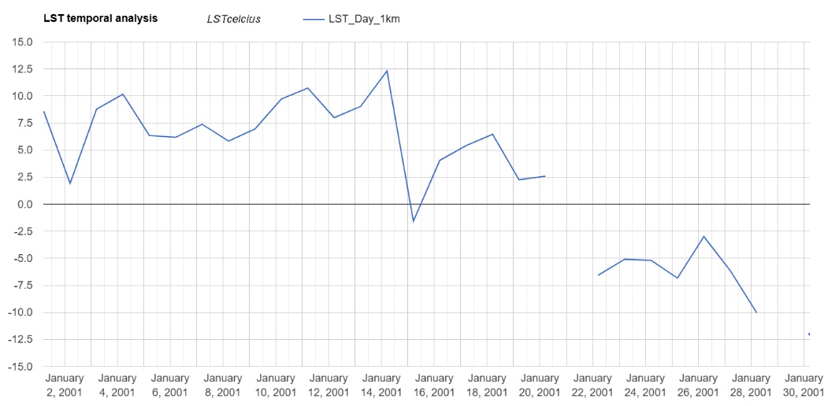
FIGURE 5. Monthly mean Land surface temperature map of Samarkand region in January 2001.

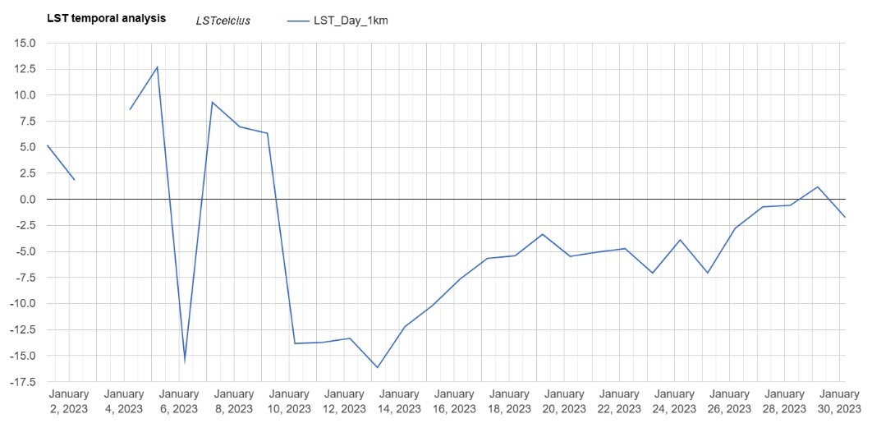
FIGURE 6. Monthly mean Land surface temperature map of Samarkand region in January 2023.

The long-term temporal analysis of LST, illustrated in Figure 9, provides a comprehensive overview of temperature changes in the Samarkand region from 2001 to 2024. The trend analysis reveals a gradual increase in annual mean LST, with an average rise of approximately 0.8–1.2°C over the study period. This warming trend is more pronounced in the southwestern parts of the region, correlating with areas of intensified urbanization and land use change. Seasonal comparisons between January (e.g., Figs. 1 and 2) and July (e.g., Figs. 3 and 4) data further indicate that summer months exhibit slightly steeper warming trends (1–3°C) compared to winter months (1–2°C), likely influenced by the urban heat island (UHI) effect and reduced vegetation cover during warmer seasons.
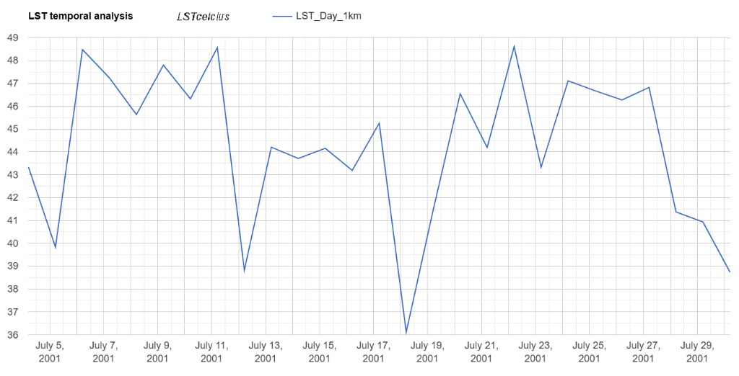
FIGURE 7. Monthly mean Land surface temperature map of Samarkand region in January 2023.

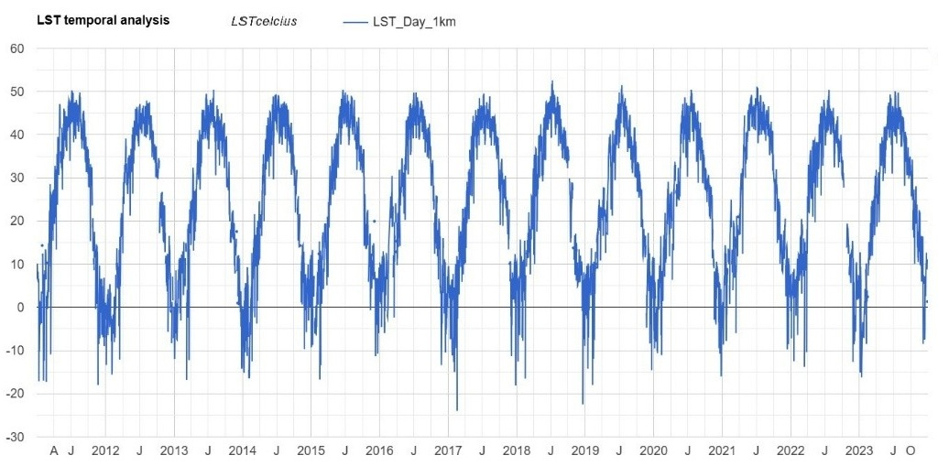
FIGURE 8. Monthly mean Land surface temperature map of Samarkand region in July 2023.
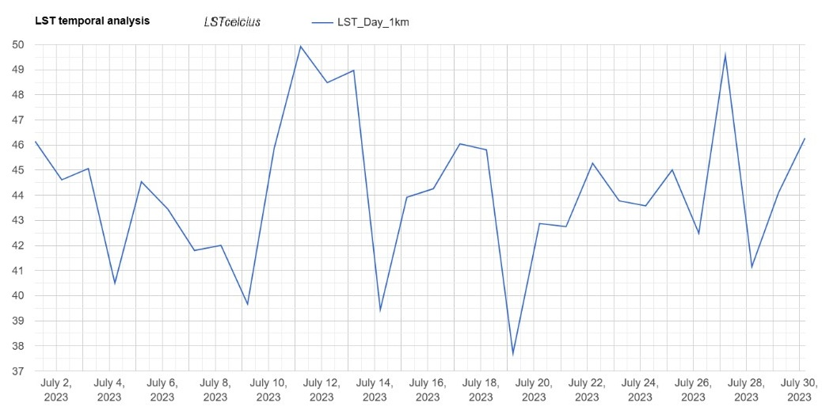
FIGURE 9. Land surface temperature temporal analysis of Samarkand region from 2001 till 2024.

The results demonstrate a clear upward trend in LST across the Samarkand region, with an overall increase in mean surface temperatures between 2001 and 2024. The southwestern zones, characterized by greater urban expansion, consistently exhibit higher LST values and more significant warming compared to other areas. Seasonal analyses highlight that summer temperatures have risen more markedly than winter temperatures, reflecting the combined impacts of climate variability and anthropogenic factors such as urbanization and agricultural intensification. The integration of GEE and MODIS data proved effective in capturing these trends, offering high-resolution insights into both spatial and temporal LST dynamics.
These findings provide a robust foundation for understanding the thermal evolution of the Samarkand region, emphasizing the utility of remote sensing technologies in environmental monitoring. The observed LST changes have implications for regional climate adaptation strategies, urban planning, and sustainable land management practices in this semi-arid landscape.
CONCLUSIONS
This study evaluated long-term Land Surface Temperature (LST) variations in the Samarkand region of Uzbekistan by employing MODIS/061/MOD11A1 data within the Google Earth Engine (GEE) platform. The investigation spanned an extended timeframe, encompassing seasonal comparisons from January and July of 2000 and 2023, alongside annual trends from 2010 to 2024. These findings enhance our understanding of the spatiotemporal LST dynamics in a semi-arid region undergoing notable climatic and human-induced changes.
The analysis reveals a steady, though modest, rise in mean LST over the study period. Seasonal assessments indicate that July temperatures significantly exceed those in January, underscoring the region’s marked seasonal variability. The southwestern areas of Samarkand, influenced by urbanization and limited vegetation cover, exhibited more pronounced LST increases compared to the northern and eastern zones, where higher elevations and intensive agriculture predominate. These patterns emphasize the role of urban heat island effects and land use alterations in shaping surface temperature trends.
The combination of MODIS data and GEE provided an effective and scalable approach for spatiotemporal LST analysis, delivering reliable insights in a region with sparse ground-based monitoring infrastructure. By harnessing long-term satellite observations, this study highlights the efficacy of remote sensing technologies in tracking and quantifying the effects of climate change and land cover transformations. Key implications include:
Urban Planning: Strategies to mitigate urban heat islands, such as afforestation, green roofing, and sustainable urban design.
Agricultural Adaptation: Enhanced irrigation and land management practices to optimize surface albedo and evapotranspiration.
Climate Resilience: Development of regional climate action plans targeting the southwestern zones, where LST increases are most significant.
The research underscores the value of integrating additional datasets, such as vegetation indices and socioeconomic factors, to gain a more comprehensive understanding of the drivers of LST changes. Furthermore, refining the analysis through higher-resolution datasets and in-situ observations could improve the precision of LST assessments and bolster localized climate adaptation efforts.
This study provides critical insights into the thermal dynamics of the Samarkand region, contributing to broader knowledge of climate change impacts in semi-arid environments. By establishing a basis for sustainable land and resource management, it offers an essential resource for policymakers and researchers tackling the challenges of global warming in the Samarkand region.
REFERENCES
- Adagbasa, E. G., Adelabu, S. A., & Okello, T. W. (2020). Development of post-fire vegetation response-ability model in grassland mountainous ecosystem using GIS and remote sensing. ISPRS Journal of Photogrammetry and Remote Sensing, 164(May), 173–183. doi: 10.1016/j.isprsjprs.2020.04.006
- Aslanov, I. (2022). Preface. IOP Conference Series: Earth and Environmental Science, 1068(1), 011001. doi: 10.1088/1755-1315/1068/1/011001
- Aslanov, I., Jumaniyazov, I., Embergenov, N., Allanazarov, K., Khodjaeva, G., Joldasov, A., & Alimova, S. (2023). Remote Sensing for Land Use Monitoring in the Suburban Areas of Tashkent, Uzbekistan. In A. Beskopylny, M. Shamtsyan, & V. Artiukh (Eds.), XV International Scientific Conference “INTERAGROMASH 2022” (pp. 1899–1907). Cham: Springer International Publishing. doi: 10.1007/978-3-031-21219-2_211
- Aslanov, I., Teshaev, N., Jabbarov, Z., Opp, C., Oymatov, R., Karimov, Y., & Henebry, G. (2024). Characterizing land surface dynamics in Aral Sea basin of Uzbekistan using climatic and remote sensing data to project future conditions. E3S Web of Conferences, 575, 04009. doi: 10.1051/e3sconf/202457504009
- Aslanov, I., Teshaev, N., Khayitov, K., Mukhtorov, U., Khaitbaeva, J., & Murodova, D. (2023). Analysis of desertification trends in Central Asia based on MODIS Data using Google Earth Engine. E3S Web of Conferences, 443, 06015. doi: 10.1051/e3sconf/202344306015
- Capolupo, A., Monterisi, C., & Tarantino, E. (2020). Landsat Images Classification Algorithm (LICA) to Automatically Extract Land Cover Information in Google Earth Engine Environment. Remote Sensing, 12(7), 1201. doi: 10.3390/rs12071201
- Duan, Y., Li, X., Zhang, L., Chen, D., Liu, S., & Ji, H. (2020). Mapping national-scale aquaculture ponds based on the Google Earth Engine in the Chinese coastal zone. Aquaculture, 520(October 2019), 734666. doi: 10.1016/j.aquaculture.2019.734666
- Goibberdiev, S., Ikromkhodjaev, G., Tajekeev, Z., Ismailov, T., Mukhtorov, U., & Aslanov, I. (2023). Improving the assessment of agricultural land reclamation condition using GIS based on the interdependence of the factors impact. E3S Web of Conferences, 443, 06013. doi: 10.1051/e3sconf/202344306013
- Kolli, M. K., Opp, C., Karthe, D., & Groll, M. (2020). Mapping of major land-use changes in the Kolleru Lake freshwater ecosystem by using landsat satellite images in google earth engine. Water (Switzerland), 12(9), 1–14. doi: 10.3390/w12092493
- Kong, D., Zhang, Y., Gu, X., & Wang, D. (2019). A robust method for reconstructing global MODIS EVI time series on the Google Earth Engine. ISPRS Journal of Photogrammetry and Remote Sensing, 155(May), 13–24. doi: 10.1016/j.isprsjprs.2019.06.014
- Li, Xiaojiang, Zhang, C., Li, W., Ricard, R., Meng, Q., & Zhang, W. (2015). Assessing street-level urban greenery using Google Street View and a modified green view index. Urban Forestry and Urban Greening, 14(3), 675–685. doi: 10.1016/j.ufug.2015.06.006
- Li, Xuecao, Gong, P., & Liang, L. (2015). A 30-year (1984–2013) record of annual urban dynamics of Beijing City derived from Landsat data. Remote Sensing of Environment, 166, 78–90. doi: 10.1016/j.rse.2015.06.007
- Mohiuddin, G., Mund, J.-P., & Rahaman, K. J. (2023). Detection of Urban Expansion using the Indices-Based Built-Up Index Derived from Landsat Imagery in Google Earth Engine. GI_Forum, 1, 18–31. doi: 10.1553/giscience2023_02_s18
- Mukhtorov, U., Aslanov, I., Lapasov, J., Eshnazarov, D., & Bakhriev, M. (2023). Creating Fertilizer Application Map via Precision Agriculture Using Sentinel-2 Data in Uzbekistan. In A. Beskopylny, M. Shamtsyan, & V. Artiukh (Eds.), XV International Scientific Conference “INTERAGROMASH 2022” (pp. 1915–1921). Cham: Springer International Publishing. doi: 10.1007/978-3-031-21219-2_213
- Muslimbekov, B., Teshaev, N., Abdurakhmonov, S., & Gaybulloev, O. (2024). Monitoring Trends of SO ₂ level Using Time-Series Sentinel-5 Images Based on Google Earth Engine. E3S Web of Conferences, 563, 03068. doi: 10.1051/e3sconf/202456303068
- Opp, C., Groll, M., Semenov, O., Shardakova, L., Kovalevskaya, Y., Kulmatov, R., … Aslanov, I. (2024). Water household changes, climate change, and human impact – reasons for the dusty side of the Aral Sea Syndrome. E3S Web of Conferences, 575, 04001. doi: 10.1051/e3sconf/202457504001
- Patel, N. N., Angiuli, E., Gamba, P., Gaughan, A., Lisini, G., Stevens, F. R., … Trianni, G. (2015). Multitemporal settlement and population mapping from Landsat using Google Earth Engine. International Journal of Applied Earth Observation and Geoinformation, 35(PB), 199–208. doi: 10.1016/j.jag.2014.09.005
- Pimple, U., Simonetti, D., Sitthi, A., Pungkul, S., Leadprathom, K., Skupek, H., … Towprayoon, S. (2018). Google Earth Engine Based Three Decadal Landsat Imagery Analysis for Mapping of Mangrove Forests and Its Surroundings in the Trat Province of Thailand. Journal of Computer and Communications, 06(01), 247–264. doi: 10.4236/jcc.2018.61025
- Recondo, C., Corbea-Pérez, A., Peón, J., Pendás, E., Ramos, M., Calleja, J. F., … Corrales, J. A. (2022). Empirical Models for Estimating Air Temperature Using MODIS Land Surface Temperature ( and Spatiotemporal. Remote Sensing, 14(13), 3206.
- Xie, S., Liu, L., Zhang, X., Yang, J., Chen, X., & Gao, Y. (2019). Automatic Land-Cover Mapping using Landsat Time-Series Data based on Google Earth Engine. Remote Sensing, 11(24), 3023. doi: 10.3390/rs11243023

