Study of protection of pasture lands using geoinformation technologies and applications (as an example of Tashkent region)
Madina Abdullayeva ^{a)}, Dilafruz Nasirkhodjaeva, Dilsuz Fayzieva
Tashkent State University of Economics, Tashkent, Uzbekistan
^{a)} Corresponding author: 1976mkmadina@gmail.com
Abstract. The main aim of the study is to conserve pasturelands in the Tashkent area by using geoinformation technology. Due to inefficient land utilization and degradation processes, the region encounters various challenges. For instance, abandoned areas and deforested lands have been transformed into open spaces, exacerbating soil deterioration. To tackle this issue, the project employs geographic information system (GIS) data analysis and remote sensing to monitor land cover changes and devise viable solutions. Gathering remotely sensed land cover images over a decade (2012–2022) forms part of the study to identify potential enhancements based on land cover alterations. GIS technology proves valuable in monitoring changes and devising strategies to mitigate the impacts of land degradation. Furthermore, the research explores the utilization of remote sensing methods to reclaim pasturelands and agrobiological techniques to enhance the fertility of degraded soils. The findings underscore the significance of geoinformation technologies in informing decision-making for sustainable pastureland management. They reveal the potential of these technologies in improving understanding and interpretation of land degradation effects, facilitating the development of monitoring maps, and furnishing predictive data for land resource management. Ultimately, the study contributes to devising practical solutions for safeguarding and enhancing pasturelands in the Tashkent region, thereby supporting the long-term sustainability of its natural resources.

INTRODUCTION
Pasture lands are essential for sustaining livestock and supporting the livelihoods of millions globally [1]. Ensuring their sustainable management and protection is crucial to prevent degradation, maintain ecological balance, and ensure agricultural productivity. Recently, geoinformation technologies have revolutionized environmental monitoring and land management. This study focuses on using these technologies to protect pasture lands, specifically in the Tashkent region [2,3].
The Tashkent region, known for its diverse and productive agricultural landscapes, faces significant challenges related to pasture degradation. Factors like overgrazing, climate change, and unsustainable land use practices have led to deteriorating pasture quality, threatening agricultural sustainability and the well-being of local communities. Traditional methods of monitoring and managing pastures often fail to provide the timely and accurate data needed for effective decision-making [4–6].
Geoinformation technologies, including Geographic Information Systems (GIS), Remote Sensing (RS), and Global Positioning Systems (GPS), offer innovative solutions to these challenges. They enable the collection, analysis, and interpretation of spatial and temporal data, providing comprehensive insights into land use patterns, vegetation health, soil conditions, and environmental changes [7–10]. Using these technologies allows for real-time monitoring of pasture conditions, assessment of various factors affecting pasture health, and implementation of targeted interventions to protect and restore these critical ecosystems [11–14].
The purpose of this study is to explore the application of geoinformation technologies in the Tashkent region for protecting and sustainably managing pasture lands. Through detailed analysis and case studies, the study aims to demonstrate how these advanced tools can enhance understanding of pasture dynamics, facilitate efficient resource allocation, and support informed policy-making. By highlighting the benefits and practical applications of geoinformation technologies, this research underscores their potential to contribute to the resilience and sustainability of pastoral systems in the Tashkent region and beyond [15–17].
EXPERIMENTAL RESEARCH
This study concentrates on safeguarding pasture lands in the Tashkent region, located in northeastern Uzbekistan. Covering around 15,300 square kilometers, the Tashkent region features a diverse landscape that includes mountains, foothills, and broad plains. This varied terrain, coupled with a continental climate, creates multiple ecological zones that support various agricultural activities, including livestock grazing [18,19].
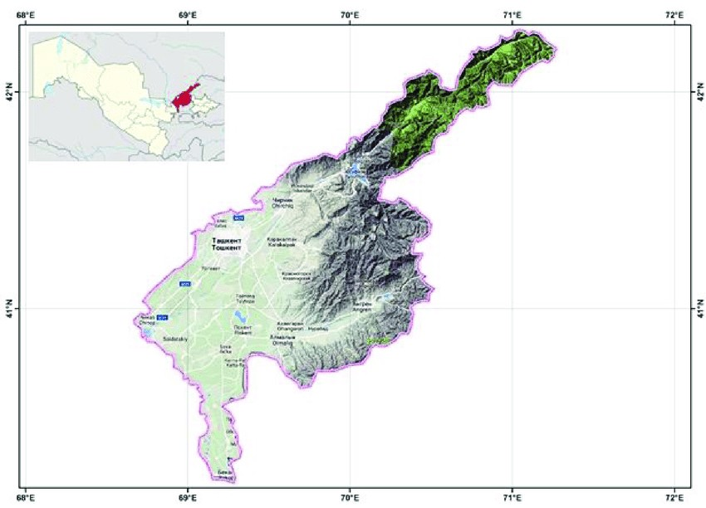
FIGURE 1. Study area Tashkent region

The Tashkent region, located in Uzbekistan, is surrounded by the Kyrgyz Republic to the east, Tajikistan to the southeast, and other Uzbek provinces to the west and northwest. Its strategic position in the region makes it crucial for agricultural productivity at the national and regional levels. The region experiences a continental climate with hot summers and cold winters, and the majority of rainfall occurs in spring and early summer. This climatic pattern directly affects vegetation growth and the availability of pasture, highlighting the need for effective management to mitigate seasonal and long-term variations [20,21].
Agriculture plays a significant role in the economy of the Tashkent region, particularly through the support of livestock, which serves as a major source of income for many rural communities. However, the region faces various challenges in maintaining the health and productivity of its pasture lands. Overgrazing, deforestation, and inadequate land management practices have resulted in soil erosion, loss of vegetation, and decreased land productivity. Additionally, the impact of climate change further exacerbates these issues, posing additional threats to the stability of pasture ecosystems [22,23].
Given the diverse geography, climatic conditions, and socio-economic context of the Tashkent region, it provides a complex yet highly relevant case for studying the protection of pasture lands using geoinformation technologies. This study aims to explore how these advanced tools can address the specific challenges faced by the region and develop strategies that can be applied not only locally but also in similar contexts around the world [24].
In order to comprehensively examine the present state of affairs in the field, site visits were conducted at the primary local farms and their proprietors were consulted. These visits entailed administering concise surveys to the farm owners. This method not only supplied vital technical data, but also afforded valuable insights into the principal production concerns [25]. Furthermore, each farm owner was mandated to submit a map illustrating the current state and whereabouts. These maps often encompassed hand-copied or photocopied sketches or antiquated plans derived from the original cadastral maps, leading to some loss of intricacy. Typically, the maps featured a key denoting field boundaries and the varieties of crops cultivated, with each field being assigned its own unique identification number [26].
In the preparation of GIS layers, various raster resolutions are utilized:
A basic resolution of 100 meters for calculating suitability.
LANDSAT images at resolutions of 30 and 15 meters.
A detailed topographic map at a scale of 1:100,000, also at a 15-meter resolution.
The area boundaries are defined as Xmin = 6490027, Ymin = 5005476, Xmax = 6587527, and Ymax = 5088076 (Gauss-Krueger system, zone 6), covering a total area of 97 by 83 kilometers [27]. The panchromatic image has a 15-meter resolution (5508 × 6501 pixels). Using this methodology, the following thematic layers are created:
Topographic map 1:100K (topo100K): Scanned and geo-referenced sheets of the 1:100K topographic map serve as the GIS foundation. In this example, a total of 19 sheets of the topographic map of the Republic of Croatia were geo-referenced and combined.
Normalized Difference Vegetation Index (NDVI): This widely used vegetation index has proven highly effective for satellite assessment and monitoring of global vegetation cover over the past decade [28].
$NDVI=\frac{\left(NIR-VIS\right)}{\left(NIR+VIS\right)}$ (1)
NIR = Near Infrared
VIS = RED
Where NIR and RED represent surface reflectances averaged over the visible (λ ∼0.6 μm) and near-infrared (NIR) (λ ∼0.8 μm) regions of the spectrum, respectively, the NDVI is correlated with specific biophysical properties of the vegetation canopy. These properties include leaf area index (LAI), fractional vegetation cover, vegetation condition, and biomass.
RESEARCH RESULTS
Various vegetation indices are commonly used in precision farming, with the NDVI (Normalized Difference Vegetation Index) being the most popular. NDVI allows for the global monitoring of fields and crops using satellite images. It is important to note that while NDVI indicates plant health, it does not reveal the specific causes of certain conditions. Instead, the index provides a snapshot of what is happening in the field.
Let's consider three scenarios for utilizing NDVI in field analysis during different stages of the growing season: early, mid, and late. At the beginning of the season, NDVI helps determine the survival of plants after winter. An NDVI below 0.15 suggests that most plants in that area likely died, as this value typically corresponds to bare soil. An NDVI between 0.15 and 0.2 is also low, indicating that plants may have entered an early phenological phase before tillering. A relatively good NDVI range is 0.2 to 0.3, which suggests that plants have likely entered the tillering stage and resumed growth. Values between 0.3 and 0.5 are considered good, but high NDVI values could mean that plants wintered in a late phenological stage. If the image was taken before vegetation resumed, the area should be re-analyzed afterwards. An NDVI above 0.5 is abnormal for the post-wintering period and should be inspected in person.
Any abnormal NDVI values that significantly differ from the field's average should prompt a field check. NDVI data for fields can be monitored under clear conditions, with images being updated every 3 to 5 days.
Remote sensing methods, when combined with accurate Landsat data, support the assessment of land cover changes. Results indicate significant changes in land cover in the mountains and highlands of Zaamin over a ten-year period. Due to inefficient pasture use in the mountainous and foothill areas of the Tashkent region spanning twenty years, these areas have become open lands. The study area shows diverse land cover changes, which may lead to soil erosion, floods, and landslides in the future. These potential hazards pose risks when certain elements are present.

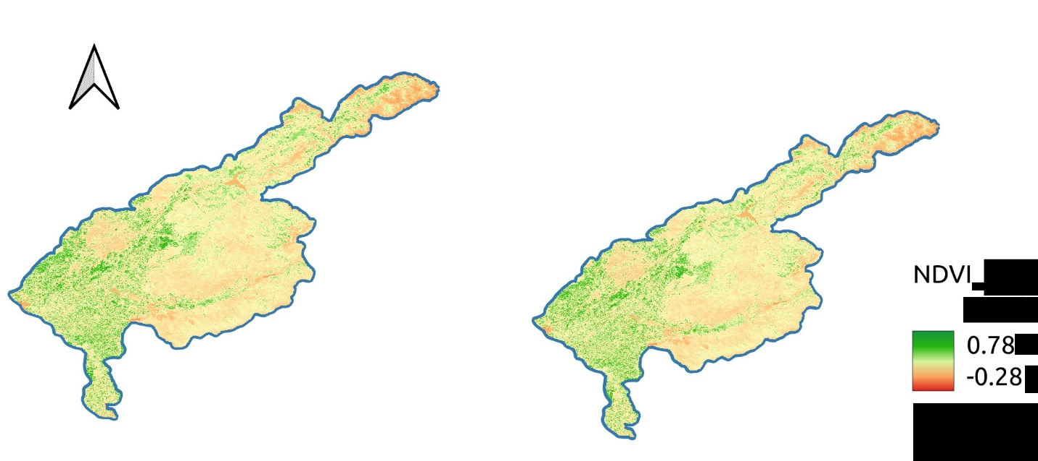
FIGURE 2. Study area Tashkent region

In the results, we obtain maps that are identified using two different methods: the traditional method and NDVI analysis. In the traditional method, an equal amount of fertilizer is applied to all contours. However, with the NDVI analysis, a map is created that allows for precise application of fertilizer at specific coordinates, providing the exact amount needed for the crop. This approach not only enhances economic efficiency but also improves soil fertility.
CONCLUSION
This scientific research primarily focuses on methodology, specifically aiming to enhance the understanding and implementation of detailed spatial planning using geoinformation technologies and applications by employees and researchers. The study was conducted within the field of geoinformation technologies and applications, incorporating relief data and satellite images for verification purposes. It is suggested that the integration and combination of remote sensing images and the vineyard register with relief and satellite images can yield even more accurate results than those presented in this paper.
There is a considerable number of potential users and applications that rely on up-to-date geo-information, particularly digital purpose maps. However, decisions regarding land use and its changes in the region are still not being made based on objective queries and criteria. Regrettably, our country lacks updated and detailed maps of areas that would accurately depict the current state of land use and the true potential of natural resources such as soil, water, and relief. Furthermore, fundamental geodesy components such as the cadastre, aero photos, and topographic maps have not been digitized or made available to these services.
The study area exhibits varying land cover changes, which can lead to future issues such as soil erosion, floods, and landslides. Once these elements are at risk, they can transform into hazards. The land cover change maps generated from this study will be utilized for further landslide susceptibility mapping in the study area. This will aid governmental authorities and stakeholders in establishing land-use planning at the local government level, aiming to mitigate natural hazard losses.
REFERENCES
- Juliev, M., Pulatov, A., Fuchs, S. & Hübl, J. (2019). Analysis of Land Use Land Cover Change Detection of Bostanlik District, Uzbekistan. Polish Journal of Environmental Studies, 28(5), 3235–3242. https://doi.org/10.15244/pjoes/94216
- Gerts, Jasmina, et al. "Multi-temporal monitoring of cotton growth through the vegetation profile classification for Tashkent province, Uzbekistan" GeoScape, vol. 14, no. 1, Jan Evangelista Purkyně University in Ústí nad Labem, 2020, pp. 62-69. https://doi.org/10.2478/geosc-2020-0006
- S. Islomov, I. Aslanov, G. Shamuratova, A. Jumanov, K. Allanazarov, Q. Daljanov, M. Tursinov, and Q. Karimbaev, in XV International Scientific Conference “INTERAGROMASH 2022,” edited by A. Beskopylny, M. Shamtsyan, and V. Artiukh (Springer International Publishing, Cham, 2023), pp. 1908–1914. https://doi.org/10.1051/e3sconf/202459001011
- Kumar, L., Sinha, P., Taylor, S., & Alqurashi, A. F. (2015). Review of the use of remote sensing for biomass estimation to support renewable energy generation. Journal of Applied Remote Sensing, 9(1), 097696-097696. https://doi.org/10.1117/1.JRS.9.097696
- L. Cabrera-Bosquet, G. Molero, A. Stellacci, J. Bort, S. Nogués, and J. Araus, NDVI as a potential tool for predicting biomass, plant nitrogen content and growth in wheat genotypes subjected to different water and nitrogen conditions. Cereal Research Communications 39, 147 (2011). https://doi.org/10.1556/crc.39.2011.1.15
- I. Ali, F. Cawkwell, E. Dwyer, B. Barrett, and S. Green, Journal of Plant Ecology 9, 649 (2016)
- V.S. Jansen, C.A. Kolden, H.J. Schmalz, J.W. Karl, R.V. Taylor, Using Satellite-Based Vegetation Data for Short-Term Grazing Monitoring to Inform Adaptive Management, Rangeland Ecology & Management, Volume 76, 2021, Pages 30-42, ISSN 1550-7424, https://doi.org/10.1016/j.rama.2021.01.006.
- Walker DA, Auerbach NA, Shippert MM. NDVI, biomass, and landscape evolution of glaciated terrain in northern Alaska. Polar Record. 1995;31(177):169-178. doi:10.1017/S003224740001367
- Qobulov, Eshbolta & Botirova, Halima & Tursunov, Nurullo & Jumayeva, Shohida & Kabulov, Kamoliddin. (2024). Study of soil salinity in agricultural land using Remote Sensing data in Amudarya district, Uzbekistan. E3S Web of Conferences. 590. 01011. 10.1051/e3sconf/202459001011.
- Mamatkulov, Z., Safarov, E., Oymatov, R., Abdurahmanov, I., & Rajapbaev, M. (2021). Application of GIS and RS in real time crop monitoring and yield forecasting: a case study of cotton fields in low and high productive farmlands. In E3S Web of Conferences (Vol. 227, p. 03001). EDP Sciences. https://doi.org/10.1051/e3sconf/202122703001
- S. Goibberdiev, G. Ikromkhodjaev, Z. Tajekeev, T. Ismailov, U. Mukhtorov, and I. Aslanov, E3S Web of Conf. 443, 06013 (2023) https://doi.org/10.1051/e3sconf/202459002008
- U. Mukhtorov, I. Aslanov, J. Lapasov, D. Eshnazarov, and M. Bakhriev, in XV International Scientific Conference “INTERAGROMASH 2022,” edited by A. Beskopylny, M. Shamtsyan, and V. Artiukh (Springer International Publishing, Cham, 2023), pp. 1915–1921. https://doi.org/10.1051/e3sconf/202459001011
- W. Liu, Q. Meng, M. Allam, L. Zhang, D. Hu, and M. Menenti, Remote Sensing 13, (2021) https://doi.org/10.3390/rs13152858
- Amankulova, K., Farmonov, N., Mukhtorov, U., & Mucsi, L. (2023). Sunflower crop yield prediction by advanced statistical modeling using satellite-derived vegetation indices and crop phenology. Geocarto International, 38(1). https://doi.org/10.1080/10106049.2023.2197509
- Mukhtorov, U. (2021). Stimulating the efficient use of agricultural land based on the improved methodology for land tax calculation. In E3S Web of Conferences (Vol. 244, p. 03013). EDP Sciences. https://doi.org/10.1051/e3sconf/202124403013
- Begmat Kh. Norov, Laziz K. Babajanov, Aziz I. Inamov, Khusnora Kh. Kholmatova. E3S Web of Conf., 390 (2023) 03028. Published online: 2023-06-01 DOI: https://doi.org/10.1051/e3sconf/202339003028
- Ruzikulova, O. (2023). Analysis of vegetation changes in land area of Syrdarya region using GIS technology and remote sensing data. In E3S Web of Conferences (Vol. 401, p. 04008). EDP Sciences.O. Ruzikulova, N. Sabitova, and G. Kholdorova, E3S Web of Conferences 227, 03004 (2021). https://doi.org/10.1051/e3sconf/202340104008
- Ten, Y.A., Oymatov, R., Khayitov, K., Saydalieva, G., Nulloev, U., & Nematov, I. (2021). Application of modern geodetic tools in the operation of railway reconstructions. E3S Web of Conferences.
- L. Gafurova and M. Juliev, in Regenerative Agriculture, edited by D. Dent and B. Boincean (Springer International Publishing, Cham, 2021), pp. 59–67. DOI : 0.1016/j.rama.2021.01.006
- M. Juliev, W. Ng, I. Mondal, D. Begimkulov, L. Gafurova, M. Hakimova, O. Ergasheva, M. Saidova. Surface displacement detection using object-based image analysis, Tashkent region, Uzbekistan. E3S Web Conf., 386 (2023) 04010. Published online: 2023-05-12. DOI: https://doi.org/10.1051/e3sconf/202338604010
- Ting Zhang, Yameng Yu, Yupu Lu, Hao Tang, Kai Chen, Jiahui Shi, Zeqi Ren, Shuilin Wu, Dandan Xia, Yufeng Zheng, Bridging biodegradable metals and biodegradable polymers: A comprehensive review of biodegradable metal–organic frameworks for biomedical application, Progress in Materials Science, Volume 155, 2026, 101526, ISSN 0079-6425, https://doi.org/10.1016/j.pmatsci.2025.101526.
- Wu Y, Wang HM, Hu XL, Zang Y, Li J, Han HH, He XP, Lewis SE, Ismail HM, James TD. Twisted intramolecular charge transfer (TICT) based fluorescent probes and imaging agents. Chem Soc Rev. 2025 Nov 21. doi: 10.1039/d3cs01118f.Epub ahead of print. PMID: 41268874.R. Pullanagari, I. Yule, M. Tuohy, R. Dynes, and W. King, Tur-Www1.Massey.Ac.Nz 1 (2010)
- Dealino, MM, Bueno, CM (2022) Production profile and microbiological properties of locally produced pork sausage in the Philippines. IOP Conference Series: Earth and Environmental Science, 1041 (1) 12079 doi:10.1088/1755-1315/1041/1/012079
- S.M. Punalekar, A. Verhoef, T.L. Quaife, D. Humphries, L. Bermingham, C.K. Reynolds, Application of Sentinel-2A data for pasture biomass monitoring using a physically based radiative transfer model, Remote Sensing of Environment, Volume 218, 2018, Pages 207-220, ISSN 0034-4257, https://doi.org/10.1016/j.rse.2018.09.028.
- Adagbasa EG, Mukwada G (2022) Mapping vegetation species succession in a mountainous grassland ecosystem using Landsat, ASTER MI, and Sentinel-2 data. PLoS ONE 17(1): e0256672. https://doi.org/10.1371/journal.pone.0256672
26. Abderrazak, Bannari & Morin, D. & Bonn, F. & Huete, Alfredo. (1996). A review of vegetation indices. Remote Sensing Reviews. 13. 95-120. 10.1080/02757259509532298.

