Study of Using GIS Technologies in Forestry Cadastre and Monitoring for Economical and Ecological Sustainability
Azizakhon Gafurova ^{a)}, Guzal Alimova, Umida Gafurova, Mokhinur Rakhimova
Tashkent State University of Economics, Tashkent, Uzbekistan
^{a)} Corresponding author: 94.aziza@gmail.com
Abstract. The integration of Geographic Information Systems (GIS) technologies in the forestry cadastre and monitoring practices in Uzbekistan represents a significant advancement in sustainable forest management. This study explores the application of GIS in enhancing the accuracy, efficiency, and comprehensiveness of forestry cadastre, which is crucial for the effective management, conservation, and restoration of forest resources in Uzbekistan. Through spatial analysis, remote sensing, and data integration, GIS technologies offer detailed insights into forest cover, land use changes, and biodiversity, providing a robust framework for decision-making and policy formulation. The research highlights how GIS tools facilitate the precise mapping of forest boundaries, monitoring of illegal logging activities, and assessment of reforestation efforts. Furthermore, the study examines the challenges and opportunities in implementing GIS in Uzbekistan's forestry sector, considering the country's unique geographical and ecological context. The findings suggest that adopting GIS technologies can significantly contribute to achieving Uzbekistan's environmental sustainability goals and improving the management of its forestry resources.
INTRODUCTION
Forests play a crucial role in maintaining ecological equilibrium, supporting biodiversity, and providing economic resources. In Uzbekistan, a country characterized by a diverse range of landscapes, from deserts to mountain ranges, forests are integral to the environment, offering a myriad of ecological services and contributing to the livelihoods of rural communities[1]. Nevertheless, the management and conservation of forest resources in Uzbekistan face significant challenges, including deforestation, illegal logging, land degradation, and the impacts of climate change. To tackle these challenges, modern technological solutions such as Geographic Information Systems (GIS) have gained increasing importance in the domains of forestry cadastre and monitoring[2]. GIS is a powerful tool that integrates both spatial and non-spatial data, allowing users to visualize, analyze, and interpret geographic information in a detailed and meaningful manner. Within the forestry context, GIS technologies are employed to map forest areas, monitor changes over time, and effectively manage forest resources[3]. By leveraging the capabilities of GIS, Uzbekistan can enhance its forestry cadastre - an official register documenting the extent, value, and ownership of forest lands - and improve the critical monitoring processes that underpin sustainable forest management[4].
A forestry cadastre is an essential component of forest management, providing vital information regarding the size, location, and condition of forested areas. In the context of Uzbekistan, where forests encompass approximately 8% of the nation's total land area, the accurate and up-to-date maintenance of a forestry cadastre is imperative for sustainable development[5–7]. This cadastre serves as the foundational framework for a range of activities, including land use planning, conservation endeavors, and the allocation of forest resources. Furthermore, it plays a critical role in monitoring deforestation and land degradation, both of which are significant concerns within the country[8–10].
Traditionally, the forestry cadastre in Uzbekistan has relied upon manual methods of data collection and analysis. However, these methods are often time-consuming, labor-intensive, and vulnerable to errors. The integration of Geographic Information System (GIS) technologies into the forestry cadastre system has the potential to revolutionize this process. GIS facilitates the efficient collection, storage, and analysis of extensive spatial data, thereby streamlining the updating and maintenance of the cadastre. Moreover, GIS provides tools for spatial analysis and modeling, thereby enhancing the decision-making process within forest management[11–13]. Monitoring is a vital component of forest management and greatly benefits from the implementation of Geographic Information System (GIS) technologies. In the context of Uzbekistan, the monitoring of forest conditions encompasses the tracking of changes in forest cover, the assessment of human activities' impact, and the detection of illicit logging and other forms of forest degradation. By combining GIS with remote sensing technologies such as satellite imagery and aerial photography, a comprehensive and integrated approach to monitoring these changes becomes possible. A key advantage of utilizing GIS in forestry monitoring lies in its ability to process and analyze data from diverse sources in a spatially explicit manner. Consequently, changes in forest cover can be identified, mapped, and analyzed over time, thereby providing valuable insights for conservation and management initiatives[14–17]. For instance, GIS can generate time-series maps that illustrate the progress of deforestation or reforestation efforts, thereby aiding in the identification of areas requiring immediate attention or intervention. Furthermore, the integration of various datasets, such as topography, soil types, climate data, and land use patterns, is facilitated by GIS technologies. These datasets are all pertinent to comprehending forest dynamics. Consequently, this holistic approach enables a more nuanced comprehension of the factors driving changes in forest cover and promotes the development of targeted strategies for forest conservation and restoration[18–20]. Despite the evident benefits of adopting GIS for forestry cadastre and monitoring, the implementation of such technologies in Uzbekistan does pose challenges. These challenges include the requirement for technical expertise, the availability of high-quality spatial data, and the initial costs associated with establishing GIS infrastructure. Nevertheless, these obstacles can be overcome through appropriate investment in capacity building and technology transfer. The incorporation of GIS technologies in Uzbekistan's forestry sector presents a plethora of opportunities for enhancing forest management practices. By increasing the accuracy and efficiency of forestry cadastre and monitoring systems, GIS can support sustainable forest management, contribute to the preservation of biodiversity, and help mitigate the consequences of climate change. As Uzbekistan remains committed to environmental sustainability, the use of GIS in forestry is poised to assume an increasingly significant role in the attainment of these objectives.
EXPERIMENTAL RESEARCH
The study area for this research on the utilization of GIS technologies in forestry cadastre and monitoring is the Bustanlik district, situated in the Tashkent region of Uzbekistan (fig.1). Positioned in the western foothills of the Tien Shan Mountains, Bustanlik is renowned for its heterogeneous topography, encompassing lowland plains and high-altitude forests[21]. Consequently, the district assumes a pivotal role in the conservation and administration of forests within Uzbekistan. Spanning an estimated area of 4,900 square kilometers, the district comprises substantial forested regions that dominate its landscape.
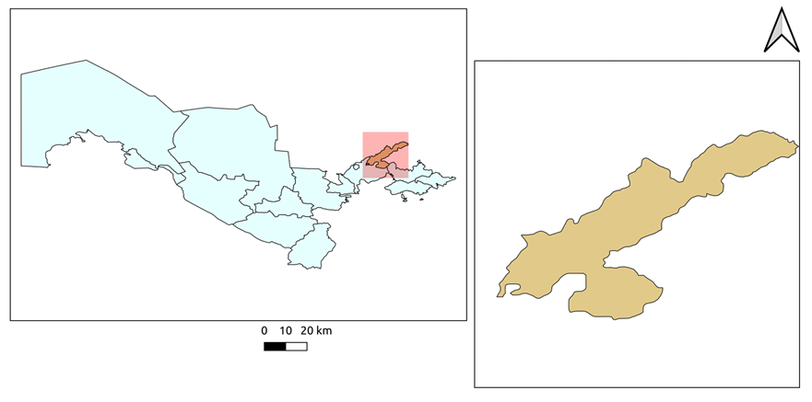
FIGURE 1. Study area

Bustanlik possesses distinct ecological attributes, rendering it a prime location for investigating the utilization of Geographic Information Systems (GIS) technologies in forestry cadastre and monitoring. The forests within this district play a vital role in the regulation of river flow, notably the Chirchiq river, which serves as a water source for agricultural irrigation and hydroelectric power generation in the vicinity. Furthermore, given the district's heightened vulnerability to the consequences of climate change, the significance of efficient forest monitoring and management cannot be overstated [22].

Data Collection
Landsat 9 OLI satellite imagery, with a spatial resolution of 30 meters, was chosen for its ability to capture high-quality, multi-spectral data over large areas. The satellite images were acquired for different seasons to capture changes in vegetation over time. The study area includes the main forested regions of study area, including mountainous areas and riparian zones, where forest dynamics are most evident.
Data preprocessing
The raw satellite images underwent several preprocessing steps to ensure data quality and accuracy. These steps included geometric correction to align the images with geographical coordinates, atmospheric correction to remove distortions caused by atmospheric conditions, and cloud masking to eliminate the impact of clouds on the analysis. This preprocessing ensured that the images accurately represented the ground conditions.
NDVI Analysis
The main method involved calculating the NDVI for each satellite image using the formula:

$NDVI=\frac{NIR-Red}{NIR+Red}$ (1)

Where: NIR (Near Infrared) and RED bands correspond to specific spectral bands captured by the Landsat 9 OLI sensor. NDVI values range from -1 to +1, with higher values indicating healthier and denser vegetation. NDVI maps were generated for different time periods, allowing for the assessment of forest cover changes, vegetation health, and areas of degradation [24].
GIS Integration
The NDVI results were integrated into a GIS platform, enabling spatial analysis and visualization. This integration allowed for the creation of detailed forest cadastre maps, identifying areas of deforestation, reforestation, and land degradation. The GIS analysis also facilitated the monitoring of illegal logging activities and the assessment of the effectiveness of forest management practices. The accuracy and reliability of the satellite-based analysis were validated using ground truth data collected from field surveys and existing forestry records.
The combination of Landsat 9 OLI imagery, NDVI analysis, and GIS integration provided a comprehensive approach to monitoring and managing Uzbekistan's forest resources, offering valuable insights for sustainable forest management.
RESEARCH RESULTS
The results of a study on the land cover changes index for transforming GIS technologies and satellite images (specifically Landsat 8.9 OLI) are proposed and evaluated for mapping forest areas. The index was able to study the changes in forest and bare land. The NDVI analysis indices were able to effectively differentiate between forest and bare land/open land due to the distinct spectral responses exhibited by these land types in all Landsat 8.9 OLI images. The land cover change map from 2013 to 2023 indicates a mixture of forest land change classes. While some areas in the study area experienced significant land cover changes over the ten-year period, large portions of forest and bare land remained unchanged in terms of land use. Some observed land cover changes during this period appeared to be related to agricultural activities (Fig. 2).
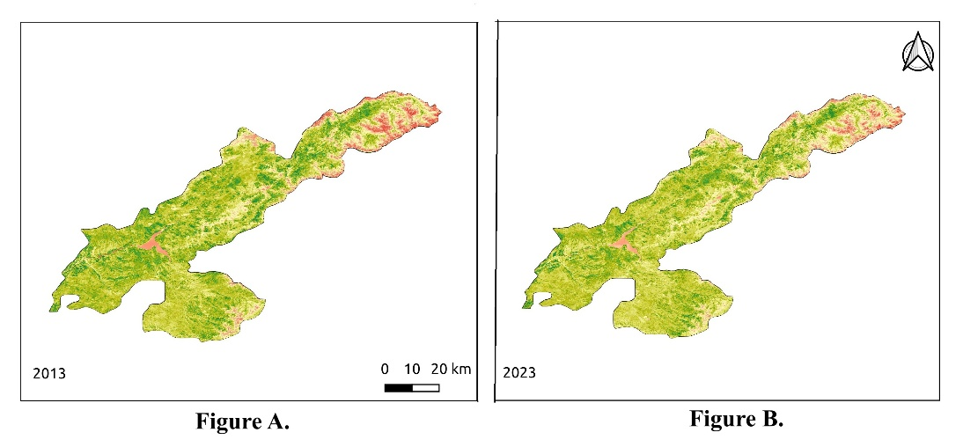
a) b)
Figure 2. Comparative NDVI analysis of the Boston region: a) 2013 and b) 2015.

The integration of NDVI with GIS allowed for precise mapping of forest boundaries and the identification of deforested areas, enabling improved forest cadastre management. Hotspots of illegal logging and areas prone to soil erosion were also detected, providing valuable information for future conservation efforts.

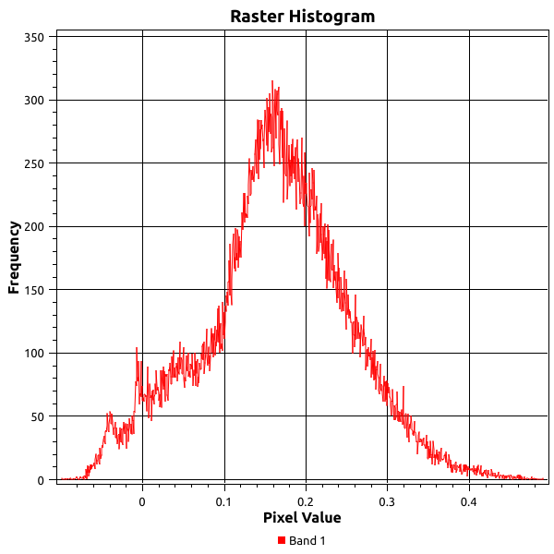
FIGURE 3. Histogram of green indexes of study area in 2013 year
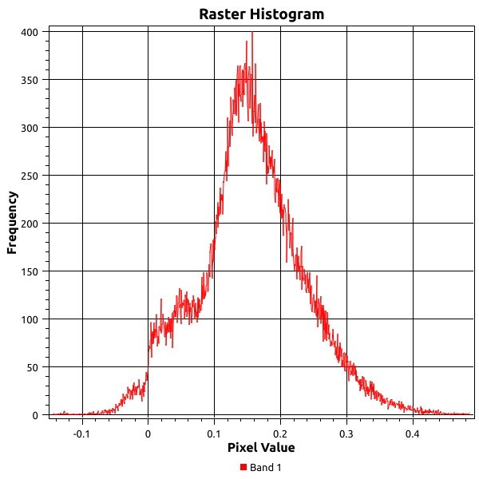
FIGURE 4. Histogram of green indexes of study area in 2023 year

"Raster histogram" showing greenness index. (Figures 3 and 4) In the figure 3 of the histogram you will find the "Frequencies" axis from 0 to 400. It's like calculating indices in degrees of precision, starting at none at the bottom and going up to 400. shows the top indicators. The figure 4 of the histogram represents the "Pixel Value" axis from -0.2 to 0.4, which represents the range of values, from open land to forest to grassland. There is a bell-shaped curve in the center of the histogram that peaks around pixel value 0.1, with a frequency of about 350 bites. This peak represents the most satisfying part of your meal, where it shows the lush green areas of the area being explored. The red dots and connecting lines are like different ingredients mixed together to create balanced indicators. In general, the application of GIS and remote sensing technologies in Bostonliq district has been effective in increasing the accuracy of forestry monitoring, improving forest management and sustainability in an ecologically sensitive region.
CONCLUSIONS
The study conducted in the Bustanlik district of Uzbekistan examines the utilization of Geographic Information System (GIS) technologies in the forestry cadastre and monitoring. This research underscores the potential of spatial analysis tools in fostering sustainable forest management practices. By integrating Landsat 9 OLI satellite imagery with Normalized Difference Vegetation Index (NDVI) analysis, the study demonstrates a highly effective approach for evaluating forest health, identifying deforestation, and monitoring land degradation in this ecologically significant area. The application of GIS facilitates accurate mapping of forested regions, offering detailed insights into changes in vegetation coverage and enabling the identification of areas vulnerable to illegal logging and unsustainable land use. Furthermore, this methodology supports the ongoing monitoring of forest resources, providing a reliable means of tracking the progress of conservation efforts over time. Given the essential role of forests in water regulation, biodiversity conservation, and local livelihoods in Bustanlik, the adoption of GIS technologies has proven invaluable in enhancing the precision and efficiency of forestry cadastre systems. By embracing these tools, forest managers and policymakers in Uzbekistan can make more informed decisions, thus contributing to the long-term sustainability of forest resources within the district. The successful implementation of GIS technologies in Bustanlik serves as a potential model for similar forest management initiatives throughout the country.
REFERENCES
- Juliev M, Pulatov A, Fuchs S and Hübl J 2019 Analysis of Land Use Land Cover ChangeDetection of Bostanlik District, Uzbekistan Pol. J. Environ. Stud. 28 3235–42 https://doi.org/10.15244/pjoes/94216
- Asori M and Adu P 2023 Modeling the impact of the future state of land use land cover change patterns on land surface temperatures beyond the frontiers of greater Kumasi: A coupled cellular automaton (CA) and Markov chains approaches Remote Sensing Applications: Society and Environment 29 100908 https://doi.org/10.1016/j.rsase.2022.100908
- Amini S, Saber M, Rabiei-Dastjerdi H and Homayouni S 2022 Urban Land Use and Land Cover Change Analysis Using Random Forest Classification of Landsat Time Series Remote Sensing 14 https://doi.org/10.3390/rs14112654
- Al Shogoor S, Sahwan W, Hazaymeh K, Almhadeen E and Schütt B 2022 Evaluating the Impact of the Influx of Syrian Refugees on Land Use/Land Cover Change in Irbid District, Northwestern Jordan Land 11 372
- Aslanov I 2022 Preface IOP Conference Series: Earth and Environmental Science 1068 011001 https://iopscience.iop.org/article/10.1088/1755-1315/1068/1/011001
- Islomov S, Aslanov I, Shamuratova G, Jumanov A, Allanazarov K, Daljanov Q, Tursinov M and Karimbaev Q 2023 Monitoring of Land and Forest Cover Change Dynamics Using Remote Sensing and GIS in Mountains and Foothill of Zaamin, Uzbekistan XV International Scientific Conference “INTERAGROMASH 2022” Lecture Notes in Networks and Systems vol 575, 908–14 https://link.springer.com/10.1007/978-3-031-21219-2_212
- Mukhtorov U, Aslanov I, Lapasov J, Eshnazarov D and Bakhriev M 2023 Creating Fertilizer Application Map via Precision Agriculture Using Sentinel-2 Data in Uzbekistan XV International Scientific Conference “INTERAGROMASH 2022” Lecture Notes in Networks and Systems vol 575, 1915–21 https://link.springer.com/10.1007/978-3-031-21219-2_213
- Oymatov R K, Mamatkulov Z J, Reimov M P, Makhsudov R I and Jaksibaev R N 2021 Methodology development for creating agricultural interactive maps IOP Conference Series: Earth and Environmental Science 868 https://doi.org/10.1088/1755-1315/868/1/012074
- Mukhtorov U, Gapparov S, Djumaev Z, Utaev A, Olloniyozov S and Karimov E 2023 Assessment of land reclamation status using remote sensing and GIS in territory of Pakhtakor district of Uzbekistan ed D Bazarov E3S Web of Conf. https://401 02002 10.1051/e3sconf/202340102002
- Reimov M, Statov V, Reymov P, Mamutov N, Abdireymov S, Khudaybergenov Y, Matchanova S and Orazbaev A 2021 Evaluation of desertified delta plant communities using spectral indexes and landscape transformation models ed L Foldvary and I Abdurahmanov E3S Web of Conferences 227 02006 https:// 10.1051/e3sconf/202122702006
- Aslanov I, Jumaniyazov I, Embergenov N, Allanazarov K, Khodjaeva G, Joldasov A and Alimova S 2023 Remote Sensing for Land Use Monitoring in the Suburban Areas of Tashkent, Uzbekistan XV International Scientific Conference “INTERAGROMASH 2022” Lecture Notes in Networks and Systems vol 575, 1899–907 https://10.1051/e3sconf/202125803012
- Khurmamatov A, Ismailov O, Yusupov R, Isamatova J and Aminova G 2024 Study of hydrodynamics of the condensation process in heat exchanger devices ed O Tursunov E3S Web Conf. 497 01022 https://www.e3s-conferences.org/10.1051/e3sconf/202449701022
- Oymatov R, Musaev I, Bakhriev M and Aminova G 2023 Monitoring agricultural land areas using GIS-online program EOS DA: case study of Andijan region ed D Bazarov E3S Web of Conf. 401 02005 https:// 10.1051/e3sconf/202340102005
- Mamatkulov Z, Rashidov J, Eshchanova G, Berdiev M and Abdurakhmonov Z 2020 Visualization and analysing the state of hydrotechnical construction via geospatial methods (on the example of Kharshi pumping stations cascade) IOP Conference Series: Earth and Environmental Science 614 012086 https:// 10.1051/e3sconf/202122703001
- Oymatov R, Reymov M, Narbaev S, Bakhriyev M, Maksudov R and Salimova B 2023 Development of the technological system of creating an electronic map of agriculture using GIS technology E3S Web of Conferences vol 386 https://10.1088/1755-1315/868/1/012074
- Lehoczky M and Abdurakhmonov Z 2021 Present Software of photogrammetric processing of digital images ed L Foldvary and I Abdurahmanov E3S Web of Conferences 227 04001 https://10.1051/e3sconf/202122704001
- Ruzikulova O 2023 Analysis of vegetation changes in land area of Syrdarya region using GIS technology and remote sensing data E3S Web of Conferences vol 401 https:// 10.1051/e3sconf/202340104008
- Khamidov M, Inamov A, Islomov U and Mamatkulov Z 2023 Application of advanced computer technologies in determination of irrigation regimes for cotton in water scarcity areas ed D Bazarov E3S Web of Conf. 365 01008 https://
- Amankulova K, Farmonov N, Mukhtorov U and Mucsi L 2023 Sunflower crop yield prediction by advanced statistical modeling using satellite-derived vegetation indices and crop phenology Geocarto International 38 2197509 https://
- Yakubov G, Mubarakov K, Abdullaev I and Ruziyev A 2021 Creating large-scale maps for agriculture using remote sensing ed L Foldvary and I Abdurahmanov E3S Web of Conferences 227 03002 https://10.1051/e3sconf/202338602001
- Juliev M, Gafurova L, Ergasheva O, Ashirov M, Khoshjanova K and Mirusmanov M 2022 Land Degradation Issues in Uzbekistan Environmental Degradation in Asia Earth and Environmental Sciences Library ed A M F Al-Quraishi, Y T Mustafa and A M Negm 163–76 https://link.springer.com/10.1007/978-3-031-12112-8_8
- Gerts J, Juliev M and Pulatov A 2020 Multi-temporal monitoring of cotton growth through the vegetation profile classification for Tashkent province, Uzbekistan GeoScape 14 62–9 https://10.2478/geosc-2020-0006
- Usman M, Liedl R, Shahid M A and Abbas A 2015 Land use/land cover classification and its change detection using multi-temporal MODIS NDVI data vol 25 https://10.1007/s11442-015-1247-y
- Bannari A, Morin D, Bonn F and Huete A R 1995 A review of vegetation indices Remote Sensing Reviews 13 95–120 http://www.tandfonline.com/doi/abs/10.1080/02757259509532298

