Dynamic investigation of machine units equipped with belt conveyor working components and drive mechanism
Akbarjon Jumaev ^{a)}, Sherzod Mamirov, Muattar Abduraxmanova, Shokhida Khojibekova, Shokhrukh Jakhonov
Almalyk State Technical Institute, Almalyk, Uzbekistan
^{a)} Corresponding author: akbarjumayev011@gmail.com
Abstract. In the article, a kinematic scheme of the conveyor and a calculation scheme of the machine unit were developed for the dynamic analysis of the working bodies of the belt conveyor and machine units with a driving mechanism. According to them, the laws of change of angular velocities and loads on the shafts of the driving, leading and driven drums of the belt conveyor were obtained. Based on these laws, graphs of the dependence of the angular velocity and torque of the driving shaft of the proposed belt conveyor machine unit on the efficiency of the angular velocity and torque of the driving and driven drums and the load on the mass of gold ore, the angular velocity and torque of the driving and driven drums on the efficiency of the vibration ranges, the angular velocity and torque of the vibration ranges of the driving and driven drums on the change in the force of their moments of inertia were developed and recommended values were obtained.
INTRODUCTION
Today, the deterioration of technical and economic indicators of rock extraction in mining enterprises with increasing quarry depth is becoming increasingly important, mainly due to the costs of transportation. The problem of transportation for removing rocks from quarries up to 90% deep remains one of the most serious problems. The use of belt conveyors as a transport vehicle for transporting rocks allows you to significantly simplify the route, reduce the length of transportation and improve the environmental situation at mining enterprises. Since modern belt conveyors produced today are capable of operating at an angle of up to 90° and are capable of continuously delivering 10 000 m³/h of cargo over a distance of 250…300 meters.
One of the components of a belt conveyor is roller mechanisms, which are distinguished by an important place in the equipment. The quantitative share of roller mechanisms is also significant, which allows for the effective solution of a number of important technical and economic problems in belt conveyors. Therefore, the creation of a single method for designing belt conveyors with the maximum formalization of all design procedures is currently a very urgent scientific and technical task. Its solution will significantly simplify the work of design organizations, allow finding optimal solutions in various design situations, allow comparing the effectiveness of their use on a particular conveyor, and also expand the scope of areas for creation.

LITERATURE REVIEW
When analyzing the reliability of belt conveyors used in mining enterprises, the roller mechanism and belt conveyor units, which are its components, have the shortest resource and require the greatest labor and financial costs. According to statistics, conveyor roller mechanisms account for up to 40 % of all repair and maintenance costs and up to 30 % of the cost of the entire conveyor. The service life of conveyor rollers in mining enterprises in loading units is from 0.5 to 1 year, and in the rest of the conveyor - from 0.7 to 2.5 years, an average of 1.7 years. The estimated service life of the roller on the middle supports, as the most loaded, is on average from 25 to 35 thousand hours, which is several times higher than the actual service life. On average, each roller on a conveyor is replaced 3 to 5 times during its entire service life, meaning that the need for rollers is always there and increases as the length of the conveyors increases [1].
Belt conveyors operate in open and closed quarries under extreme conditions of temperature changes in winter, high humidity in summer and dust, and these factors affect different conveyor assemblies differently. Thus, in a three-roller support with rollers of equal length, the load on the middle roller is approximately 70 % of the total load per 1 m of the conveyor length, the weight of the belt and the rotating parts of the roller support. The side rollers account for approximately 30 % of the load, so the load on the middle roller bearings is 2.5 times greater than on the side rollers. Incorrect selection of the roller support design leads to premature failure of the belt and rollers. An increase in belt width leads to an increase in the load on the roller bearings, especially the horizontal support rollers, which leads to an increase in the number of failures and a decrease in the overall reliability of the belt conveyor [2].
Thus, roller mechanisms are one of the mass components of a belt conveyor. Roller mechanisms are one of the most important components that determine the performance and reliability of a belt conveyor. Conveyor roller mechanisms are used not only in belt conveyors, they are also used in roller conveyors for transporting piece and packaged goods, where the cost of roller mechanisms is 50-80 % of the cost of continuous conveyors. Inter-conveyor transfer devices have a roller bed, and they are also widely used in various storage elevators. For example, in Kazakhstan, the demand for roller mechanisms, according to average statistical data, is 25 thousand units per year, and this demand is increasing with the commissioning of new mines and enterprises [3].
DISCUSSION
Development of computational schemes for belt conveyor machine assemblies. In the proposed design, the primary working element is considered to be a composite roller mechanism in which the structural working components are mounted on the outer side of the shaft bearing through rubber shock absorbers. When the roller mechanism interacts with the loads applied to the belt, the shock absorbers undergo deformation, resulting in combined rotational and oscillatory motions. Determining the magnitude of these oscillations through theoretical investigations is of significant importance, as such vibrations can cause the roller mechanisms to experience high angular acceleration – i.e., impulsive forces – leading to premature wear and frequent maintenance requirements.
In establishing the laws of motion, the electric drive, gearbox, and both the driving and driven drums are taken into account, allowing the system to be analyzed as an integrated machine assembly.
Figure 1 shows the kinematic diagram of a belt conveyor. This belt conveyor operates in the following order: the movement is transmitted from the 5AM250M4 electric drive 1 through the coupling 2 to the reducer 3. Then the movement is transmitted from the reducer 3 through the coupling 4 to the driving drum 5 using the belt 7 to the driven drum 6. During the transportation of minerals, rollers 8 are used to provide support and tension on the belt.
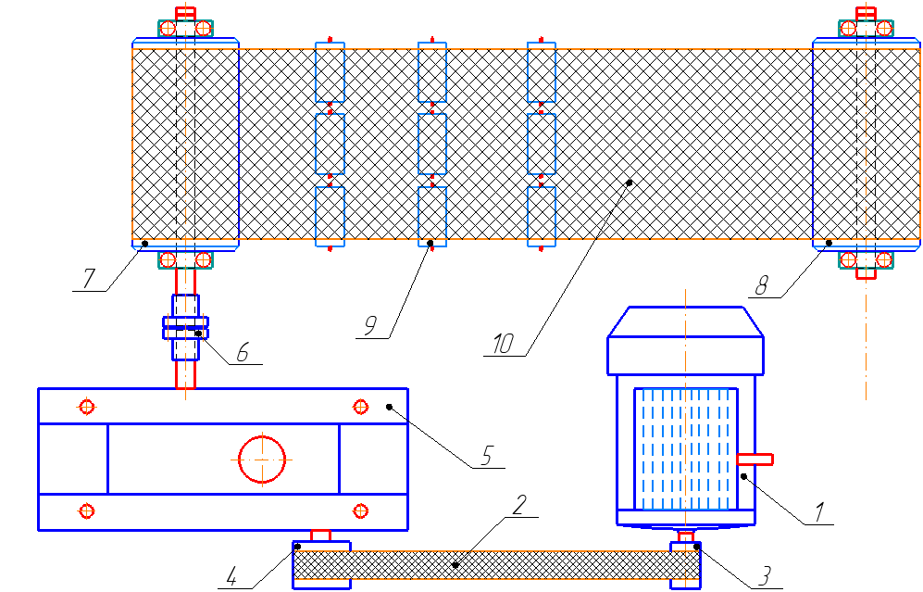
1 - electric drive, 2 - belt, 3, 4 - pulley, 5 - reducer (cylindrical bevel gear), 6 - coupling, 7 - driving drum, 8 - driven drum, 9 - roller mechanism (bearing support with belt bushing), 10 - tape (tape)
FIGURE 1. Kinematic diagram of a belt conveyor
In order to obtain the results of the laws of motion of each working body with sufficient accuracy, theoretical studies were considered as machine units. In this case, the mechanical dynamic characteristics of electric drives, the belt-dissipative properties of transmission mechanisms, transmission ratios and technological loads are taken into account [4, 5].
To date, in the general theory of machines and mechanisms, the issue of the dynamics of each machine unit has been considered separately. In the belt conveyor machine unit we are considering, the laws of change in the angular acceleration of the technological resistance acting on the machine unit, which includes the electric drive, reducer and drum shafts, were taken into account (Fig. 2).
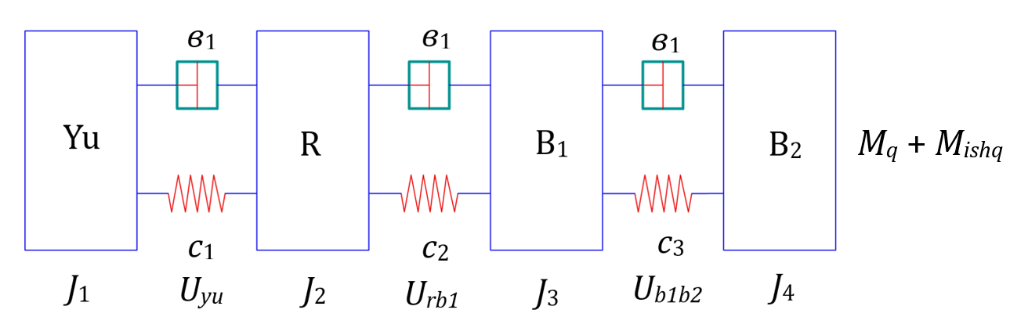
1-mass, rotor of the electric drive; 2-mass, the masses of the rotating elements of the reducer brought to the output shaft and the mass of the half-coupling; 3-mass, the mass of the half-coupling and the driving drum; 4-mass, the mass of the driven drum is taken
FIGURE 2. Calculation scheme of the belt conveyor driving mechanism machine unit

Accordingly, in the calculation scheme of the belt conveyor drive mechanism machine unit, J₁ - moment of inertia of the driving electric drive rotor and half-coupling, J₂ - moment of inertia of the half-coupling and driven pulley, J₃ - moment of inertia of the driving drum, J₄ - moment of inertia of the driven drum, c₁, c₂, c₃, v₁, v₂, v₃ - coefficients of inertia and dissipation of the corresponding belt elements, M_{em} - driving torque on the electric drive rotor shaft, M_{res}, M_{fric} - moments of technological resistance and friction forces, U_{em}, U_{red}, ${\dot{U}}_{d_{1}, d_{2}}$ - transmission ratios between the masses are given.
RESULTS
A mathematical model representing the motion of a belt conveyor machine unit with a roller mechanism consisting of a bearing support and a belt bushing. To derive the equations of motion of the machine unit including the working bodies of the proposed resource-saving design of the belt conveyor, we use the existing Lagrange equation of the second order [6, 7]:
$\frac{d}{dt}\left(\frac{dT}{d\dot{q_{i}}}\right)-\frac{dT}{dq_{i}}+\frac{dF}{d\dot{q_{i}}}+\frac{dP}{dq_{i}}=Q_{i}\left(q\right)$ (1)
where, T, P, F are the kinetic and potential energies of the system and the Rayleigh dissipative function, respectively, $q_{i}$ and ${\dot{q}}_{i}$ are the generalized coordinate and its velocity; Q_{i} are the generalized forces [8].
According to Lagrange’s second-order equation (1), the kinetic energy of the machine unit has the following form:
$T=\frac{J_{ed}{\dot{φ}}_{ed}}{2}+\frac{J_{red}{\dot{φ}}_{red}}{2}+\frac{J_{d_{1}d_{2}}{\dot{φ}}_{d_{1}d_{2}}}{2}$ ; (2)
where, J_{ed}, J_{red}, and $J_{d_{1}d_{2}}$ are the moments of inertia of the electric drive rotor, the reducer output shaft, and the leading and trailing drum shafts, respectively; ${\dot{φ}}_{ed}$, ${\dot{φ}}_{red}$, ${\dot{φ}}_{d_{1}d_{2}}$ – are the angular velocities of the electric drive rotor, the reducer output shaft and the leading and trailing drum shafts, respectively.
Accordingly, the dissipative functions of the elastic elements (Relay) of the belt conveyor machine unit [9]:
$F=\frac{1}{2}$ в₁ ${\left(\ddot{φ}-u_{ed}{\dot{φ}}_{red}\right)}^{2}+$ $\frac{1}{2}$ в₂ ${\left(\ddot{φ}-u_{red}{\dot{φ}}_{d_{1}d_{2}}\right)}^{2}$ (3)
where, в₁, в₂ are the rotational dissipation coefficients of the elastic elements in the machine unit; u_{ed}, u_{red} – are the transmission ratios of the transmission mechanisms.
The potential energy of the structural elements of a belt conveyor machine unit is as follows [10]:
$P= \frac{1}{2}c_{1}{\left(φ-u_{ed}{\dot{φ}}_{red}\right)}^{2}+$ $\frac{1}{2}c_{2}{\left(φ-u_{red}{\dot{φ}}_{d_{1}d_{2}}\right)}^{2}$ (4)
where, c₁, c₂ are the rotational stiffness coefficients of the elastic elements in the machine units.
The driving torques of a belt conveyor machine unit are determined from the mechanical dynamic characteristics of the drive. In theoretical studies, we use mathematical models recommended by I.S. Pinchuk to determine these characteristics [11]:
$\frac{1}{2ω_{s}M_{k}}\dot{M}+\frac{S_{k}}{2M_{k}}M=\frac{ω_{0}+\dot{φ}}{ω_{o}}$ ; (5)
where, $\dot{M}$, $M$, $M_{k}$ – are the driving torques in the drive rotor and their critical values; $ω_{0}$, $ω_{s}$ – are the source rotation frequencies for ideal calculation; $S_{k}$ – are the critical slip values of the electric drive [12].
We determine the integrals of the Lagrange equation for the considered belt conveyor machine unit [13]:
$\frac{d}{dt}\left(\frac{dT}{d\dot{φ}}\right)=J_{ed}{\ddot{φ}}_{ed}$; $\frac{d}{dt}\left(\frac{dπ}{d{\dot{φ}}_{red}}\right)=J_{r}{\ddot{φ}}_{r}$; $\frac{d}{dt}\left(\frac{dT}{d{\dot{φ}}_{d_{1}d_{2}}}\right)=J_{d_{1}d_{2}}{\ddot{φ}}_{d_{1}d_{2}}$;
$\frac{dF}{d\dot{φ}}=$ в $\left(\dot{φ}-u_{ed}{\dot{φ}}_{red}\right)$; $\frac{dF}{d\dot{φ}}=$ – в₁ $u_{ed}\left(\dot{φ}-u_{ed}{\dot{φ}}_{red}\right)$; $\frac{dF}{d\dot{φ}}=$ в₂ $u_{r}\left(\dot{φ}-u_{red}{\dot{φ}}_{d_{1}d_{2}}\right)$;
$\frac{dP}{d\dot{φ}}=c\left(φ-u_{ed}φ_{red}\right)$; $\frac{dP}{dφ}=-c_{1}u_{ed}\left(φ-u_{ed}φ_{r}\right)$; $\frac{dP}{dφ}=c_{2}u_{ed}\left(φ-u_{r}{\dot{φ}}_{d_{1}d_{2}}\right)$ (6)
Correspondingly generalized moments of forces [14, 15]:
$M\left(φ\right)=M$; $M\left(φ_{ed}\right)=M_{k}=\left(M_{red}±∆M_{red}\right)r_{red}^{2}{\ddot{φ}}_{red}$ (7)
By substituting the obtained (4), (5), (6) and (7) into the Lagrange II-order equations (1), we obtain a system of generalized differential equations expressing the motion of the interacting machine unit, which includes the mechanisms of the working bodies of the proposed belt conveyor:
$\frac{1}{{2ω}_{s}M_{k}}\dot{M}+\frac{S_{k}}{{2M}_{k}}M=\frac{ω_{0}-\dot{φ}}{ω_{0}}$;
$J_{ed}\ddot{φ}=M-$ в $\left(\dot{φ}-u_{ed.red}{\dot{φ}}_{red}\right)-c\left(φ-u_{ed.red}φ_{red}\right)$;
$J_{red}{\ddot{φ}}_{red}=$в$u_{ed.red}$ $\left(\dot{φ}-u_{ed.red}{\dot{φ}}_{red}\right)-cu_{ed.red}\left(φ-u_{ed.red}φ_{red}\right)-\left(M_{d}±∆M_{d}\right)r_{d}^{2}{\ddot{φ}}_{d}$ (8)
As a result of obtaining the numerical solution of the derived system of equations (8), the motion laws and loads of the electric drive rotor, the output shaft of the gearbox, and the drums are determined.
To obtain the numerical solution of the system of differential equations (8), which describe the motion laws of the working components of the belt conveyor machine assembly, the initial values of the parameters were taken as follows [16, 17].
$$t=0; {\dot{φ}}_{ed}={\dot{φ}}_{d_{1}d_{2}}={\dot{φ}}_{1}={\dot{φ}}_{2}=0; M_{ed}=198 km; N_{ω}=12 kvt;$$
$n_{ed}=1500 rpm; u_{ed}=1,0; u_{red}=5,0; u_{d_{1}d_{2}}=1,0; n_{red}=315 rpm;$
$J_{ed}=0,213 {kgm}^{2}; J_{red}=0,391 {kgm}^{2}; J_{d_{1}}=J_{d_{2}}=0,42 {kgm}^{2}; k_{1}=1,0÷1,15;$
$c_{2}=\left(260÷380\right)\frac{Nm}{rad};$в₁$=\left(10÷12\right)\frac{Nm}{rad};$
$c_{1}=\left(200÷250\right)\frac{Nm}{rad};$в₂ $=\left(8,0÷10\right)\frac{Nm}{rad};$
$$M_{res}+M_{fric}=\left(1,0÷1,5\right)∙{10}^{2} Nm.$$
The peculiarity of solving the problem is that the equations of the belt conveyor machine unit were implemented simultaneously. In this case, the law of change of $\ddot{φ}$ in the solution of the machine unit is taken into account as the technological resistance to the leading and driven drums of the corresponding mass. Accordingly, the law of change of ${\ddot{φ}}_{ed}$ formed in it is taken into account as the technological resistance to the movement of the drive shaft. The results were implemented on a computer based on a special program. The results obtained based on the solution were obtained as the laws of change of u ${\ddot{φ}}_{ed}$, M_{red} and ${\ddot{φ}}_{d_{1}d_{2}}$, M_{fric} over time.
In particular, Figure 3 shows the patterns of changes in the angular velocities and loads of the drive shaft and the leading and driven drums depending on the change in the performance of the belt conveyor.
The analysis of the obtained results shows that when the belt conveyor throughput is 650 kg per minute and the variation limit is ± (7.0 ÷ 8.2), the values of ${\dot{φ}}_{ed}$ and ${\dot{φ}}_{d_{1}d_{2}}$ are at the average nominal output, and the oscillation ranges of ${∆\dot{φ}}_{ed}$ and ${\dot{∆φ}}_{d_{1}d_{2}}$ do not exceed (3.0 ÷ 6.2) %. Accordingly, when the belt conveyor throughput increases by almost 1.3 times, the oscillation ranges of angular velocities increase to (8.0 ÷ 14) %. In general, the increase in ${∆\dot{φ}}_{ed}$ and ${∆\dot{φ}}_{d_{1}d_{2}}$ affects the periodicity of the roller mechanism, at the same time, the increase in ${∆\dot{φ}}_{ed}$ and ${∆\dot{φ}}_{d_{1}d_{2}}$ increases the reaction force on the supports of the working bodies, increases the vibration amplitudes, and increases the noise in the equipment. Therefore, excessively large ${∆\dot{φ}}_{ed}$ and ${∆\dot{φ}}_{d_{1}d_{2}}$ can lead to negative consequences. Based on the obtained laws, graphs of the interrelation of parameters were constructed.
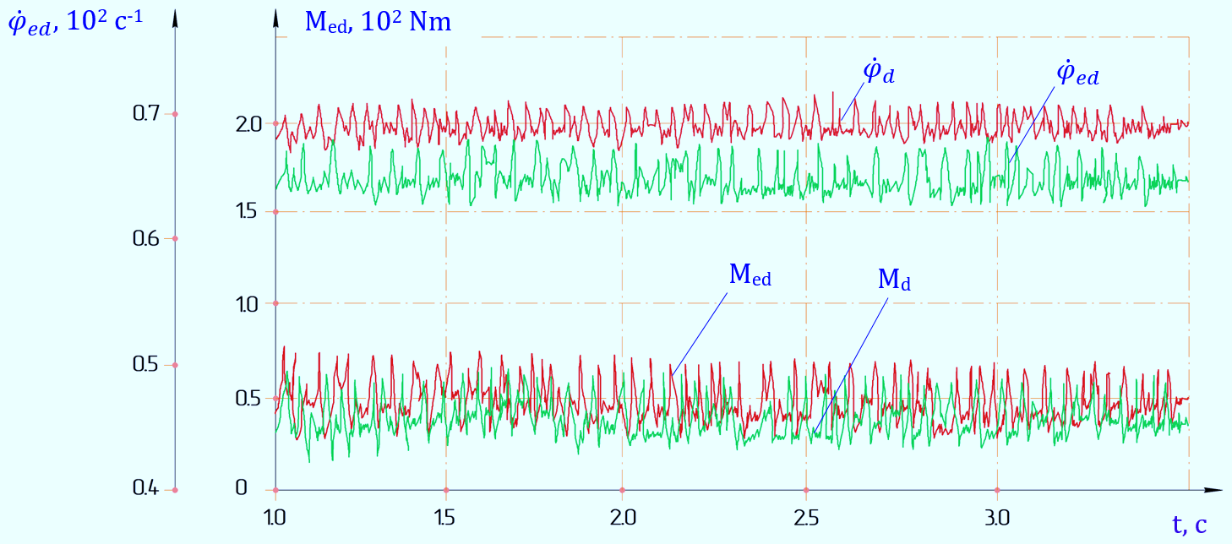
с₂ = 350 Nm/rad; i. u. = 650 kg/s; l = 1,5·10⁻³ m
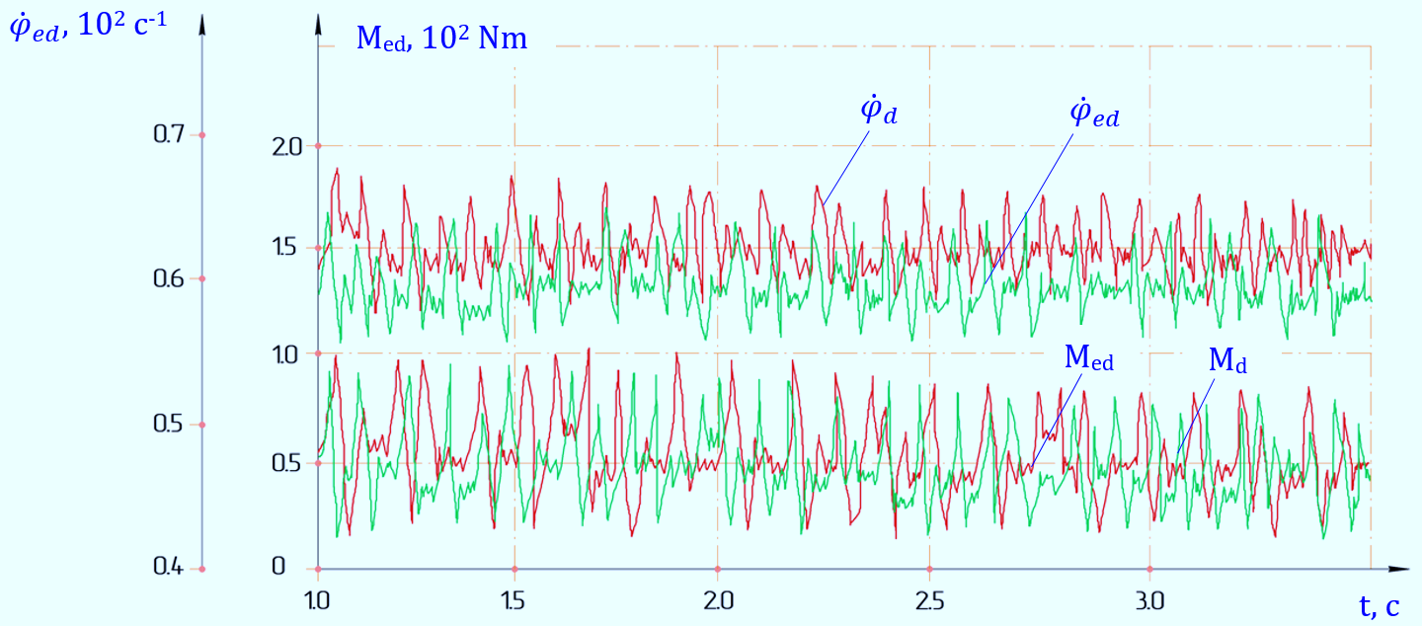
с₂ = 250 Nm/rad; i.u = 1150 kg/s; l = 2,5·10⁻³ m
FIGURE 3. Patterns of angular velocities and loads on the shafts of the driving, leading and driven drums of a belt conveyor

In particular, Figure 4 shows graphs of the dependence of the angular velocity of the proposed belt conveyor drive shaft and the torque of the drill on the performance. According to the analysis of the obtained graphs, when the technological resistance, that is, the mass of gold ore increases from 12 kg to 18 kg and J_{ed} = 0.75 kgm², the angular velocity of the drive shaft in the belt conveyor machine unit decreases from 12.2 c⁻¹ to 8.41 c⁻¹ in a nonlinear manner, the values of the turning torque in it increase from 24.6 Nm to 54 Nm in a nonlinear relationship. Accordingly, when the moment of inertia of the drive shaft increases to 0.26 Nsm², its angular velocity decreases from 20.2 c⁻¹ to 12.2 c⁻¹, the values of the turning torque in it increase from 24.8 Nm to 32.4 Nm. This is because an increase in the working capacity of the belt conveyor increases the load on the drive shaft, and accordingly the angular velocity decreases. The constructed graphs were obtained at the average values of the parameters and the influence of the values of u ${\ddot{φ}}_{ed}$ and ${\ddot{φ}}_{d_{1}d_{2}}$ did not exceed (4.2 ÷ 6.2) %, respectively. Therefore, in order to ensure that the angular velocity of the working body, which is the driving mechanism, does not decrease too much and the load does not increase, it is desirable that the mass of gold ore does not exceed the range $m_{d_{1}d_{2}}$ ≤ (650 ÷ 1150) kg at the same time.
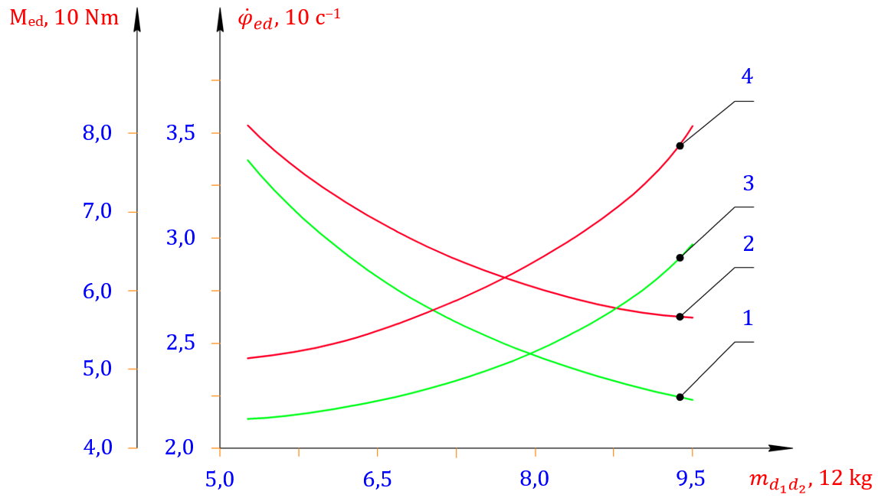
1, 2 – ${\dot{φ}}_{ed}$ = f ($m_{d_{1}d_{2}}$); 3, 4 – M_{ed} = f ($m_{d_{1}d_{2}}$)
FIGURE 4. Graphs of the dependence of the angular velocity of the proposed belt conveyor drive shaft and the torque of the drill on the efficiency

It is known that during the transportation of gold ore on a belt conveyor, the angular velocities of the drive shaft, leading and driven drums, i.e. the values of the moment of impulse, depend on the value of the moment of force. Figure 5 shows graphs of the dependence of the angular velocity and loading of the leading and driven drums of the improved design belt conveyor machine unit on the mass (performance) of gold ore.
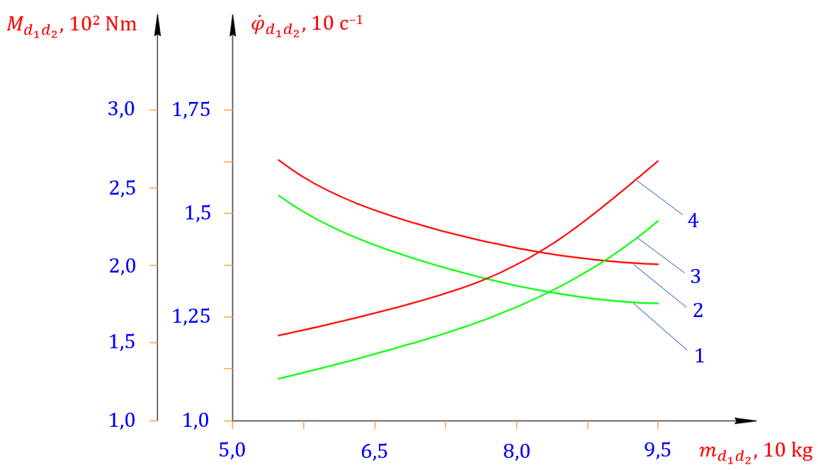
1, 2 – ${\dot{φ}}_{d_{1}d_{2}}$= f ($m_{d_{1}d_{2}}$); 3, 4 – $M_{d_{1}d_{2}}$= f ($m_{d_{1}d_{2}}$); 2,3 – $J_{d_{1}d_{2}}$ = 1,875 kgm²; 1,4 – $J_{d_{1}d_{2}}$ = 2,275 kgm²
FIGURE 5. Graphs of the dependence of the angular velocity and loading of the leading and driven drums of the belt conveyor machine unit on the mass of gold ore (performance)
That is, during the separation of cottonseed hulls, variations in the angular velocity and load of the mesh-surfaced drum, as well as its rotational vibrations, play a crucial role in the process. Specifically, when the mass of the gold ore increases from 12 kg to 18 kg, and the moment of inertia of the driving and driven drums is $J_{d_{1}d_{2}}$, the angular velocity ${\dot{φ}}_{d_{1}d_{2}}$ decreases nonlinearly from 1.55 c⁻¹ to 1.35 s⁻¹, while the corresponding torque rises from 129 Nm to 218 Nm. Likewise, when the moment of inertia of the driving and driven drums increases to 2.275 kgm², the angular velocity ${\dot{φ}}_{d_{1}d_{2}}$ further decreases nonlinearly from 1.55 c⁻¹ to 1.25 c⁻¹, and the torque $M_{d_{1}d_{2}}$ correspondingly increases nonlinearly from 165 Nm to 275.5 Nm. It is well established that in slow-rotating working bodies, the torque tends to have higher values. The primary reason for this phenomenon is that the moment of the inertial force decreases as the angular acceleration ${\dot{φ}}_{d_{1}d_{2}}$ becomes smaller.
Figure 6 shows graphs of the dependence of the angular velocities and turning moments of the roller mechanisms, which are the shafts of the leading and driven drums of the belt conveyor machine unit and the bearing support with a belt element, on the performance (mass of gold ore) of the vibration ranges.
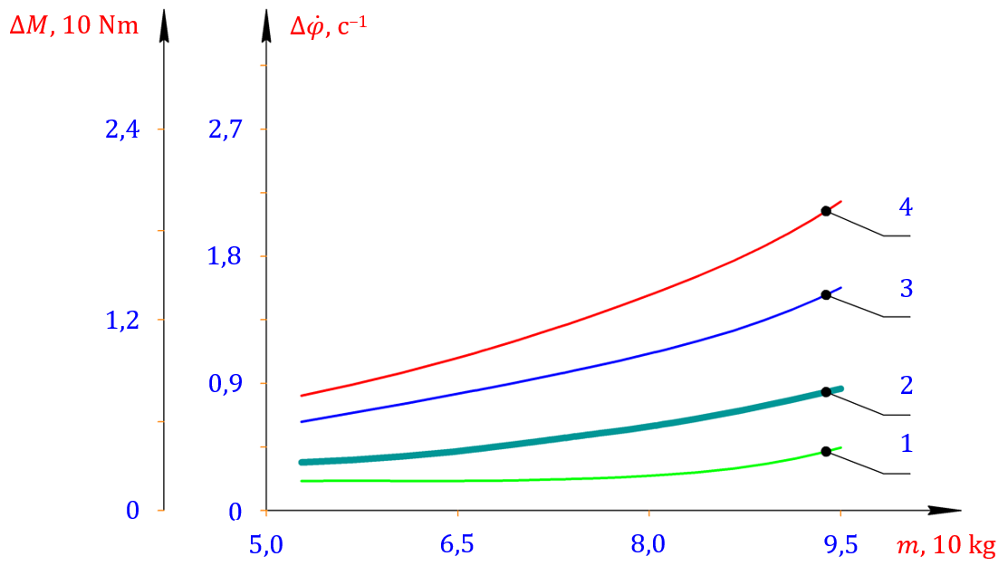
1 – $∆{\dot{φ}}_{r}$; 2 – $∆M_{d_{1}d_{2}}$; 3 – $∆{\dot{φ}}_{d_{1}d_{2}}$; 4 – $∆M_{r}$
FIGURE 6. Graphs of the dependence of the angular velocities and torques of the roller mechanisms with a bearing support with a belt element and a shaft of the leading and driven drums of the belt conveyor machine unit on the performance (mass of gold ore) of the vibration ranges

If the increase in productivity increases the load fluctuation, the values of $∆{\dot{φ}}_{d_{1}d_{2}}$ and $∆{\dot{φ}}_{r}$ increase significantly. It should be noted that the values of $∆{\dot{φ}}_{d_{1}d_{2}}$, $∆{\dot{φ}}_{r}$ and $∆M_{r}$, $∆M_{d_{1}d_{2}}$ are also significantly affected by the values of $∆{\ddot{φ}}_{r}$, $∆{\ddot{φ}}_{d_{1}d_{2}}$. Their influence affects the composition of technological resistances. In the general theory of machines and mechanisms, the values of the moments of inertia of rotating shafts and working bodies are increased in order to save on the movement of their working bodies. If the roller mechanisms with a bearing support with a belt element and a shaft of the leading and driven drums in the belt conveyor machine unit rotate smoothly, the vibrational motion of the gold ore is reduced, since the impulse forces are also reduced due to $∆{\ddot{φ}}_{r}$→ 0, and $∆{\ddot{φ}}_{d_{1}d_{2}}$→ 0. This, in turn, also reduces the technological resistance.
Figure 7 shows graphs of the angular velocities and turning moments of the roller mechanisms with a bearing support with a belt element and a shaft of the leading and driven drums of the belt conveyor machine units, as a function of the force of change in their moments of inertia. Based on the analysis of the above graph, it can be noted that when the moment of inertia of the leading and trailing drums increases from 0.3 kgm² to 1.5 kgm², the values of $∆{\dot{φ}}_{r}$ decrease from 3.1 c⁻¹ to 1.425 c⁻¹ in the nonlinear coupling, while the values of $∆M_{r}$ decrease from 24.2 km to 15.7 km in the nonlinear coupling. The main reason for this is that the larger the rotating mass, the more accurate its rotation, in which case the values of $∆{\dot{φ}}_{d_{1}d_{2}}$ and $∆M_{d_{1}d_{2}}$ also decrease. It can be seen that when the moment of inertia of roller mechanisms with a bearing support with a sliding element increases from 0.354 kgm² to 3.6 kgm², the angular velocity range of the roller mechanisms decreases in a nonlinear manner from 0.64 c⁻¹ to 0.308 c⁻¹, respectively, and the range of the turning moment decreases from 26.5 Nm to 12.5 Nm (Figure 7; graphs 3, 4).
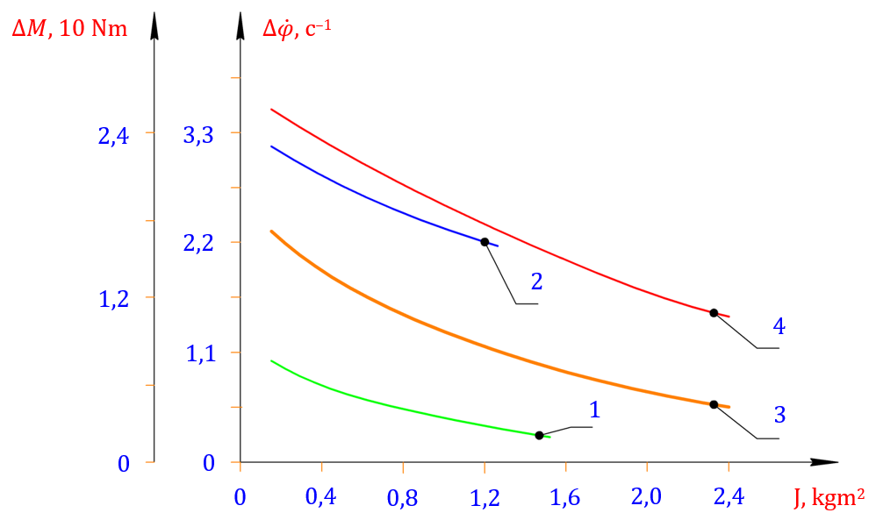
1 – $∆{\dot{φ}}_{r}$ = f (J_{r}); 2 – $∆M_{d_{1}d_{2}}$ = f (J_{r}); 3 – $∆{\dot{φ}}_{d_{1}d_{2}}$ = f ($J_{d_{1}d_{2}}$); 4 – $∆M_{r}$ = f ($J_{d_{1}d_{2}}$)
FIGURE 7. Graphs of the dependence of the angular velocities and turning moments of the roller mechanisms with a bearing support with a belt element and a shaft of the leading and driven drums of the belt conveyor machine units on the force of change of their moments of inertia

When analyzing the motion of interacting machine units, the values of the angular velocities $∆{\dot{φ}}_{r}$ and $∆{\dot{φ}}_{d_{1}d_{2}}$ that are formed with a decrease in the values of $∆{\dot{φ}}_{r}$ and $∆{\dot{φ}}_{d_{1}d_{2}}$ also decrease. At the same time, the transported gold ore slows down, that is, the technological resistance in the machine unit also decreases. Therefore, when the values of $∆{\dot{φ}}_{r}$ increase by (2.0 ÷ 2.5) c⁻¹ and to ensure that $∆{\dot{φ}}_{d_{1}d_{2}}$ ≥ (0.65 ÷ 0.75) c^{–1}, it is advisable to set the recommended values of the moments of inertia $J_{d_{1}d_{2}}$ ≤ (1.95 ÷ 2.4) kgm² and $J_{r}$ ≤ (0.42 ÷ 0.42) kgm².
CONCLUSION
Thus, dynamic and mathematical models of machine units with mechanisms of working bodies of the proposed belt conveyor were developed taking into account the mechanical characteristics of the electric drive, the friction-dissipative, inertial properties of the rolling elements, and technological resistances. Accordingly, taking into account the angular accelerations of the leading and driven drums of the roller mechanisms with a bearing support with rolling elements, formulas for determining technological resistances were obtained, and it was concluded that the laws of motion of the working bodies should be constantly monitored for changes in the efficiency and moments of inertia, the efficiency of the angular velocity and the torque of the auger, the amplitudes of the oscillations of the drum angular velocities and torques of the auger on the mass of gold ore, and the changes in their moments of inertia.
REFERENCES
1. Djuraev, A., Jumaev, A.S., Abduraxmanova, M.M.. Analysis of the results of physical and mechanical experimental studies of the modernized belt conveyor. Journal of Physics: Conference Series, 2023, 2573(1), 012012. https://iopscience.iop.org/article/10.1088/1742-6596/2573/1/012012
2. Abduvaliev, U., Jumaev, A., Nurullaev, R., Jakhonov, S., Jurakulov, I. Investigation of the process of the influence of winding spindles with cotton fiber on the performance of a cotton picker. E3S Web of Conferences, 2024, 548, 04013. https://www.e3s-conferences.org/articles/e3sconf/abs/2024/78/e3sconf_agritech-x_04013/e3sconf_agritech-x_04013.html.
3. Djuraev, A., Jumaev, A.S., Ibragimova, N.I., Turdaliyeva, M.Y. Analysis of the dynamics of a belt conveyor with composite guide rollers and elastic elements. Journal of Physics: Conference Series, 2023, 2573(1), 012026. https://api.scienceweb.uz/storage/publication_files/9737/26378/666ad94ba5c1b
4. Abduvaliev, U., Jumaev, A., Nurullaev, R., Ashirov, A., Abdurafikov, B. Influence of the Sectional Shape of the Grabbing Element of a Screw Composite Spindle on Agricultural Performance and Stability of Operation of a Cotton-Picking Machine. Lecture Notes in Networks and Systems, 2024, 1129. https://link.springer.com/chapter/10.1007/978-3-031-70670-7_25
5. Jumaev, A., Istablaev, F., Dustova, M. Development of the theory of calculation of constructive and rational parameters of belt conveyor roller mechanisms. AIP Conference Proceedings, 2022, 2467, 060025. https://api.scienceweb.uz/storage/publication_files/9737/26397/666af69e34968.
6. Tilabov, B., Jumaev, A., Sherbutaev, J., Normurodov, U., Salimov, G. Testing of heat-treated surfaced samples and machine parts for hardness and wear resistance. E3S Web of Conferences, 2024, 548, 03014. https://www.e3s-conferences.org/articles/e3sconf/abs/2024/78/e3sconf_agritech-x_03014/e3sconf_agritech-x_03014.html
7. Jumaev, A., Mamirov, Sh., Abduraxmanova, M., Ashirov, A., Jakhonov, Sh. (2025). Design Improvement and Parameter Justification for Composite Guide Rollers in Belt Conveyors. AIP Conference Proceedings, 3454.
8. D.M. Berdiev, M.A. Umarova, R.K. Toshmatov Phase and Structural Transformations of Structural Steels in Nontraditional Heat Treatment | Russian Engineering Research, 2021, vol. 41, no. 1, pp. 46–48. https://link.springer.com/article/10.3103/S1068798X21010068
9. L. Raufov, D. Berdiev, M. Umarova, R. Tashmatov, Z. Sadullayev, D. Fazilov, Sh. Khojibekova.: The Influence of High-Chromium Powder Coatings on Wear Resistance of Working Parts | SpringerLink. ICoRSE 2025, LNNS 1592, pp. 15–26, 2025. https://doi.org/10.1007/978-3-032-02508-1_2
10. Jumaev, A., Dadaev, M., Abduraxmanova, M., Ashirov, A., Muzaffarov, A. (2025). Modeling and Analysis of Forced Vibrations in Composite Bearings for Belt Conveyors. AIP Conference Proceedings, 3454.
11. M. Khudjaev, Sh. Ibrohimov, G. Pirnazarov, E. Nematov, B. Khasanov, J. Temirov. International journal of Mexatronix and Applied Mexanics. 2025. Issue 20, Vol. 1, pp. 202-207.
12. D.M. Berdiev, A.A. Yusupov, R.K. Toshmatov, A.Kh. Abdullaev: Increasing Die Durability in Cold Stamping by Quenching with Intermediate Tempering | Russian Engineering Research. 42(10), 1011–1013 (2022). https://doi.org/10.3103/S1068798X22100057
13. Ermatov, Z., Dunyashin, N., Yusupov, B., Saidakhmatov, A., & Abdurakhmonov, M. (2022). Modelling the chemical composition process concerning formation of metals from manual arc surface on the basis of the electrode coating charge components classification. International Journal of Mechatronics and Applied Mechanics, 12. https://doi.org/10.17683/ijomam/issue12.25
14. Kholmirzaev, N., Turakhodjaev, N., Saidmakhamadov, N., Tadjiev, N., Khasanov, J., Yusupov, B., Juraev, J. (2024, December). Improvement of the Technology of Melting of Low Alloy Steel Alloy in an Electric Arc Furnace. In Materials Science Forum (Vol. 1139, pp. 3-9). Trans Tech Publications Ltd. https://www.topflycarbon.com/products_details/2.html?gad_source
15. Karimov Sh.A., Mamirov Sh.Sh., Khabibullayeva I.A., Bektemirov B.Sh., Khusanov, N. Friction and wear processes in tribotechnical system International Journal of Mechatronics and Applied Mechanics; Bucharest (2021): 204-208. https://ijomam.com/wp-content/uploads/2021/11/pag.
16. Kholmirzaev, N., Saidmakhamadov, N., Khasanov, J., Tadjiev, N., Yusupov, B., Sadikova, N., Nurdinov, Z. (2024, December). Mathematical Modeling of the Effect of TiC Nanopowder Particles on the Wear Resistance Properties of Low-Alloy Steel. In Materials Science Forum (Vol. 1139, pp. 11-19). Trans Tech Publications Ltd. https://www.topflycarbon.com/products_details/2.html?gad_source
17. F.M. Matmurodov, X.X. Boboyev, I.N. Nugmanov, Sh.Sh. Mamirov. Analytical dynamic modeling of damping of a multi-hierarchical mechanical system and mobile power engine shaft with the help of multi-mass rheological models. Journal of Physics: Conference Series. https://iopscience.iop.org/article/10.1088/1742-6596/2573/1/012044
18. M. Khudjaev, E. Nematov, A. Karimova, D. Khurramov, B. Khasanov. Modeling the process of force load generation at the initial periodic change in pressure (a plane problem). E3S Web of Conferences 258, 08020 (2021). https://www.e3s-conferences.org/articles/e3sconf/abs/2021/34/e3sconf_uesf2021_08020/e3sconf_uesf2021
19. E. Nematov, M. Khudjaev, B. Khasanov. Development of a mathematical model of dynamic characteristics of a drive with a planetary mechanism. E3S Web of Conferences 258, 08022 (2021). https://www.e3s-conferences.org/articles/e3sconf/abs/2021/34/e3sconf_uesf2021_08022/e3sconf_uesf2021_08022.html

