Theoretical basis for developing a resource-effective design of variable parameter and flexible element gear transmissions of a belt conveyor reducer
Akbarjon Jumaev^{1 a)}, Xamza Boboyev¹, Alisher Ashirov¹ Abdurashidkhon Muzaffarov¹, Mirzakhmad Dadaev²
¹ Almalyk State Technical Institute, Almalyk, Uzbekistan
²Tashkent state technical university named after Islam Karimov, Tashkent, Uzbekistan
^{a)} Corresponding author: akbarjumayev011@gmail.com
Abstract. The article deals with the development of a resource-saving design of a belt conveyor reducer with variable parameters and a flexible element gear transmission, the design of a flexible element gear transmission and a calculation scheme for the displacement deformation of the gear wheel bushing-damper. Based on the laws of change in angular velocities on the shafts of the belt conveyor electric drive rotor, gear wheels, leading and driven drums, and the drive load, graphs of the dependence of the angular velocities on the shafts of the conveyor electric drive rotor, leading gear wheel, composite gear wheel, leading gear wheel, and leading and driven drums, the load change in the drive, the change in technological resistance, the angular velocities of the gear wheels, leading and driven drums in the reducer drive, the unevenness coefficients, and the moments of inertia of the drive load have been developed and recommended values are presented.
INTRODUCTION
Today, the use of energy-saving, high-performance vehicles and mechanisms is taking a leading place in mining enterprises. Given the increasing production of modern vehicles and mechanisms and the emergence of high-speed equipment, the production of modern, high-power reducers is increasing, which requires the implementation of high-speed and vibration-damping gear mechanisms in various technological processes. This is largely due to the widespread use of energy-saving, high-performance and vibration-damping gear mechanisms in the drives of technological machines.
Research and development work is being carried out to develop new, resource-saving and efficient designs of gear and flexible link mechanisms widely used in reducers that are part of belt conveyors, to conduct structural, kinematic and dynamic analysis to substantiate their parameters, and to develop their scientific and technical solutions. In this regard, special attention is paid to the creation of modern designs of gear reducers with composite, flexible elements used in belt conveyor drives at mining enterprises, to reduce friction, wear and noise in gear mechanisms, and to substantiate their technological processes and parameters.

LITERATURE REVIEW
As a result of research conducted at industrial enterprises, in particular on the design of new structures of belt conveyor structural mechanisms, improvement of methods of mathematical modeling and analysis, determination of operational characteristics, creation of new structures of gear mechanisms with flexible elements, a number of scientific results were obtained, including the following [1]:
– methods for synthesizing new structural schemes of gear mechanisms were implemented;
– methods for mathematical modeling and analysis of the movement of gear mechanisms with variable parameters were proposed;
– operational characteristics of gear mechanisms in machines were optimized; optimal methods for designing and analyzing mechanisms were implemented;
– new structural schemes of gear mechanisms with variable parameters and flexible elements were recommended.
As a result of the theoretical explanation of the theory of involute gears, it is important to study the friction and wear of teeth in gear wheels. Because increased friction leads to wear. This negatively affects the kinematics and dynamics of the gear, reduces the service life and increases noise. Therefore, the profiles of the teeth are made involute curves. In this case, the teeth rotate overlapping each other without slipping, and the wear is very small [2].
The general technical application, dynamics and kinematics of gears, and wear issues have been the subject of research by a number of researchers. A number of scientists have conducted research aimed at solving the problems of lubrication of gears in the production machine and protection from various environmental influences, accuracy and durability. However, the changes in the geometric characteristics of gear parts as a result of wear were not taken into account. They mainly focused on the issues of slowing down the wear process when the gear parts are sufficiently lubricated, and mainly studied the technical characteristics of the gear [3].
Taking into account the weight of the gear and the speed of movement, the mathematical model of the forced transverse vibrations of the gear involute, depending on the eccentricity of the tooth edges, is considered. The equation of the true trajectory of the tooth is constructed. The problem of transverse vibrations is considered for a simplified two-mass system. There is a number of technical literature on methods for calculating the strength of teeth. Depending on the characteristics of the gear parameters used, the calculation of strength is carried out in various ways [4].
DISCUSSION
It is known that the analysis of machine mechanisms is divided into the following types: structural, kinematic and dynamic [5, 6].
Structural analysis of mechanisms is of great importance, in which the degree of mobility of the mechanism is determined. The degree of mobility of the mechanism allows you to determine the number of moving links, kinematic pairs, as well as the number of gears. It is known that the degree of mobility of mechanisms is determined by the Chebeshev formula [7, 8]. It should be noted that when using the Chebeshev formula, the joints of the mechanism are considered absolutely rigid, elastic connections and connections are not taken into account.
Figure 1 below shows the construction of gear transmissions: the wheel, that is, the driven wheel structure has a flexible element.
So, let us consider a systematic analysis of the gear mechanisms shown in Figure 1. The degree of mobility of the mechanisms under consideration is determined according to the methodology presented in [9, 10]:
$W=3n-{2P}_{5}-P_{4}=3*2-2*2-1=1$ (1)
where, n – is the number of moving links; P₅ – is the number of fifth-class kinematic pairs; P₄ is the number of fourth-class kinematic pairs.
For the gear mechanisms presented below, the degree of mobility is equal to one [11, 12]. At the same time, it is important to identify redundant connections in mechanisms that can significantly reduce the working resource due to increased friction, vibrations, and unnecessary reactions (Figure 1).
Redundant links are determined by the following formula:
$q=W-6n+5P_{5}+4P_{4}=1-6∙2+5∙2+4∙1=3$ (2)
In order to reduce friction in kinematic pairs in a reducer with a belt conveyor component mechanism and increase the operating cycle of the mechanism, we recommend using a gear part with a composite elastic element. For this purpose, a formula is recommended that takes elastic elements into account when determining redundant links in the mechanism [13, 14]:
$q=W-6n+5P_{5}+4P_{4}-n_{u}$ (3)
where, $n_{u}$ – is the number of flexible elements in the mechanism.
As can be seen from formula (3), each flexible element included in the mechanism reduces the redundant link by one.
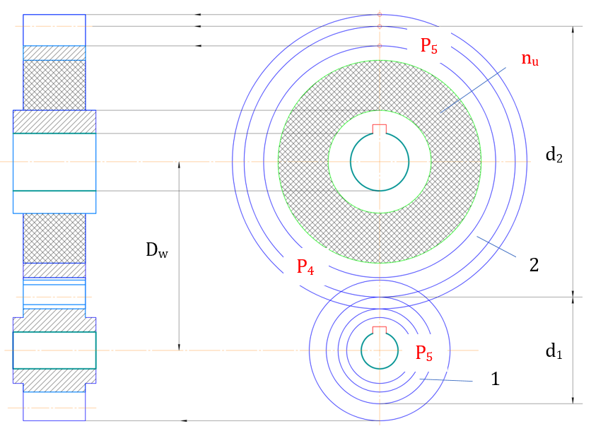
n = 2, n_{u} = 1, p₄ = 2, p₅ = 2, w = 1
FIGURE 1. Structural diagram of gears with flexible elements

To completely eliminate redundant links in the gear train, it is recommended to install rubber bushings in the housing for mounting on the bearing on the drive gear shaft.
RESULTS
Calculation of the displacement deformation of a gear wheel bushing-damper with a belt element in a belt conveyor reducer. As is known, gear transmissions are widely used in technological machines [15, 16]. The main disadvantages of these mechanisms are the direct transmission of loads to the shafts of the gears due to the tight interaction of the gear teeth and the change in the load.
In the proposed new scheme (see Fig. 1), the gear 4 and the gear 1 are brought into an inseparable position, in which the shock absorber-bush is inserted into the gear wheel under special pressure and fixed.
In this case, the thickness of the shock absorber-bush is selected depending on the gear ratio [17, 18].
$∆_{1}=\frac{d_{1}-d_{1}^{`}}{2}$ $∆_{2}=\frac{d_{2}-d_{2}^{`}}{2}$ $U_{12}=\frac{ω_{1}}{ω_{2}}=\frac{R_{2}}{R_{1}}=\frac{∆_{2}}{∆_{1}}$ (4)
where, $d_{1}$ , $d_{1}^{`}$ – outer and inner diameters of the shock absorber-bush, gear; $d_{2}$ , $d_{2}^{`}$ – outer and inner diameters of the shock absorber-bush, wheel; $R_{1}$ and $R_{2}$ – radii of the main circles of the gear and wheel; $ω_{1}$ and $ω_{2}$ – are the angular velocities of the gear and wheel; $U_{12}$ is the gear ratio of the transmission.
Figure 2 below presents a structural diagram for determining the displacement deformation of the belt element - bushing of the proposed belt conveyor reducer gear wheel with a belt element.
Due to the deformation of the rubber placed between this gear wheel, the outer bushing of the shock absorber rotates at an angle, in which the displacement angle of the bushing with the elastic element is equal to the following equation [19]:
$tgγ=\frac{∆φ_{1}r}{∆r}$ (5)
In this case, the sliding surface of the selected bushing with a sliding element will be as follows:
$F=2πrl$ (6)
The length of the inner circumference of the bushing with a flexible element, where l is the length of the bushing (gear).
The rotational shear force of the flexible element in use is equal to:
$Q=GFtgγ=2πlG\frac{r∆φ_{1}}{∆r}$ (7)
where, G is the shear modulus of the elastic element, N/m².
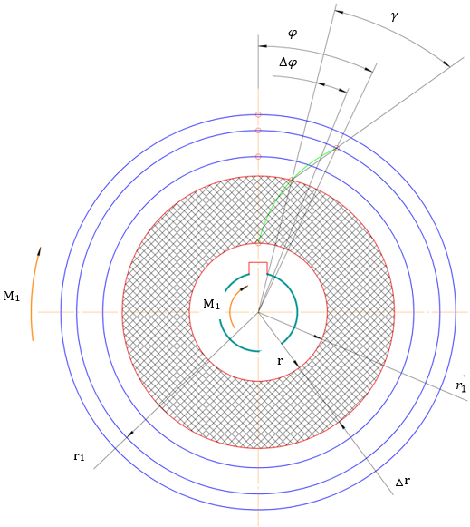
FIGURE 2. Calculation scheme for determining the displacement deformation of the
bushing with a flexible element of a gear wheel of a belt conveyor reducer

External turning moment value:
$M_{1}=Qr=2πGlr^{3}\frac{∆φ_{1}}{∆r}$ (8)
By redistributing from (8), we can obtain:
$φ_{1}=\frac{M_{1}}{2πGl}\int_{r_{1}^{`}}^{r_{1}}{\frac{dr}{r^{3}}}=\frac{M_{1}}{2πGl}\left[\frac{1}{2{\left(r_{1}^{`}\right)}^{2}}-\frac{1}{2{\left(r_{1}\right)}^{2}}\right]$ (9)
The same expression can be obtained from $φ_{2}$:
$φ_{2}=\frac{M_{2}}{4πGl}\left[\frac{1}{r_{2}^{`2}}-\frac{1}{r_{2}^{2}}\right]$ (10)
The gear ratio of the gears is variable and is determined by the following formula:
$U_{12}=\frac{M_{1}\left[\frac{1}{r_{1}^{2}}-\frac{1}{r_{1}^{2}}\right]}{M_{2}\left[\frac{1}{r_{1}^{2}}-\frac{1}{r_{1}^{2}}\right]}$ (11)
The initial values of the parameters in the numerical solution are: M₁ = 9.2 Nm; M₂ = 7.2 Nm; π = 3.14;
l = 26.4·10⁻³ m; r₁ = 4.2·10⁻² m; r₂ = 5.8·10⁻² m.
Calculations were made based on the numerical solutions of the above problem.
In Figure 3, graphs of the dependence of the change in the shear deformation of the belt element on the belt conveyor belt conveyor gear wheel on the change in the bushing shear modulus and the values of the externally applied torques were obtained. The turning torque is 0.42 ꞏ 10² Nm, and $φ_{1}$ = 0.098 ꞏ 10⁻¹ rad increases from 0.28 ꞏ 10⁻¹ rad, and the displacement angle $φ_{1}$ increases to 0.406 ꞏ 10⁻¹ rad for r₁ = 2.4 ꞏ 10^{–2} m and r₁ = 3.4 ꞏ 10^{–2} m. Accordingly, the displacement angle of the gear wheel rubber bushing increases to $φ_{1}$ = 0.74 ꞏ 10⁻¹ rad, r₁ = 3.7 ꞏ 10^{–2} m and
r₁ = 5.2 ꞏ 10^{–2} m, $φ_{2}$ = 1.04 ꞏ 10⁻¹ rad. At relatively large values of $φ_{1}$ and $φ_{2}$, in order to reduce the shock effects arising from the mutual engagement of the gear wheels of the transmission, it is advisable to take the values of the torques M₁ = (0.026 ÷ 0.029)·10² Nm, M₂ = (0.04 ÷ 0.038)·10² Nm. To reduce the values of the angular displacement deformation of the rubber bushings, it is recommended to take the shock absorber displacement modulus in the range (0.35 ÷ 0.45)·10³ N/m².
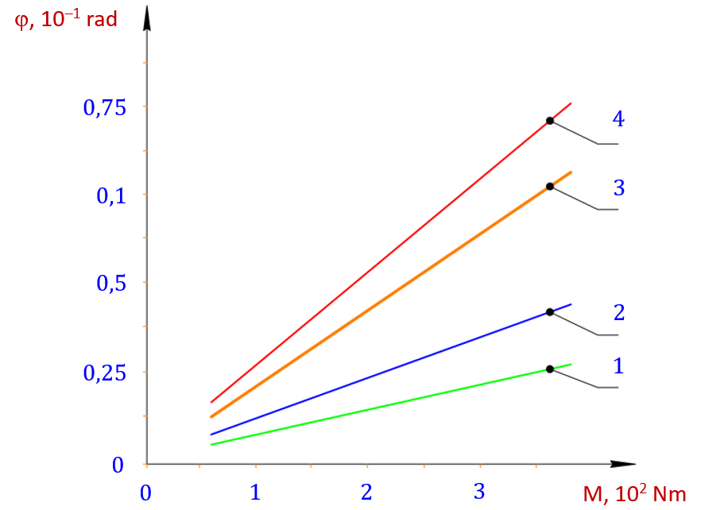
1, 2 – φ₁ = f (M₁); 3, 4 – φ₂ = f (M₂); 1 – r₁ = 2,4·10⁻² m; 2 – r₁ = 3,4·10⁻² m; 3 – r₁=3,7·10⁻² m; 4 – r₁ = 5,2·10⁻² m
FIGURE 3. Graphs of the dependence of the change in the displacement deformation of the belt element in the gear wheel of the belt conveyor reducer on the change in the values of the bushing displacement module and the externally applied torques

It is known that in a number of technological machines of manufacturing enterprises, special shock-absorbing belt elements are used to reduce vibrations, transmission torques and vibration amplitudes, that is, to dampen them. In particular, rubber bushings are now used in mechanisms that are components of belt conveyors used in mining enterprises. The main requirement for these rubber bushings is that their roughness is evenly distributed over their surfaces. Figure 4 shows the kinematic scheme and principle of operation of the recommended belt conveyor.
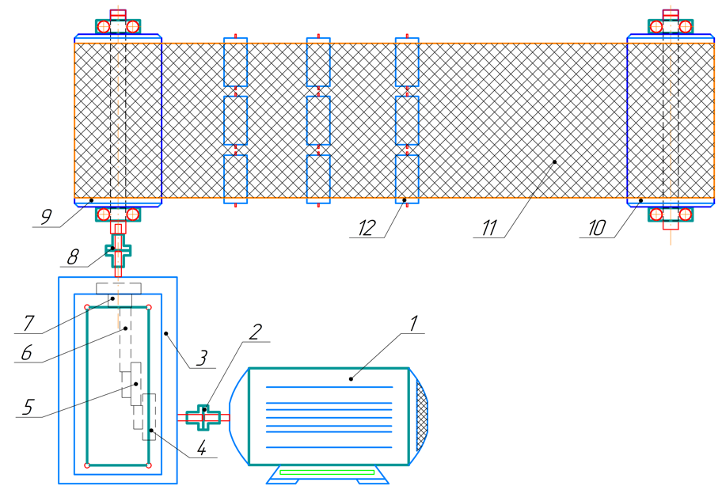
1 – electric drive, 2, 8 – coupling, 3 – reducer, 4, 5, 6, 7 – gear,
9 – driving drum, 10 – driven drum, 11 – belt, 12 – roller mechanism
FIGURE 4. Kinematic diagram of the proposed belt conveyor
Based on the proposed belt conveyor kinematic scheme, the equipment operates as follows. The power is transmitted from an electric drive 1 with a capacity of 24 kW, n = 1000 rpm, to a reducer 3 through a clutch 2. The reducer is two-stage and is transmitted through a gear wheel 4 to a gear wheel with a belt element consisting of 5 components. In this case, the wheel 5, in turn, transmits the clutch 8 to the leading drum 9. From the leading drum 9 to the leading drum 10 through a belt 11. In this case, the tension of the belt 11 and the supporting rotational movement are provided by roller mechanisms.
It is known that during the operation of any transport vehicle, for example, belt conveyors, the main noise and vibration is generated by the reduction gear. In order to prevent such situations, it is possible to reduce “$δ$” by increasing the drum mass. However, this will significantly increase the power consumption. In this case, it would be possible to use belt and chain transmissions. However, due to the large power transmitted, the service life of these transmissions is greatly reduced. Therefore, in order to reduce the torque, speed fluctuations, and noise in the reduction gear, we made the middle gear of the two-stage reducer a composite gear and added a flexible element. When using this flexible element bushing, it was possible to provide the gear with the required rigidity, thereby reducing the amplitudes of speed and torque fluctuations, as well as noise.
In a belt conveyor, the gear wheel wears out quickly due to friction and load changes during the transmission of motion, which results in increased noise and a reduced service life of the reducer. After installing a flexible bushing as a component of the intermediate gear wheel of the reducer, the shock in the couplings decreases, the amplitudes of the load oscillations decrease, and the movement stabilizes. As a result, the service life increases. Therefore, it is important to determine the parameters of the proposed flexible element, the required values of the transmission operating modes, and to justify the inertial-dissipative parameters.
The laws of variation of the angular velocities of the electric drive, gear wheels, and leading and trailing drums, as well as the driving load, were obtained from the calculated values of the initial conditions and parameters. Figure 5 shows the laws of variation of the angular velocities of the electric drive rotor, gear wheels, and leading and trailing drums, which are considered as structural mechanisms of the belt conveyor, and the laws of variation of the angular velocities of the driving load and the driving load.
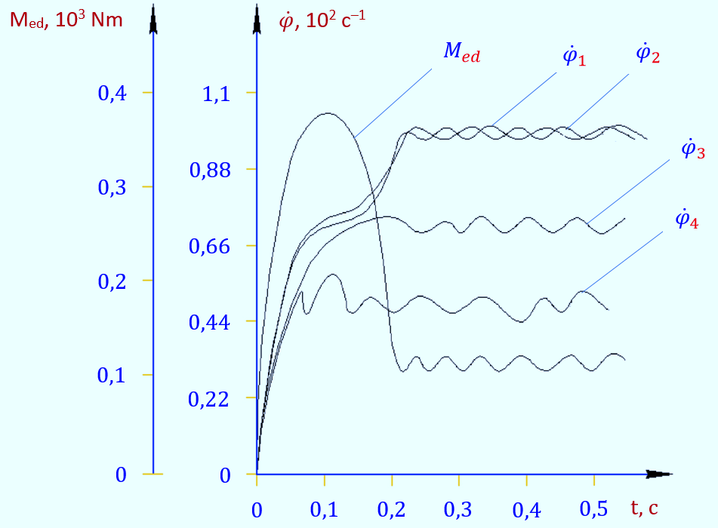 | 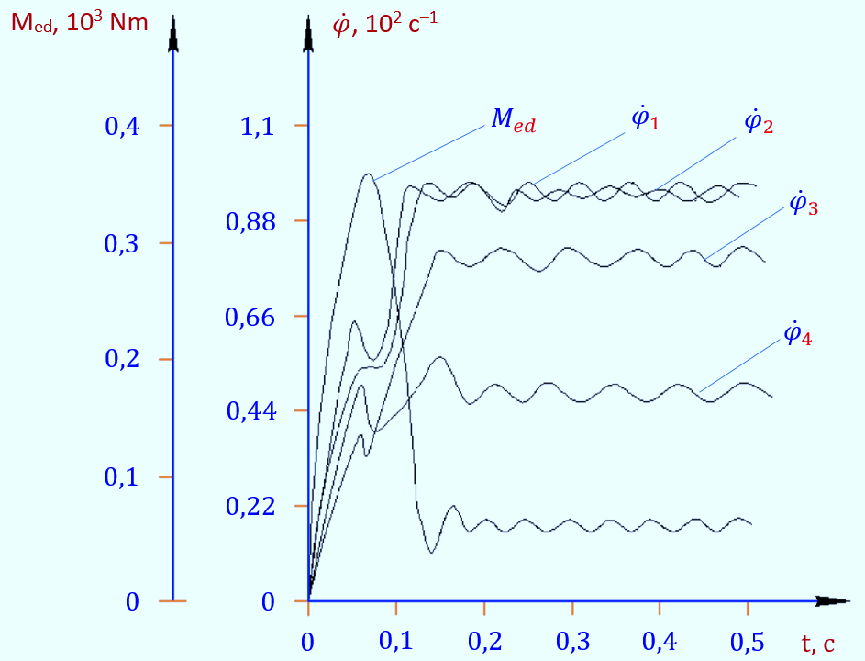
a – M_{ed} = 182 Nm; M_{res} = 135 Nm | b – M_{ed} = 185.5 Nm; M_{res} = 176 Nm
FIGURE 5. Angular velocities on the shafts of the belt conveyor electric drive rotor, gears, driving and driven drums, and the laws of change in the drive load

Based on the obtained laws (see Fig. 5, a), the resistance is taken as 135 Nm, and (see Fig. 5, b) as 185 Nm. Analysis of the obtained results shows that when the load is 135 Nm, the average value of the angular velocity on the electric drive shaft is between 96.8 c⁻¹ and almost the same as on the first gear shaft of the reducer, 95.7 c⁻¹. In this case, the average angular velocity of the second gear shaft with a composite belt element is 84.3 c⁻¹, while the angular velocity of the output gear shaft and the shaft driven by the driving and driven drums is 53.2 c⁻¹. In this case, the torque on the rotor shaft of the electric drive is in the range of 86.8 Nm. Accordingly, with an increase in technological resistance, that is, the tape damper connecting the leading and trailing drums, in which the tape thickness increases, or when a tape with a high density and stiffness is used, the load on the drive also increases. That is, it was determined that when M_{res} = 176 Nm, it will be in the range of M_{ed} = 185.2 Nm. In this case, the resistances arising from additional friction were calculated by taking the calculated values.
As a result of processing the obtained laws, graphs of the relationship between the parameters were constructed. Figure 6 shows graphs of the dependence of the angular velocities of the belt conveyor electric drive rotor, driving gear, composite gear, driven gear and shafts of the driving and driven drums on the load change in the drive, and the technological resistance change. Based on the analysis of the constructed graphs, it can be noted that when the distributed resistance increases from 0.39∙10² Nm to 2.27 10² Nm, the angular velocity of the electric drive rotor shaft decreases in a nonlinear manner from 97.8 c⁻¹ to 77.8 c⁻¹, and it can be observed that the angular velocity of the belt element gear shaft decreases from 83.2 c⁻¹ to 67.8 c⁻¹.
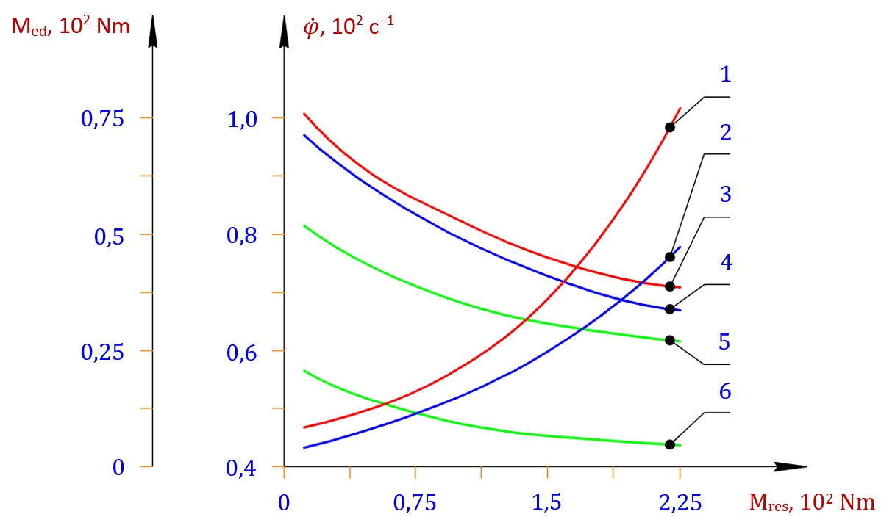
1 – M_{ed} = f (M_{res}) – J_{ed} = 0,27 kgm²; 2 – M_{ed} = f (M_{res}) – J_{ed} = 0,215 kgm²;
3 – ${\dot{φ}}_{1}$ = f (M_{res}); 4 – ${\dot{φ}}_{2}$ = f (M_{res}); 5 – ${\dot{φ}}_{3}$ = f (M_{res}); 6 – ${\dot{φ}}_{4}$ = f (M_{res})
FIGURE 6. Graphs of the dependence of the angular velocities of the rotor, drive gear, input gear, driven gear and shafts of the drive and driven drums of a belt conveyor electric drive, load changes in the drive, and technological resistance changes

The angular velocities of the leading and driven drums decreased from 54.7 c⁻¹ to 47.8 c⁻¹ in a nonlinear manner. Accordingly, it was found that the load on the electric drive increased from 0.09∙10² Nm to 0.76∙10² Nm in a nonlinear manner when J_{ed} = 0.215 kgm². When the moment of inertia of the first mass of the belt conveyor machine unit was observed to be 0.27 kgm², the load on the electric drive increased to 1.10∙10² Nm. Therefore, to ensure that the load on the electric drive did not exceed (0.10 ÷ 0.97) 10² Nm, it was recommended that the technological resistance M_{res} ≤ (155 ÷160) Nm.
It is known from the theory of machines and mechanisms that smoothing the movement of rotating working bodies is achieved by increasing their moments of inertia. However, excessive increase in the moment of inertia increases the load, power consumption, and the machine’s service life is also reduced. Figure 7 shows graphs of the angular velocities of the gear wheels, leading and driven drums in the belt conveyor reducer drive, the unevenness coefficients, and the inertia moments of the drive load.
These dependence graphs were considered for each mass, the effect of the moment of inertia of this mass. In this case, the moments of inertia of the masses were taken equal in the calculation values. In particular, when the moments of inertia of the leading and driven drums increase from 0.6 kgm² to 3.2 kgm², the coefficient of unevenness of the angular velocities of their shafts decreases from 0.167 to 0.066. The coefficient of unevenness of the angular velocity of the gear wheel with a flexible element ${ δ}_{3}$ decreases in a nonlinear manner from 0.125 to 0.05. It was found that the coefficient of unevenness of the rotor shaft of the electric motor ${ δ}_{1}$ decreases from 0.043 to 0.019. It should be noted that, based on the results of experimental studies, it is possible to implement the technological process requirements in such a way that the angular velocities of the leading and driven drums do not exceed the unevenness coefficients (0.06 ÷ 0.09).
Based on the recommended parameters, it should be noted that while it is recommended to take the moments of inertia of the first three masses of the belt conveyor machine assembly higher than the design values, it is advisable to reduce the moments of inertia of the fourth mass, that is, the working drums, compared to the design values.

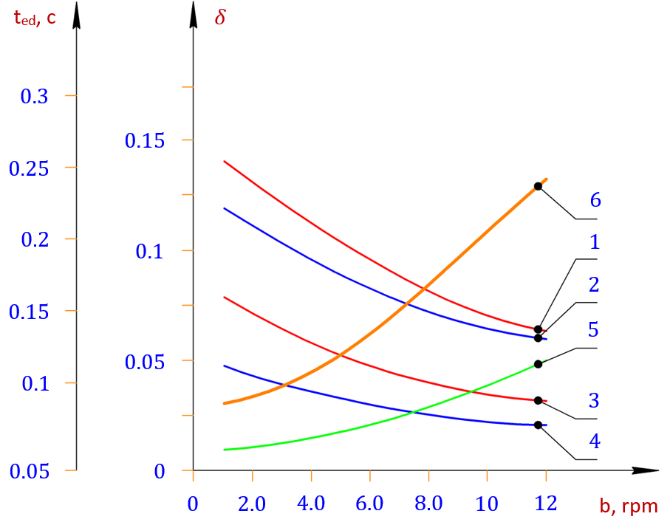
1 – $δ_{1}$ = f (J_{r} + J_{m}); 2 – $δ_{2}$ = f (J_{ed} + J_{g`1}); 3 – $δ_{3}$ = f [J_{g`2} + (J_{g`3} + J_{m})]; 4 – $δ_{4}$ = f (J_{m} + J_{g`4} + J_{b1} + J_{b2});
5 – M_{ed} = f (J_{ed}) – M_{res} = 125 Nm; 6 – M_{ed} = f (J_{ed}) – M_{res} = 176 Nm
FIGURE 7. Graphs of the relationship between the angular velocities of the gears, leading and driven drums, unevenness coefficients, and the moments of inertia of the drive load in the belt conveyor reducer drive
CONCLUSION
Therefore, in modern machine mechanisms, it has become essential to design and develop components that ensure a reduction in the peak vibration amplitudes of gear transmission shafts, an increase in their service life, and a decrease in noise levels while maintaining efficient performance at high speeds and under a wide range of technological loads. The proposed gear transmission with an elastic composite element allows the elastic bushing to deform during operation, thereby partially equalizing the load variations caused by gear tooth vibrations. The extent of this damping effect mainly depends on the elasticity coefficient of the elastic bushing.
In this study, a belt conveyor system was selected as the object of analysis. Based on the variations in angular velocities and drive loads of the electric motor rotor, gears, and both the driving and driven drum shafts, the relationships between the angular velocities of the electric motor rotor, driving gear, composite gear, driven gear, and the driving and driven drums were examined. Additionally, the changes in transmission loads, technological resistance, and the nonuniformity coefficients of the angular velocities of the gears and drums within the gearbox drive were analyzed. Graphs illustrating the dependencies between these parameters and the moments of inertia were developed, taking into account the recommended values for optimal performance.
REFERENCES
1. Artobolevsky I.I., Edelstein B.V. Collection of problems in the theory of mechanisms and machines. Moscow: Nauka, Main Editorial Board of Physical and Mathematical Literature, Moscow: 1973. – 256 p.
2. Lapoto G.A., Kabatov N.F. and Segal M.G. Bevel and hypoid gears with circular teeth. Moscow: Mechanical Engineering, 1977.-423 p.
3. Jumaev, A., Istablaev, F., Dustova, M. Development of the theory of calculation of constructive and rational parameters of belt conveyor roller mechanisms. AIP Conference Proceedings, 2022, 2467, 060025.
https://api.scienceweb.uz/storage/publication_files/9737/26397/666af69e34968.
4. Abduvaliev, U., Jumaev, A., Nurullaev, R., Jakhonov, S., Jurakulov, I. Investigation of the process of the influence of winding spindles with cotton fiber on the performance of a cotton picker. E3S Web of Conferences, 2024, 548, 04013. https://www.e3s-conferences.org/articles/e3sconf/abs/2024/78/e3sconf_agritech-x_04013/e3sconf_agritech-x_04013.html.
5. Djuraev, A., Jumaev, A.S., Ibragimova, N.I., Turdaliyeva, M.Y. Analysis of the dynamics of a belt conveyor with composite guide rollers and elastic elements. Journal of Physics: Conference Series, 2023, 2573(1), 012026. https://api.scienceweb.uz/storage/publication_files/9737/26378/666ad94ba5c1b
6. Jumaev, A., Mamirov, Sh., Abduraxmanova, M., Ashirov, A., Jakhonov, Sh. (2025). Design Improvement and Parameter Justification for Composite Guide Rollers in Belt Conveyors. AIP Conference Proceedings, 3454.
7. Abduvaliev, U., Jumaev, A., Nurullaev, R., Ashirov, A., Abdurafikov, B. Influence of the Sectional Shape of the Grabbing Element of a Screw Composite Spindle on Agricultural Performance and Stability of Operation of a Cotton-Picking Machine. Lecture Notes in Networks and Systems, 2024, 1129. https://link.springer.com/chapter/10.1007/978-3-031-70670-7_25
8. Djuraev, A.,Jumaev, A.S., Abduraxmanova, M.M.. Analysis of the results of physical and mechanical experimental studies of the modernized belt conveyor. Journal of Physics: Conference Series, 2023, 2573(1), 012012. https://iopscience.iop.org/article/10.1088/1742-6596/2573/1/012012
9. Tilabov, B., Jumaev, A., Sherbutaev, J., Normurodov, U., Salimov, G. Testing of heat-treated surfaced samples and machine parts for hardness and wear resistance. E3S Web of Conferences, 2024, 548, 03014. https://www.e3s-conferences.org/articles/e3sconf/abs/2024/78/e3sconf_agritech-x_03014/e3sconf_agritech-x_03014.html
10. Jumaev, A., Dadaev, M., Abduraxmanova, M., Ashirov, A., Muzaffarov, A. (2025). Modeling and Analysis of Forced Vibrations in Composite Bearings for Belt Conveyors. AIP Conference Proceedings, 3454.
11. D.M. Berdiev, M.A. Umarova, R.K. Toshmatov. Phase and Structural Transformations of Structural Steels in Nontraditional Heat Treatment | Russian Engineering Research, 2021, vol. 41, no. 1, pp. 46–48. https://link.springer.com/article/10.3103/S1068798X21010068
12. R. Murodqosimov, S. Tursunbaev, A. Turakhujaeva, U. Mardonov, Sh. Mardonakulov, M. Saidova, N. Kudratkhodjaeva, Analysing the alternations in the aluminium alloy properties under the influence of silicon and germanium alloying elements. International Journal of Mechatronics and Applied Mechanics 2025, Issue 21, Vol. 1.
https://ijomam.com/wp-content/uploads/2025/09/Pp.-365-372
13. Kholmirzaev, N., Turakhodjaev, N., Saidmakhamadov, N., Tadjiev, N., Khasanov, J., Yusupov, B., Juraev, J. (2024, December). Improvement of the Technology of Melting of Low Alloy Steel Alloy in an Electric Arc Furnace. In Materials Science Forum (Vol. 1139, pp. 3-9). Trans Tech Publications Ltd. https://www.topflycarbon.com/products_details/2.html?gad_source
14. L. Raufov, D. Berdiev, M. Umarova, R. Tashmatov, Z. Sadullayev, D. Fazilov, Sh. Khojibekova. The Influence of High-Chromium Powder Coatings on Wear Resistance of Working Parts | SpringerLink. ICoRSE 2025, LNNS 1592, pp. 15–26, 2025. https://doi.org/10.1007/978-3-032-02508-1_2
15. Ermatov, Z., Dunyashin, N., Yusupov, B., Saidakhmatov, A., & Abdurakhmonov, M. (2022). Modelling the chemical composition process concerning formation of metals from manual arc surface on the basis of the electrode coating charge components classification. International Journal of Mechatronics and Applied Mechanics, 12. https://doi.org/10.17683/ijomam/issue12.25
16. Karimov Sh.A., Mamirov Sh.Sh., Khabibullayeva I.A., Bektemirov B.Sh., Khusanov, N. Friction and wear processes in tribotechnical system International Journal of Mechatronics and Applied Mechanics; Bucharest (2021): 204-208. https://ijomam.com/wp-content/uploads/2021/11/pag.
17. D.M. Berdiev, A.A. Yusupov, R.K. Toshmatov, A.Kh. Abdullaev: Increasing Die Durability in Cold Stamping by Quenching with Intermediate Tempering | Russian Engineering Research. 42(10), 1011–1013 (2022). https://doi.org/10.3103/S1068798X22100057
18. F.M. Matmurodov, X.X. Boboyev, I.N. Nugmanov, Sh.Sh. Mamirov. Analytical dynamic modeling of damping of a multi-hierarchical mechanical system and mobile power engine shaft with the help of multi-mass rheological models. Journal of Physics: Conference Series. https://iopscience.iop.org/article/10.1088/1742-6596/2573/1/012044
19. E. Nematov, M. Khudjaev, B. Khasanov. Development of a mathematical model of dynamic characteristics of a drive with a planetary mechanism. E3S Web of Conferences 258, 08022 (2021). https://www.e3s-conferences.org/articles/e3sconf/abs/2021/34/e3sconf_uesf2021_08022/e3sconf_uesf2021_08022.html
20. R. Murodqosimov, A. Turakhujaeva, A. Turaev, S. Tursunbaev, Sh. Mardonakulov, Sh. Tashbulatov, F. Odilov, M. Rakhmonova, S. Murodov. Mathematical Modeling of the Effect of the Lithium Element on the Fluidity of Al-Si and Al-Cu Alloys. International Conference on Reliable Systems Engineering (ICoRSE) – 2025. ICoRSE 2025, LNNS 1592, pp. 62–69, 2025. https://link.springer.com/chapter/10.1007/978-3-032-02508-1_6

