Analysis of the results of experimental studies of a modernized belt conveyor
Akbarjon Jumaev, Ravshan Tashmatov ^{a)}, Behzod Yusupov, Bekzod Yuldashev, Shakhrukh Akhmadaliev
Almalyk State Technical Institute, Almalyk, Uzbekistan
^{a)} Corresponding author: r.tashmatov@odti.uz
Abstract. The article presents a modernized experimental device of a belt conveyor with a roller mechanism, the bearing support of which consists of a rubber bushing, and presents ideas on installing rubber bushings with rubber elements in the bearing housings, which provide a support for the roller mechanism, providing smooth rotational movement. According to the results of the study, the vibration of the roller mechanism is compared with the vibration of a conventional roller mechanism, and according to the results of the comparison, it is possible to prevent the premature failure of the proposed roller mechanism by reducing vibrations in the mechanism.
INTRODUCTION
Today, it is difficult to imagine the operation of modern industrial enterprises without belt conveyors - they allow you to automate the production process and make it more efficient. A belt conveyor is a continuously moving vehicle and is the most common type of conveying machinery. Belt conveyors are used in almost all industries, ensuring the continuity of transportation of various types of cargo and materials. At the same time, the advantage of belt conveyors over other transportation methods is that due to the significant speed of the belt, high efficiency and productivity of technological processes are ensured with low energy consumption, simplicity of the device design, reliability and durability. For optimal operation of conveyors, they are recommended to be used at temperatures from – 40 to + 45 °C. Depending on the characteristics and properties of the transported cargo, the angle of inclination of the working side of the belt can be set to 90°.
Continuously operating machines are characterized by the movement of bulk or piece goods along a certain route without stopping. Conveyors are highly reliable, easy to operate and maintain, have a long transport length, work automatically in conjunction with technological equipment and provide high productivity due to the continuity of the transport process. Some technological operations can be carried out simultaneously with the transportation of goods on belt conveyors. A belt conveyor is often one of the parts of the transport device of a machine or mechanical system.

LITERATURE REVIEW
Belt conveyors are conditionally divided into three groups according to their use: general-purpose (GOST 22644-77); special and underground, open-pit mining conveyors. Belt conveyors can be stationary or movable, they are designed for horizontal and inclined (up to 24°) transportation of piece and containerized cargo, this is provided by the possibility of organizing right and left, single and double-sided mounted - driven versions. They can be part of various construction, municipal and road machinery, as well as be part of waste formation equipment and material reloading equipment [1, 2].
Most belt conveyors in mining enterprises (coal, gravel, limestone, various ore rocks) operate in extreme conditions of temperature changes in winter, high humidity in summer and dust, and these factors affect different conveyor assemblies differently. Thus, in a three-roller support with rollers of equal length, the load on the middle roller is approximately 70 % of the total load per 1 m of the conveyor length, the weight of the belt and the rotating parts of the roller support. The side rollers account for approximately 30 % of the load, so the load on the middle roller bearings is 2.5 times greater than on the side rollers. Incorrect selection of the roller support design leads to premature failure of the belt and rollers. Increasing belt width leads to increased load on roller bearings, especially horizontal support rollers, which leads to an increase in the number of failures and a decrease in the overall reliability of belt conveyors [3].
When analyzing the reliability of belt conveyor units in various mines, gravel, limestone and other enterprises, conveyor units such as conveyor rollers and conveyor belts have the shortest resource and require the greatest labor and financial costs. According to statistics, conveyor rollers account for up to 40 % of all repair and maintenance costs and up to 30 % of the cost of the entire conveyor. The service life of conveyor rollers in loading units in mining enterprises is from 0.5 to 1 year, and in the rest of the conveyor - from 0.7 to 2.5 years, an average of 1.7 years. The estimated service life of the roller on the middle supports, as the most loaded, is on average from 25 to 35 thousand hours, which is several times higher than the actual service life. On average, each roller on a conveyor is replaced 3 to 5 times during its entire service life, meaning that the need for rollers is always there and increases as the length of the conveyors increases [4].
DISCUSSION
The purpose, objectives and methods of experimental research. The purpose of the experimental research is to determine the torques, rotation frequencies, vibration resistance and efficiency of the roller mechanism, the bearing support of which is formed by a belt bushing, on a pilot version of the proposed belt conveyor. In this case, the process of continuous transportation of minerals on the conveyor is studied, the movement of minerals on the belt surface, vertical vibrations due to depreciation and forces affecting friction are determined. The experimental research took into account the density of the transported mineral, the dependence of the friction coefficient of the material, the graininess of the material of different grades of rubber belts. The experiments were carried out on an experimental stand of a belt conveyor with rubber bushings of the 7B-54MBC, 7IRP13-46, 7IRP13-48 brands installed on the bearing supports for transporting and loading various materials [5,6].
The tasks of the ongoing research are: to determine the efficiency of a belt conveyor with a roller mechanism consisting of a bearing support consisting of a belt bushing; to study the dependence of the efficiency of a belt conveyor on the friction force of the transported mineral; to determine the laws of change of the torques and angular velocities of a roller mechanism consisting of a bearing support consisting of a belt bushing, to measure the rotation frequency, to study the effect of the vibration amplitude, torque and rotation frequency, and to recommend optimal values of the parameters based on full-factor experiments. The research also includes checking the compatibility of the results obtained with the results of theoretical studies.
A prototype of the modernized belt conveyor was prepared and existing methods for conducting experimental studies were used [7]. Figure 1 shows the prototype of the prepared belt conveyor.
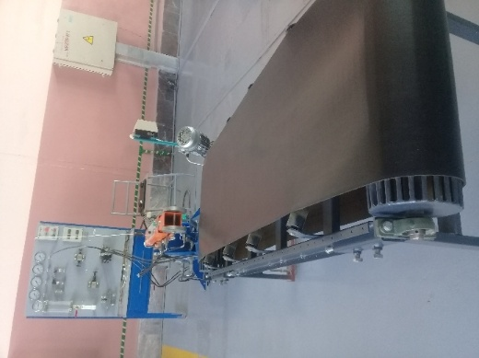 | 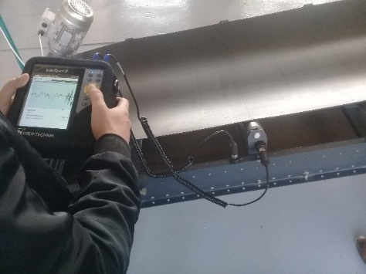  Note: This is a copy of a new experimental device for a belt conveyor: the author of the article's dissertation was prepared and test results were obtained at the NMB PPA, affiliated to the NMMC JC, for conducting experimental research.
FIGURE 2 shows an electrotensometric diagram of a prototype of a belt conveyor with a roller mechanism consisting of a bearing support consisting of a belt bushing, designed for continuous transportation of fine-grained gold ore.
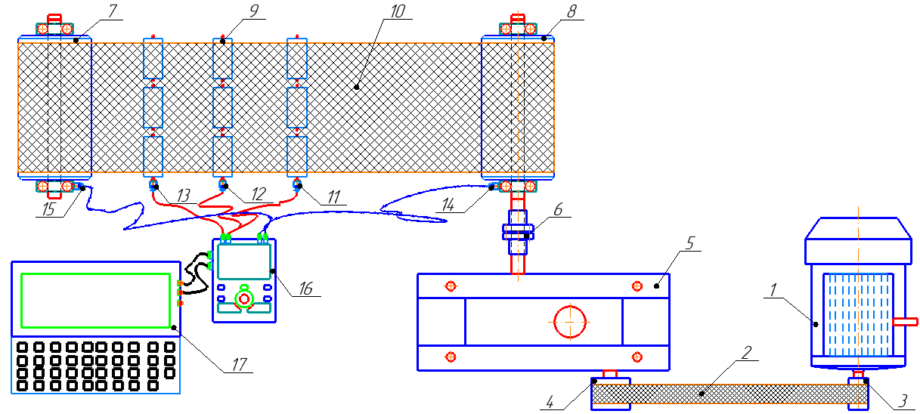
1 – electric drive; 2 – belt; 3-reducer; 3, 4 - pulley; 5 – reducer; 6 - coupling; 7, 8 – leading and driven drum;
9 – roller mechanism; 10 – tape (tape); 11, 12, 13, 14, 15 – strain gauges; 16 – vibXpert special numerical switch device (laboratory equipment); 17 – computer.
FIGURE 2. Electrotensometric scheme of the experimental stand of a belt conveyor with a roller mechanism, the bearing support of which consists of a belt bushing

The experimental device was equipped with a synchronous electric drive of the 4A 112UA 843 type with a power of P = 2.2 kW and a speed of n = 700 rpm. When the experimental stand is started, the electric drive 3, 4 pulleys transmit the movement to the reducer 5 through a belt 2, to the driving drum 8 through a clutch 6, and to the driving drum 7 through a belt 10. In this case, there are 9 roller mechanisms that provide belt tension and support rotational movement, which are fixed to the frame [8,9].
To measure the required values, magnetic sensors are installed on the bearing housing and frame, respectively, and the data is transmitted to the computer via the VibXpert II special sensor device (Figure 1).
When the electric motor starts rotating, the belt conveyor starts, and these universal sensors allow you to measure the vibration speed, vibration acceleration, vibration amplitude, torque, and angular velocities of the roller mechanism with high accuracy. In order to increase the accuracy of the results obtained, the experiments were repeated 3 times in the same mode. As mentioned above, in order to increase the operational performance of the belt conveyor, a roller mechanism consisting of a bearing support and a belt bushing was used. As a result, the torques, angular velocities, accelerations, and vibration amplitudes of the roller mechanism were determined sequentially.
Experimental studies were conducted on an existing belt conveyor with a new design of bearing supports made of rubber material 7B-54MBC, 7IRP13-46, 7IRP13-48 [10, 11], with a roller mechanism consisting of a belt bushing. In the manufacture of a bearing support with a belt element, leucanate glue was applied between the hub and the outer ring through a special press mold and filled with chrome-plated rubber (Fig. 3).
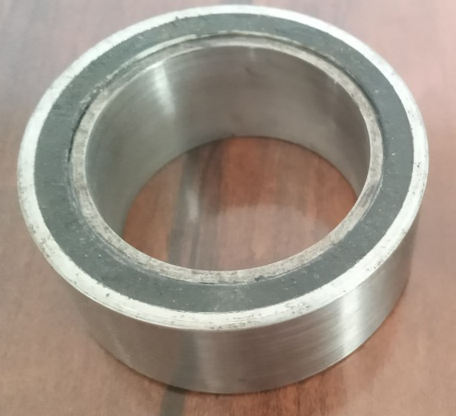
FIGURE 3. Bearing support bushing detail in a roller mechanism
The technical characteristics of the recommended rubber material are given in Table 1. Then, the required pressure and temperature were maintained in a heating oven at a temperature of 120 °C for 35 minutes. The purpose of using rubbers of the 7B-54MBC, 7IRP13-46, 7IRP13-48 brands is to use technical rubbers that do not lose their properties in hot and cold weather and are resistant to petroleum products, lubricants [12,13].
These types of rubbers are used to make tires, cuffs, plugs, tubes and other products of various sizes that are resistant to friction and wear [14]. Such rubber products are considered to have high resistance to technical oils, ethanol and petroleum products and can be used in the temperature range from – 60 °C to +140 °C [15,16].

Table 1. Indicators of rubber grades used for bushings
Characteristic of Rubber Material  7B-54MBC | Unit of Measurement | Indicator
Relative elongation | % | 130
Hardness (by Shore A) | Shore A | 74-76
Hardness | kg/cm² | 90,0
Tensile strength | MPa | 12
Elasticity coefficient | (N/m) | 0,42∙10⁴
Operating temperature | °C | -40 ... +100

Characteristic of Rubber Material  7IRP13-46 | Unit of Measurement | Indicator
Relative elongation | % | 120
Hardness (by Shore A) | Shore A | 75-80
Hardness | kg/cm² | 75-80
Tensile strength | MPa | 11
Elasticity coefficient | (N/m) | 0,25∙10⁴
Operating temperature | °C | -40 ... +100

Characteristic of Rubber Material  7IRP13-48 | Unit of Measurement | Indicator
Relative elongation | % | 110
Hardness (by Shore A) | Shore A | 85-90
Hardness | kg/cm² | 90-95
Tensile strength | MPa | 10
Elasticity coefficient | (N/m) | 0,51∙10⁴
Operating temperature | °C | -45 ... +100

A piezoelectric accelerometer with a wide frequency range was used to numerically describe mechanical vibrations in a belt conveyor. Piezo accelerometers have measurement errors and can detect them in a wide frequency range from 5 Gs to 15 thousand Gs. The mass of the sensor should be small compared to the mass of the objects being tested and should not affect the vibration characteristics.
In the process of measuring the vibration displacement, vibration velocity, the piezoelectric sensor was mounted in the vertical and horizontal directions on the bearing housing near the supports using a special magnet. The measurement results are processed by the «VibXpert II» microprocessor. Each experiment is carried out 3 times on the average, which guarantees the reliability of the measurements. The values of the vibrations at the frequency selected according to the measurement results were monitored on a personal computer using the «VibXpert II» controller, after transmitting the data, according to the available spectrum [17,18].
According to the experimental results, a satisfactory approximation of the parameters obtained from the analytical data of the eigenfrequency spectra of the belt conveyor was observed. The dependence of the roller mechanism vibration speed, vibration acceleration, roller mechanism rotation time, and vibration amplitude on the measuring instrument «VibXpert II» was determined and the dependence on the operating parameters of the belt conveyor was determined.
RESULTS
Initially, experiments were conducted on the vertical vibration speed and acceleration of the existing and new design of the belt conveyor, which consists of a roller mechanism with three different bearing supports and a belt bushing, at a rotation speed of 250 rpm (Figure 4).
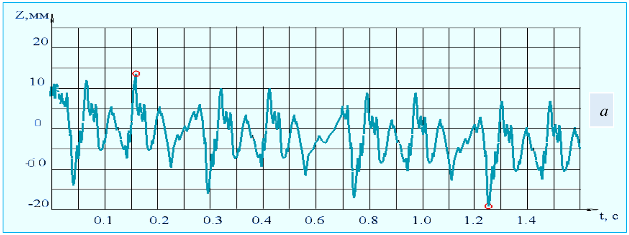
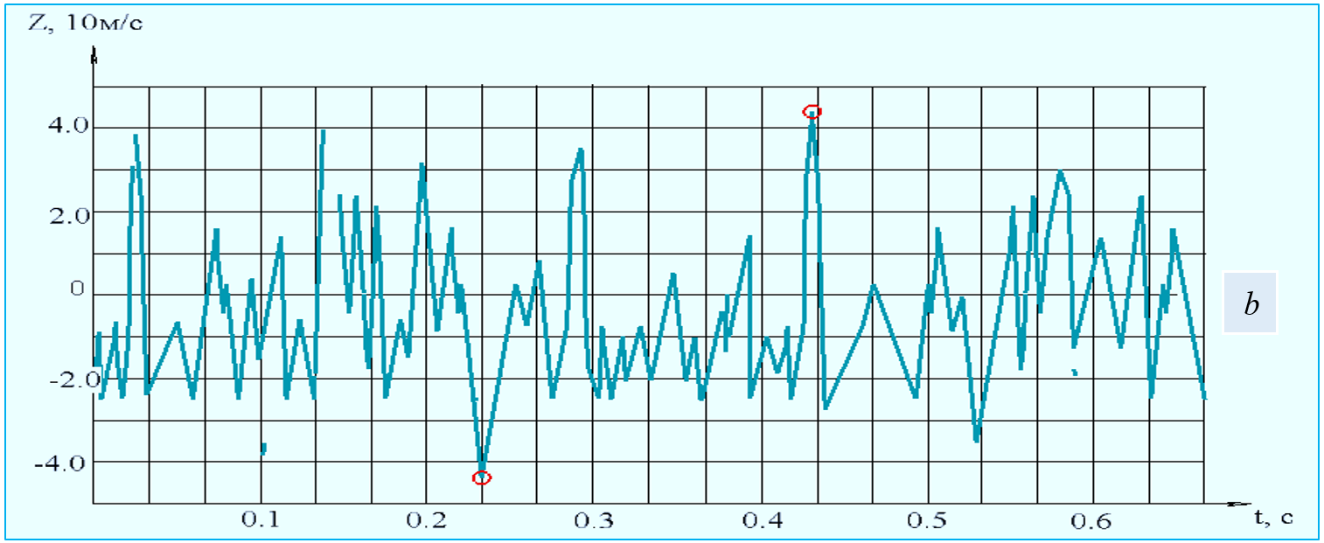
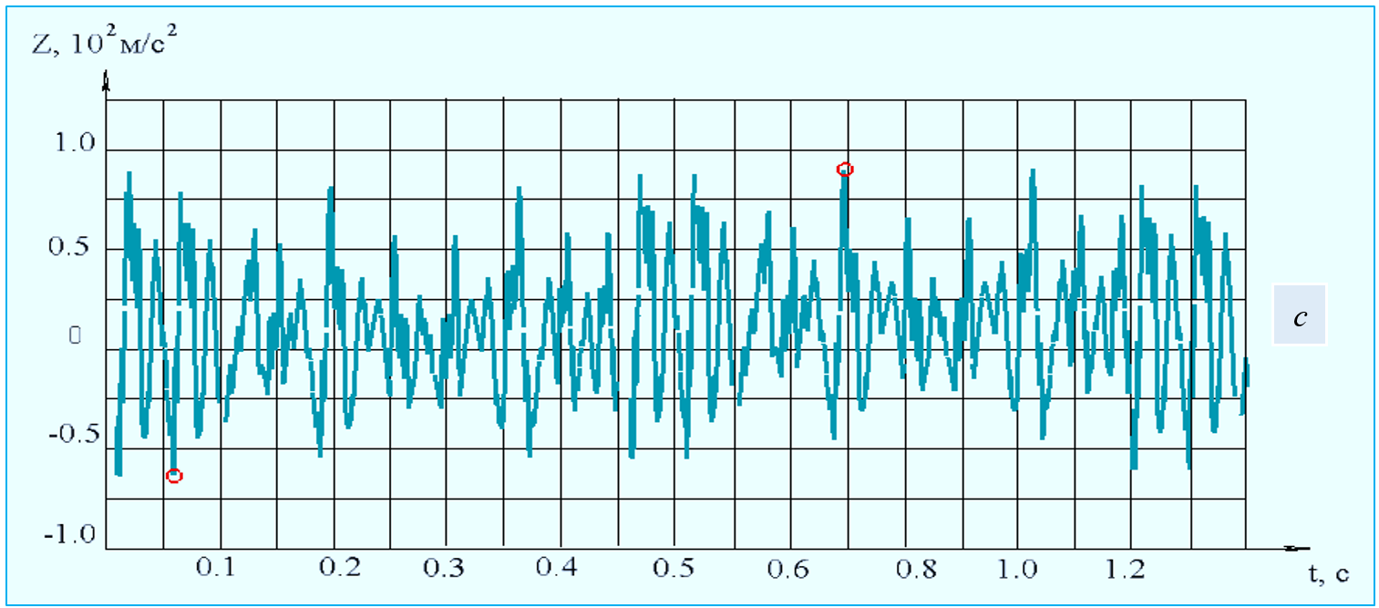
a - displacement, b - velocity, c - acceleration
FIGURE 4. The laws of variation of vibrations in vertical displacement, velocity and acceleration of a roller mechanism consisting of a belt bearing support and a belt bushing

According to the obtained results, the following conclusions were drawn. Based on the analysis of the obtained oscillograms (Figure 4), it was determined that the vertical displacements ∆z₁ of the roller mechanism with an elastic bushing bearing support ranged within (2.5 ÷ 3.5)·10⁻³ m when the rotational speed was n_{v} = 250 rpm and the productivity was 650 kg/s during gold ore transportation. Correspondingly, the velocity values varied within (6.7 ÷ 8.5)·10 m/s, and the acceleration values ranged within (0.67 ÷ 0.85)·10² m/s².
Figure 5 shows graphs of the dependence of the vertical displacement speed and vibration amplitudes of the roller mechanism axis of the belt conveyor bearing support consisting of a rubber bushing on the displacement, speed, and acceleration amplitudes of the bearing rubber bushing.
When analyzing the graphs, it can be seen that the axial displacement z₁, speed and acceleration of the roller mechanisms consisting of a belt bushing of a belt conveyor bearing support follow a nonlinear law. In this case, when the coefficient of rigidity of the rubber bushing of the bearing support increases from 2.2 102 N/m to 6.2 102 N/m, the values of ∆z₁ decrease from 3.47 10⁻³ m to 1.34 10⁻³ m in a nonlinear law. In this case, the values of the vertical displacement speed decrease from 0.128 10 m/s to 0.074 10 m/s, respectively, and the indicators decrease from 0.34 10² m/s² to 0.19 10² m/s². In this case, the eccentricity of the belt tensioning roller mechanisms is 1.6 10⁻³ m, i.e., in order to increase the vertical vibrations of the roller mechanism of the belt conveyor bearing support, it is necessary to reduce the belt support stiffness. Therefore, it is recommended to take the belt support stiffness of the roller mechanism of the belt support support in the range c₁ ≤ (3.5 ÷ 4.5) 10² N/m, i.e., the bushing is made of rubber grade 7IRP13-48. In this case, the z1 values are provided in the range of less than (8.5 ÷ 10.5) 10⁻³ m. At these indicators, the values of and ∆z₁ are high, which accelerates the transportation of gold ore. The proposed belt conveyor bearing support consists of a roller mechanism consisting of a belt bushing, in addition to vertical vibrations, transverse vibrations play a special role. In this case, the intensity of product displacement is high only if the amplitude of the vibrations is larger than that at the outlet.
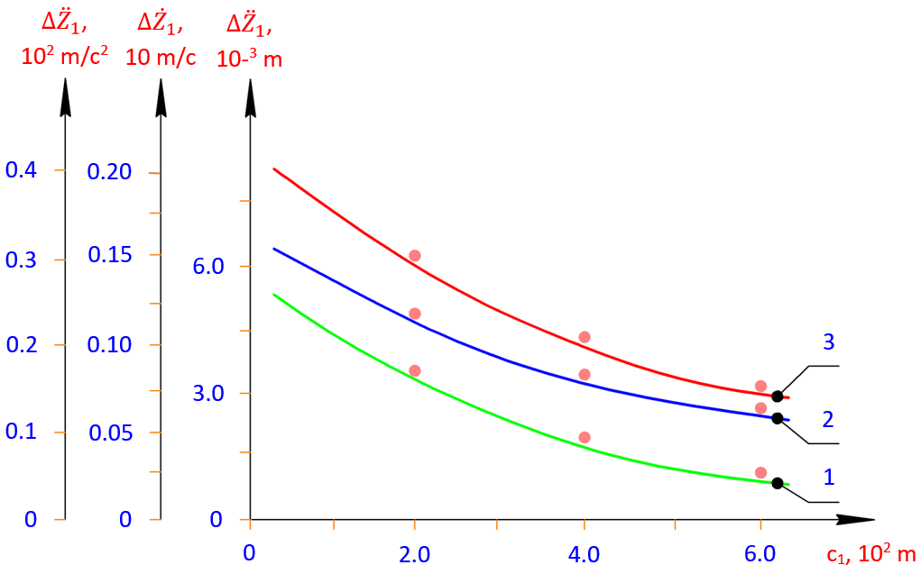
$1-∆z_{1}=f\left(c_{1}\right)$; $2-∆{\dot{z}}_{1}=f\left(c_{1}\right)$; $2-∆{\ddot{z}}_{1}=f\left(c_{1}\right)$;
productivity 1125 kg/h, (when transporting gold ore) l = 1.5·10⁻³m
FIGURE 5. Graph of the dependence of the displacement, speed, and acceleration ranges of the roller mechanisms consisting of a belt conveyor bearing support and a rubber bushing on the friction coefficient of the input bearing

Figure 6 shows graphs of the dependence of the vertical displacement speed and vibration amplitude of the roller mechanism axis of the belt conveyor bearing support consisting of a rubber bushing, the displacement, speed, and acceleration amplitudes at the output section on the stiffness coefficient of the bearing rubber bushing. In this case, when the coefficient of friction of the rubber bushing increases from 3.2·10² N/m to 10.9·10² N/m, it can be seen that the values of $∆z$ decrease from 3.22·10⁻³ m to 0.52·10⁻³ m in a nonlinear pattern. At the same time, the vertical displacement speed of the roller mechanism decreases from 0.90·10 m/s to 0.30·10 m/s, and the values decrease from 0.287·10² m/s² to 0.110·10² m/s² in a nonlinear pattern.
It is desirable to make the vertical displacement vibration range of the shaft in the bearing support smaller. Therefore, in order to ensure that the difference between the vertical displacements of the roller mechanism axis on the supports is within the range $∆z$ ≥ (4.5 ÷ 8.5), it is desirable that the range of displacement vibrations of the roller mechanism axis on the output support be $∆z_{2}$ values (3.5 ÷ 4.5)·10⁻³ m, and the coefficient of rigidity of the bearing support rubber bushing is within the range (8.5 ÷ 11.5)·102 N/m. In this case, it is recommended to make the bearing support belt bushing from 7IRP13-48 rubber. Also, the values and also change in a nonlinear manner, allowing for intensive transportation of products.
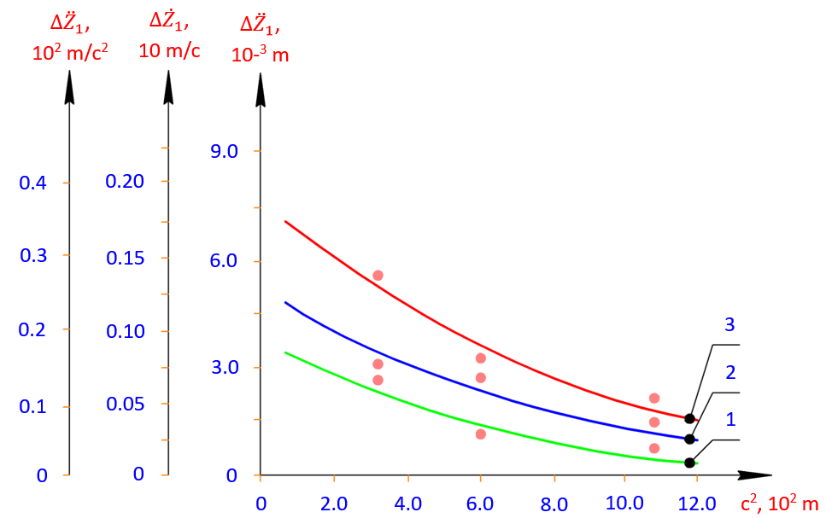
1 – $∆z_{1}$ = f (c₁); 2 – $∆{\dot{z}}_{2}$ = f (c₂); 3 – $∆{\ddot{z}}_{3}$ = f (c₃)
productivity 650 kg/h; (for gold ore transportation) l = 1.5·10⁻³ m
FIGURE 6. Graph of the dependence of the displacement, speed, and acceleration ranges of the roller mechanisms consisting of a belt conveyor bearing support and a rubber bushing on the friction coefficient of the bearing

Experimental determination of angular velocities and loads on the shafts of the driving and driven drums of roller mechanisms consisting of a belt conveyor bearing support and a belt bushing. As a result of experimental studies, the laws of change of angular velocities and torques of the drive, leading and driven drum shafts of a belt conveyor [14] in various operating processes were determined.
These laws of change were determined by the oscillograms presented in Figure 7. Based on the analysis of the determined oscillograms, it can be noted that the laws of change of angular velocities of the drive shaft, leading and driven drum shafts are close to each other, but it can be noted that the amplitudes of oscillations of the angular velocities of the drive shaft are significantly larger than the amplitudes of oscillations of the angular velocities of the drive and driven drum shafts. It can be noted that the average values of the angular velocity on the driving shaft are smaller than the average values of the angular velocity on the leading and driven drum shafts, as can be seen from the oscillograms representing the obtained laws of motion. At the same time, the values of the turning moment M_{ed} are larger, and the vibration amplitude ∆M_{ed} is larger than M_{d} and larger than ∆M_{d}, respectively. It is known that a decrease in speed leads to an increase in the turning moment [17].
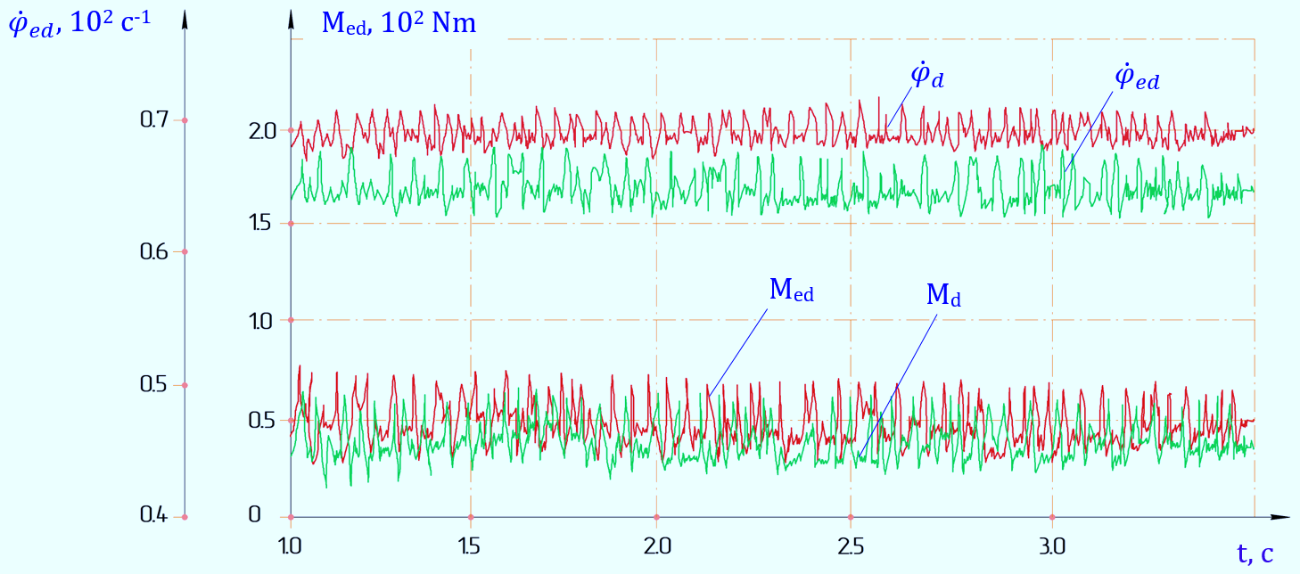
с₂ = 350 Nm/rad; i. u. = 650 kg/s; l = 1,5·10⁻³ m
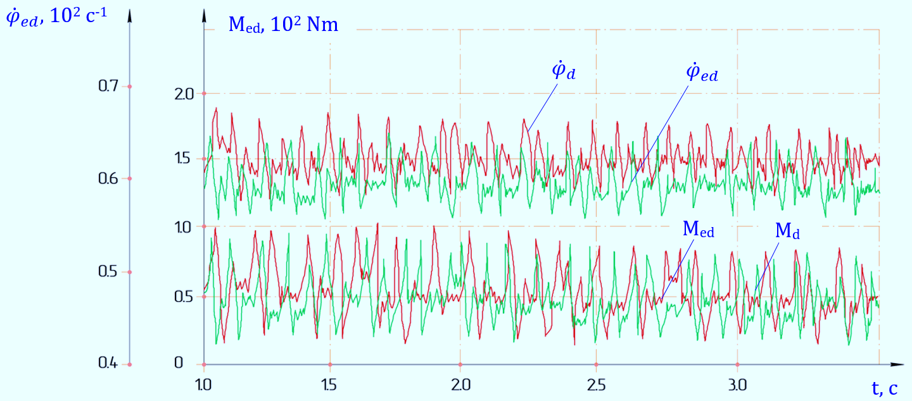
с₂ = 250 Nm/rad; i.u = 1150 kg/s; l = 2,5·10⁻³ m
FIGURE 7. Patterns of angular velocities and torques on the shafts of the driving, leading and driven drums of a belt conveyor

By reworking the above-obtained laws of motion and load changes, several connection graphs were constructed. The graphs of the dependence of the load on the belt conveyor drive, leading and driven drum shafts and their vibration amplitudes on the conveyor performance are presented in Figure 8 below.
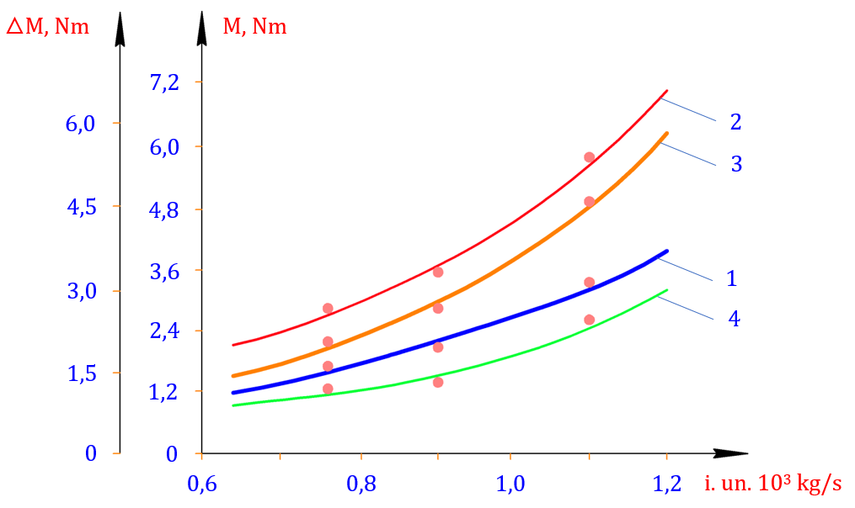
1 – ∆М_{yu} = f (kg/s); 2 – М_{yu} = f (kg/s); 3 – М_{b} = f (kg/s); 4 – ∆М_{b} = f (kg/s);
t_{yu} = 2t_{k} = (25 ÷ 35)·10⁻³ m; h_{t} = (3,5 ÷ 5,0)·10⁻³ m
FIGURE 8. Graphs of the dependence of the load on the belt conveyor drive, leading and driven drum shafts and their vibration amplitudes on the conveyor performance

According to the analysis, when transporting gold ore using a belt conveyor equipped with a roller mechanism whose bearing support consists of an elastic bushing, the productivity increases from 0.8 ÷ 10³ kg/s to 2.3 ÷ 10³ kg/s. Correspondingly, the torque on the drive shaft rises in a nonlinear relationship from 3.11 ÷ 10 Nm to 5.85 ÷ 10 Nm, while the M_{d} values increase from 2.4 ÷ 10 Nm to 5.75 ÷ 10 Nm. Furthermore, it can be observed that the amplitude of torque fluctuations on the driving and driven drum shafts also increases nonlinearly, ranging from 0.84 Nm to 2.35 Nm. It is well known that as productivity rises, the values of M_{ed} and M_{d1d2}, as well as the power consumption, increase accordingly.
As noted, the values of M_{ed} and M_{d1d2} depend on the law of variation of the work output, as well as on the dimensions of the eccentricity of the belt drive tension roller mechanisms. Figure 9 shows graphs of the dependence of the angular velocities of the belt conveyor drive and the leading and driven drums and their vibration ranges on the work output. An increase in the work efficiency leads to a decrease in the corresponding case and ${\dot{φ}}_{ed}$ in a nonlinear manner. The peculiarity is that the difference between them increases with increasing work efficiency and at 1.4·10³ kg/s the value of ${\dot{φ}}_{ed}$ reaches (1.2 ÷ 1.5) c⁻¹. This is especially noticeable in the transportation of gold ore.
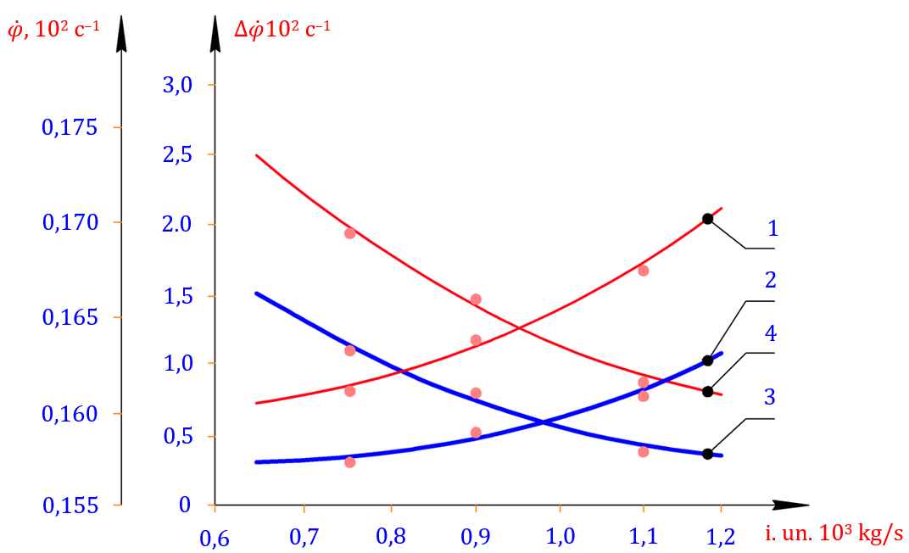
1 – $∆{\dot{φ}}_{d_{1}d_{2}}$ = f (kg/s); 2 – $∆{\dot{φ}}_{ed}$ = f (kg/s); 3 – $∆{\dot{φ}}_{ed}$ = f (kg/s); 4 – $∆{\dot{φ}}_{d_{1}d_{2}}$ = f (kg/s);
t_{ed} = 2t_{k} = (25 ÷ 35)·10⁻³; h_{t} = (3,5 ÷ 4,8)·10⁻³
FIGURE 9. Graphs of the dependence of the angular velocities of the belt conveyor drive and the leading and trailing drums and their vibration ranges on the performance

Figure 10 shows graphs of the dependence of the vibration range of the angular velocities on the shafts of the belt conveyor electric drive, leading and driven drums on the belt rotational stiffness coefficient.
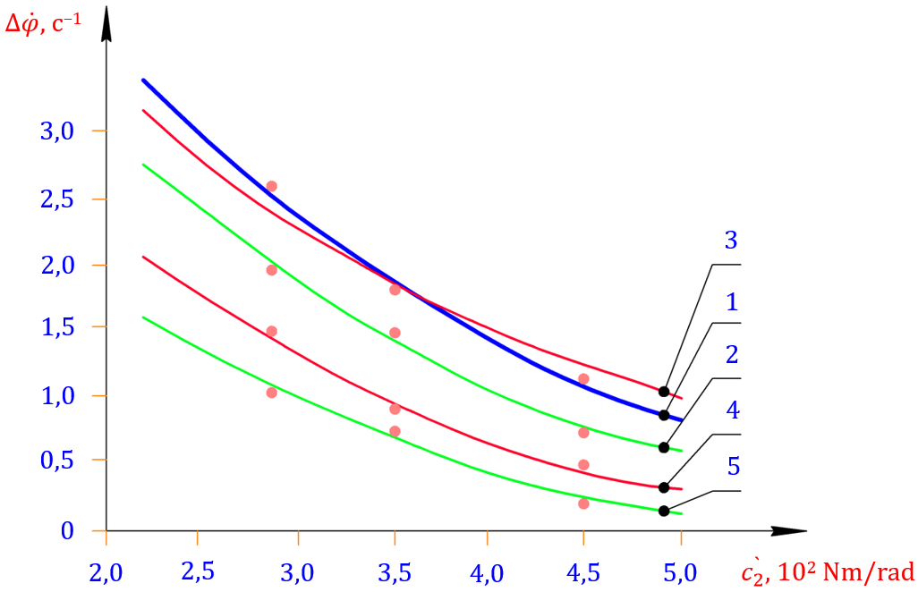
1, 2 – experimental graphs; 3 – theoretical graph; 1, 3, 4 – $∆{\dot{φ}}_{ed}$ = f (c₂); 2, 5 - $∆{\dot{φ}}_{d_{1}d_{2}}$ = f (c₂);
1, 2 – l = 2,5·10⁻³ m; 4, 5 – l = 1,25·10⁻³ m
FIGURE 10. Graphs of the dependence of the angular velocities of the belt conveyor electric drive, driving and driven drum shafts on the belt circumferential stiffness coefficient

It can be seen that when the belt rotational stiffness increases from 2.9·10² Nm/rad to 4.7·10² Nm/rad and l = 2.5·10⁻³ m, the values of ${\dot{φ}}_{ed}$ decrease from 2.65 c⁻¹ to 1.45 c⁻¹ in the nonlinear coupling (Figure 10, graphs 1, 2). When the correspondingly obtained graph is compared with the theoretical graph, the total difference does not exceed (4.5 ÷ 5.5) %. It was found that the vibration range of the angular velocities on the shafts of the leading and driven drums decreases from 2.3 c⁻¹ to 0.9 c⁻¹. When the eccentricity of the belt drive tension roller mechanism decreases to 1.27·10⁻³ m, the corresponding reduction in $∆{\dot{φ}}_{ed}$ goes from 1.8 c⁻¹ to 0.51 c⁻¹, and the values of $∆{\dot{φ}}_{d_{1}d_{2}}$ decrease from 1.4 c⁻¹ to 0.45 c⁻¹ in a nonlinear connection (Fig. 10, graphs 4, 5). To ensure that the angular velocity oscillation range of the leading and driven drums does not exceed (8.5 ÷ 13) % relative to its average value, it is recommended to select the belt drive rotational inertia in the range of (375 ÷ 415) Nm/rad and the eccentricity of the tension roller mechanism in the range of (1.7 ÷ 2.5)·10⁻³.
It should be noted that vertical and oblique vibrations of roller mechanisms with a bearing support with a flexible element lead to a change in the friction force in the supports. It is known that, according to the results of theoretical studies, with an increase in the stiffness and deformation value of the flexible support, the moment of friction force in the bearing also increases. Therefore, it is important to study the effect of the ratio of the stiffness of rubber bushings on the moment of friction force in experiments and reduce the load to their optimal values, ensuring $∆{\dot{φ}}_{d_{1}d_{2}}$ in the required range.
Figure 11 shows graphs of the dependence of the angular vibration range of roller mechanisms with a bearing support on the ratio of the stiffness coefficients of the supports.
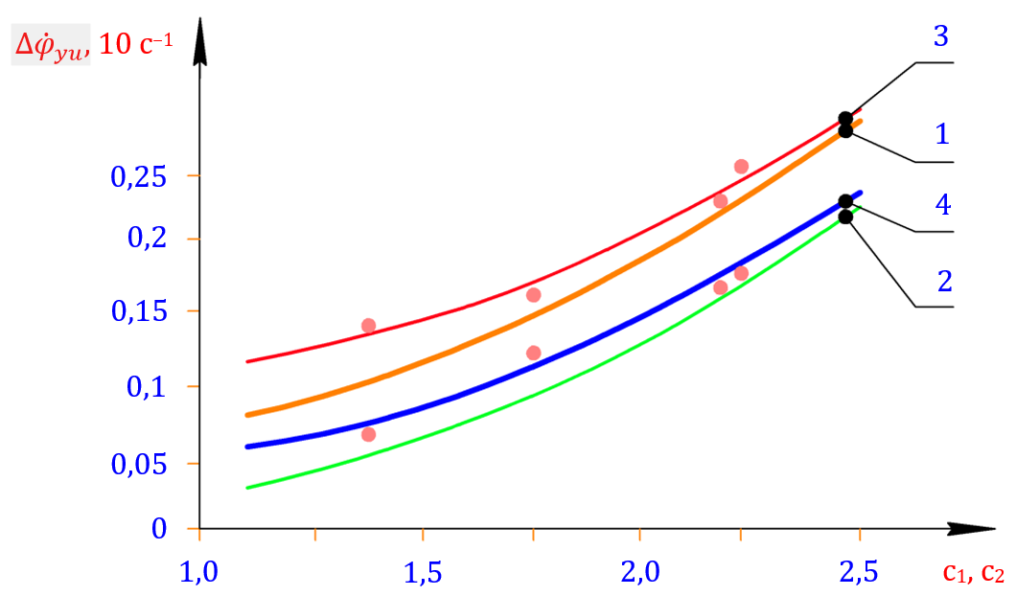
1, 2 – theoretical graph; 3, 4 – experimental graph; 1, 3 – working capacity 1125 kg/s;
2, 4 – working capacity 650 kg/s, n_{r} = 188 rpm
FIGURE 11. Graphs of the dependence of the angular vibration range of roller mechanisms with a bearing support of a belt conveyor with a belt element on the ratio of the stiffness coefficients of the supports

Based on the analysis of the plotted graphs, as the ratio of c₂/c₁ increases from 1.34 to 2.35, the angular velocity fluctuation range $∆{\dot{φ}}_{r}$ of roller mechanisms with an elastic bearing support increases nonlinearly from 1.55 c⁻¹ to 2.42 c⁻¹ at a rotational frequency of 188 rpm and a throughput of i.u = 650 kg/s. When compared with the theoretical relationship, the results show good agreement, with a deviation within the range of (8.5 ÷ 9.5) % (see Fig. 11, curves 2 and 4).
It should be noted that this deviation tends to decrease as the c₂/c₁ ratio increases. When the productivity decreases to i.u = 1125 kg/s, the values of $∆{\dot{φ}}_{r}$ rise nonlinearly from 0.65 c⁻¹ to 1.85 c⁻¹, while the deviation from theoretical values reduces further and does not exceed (6.0 ÷ 7.0) %. Therefore, to ensure that the values of $∆{\dot{φ}}_{r}$ do not exceed the range of (2.1 ÷ 2.5) c⁻¹, it is recommended to select the ratio c₂/c₁ within the interval of (1.45 ÷ 2.15).
CONCLUSION
Therefore, taking into account the rigidity of the bearing supports and the technological resistance of the transported gold ore, a mathematical model of the vertical vibration of the roller mechanism was obtained, and it was found that the vertical vibrations of the roller mechanisms depend on the displacement, rotation speed, and the vibration amplitude on the density of the transported gold ore. It was found that increasing the rigidity coefficient of the bearing support with a flexible element not only leads to a decrease in the vibration amplitude and speed of the roller mechanism, but also to an increase in the vibration frequency. This, in turn, also reduces the static deformation value of the bearing support with a flexible element. Due to the change in the rotational rigidity coefficient of the flexible supports, the vertical displacement of the roller mechanism shaft and the vibration amplitude of the speed change.
REFERENCES
1. Djuraev, A., Jumaev, A.S., Abduraxmanova, M.M.. Analysis of the results of physical and mechanical experimental studies of the modernized belt conveyor. Journal of Physics: Conference Series, 2023, 2573(1), 012012. https://iopscience.iop.org/article/10.1088/1742-6596/2573/1/012012
2. Abduvaliev, U., Jumaev, A., Nurullaev, R., Jakhonov, S., Jurakulov, I. Investigation of the process of the influence of winding spindles with cotton fiber on the performance of a cotton picker. E3S Web of Conferences, 2024, 548, 04013. https://www.e3s-conferences.org/articles/e3sconf/abs/2024/78/e3sconf_agritech-x_04013/e3sconf_agritech-x_04013.html.
3. Djuraev, A., Jumaev, A.S., Ibragimova, N.I., Turdaliyeva, M.Y. Analysis of the dynamics of a belt conveyor with composite guide rollers and elastic elements. Journal of Physics: Conference Series, 2023, 2573(1), 012026. https://api.scienceweb.uz/storage/publication_files/9737/26378/666ad94ba5c1b
4. Abduvaliev, U., Jumaev, A., Nurullaev, R., Ashirov, A., Abdurafikov, B. Influence of the Sectional Shape of the Grabbing Element of a Screw Composite Spindle on Agricultural Performance and Stability of Operation of a Cotton-Picking Machine. Lecture Notes in Networks and Systems, 2024, 1129. https://link.springer.com/chapter/10.1007/978-3-031-70670-7_25
5. Jumaev, A., Istablaev, F., Dustova, M. Development of the theory of calculation of constructive and rational parameters of belt conveyor roller mechanisms. AIP Conference Proceedings, 2022, 2467, 060025. https://api.scienceweb.uz/storage/publication_files/9737/26397/666af69e34968.
6. Tilabov, B., Jumaev, A., Sherbutaev, J., Normurodov, U., Salimov, G. Testing of heat-treated surfaced samples and machine parts for hardness and wear resistance. E3S Web of Conferences, 2024, 548, 03014. https://www.e3s-conferences.org/articles/e3sconf/abs/2024/78/e3sconf_agritech-x_03014/e3sconf_agritech-x_03014.html
7. L. Raufov, D. Berdiev, M. Umarova, R. Tashmatov, Z. Sadullayev, D. Fazilov, Sh. Khojibekova. The Influence of High-Chromium Powder Coatings on Wear Resistance of Working Parts | SpringerLink. ICoRSE 2025, LNNS 1592, pp. 15–26, 2025. https://doi.org/10.1007/978-3-032-02508-1_2
8. D.M. Berdiev, M.A. Umarova, R.K. Toshmatov. Phase and Structural Transformations of Structural Steels in Nontraditional Heat Treatment | Russian Engineering Research, 2021, vol. 41, no. 1, pp. 46–48. https://link.springer.com/article/10.3103/S1068798X21010068
9. Jumaev, A., Mamirov, Sh., Abduraxmanova, M., Ashirov, A., Jakhonov, Sh. (2025). Design Improvement and Parameter Justification for Composite Guide Rollers in Belt Conveyors. AIP Conference Proceedings, 3454.
10. Ermatov, Z., Dunyashin, N., Yusupov, B., Saidakhmatov, A., & Abdurakhmonov, M. (2022). Modelling the chemical composition process concerning formation of metals from manual arc surface on the basis of the electrode coating charge components classification. International Journal of Mechatronics and Applied Mechanics, 12. https://doi.org/10.17683/ijomam/issue12.25
11. D.M. Berdiev, A.A. Yusupov, R.K. Toshmatov, A.Kh. Abdullaev: Increasing Die Durability in Cold Stamping by Quenching with Intermediate Tempering | Russian Engineering Research. 42(10), 1011–1013 (2022). https://doi.org/10.3103/S1068798X22100057
12. Jumaev, A., Dadaev, M., Abduraxmanova, M., Ashirov, A., Muzaffarov, A. (2025). Modeling and Analysis of Forced Vibrations in Composite Bearings for Belt Conveyors. AIP Conference Proceedings, 3454.
13. R. Murodqosimov, S. Tursunbaev, A. Turakhujaeva, U. Mardonov, Sh. Mardonakulov, M. Saidova, N. Kudratkhodjaeva, “Analysing the alternations in the aluminium alloy properties under the influence of silicon and germanium alloying elements” International Journal of Mechatronics and Applied Mechanics 2025, Issue 21, Vol. 1. https://ijomam.com/wp-content/uploads/2025/09/Pp.-365-372
14. Kholmirzaev, N., Saidmakhamadov, N., Khasanov, J., Tadjiev, N., Yusupov, B., Sadikova, N., Nurdinov, Z. (2024, December). Mathematical Modeling of the Effect of TiC Nanopowder Particles on the Wear Resistance Properties of Low-Alloy Steel. In Materials Science Forum (Vol. 1139, pp. 11-19). Trans Tech Publications Ltd. https://www.topflycarbon.com/products_details/2.html?gad_source
15. F.M. Matmurodov, X.X. Boboyev, I.N. Nugmanov, Sh.Sh. Mamirov. Analytical dynamic modeling of damping of a multi-hierarchical mechanical system and mobile power engine shaft with the help of multi-mass rheological models. Journal of Physics: Conference Series. https://iopscience.iop.org/article/10.1088/1742-6596/2573/1/012044
16. M. Khudjaev, E. Nematov, A. Karimova, D. Khurramov, B. Khasanov. Modeling the process of force load generation at the initial periodic change in pressure (a plane problem). E3S Web of Conferences 258, 08020 (2021).
17. E. Nematov, M. Khudjaev, B. Khasanov. Development of a mathematical model of dynamic characteristics of a drive with a planetary mechanism. E3S Web of Conferences 258, 08022 (2021). https://www.e3s-conferences.org/articles/e3sconf/abs/2021/34/e3sconf_uesf2021_08022/e3sconf_uesf2021_08022.html
18. Karimov Sh.A., Mamirov Sh.Sh., Khabibullayeva I.A., Bektemirov B.Sh., Khusanov, N. Friction and wear processes in tribotechnical system International Journal of Mechatronics and Applied Mechanics; Bucharest (2021): 204-208. https://ijomam.com/wp-content/uploads/2021/11/pag.

