Kinematic and dynamic analysis of belt conveyor tensioning and roller mechanisms with flexible elements
Akbarjon Jumaev ^{a)}, Ubaydulla Abduvaliev, Ikram Nugmanov, Zarif Sadullayev, Dusmurat Fazilov
Almalyk State Technical Institute, Almalyk, Uzbekistan
^{a)} Corresponding author: akbarjumayev011@gmail.com
Abstract. The article develops a calculation scheme for a belt drive consisting of a tensioning roller mechanism of a belt conveyor belt, as well as formulas for calculating the rigidity of the belt bushing. The dependences of the change in the rigidity coefficient of the belt bushing of the tensioning roller mechanisms of the tensioning roller mechanisms on its radius and friction coefficient are obtained, and the recommended parameters are determined. The formula expressing the law of the change in the transfer function of the conveyor belt is determined, the graph of the dependence of the change in the transfer function on the angular velocity of the tensioning roller mechanism and the formulas for calculating the deforming force and the rigidity coefficient of the belt element are determined, the graphs of the dependence of the deforming force on the angular velocity and radius of the tensioning roller mechanisms of the belt conveyor, and the graphs of the change in the transverse vibration amplitude of the belt section interacting with the tensioning roller mechanisms of the tensioning roller mechanisms of the belt conveyor are obtained, and the recommended values are developed.
INTRODUCTION
In the development of science today, one of the main issues of mechanical engineering in particular is the design and implementation of high-quality, reliable, modern, and economically efficient machines and mechanisms. It should be noted that the development of science and technology is closely related to the design of new resource-saving machines and mechanisms. In particular, the introduction of advanced technologies into production and the effective use of modern equipment created on the basis of the latest achievements of science and technology are gaining importance in order to provide mining enterprises with affordable and high-quality products.
Mining enterprises are conducting extensive targeted research and development to increase the productivity of technological machines and improve product quality by developing resource-efficient belt conveyors and improved designs of their components for transporting rock. In this direction, the creation of new designs of belt conveyors for transporting products at all manufacturing enterprises is an important issue, which is to ensure long-term operation of conveyor spare parts, high productivity, prevent wear of spare parts from vibration and friction, and to justify the parameters of working bodies.

LITERATURE REVIEW
The requirements for the technologies used by mining enterprises are to design new designs of compact and beautiful, high-quality, reliable, competitive machines and equipment and to widely introduce them into production. Among the large number of enterprises operating in foreign countries and our republic, the contribution of mining enterprises in particular is very large. In recent years, technical and technological innovations and modern modernization work have been carried out at a rapid pace in all sectors of mining enterprises. A large number of scientific research studies are being conducted to develop and improve efficient, resource-saving designs of technological machines and equipment in all industrial enterprises. In particular, many scientists are making their contribution to the development of mining enterprises in our republic and foreign countries.
The main structural element of belt conveyors is an endless belt rotating around the drive and tension drums. Along the entire length of the conveyor, the belt is supported from below by roller supports of the load-bearing and idler networks. The design of the conveyor also includes drive, belt tensioning and cleaning devices, holders, special roller supports, and elements for automatic control and management of the belt movement [1].
Various types of bearings are widely used in the design of bearing units of roller mechanisms that provide belt tension on conveyors. The use of bearings is associated with low friction losses; high efficiency; low friction torque during start-up; compact overall dimensions in the axial direction; ease of maintenance and repair of the equipment due to the interchangeability of bearings. Most often, ball and roller radial support tapered single-row bearings are installed in the bearing units of roller mechanisms. The efficiency of bearings in roller mechanisms is mainly determined by the design of the mechanism, the accuracy of the manufacturing surfaces of parts, the working load, the type of lubrication and operating conditions [2].
One of the main reasons for the failure of bearings installed in the belt tensioning roller mechanisms of the linear part of the conveyor structure is the wear of the bearing friction surfaces (outer and inner rings, rolling elements) due to the constant and variable load forces arising from the weight of the transported load over a long period of time. During the movement of rocks, the failure of the bearing units of the roller mechanisms controlling the belt tension on the conveyor at loading points can occur due to loads exceeding the static strength of their working parts. In rare cases, bearings can jam due to the ingress of large abrasive particles into them, as well as due to the failure of the separators. This type of wear occurs due to the factors listed above or as a result of improper use of rollers and bearings that do not take into account the influence of operating conditions [3].
DISCUSSION
As is known, belt drives, which are the main structural mechanism of a belt conveyor, which is a transport equipment used in mining enterprises, are used to transmit rotary motion over a long distance. In a conveyor, the belt has the ability to transmit greater power than other structural mechanisms, and its advantages are high in durability and accuracy in transmitting the law of motion. One of the main factors leading to increased belt wear and a decrease in the FIK in belt drives is the failure of the support and tensioning roller mechanisms. Therefore, much attention is paid to the belt tensioning devices, that is, roller mechanisms, in the conveyor. The main disadvantage of row tensioning roller mechanisms is that their failure during operation leads to the creation of an additional resistance moment in the belt. To maintain the belt tension in the conveyor at a constant level, the tensioning roller mechanisms must move in a sufficiently vertical direction. Therefore, while maintaining the simplicity of the design, we recommended making the tension roller structural, with the upper shell made of a rubber bushing, and a sliding bearing instead of a rolling bearing (shown in Figure 1).
The recommended belt tensioning roller mechanism with a composite belt element deforms the belt bushing during operation, somewhat smoothing out the loads from belt vibration. The degree of this normalization mainly depends on the belt bushing elasticity coefficient. However, an increase in the belt bushing deformation leads to failure of the supports and an increase in friction between the belt and the belt bushing, which leads to a decrease in the transmission resistance [4, 5].
For a belt conveyor with a belt element roller mechanism with average linear speeds (v ≤ 12 m/s), it is recommended that the deformation of the belt bushing does not exceed 2 – 3 mm. For this, it is necessary to determine the rigidity of the belt bushing [6, 7].
According to the above calculation scheme (from Fig. 1), $∆$MKO₃ from
$MK=r_{3}{\sin{φ}}_{3}$, (1)
From this, the length of the belt overlap with the tension roller mechanism MN can be determined:
$MN={2r}_{3}{\sin{φ}}_{3}$, (2)
where, $r_{3}$ – is the radius of the tension roller; $φ_{3}$ – is ½ of the coverage angle.
The relative weight of the belt in the zone of influence of the tension roller mechanism (in the range MN):
$q_{MN}=2q∙r_{3}{sinφ}_{3}$, (3)
where, q – is the weight of the strip per unit length, N/m.

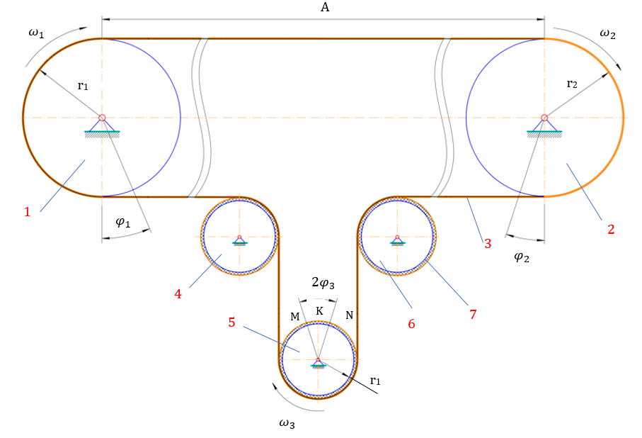
1-leading drum; 2-leading drum; 3-belt; 4, 5, 6-roller mechanism with a composite belt element providing belt tension; 7-belt element
FIGURE 1. Calculation scheme of a belt transmission consisting of a composite tension roller mechanism (Belt conveyor)

In this case, taking into account the fact that the tension force in the leading link of the belt is mainly generated by the friction force between the tension roller mechanism and the belt, and the research results in [8, 9], we derive the following expression:
$Q_{T}={2f}_{u}{qr}_{3}{cosφ}_{3}\sqrt{2\left[1-cos\left(φ_{3}+\frac{∆_{3}}{l_{3}}\right)\right]}$, (4)
where, $f_{u}$ – is the friction coefficient of the belt with the tension roller mechanism, $∆_{3}$ – is the slack of the belt, and $l_{3}$ – is the length of the belt drive chain.
If the vertical forced vibrations of the belt occur mainly under the influence of the tension roller mechanisms, then taking into account the dependence of the natural vibration frequency $ρ$ on the belt mass and the given elasticity coefficient
$ρ=k∙\frac{z_{3}n_{3}}{60}$, (5)
where, $z_{3}$ – the number of elements of the belt that are affected by the tension roller mechanism, $n_{3}$ – the frequency of rotation of the tension roller mechanism, $k$ – the coefficient of proportionality.
The frequency of natural vibrations:
$ρ=\sqrt{\frac{C_{3}g}{ql}}$, (6)
where, $C_{3}$ – is the elastic coefficient of the belt in tension, $l$ – is the length of the part of the belt that interacts with the tension roller mechanism.
Taking into account the above, we derive a formula for calculating the rigidity of the belt bushing of the tension roller mechanisms [10, 11]:
$C_{T}=\frac{2}{δ_{m}}f_{u}{qr}_{3}{cosφ}_{3}\sqrt{2\left[1-cos2\left(φ_{3}+\frac{{4∆}_{3}}{l_{3}}\right)\right]}$, (7)
where, $δ_{m}$ – is the deformation value of the belt (rubber) bushing of the tension roller mechanism.
During the operation of the conveyor belt transmission, the rigidity of the belt element of the tension roller mechanisms mainly depends on the rubber structure, the impact force of the belt, the friction coefficient, the radius of the roller mechanism and the angle of coverage.

RESULTS
As a result of the research, graphs of the dependence of the belt bushing stiffness of a belt conveyor on the radius of the tension roller mechanisms and the coefficient of friction with the belt were obtained (Fig. 2). Analysis of the obtained graphs showed that with an increase in the radius of the tension roller mechanism, the belt bushing stiffness coefficient increases in a nonlinear manner (Fig. 2, a).
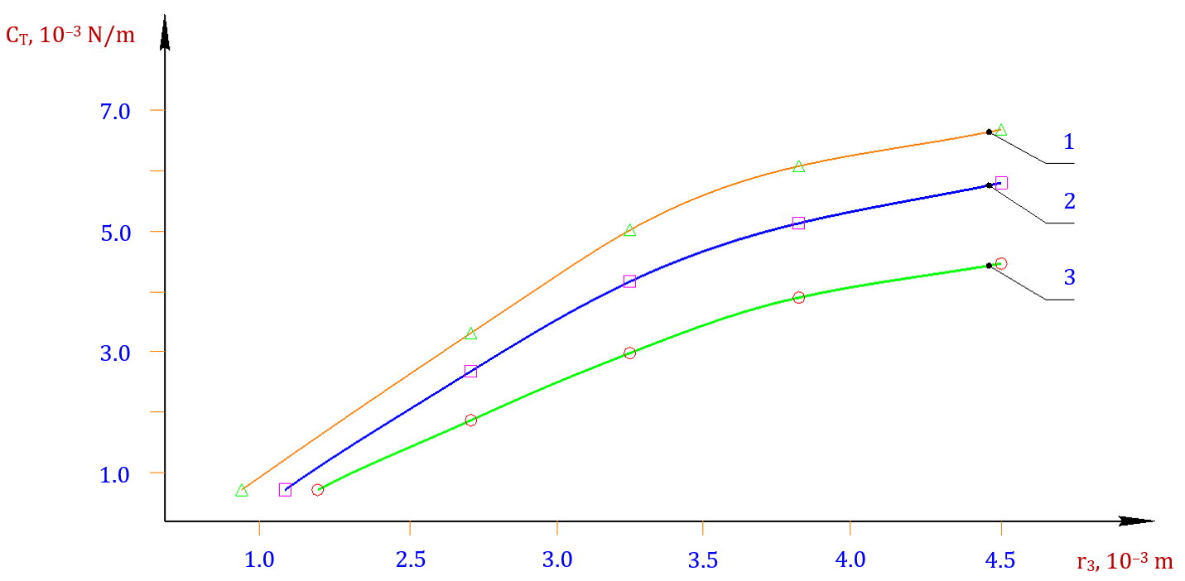
a – the rigidity of the belt bushing of the tension roller mechanism, depending on the roller radius
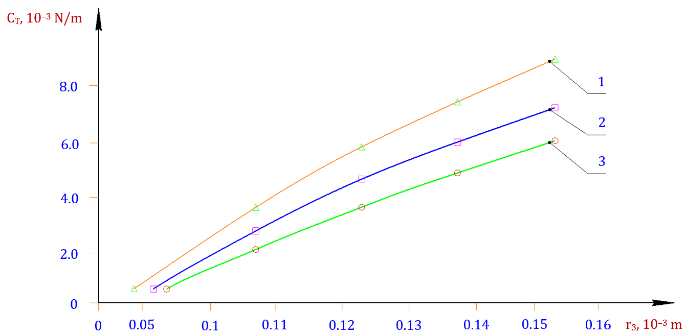
b – dependence on the coefficient of friction between the belt and the roller mechanism
where, |  | $φ_{3}=$0.427; |  | $φ_{3}=$0.36; |  | $φ_{3}=$0.19
FIGURE 2. Graphs of the dependence of the radius of the tension roller mechanisms of the belt conveyor belt bushing on the friction coefficient between the belt and the roller mechanism

In particular, when the radius of the tension roller mechanism increases from 2.2 ꞏ10^{–3} m to 5.2 ꞏ10^{–3} m, the stiffness increases from 1.2 ꞏ10³ N/m to 5.8 ꞏ10³ N/m. This can be explained by the fact that with an increase in the radius of the tension roller mechanism, the impact of the belt on the belt bushing also increases, as a result of which its deformation also increases. The angle of coverage also increases accordingly. As a result of the research, it was found that the increase in friction between the belt and the tension roller mechanism of the belt bushing leads to an increase in stiffness in a linear manner. Figure 2, b shows these graphical relationships. In the case of a friction coefficient of 0.12 and $φ_{3}$ = 0.432 rad, the stiffness of the belt bushing is equal to 1.87 10³ N/m. In the case of friction, the stiffness of the belt bushing is 7.97 10³ N/m.
Calculation scheme and mathematical model of chain vibrations. The service life of a belt drive on a conveyor depends on the operation of the support roller mechanisms and tension roller mechanisms. In many cases, the hardening or long-term operation of these mechanisms depends on the vibrations of the belt. Figure 3 calculation scheme of transverse vibrations of the conveyor belt affected by the tension roller mechanism.
To develop a mathematical model of the tasmanine oscillation, we use Langrage’s II order equation [12]:
$\frac{d}{dt}∙\left(\frac{∂T}{∂\dot{x}}\right)-\frac{dT}{dx}=-\frac{dP}{dx}-\frac{dR}{d\dot{x}}+Q_{y}$, (8)
where, T, P – kinetic and potential energy of the system, x – generalized coordinate, R – Reley’s dissipative function, Q_{y} – generalized external force.
According to the calculation scheme, the kinetic energy of the considered conveyor belt transmission due to transverse vibrations
$T_{3}=\frac{m_{3}}{2}{\left(\frac{{dx}_{3}}{dt}\right)}^{2}$. (9)
Potential energy:
$P_{3}=\frac{C_{T}x_{3}^{2}}{2}$ . (10)
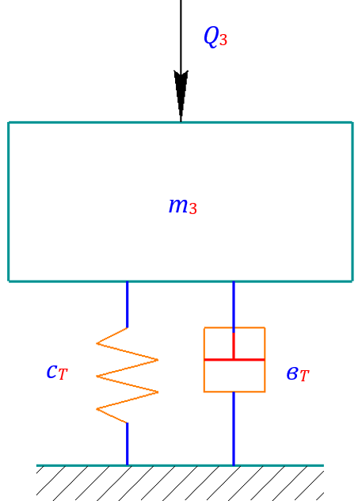
FIGURE 3. Calculation scheme of transverse vibrations of the conveyor belt affected by the tension roller mechanism

Dissipative function:
$R_{3}=\frac{b_{T}}{2}{\left(\frac{dx}{dt}\right)}^{2}$. (11)
where, x₃ – is the displacement of the belt in transverse vibrations, C_{T} – is the rigidity of the belt bushing, b_{T} – is the dissipation coefficient of the belt bushing, m₃ is the mass of the part of the belt affected by the tension roller mechanism.
According to the obtained expressions (9), (10) and (11), we determine the integrals of the Lagrange equation:
$\frac{d}{dt}∙\frac{{dT}_{3}}{{dx}_{3}}=m_{3}{\ddot{x}}_{3}$ $\frac{{dP}_{3}}{{dx}_{3}}=c_{T}x_{3}$ $\frac{dR_{3}}{d\dot{x}}=$ в_{Т}${\dot{x}}_{3}$. (12)
Substituting the obtained expression (12) into expression (8), we obtain a differential equation expressing the transverse vibrations of the part of the belt drive that interacts with the tension roller mechanism:
$m_{3}∙\frac{d^{2}x_{3}}{{dt}^{2}}+b_{T}∙\frac{{dx}_{3}}{dt}+c_{T}x_{3}=Q_{y}$. (13)
Considering the expression (7) for determining the stiffness coefficient of the belt bushing of the conveyor tension roller mechanism, the mathematical model representing the vibration of the belt is as follows:
$m_{3}∙\frac{d^{2}x_{3}}{{dt}^{2}}+b_{T}∙\frac{{dx}_{3}}{dt}+\frac{{2x}_{3}}{δ_{m}}f_{u}{qr}_{3}{cosφ}_{3}\sqrt{2\left[1-cos2\left(φ_{3}+\frac{{4∆}_{3}}{l_{e}}\right)\right]}=Q_{y}$. (14)
The law of change of the acting force is based on Figure 4:
$Q_{y}=Q_{j}+Q_{1}\left|\sin{ωt}\right|$. (15)
We expand the resulting expression (15) into a Fourier series based on [13]:
$Q_{y}\left(t\right)=Q_{1}+Q_{0}\left[\frac{2}{π}-\frac{4}{π}\left(\frac{{cos2ω}_{3}t}{1∙3}+\frac{cos{4ω}_{3}t}{3∙5}+\frac{cos6ω_{3}t}{5∙7}+…+\frac{{cos2nω}_{3}t}{\left(2n-1\right)∙\left(2n+1\right)}\right)\right]$ (16)
where, n = 1, 2, 3
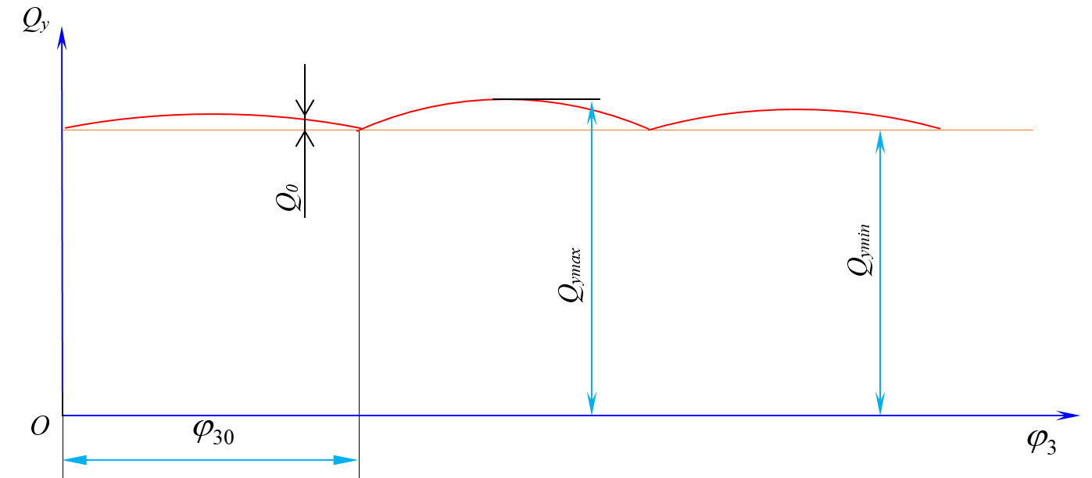
where, Q₁ – is the constant component of the impact force, Q₀ – is the amplitude of the force oscillation,
$φ_{30}$ – is the angle of coverage of the tension roller mechanism for a full change in force
FIGURE 4. Graph of the change in force acting on the belt section interacting with the conveyor tension roller mechanism

It is known [14, 15] that in vibrating systems the dissipation coefficient mainly allows to reduce the amplitude of vibrations and to accelerate the processes. However, it does not affect the frequency of vibrations. Therefore, it is appropriate to observe the maximum amplitude of vibrations of the tension roller mechanisms of the considered belt transmission under the influence of the belt bushing. Therefore, the problem was solved without taking into account the dissipation coefficient in (15). As a result, taking into account (16), the equation of transverse vibration of the belt becomes:

$m_{3}∙\frac{d^{2}x_{3}}{{dt}^{2}}+\frac{{2x}_{3}}{δ_{m}}f_{u}{qr}_{3}{cosφ}_{3}\sqrt{2\left[1-cos2\left(φ_{3}+\frac{{4∆}_{3}}{l_{e}}\right)\right]}=Q_{1}+$
$+Q_{0}\left[\frac{2}{π}-\frac{4}{π}\left(\frac{{cos2ω}_{3}t}{1∙3}+\frac{cos{4ω}_{3}t}{3∙5}+\frac{cos6ω_{3}t}{5∙7}+…+\frac{{cos2nω}_{3}t}{\left(2n-1\right)∙\left(2n+1\right)}\right)\right]$. (17)

The solution of the derived differential equation (17) was obtained using the solution method presented in [16]. The solution of equation (17) consists of the sum of the solutions for each term presented in (16), i.e.

$x_{3}=\frac{1}{C_{T}}\left(Q_{1}+\frac{{2Q}_{0}}{π}\right)-\frac{{4Q}_{0}}{{πm}_{3}}\sum_{n=1}^{∞}{\frac{cos2nωt}{\left(2n-1\right)\left(2n+1\right)\left(ρ_{0}^{2}-{4n}^{2}ω_{3}^{2}\right)}}$ (18)

From the solution to the problem, it can be seen that the transverse vibrations of the conveyor belt drive due to the interaction of the tension roller mechanism with the belt bushing follow a harmonic law.
Analysis of the dependence of conveyor belt vibrations on the parameters of the roller mechanism with a belt element. Let us consider the analysis of the vibrations of the proposed conveyor belt transmission parameters when they are affected by the tension roller mechanism. Based on the numerical solution of the obtained expression (17), the law of transverse belt vibration was determined.
Figure 5 shows the diagrams of the dependence of the transverse displacement, speed and acceleration changes over time under the influence of the tension roller mechanisms of the conveyor belt with different angular velocities.
The vibration frequency of the conveyor belt mainly varies depending on the angular velocity of the tension roller mechanisms. In this case, the vibration amplitude is 0.76 mm at an angular velocity of 20 c⁻¹, and at an angular velocity of 30 c⁻¹, the amplitude decreases to 0.65 mm. That is, with an increase in the impact velocity, the deformation time of the tension roller mechanisms (shell) decreases and the impact angle increases. Therefore, the vibration amplitude decreases (see Fig. 5, a, b and c). Also, when the rotation speed is 27 c⁻¹, the lower component of the belt vibration frequency is 12.5 Gs, and the upper frequency is 45.68 Gs. Similarly, with a tension roller mechanism with an angular velocity of 30 c⁻¹, the upper frequency of the belt vibration is 42.6 Gs, and the lower frequency is 8.5 Gs.

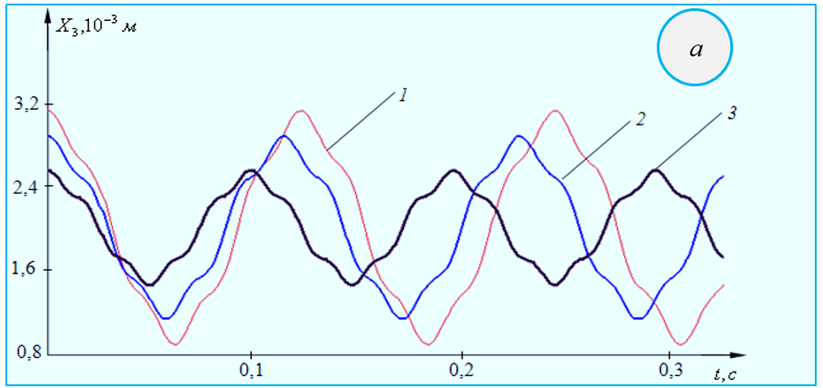
a
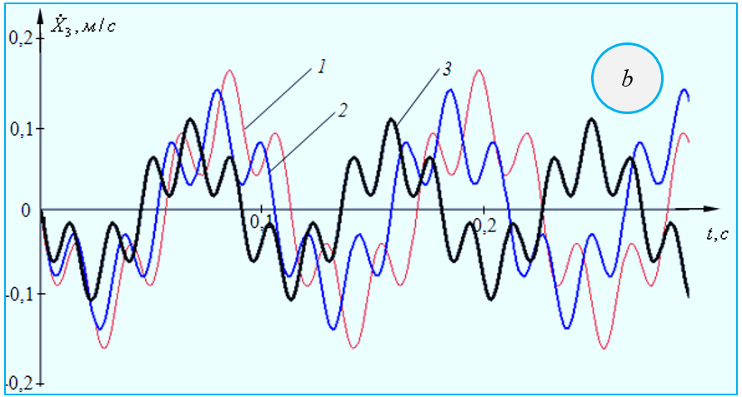
b
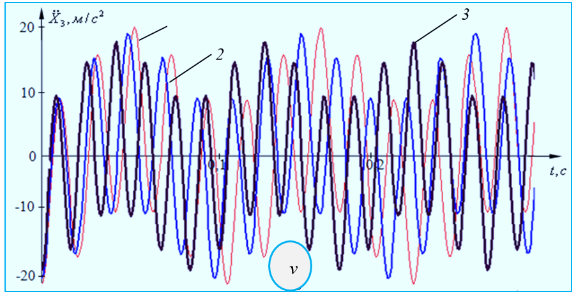
v)
where, 1 – $ω_{3}$ = 20 c^{–1}; 2 – $ω_{3}$ = 25 c^{–1}; 3 – $ω_{3}$ = 30 c^{–1}.
a – the law of belt vibration, b – the speed of belt vibration, v – the acceleration of belt vibration with respect to time, its change depending on the angular velocity of the roller mechanism.
FIGURE 5. Diagrams of the dependence of the transverse displacement, speed and acceleration of the tensioning roller mechanisms on the time of the tensioning roller mechanisms

It should be noted that the displacement of the conveyor belt from a static position with tension roller mechanisms is on average 2.6 mm, respectively, according to (18) (Fig. 5). It is known that in oscillatory motion, a change in the vibrating mass directly affects its amplitude.
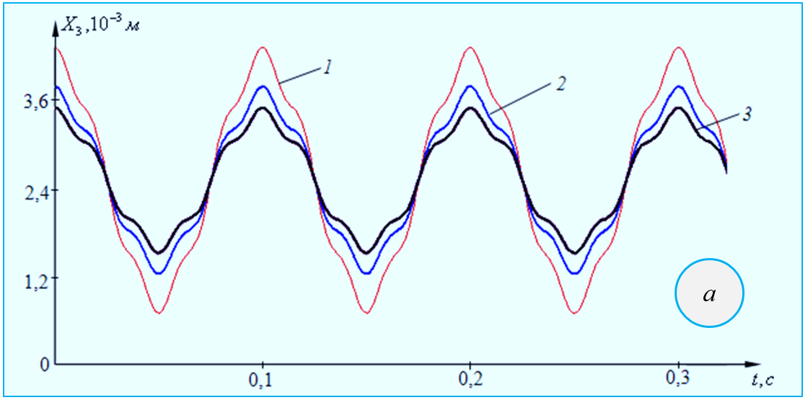
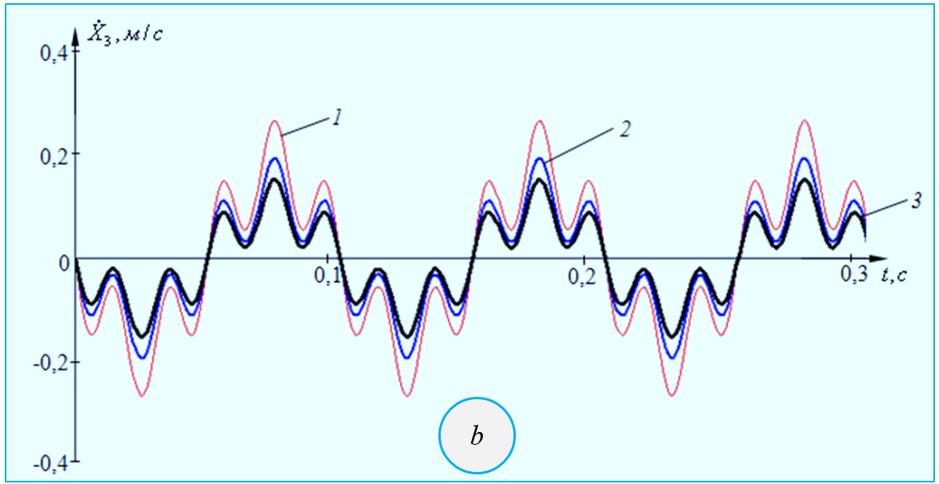
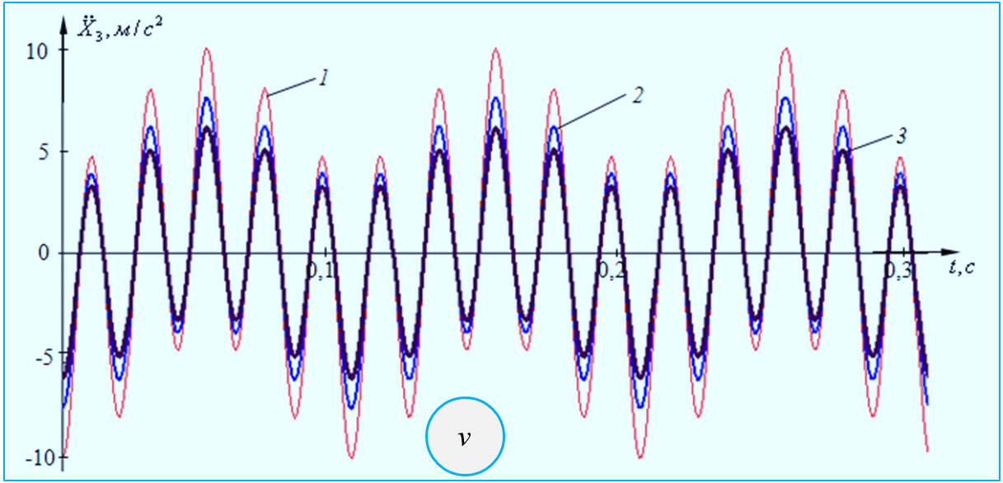
a – the transverse vibration of the conveyor belt, b – the transverse vibration speed of the conveyor belt, c – the transverse vibration acceleration of the conveyor belt with time and the mass of the belt in the range of influence;
where, 1 – m₃ = 0.020 kg; 2 – m₃ = 0.040 kg; 3 – m₃ = 0.060 kg
FIGURE 6. Diagrams of the dependence of the law of transverse vibration of the belt conveyor belt, the change in speed and acceleration on the mass of the roller mechanisms

Figure 6 shows diagrams of the dependence of the transverse vibration law (a), speed (b) and acceleration (v) of the belt conveyor belt on the mass of the roller mechanisms with tension. It can be seen from the obtained vibration laws that increasing the mass of the part of the conveyor belt affected by the tension roller mechanisms also leads to a decrease in the amplitude of vibration, velocity and acceleration amplitudes. However, the frequencies of displacement, velocity and acceleration vibrations remain almost unchanged. For example, when the mass is 0.020 kg, the vibration amplitude is 1.40 mm, respectively, the amplitude of the velocity vibration reaches 0.245 m/s, and the amplitude of the acceleration vibration reaches 8.86 m/s.
When the mass of the transversely vibrating part of the chain increases by 0.047 kg, its vibration amplitude decreases to 0.89 mm, the velocity amplitude decreases to 0.170 m/s, and the acceleration amplitude decreases to 3.16 m/s. It should be noted here that the amplitude of the high-frequency component of the belt vibration also decreases accordingly. Research has shown that the effect of angular velocity on tension roller mechanisms is important in studying the effect of mass on belt vibrations.
Figure 7 shows graphs of the change in the transverse vibration amplitude of a belt section interacting with the tension roller mechanisms of a belt conveyor as its mass changes.
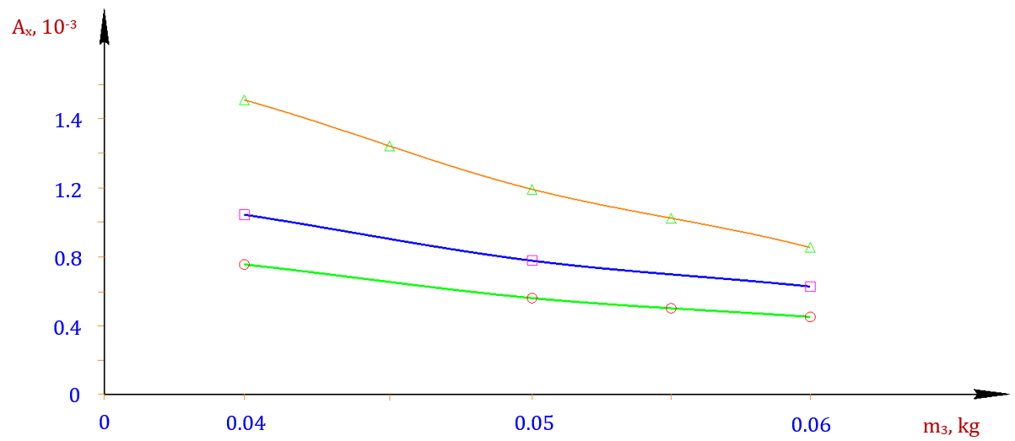
where, |  | $ω_{1}=$ 35 c^{–1}; |  | $ω_{2}=$ 40 c^{–1}; |  | $ω_{3}=$ 45 c^{–1}.
FIGURE 7. Graphs of the change in the amplitude of transverse vibrations of a belt conveyor with a change in the mass of the belt section interacting with the tension roller mechanisms

Based on the analysis of the obtained graphs, it was found that the vibration amplitude of the belt conveyor tension roller mechanisms at an angular velocity of 35 c⁻¹ and m₃ = 0.06 kg was 1.75 10^{–3} m, and when the mass increased to 0.08 kg, the vibration amplitude became 0.95 10^{–3} m. Also, when the angular velocity was 45 c⁻¹, the vibration amplitude decreased from 0.75 10^{–3} m to 0.55 10^{–3} m with an increase in the mass to 0.08 kg. That is, the mass value has little effect on the change in the vibration amplitude with an increase in the angular velocity. To reduce the vibration of the conveyor belt, it is advisable to take the angular velocity of the tension roller mechanisms in the range of 35 ÷ 45 c^{–1}, and the mass of the belt in this section in the range of (0.50 ÷ 0.60) 10^{–1} kg. In this case, the vibration range (doubled amplitude) does not exceed (1.6 ÷ 2.0) 10^{–3} m. The characteristics of the conveyor belt vibrations also depend to a large extent on the change in the radius of the tension roller mechanism affected by it.
CONCLUSION
Formulas for calculating the stiffness of the belt bushing of the tensioning roller mechanism of a belt conveyor belt were developed. The dependences of the change in the stiffness coefficient of the belt bushing of the tensioning roller mechanisms of the tensioning roller mechanisms on its radius and friction coefficient were obtained, and the recommended parameters were determined. The formula expressing the law of change in the transfer function of the conveyor belt was determined, and the graph of the dependence of the change in the transfer function on the angular velocity of the tensioning roller mechanism was obtained. Formulas for calculating the deforming force and stiffness coefficient of the belt element of the tensioning roller mechanisms were determined, and the graphs of the dependence of the deforming force on the angular velocity and radius of the tensioning roller mechanisms of the tensioning roller mechanisms of the belt conveyor, and the graphs of the change in the transverse vibration amplitude of the belt section interacting with the tensioning roller mechanisms of the tensioning roller mechanisms of the belt conveyor were obtained, and the recommended values were developed.
REFERENCES
1. Jumaev, A., Istablaev, F., Dustova, M. Development of the theory of calculation of constructive and rational parameters of belt conveyor roller mechanisms. AIP Conference Proceedings, 2022, 2467, 060025.Djuraev, A., https://api.scienceweb.uz/storage/publication_files/9737/26397/666af69e34968.
2. Abduvaliev, U., Jumaev, A., Nurullaev, R., Jakhonov, S., Jurakulov, I. Investigation of the process of the influence of winding spindles with cotton fiber on the performance of a cotton picker. E3S Web of Conferences, 2024, 548, 04013. https://www.e3s-conferences.org/articles/e3sconf/abs/2024/78/e3sconf_agritech-x_04013/e3sconf_agritech-x_04013.html.
3. Djuraev, A., Jumaev, A.S., Ibragimova, N.I., Turdaliyeva, M.Y. Analysis of the dynamics of a belt conveyor with composite guide rollers and elastic elements. Journal of Physics: Conference Series, 2023, 2573(1), 012026. https://api.scienceweb.uz/storage/publication_files/9737/26378/666ad94ba5c1b
4. Abduvaliev, U., Jumaev, A., Nurullaev, R., Ashirov, A., Abdurafikov, B. Influence of the Sectional Shape of the Grabbing Element of a Screw Composite Spindle on Agricultural Performance and Stability of Operation of a Cotton-Picking Machine. Lecture Notes in Networks and Systems, 2024, 1129. https://link.springer.com/chapter/10.1007/978-3-031-70670-7_25
5. Djuraev, A., Jumaev, A.S., Abduraxmanova, M.M.. Analysis of the results of physical and mechanical experimental studies of the modernized belt conveyor. Journal of Physics: Conference Series, 2023, 2573(1), 012012. https://iopscience.iop.org/article/10.1088/1742-6596/2573/1/012012
6. Jumaev, A., Mamirov, Sh., Abduraxmanova, M., Ashirov, A., Jakhonov, Sh. (2025). Design Improvement and Parameter Justification for Composite Guide Rollers in Belt Conveyors. AIP Conference Proceedings, 3454.
7. Tilabov, B., Jumaev, A., Sherbutaev, J., Normurodov, U., Salimov, G. Testing of heat-treated surfaced samples and machine parts for hardness and wear resistance. E3S Web of Conferences, 2024, 548, 03014. https://www.e3s-conferences.org/articles/e3sconf/abs/2024/78/e3sconf_agritech-x_03014/e3sconf_agritech-x_03014.html
8. L. Raufov, D. Berdiev, M. Umarova, R. Tashmatov, Z. Sadullayev, D. Fazilov, Sh. Khojibekova.: The Influence of High-Chromium Powder Coatings on Wear Resistance of Working Parts | SpringerLink. ICoRSE 2025, LNNS 1592, pp. 15–26, 2025. https://doi.org/10.1007/978-3-032-02508-1_2
9. Ermatov, Z., Dunyashin, N., Yusupov, B., Saidakhmatov, A., & Abdurakhmonov, M. (2022). Modelling the chemical composition process concerning formation of metals from manual arc surface on the basis of the electrode coating charge components classification. International Journal of Mechatronics and Applied Mechanics, 12. https://doi.org/10.17683/ijomam/issue12.25
10. Jumaev, A., Dadaev, M., Abduraxmanova, M., Ashirov, A., Muzaffarov, A. (2025). Modeling and Analysis of Forced Vibrations in Composite Bearings for Belt Conveyors. AIP Conference Proceedings, 3454.
11. D.M. Berdiev, M.A. Umarova, R.K. Toshmatov Phase and Structural Transformations of Structural Steels in Nontraditional Heat Treatment | Russian Engineering Research, 2021, vol. 41, no. 1, pp. 46–48.
https://link.springer.com/article/10.3103/S1068798X21010068
12. Karimov Sh.A., Mamirov Sh.Sh., Khabibullayeva I.A., Bektemirov B.Sh., Khusanov, N. Friction and wear processes in tribotechnical system International Journal of Mechatronics and Applied Mechanics; Bucharest (2021): 204-208. https://ijomam.com/wp-content/uploads/2021/11/pag.
13. D.M. Berdiev, A.A. Yusupov, R.K. Toshmatov, A.Kh. Abdullaev: Increasing Die Durability in Cold Stamping by Quenching with Intermediate Tempering | Russian Engineering Research. 42(10), 1011–1013 (2022). https://doi.org/10.3103/S1068798X22100057
14. E. Nematov, M. Khudjaev, B. Khasanov. Development of a mathematical model of dynamic characteristics of a drive with a planetary mechanism. E3S Web of Conferences 258, 08022 (2021). https://www.e3s-conferences.org/articles/e3sconf/abs/2021/34/e3sconf_uesf2021_08022/e3sconf_uesf2021_08022.html
15. F.M. Matmurodov, X.X. Boboyev, I.N. Nugmanov, Sh.Sh. Mamirov. Analytical dynamic modeling of damping of a multi-hierarchical mechanical system and mobile power engine shaft with the help of multi-mass rheological models. Journal of Physics: Conference Series. https://iopscience.iop.org/article/10.1088/1742-6596/2573/1/012044
16. R. Murodqosimov, A. Turakhujaeva, A. Turaev, S. Tursunbaev, Sh. Mardonakulov, Sh. Tashbulatov, F. Odilov, M. Rakhmonova, S. Murodov. Mathematical Modeling of the Effect of the Lithium Element on the Fluidity of Al-Si and Al-Cu Alloys. International Conference on Reliable Systems Engineering (ICoRSE) – 2025. ICoRSE 2025, LNNS 1592, pp. 62–69, 2025. https://link.springer.com/chapter/10.1007/978-3-032-02508-1_6
17. Kholmirzaev, N., Turakhodjaev, N., Saidmakhamadov, N., Tadjiev, N., Khasanov, J., Yusupov, B., Juraev, J. (2024, December). Improvement of the Technology of Melting of Low Alloy Steel Alloy in an Electric Arc Furnace. In Materials Science Forum (Vol. 1139, pp. 3-9). Trans Tech Publications Ltd. https://www.topflycarbon.com/products_details/2.html?gad_source
18. R. Murodqosimov, S. Tursunbaev, A. Turakhujaeva, U. Mardonov, Sh. Mardonakulov, M. Saidova, N. Kudratkhodjaeva, Analysing the alternations in the aluminium alloy properties under the influence of silicon and germanium alloying elements. International Journal of Mechatronics and Applied Mechanics 2025, Issue 21, Vol. 1.
https://ijomam.com/wp-content/uploads/2025/09/Pp.-365-372

