Determination of the Content of Amino Acids in Natural Propolis
Akmal Islomov^{1,2}, Shovkat Saytdjanov², Kamola Mannapova^{2,a)}, Anvar Makhmudov², Shaxlo Saydaliyeva²
¹Institute of Bioorganic Chemistry named after Academician Obid Sodiqovich Sodiqov, Academy of Sciences of the Republic of Uzbekistan, Tashkent, Uzbekistan
²Tashkent State Transport Universit, Tashkent, Uzbekistan
^{a)} Corresponding author: mannapova.kamola@mail.ru
Abstract. This article provides information on the amino acid content of natural propolis and its medicinal uses.
INTRODUCTION
Today, the cultivation of medicinal natural products, the study of their chemical composition, the isolation of biologically active compounds, and the development of new types of drugs and natural biologically active additives (BAA) based on herbal preparations are among the pressing issues in the field of natural sciences (chemistry, physics, biology, pharmacy). In our republic, comprehensive measures are being taken to organize high-level scientific research in the direction of developing and creating effective biologically active food additives (BAA) and medicines based on local raw materials and providing the domestic pharmaceutical market with high-quality medicines and natural biologically active additives (BAA). Each study conducted on propolis has proven that it is one of the most powerful natural antibiotics with various medicinal properties. It is so strong that even viruses and bacteria cannot adapt to it, and in many cases, they quickly acquire a genetic code for resistance to antibiotics, get used to them, and even eat them. Therefore, propolis is an officially recognized natural antibiotic that successfully fights bacteria, fungi, and viruses. [1-3].
THEORETICAL PART
Propolis is a term derived from two Greek words: pro ''in front'' and polis ''community'' or ''city'', and means to protect the hive. Honey bees produce propolis from several parts (twigs, flowers, pollen, and buds) collected from various plant sources and with the addition of modified salivary secretions, wax, and pollen in the hive. In particular, its antimicrobial and antioxidant activity has important applications in the field of propolis, it is used as a raw material in the production of drugs and as a food additive in the pharmaceutical industry. An overview of bees and propolis is presented in Figure 1. [2-3].
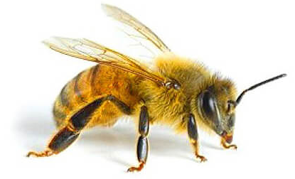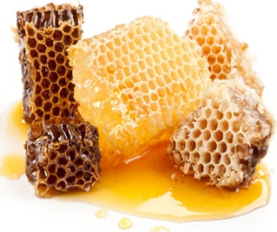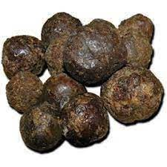
FIGURE 1. Bees and natural propolis
Propolis contains most of the microelements necessary for humans, including magnesium, potassium, sodium, iron, zinc, manganese, copper, etc. Propolis is rich in vitamins A, C, E, H, and P, as well as B vitamins (B1, B2, B6). Bee glue contains amino acids, including those necessary for humans, including alanine, valine, isoleucine, lysine, leucine, methionine, ornithine, threonine, tryptophan, phenylalanine, etc. [3-4].
The medicinal properties of propolis include the fact that it kills more than a hundred bacteria, viruses, and fungi, including microbes that cause tuberculosis, diphtheria, typhoid, and influenza. Propolis is extremely effective in the treatment of the nasal cavity, respiratory tract, infectious goiter, stomach, skin diseases, edema, difficult-to-heal wounds, and burns. It is also an immunostimulant for chronic diseases and the treatment of weakened patients. In such cases, it is used in combination with honey. There is no better medicine for women's diseases and urinary tract colds. Preparations from bee glue are also used in the treatment of diseases of the peripheral nervous system and the musculoskeletal system. There have also been cases of improvement in the condition of cancer patients after a course of treatment with propolis. In general, propolis, due to its ability to destroy various bacteria, and antidotes and increase overall strength, when used in combination with chemical drugs enhances their therapeutic effect and reduces side effects. [4]. Endogenous amino acids are those that are synthesized in the body of humans and animals, i.e. they are formed from various organic compounds depending on whether they are biosynthesized in the body or not; these include glycine, alanine, proline, serine, cysteine, asparagine, glutamine, aspartic acid, glutamic acid, and tyrosine. Non-exogenous amino acids are those that are not synthesized in the body of humans and animals, i.e. are not formed. These are α-amino acids that are introduced into the body from the outside with food. Non-exogenous α-amino acids that are not exchanged in the body, i.e. are introduced into the human body from the outside with food, are divided into eight non-exchangeable α-amino acids (valine, leucine, isoleucine, threonine, lysine, methionine, phenylalanine, tryptophan) [5].
DISCUSSION OF RESULTS
The amino acid content in propolis was determined by high-performance liquid chromatography (HPLC) using a centrifuge tube. For this purpose, 1 ml (exact volume) of 20% CHCl₃ (trichloroacetic acid CCl₃COOH) was added to 1 ml of the test sample. After 10 minutes, the precipitate was separated by centrifugation at 8000 rpm for 15 minutes. 0.1 ml of the supernatant was separated and lyophilized. The hydrolysate was evaporated, the dry residue was washed with triethylamine-acetonitrile-water (1:7:1), dissolved in a water mixture, and dried, and this operation was repeated twice to neutralize the acid. Phenylthiocarbamyl (PTC) derivatives of amino acids were obtained by reaction with phenylthioisocyanate according to the method of Stephen A., Cohen Daviel. Determination of amino acid derivatives was carried out using YSSX. Chromatography Agilent Technologies 1200 with DAD detector, Discovery HS C 18 75x4.6 mm column. Solution A: 0.14 M CH₃COONa + 0.05% TEA pH 6.4, B: CH₃CN. Flow rate 1.2 ml/min, absorbance 269 nm. Gradient %B/min: 1-6% / 0-2.5 min; 6-30% / 2.51-40 min; 30-60% / 40.1-45 min; 60-60% / 45.1-50 min; 60-0% / 50.1-55 min. The amount of these amino acids was determined by USSX based on the appropriate accurate methodology. The chromatogram showing the quantitative composition of the amino acids in the studied sample is shown (Figure 2).
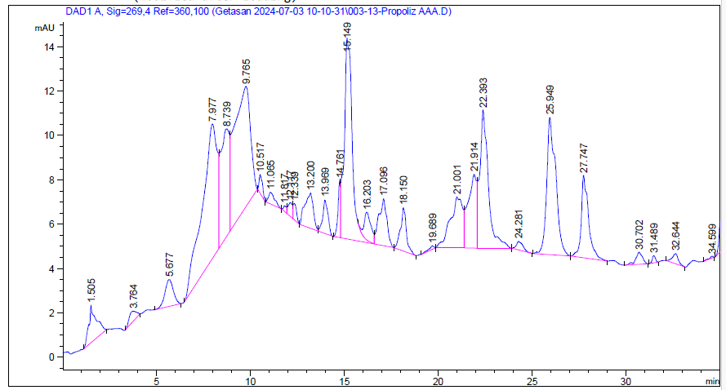
FIGURE 2. Chromatogram of amino acids present in propolis.
According to the chromatogram of amino acids present above, the amount of amino acids in propolis is presented in Table 1.
TABLE 1. Amount of amino acids in propolis
№ | Name Amino acids | Amino acids mg/g | № | Name Amino acids | Amino acids mg/g
1 | Asparagine C₄H₇NO₄ | 0.252744 | 11 | Proline C₅H₉NO₂ | 1.004854
2 | Glutamate C₅H₉NO₄ | 0.297289 | 12 | Tyrosine C₉H₁₁NO₃ | 1.226887
3 | Serine C₃H₇NO₃ | 0.582589 | 13 | Valine C₅H₁₁NO₂ | 0.598054
4 | Glycine C₂H₅NO₂ | 0.172879 | 14 | Methionine C₅H₁₁ SHO₂ | 0.477111
5 | Asparagine C₄H₈N₂O₃ | 0.34865 | 15 | Histidine C₆H₉N₃O₂ | 0.419455
6 | Glutamine C₅H₁₀N₂O₃ | 2.75664 | 16 | Isoleucine C₇H₁₅NO₂ | 0.299409
7 | Cysteine C₃H₇ SNO₂ | 1.019672 | 17 | Leucine C₆H₁₃NO₂ | 0.658733
8 | Threonine C₄H₉NO₃ | 0.703812 | 18 | Tryptophan C₁₁H₁₂N₂O₂ | 0.261614
9 | Arginine C₆H₁₄N₄O₂ | 0.543038 | 19 | Phenylalanine C₉H₁₁NO₂ | 0.092638
10 | Alanine C₃H₇NO₂ | 0.285026 | 20 | Lysine C₆H₁₄N₂O₂ | 0.163126
 | Total |  |  |  | 12.16422

As can be seen from the table above, propolis contains 20 amino acids. Based on the analysis, the amount of amino acids was determined to be 12.16422 mg/g.
Chromatography shows that bee propolis contains various amino acids necessary for the human body, and their amounts were determined.
CONCLUSION
When determining the number of amino acids in natural propolis using a high-performance liquid chromatography (HPLC) device, it was determined that propolis contains 20 amino acids, and their amount was 12.16422 mg/g.
REFERENCES
1. X. A. Saidova, I. R. Asqarov, and A. X. Islomov, Chemical composition of bee venom and its application in folk medicine, Educ. Sci. Innov. Ideas World, 50(2), 3–8 (2024).
2. X. A. Saidova, A. X. Islamov, and Sh. Ch. Misirov, Determination of water‑soluble vitamins in a 1:2 complex of propolis and monoammonium glyceric acid salt, Proc. Military‑Applied Theoretical Issues Conf., 189–191 (2024).
3. X. A. Saidova, I. R. Asqarov, A. Kh. Islomov, D. Abdugafurova, L. Mahmudov, A. Inkhonova, and U. J. Ishimov, Development and HPLC characterization of a water‑soluble supramolecular complex acid monoammonium salt: composition, toxicity, and pharmaceutical potential, Biomed. Pharmacol. J. 18(1), 1017–1029 (2025).
4. I. R. Asqarov, A. Kh. Islomov, and Kh. A. Saidova, Determination of vitamin content in propolis and its use in folk medicine, Folk Med. Plus, 2(23), 2–5 (2025).
5. G. I. Mukhamedov, P. Mirkhamidova, A. X. Islomov, and N. I. Mamadalieva, Bioorganic Chemistry, Bokmany Print, Tashkent, 384 p. (2025).

