Didactic opportunities for Developing Students' Media Literacy in the Context of Summative Assessment in Uzbekistan
Dilnoza Kadirova ^{a)}, Aziza Maxamadiyeva, Shukxrat Kholmurodov
Termez State Pedagogical Institute, Termez, Uzbekistan
^{a)} Corresponding author: dilnozaqodirova24022@gmail.com
Abstract: This study explores the integration of media literacy development within Uzbekistan's educational assessment framework, examining current didactic approaches and identifying opportunities for systematic implementation in summative evaluation practices. Through analysis of contemporary research on media literacy pedagogy and assessment methodologies, this paper proposes a structured framework for incorporating media literacy competencies into Uzbekistan's evolving educational system. The research identifies key pedagogical strategies including project-based learning, critical inquiry methods, and technology-enhanced approaches that demonstrate effectiveness in developing students' media literacy skills. While evidence of comprehensive national reforms in Uzbekistan remains limited, the study presents practical recommendations for integrating media literacy assessment into existing summative evaluation structures, emphasizing the need for teacher preparation, assessment tool development, and policy alignment with international best practices.
INTRODUCTION
In the contemporary digital landscape, media literacy has emerged as a fundamental competency for students across all educational levels. The ability to critically analyze, evaluate, and create media content has become essential for academic success, civic participation, and professional development [1]. As educational systems worldwide undergo digital transformation, the integration of media literacy into formal assessment practices presents both significant opportunities and complex challenges.
Uzbekistan's educational system, like many post-Soviet nations, is experiencing substantial reforms aimed at modernizing pedagogical approaches and aligning with international educational standards [2]. The country's commitment to educational innovation, demonstrated through various policy initiatives since 2016, creates a favorable environment for incorporating media literacy development into systematic educational practices. However, the specific integration of media literacy competencies into summative assessment frameworks remains an underexplored area requiring targeted research and practical solutions.
This study addresses the critical gap between media literacy education theory and its practical implementation within assessment systems, with particular attention to the Uzbekistan context. The research examines current didactic approaches for media literacy development and proposes actionable strategies for incorporating these competencies into summative evaluation practices.
Literature Review:Theoretical Foundations of Media Literacy Education
Media literacy education encompasses the development of critical thinking skills necessary for analyzing, evaluating, and creating media messages across various platforms and formats [3]. Contemporary research identifies several core competencies within media literacy frameworks, including source evaluation, bias recognition, fact-checking abilities, and multimodal communication skills [4].
The pedagogical approaches to media literacy education have evolved significantly over the past decade, with evidence supporting active, inquiry-based methodologies over traditional lecture-based instruction [5]. Critical media literacy frameworks emphasize the importance of questioning power structures, representation issues, and ethical considerations in media consumption and production [3].
Didactic Methods in Media Literacy Development
Current research identifies several effective pedagogical strategies for developing media literacy skills:
Project-Based Learning Approaches: Studies demonstrate that project-based, inquiry-driven modules significantly increase the complexity of student questioning and critical inquiry abilities [3]. These approaches prove effective across both university and school levels, providing students with authentic contexts for applying media literacy skills.
Critical Analysis and Discussion Methods: Pedagogical approaches grounded in critical pedagogy, which emphasize questioning representations, power dynamics, and ethical considerations, support civic and reflective uses of media in educational settings [8]. These methods encourage students to engage with media content beyond surface-level consumption.
Educational Context in Central Asia and Uzbekistan
Research on media literacy initiatives in Central Asian educational systems remains limited, with most available evidence focusing on programmatic rather than policy-level implementations. Available studies document course introductions and program changes at the university level, with some evidence of improved student media literacy measures in regional institutions [2].
However, comprehensive data on national-level reforms, systematic teacher training programs, or standardized summative assessment implementation in Uzbekistan's educational system remains insufficient in the current research literature [5]. This gap represents a significant opportunity for targeted research and policy development.
EXPERIMENTAL RESEARCH
This study employs a comprehensive literature review methodology, analyzing peer-reviewed research from multiple academic databases including SciSpace, Google Scholar, and specialized educational research repositories. The search strategy focused on three primary domains:
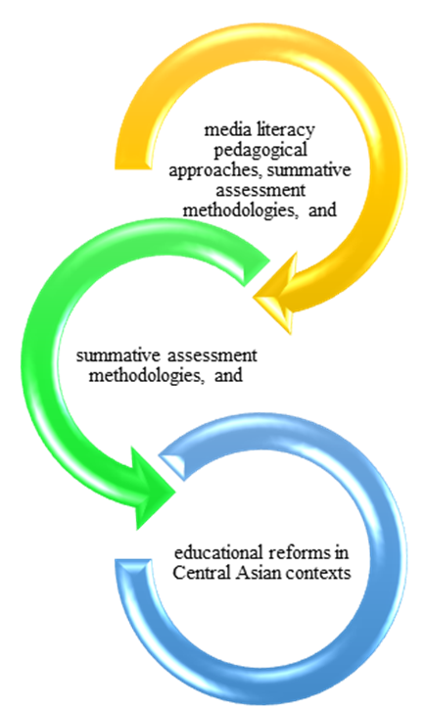
Fig.1. Three primary domains
(1) media literacy pedagogical approaches, (2) summative assessment methodologies, and (3) educational reforms in Central Asian contexts.
Search terms included combinations of "media literacy," "didactic methods," "summative assessment," "educational technology," "digital literacy," and "Central Asia education reforms." The review encompassed 240 relevant academic papers published between 2015 and 2024, with particular emphasis on recent developments in assessment methodology and pedagogical innovation.
Additional data sources included policy documents, institutional reports, and web-based resources documenting current educational reform initiatives in Uzbekistan and neighboring countries.
RESEARCH RESULTS
Effective Didactic Strategies for Media Literacy Development
The analysis reveals convergence around several pedagogical approaches that demonstrate consistent effectiveness in developing students' media literacy competencies:
Active Inquiry and Project Learning: Evidence consistently supports project-based, inquiry-driven approaches that increase the complexity of student questioning and critical analysis abilities. These methods prove effective across educational levels and provide authentic contexts for skill application.
Participatory and Inclusive Methods: Co-developed modules, peer presentations, and culturally responsive topics improve relevance for diverse learners while maintaining pedagogical effectiveness.
Skill Scaffolds and Task Sequencing: Multi-level task designs and explicit instruction on verification strategies, including lateral reading and fact-checking simulations, produce measurable gains in inquiry and analysis capabilities.
Blended Learning Integration: Technology-enhanced delivery methods, including AI-supported lessons and online collaboration platforms, demonstrate scalability potential while maintaining engagement and learning outcomes.
Implementation Framework for Uzbekistan Context
Based on the literature analysis and consideration of Uzbekistan's educational reform trajectory, this study proposes a structured implementation framework:
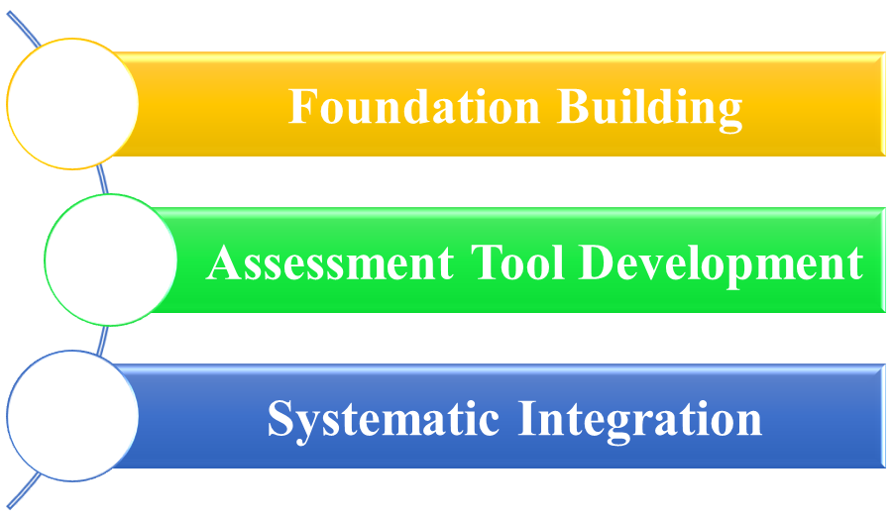
Fig.2. Implementation Framework for Uzbekistan Context

Phase 1: Foundation Building
- Develop teacher training programs focused on media literacy pedagogy and assessment design
- Create standardized rubrics aligned with national educational standards
- Establish pilot programs in select educational institutions
Phase 2: Assessment Tool Development
- Design task-based assessment instruments suitable for summative evaluation
- Implement digital platforms for assessment delivery and data collection
- Develop multi-level competency frameworks aligned with curriculum standards
Phase 3: Systematic Integration
- Integrate media literacy competencies into existing subject assessments
- Establish quality assurance (1mechanisms for consistent implementation
- Create feedback systems for continuous improvement
Pedagogical Recommendations
- Adopt Project-Based Approaches: Implement inquiry-driven, project-based learning modules that provide authentic contexts for media literacy skill development.
- Integrate Production and Analysis: Design learning experiences that combine media production tasks with critical analysis components.
- Utilize Technology Effectively: Leverage digital tools and platforms to enhance engagement while providing scalable practice opportunities.
- Emphasize Cultural Relevance: Develop content and examples that reflect local cultural contexts while maintaining universal media literacy principles.
Assessment Recommendations
- Develop Comprehensive Rubrics: Create detailed assessment rubrics that capture both process and product elements of media literacy competencies.
- Implement Portfolio Systems: Utilize portfolio-based assessment approaches that allow for authentic evaluation while maintaining summative validity.
- Establish Moderation Protocols: Develop inter-rater reliability procedures to ensure consistent assessment across different evaluators and contexts.
- Create Feedback Mechanisms: Implement systems for providing meaningful feedback to students while collecting data for program improvement.
CONCLUSIONS
This study demonstrates that significant opportunities exist for integrating media literacy development into summative assessment practices within Uzbekistan's educational system. The convergence of research evidence around effective pedagogical approaches, combined with emerging assessment methodologies, provides a foundation for systematic implementation.
The proposed framework offers a practical pathway for incorporating media literacy competencies into existing educational structures while addressing key challenges related to teacher preparation, assessment validity, and resource requirements. Success in this endeavor requires coordinated efforts across policy, pedagogical, and assessment domains.
The integration of media literacy into summative assessment represents both a pedagogical opportunity and a practical necessity in contemporary education. With appropriate planning, resource allocation, and stakeholder engagement, Uzbekistan can establish itself as a regional leader in innovative literacy education approaches.
REFERENCES
1. A. Akhmetova and G. Beysembaeva, Navigating media literacy challenges in higher education EFL courses: insights from student behaviors and pedagogical strategies, Bull. Shokan Ualikhanov Kokshetau Univ. Philol. Ser. 1, 214–228 (2024). https://doi.org/10.59102/kufil/2024/iss1pp214-228
2. O. Chekhratova, O. Kovalenko, V. Petrenko, T. Pohorielova, and T. Ved, Developing students’ autonomy and responsibility via promoting digital and media literacy in an English‑language classroom, Rev. Amazonia Investiga 11(52), 15–23 (2022). https://doi.org/10.34069/ai/2022.52.04.2
3. J. Share, T. Mamikonyan, and E. Lopez, Critical media literacy in teacher education: theory and practice, Oxford Res. Encycl. Educ. (2019). https://doi.org/10.1093/acrefore/9780190264093.013.1404
4. I. M. Chemerys, Building media literacy skills for future journalists: strategies to analyze fake news and resist disinformation, Pedagogical Almanac 55, 183–191 (2024). https://doi.org/10.37915/pa.vi55.516
5. J. Valverde‑Berrocoso, M. R. Fernández‑Sánchez, F. I. R. Dominguez, and M. J. Sosa‑Díaz, The educational integration of digital technologies pre‑COVID‑19: lessons for teacher education, PLoS ONE 16(8), e0256283 (2021). https://doi.org/10.1371/journal.pone.0256283

