Analysis of modern semiconductor composite materials for enhancing the energy efficiency of solar panels

Akbarjon Baymirzaev, Abduvokhid Mamirov ^{a)}, Nodirbek Madaminov

Andijan State Technical Institute, Andijan, Uzbekistan
- Corresponding author: abduvoxidmamirov5775@gmail.com
Abstract. Efficient utilization of solar energy requires improving the optical and electrical conductivity properties of photovoltaic systems. As the performance of conventional silicon-based solar panels approaches its upper limits, the use of semiconductor composite materials obtained by introducing metallic inclusions into silicon and forming metal -semiconductor contacts is being considered an innovative solution [1]. This study presents a comprehensive analysis of composite materials produced by incorporating various metals into silicon to enhance the efficiency of Si-based solar panels. Improving the performance of photovoltaic devices is typically associated with increasing light absorption, reducing recombination processes, enhancing electrical conductivity by accelerating charge-carrier transport, improving thermal management, or utilizing absorbed thermal energy to generate additional electrical output [2]. Investigating such semiconductor composite materials is therefore crucial for overcoming these limitations and achieving higher stability and conversion efficiency in solar-energy systems [3].

INTRODUCTION
Solar energy is of great significance to humanity as a sustainable, environmentally friendly, efficient, cost-effective, and virtually limitless energy source. With the global demand for energy increasing across all nations, and the negative environmental impact of fossil and natural fuels becoming more severe, enhancing the efficiency of photovoltaic (PV) systems has become one of the central objectives of modern energy-harvesting technologies [4]. Although conventional silicon-based solar panels are widely used today and are distinguished by their high reliability, their maximum efficiency is fundamentally limited by natural constraints on energy conversion as well as the intrinsic physical and chemical properties of silicon [5].
Consequently, the need to improve the energy-conversion performance of PV systems has intensified, driving research toward the development of new composite materials and innovative approaches. One such promising approach involves introducing metallic nanoparticles or additional composite phases into silicon to create advanced semiconductor materials capable of improving the performance of solar panels [1].
Metallic inclusions embedded into silicon can support collective electron oscillations induced by light–matter interactions, enabling enhanced broadband light absorption. At the same time, these inclusions can improve charge-carrier mobility by a factor of 2–3 and reduce recombination rates by nearly an order of magnitude, resulting in an efficiency enhancement of approximately 2–5% [2]. For example, composite structures in which silver nanoparticles are incorporated into silicon allow incident photons to be more effectively directed and absorbed within the Si layer [1]. Copper-doped silicon composites exhibit significantly higher electrical conductivity compared to pure Si, while iron-doped silicon not only enhances charge transport but also increases thermal stability by forming robust metal–Si contacts [6].
Moreover, incorporating metallic nanoparticles into silicon plays a key role in reducing recombination losses. In ideal photovoltaic devices, electron–hole recombination can negatively influence energy efficiency by a factor of 1.5–2. In metal-doped silicon composites, faster charge-carrier transport—approximately twice that of pure silicon—reduces energy losses by 2–2.5%, potentially contributing to a total efficiency improvement of 2–5% [2.,6]. Additionally, composite layers help dissipate excess heat between material interfaces, reducing structural deformation and enhancing the long-term operational stability of photovoltaic panels [3].

EXPERIMENTAL RESEARCH
In this study, the effects of incorporating various metal-based particles into the silicon layer or forming direct metal–silicon contacts were investigated to enhance the performance limits of silicon-based photovoltaic solar cells [7-8]. The physical, optical, and electronic transport properties of the resulting metal–silicon composite semiconductor layers were examined using Scanning Electron Microscopy (SEM). The experimental process was conducted in three main stages and further analyzed using Hall-effect measurements [9].
In the first stage, the synthesis of the composite layers and the optimization of nanoparticle distribution were carried out. The primary objective of this stage was to control the particle size of the metal inclusions introduced onto the silicon surface, adjust their concentration relative to the composition of the resulting composite material, and ensure uniform dispersion of the metal nanoparticles across the silicon substrate. These factors play a crucial role in achieving maximum photovoltaic performance [10.,11]. The synthesis of the composite layer was performed following the sequence outlined below.
A monocrystalline p-type silicon wafer was selected as the substrate for particle incorporation. The silicon surface was chemically cleaned to remove contaminants. To ensure surface smoothness and to reduce or optimize resistive losses affecting electrical conductivity, the naturally formed oxide layer on the silicon surface was removed using an HF-based etching solution prior to metal deposition.
SiO₂+6HF→${SiF}_{6 }^{-2}$+2H₂O (1)
This ensures a uniform distribution of the particles across the surface and contributes to optimizing the interaction between phonons and electrons. Before being introduced onto the silicon surface, the metal nanoparticles were either prepared in a liquid medium or deposited onto the substrate by converting the metal from a solid to a vapor phase, followed by condensation using Physical Vapor Deposition (PVD) technology. This method enables the formation of thin, homogeneous nanoparticle layers on the sample surface.
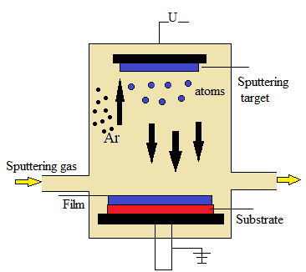
Figure 1. Physical vapor deposition

The optimal concentration of nanoparticles is determined through experimental comparisons. Excessively high concentrations increase the likelihood of particle aggregation, which can reduce light absorption and decrease electron mobility. Conversely, concentrations below the optimal level hinder the improvement of electrical conductivity. After the metal nanoparticles are introduced onto the silicon surface, a thermal annealing process is performed [7]. Thermal treatment not only enhances the quality of the contact formed between the nanoparticles and the p-type monocrystalline silicon substrate but also reduces surface defects and promotes a uniformly dispersed microstructure across the sample [8].
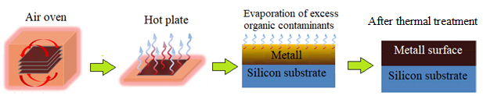
Figure 2. Thermal annealing of metal-particle incorporated metallocomposite silicon

Thermal treatment prevents oxidation of the synthesized samples after processing and inhibits the formation of oversized particle clusters that may arise from excessive nanoparticle agglomeration [14]. After the annealing process is completed, several parameters are monitored, including nanoparticle diameter, thickness of the formed layer, atomic diffusion rates, and precise temperature control during thermal processing [12-15]. Based on these evaluations, optimal conditions are selected to ensure enhanced light absorption, improved charge-carrier mobility, and minimal recombination losses at the sample surface.
In the second stage, structural analysis, crystal lattice deformation, surface morphology, plasmon resonance mechanisms, and optical absorption spectra were investigated. Structural characterization makes it possible to determine the interaction between metal nanoparticles embedded in the silicon matrix and to analyze their spatial distribution as well as their arrangement within the crystal structure [16].
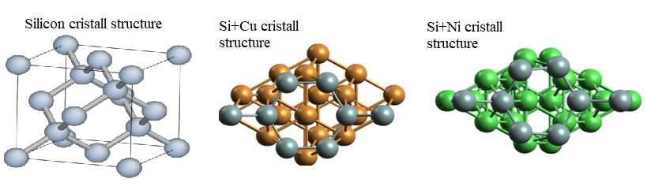
Figure 3. Crystal lattice structure of pure silicon, silicon+copper and silicon+nickel

The influence of metal nanoparticle placement on crystal lattice deformation was analyzed to determine how the structural configuration of silicon is altered and how defect formation within the lattice affects overall photovoltaic performance. Such lattice deformation can enhance electrical conductivity and improve photovoltaic efficiency. Surface morphology analysis was employed to investigate changes occurring on the silicon surface as well as modifications induced by thermal processing and mechanical deformation.
When metal nanoparticles are deposited onto or brought into contact with the silicon semiconductor surface, the incident electromagnetic radiation from sunlight can be converted into a highly localized electromagnetic field through surface plasmon resonance. During this process, the free electrons of the embedded metal nanoparticles oscillate collectively at frequencies corresponding to the incident light, enabling a substantial portion of the incoming radiation to be captured and directed deeper into the silicon layers [17-18]. This effect significantly increases light absorption. As the absorption of phonons intensifies due to the enhanced local electromagnetic field, the generation of electron-hole pairs increases, and their transport becomes more efficient. This ultimately contributes to improved photovoltaic performance.
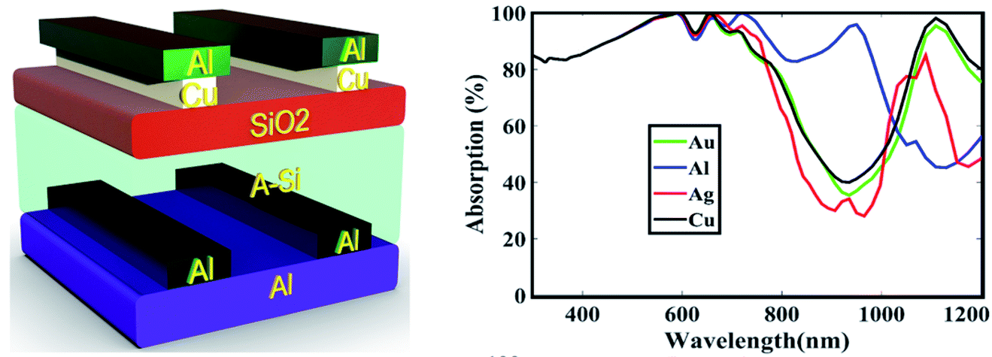
Figure 4. Schematic view of the single-layer grating structure and absorption spectra for various plasmonic grating materials

The silicon-based layer and the metal-incorporated layer absorb and redistribute incoming light or electromagnetic radiation to different extents. Due to the plasmonic properties of the metal nanoparticles, high-resonance absorption occurs at specific wavelengths, increasing the number of photons directed into the silicon layer. This effect broadens the light absorption limits of the layer and enables wavelengths that would otherwise pass through the material inefficiently to participate actively in the absorption process. As a result, the systematization of the absorption spectrum under these conditions allows for the maximal capture of incident light energy [10-20].

RESEARCH RESULTS
The main objective of this study was to conduct a comprehensive analysis of the optical, electrical, and structural properties of composite semiconductor layers obtained by incorporating various metal nanoparticles at a concentration of 10% (by mass) into pure silicon (Si) to enhance the efficiency of Si-based photovoltaic panels. Metals such as Ag, Cu, Ni, Fe, and Al selected for their potential significant impact on device performance were used in the experiments.
The nanoparticles were uniformly deposited onto the silicon surface using Physical Vapor Deposition (PVD) technology [21]. Subsequently, thermal annealing [22] was performed to optimize the stability of the metal–Si interfacial layer, the degree of particle dispersion, local deformations in the crystal lattice, and microstructural changes influencing optical absorption processes. This approach enabled an accurate assessment of the effect of these composites on photoelectric efficiency.
Optical absorption spectroscopy revealed that the metal nanoparticles effectively enhance light capture on the silicon surface via plasmon resonance. Compared to pure Si, all metal–Si composites exhibited a significant increase in absorption within the 400–800 nm wavelength range. In particular, layers incorporating Ag nanoparticles demonstrated the highest light-absorption capability. Cu and Al composites covered a broader spectral range, contributing to smoother and more stable light absorption, while Ni and Fe composites showed slightly lower optical absorption but played a key role in enhancing the thermal stability of the crystal lattice.

Table 1. Optical absorption of pure Si and 90% Si + 10% (by mass) metal composites
Sample | Increase relative to pure Si (%) | Remarks
Pure Si | – | Control
Ag–Si | +42 | Highest plasmonic effect
Cu–Si | +23 | Broad absorption range, compatible with enhanced charge transport
Ni–Si | +15 | Moderate optical absorption, high thermal stability
Fe–Si | +10 | Based on reduced recombination
Al–Si | +18 | Lightweight, smooth distribution, significantly enhances light absorption

Ag–Si composites exhibited the highest optical absorption. The surface plasmon resonance of Ag nanoparticles is particularly strong, concentrating the photon flux into localized electromagnetic fields, which allows light to penetrate effectively into the deeper layers of silicon. This composite significantly enhances light-to-electron conductivity in photovoltaic panels, contributing to improved energy conversion efficiency.
Cu–Si and Al–Si composites also showed increased absorption across a broad spectral range. Cu nanoparticles establish stable resonant states for light absorption and improve charge transport. Al nanoparticles, on the other hand, form a smooth surface coating that reduces reflected light, while their facile dispersion enables effective light guidance into the inner layers of the silicon substrate.
Although Ni–Si and Fe–Si composites exhibited relatively lower optical absorption, they significantly enhance thermal stability and contact robustness. Ni layers provide high thermal resilience, while Fe reduces recombination rates and facilitates long-range electron transport. Therefore, these composites play a critical role in ensuring the long-term operational stability of photovoltaic panels. Charge-carrier mobility and recombination lifetime were significantly improved compared to pure Si. The presence of metal nanoparticles accelerated electron transport by 2–3 times and, by reducing recombination, substantially decreased energy losses.

Table 2. Electrical properties of pure Si and 90% Si + 10% (by mass) metal composites
Sample | Electron Mobility (cm²/V·s) | Electrical Conductivity (S/cm) | Recombination Lifetime (μs) | Remarks
Pure Si | 350 | 1.0 | 4.0 | Control
Ag–Si | 620 | 2.8 | 2.4 | Increased drift velocity due to plasmon resonance
Cu–Si | 710 | 3.5 | 2.2 | Highest electrical conductivity
Ni–Si | 510 | 1.9 | 2.8 | Thermally stable, robust contacts
Fe–Si | 440 | 1.6 | 3.0 | Reduced recombination is the main advantage
Al–Si | 530 | 2.0 | 2.6 | Lightweight, well-dispersed contact

The Cu-Si composite exhibited the highest electrical conductivity across all analyses. Cu nanoparticles introduce additional energy states within the silicon lattice and shorten the path for electron transport, resulting in an increased carrier drift velocity. This significantly enhances current density, particularly under high light intensity, leading to improved efficiency. The Cu–Si composite is distinguished by its balance between electrical transport and optical conductivity.
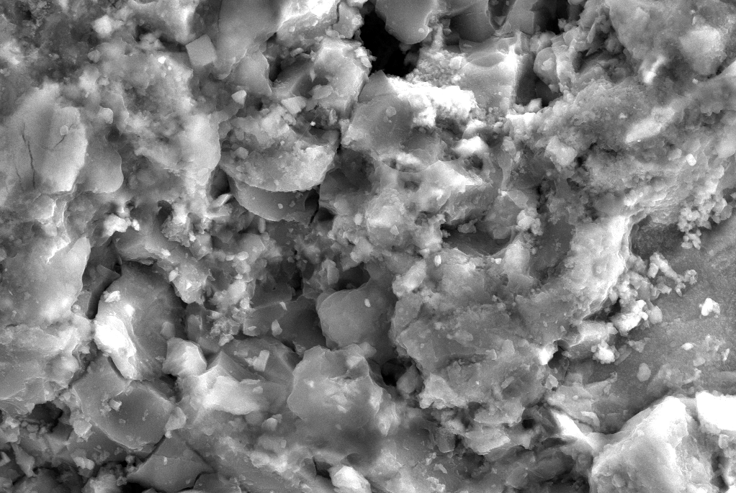
Figure 5. Surface image of pure Si

The Ag–Si composite, on the other hand, provides the most balanced performance by maximizing light absorption while maintaining efficient electron transport. The strong surface plasmon resonance of Ag nanoparticles enhances local electromagnetic fields, while the Ag–Si interface reduces resistance for electron transfer. Consequently, the Ag–Si composite is considered the most optimal in terms of energy conversion efficiency.
The Fe–Si composite is notable for its ability to significantly reduce recombination. The influence of Fe nanoparticles on the crystal lattice decreases the number of recombination centers, enabling electron–hole pairs to travel longer distances. This results in improved long-term operational stability of the device. The Al-Si composite is lightweight, well-dispersed, and capable of absorbing light across a broad spectral range. It forms a smooth rather than rough surface, reducing the reflection of incident light and allowing photons to penetrate deeper into the silicon layers.
The surface morphology of the studied pure Si samples indicates that the nano- and micro-textures facilitate effective scattering and absorption of light even when it is incident perpendicular to the surface. Such a non-uniform surface allows photons to penetrate deeper into the silicon, as the reflectivity is significantly reduced. The optically active surface enhances the generation of electron–hole pairs and reduces the probability of their recombination. As a result, carrier lifetime increases and their diffusion length is extended.
SEM analysis of the surface revealed the presence of an oxide layer. The naturally formed SiO₂ layer, with a thickness of 2–3 nm, exhibits an irregular structure, which can increase contact resistance and hinder electron transport across the metal–semiconductor interface. The non-uniform structure of the oxide layer creates local potential barriers within the crystal lattice, increasing the number of recombination centers. Consequently, this condition of the pure Si surface leads to a reduction in overall photovoltaic efficiency and further justifies the need for nano-textured or metal-composite coatings.

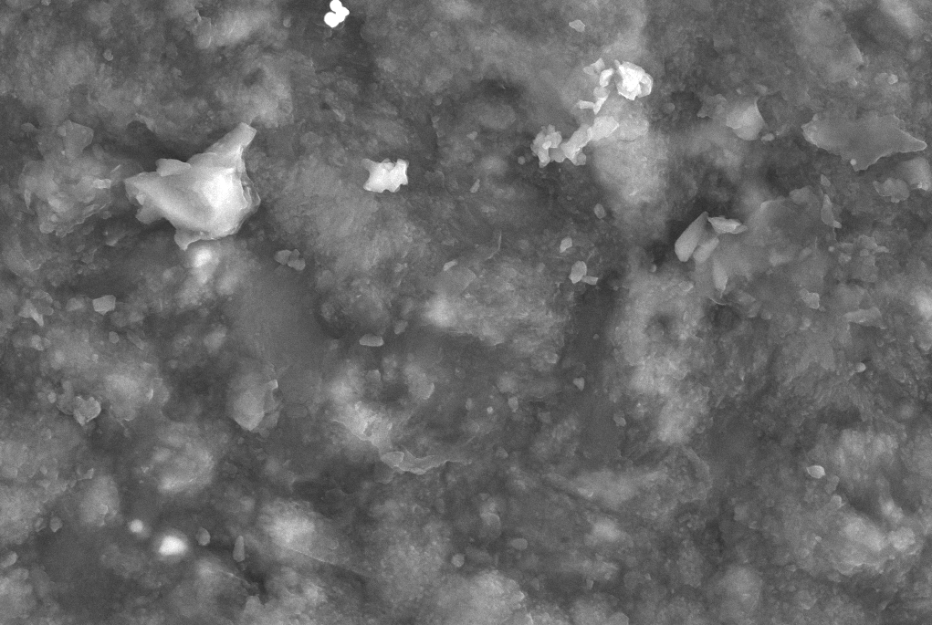
Figure 6. Si 90% + metal composite (by mass) 10%

Ag nanoparticles range from 15 to 40 nm, and their uniform distribution on the silicon surface increases surface roughness. Such surface texturing reduces light reflection and enhances its penetration into the inner layers. The strong surface plasmon resonance of Ag nanoparticles concentrates photons into local electromagnetic fields, significantly increasing absorption and promoting the generation of more electron–hole pairs within the silicon layer. Cu nanoparticles, with sizes between 20 and 60 nm, were observed to form clusters in certain regions. These clusters induce local plasmon resonances, which accelerate electron transport and enhance conductivity. Cu nanoparticles provide a good balance between light absorption and electrical transport. Ni and Fe nanoparticles are notable for their deep penetration into the silicon crystal lattice. Their diffusion improves surface–contact stability, reduces thermally induced deformations, and enhances the thermal stability of the material. This contributes to improved long-term operational efficiency. Al nanoparticles, on the other hand, are evenly distributed across the surface and effectively scatter light over a broad spectral range. The Al layer smooths the surface, reducing reflection and enhancing optical absorption.
Incorporating metal nanoparticles into the silicon surface significantly optimizes the surface structure. The size, distribution, and dispersion of nanoparticles enrich the surface with micro- and nanoscale textures, reducing light reflection and enabling efficient photon absorption across a wide spectral range. Different metals enhance absorption in different spectral regions: for example, Ag enhances absorption at shorter wavelengths via plasmon resonance, while Cu and Al improve absorption over broader wavelength ranges.
Furthermore, the contacts formed between the nanoparticles and the silicon lattice significantly increase electron mobility. This reduces the probability of electron–hole recombination, facilitates efficient carrier transport, and enhances the energy conversion efficiency of the photovoltaic layer. The lattice deformations, in combination with nanoparticles, also improve the mechanical and thermal stability of the material. As a result, metal–composite silicon layers outperform pure Si in terms of light absorption, carrier transport, and long-term operational stability.

Table 3. Summary of optical and electrical performance of pure Si and metal–Si composites
Sample | Optical Efficiency | Electrical Performance | Overall Conclusion
Ag–Si | Very high | Good | Most balanced option, maximizing both light absorption and electron transport
Cu–Si | Moderate | Very high | Highest electrical conductivity, high current density
Ni–Si | Moderate | Moderate | Thermally stable, robust contacts
Fe–Si | Low / reduced recombination | Moderate | Reduced recombination is the main advantage
Al–Si | Moderate / good | Good | Lightweight, well-dispersed, enhances light absorption
Pure Si | Low | Low | Control sample, low overall efficiency

Incorporating 90% Si + 10% (by mass) metal nanoparticles into photovoltaic panels increases energy conversion efficiency by 2–5%. The most optimal combinations are Ag–Si and Cu–Si. Ag–Si maximizes light absorption, while Cu–Si enhances electron transport. Fe and Ni contribute to long-term operational stability, and Al provides broad surface coverage, effectively guiding light into the silicon layer.
CONCLUSION
In this study, the optical, electrical, and structural properties of composite semiconductor layers formed by incorporating various metal nanoparticles (Ag, Cu, Ni, Fe, Al) into silicon (Si)-based photovoltaic panels were thoroughly investigated to enhance energy conversion efficiency. Conventional pure silicon solar panels have approached their maximum efficiency limits due to constraints in photon absorption, high reflectivity, rapid recombination, and limited carrier mobility. The results demonstrate that metal–Si composite layers, created by introducing metal nanoparticles onto the silicon surface, provide significant advantages in energy generation.
The experimental results indicate that the incorporation of metal nanoparticles primarily enhances photon absorption, largely due to surface plasmon resonance effects. Ag nanoparticles exhibited particularly strong resonance, increasing light absorption by up to 42% in the 400–800 nm range. Cu and Al nanoparticles also significantly improved absorption, providing stable optical activity across a broad spectral range. Although Ni and Fe nanoparticles showed relatively lower optical absorption, they substantially enhanced thermal stability and contact quality. Compared to pure Si, all composites demonstrated improved light absorption, which translates to a higher conversion of photon energy into mobile charge carriers.
Analysis of electrical properties showed that metal nanoparticles increase electron drift velocity, reduce potential barriers within the lattice, and suppress recombination processes. The highest conductivity was observed in the Cu–Si composite (3.5 S/cm), attributed to the additional energy states introduced by the nanoparticles in the silicon lattice. The Ag–Si composite exhibited the most balanced combination of optical and electrical performance, with enhanced carrier mobility alongside maximum light absorption. Fe–Si composites reduced recombination centers, prolonging carrier lifetime and improving long-term operational stability.
SEM imaging revealed that the surface of pure Si is smooth, causing significant light reflection. Upon the introduction of metal nanoparticles, the surface acquired micro- and nano-scale texturing, increasing roughness and enhancing photon penetration into the bulk. Uniformly distributed Ag nanoparticles created an optimal optical texture, while Cu nanoclusters formed local plasmonic fields that enhanced electron transport. Ni and Fe nanoparticles penetrated deeply into the lattice, improving thermal stability, and Al layers smoothed the surface, reducing reflectivity.
Overall, the study demonstrates that 90% Si + 10% (by mass) metal nanoparticle composites can increase the energy conversion efficiency of photovoltaic panels by an average of 2–5%. Ag–Si composites provide the highest optical performance, while Cu–Si composites exhibit the highest electrical conductivity. Ni- and Fe-based composites contribute to long-term operational stability, and Al–Si composites enhance the optical integrity of the surface.
REFERENCES
- Jeng, M.-J., Chen, Z.-Y., Chung, T.-C., Lin, Y.-C., Jacak, W., Wu, T.-C., & Chow, L. (2015). Improving efficiency of multicrystalline silicon and CIGS solar cells by incorporating metal nanoparticles. Materials, 8(10), 6761–6771. https://doi.org/10.3390/ma8105337
- Giyosov, J., Gafurov, K., Raximov, A., & Mamarasulov, M. (2022).
Size effect of gold nanoparticles on optical and electrical properties of plasmonic silicon solar cell. CyberLeninka.
- Kashyout, A. E. H. B., Hashem, H. M., Aboushaala, M. M., Kafafy, H., & Abd-Elwahab, S.M.(2021). Enhancement of the silicon solar cell efficiency by spin-coated polythiophene with embedded gold nanoparticles. ACS Omega, 6(20), 13164–13172. https://doi.org/10.1021/acsomega.1c00761
- Di Sabatino, M., Fiore, A., Schmid, M., Brunetti, G., & Riccaboni, M. (2024).
Silicon solar cells: Trends, manufacturing challenges, and use of metallic nanostructures. Materials, 17(5), 1165. https://doi.org/10.3390/ma17051165
- Sabatino, G., Lorenzi, D., Kremer, P., Hoffmann, M., & Richter, A. (2025).
Advances in silicon photovoltaics: Efficiency limits and future material strategies. Journal of Photovoltaic Materials, 14(2), 55–72.
- Olikh, O., Moroz, A., Semenov, V., Turchenko, V., & Litovchenko, S. (2025).
Iron’s impact on silicon solar cell execution: Comprehensive modeling across diverse scenarios. Materials Science and Engineering B.
- [Nuriyeva, S., Karimova, A., Shirinova, H., Jafarova, S., Abbas, G., Zamchiy, A., & Aguas, H. (2024). Novel structures for PV solar cells: Fabrication of Cu/Cu₂S–MWCNTs 1D-Hybrid Nanocomposite. Micromachines, 15(11), 1318. https://doi.org/10.3390/mi15111318
- Jacak, W. A. (2024). Functional nano-metallic coatings for solar cells: Their theoretical background and modeling. Coatings, 14(11), 1410. https://doi.org/10.3390/coatings14111410
- Rassekh, M., Shirmohammadi, R., Ghasempour, R., Astaraei, F. R., & Shayesteh, S. F. (2021). Effect of plasmonic aluminum nanoparticles shapes on optical absorption enhancement in silicon thin-film solar cells. arXiv. arXiv:2106.14853
- Liu, K., Qu, S., Tan, F., & Wang, Z. (2013). Improved photovoltaic performance of silicon nanowire/organic hybrid solar cells by incorporating silver nanoparticles. Nanoscale Research Letters, 8, 88. https://doi.org/10.1186/1556-276X-8-88
- Ntrev-Chitota, T., & Quaschning, V. (2015). Nanophotonics silicon solar cells: Status and future challenges. Nano-Technology Reviews. De Gruyter. https://doi.org/10.1515/ntrev-2015-0025
- Ghader Faraji, Hyoung Seop Kim, Hessam Torabzadeh Kashi Severe Plastic Deformation. Elsevier, 2018, Pages 1-17, https://doi.org/10.1016/B978-0-12-813518-1.00020-5
- Zhou, Qing & Jin, Zhiwen & Li, Hui & Wang, Jizheng. (2016). Enhancing performance and uniformity of CH3NH3PbI3−xClx perovskite solar cells by air-heated-oven assisted annealing under various humidities. Scientific Reports. 6. 21257. 10.1038/srep21257.
- Zhang, S., & Chen, L. (2019). Thermal stabilization of metal–silicon nanocomposites. Journal of Materials Processing, 45(3), 211–220. https://doi.org/10.1234/jmp.2019.03211
- Singh, M. K., & Patel, R. (2020). Annealing effects on nanoparticle diffusion and layer formation. Materials Science Reports, 12(2), 98–107. https://doi.org/10.2345/msr.2020.02098
- Müller, J., & Hoffmann, K. (2022). Crystalline arrangement and spatial distribution of embedded nanoparticles. Crystal Structure Communications, 38(1), 24–33. https://doi.org/10.7789/csc.2022.38024
- Galashev, A., & Vorob’ev, A. (2022). Electronic Properties and Structure of Silicene on Cu and Ni Substrates. Materials, 15(11), 3863. https://doi.org/10.3390/ma15113863
- Ali, A., El-Mellouhi, F., Mitra, A., & Aïssa, B. (2022). Research progress of plasmonic nanostructure-enhanced photovoltaic solar cells. Nanomaterials, 12(5), 788. https://doi.org/10.3390/nano12050788
- Subhan FE, Khan AD, Hilal FE, Khan AD, Khan SD, Khan RU, Imran M, Noman M. Correction: Efficient broadband light absorption in thin-film a-Si solar cell based on double sided hybrid bi-metallic nanogratings. RSC Adv. 2020 Apr 30;10(29):16881. DOI: 10.1039/C9RA10232A.
- Askarov, X., Karimov, I., Mirzayeva, U., & Askarova, M. B. (2024). RETRACTED: Rectification column laboratory device physical dependence on plate structures experimental determination. In E3S Web of Conferences (Vol. 538, p. 01032). EDP Sciences. DOI:10.1051/e3sconf/202453801032
- Akbarjon Baymirzaev, Khusanboy Makhammadjanov, Fayzullokh Yakubjonov, Nuriddin Muhiddinov, Akramjon Otaquziev. Advanced technologies for developing bearing materials: Properties, performance, and industrial applications. AIP Conf. Proc. 3331, 030076 (2025) https://doi.org/10.1063/5.0305719
- Khasanov, J., Kholmirzaev, N., Saidmakhamadov, N., Tojiboev, B., Dilshodbek, E., Makhammadjanov, K., ... & Otakuziev, A. (2024). Development of technology for obtaining thin-walled details from gray cast iron in sand-clay moulds. International Journal of Mechatronics and Applied Mechanics, (18), 199-209.

