Reliability and Safety Issues of the Railway Traction Substation
Sulton Amirov^{1, a)}, Salixdjan Khalikov², Sarvar Khalikov¹
¹ Tashkent State Transport University, Tashkent, Uzbekistan.
²Tashkent State Technical University named after Islam Karimov, Tashkent, Uzbekistan.
^{a)} Corresponding author: sulton.amirov@bk.ru

Abstract. The traction substations of the railway transport currently operating in the Republic of Uzbekistan have reached the stage of wear-related failures due to their age. This period of operation is characterized by an increase in the frequency of failures and accidents, a rise in the volume of repair work, as well as reconstruction and modernization of buildings, structures, and equipment, which in turn leads to higher costs and energy consumption per unit of transmitted electric power. Therefore, at present, proper and safe management of railway traction substations in the Republic of Uzbekistan has become an important issue caused by their long service life. The purpose of this article is to determine and assess the reliability and safety of railway traction substations. The article presents the results of a study on the determination of reliability and safety using the example of the “Chuqursay” railway traction substation. Based on the type of statistical probability density function of the failure-free operation time, it was found that the exponential distribution most closely corresponds to the determination of the failure-free operation time of the railway traction substation. The equations for quantitative reliability characteristics were derived. A structural scheme for assessing the reliability of the “Chuqursay” railway traction substation was developed, and formulas for calculating the probability of failure-free operation, risk, and safety of the railway traction substation were obtained.
INTRODUCTION
The traction substations (TSS) of the railway transport currently operating in the country have reached the stage of wear-related failures due to their age. This period of operation is characterized by an increase in the frequency of failures and accidents, a rise in the volume of repair work, as well as reconstruction and modernization of buildings, structures, and equipment, which in turn leads to higher costs and energy consumption per unit of transmitted electric power. Therefore, at present, proper and safe management of traction substations (TSS) in the Republic of Uzbekistan has become an important issue caused by their long service life [1,2].
The assessment of risk and safe condition of TSS should be carried out systematically, starting from the design stage, continuing through construction, and further during operation. For diagnosing the condition of electrical equipment, determining risks, and managing the safety of TSS in real time, it is necessary to develop methodologies for evaluating reliability and safety. Based on five years (2018–2022) of operational data from the Chuqursay TSS, the types of failures, their quantities, and their intensities (λ) were determined. Thus, an experimental graph of the probability density distribution of the failure-free operation time of the Chuqursay TSS was obtained. According to the type of statistical probability density distribution of the failure-free operation time, it was found that the exponential distribution most closely corresponds to the determination of the failure-free operation time of the TSS [3,4].
The equations for the quantitative characteristics of reliability have the following form:
${ P}_{TSS}\left(t\right)=e^{-⋏t}$; $Q_{TSS}\left(t\right)=1-e^{-⋏t}$; $a\left(t\right)=⋏e^{-⋏t} \}$ (1)

where, ${ P}_{TSS}\left(t\right)$ – probability of failure-free operation of the traction substation (TSS); $Q_{TSS}\left(t\right)$– probability of failures of electrical equipment; a(t) – probability of failures of electrical equipment; λ(t) – failure intensity. The traction substation (TSS) can be represented as a “system”. To calculate the reliability of this system, it is necessary to use information about its functional diagram and reliability indicators of the elements included in these diagrams. A functional diagram for assessing the reliability of the TSS has been developed, which is shown in Figure 1.
Based on these, a functional reliability evaluation diagram of the “Chuqursay” traction substation was developed (shown in Figure 1).
EXPERIMENTAL RESEARCH
The functional reliability assessment diagram of the “Chuqursay” traction substation (TSS) is shown in Figure 1. The diagram includes the main electrical components and their logical interconnections within the system.
where the probability of failure-free operation of the substation elements is as follows:
1.P_{PTL1}(t), 14. P_{PTL2}(t) – power transmission lines;
2.P_{LD1}(t), 15. P_{LD2}(t) – line disconnectors;
3.P_{WCB1}(t), 16. P_{WCB2}(t) – withdrawable circuit breakers;
4.P_{BID1}(t), 17. P_{BID2}(t) – busbar input disconnectors;
5.P_{BS1}(t), 18. P_{BS2}(t) – busbar sections;
6.P_{TBD1}(t), 19P_{TBD2}(t) – transformer bus disconnectors;
7.P_{TGD1}(t), 20. P_{TGD2}(t) – transformer grounding disconnectors;
8.P_{F1}(t), 21.P_{F2}(t) – fuses;
9.P_{OT1}(t), 22.P_{OT2}(t) – oil transformers;
10.P_{A1}(t), 23.P_{A2}(t) – automatic circuit breakers;
11.P_{SD1}(t), 13.P_{SD2}(t) – sectional disconnectors;
12.P_{S} (t) – switchgear;

Based on the calculations performed using formula (1), graphs of the dependencies P(t), Q(t), and a(t) for the “Chuqursay” traction substation (TSS) were constructed [4,5].
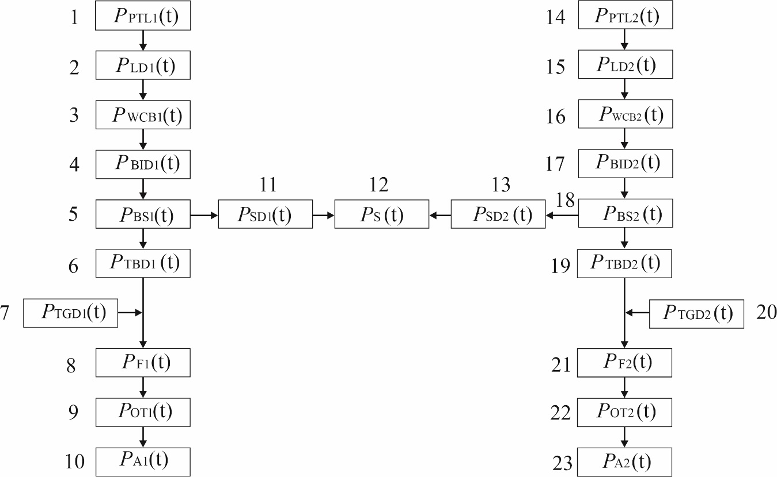
FIGURE 1. Structural diagram for assessing the reliability of the “Chuqursay” traction substation (TSS).

The probability of failure-free operation of the traction substation, based on the structural diagram (Figure 1), is expressed as follows:
P_{TSS}(t)= [1$-$ P_{PTL}1(t) $∙$ P_{DL}1 (t) $∙$ P_{WCB}1(t) $∙$ P_{BID}1(t) $∙$ P_{BS}1(t)] $∙$ [1- P_{PTL} 2 (t) $∙$ P_{DL} 2 (t) $∙$ P_{WCB} 2 (t) $∙$ P_{BID} 2 (t) $∙$ P_{BS} 2 (t)] $∙$ P_{SD}1 (t) $∙$ P_{DD} (t) $∙$ P_{SD}2 (t) $∙${1- P_{BD}1(t)$∙$ [1$-$ P_{TGD}1(t),] $∙$ P_{F}1(t) $∙$ P_{OT}1(t)$∙$ P_{A}1(t)}$∙$ {1$-$P_{BD}2(t)$∙$[1$-$ P_{TGD} 2 (t),] $∙$ P_{F} 2 (t) $∙$ P_{OT} 2 (t)$∙$ P_{A} 2 (t)} | (2)

Based on calculations made according to formula (1), graphs of graphs of dependencies P(t), Q(t) and a(t) for the TSS "Chuqursay" are constructed [4,5].
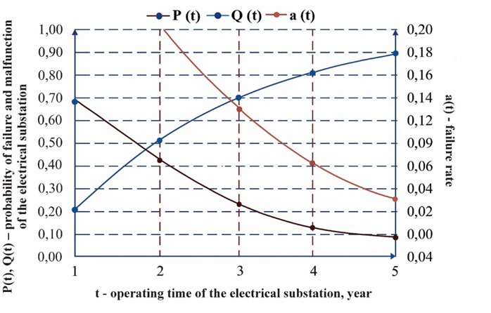
FIGURE 2. Graphs of P(t), Q(t), and a(t) values over 5 years of operation for the “Chuqursay” TSS.

Due to the necessity of addressing safety issues, a method for assessing the risk of the traction substation (TSS) has been developed. Quantitative risk assessment involves determining the numerical values of the probability and consequences of undesirable processes, phenomena, or events [6,7].
Taking this into account, the total risk of the pumping unit is calculated using the following formula:

Z (R_{TSS}) = X (R_{TSS}) + Y (R_{TSS}) (2)
X (R_{TSS}) – the direct loss caused by the risk R_{TSS}, i.e., depreciation or amortization costs
Y (R_{TSS}) – reduced costs associated with maintaining the safety of the TSS, characterized by average annual costs for its repair and determined by operational data, i.e. by the values of the costs incurred for the repair of the TSS for the considered period of operation of the pumping units of the pumping station [8,9].
The formulas above make it possible to evaluate the reliability and safety of the traction substation (TSS).
At the initial stage, the risk of the traction substation R_{TSS} [monetary units / year] is calculated. The risk can be expressed in monetary form (conditional units) or using a point-based system. In this study, the risk is expressed in monetary conditional units as follows:
$R_{TSS}= \sum_{i=1}^{n}{\left\{\left[Q_{TSSi}+C ∙ {ΔQ}_{TSSi}∙ T_{i} \right]∙ P_{TSS}+Q_{TSS}^{ed}\right\}\frac{1}{T_{year}} }\left[monetary units / year\right]$ (3)

where: Р_{TSSi} = f (ENF, Р); Р_{TSSi} – probability of occurrence of the i-th event at the traction substation (TSS);
Р- probability of the initial (primary) event; ENF – expected number of failures; Q_{TSSi} – damage caused to substation elements during the i-th event [m.u.]; ΔQ_{TSSi} – power losses of the TSS due to downtime during the i-th event [kW];
Тi – downtime of the TSS during the i-th event [h];
C – cost of 1 kWh of electrical energy [m.u./kWh];
$Q_{TSSi}^{ed}$ external damage caused to consumers due to under-supply of electrical energy during the i-th event at the TSS [m.u.];
Т_{year} - inter-repair operating period of the TSS per year [year].

RESEARCH RESULTS
Table 1. The obtained risk values are divided into four safety categories in terms of conventional monetary units, and the magnitude of economic damage is adopted according to.
Safety Category | Economic and Social Consequences
I | Economic damage may be very significant. R_{TSS}≥ 100 million m.u./year
II | Economic losses may be significant. R_{TSS} ≥ 1 million monetary units / year
III | Possible losses are minor. R_{TSS}≥ 100 thousand monetary units /year
IV | Minimal losses, future consequences are practically absent. R_{TSS} ≤ 100 thousand monetary units /year
The obtained risk values are divided into four safety categories in terms of conventional monetary units, and the magnitude of economic damage is adopted according to Table 1. For the calculation of the total risk, its components, and the determination of the optimal risk value using the example of the “Chuqursay” TSS, Table 2 was compiled. Changes in the indicators were plotted, and the corresponding graphs and R values were presented.

Table 2. Results of calculating the total risk and its components for the “Chuqursay” TSS
The risk of TSS"Chuqursay"
t, years | 1 | 2 | 3 | 4 | 5 | 5,3 | 6 | 7 | 8 | 9 | 10
X = f (R_{TSS}) | 8 | 6 | 5 | 3,9 | 3,1 | 2,8 | 2,5 | 2 | 1,8 | 1,4 | 1,5
Y = f (R_{TSS}) | 1,4 | 1,6 | 2 | 2,1 | 2,7 | 2,8 | 3,2 | 4,3 | 5,2 | 7 | 9,2
Z = f (R_{TSS}) | 9,4 | 7,6 | 7 | 6 | 5,8 | 5,6 | 5,7 | 6,3 | 7 | 7,9 | 10,7

FIGURE 3 shows the values of the polynomials Z = f (R_{TSS}), Y = f (R_{TSS}), and X = f (R_{TSS}); their graphs were plotted, and the corresponding Rₜₚₛ values are presented [10].
Here, the intersection of the graphs Y = f (R_{TSS}) and X = f (R_{TSS}) determines the optimal risk value of the TSS, which is Rₒₚₜ._{TSS} = 2.8 × 10⁷ sum [11]. The adequacy check of the TSS risk determination model showed that the discrepancy between the simulation results and the actual data for TSS risk according to Fisher’s criteria was less than 3.5%, indicating that the obtained results are sufficiently accurate. Analysis of the graphs of polynomial risk changes for the TSS over 10 years of operation shows that the downtime due to the impact of initial events for the “Chuqursay” TSS is Tᵢ = 5000 hours, while the annual operating time of the TSS is T_{year} = 8760 hours. The value of risk X = f (R_{TSS}) decreases by 82%, while the cost-related risk Y = f (R_{TSS}) (expenses for maintenance and repair) increases by 75.1% [12].

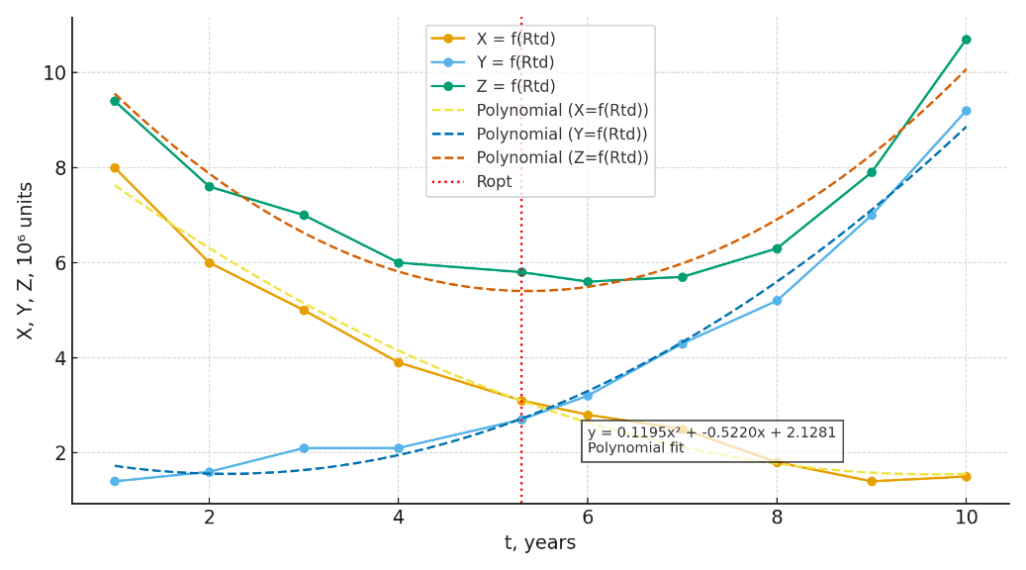
FIGURE 3. Graphs of the polynomials Z = f (Rₜₚₛ), Y = f (R_{TSS}), X = f (R_{TSS}) and the values of Rₒₚₜ.
CONCLUSIONS
1. The components of the “Chuqursay” traction substation (TSS) were studied, and its operational performance was analyzed.
2. The distribution of failure-free operation time of the power supply substation was determined to correspond to the exponential law, based on operational data of the substation, taking into account the statistical probability density distribution of the failure-free operation time of its elements.;
3. Structural diagrams for the layout and reliability of the “Chuqursay” TSS were developed, and based on them, formulas for determining the probability of failure-free operation of the substation and its elements were derived.
4. Mathematical expressions for calculating the risk of the power supply substation and its elements were identified, taking into account reliability indicators, damage to electrical equipment, energy losses due to downtime of substation elements affecting consumers, and average annual repair costs [1–12].
REFERENCES
1. F. Amirov, S. Khalikov, S. Khalikov. “Research and evaluation of reliability indicators,” Journal, pp. 37–42, (in Russian).
2. Amirov S.F., Khalikov S.S., Khalikov S.S. Reliability Issues of the Power Supply Substation. Problems of Energy and Resource Saving, 2023, No. 3, pp. 123–130, (in Russian).
3. Khalikov S.S., Khalikov S.S. Issues of Determining Reliability and Assessing Safety of a 10 kV Electrical Substation. Problems of Energy and Resource Saving, TSTU, 2021, No. 3, pp. 94–102, (in Russian).
4. Toirov O.Z., Amirov S.F., Khalikov S.S. Diagnostics of the Condition of Elements of an Electric Power Supply Substation. Scientific and Technical Journal of Namangan Institute of Engineering and Technology, 2025, Vol. 10, Issue 2, pp. 272–280.
5. Khalikov S.S., Khalikov S.S. Application of a Neural Network for Probabilistic Safety Analysis During Substation Operation. Problems of Energy and Resource Saving, TSTU, 2021, No. 4, pp. 194–199, (in Russian).
6. Amirov S.F., Turdybekov K.Kh., Khalikov S.S., Khalikov S.S. Reliability Issues of the Power Supply Substation. Proceedings of the International Scientific and Technical Conference “Innovative Solutions to Technical, Engineering, and Technological Production Tasks”, Jizzakh, 2022, pp. 539–542, (in Russian).
7. Amirov S.F., Toirov O.Z., Khalikov S.S., Khalikov S.S. Reliability and Safety of the Power Supply Substation.
Proceedings of the International Scientific and Technical Conference “Topical Issues of Energy Efficiency of Automated Electromechanical and Electrotechnological Systems”, Tashkent, 2022, pp. 384–386, (in Russian).
8. Amirov S.F., Khalikov S.S. Operational Safety Management of the Power Supply Substation. XXVI International Scientific and Practical Conference “Innovation-2022”, Tashkent, 2022, pp. 154–156, (in Russian).
9.Amirov S.F., Khalikov S.S. Determining the Reliability of the Power Supply Substation. XXVI International Scientific and Practical Conference “Innovation-2022”, Tashkent, 2022, pp. 162–164, (in Russian).
10. Amirov S.F., Khalikov S.S., Khalikov S.S. Operational Regulation of the Safety of the Power Supply Substation.
International Scientific and Practical Conference “Prospects in Energy and Modern Solutions to Problems”, Namangan, 2022, pp. 118–121.
11. Amirov S.F., Khalikov S.S., Khalikov S.S.Determination of Reliability and Safety Assessment of the Power Supply Substation. International Scientific and Practical Conference “Current Issues of Energy Development in the Context of Economic Digitalization”, Bukhara, 2022, pp. 140–142, (in Russian).
12. S. F. Amirov, S. S. Khalikov, and S. S. Khalikov, “Risk determination and safety assessment of the power supply substation,” in Proc. Int. Sci.-Pract. Conf. “Prospects in Energy and Modern Solutions to Problems”, Namangan, 2022, pp. 116–118. https://doi.org/10.1063/5.0117214 (AIP Conf. Proc., related topic). (in Russian).

