Technical Solutions for the Modernization of the Main Parts and Improvement of the Bodies of the Man TGS Mine Dump Truck
Lochin Khudoyberdiyev ^{1, a)}, Firdavs Usmonov², Ilkhom Khushbokov¹
¹Navoi State Mining and Technological University, Navoi, Uzbekistan
²Asia International University, Bukhara, Uzbekistan
^{a)} Corresponding author: xudoyberdiyev.lochin@mail.ru
Abstract. This article analyzes the design, body materials, load-bearing capacity, and operational indicators of MAN TGS series three-axle and four-axle dump trucks widely used worldwide. The design features of bodies with a volume of 17.5-21 m³, manufactured by the companies FX MEILLER and Betsema, in particular, the advantages of the two-story "Format" generation body, are highlighted. The technical and economic significance of reducing wear and increasing the load-bearing capacity utilization coefficients by installing a coating made of high-strength carbon steel on the lower part of the body is substantiated. Dynamic forces acting on the body, pulses, and their influence on wear were mathematically modeled, and stress and strain states were determined using the SolidWorks program. The advantages of the optimized MAN dump trucks are high lifting capacity, reliable chassis, economical fuel consumption, and ease of service.
INTRODUCTION
The two most common models worldwide are the three-axle MAN TGS 40.390 6x4 BB-WW and four-axle MAN TGS 41.390 8x4 BB-WW dump trucks. The dump truck of the famous German company FX MEILLER GmbH&Co with a body volume of 17.5 m³ is mounted on a three-axle chassis, and the dump truck of the Krasnogorsk Betsema plant with a body volume of 20 m³ is mounted on a four-axle chassis. The assortment of dump trucks was supplemented with the full-drive TGS 41.480 8×8 with a KH-Kipper body with a volume of 21 m³, a load capacity of 32 tons, and a load capacity of 16 m³ 25 tons. [1-5]. The main features of MAN dump trucks, adapted for heavy loads, are their faced sides and a two-story new generation "Format" body. This is a new product in the assortment of models belonging to the new "Format" family, previously 6x4 and 6x6 wheeled dump trucks with a body volume of 15-18 m³, as well as 8x4 coal-carrying dump trucks (V_{k}=25 m³) and 8x8 all-wheel-drive dump trucks (V_{k}=20 m³). The new four-axle version with 8x4 wheels and a body volume of 20 m³ has become an addition to the assortment and will further strengthen the market position of dump trucks [3-4].
MATERIALS AND METHODS
The base of the housing consists of two bayonets made of a square tube and a frame of transverse elements. The foundation is two-layered: the upper layer is made of 8 mm thick steel, with a hardness of at least 450 HB and a deflection power σ=0.2, equal to or greater than 1000-1200 N/mm². In this case, the body bends upwards. The lower or upper layer is made of 3 mm thick sheet [10-16]. The side elements, the space between the upper and lower floors, and the rear reinforcement form a system for heating the body with exhaust gases. Gases are released into the atmosphere through the holes in the upper part of the side reinforcement, and condensate is released through the holes made in the lower part when the housing is lowered [1-2].
The coefficient of utilization of the introduced volume, taking into account the body capacity of quarry dump trucks ($K_{pro}^{ge}$), is determined by the formula:
$K_{pro}^{ge}=\frac{V_{fak}}{V_{k}}$ , (1)
where: V_{fak} - is the actual volume of rock mass in the dump truck body, m³;
V_{k}-geometric capacity of the dump truck body, m³.
By updating the body of a standard dump truck with a lower thickness of 8-12 mm with a specially developed coating made of high-strength carbon steel up to 4 mm thick, the interaction of "rock + rock" and, at the same time, the reduction of wear in the lower part of the body are achieved [14-16].
At the same time, to determine the effectiveness of the technical solution, we adopt the coefficient of utilization of the actual load capacity of the dump truck, determined by the following formula:
$K_{pro}^{ge}=\frac{Q_{k}+Q_{c}}{Q_{k}+Q_{b}+Q_{y.o}}$ , (2)
where Q_{k} - is the actual weight of the dump truck body, tons;
Q_{c} - actual carrying capacity of a mine dump truck, tons;
Q_{b} - total mass of body lining elements, tons;
The actual weight of the payload in the body of a dump truck (Q_{y.o}) is determined by the formula:
$Q_{y.o}=V_{k}×K_{f}×γ$ , (3)
where K_{f} - coefficient of body filling;
γ - bulk density of crushed (loaded) rock, tons/m³.
The technical solution provides for the reinforcement of the rear side locks, while the front, side, and rear sides are molded and made of steel sheet 5-6 mm thick and with a hardness of 400-450 HV according to the Brinell scale. To bring the hydraulic cylinder as close as possible to the cab, the front side is bent [12-16]. The upper layer of the lower part of the body is made of 8 mm thick steel (Fig. 1). The body is mounted on the MAN TGS 40.400 chassis, which is required in industrial sectors as a base for dump trucks, concrete mixers, concrete pumps, garbage trucks, and other special equipment.

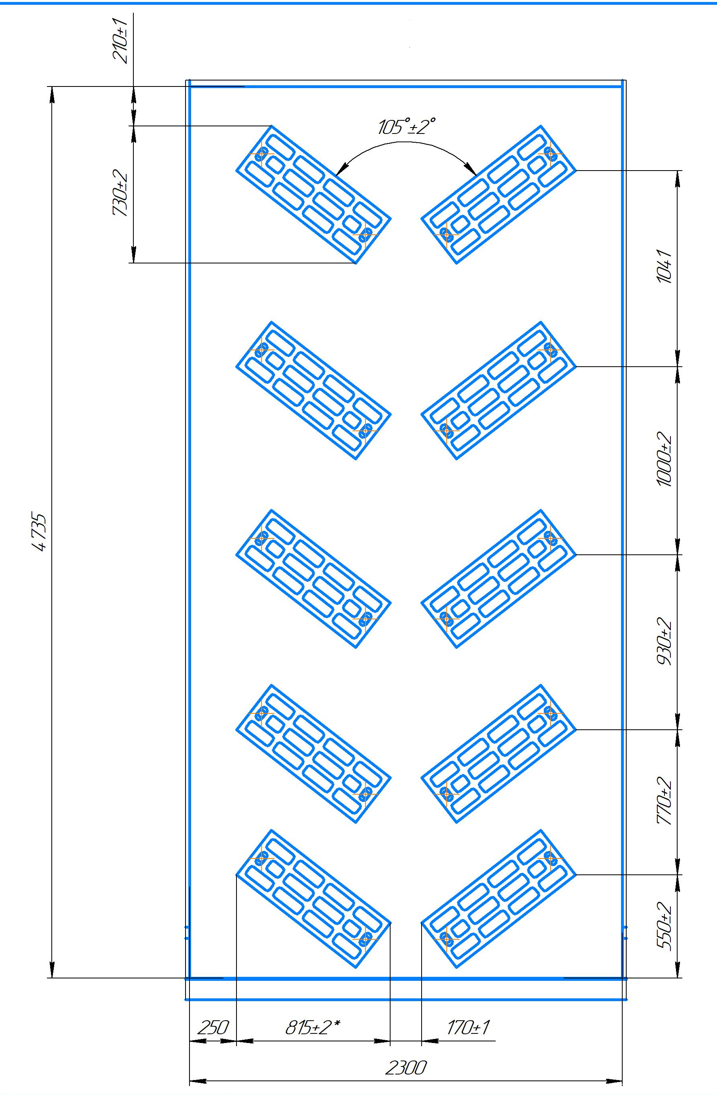 | 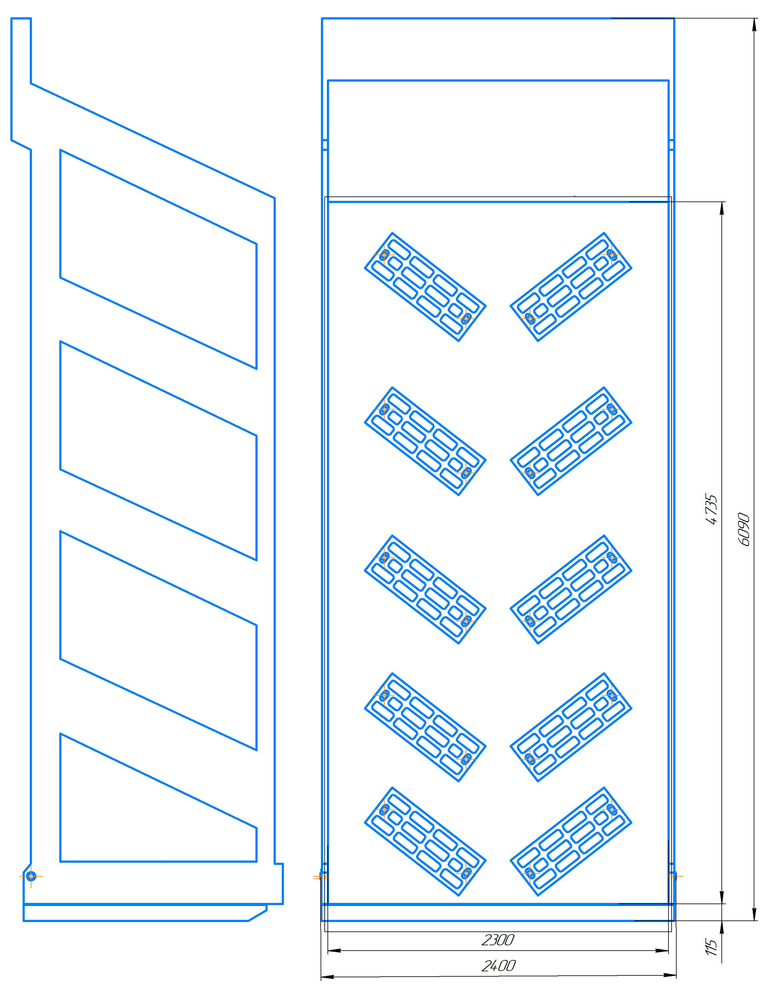
a) | b)
FIGURE 1. The shape and installation scheme of the covering installed on the lower part of the body;
a) Structural diagram of the body, front and interior views; b) Structural diagram of the body, side and rear views.

A mathematical model of the change in the load-bearing capacity and wear rate of the dump truck body after the introduction of changes has been developed. Structural changes in the dump truck body lead to various dynamic changes [1].
RESULTS AND DISCUSSION
If we take into account that the introduced volume is a rectangle (Fig. 2), then $V=a_{1}b_{1}c_{1}$.
In this case, the lengths of the sides of the quadrilateral a₁, b₁, c₁ are equal to $V_{total}=nV_{1}=na_{1}b_{1}c_{1}$,
where V - is the initial volume, m³ a, b, c are the sides of the initial volume, m.

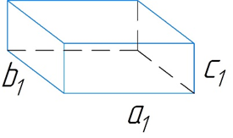
FIGURE 2. Equivalent view of input volume

G₁ and G₂ - the force of gravity acting on the wheels of the initial and subsequent dump truck, kN;
G_{load1} and G_{load2} - loads on the body of the first and subsequent dump truck, kN;
n - the number of protruding rectangles of the lower surfaces, pieces.

$\left(V-{na}_{1}b_{1}c_{1}\right)=ΔV$ , (4)

$V-ΔV={na}_{1}b_{1}c_{1}⇒$ $n=\frac{V-ΔV}{a_{1}*b_{1}*c_{1}}$ . (5)
Based on the resulting formula, taking into account the dynamic parameters, we analyze the following mathematical solution.
$G_{load1}=Vρ_{mine}$ ; $G_{load2}=ΔVρ_{mine}$ , (6)

$N_{load1}=G_{load1}$ ; $N_{load2}=G_{load2}$ . (7)
Since the position of the load is mainly vertical, it is chosen as the coordinate axis and the directions of the force are projected.
In the case of cargo transportation, the dynamic parameters of the cargo change with altitude. Here, the load is found based on the 1st problem of dynamics:

$∑F_{y}=G=ma_{y}⇒$ $m_{a}y=G_{yuk}⇒ma_{y}=mg$ ; (8)

$a_{y}=g⇒\frac{dv_{y}}{dt}=g⇒\int{dv_{y}=g\int{dt}}\int_{0}^{t}{.}$ (9)
$V_{y}=gt+C_{1}$ if t=0, $C_{1}=v_{0}$ in this initial state the loader gives the ore mass a certain velocity.
Condition: $C_{1}≠0$, $C_{1}=v_{0}$,
$V_{y}=gt+C_{1}=gt+v_{0}$ if $V_{y}=\frac{{dh}_{y}}{dt}=(gt+v_{0})$ ; (10)

$\int{dh_{y}=}\left(gt+v_{0}\right)\int{dt}⇒h_{y}=\frac{gt^{2}}{2}+v_{0}t+C_{2}$ , (11)

if t=0, $C_{2}=0{ h}_{y}=\frac{gt^{2}}{2}+v_{0}t$, the height is considered variable after the load is applied:
$\left\{\begin{aligned}2{(h}_{y}-C_{1})= t_{1}(gt_{1}+v_{0}) \\ 2h_{y}=t_{2}(gt_{2}+v_{0})\end{aligned}\right.$ , (12)

$\frac{h_{y}-C}{h_{y}}=\frac{t_{1}(gt_{1}+v_{0})}{t_{2}(gt_{2}+v_{0})}$ , (13)

$\frac{C}{h_{y}}=\frac{t_{1}(gt_{1}+v_{0})}{t_{2}(gt_{2}+v_{0})}+1$ . (14)
If the momentum of the force $ΔFΔt=mΔv$, then to decay $v_{max}=\frac{N_{max}}{A}≤[δ]$.
Based on the proportionality $N_{max}\sim ΔF$, the impulses of the load on the truck body (Fig. 3) and its influence on the wear of the lower surface of the body (Fig. 4) were determined.
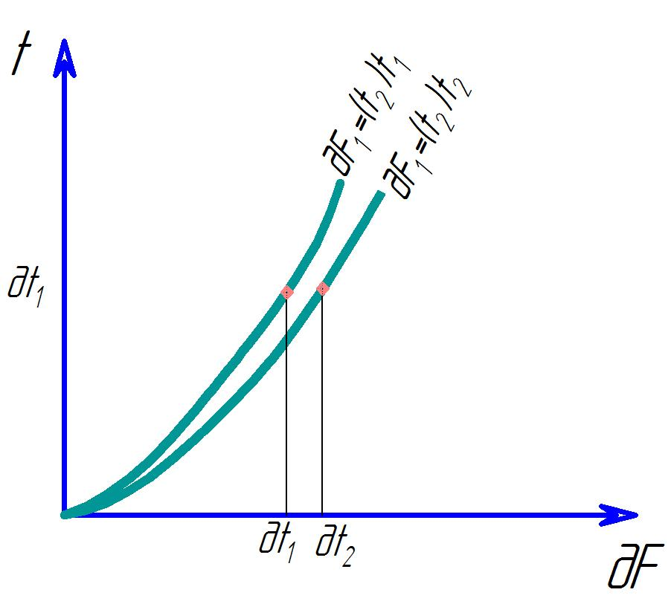 | 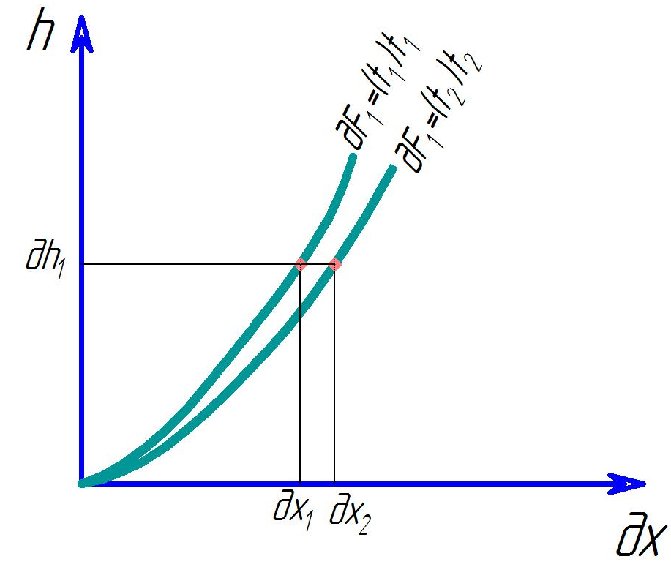
FIGURE 3. Impulses of cargo entering the dump truck onto the body | FIGURE 4. Deterioration of the lower surface of the body due to load on the dump truck
дx₁ - possible deterioration of the lower part of the body by impulse when applying a coating.
дx₂ - possible deterioration of the lower part of the body by impulse in the absence of a coating.

As a result of mathematical analysis, it was established that changes made to the lower part of the dump truck body slow down the annual wear of the body surface, and as a result of calculations using the standard "SolidWorks" program of the analytical expression, the quantitative values of stresses, deformations, and wear in the body were determined (Fig. 5).
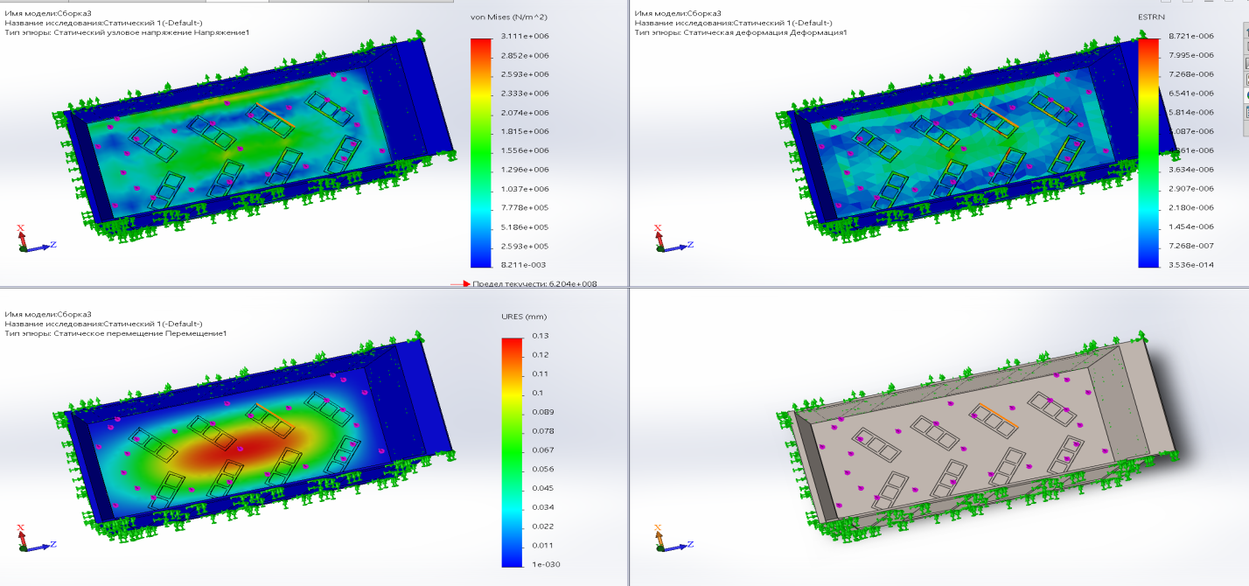
FIGURE 5. Influence of the load on the lower part of the body based on the SolidWorks program

At the same time, the advantages of the optimized MAN dump trucks are: high load capacity; powerful engine, the availability of the necessary base for installing the Betsema body; relatively low fuel consumption; MAN service availability; high-quality materials.
CONCLUSION
In this study, the influence of the design of quarry dump trucks of the MAN TGS series, especially structural changes in the lower part of the body, on operational indicators was comprehensively studied. Based on mathematical modeling, the dynamic characteristics of the wear process, the distribution of impulse forces, and the maximum stresses on the material were assessed by applying a high-strength steel coating to the body.
The analysis showed that the two-story "Format" generation body and the technology of bottom layer coating increase the reliability of the body, reduce local wear points, and can significantly extend the service life of the body. Comparative reports showed an increase in the utilization coefficient of the dump truck's real load capacity, and the changes made to the design made it possible to operate effectively while minimizing the additional load.
The simulation results obtained in the SolidWorks environment confirmed the mechanical advantage of structural changes: the stress distribution improved, the maximum deformation points decreased, and the effect of dynamic loads stabilized. This is an important factor in increasing the reliability and operational stability of dump trucks in difficult operating modes arising in quarry conditions.
REFERENCES
- Sherzod Makhmudov, Azamat Makhmudov, Lochin Khudojberdiev, Izzat Rakhmonov, "Criteria for assessing the performance of mining and transport equipment of mining enterprises," Proc. SPIE 12986, Third International Scientific and Practical Symposium on Materials Science and Technology (MST-III 2023), 129860P (19 January 2024); doi: 10.1117/12.3017722
- Rabatuly M., Myrzathan S.A., Toshov J.B., Nasimov J., Khamzaev A. Views on drilling effectiveness and sampling estimation for solid ore minerals. Kompleksnoe Ispolzovanie Mineralnogo Syra = Complex Use of Mineral Resources, №1(336), 2026. https://doi.org/10.31643/2026/6445.01
- Mislibaev I.T., Makhmudov A.M., Makhmudov Sh.A. Theoretical generalisation of functioning modes and modelling of operational indicators of excavators. // Mining information-analytical bulletin. - 2021. №1. с. 102-110. DOI: 10.25018/0236-1493-2021-1-0-102-110
- Toshov J.B., Rabatuly M., Khaydarov Sh., Kenetayeva A.A., Khamzayev A., Usmonov M., Zheldikbayeva A.T. Methods for Analysis and Improvement of Dynamic Loads on the Steel Wire Rope Holding the Boom of Steel Wire Rope Excavators. Kompleksnoe Ispolzovanie Mineralnogo Syra = Complex Use of Mineral Resources 2026; 339(4):87-96 https://doi.org/10.31643/2026/6445.43
- Zokhidov O.U., Khoshimov O.O., Khalilov Sh.Sh. Experimental analysis of microges installation for existing water flows in industrial plants. III International Conference on Improving Energy Efficiency, Environmental Safety and Sustainable Development in Agriculture (EESTE2023), E3S Web of Conferences. Volume 463. Pages 02023. 2023. https://doi.org/10.1051/e3sconf/202346302023
- Zokhidov O.U., Khoshimov O.O., Sunnatov S.Z. Selection of the type and design of special water turbines based on the nominal parameters of Navoi mine metallurgical combine engineering structures. AIP Conf. Proc. 3331, 050022 (2025). https://doi.org/10.1063/5.0306554
- Khamzaev A.A., Mambetsheripova A., Arislanbek N. Thyristor-based control for high-power and high-voltage synchronous electric drives in ball mill operations/ E3S Web Conf. Volume 498, 2024/ III International Conference on Actual Problems of the Energy Complex: Mining, Production, Transmission, Processing and Environmental Protection (ICAPE2024) DOI: https://doi.org/10.1051/e3sconf/202449801011
- Toshov B.R., Khamzaev A.A. Development of Technical Solutions for the Improvement of the Smooth Starting Method of High Voltage and Powerful Asynchronous Motors/AIP Conference Proceedings 2552, 040018 (2023); https://doi.org/10.1063/5.0116131 Volume 2552, Issue 1; 5 January 2023
- Toshov B.R., Khamzaev A.A., Sadovnikov M.E., Rakhmatov B., Abdurakhmanov U./ Automation measures for mine fan installations/ SPIE 12986, Third International Scientific and Practical Symposium on Materials Science and Technology (MST-III 2023), 129860R (19 January 2024); doi: 10.1117/12.3017728. Third International Scientific and Practical Symposium on Materials Science and Technology (MST-III 2023), 2023, Dushanbe, Tajikistan.
- Toshov B.R., Khamzaev A.A., Namozova Sh.R.Development of a circuit for automatic control of an electric ball mill drive. AIP Conference Proceedings 2552, 040017 (2023) Volume 2552, Issue 1; 5 January 2023.
- Toirov, O., Pirmatov, N., Khalbutaeva, A., Jumaeva, D., Khamzaev, A. Method of calculation of the magnetic induction of the stator winding of a spiritual synchronous motor. E3S Web of Conferences, 2023, 401, 04033
- Ataqulov L.N., Haydarov Sh.B., Polvonov N.O. Impact forces on side and middle rollers. SPIE 12986, Third International Scientific and Practical Symposium on Materials Science and Technology (MST-III 2023), 129860Q (19 January 2024); doi: 10.1117/12.3017724
- Atakulov L.N., Kakharov S.K., Khaidarov S.B. Selection of optimal jointing method for rubber conveyor belts. Gornyl Zhurnal, 2018. (9), ct 97-100. DOI: 10.17580/gzh.2018.09.16
- Azamatovich, N., Abdullayev, S., Zhuraev, A., Turdiyev, S. Experimental study of improved constructions increasing the efficiency of ball mill protective coatings used in enrichment factories. E3S Web of Conferences., 2024, 525, 06006. https://doi.org/10.1051/e3sconf/202452506006
- Zhuraev, A.S., Turdiyev, S.A., Jurayev, S.T., Salimova, S.S.Q. Characteristics of packing gland seals in hydraulic systems of quarry excavators and results of comparative analysis of experimental tests Vibroengineering Procedi., 2024, 54, Pages 252–257. https://doi.org/10.21595/vp.2024.24051
- Mahmudov A, Musurmanov E, Chorikulov A, Tukhtaev Sh. Justification of the development of the ventilation network and increasing the efficiency of ventilation equipment by controlling themovement of air flow. Third International Scientific and Practical Symposium on Materials Science and Technology (MST-III 2023), Proc. of SPIE Vol. 12986, 1298610.

