Synthesis and study of a polymer based on nitrogen-containing heterocyclic compounds
Tadjieva Shakhnoza^{1, a)}, Maksumova Aytura¹, Tadjieva Gulmira², Fazlıddın Murodullaev ², Shukhrat Ashurov²
¹ Tashkent Institute of Chemical Technology, Tashkent, Uzbekistan
²Tashkent state technical university named after Islam Karimov, Tashkent, Uzbekistan
^{a)} Corresponding author: tshah84@mail.ru
Abstract. This article synthesizes new nitrogen-containing acrylic monomers based on benzotriazole with acrylic acid. The synthesis of these monomers was carried out by reacting benzotriazole and acrylic acid at a temperature of 80 °C in an organic solvent medium. The structure of the synthesized monomer and polymer was confirmed by infrared spectroscopy, and the thermal properties were studied using thermogravimetric analysis and their physicochemical parameters were determined. A TLC method has been developed for qualitative and quantitative analysis of the target product. The effect of temperature on the process of obtaining the synthesized monomer and polymer of nature, temperature on the yield of reaction products was studied. The yield of the product was 80%.
INTRODUCTION
The development of various industries puts forward new tasks for science to expand the range of cationic polyelectrolytes that would have a complex of valuable properties, including surface-active ones. Therefore, the synthesis of new monomers containing nitrogen-containing acrylic groups is a very urgent task, which is of great scientific and practical interest [1].
Acrylic chemistry provides convenience in the production of various functional polymers due to the large number of commercially available monomers and the easy polymerization method.
Polymers of nitrogen-containing acrylic monomers have a very wide range of applications. They are used to stabilize suspensions, precipitate polymer latexes, in water treatment and in the electronic industry, are used as a fixing agent in fiber dyeing, to coagulate dispersed dyes, improve pigment distribution in the dye, inhibit dye interaction, anti-shrinkage treatment of wool, etc. They are also used as an anticorrosive agent [1-2], antistatic agent, etc. [3]
The authors investigated novel fluorinated acrylic polymers with benzotriazole pendant have been successfully synthesized by radical polymerization. These polymers demonstrated significantly high thermal stability and low surface energy due to fluorinated alkyl groups, as well as excellent optical properties due to the presence of fluorinated alkyl groups and intense UV absorption of the benzotriazole group (i.e., relatively low refractive indices), illustrating ideal ultraviolet blocking characteristics up to about 380 nm [4]. 1,2,3 ¬ of benzotriazole with ethanolamine and formaldehyde in a ratio of 2:1:2 in order to include an aliphatic unit that reduces steric difficulties during polymerization. The authors found that oxygen can also participate in the reaction, as can the amine [5].
Alkylation of α -aminoacids with chloride (bromide) allyl yielded new monomers: N, N-diallylaminoethane, N, N-diallylamino-isopentane, N, N-diallylaminoisocaproic, N, N-diallylamino-butanedioic (N, N diallylaspartic) acids and the conditions of their thermopolymerization in the presence of radical initiators were investigated [6].
Other authors synthesized the monomer 2 ¬ (bis ((1H - benzo [d] [1,2,3] triazole - 1-yl) methylamino) ethyl acrylate (BMEA), which includes two side benzotriazole groups [7]. By solution polymerization of this monomer, an adsorbent was obtained which has a great tendency to absorb moisture in contact with air.
The authors synthesized benzotriazole containing acrylic polymers with different contents of fluorine atoms in the alkyl side chain [8]. They investigated the thermal and optical properties of polymers, as well as the surface properties of a thin film coated on a flexible PET substrate. Fluorinated polymers have demonstrated excellent thermal stability, low surface energy (high hydrophobicity), low refractive index, and high visible light transmittance in addition to ideal ultraviolet blocking characteristics.
In this regard, the search and creation of effective methods for producing new polyfunctional unsaturated heterocyclic compounds, the study of their polymerization, the structure of synthesized products, and their properties generally determine the relevance of the chosen topic, both in the fundamental and in the applied aspect.

EXPERIMENTAL RESEARCH
As objects of researches are chosen: benzotriazole, acrylic acid, which were purified by known methods [9].
Acrylic acid (propenic acid, ethenecarboxylic acid) CH₂=CH−COOH of the " сh.р" brand was dried over calcined magnesium sulfate and purified by distillation in vacuo.: T_{boil.}=141°C; d²⁰₄=1.0511 g/cm³.
The benzotriazole was purified by recrystallization. Pier. weight is =119,13 g/mol; d²⁰₄ = 1,36 g/cm³; P_{mlt} = 100 °C. Colorless needle-shaped crystals. It is well soluble in alcohol, benzene, toluene, methanol, practically insoluble in water.
N, N-dimethylformamide (DMPA) - "p" grades were dried with barium oxide and purified by distillation (TU 2636-056-05761637-2005). Boiling point = 153 °C; P_{mlt}=-61°C; d²⁰₄ = 0.9445 g/cm³; nD²⁰ = 1.43.
Benzotriazolium acrylic acids - is a white crystal; T_{boil} =279ºС
Ethanol- "сh.р " - С₂H₅OH, CAS 64-17-5. GOST 5962-2013. Volatile, combustible, colorless transparent liquid. М= 46.1, Т_{boil}= 78.4 ^{о}С; ρ=0.7893 g/cm³
Acetone is a С₃Н₆O of the "chemical part" brand. Colorless highly volatile liquid with a sharp odor; dried over calcium chloride, T_{boil} = 56 °C, ρ = 0.79 g/cm3, _{n}D²⁰ = 1.3558.
Method of obtaining a monomer. The synthesis reaction was carried out in an organic solvent medium at a temperature of 80-90°C for 3-5 hours. Monomer synthesis was carried out in a glass reactor, which is a conical flask equipped with a reverse cooler and a magnetic stirrer. Benzotriazole (1 mol) was dissolved in dimethylformamide (100 ml). Then, the reaction mixture was stirred for 5 minutes at room temperature. 1 mol of acrylic acid (AA) with 0.1 g of hydroquinone (as a polymerization inhibitor) was added dropwise and the contents in the flask were stirred for 5 hours at 80 °C. It was cooled to room temperature. After cooling, light yellow crystals fell. The precipitated crystals from the reaction mixture were separated by filtration. The crystalline product was washed with water. The synthesized product is a white crystalline substance. Yield 80%.
Method of obtaining a polymer. The synthesis of polymers based on acrylic acid benztriazole was carried out according to the typical method of radical polymerization in ampoules. The reaction was carried out in an aqueous solution in the presence of the radical initiator azobisisobutyronitrile (DAB) at a temperature of 80 °C in a nitrogen medium for 72 hours. After the reaction, the reaction mixture was precipitated in ethanol, filtered, and dried to a constant mass at room temperature.
UV-spectrums were removed on a spectrometer of "IRTracer- 100" (Shimadzu CORP., Japan, 2017) complete with a prefix of the broken, full internal reflection (NRVO) of MIRacle-10 with diamond/ZnSe prism (spectral range on a scale of wave numbers-4000÷400 of cm-1; Resolution 4 cm⁻¹, sensitivity ratio noise signal - 60,000:1; Scan rate - 20 spectra per second)
Thermoanalytic studies of the presented samples were carried out on Netzsch Simulated Analyzer STA 409 PG (Germany), with K-type thermocouple (LowRGSilver) and aluminum crucibles. All measurements were carried out in an inert nitrogen atmosphere at a nitrogen flow rate of 50 ml/min. The temperature range of the measures was 25- 370oC, and the heating rate was 5K/min. The amount of sample per measurement is 5-10 mg. The measuring system was calibrated with a standard set of substances KNO₃, In, Bi, Sn, Zn.
The high performance liquid chromatogram was run on Agilent 1260 infinity II (USA). Chromatographic analysis conditions: column - Porosella 120 EC-C18, 4 μm, 4.6 × 150 mm, detector - detector of the diode matrix eluent - acetonitrile: water (50:50), flow rate - 1 mL/min, detection - 246 nm, amount added to the column - 5 µL, thermostat temperature - 30 0S, analysis time - 5 min.
RESEARCH RESULTS
This work presents the results of the process for the preparation and study of nitrogen-containing heterocyclic compounds of benzotriazole with acrylic acid (BTAC). It has been experimentally established that the synthesized monomer is highly soluble in organic solvents [10-11]
The physicochemical characteristics of the synthesized salt are given in Table 1
TABLE 1. Physical and chemical characteristics of BTAA

Formula of the synthesized compound | Gross formula | Aggregate state | Mol. weight | Т_{boil} ^{о}С | Solubility
 | С₉Н₇N₃O | white crystal | 173 | 279 | dimethylformami de, ethanol, acetone

Thermocatalytic studies of synthesized monomer were performed.

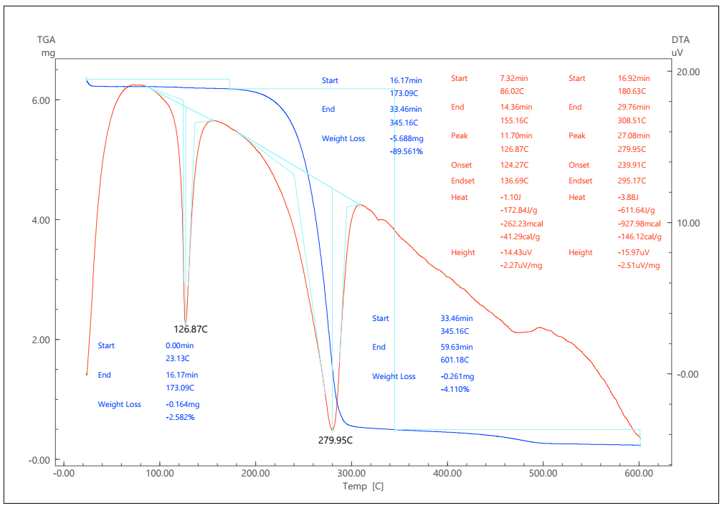
FIGURE 1. Thermogravimetric analysis of benzotriazole monomer with acrylic acid

In TGA, with an increase in temperature, changes in the mass of the test sample of the substance are observed. Loss of the main mass during thermal decomposition of all compounds occurs in the temperature range from 100 °C to 600 °C. Thermogravimetric analysis found that at a temperature of 86-155 oС, the BTAK weighed amount will lose 2.6% of the mass. At 126 °C, an endothermic peak (∆ Q = -172.84 J/g) is observed, which corresponds to the melting temperature of the test compound. Further heating at 279.95 °C, the sample weight loss is 89.56%.
The structure of the synthesized monomers and polymers was confirmed by UV- spectrum.
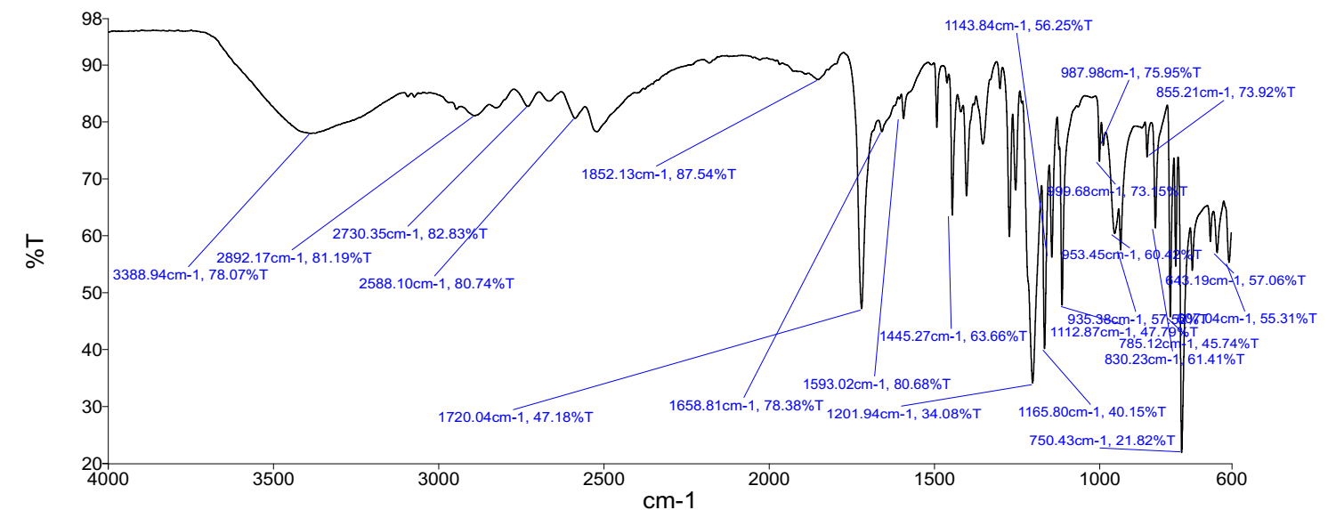
FIGURE 2. UV- spectrum of a benztriazole-acrylic monomer

As can be seen from Figure 1, in the UV- spectrum of the synthesized BTAA monomer, absorption bands of valence oscillations (-C = O-) groups in the region of 1720 cm⁻¹ are observed. Characteristic absorption bands of -N = N- groups are in the region of 1457 cm⁻¹, valence fluctuations of double bonds of -C = C- groups at 1658 cm⁻¹, valence fluctuations of C-N and -N-C = O- groups, respectively, at 1146 cm⁻¹, 620 cm⁻¹.

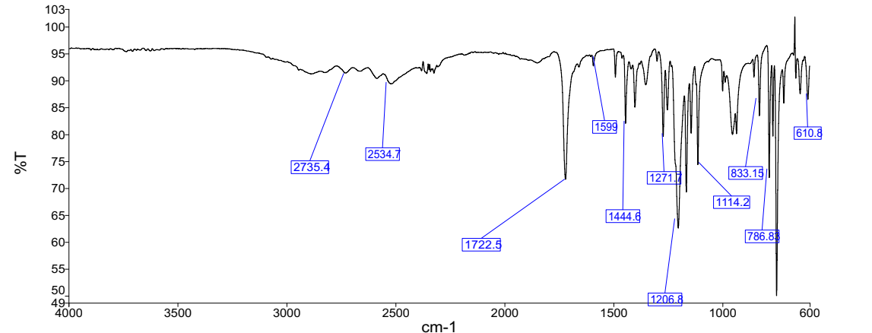
FIGURE 3. UV- spectrum of benzotriazole polymer with acrylic acid

To determine the optimal synthesis conditions, the influence of temperature, reaction time and the ratio of interacting reagents was investigated.
The purity and functional groups of the monomer and polymer were determined by high performance liquid chromatography of Agilent 1260 infinity II (USA) with conductometric detector.

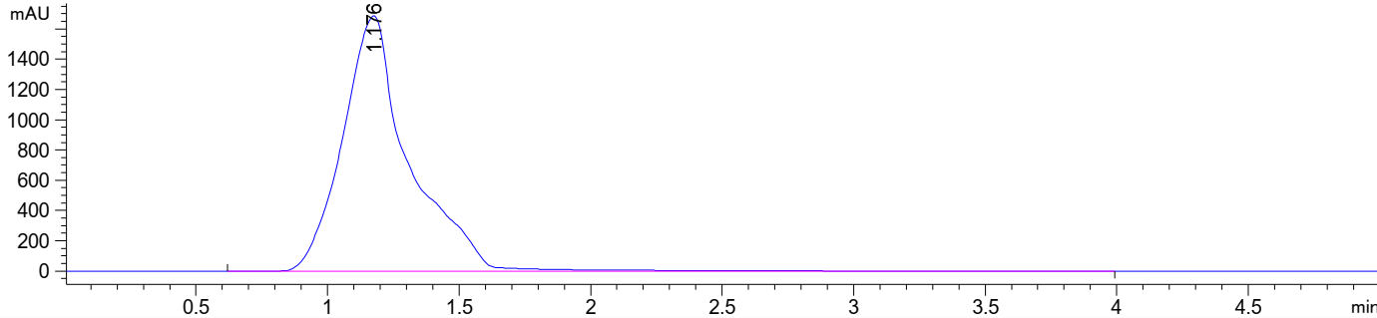
FIGURE 4. Chromatogram of benzotriazole monomer with acrylic acid

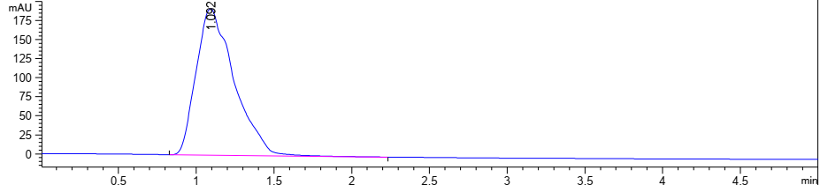
FIGURE 5. Chromatogram of benzotriazole polymer with acrylic acid

The polymerization conditions of these monomers were determined, the influence of various factors was studied: the nature of the solvent, initiator, concentration of the initiator, monomer and azobisisobutyronitrile (DAC), benzoyl peroxide were used as initiators.
CONCLUSIONS
- As a result of scientific research, new nitrogen-containing acrylic monomers based on benzotriazole with acrylic acid have been successfully synthesized.
- The structure of the synthesized monomer was confirmed by IR spectroscopy, and for the qualitative and quantitative analysis of the target product, they were determined by high-performance liquid chromatography.
- The effect of temperature on the process of obtaining the synthesized monomer and polymer of nature, temperature on the yield of reaction products was studied. The monomer yield was 80%.
- In the future, it is advisable to conduct studies of the mechanical properties of the obtained materials and evaluate them as an anticorrosive additive in enamels.

REFERENCES

1. A. E. Moen, Breaking Basel: The elements of the Basel Convention and its application to toxic ships, Mar. Policy 32(6), 1053–1062 (2008).
2. C. Ezeah and C. L. Roberts, Analysis of barriers and success factors affecting the adoption of sustainable municipal solid waste management in Nigeria, J. Environ. Manage. 103, 9–14 (2012).
3. H. Chen, J. Hou, S. Zhang, Y. Liang, G. Yang, Y. Yang, L. Yu, Y. Wu, and G. Li, Polymer solar cells with enhanced open-circuit voltage and efficiency, Nat. Photonics 3, 649–653 (2009). https://doi.org/10.1038/NPHOTON.2009.192
4. D. C. Han, H. Kim, and G. Kwak, Benzotriazole-containing fluorinated acrylic polymer coatings with high thermal stability, low surface energy, high visible light transparency, and UV-blocking performance, Polym. Bull. 80, 5641–5654 (2023). https://doi.org/10.1007/s00289-022-04340-w
5. M. Galán, V. Pozzoli, and M. M. Alho, Synthesis and characterization of acrylic polymer containing 1,2,3-benzotriazole pendant groups, Polym. Sci. Peer Rev. J. 4(5), 000600 (2023). https://doi.org/10.31031/PSPRJ.2023.04.000600
6. M. B. Begieva and T. L. Elephants, Synthesis of water-soluble polymers based on alkylated α-amino acids, Int. Conf. Org. Chem., St. Petersburg, p. 721 (2006).
7. M. Galán, V. Pozzoli, and M. M. Alho, The synthesis and characterization of acrylic polymer with 1,2,3-benzotriazole pendant groups, Polym. Sci. Peer Rev. J. 4(5), 000600 (2023).
8. D. C. Han, H. Kim, and G. Kwak, Benzotriazole-containing fluorinated acrylic polymer coatings, Polym. Bull. 80, 5641–5654 (2023). https://doi.org/10.1007/s00289-022-04340-w
9. G. B. Volodina and I. V. Yakunina, Laboratory workshop on organic chemistry, Tambov State Technical University Press, 80 p. (2004).
10. Sh. A. Tadzhieva et al., Synthesis of benzotriazole 1N-acrylic acid, Universum: Chem. Biol. 11(137) (2025). https://7universum.com/ru/nature/archive/item/21034
11. S. A. Tadjieva, O. S. Maksumova, and G. A. Tadjieva, Polymerization of 1,3-diallylbenzimidazolium bromide, Uzbek–Tajik Symp. Polymer Sci., Tashkent, 147–148 (2024).

