Increasing the hardness of ductile iron by modifying it with nickel
Boburjon Ibrokhimov ^{1, a)}, Sarvar Tursunbaev ¹, Bekzod Yusupov ², Bekzod Yuldashev ², Sharofuddin Mardonakulov ¹
¹ Tashkent state technical university, Tashkent, Uzbekistan
² Almalyk state technical institute, Almalyk, Uzbekistan
^{a)} Corresponding author: anvarovichsarvar908@gmail.com
Abstract. Cast iron is widely used in the casting of components. This article uses experiments to analyze hardness, a mechanical property of nickel-modified malleable cast iron. An SPB-B2 induction furnace was used to melt the samples, which were cast in sand-clay molds. The samples were modified with pure nickel at levels of 0.1%, 0.3%, and 0.5% relative to the charge. The hardness of the resulting samples was determined using an HXS-1000Z hardness tester. It was found that increasing nickel content increases the hardness of the samples. A graph was plotted based on the obtained results. The authors' conclusions are presented at the end of the article.
INTRODUCTION
At present, ferrous and non-ferrous alloys are the main materials widely used in the mechanical engineering industry [1–4]. Cast iron belongs to the group of ferrous metallurgy materials and is widely used in various sectors of industry due to its unique characteristics and diverse properties [5–8]. Ferrous metallurgy plays a key role in the economy, determining the viability of industry. Almost all enterprises use products of ferrous metallurgy, which serve as the primary materials for the production of equipment and tools.
The advantage of cast iron is that it can be used to manufacture parts of complex shapes, as demonstrated by the engine block and cylinder head of an internal combustion engine. This casting method is known for its cost-effectiveness when producing components with intricate geometries. However, a disadvantage of cast iron is its high density, which results in the production of heavy parts. Engineers and metallurgists face the task of reducing the weight of these components. The use of alloying elements and heat treatment can improve the properties of the alloy, affecting its machinability [9–12]. Due to the limitations in achieving manufacturing tolerances solely through casting, mechanical machining is required to improve the surface quality and dimensional accuracy of castings [13].
Toshiro Kobayashi and Hironobu Yamamoto conducted research aimed at increasing the impact strength of austenitic ductile iron by strengthening the sites of crack origin, such as graphite–matrix interfaces and eutectic cells, due to microsegregation of alloying elements [14]. In the work of Taiwanese researchers S. S. Shi and his colleagues, the tensile properties of austenitic ductile iron (ADI) with an upper-bainitic structure were investigated at temperatures from 27 to 420°C using cast iron with spheroidal graphite [15]. The results showed that the stress decreases with increasing temperature of austenization and hardening treatment.
Based on the above research and analyses, this study examines the enhancement of the hardness of malleable cast iron by modifying it with nickel.

MATERIALS AND EXPERIMENTS
An electric induction furnace of the SPB-B2 brand was used for melting the cast iron [16], which ensures very high quality of the cast iron and allows the use of any charge materials (Fig. 1). The chemical composition of the malleable cast iron selected as the research object is presented in Table 1. This type of cast iron is used for casting parts that operate under various high loads [17–20]. Nickel was added to the samples as a modifying element in the amounts of 0.1%, 0.3%, and 0.5% relative to the charge. To measure the hardness of the cast samples, an HXS-1000Z hardness measuring device was used (Fig. 2).

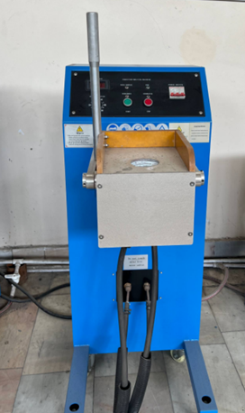
FIGURE 1. Induction furnace

TABLE 1. The composition of ductile iron
C | Si | Mn | S | P | Cr | -
2.6 - 2.9 | 1 - 1.6 | 0.4 - 0.6 | до 0.2 | до 0.18 | до 0.08 | C+Si = 3.7 - 4.2

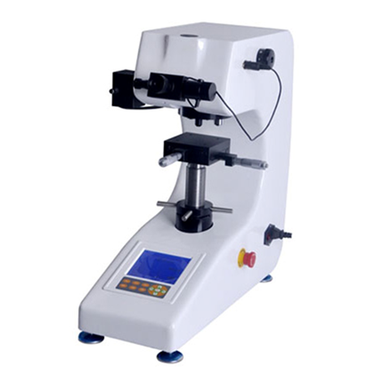
FIGURE 2. HXS-1000z hardness tester
Hardness was measured using the Brinell method. The polished surfaces of the samples were used for testing, so that when pressed with a 10 mm diameter ball indenter, it would be smooth and flat. Before polishing the sample, it was necessary to cut off a piece from the finished part or sample for further testing. An electric erosion machine model DK7725 was used for cutting (Fig.3). The cut samples with different percentages of nickel were wider and 5x50 millimeters long, and the thickness was 5 mm (Fig.4).

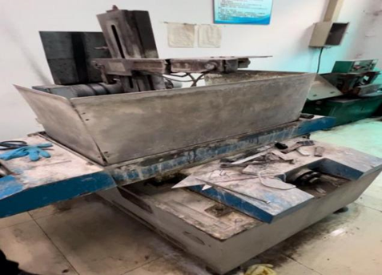 | 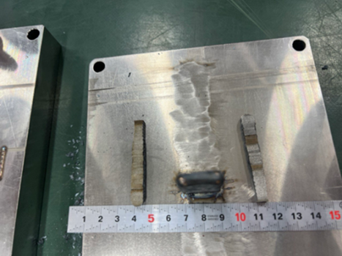
FIGURE 3. Electroerosion machine for sample preparation | FIGURE 4. Samples for hardness testing

RESEARCH RESULTS
After preparation and cutting of the samples for Brinell hardness testing, the surfaces were manually ground to obtain a smooth and even finish. Grinding was carried out using sandpaper of various grits, starting from P80 and up to P1200. This was done to ensure that the processed surface eliminated surface irregularities and provided reliable contact with the indenter. The measurement step was 1 mm to ensure high data accuracy and to eliminate possible errors during testing, as shown in Figure 6.

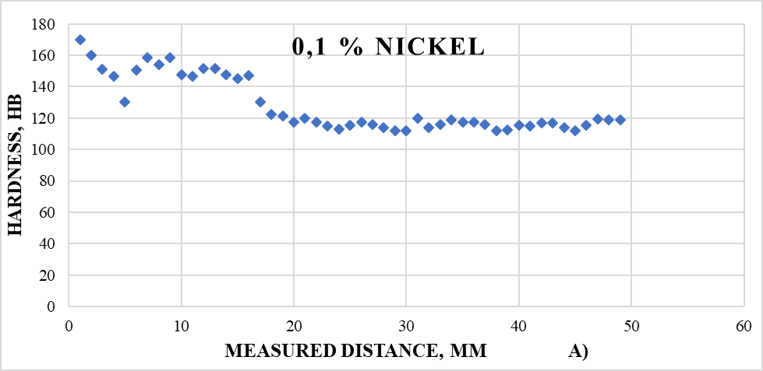
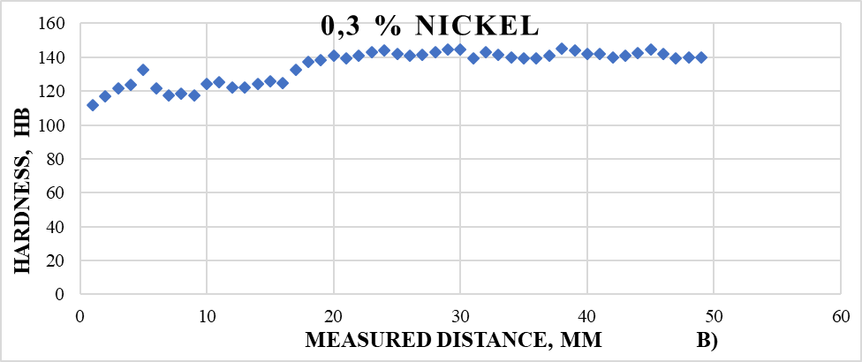

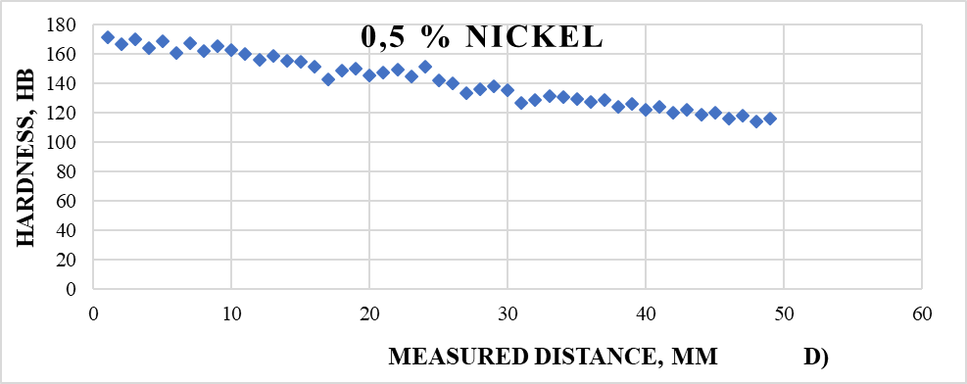
FIGURE 5. Hardness of samples in terms of nickel concentration: a) 0.1% b) 0.3% and d) 0.5 %

CONCLUSIONS
Based on the obtained data, it can be concluded that as the nickel content in malleable cast iron increases, the hardness increases proportionally to its concentration. With the addition of 0.1% Ni, the average hardness based on 49 measurements was 127.77 HB with a deviation of ±9.28. For the alloy with 0.3% Ni, the average hardness reached 135.89 HB with a deviation of ±16.54, and with 0.5% Ni, the hardness was 157.49 HB with a deviation of ±8.54. In all samples, a common trend was observed: the hardness on the outer surface was higher compared to the middle and the end of the sample. This may be due to the fact that the modifier used acts more strongly on the surface of the part.
REFERENCES
- Delin Li. Discussion of ‘‘Microstructure and Hot Oxidation Resistance of SiMo Ductile Cast Irons Containing Si-Mo-Al’’ https://doi.org/10.1007/s11663-018-1184-0
- Wang, G. hua, & Li, Y. xiang. (2020). Thermal conductivity of cast iron -A review. China Foundry, 17(2). https://doi.org/10.1007/s41230-020-9112-8
- Tursunbaev, S., Turakhodjaev, N., Zhang, L., Wang, Z., Mardonov, U., & Saidova, M. (2024). Mechanical properties and evolution of the microstructure of al-cu-mg system alloys under the influence of alloying elements (GE AND SI). International Journal of Mechatronics and Applied Mechanics, 2024(18), 164–169. https://doi.org/10.17683/ijomam/issue18.19
- Bai, J., Xu, H., Wang, Y., Chen, X., Zhang, X., Cao, W., & Xu, Y. (2022). Microstructures and Mechanical Properties of Ductile Cast Iron with Different Crystallizer Inner Diameters. Crystals, 12(3). https://doi.org/10.3390/cryst12030413
- Dawson, S., & Schroeder, T. (2004). Practical applications for compacted graphite iron. In AFS Transactions (Vol. 47, Issue 5). pp.1–9.
- Domeij, B., & Diószegi, A. (2024). A Review of Dendritic Austenite in Cast Irons. International Journal of Metalcasting, 18(3). https://doi.org/10.1007/s40962-023-01239-8
- Kholmirzaev, N., Saidmakhamadov, N., Khasanov, J., Tadjiev, N., Yusupov, B., Sadikova, N., Yuldashev, O., Makhmudov, F., Nosirkhujaev, I. S., & Nurdinov, Z. (2024). Mathematical Modeling of the Effect of TiC Nanopowder Particles on the Wear Resistance Properties of Low-Alloy Steel. In Materials Science Forum (Vol. 1139). https://doi.org/10.4028/p-gIS27O
- De Sousa, J. A. G., Sales, W. F., & Machado, A. R. (2018). A review on the machining of cast irons. International Journal of Advanced Manufacturing Technology, 94(9–12). https://doi.org/10.1007/s00170-017-1140-1
- Tursunbaev, S., Turakhodjaev, N., Mardonakulov, S., & Toshmatova, S. (2024). Effect of germanium oxide on the properties of aluminum casting details in agricultural machinery. BIO Web of Conferences, 85. https://doi.org/10.1051/bioconf/20248501024
- Janerka, K., Kostrzewski, L., Stawarz, M., Jezierski, J., & Szajnar, J. (2022). Various Aspects of Application of Silicon Carbide in the Process of Cast Iron Melting. Archives of Metallurgy and Materials, 67(3). https://doi.org/10.24425/amm.2022.139708
- Sarvar, T., Nodir, T., Mardonov, U., Saydumarov, B., Kulmuradov, D., & Boltaeva, M. (2024). EFFECTS of germanium (ge) on hardness and microstructure of al-mg, al-cu, al-mn system alloys. International Journal of Mechatronics and Applied Mechanics, 2024(16), 179–184. https://doi.org/10.17683/ijomam/issue16.21
- Takemoto, Y., Mizumoto, M., & Kinno, K. (2021). Internal Porosity Defects in Ductile Cast Irons. International Journal of Metalcasting, 15(3). https://doi.org/10.1007/s40962-020-00527-x
- Mardonov, U., Yang, Y., Wang, X., Khasanov, O., Tursunbaev, S., & Ozodova, S. (2025). Analysis of Thermocouple Measurement Errors in Various Contact Methods During Turning Operations. Lecture Notes in Networks and Systems, 1592 LNNS, 1–14. https://doi.org/10.1007/978-3-032-02508-1_1
- Kobayashi, T., & Yamamoto, H. (1988). Development of high toughness in austempered type ductile cast iron and evaluation of its properties. Metallurgical Transactions A, 19(2). https://doi.org/10.1007/BF02652541
- Shieh, C. S., Lui, T. S., & Chen, L. H. (1995). Tensile Characteristics of Austempered Ductile Cast Iron in the Temperature Regime of 300 K to 693 K. Materials Transactions, JIM, 36(5). https://doi.org/10.2320/matertrans1989.36.620
- Tursunbaev, S., Turakhodjaev, N., Odilov, F., Mardanokulov, S., & Zokirov, R. (2023). Change in wear resistance of alloy when alloying aluminium alloy with germanium oxide. E3S Web of Conferences, 401. https://doi.org/10.1051/e3sconf/202340105001
- Sandomirskiy, S. G., Pisarenko, L. Z., & Lukashevich, S. F. (2002). Quantitative analysis of the relationship between microstructure and magnetic properties of “nipple 1¼”-type products made of malleable cast iron KCh30-6. Defectoscopy, (4), 18–24.
- Saidmakhamadov, N., Turakhodjaev, N., Tursunbaev, S., Zokirov, R., Tadjiev, N., Abdullaev, K., Hamroev, V., Rakhmanov, U., & Juraev, J. (2024). Improving the design of the lining of the ball mill used to improve the quality of grinding. E3S Web of Conferences, 525. https://doi.org/10.1051/e3sconf/202452502017
- Saidova, M., Alimova, F., Tursunbaev, S., Kulmuradov, D., & Boltaeva, M. (2023). Influence of the shape of the disc slots of the seeder on the suction force of the vacuum for precise sowing of seeds. IOP Conference Series: Earth and Environmental Science, 1284(1), 012014. https://doi.org/10.1088/1755-1315/1284/1/012014
- Zhang, D., Li, Y., Du, X., Fan, H., & Gao, F. (2022). Microstructure and tribological performance of boride layers on ductile cast iron under dry sliding conditions. Engineering Failure Analysis, 134. https://doi.org/10.1016/j.engfailanal.2022.106080

