Developing water-resistant composite paper materials from annual plants, cellulose, and basalt fibers, and studying their sorption properties
Elmurod Egamberdiev^{1, a)}, Nazokat Giyasova¹, Ra’no Khabibullaeva¹,
Indirakhon Ayubova¹, Dilara K. Sunakbaeva²
¹Tashkent State Technical University, Tashkent,Uzbekistan;
²Khoja Akhmet Yassawi International Kazakh-TurkishUniversity, Turkestan, Kazakhstan
^{a)} Corresponding author: el.1909@mail.ru
Abstract. This article details technologies for creating water-resistant composite paper materials using inexpensive and renewable resources available in Uzbekistan: cellulose from annual plants (Helianthus tuberosus, cotton, cotton stalks, straw) and local basalt fibers. In experiments, paper samples were prepared in a lab using a wet method, mixing different compositions of cellulose and basalt fibers. The research focused on drying and pressing the samples, assessing their wet sorption properties, degree of swelling in water, and water intake at 70% relative humidity. The results showed that as the proportion of basalt fibers increased, the water intake of the composite paper decreased. Notably, samples made from Helianthus tuberosus cellulose and basalt fiber had good physical and sorption properties. These developments could help create environmentally friendly, water- and moisture-resistant paper products, and could lead to materials for industrial filtration, construction, and technical packaging.
INTRODUCTION
Paper is used in almost every part of our everyday lives. Global yearly paper production is in the hundreds of millions of tons. Many countries, including Uzbekistan, rely heavily on imports to meet their paper needs. Statistics indicate that in 2009, Uzbekistan's local paper production met only about 10% of its domestic demand [1]. This situation shows a need to boost local production of affordable, quality paper products using local resources. Lately, there has been more interest in using annual plants for paper production. Using agricultural waste like Helianthus tuberosus, cotton, cotton stalks, and straw is useful in this context [2]. Composite methods are used to improve the material's strength, heat resistance, and water resistance. Adding a high-mass component can significantly improve product quality [3].
This study focuses on creating composite paper samples with different compositions using cellulose from annual plants (Helianthus tuberosus, cotton, cotton stalks, etc.) and local basalt fibers. We aimed to evaluate their water absorption and sorption properties [4]. The study results will show the chance to produce moisture-resistant composite paper materials that can be used in various industries [5].
It's difficult to consider any field where paper isn't used. World paper production is 339 million tons per year (2003), and in Russia, it is 350 thousand tons (2000). According to 2009 data, paper produced in Uzbekistan meets only 10% of the demand for this product. The remaining amount of paper is imported [6].
In recent years, the production of paper from annual plants has risen. China makes 75% of the world's paper from annual plants and meets 50% of its paper needs with paper from these plants.
Uzbekistan has a large raw material base for making paper from annual plants, including cotton stalks, rice straw, hemp, and others. The rising demand for paper and paper products has encouraged exploration of alternative resources for paper production, spurring research efforts [7].
Cellulose-containing waste, annual plant cellulose, and other components can be combined to create composites with different properties. One such ingredient available locally is basalt fiber, which has heat resistance and high strength. Basalt fiber is more prone to crystallization than other glass fibers [8]. It stands out because of its high resistance to heat, chemicals, and burning, as well as its high strength.
For this reason, it can replace carcinogenic asbestos in composite plastics. For our tests, we used basalt fiber mined from the Asmosoy deposit in Uzbekistan. It has a melting point of 1250 °C, which is lower than basalt fiber from other places [9,10].
MATERIALS AND METHODS
The study chose the objects below. This study used the materials below as the main part to make composite paper materials and make them more waterproof. Annual plants gave us cellulose from Helianthus tuberosus, cotton linter, cotton stalks, and straw [11,12]. The inorganic fibers came from local basalt fiber (taken from the Aamoni deposit and used after grinding). The method for making the test materials was to use wet paper casting in a lab. Cellulose and basalt fibers of different kinds were mixed to make a 1-1.5% water suspension. We shaped a paper sample by pouring this mix onto a mesh on a paper casting machine, drying it at 105-110 °C, and then squeezing it under a press for 30 minutes [13].
RESULTS AND DISCUSSION
We made paper samples from composite materials with different mixes of annual plant cellulose and basalt fibers and studied what they were like. The main goals were to make the paper stronger and to make it burn and absorb less water.
We produced five kinds of composite materials that hold cellulose and basalt fiber. To make these composite materials, we used basalt and cellulose from Helianthus tuberosus, cotton linter and cotton stalks. Each of these was used on its own in equal amounts. Then, we made a composite material in the lab with the wet method. We mixed basalt fiber with annual plant celluloses in different amounts. The mix was weakened to 1-1.5%, and a sample was placed as paper on a paper machine. We made a wet cellulose layer by slowly lifting the machine’s cylinder and mesh section, letting the water pass through the mesh. The cellulose layer was taken with the mesh and dried in a drying room at 105-110 °C until 75-80% of the water was gone. Then, it was pressed until it had the needed thickness and kept there for 30 minutes.
The samples are dried to a moisture content of 5-6%. Then, they are cut into 6x6 cm pieces, and their mass is measured using an analytical balance. The thickness of each sample is measured using a caliper. These steps are repeated for all samples. After drying, the technical properties of the samples are determined, along with other physical-chemical, thermal conductivity, and thermal properties. In this paper, we study the water absorption rate of the obtained composite paper samples. The masses of the initial samples were first measured.
The next step is to find out how much the composite materials absorb.
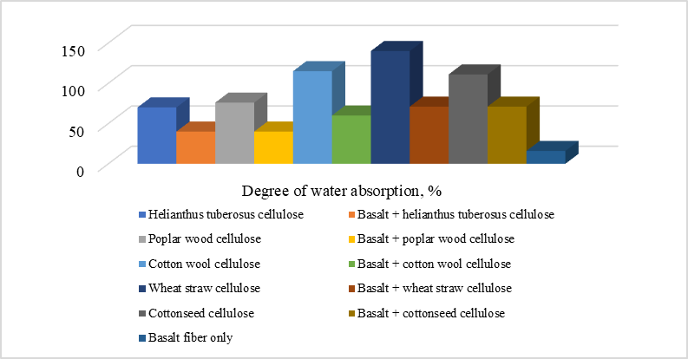
FIGURE 1. Degree of boiling of composite paper samples in water.

Methods for determining the absorption rate of samples:
1. To find the degree of boiling, a 1 g sample is taken, soaked in water for 30 minutes, and then centrifuged at 5000 rpm to remove excess water and measure its mass.
2. The samples are kept in water for 30 minutes, then placed between two pieces of cellulose plate, and excess water is removed with a 2 kg load to measure its mass.
3. After creating a 70% relative humidity in a desiccator in a concentrated salt environment for 24 hours, its mass is measured.
We studied how the obtained materials absorb. This work was carried out according to the above guidance. For this, we determined the amount of water absorbed by the samples, the degree of boiling by soaking in water, and the degree of absorption of 70% relative humidity. The absorption rate of the samples is given in the table below.
Based on the table, the composite paper sample made with Helianthus tuberosuss, cotton linter cellulose, and basalt fiber has a water saturation range of 40-60%, which is a good outcome. Because our goal is to create moisture-resistant composite paper for different industry uses. In the next phase of our work, we studied how well the composite paper samples absorbed moisture from air at 70% relative humidity.
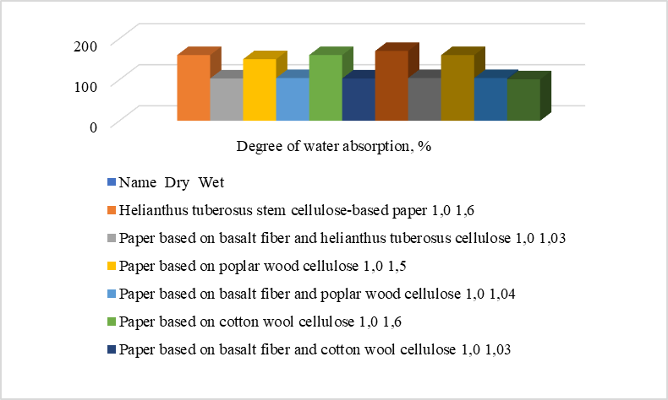
FIGURE 2. Moisture sorption rate of composite paper samples from 70% relative humidity air.
The data show that moisture absorption depends on the kind of sample. Composite paper samples made with Helianthus tuberosus, cotton linter celluloses, and basalt fiber absorb about 3% of moisture.

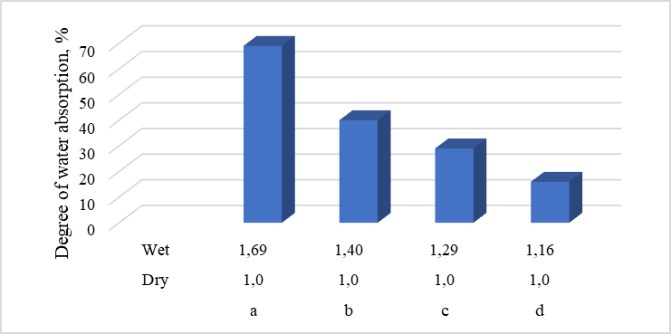
FIGURE 3. Sorption rate of paper made from basalt fiber and Helianthus tuberosus cellulose.
These values reflect the structure of the composite paper samples. The more moisture a sample absorbs, the more porous its cellulose fibers are. So, paper samples from poplar, straw, cotton stalks celluloses, and basalt fiber are more porous than those from cotton linter and Helianthus tuberosus cellulose.
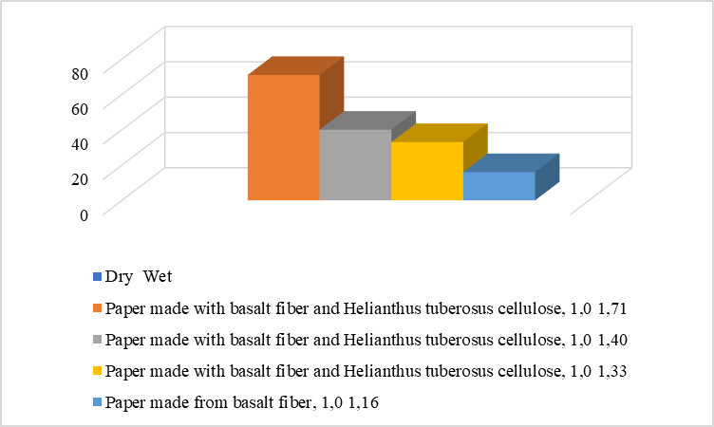
FIGURE 4. Sorption Levels of Paper Made From Basalt Fiber and Wood Cellulose.

Next, we mixed annual plant cellulose and basalt fibers in different amounts to make paper samples and studied their properties. The results are in the table below.

TABLE 1. Sorption rate of paper made with basalt fiber and cotton linter cellulose.
№ | Name and composition structure | Mass, g |  | Degree of water absorption, %
№ | Name and composition structure | Dry | Wet | Degree of water absorption, %
1 | Paper made with basalt fiber and Helianthus tuberosus cellulose, 25:75 1.0 1.69 69 | 1,0 | 1,87 | 87
2 | Paper made with basalt fiber and Helianthus tuberosus cellulose, 50:50 1.0 1.40 40 | 1,0 | 1,60 | 60
3 | Paper made with basalt fiber and Helianthus tuberosus cellulose, 75:25 1.0 1.29 29 | 1,0 | 1,41 | 41
4 | Paper made from basalt fiber, 100 1.0 1.16 16 | 1,0 | 1,16 | 16

TABLE 2. Sorption degree of paper from basalt fiber and straw cellulose.
№ | Name and composition structure | Mass, g |  | Degree of water absorption, %
№ | Name and composition structure | Dry | Wet | Degree of water absorption, %
1 | Paper made with basalt fiber and Helianthus tuberosus cellulose, 25:75 1.0 1.69 69 | 1,0 | 1,90 | 90
2 | Paper made with basalt fiber and Helianthus tuberosus cellulose, 50:50 1.0 1.40 40 | 1,0 | 1,71 | 71
3 | Paper made with basalt fiber and Helianthus tuberosus cellulose, 75:25 1.0 1.29 29 | 1,0 | 1,47 | 47
4 | Paper made from basalt fiber, 100 1.0 1.16 16 | 1,0 | 1,16 | 16

TABLE 3. Sorption rate of paper made from basalt fiber and cotton stalk cellulose.
№ | Name and composition structure | Mass, g |  | Degree of water absorption, %
№ | Name and composition structure | Dry | Wet | Degree of water absorption, %
1 | Paper made with basalt fiber and Helianthus tuberosus cellulose, 25:75 1.0 1.69 69 | 1,0 | 1,89 | 89
2 | Paper made with basalt fiber and Helianthus tuberosus cellulose, 50:50 1.0 1.40 40 | 1,0 | 1,71 | 71
3 | Paper made with basalt fiber and Helianthus tuberosus cellulose, 75:25 1.0 1.29 29 | 1,0 | 1,45 | 45
4 | Paper made from basalt fiber, 100 1.0 1.16 16 | 1,0 | 1,16 | 16
Based on the data in the tables above, an increase in the amount of basalt fiber added to the composite mix reduces the water absorption rate of the resulting composite paper. It should also be noted that the paper made from basalt fiber and Helianthus tuberosus cellulose was considered the best option from our trials.
 | 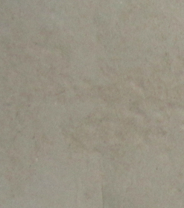
Paper made from basalt fiber and wheat straw cellulose (1:1). | Paper made from basalt fiber and cotton linter cellulose (1:1).
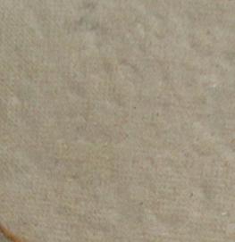 | 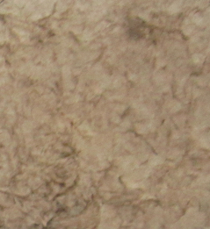
Paper made from basalt fiber and poplar cellulose (1:1) | Paper made from basalt fiber and cotton stalk cellulose (1:1)
Paper made from a mixture of basalt and Helianthus tuberosus cellulose (1:1)
FIGURE 5. Samples of composite paper obtained through experiments are shown below.
CONCLUSION
Research indicates that composite paper samples made with annual plant cellulose and basalt fibers have considerable water and humidity resistance, making them suitable for industrial applications thanks to their physicochemical properties. As the proportion of basalt fiber in the composite rises, water swelling decreases, boosting the product's humidity resistance. Evaluation of sorption properties shows a water swelling level of about 40-60%, suggesting a relatively high hydrophobicity. Low moisture absorption (roughly 3%) at 70% relative humidity suggests the composite materials are dense and have little porosity. Samples made from Helianthus tuberosus cellulose and basalt fiber gave the best results. According to this study, basalt fiber-reinforced composite paper materials can be utilized as filter materials, industrial technological packaging, moisture-resistant technical sheets, and fire-resistant coatings. Technological solutions based on local raw materials have proven able to create import-substitution goods for usage in a variety of industries.
REFERENCES
- Aluko, O. G., Yatim, J. M., Kadir, M. A. A., & Yahya, K. (2023). Fire performance and residual properties of fibre-reinforced cementitious composites exposed to elevated temperatures. Fire Technology. https://doi.org/10.1007/s10694-023-01482-2
- Mohammad, S. A., Krishna, T. N. C., Saketh, T., Ganesh, C. Y., & Sathyan, D. (2023). Mechanical and durability performance of sustainable cement-based composites. Materials Today: Proceedings, 80, 443–449. https://doi.org/10.1016/j.matpr.2023.02.369
- Sreenivasan, V. S., Somasundaram, S., Ravindran, D., Manikandan, V., & Narayanasamy, R. (2011). Microstructural, physico-chemical and mechanical characterization of natural fibre reinforced composites. Materials & Design, 32, 453–461. https://doi.org/10.1016/j.matdes.2010.06.017
- Boutin, M. P., & Elamin, C. (2013). Bio-aggregate based construction materials and their properties. In Bio-Aggregate-Based Building Materials (pp. 289–312). Hoboken, NJ: Wiley.
- Egamberdiev, E., Umarova, M., & Maksumova, O. (2023). Resource-saving modifiers based on waste oils for construction materials. E3S Web of Conferences, 401, 05087. https://doi.org/10.1051/e3sconf/202340105087
- Augustino, D. S., Kanali, C., Onchiri, R. O., & Kabubo, C. (2023). Sustainable cement composites reinforced with natural fibres: Mechanical and durability assessment. Heliyon, 9, e14441. https://doi.org/10.1016/j.heliyon.2023.e14441
- Banthia, N., Majdzadeh, F., Wu, J., & Bindiganavile, V. (2014). Fiber synergy in hybrid fiber reinforced concrete. Cement and Concrete Composites, 48, 91–97. https://doi.org/10.1016/j.cemconcomp.2013.09.015
- Egamberdiyev, E. A., Turabdjanov, S., Azimov, D., Igamkulova, N., & Mengliev, S. (2025). Environmental and mechanical performance of modified cement-based composites. Procedia Environmental Science, Engineering and Management, 12, 261–267.
- Duschanova, Z. A., Egamberdiyev, E. A., Turabdjanov, S., & co-authors. (2024). Nanostructured additives for improving cement composite properties. Journal of Nanostructures, 14, 789–797. https://doi.org/10.22052/JNS.2023.03.020
- Egamberdiev, E., Umarova, M., & Azimov, D. (2024). Eco-efficient binders modified with industrial waste. E3S Web of Conferences, 497, 03031. https://doi.org/10.1051/e3sconf/202449703031
- Egamberdiev, E., Turabdjanov, S., & Mengliev, S. (2024). Physical and mechanical behavior of composite binders with modifiers. E3S Web of Conferences, 497, 02026. https://doi.org/10.1051/e3sconf/202449702026
- Egamberdiyev, E. A., Turabdjanov, S., Azimov, D., Igamkulova, N., & Mengliev, S. (2025). Sustainable construction materials based on modified cement systems. Procedia Environmental Science, Engineering and Management, 12(1), 261–267.
- Akhmatovna, A. M., Elmurod, E., Gulzat, O., Sabokhat, S., & Inomjon, M. (2025). Nanostructured modifiers and their effect on cement composite performance. Journal of Nanostructures, 15(3), 1041–1049. https://doi.org/10.22052/JNS.2025.03.021

