Production technology of two-layer filter materials based on Jerusalem Artichoke cellulose and basalt fibers and their stability properties
Elmurod Egamberdiev^{1, a)}, Sadritdin Turabdjanov¹, Borikhon Mukhiddinov¹, Kamoliddin Makhmudov¹, Khusniddin Rakhimov²
¹Tashkent State Technical University, Tashkent, Republic of Uzbekistan;
²Tashkent Chemical-Technological Institute, Tashkent, Republic of Uzbekistan
^{a)} Corresponding author: el.1909@mail.ru
Abstract. This article talks about the making of one and two-layer filter materials with different ingredients, using Jerusalem artichoke cellulose, basalt fibers, and cotton cellulose. The study looks at the physical, chemical, aerodynamic, and structural properties of these filter materials. It pays close attention to how the two-layer creation affects the material's stability, strength, and how well it lets things pass through. Tests showed that samples made with basalt fibers using the two-layer method had better structural stability and let less through compared to single-layer materials. The permeability dropped by three times in mixes made of fibers that were d6=0.25 μm big. This method could lead to making good materials for personal respirators, industrial filtering systems, and sterilization equipment.
INTRODUCTION
There is a growing need for filter materials in industries for cleaning gas and air and preventing harm from airborne materials. It's very important to create materials that can catch tiny aerosols, radioactive gases, and harmful particles. Paper-like filters are often used, and what they are made of, how they are layered, how the fibers interact, and how well they filter are important factors. In this study, one and two-layer filters were created using Jerusalem artichoke cellulose, basalt fibers, and cotton cellulose. The filters were tested for strength, permeability, aerodynamic resistance, and structure [1]. The research looked at how the number of layers, the amount of basalt fibers, fiber size, and spread affected how well the filters worked. The goal was to create filters that are strong, do not let much through, and last a long time.
The demand for paper and paper products is rising today. Increasing the types of paper and producing competitive, import-substituting, export-oriented products is an important issue. The key components of paper composite materials include reinforcing fibrous fillers, binders, and strengthening additions [2]. The components added to paper composite materials are selected based on their intended use, and the needed requirements are imposed. To reach certain properties, a multi-component system must be setup in all situations, and a suitable process must be picked. Making materials that clean gases from small aerosol particles, and that run in high temperature and harsh environments is a potential area [3]. In this situation, if the process difficulty is solved well and a material with a constant level of strong properties is made, mineral fibers will provide the needed performance traits [4].
As a result, a number of tools for cleaning air from submicron aerosols are common as personal respiratory protection devices in industrial cleaning of gases from radioactive, toxic, and bacterial aerosols, and also in fibrous filters taken in the analysis of process gases and aerosols in the air [5,6]. For such uses, we will look at the chance of making materials like paper. They must work for a long time at high temperatures and show a high resistance to chemical (acid and base) attack.
Based on the role of the filter material, it must provide enough holding ability for the disperse phase ratio, a small pressure drop in filtering, a long service life depending on mechanical strength and stability in a harsh environment, a small link with deposits because of stickiness, enough resistance to hold it in place when arranging it, but also to fully accept the deposit formed by the filtering surface, stability against pore blockage, and easy cleaning (flow recovery), convenience and fast change in the sense of easy connection to the supports of the filter, and low cost [7].
Making a filtering material that meets all the needs listed above is tricky. The material that is made often only meets one or two demands set for its use [8]. For all kinds of paper and paper products, mechanical strength, a property is needed. We must consider if the paper sheet can be used and reprocessed. With the above ideas in mind, and knowing the importance and the needs for the product, we set our tests to study the effect of composition on the production and quality of filtering materials [9]. We first chose to get it only from plant cellulose, but the results did not come out as we had hoped. We ran the tests using ways of forming the filter paper with one and two layers. Based on the results, we conclude that filter paper made with a two-layer forming method based only on plant fibers has almost no gains over filter paper made with a one-layer forming method. Based on our knowledge, we ran our next tests assuming that the factors that affect them rely on the nature of the mineral fibers and the amount added to the mix. In our tests, we chose to use basalt fiber, an inorganic fiber [10,11].
MATERIALS AND METHODS
This study involved selecting Jerusalem artichoke cellulose, basalt fibers, cotton linter cellulose, and different amounts of fibrous fillers as key ingredients in creating filter materials. The impact of single and double-layer creation techniques on the quality of filter materials was carefully assessed [12]. The stability, permeability and structural integrity of mixtures of fibers with different diameters (d6=0.25 μm and d6=0.75 μm) was evaluated. Jerusalem artichoke cellulose served as the main component in the filter, being a renewable raw material [13,14]. Basalt fibers, which are able to withstand high temperatures and harsh conditions, were used as an inorganic fiber to provide mechanical support. Cotton linter cellulose, a component that has both softening and binding properties, was added. The fillers were added to disperse, improve structural stability, and regulate permeability [15].
The research methodology included these steps. Creation Techniques: Single and double-layered filter materials were created using separate methods for each mixture. The double-layered samples had a combined structure to increase density. Stability Evaluation: The structural integrity of the materials was checked using an optical method [16]. Mechanical Properties: The bond between layers and resistance to deformation were tested in a laboratory setting. Resistance to Aerosols (Aerodynamic Resistance): The resistance to air flow was assessed in mm of water column. Permeability Coefficient: The rate at which the filter material allows particles to pass through a gas-air environment was recorded as a percentage. pH Environment Analysis: The pH of the environment was monitored to measure the dispersion of basalt fibers and the inter-particle electrochemical balance [17]. Peak dispersion occurred at a neutral pH of approximately 7.
RESULTS AND DISCUSSION
In the making of filter materials, Jerusalem artichoke cellulose and cotton linter cellulose, along with basalt fibers, were used to provide mechanical support at the fiber level. In a water environment, basalt fibers have a negative electric kinetic potential. The maximum magnitude of this value occurs at pH=7. Therefore, dispersing basalt fibers in a neutral environment is preferred. The results are shown as graphs in Figures 1-5, except for permeability coefficient.
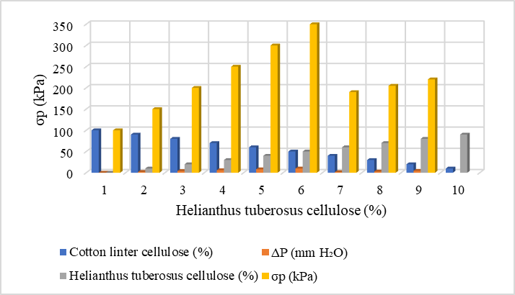
FIGURE 1. The impact of composition on the quality of a two-layer filter material.
The results suggest that for mixtures of cotton linter cellulose and Jerusalem artichoke cellulose, a double-layer creation process leads to poor results. Comparatively, filter materials made from Jerusalem artichoke cellulose and basalt fibers showed better results with a double-layer process than with a single-layer process.

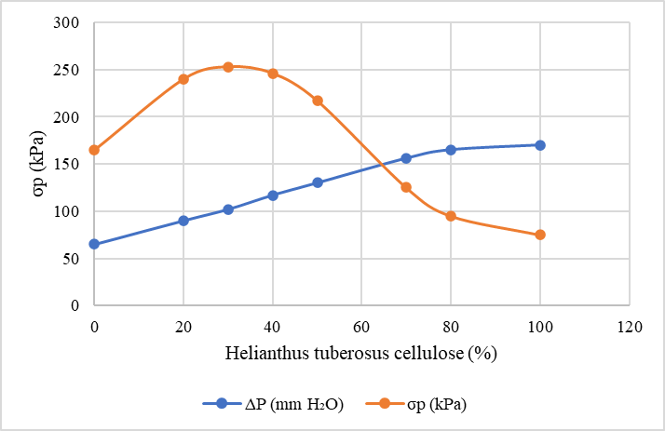 | 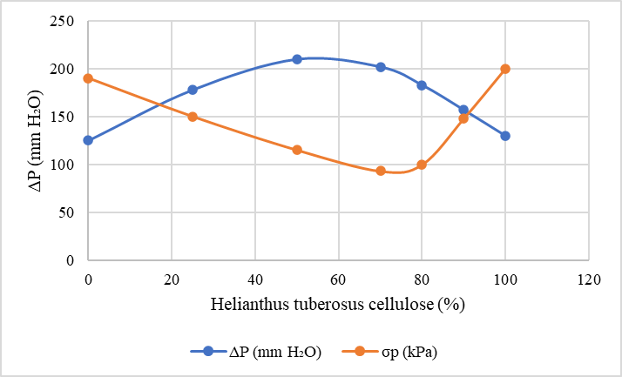
FIGURE 2. shows the impact of fiber composition on the quality of the filtration material. | FIGURE 3. The influence of fiber composition on the grade of filter media.
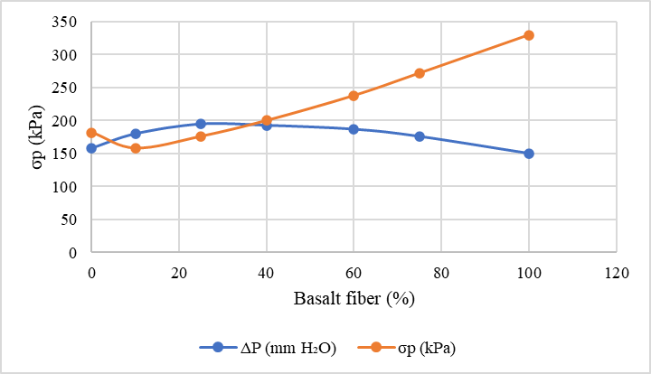 | 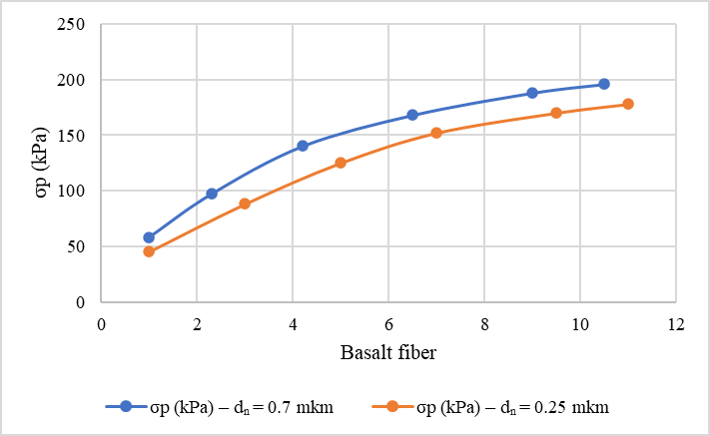
FIGURE 4. The impact of fiber composition on filter media quality. | FIGURE 5. Influence of fiber composition on the quality of the filter material.

A material with two layers containing cotton fibers shows less strength compared to a single layer, especially when using Jerusalem artichoke cellulose composites where d6=0.25 μm (compared to composites with d6=0.75 μm). These values are similar for both two-layer and single-layer formations.
Filtering materials from Jerusalem artichoke cellulose, with d6=0.25 and 0.75 μm, are not very sensitive to changes in the formation method. The resistance to air flow and the air flow coefficient for single and double-layer samples are alike, and the small differences aren't very important. The connection between formation method and strength is clearer when analyzing stability. Samples with less than 25% d6=0.75 μm Jerusalem artichoke cellulose show lower strength after two-layer formation. This paper quality depends on the sheet formation. When the sample has 75% d6=0.75 μm Jerusalem artichoke cellulose, the two-layer formation shows better strength.
The relation between strength and d6=0.7 μm Jerusalem artichoke cellulose composites is alike for one and two-layer formations: Strength rises as the amount of these fibers rise, but it rises more quickly with two-layer formation.
Two-layer filter materials with basalt fibers appear to be better than single layer. Two-layer filter materials made of basalt and Jerusalem artichoke cellulose with a diameter of 0.25 μm show greater strength across all tested levels. But, when there's less basalt fiber in the composition, strength goes down.
We see the same idea with mixes of basalt and Jerusalem artichoke cellulose with a diameter of 0.75 μm. Two-layer filtering materials made of mixtures of cotton fibers and basalt fibers are 1.5 to 2.0 times stronger than single-layer ones. But, reducing the number of basalt fibers does the reverse.
For other composites with basalt fiber, there isn't a clear link between the filter material's aerodynamic resistance and how it's formed. Generally, two-layer samples have a bit more aerodynamic resistance, but the difference is small, around 10 mm of water.
The two-layer formation method seems to help the air flow coefficient of filter material made from a mix of basalt and Jerusalem artichoke cellulose with d6=0.25 μm. In this mix, air flow is three times lower in two-layer materials than in single-layer ones. In both cases (basalt and Jerusalem artichoke cellulose ratios of 3:1 and 1:1), the coefficient fits what's needed for air cleaning materials.
Two-layer samples with other composites that have basalt fibers also have lower air flow. But the difference isn't much - less than 65 times. The set minimum of 0.0113% is too big for filter materials made to clean air.
With two-layer formation, the two samples join at their outsides, making a layer full of issues in the middle of the material. This doesn't happen with one-layer formation.
Jerusalem artichoke cellulose isn't made of strong fibers. So, changing how pure Jerusalem artichoke cellulose composites are formed doesn't change the structure much. Also, two-layer materials don't differ much from one-layer ones in quality.
Basalt fibers aren't stronger than cotton fibers. But they do contain normal fibers linked to foreign small things (or mixes).
When making the mix, these things don't break away from the fibers and move to the mold. So, two-layer forming of materials with basalt fiber is a lot like making two-layer plant fiber paper. The small number of issues in one layer are covered by the normal parts of the next layer. Two-layer materials have a alike design, and their quality is better than one-layer materials.
Changes in the quality of two and one-layer filter materials with different mixes depend on the chemical and physical and chemical details of the mineral fibers. For example, how many and how well these things can react, the size and type of the coordination electrokinetic potential with aluminum, the area of the fibers, and so on. But these things aren't very important here.
In short, changing from one-layer to two-layer formation allows mineral fiber filters to have a wider range of properties in some situations. Two-layer formation is suggested for materials with basalt fibers.
But we still might not get a good filter material for air cleaning with this method. Adding basalt fiber to filtering materials is a good idea for cleaning and sterilizing air in special cleaning filters.
CONCLUSION
Research shows that filter materials made from Jerusalem artichoke cellulose and basalt fibers using a two-layer method have good structural stability and strength. Samples with Jerusalem artichoke cellulose at d6=0.25 μm, mixed with basalt fibers, showed better permeability. The two-layer method, which involves combining layers under high pressure eliminates structural defects and improved material quality. These materials can make products with aerodynamic drag of less than 10 mm of water column, good stability, and self-healing properties in the filter layer. In summary, the two-layer filter materials made in this study are more when basalt fibers are added. This makes them useful for respirators, sterilizing technological gases, and industrial filtration systems.
REFERENCES
- De Rosa, I. M., Kenny, J. M., Puglia, D., Santulli, C., & Sarasini, F. (2010). Morphological, thermal and mechanical characterization of okra (Abelmoschus esculentus) fibres as potential reinforcement in polymer composites. Composites Science and Technology, 70, 116–122. https://doi.org/10.1016/j.compscitech.2009.09.013
- Sevilla, M., & Fuertes, A. B. (2011). Sustainable porous carbons with a superior performance for CO₂ capture. Energy & Environmental Science, 4, 1765–1771. https://doi.org/10.1039/C0EE00784F
- Mabuda, A., Mamphweli, N., & Meyer, E. (2016). Trends in the thermochemical conversion of biomass to energy. Renewable and Sustainable Energy Reviews, 53, 1656–1669. https://doi.org/10.1016/j.rser.2015.07.038
- Bhatia, S. K., Jagtap, S. S., Bedekar, A. A., et al. (2019). Recent developments in pretreatment technologies on lignocellulosic biomass: Effectiveness, challenges and future prospects. Bioresource Technology, 300, 122724. https://doi.org/10.1016/j.biortech.2019.122724
- Tofani, G., Cornet, I., & Tavernier, S. (2022). Recent advances in biomass conversion technologies for biofuel production. Biomass Conversion and Biorefinery, 12, 3409–3423. https://doi.org/10.1007/s13399-021-01628-4
- Kim, S. (2019). Life cycle assessment of biofuels: A review. Frontiers in Energy Research, 7, 72. https://doi.org/10.3389/fenrg.2019.00072
- Egamberdiyev, E. A., Turabdjanov, S., Azimov, D., Igamkulova, N., & Mengliev, S. (2025). Environmental and mechanical assessment of modified construction materials based on industrial waste. Procedia Environmental Science, Engineering and Management, 12, 261–267.
- Bedzo, O., Mandegari, M., Johann, F., & Görgens, J. F. (2020). Techno-economic assessment of integrated biorefineries for biofuel production. Biofuels, Bioproducts and Biorefining, 14, 766–780. https://doi.org/10.1002/bbb.2105
- Matías, J., Encinar, J. M., González, J., & González, J. F. (2015). Optimisation of biofuel production from biomass using thermochemical processes. Energy for Sustainable Development, 25, 34–41. https://doi.org/10.1016/j.esd.2015.01.003
- Mukhtorova, N., Egamberdiev, E., Turabdjanov, S., et al. (2024). Energy-efficient biomass utilization technologies for sustainable development. E3S Web of Conferences, 497, 03046. https://doi.org/10.1051/e3sconf/202449703046
- Li, Y., Zhang, R., Liu, G., et al. (2022). Biochemical conversion pathways of lignocellulosic biomass to biofuels. Biochemical Engineering Journal, 178, 108296. https://doi.org/10.1016/j.bej.2021.108296
- Yunusov, O., Egamberdiev, E., Azimov, D., et al. (2024). Sustainable bioenergy production from agricultural waste. E3S Web of Conferences, 497, 03053. https://doi.org/10.1051/e3sconf/202449703053
- Ergashev, Y., Egamberdiev, E., & Akmalova, G. (2024). Assessment of renewable energy potential based on biomass resources. E3S Web of Conferences, 477, 00053. https://doi.org/10.1051/e3sconf/202447700053
- Egamberdiev, E., Umarova, M., & Azimov, D. (2024). Eco-friendly binders and modifiers for construction and energy applications. E3S Web of Conferences, 497, 03052. https://doi.org/10.1051/e3sconf/202449703052
- Egamberdiev, E., Turabdjanov, S., & Mengliev, S. (2024). Physical and chemical properties of composite materials modified with waste-derived additives. E3S Web of Conferences, 497, 02026. https://doi.org/10.1051/e3sconf/202449702026
- Egamberdiyev, E. A., Turabdjanov, S., Azimov, D., Igamkulova, N., & Mengliev, S. (2025). Sustainable construction materials based on secondary raw resources. Procedia Environmental Science, Engineering and Management, 12(1), 261–267.
- Akhmatovna, A. M., Elmurod, E., Gulzat, O., Sabokhat, S., & Inomjon, M. (2025). Nanostructured modifiers and their influence on the performance of cement-based composites. Journal of Nanostructures, 15(3), 1041–1049. https://doi.org/10.22052/JNS.2025.03.021

