Visualization of Nickel Atom Clusters in Silicon using Near-Infrared Transmission Microscopy Based on a Digital Microscope
Kanatbay Ismailov¹, Ernazar Kosbergenov^{2,a)}, Sobir Isamov³, Bobir Isakov³, Giyosiddin Kushiev³, Temur Ismailov², Nuraddin Abdullayev², Xushbak Shamayev², Shoxida Sodiqova², Shohruh Sayfulloev², Mirzaakhmad Kurbanov²
¹ Karakalpak state university, Nukus, Uzbekistan
² National university of Uzbekistan, Tashkent, Uzbekistan
³ Tashkent State Technical University, Tashkent, Uzbekistan
⁴ Tashkent State Transport University, Tashkent, Uzbekistan
^{a)} Corresponding author: kosbergenov_y@nuu.uz
Abstract. A near-infrared transmission microscopy system based on a digital USB microscope of the 1600X type has been developed and experimentally tested for the visualization of defect regions and impurity atom clusters in silicon. A brief review of the physical properties and formation mechanisms of nickel-related clusters in silicon is presented to justify the experimental approach. The method operates in the near-infrared spectral range close to the fundamental absorption edge of silicon (λ ≈ 0.9–1.1 μm), where silicon becomes partially transparent, enabling transmission-mode imaging. Near-infrared images of nickel-doped silicon samples were obtained using the developed setup. It is shown that dark contrast regions are observed exclusively in nickel-doped samples, whereas such features are absent in undoped silicon, indicating their relation to the presence of nickel-containing impurity clusters and accompanying lattice defects. The characteristic sizes of the observed regions are on the order of several tens of micrometers, which is in qualitative agreement with literature data. The proposed near-infrared transmission system provides a simple, low-cost, and effective tool for qualitative diagnostics of silicon materials contaminated with metallic impurities and can be applied in micro- and nanoelectronics, as well as in educational and research laboratories.
INTRODUCTION
The interaction of silicon atoms with dopant and uncontrolled impurity atoms, as well as with intrinsic point defects, leads to the formation of various impurity–defect clusters [1-4]. In nickel-doped silicon, such clusters determine the thermal stability of electrical parameters and their evolution under external influences, including γ-irradiation. Similar clustering effects are observed for other impurity atoms such as Ga, Sb, Mn, Ge, Zn, and S, which form complex defect structures and binary compounds in the silicon lattice [5–12].
Magnetic and transport anomalies caused by transition-metal impurities in silicon have been reported for Mn-, Ge-doped, and mixed Ge_{x}Si_{1−x} - based systems [5–11]. The mechanisms of binary compound formation between Zn and S impurity atoms [12] and the technological control of multilayer silicon systems with binary nanoclusters involving Group III and V elements [13] further confirm the key role of impurity clustering.
Modification of the electronic structure of silicon due to impurity compounds was demonstrated for GaSb inclusions [14], while impurity transport processes such as electrodiffusion of manganese [15], redistribution of Mn and Cr [17], and surface segregation in Ga- and Sb-doped silicon [18] significantly affect the spatial distribution of electrically active centers. The effective charge states of Mn and Ni atoms under an external electric field were experimentally determined in Ref. [16].
A fundamental difference in the behavior of nickel in Czochralski-grown and float-zone silicon was established in Ref. [19]. In Cz-Si, the higher apparent Ni concentration is associated with the formation of Ni–P and Ni–P–O complexes promoted by oxygen, which acts as an efficient nucleation center for nickel precipitation.
Thus, numerous studies [1–19] indicate that nickel atoms in silicon actively participate in impurity–defect complex formation and clustering processes that significantly affect the electrical, magnetic, and optical properties of the material. However, direct visualization of such clusters in bulk silicon remains limited. This motivates the development of simple and accessible optical methods, including the near-infrared transmission microscopy approach applied in the present work.
In Ref. [20], the mechanisms of gettering and segregation of Ni atoms in p/p⁺ epitaxial wafers were investigated. It was demonstrated that the cluster size decreases with decreasing resistivity of the p⁺ substrates (Fig. 1). The formation of Ni atom clusters in the epitaxial layers is governed by the segregation effect at the p/p⁺ junction.

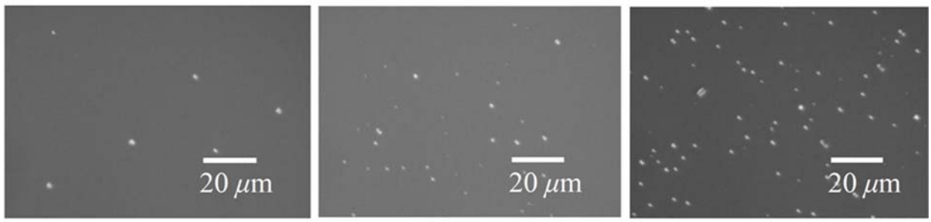
FIGURE 1. Optical micrographs of etch pits formed by nickel clusters on the surface of silicon wafers.

It was established that after quenching to room temperature, Ni atoms precipitate inside the crystal, forming clusters with a diameter of about 10 μm. With increasing annealing temperature, the cluster size increases.
Investigation of Ni clusters in Cz-Si by infrared (IR) transmission microscopy [21] revealed the presence of hexagonal precipitates (Fig. 2). The diameter of large hexagons is about 30 μm. Such structures are not observed in Fz-Si crystals, which indicates the role of oxygen as an impurity involved in dislocation pinning.
Ni clusters are formed both during diffusion and subsequent thermal treatment; however, they do not have a significant effect on the electrical parameters of silicon. The concentration, size, and composition of the clusters are determined by the annealing temperature, the overall Ni concentration, and the cooling rate.

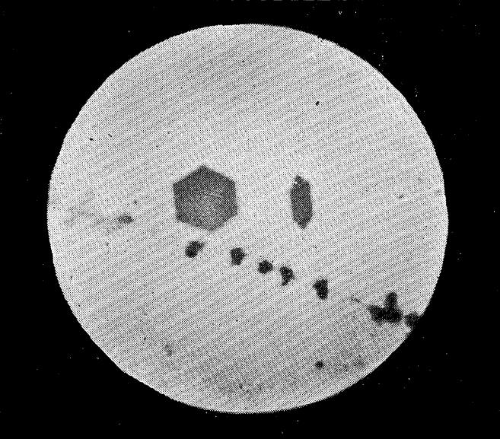 | 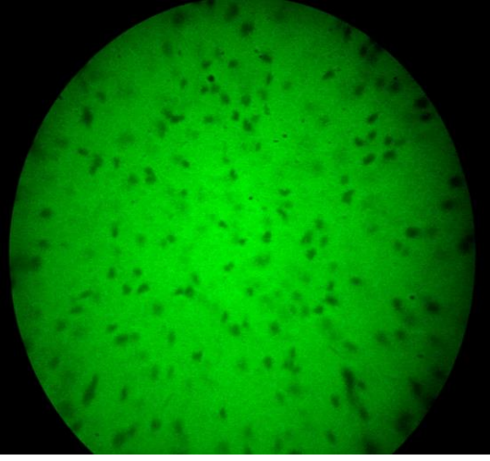
FIGURE 2. Infrared image of hexagonal nickel clusters with a size of 30 μm. | FIGURE 3. Infrared transmission image of Si samples.

Studies performed by IR microscopy [22] have shown that Ni atoms in the Si lattice form clusters as a result of self-organization. Thermal treatment in the temperature range of 650–900 °C leads to changes in the concentration and size of the clusters, as well as to the formation of loop-shaped block structures (Fig. 3).
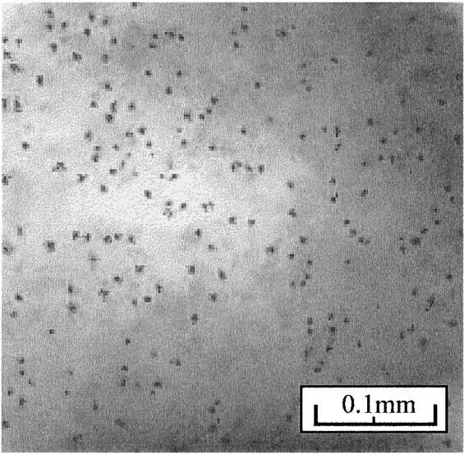 | 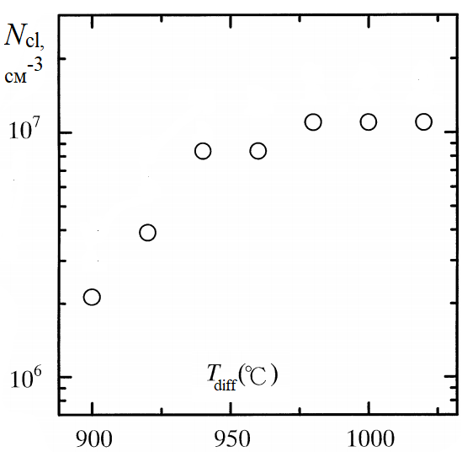
a | b
FIGURE 4. (a) Infrared image of nickel-doped Si samples, (b) dependence of the cluster concentration on the diffusion annealing temperature.

The cluster concentration varies with time in accordance with a dissociative mechanism. The diffusion and annealing processes are accelerated due to the precipitation of nickel in the bulk. It was noted in Ref. [23] that the spots observed in the IR images of Si samples are associated with the precipitation of Ni atoms, since they are absent in the reference samples (Fig. 4). The cluster diameter typically ranges from 1 to 3 μm, and their concentration is on the order of 10⁶–10⁷ cm⁻³.
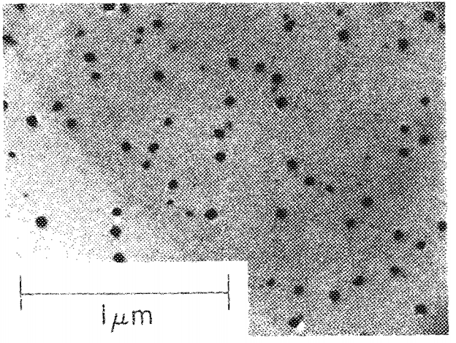 | 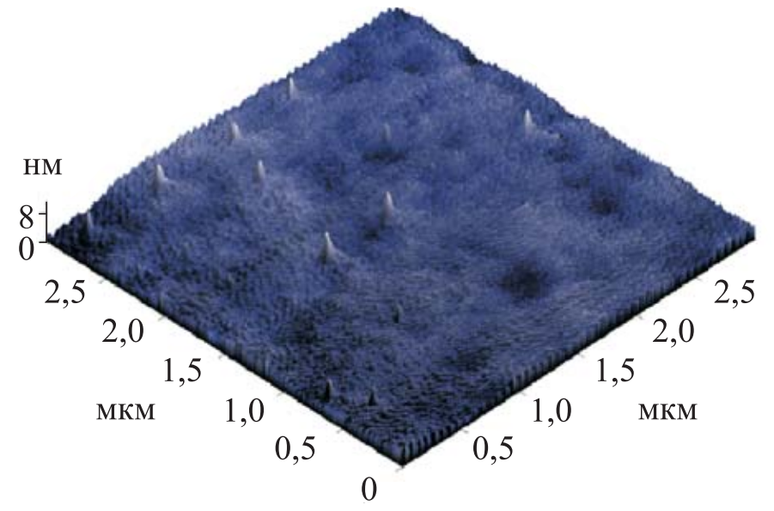
FIGURE 5. Micrograph of amorphous silicon implanted with Ni atoms. | FIGURE 6. Three-dimensional image of the surface of the n-Si⟨P, Ni⟩ sample.

Ref. [24] reported the formation of Ni clusters in thin films of amorphous Si implanted with nickel. Upon annealing, Ni clusters with sizes of less than 1 μm are formed (Fig. 5).
Ni clusters on the silicon surface contain significant amounts of oxygen and recombination impurities (Cu, Fe, Cr) [1,13]. However, no inter-impurity interaction is observed during the simultaneous diffusion doping of Si with Mn and Ni atoms [5,6]. Ni clusters exhibit an anomalously high diffusion mobility (D ≈ 10⁻⁹ cm²/s at T = 800 °C) [22].
Ni atoms can be used as getters for the removal of gold sample from Si and also reduce the oxygen concentration in Si and Ge. The introduction of Ni into Si leads to the appearance of negative magnetoresistance (up to 10%) and to a decrease in resistivity at low temperatures [26]. These effects are explained by the formation of magnetic clusters of impurity atoms.
The size and shape of the clusters determine their structure (monolayer or multilayer) [25-30]. Under hydrostatic pressure in the range of P = 10⁸–1.6 × 10⁹ Pa, the destruction of Ni clusters occurs, which leads to an increase in the resistivity of the samples.
Deep levels are observed in Si samples [28]. Their concentration depends on the quenching conditions after diffusion. It is assumed that the electrically active levels are formed by Ni–V complexes and depend on the configuration of Ni atoms in the lattice. During slow cooling, Ni atoms have sufficient time to migrate to dislocations, forming electrically inactive clusters. With increasing diffusion temperature, the concentration of these levels, for example E_{V}+0.152 eV, decreases, which is explained by their clustering.
Studies show that Ni atoms form impurity–defect formations of a star-like shape (Fig. 6), with sizes reaching 10–40 μm. At the same time, the minority carrier lifetime (τ) increases with increasing cluster concentration [25].
The literature review indicates that the study of nickel clusters in silicon is a relevant and important research problem. One of the accessible and effective methods for such investigations is infrared microscopy.

EXPERIMENTAL RESEARCH
To visualize defect regions and impurity atom clusters in silicon, a transmission optical scheme in the near-infrared spectral range was implemented using a digital USB microscope of the 1600X type.
The physical principle of the method is based on the fact that silicon is opaque in the visible wavelength range (λ<0.7 μm) and becomes partially transparent in the near-infrared region near the band-gap edge (λ≈0.9–1.1 μm). In this spectral range, the absorption coefficient of silicon decreases sharply, which makes it possible to implement transmission-mode imaging of the sample and to form an image due to the transmitted radiation.
The optical scheme of the setup (Fig. 7), placed in a metal housing (1), includes a continuous radiation source—a tungsten incandescent lamp (2), which forms a broad spectrum containing visible and near-infrared components (7). The radiation is focused onto the investigated silicon sample using a convex lens (3). To suppress the visible part of the spectrum, a silicon filter (5) was used in the optical path; it effectively absorbs radiation in the visible range and partially transmits near-infrared radiation (8). The sample is mounted on a substrate (4) with a circular aperture.
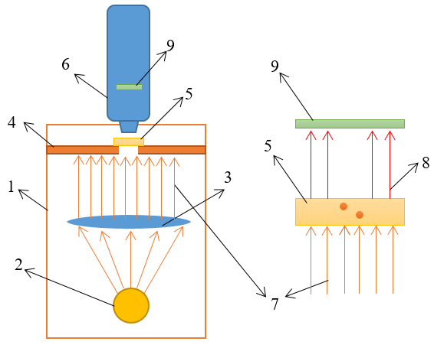
FIGURE 7. Schematic diagram of the setup for registering infrared radiation from nickel atoms. The beam (7) containing IR spectral components is incident on the silicon sample (5). The transmitted beam (8) passing through the silicon (5) is detected by the sensor of the digital microscope (9).

The radiation transmitted through the sample is detected by the CMOS sensor (9) of the digital microscope (6). The microscope sensor has a spectral sensitivity in the range of 0.35–1.0 μm, which corresponds to the near-infrared region close to the fundamental absorption edge of silicon. The image contrast is formed due to local variations in the absorption coefficient associated with the presence of impurity atom clusters, crystal lattice defects, and structural inhomogeneities.
The digital microscope is connected to a personal computer via a USB interface. Image acquisition and processing were performed using the HiView software, which provides real-time capture of static images and video recording (Fig. 8).
A standard calibration film with linear and grid reference structures (Fig. 9) was used for spatial scale calibration. This made it possible to measure the characteristic dimensions of the observed defect regions and impurity atom clusters.
Before the measurements, the silicon samples were subjected to mechanical treatment. The surface was ground and subsequently polished using a special abrasive paste to eliminate surface damage and to ensure optical uniformity (Fig. 10). Control measurements were also performed on undoped silicon samples.

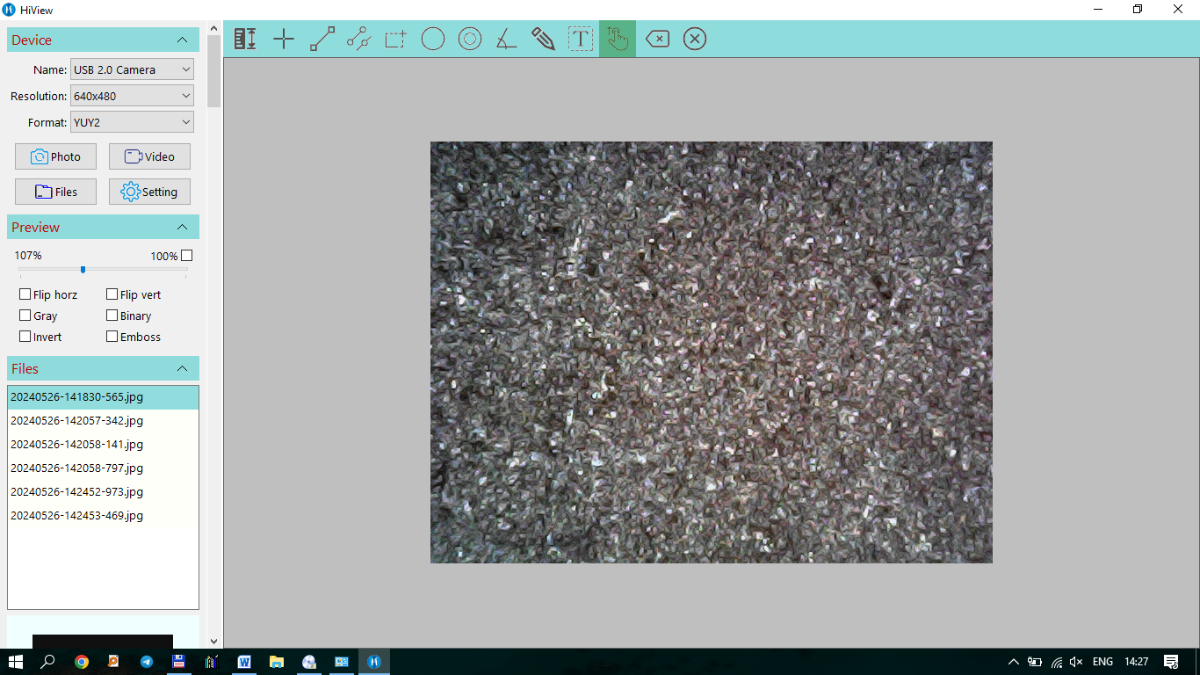
FIGURE 8. HiView software interface.
It should be noted that the developed setup operates in the near-infrared transmission microscopy mode in the wavelength region adjacent to the band-gap edge of silicon. The used system does not belong to classical mid- and far-infrared microscopes; however, it provides sufficient optical contrast for high-quality visualization of defect regions and impurity atom clusters in silicon.
RESULTS
During the operation of the setup, a dedicated software package HiView was used for image acquisition and analysis (Fig. 8). The system is also equipped with a calibration film containing lines of various thicknesses, grids, circles, and scales for measuring small regions of the image.
The calibration film (Fig. 9) includes:
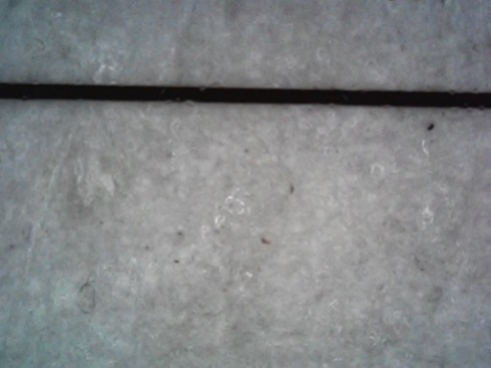 | 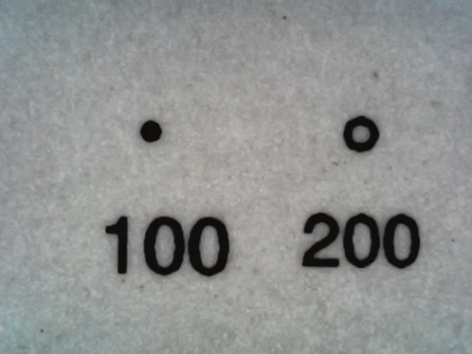
a | b
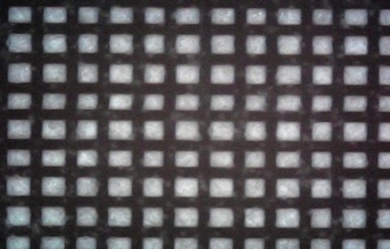 | 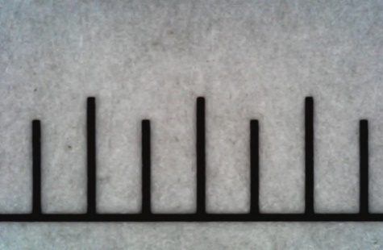
c | d
FIGURE 9. Reference standards for calibration and measurement of image dimensions.
a) a line with a thickness of 30 μm; b) circles with diameters of 100 and 200 μm;
c) a grid with a cell size of 100 μm; d) a scale with a division of 500 μm.
Using the developed setup, near-infrared images of silicon doped with nickel atoms were obtained. To acquire high-quality data, the samples were preliminarily polished by a mechanical method using a special polishing paste. Figure 10(a) shows the samples after grinding (before polishing), while Fig. 10(b) shows the samples after polishing. Undoped silicon samples were also examined for reference.

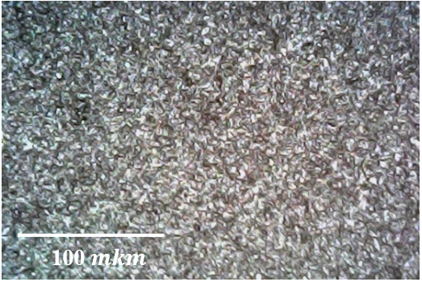 | 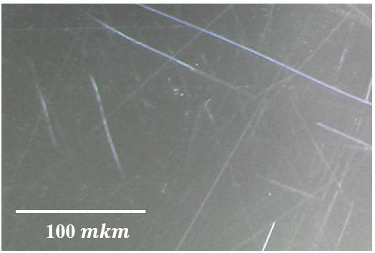
FIGURE 10. Images of silicon samples before (a) and after (b) polishing.
In the near-infrared images of nickel-doped silicon, dark regions are observed, whereas such features are absent in the undoped samples. This allows concluding that the dark areas are associated with nickel-containing compounds. (Fig. 11). The obtained results are in good agreement with the data acquired using other types of infrared microscopes.

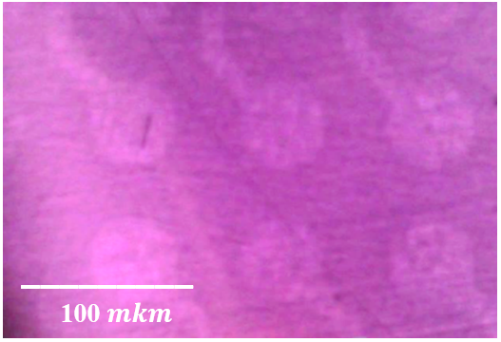 | 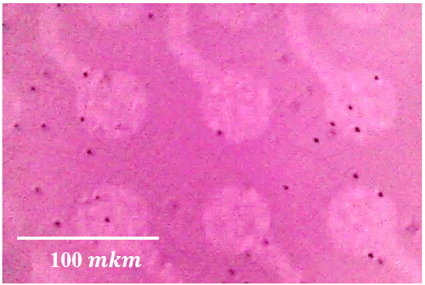
FIGURE 11. Near-infrared images of silicon: (a) undoped; (b) nickel-doped.

CONCLUSIONS
In this work, a transmission optical system operating in the near-infrared range based on a digital USB microscope of the 1600X type was implemented and experimentally tested for the visualization of defect regions and impurity atom clusters in silicon.
It is shown that near the fundamental absorption edge of silicon (λ≈0.9–1.1 μm), the registration of transmitted radiation and the formation of contrast become possible due to local variations in the absorption coefficient. In this spectral range, the dark regions observed in the images of nickel-doped silicon are associated with the presence of impurity atoms and accompanying crystal lattice defects.
It was established that pronounced dark regions are absent in the images of undoped silicon samples, whereas stable contrast inhomogeneities characteristic of impurity clusters are observed in nickel-doped samples. The characteristic sizes of the observed regions are in the range of several tens of micrometers and are in good qualitative agreement with the literature data.
The developed near-infrared transmission system provides stable visualization of the spatial distribution of impurity atom clusters and can be used for qualitative diagnostics of silicon materials contaminated with metallic impurities. The advantages of the proposed approach include its simplicity of implementation, the availability of its components, and the possibility of rapidly acquiring visual information on structural inhomogeneities.
It should be noted that the results obtained in this work are predominantly qualitative. Further targeted studies are required for the quantitative determination of cluster concentrations, construction of statistical size distributions, and establishment of correlations with the electrophysical parameters of silicon.
The proposed method can be applied for preliminary diagnostics of silicon wafers for micro- and nanoelectronics, for monitoring technological cleanliness, as well as in educational and research laboratories for studying the processes of impurity atom clustering in semiconductors.
REFERENCES
- M. K. Bakhadyrkhanov, K. A. Ismailov, and E. Zh. Kosbergenov, Thermal stability of electrical parameters of silicon crystal doped with nickel during growth, Semiconductor Physics, Quantum Electronics & Optoelectronics 25(1), 6–9 (2022). https://doi.org/10.15407/spqeo25.01.006
- M. Iliev, K. A. Ismailov, E. Zh. Kosbergenov, V. B. Odzhaev, V. S. Prosolovich, Yu. N. Yankovsky, Z. T. Kenzhaev, B. O. Isakov, and G. A. Kushiev, The Influence of γ-Irradiation on the Electrophysical Parameters of Nickel-Doped Silicon Grown by the Czochralski Method, Surface Engineering and Applied Electrochemistry 61(6), 854–859 (2025). https://doi.org/10.3103/S1068375525700942
- Z. T. Kenzhaev, Kh. M. Iliev, V. B. Odzhaev, G. Kh. Mavlonov, V. S. Prosolovich, E. Zh. Kosbergenov, B. K. Ismaylov, S. B. Isamov, and Sh. Z. Ollambergenov, The effect of gamma irradiation on the electrophysical parameters of nickel-doped silicon solar cells, Surface Engineering and Applied Electrochemistry 60(6), 851–856 (2024). https://doi.org/10.3103/S1068375524700467
- Kh. M. Iliev, S. V. Koveshnikov, B. O. Isakov, E. Zh. Kosbergenov, G. A. Kushiev, and Z. B. Khudoynazarov, Elemental composition investigation of silicon doped with gallium and antimony atoms, Surface Engineering and Applied Electrochemistry 60(5), 633–639 (2024). https://doi.org/10.3103/S106837552470025X
- N. F. Zikrillaev, S. V. Koveshnikov, L. Trabzon, G. Kh. Mavlonov, B. K. Ismaylov, T. B. Ismailov, and F. E. Urakova, Ferromagnetic properties of silicon doped with manganese atoms, Surface Engineering and Applied Electrochemistry 61(1), 75–80 (2025). https://doi.org/10.3103/S1068375524700571
- N. F. Zikrillayev, G. Kh. Mavlonov, L. Trabzon, S. V. Koveshnikov, Z. T. Kenzhaev, T. B. Ismailov, and Y. A. Abduganiev, Magnetic properties of silicon with paramagnetic impurity atoms, East European Journal of Physics 3, 380–384 (2023). https://doi.org/10.26565/2312-4334-2023-3-40
- G. A. Kushiev, B. O. Isakov, and U. X. Mukhammadjonov, Prospects of obtaining a new material with a hetero-baric structure Ge_{x}Si_{1−x} based on silicon for photoenergy applications, Journal of Nano- and Electronic Physics 16(3), 03003 (2024). https://doi.org/10.21272/jnep.16(3).03003
- N. F. Zikrillaev, A. A. Sattorov, X. F. Zikrillaev, U. Kh. Kurbanova, N. Norkulov, M. M. Shoabdurakhimova, G. A. Kushiev, Y. A. Abduganiev, and N. Abdullaeva, Effect of uniaxial compression on excitation conditions and parameters of low-frequency auto-oscillations of current in compensated silicon, Journal of Nano- and Electronic Physics 17(2), 02014 (2025). https://doi.org/10.21272/jnep.17(2).02014
- N. F. Zikrillaev, F. E. Urakova, A. R. Toshev, G. A. Kushiev, T. B. Ismailov, Y. A. Abduganiev, and N. Norkulov, Physical and magnetic properties of silicon doped with impurity germanium atoms, East European Journal of Physics 1, 184–189 (2025). https://doi.org/10.26565/2312-4334-2025-1-18
- N. F. Zikrillaev, K. S. Ayupov, N. Narkulov, F. E. Urakova, G. A. Kushiev, and O. S. Nematov, Silicon with binary Ge_{x}Si_{1−x} compounds, Surface Engineering and Applied Electrochemistry 60(6), 806–813 (2024). https://doi.org/10.3103/S106837552470039X
- N. F. Zikrillaev, Kh. M. Iliev, G. A. Kushiev, S. B. Isamov, S. V. Koveshnikov, B. A. Abdurakhmanov, and B. O. Isakov, Study of photocells based on Ge_{x}Si_{1−x} structures, Journal of Applied Science and Engineering 29(3), 685–691 (2026). https://doi.org/10.6180/jase.202603_29(3).0019
- N. F. Zikrillaev, M. K. Khakkulov, and B. O. Isakov, Mechanism of the formation of binary compounds between Zn and S impurity atoms in the Si crystal lattice, East European Journal of Physics 4, 177–181 (2023). https://doi.org/10.26565/2312-4334-2023-4-20
- N. F. Zikrillayev, S. B. Isamov, B. O. Isakov, T. Wumaier, Li Wen, J. X. Zhan, and T. Xiayimulati, New technological solution for the tailoring of multilayer silicon-based systems with binary nanoclusters involving elements of Groups III and V, Journal of Nano- and Electronic Physics 15(6), 06024 (2023). https://doi.org/10.21272/jnep.15(6).06024
- Kh. M. Iliev, N. F. Zikrillaev, K. S. Ayupov, B. O. Isakov, B. A. Abdurakhmanov, Z. N. Umarkhodjaeva, and L. I. Isamiddinova, Effect of GaSb compound on silicon band-gap energy, Journal of Nano- and Electronic Physics 16(2), 02004 (2024). https://doi.org/10.21272/jnep.16(2).02004
- X. M. Iliyev, Z. B. Khudoynazarov, B. O. Isakov, M. X. Madjitov, and A. A. Ganiyev, Electrodiffusion of manganese atoms in silicon, East European Journal of Physics 2, 384–387 (2024). https://doi.org/10.26565/2312-4334-2024-2-48
- B. O. Isakov, X. M. Iliyev, Z. B. Khudoynazarov, and G. A. Kushiev, Effective charge of Mn and Ni impurity atoms in silicon under the influence of an external electric field, East European Journal of Physics 2, 215–219 (2025). https://doi.org/10.26565/2312-4334-2025-2-23
- G. H. Mavlonov, Kh. Kh. Uralbaev, B. O. Isakov, Z. N. Umarkhodjaeva, and Sh. I. Hamrokulov, Diffusion distribution of Cr and Mn impurity atoms in silicon, East European Journal of Physics 2, 237–241 (2025). https://doi.org/10.26565/2312-4334-2025-2-27
- X. M. Iliyev, S. B. Isamov, B. O. Isakov, U. X. Qurbonova, and S. A. Abduraxmonov, Surface study of Si doped simultaneously with Ga and Sb, East European Journal of Physics 3, 303–307 (2023). https://doi.org/10.26565/2312-4334-2023-3-29
- R. D. Thompson, D. Gupta, and K. N. Tu, Low-temperature behavior and solubility of Ni in P-doped Czochralski-grown Si, Physical Review B 33(4), 2636–2641 (1985).
- K. Torigoe, T. Ono, and K. Nakamura, Competitive interaction between segregation gettering and surface precipitation of nickel in p/p⁺⁺ silicon epitaxial wafers, ECS Journal of Solid State Science and Technology 4(9), 110–114 (2015).
- T. Iizuka, M. Kikuchi, and K. Kanasaki, Hexagonal platelets observed in nickel-diffused silicon, Japanese Journal of Applied Physics 2, 309–310 (1963).
- M. K. Bakhadyrkhanov, Kh. M. Iliev, K. S. Ayupov, B. A. Abdurakhmonov, Yu. P. Krivenko, and R. L. Kholmukhamedov, Self-organization of nickel atoms in silicon, Inorganic Materials 47(9), 962–964 (2011).
- S. Tanaka, T. Ikari, and H. Kitagawa, In-diffusion and annealing processes of substitutional nickel atoms in dislocation-free silicon, Japanese Journal of Applied Physics 40, 3063–3068 (2011).
- R. C. Cammarata, C. V. Thompson, and K. N. Tu, NiSi₂ precipitation in nickel-implanted silicon films, Applied Physics Letters 51, 1106–1108 (1987).
- S. Z. Zainabidinov and A. O. Kurbanov, Clusters of nickel impurity atoms and their influence on the recombination properties of silicon, Bulletin of Bauman Moscow State Technical University, Series Natural Sciences 2, 81–93 (2019).
- S. Yatsukhnenko, A. Druzhinin, I. Ostrovskii, Y. Khoverko, and M. Chernetskiy, Nanoscale conductive channels in silicon whiskers with nickel impurity, Nanoscale Research Letters 12, 78 (2017).
- N. A. Turgunov, E. Kh. Berkinov, and D. Kh. Mamajonova, Decay of impurity clusters of nickel and cobalt atoms in silicon under the influence of pressure, Journal of Nano- and Electronic Physics 13(5), 05006 (2021).
- L. Scheffler, Vl. Kolkovsky, and J. Weber, Electrical levels in nickel-doped silicon, Journal of Applied Physics 116, 173704 (2014).
- N.F. Zikrillaev et al., J. Nano- Electron. Phys. 17 No 2, 02014 (2025) https://doi.org/10.21272/jnep.17(2).02014
- N.F. Zikrillaev, G.A. Kushiev, Sh.I. Hamrokulov, Y.A. Abduganiev. Optical Properties of GexSi1–x Binary Compounds in Silicon. J. Nano- Electron. Phys. 15 No 3, 03024 (2023) https://doi.org/jnep.15(3).03024M.K.

