Electroless Nickel Contacts for Laboratory Characterization of Silicon Solar Cells
Kanatbay Ismailov¹, Ernazar Kosbergenov^{2, a)}, Anvar Yunusov², Giyosiddin Kushiev³, Ravshan Alimov², Nebodir Nurmatov², Yunusali Xolboyev², Хayotjon Kurbanov⁴, Mavjuda Mansurova⁴, Shoira Usmanova ⁵
¹ Karakalpak state university, Nukus, Uzbekistan
² National university of Uzbekistan, Tashkent, Uzbekistan
³ Tashkent State Technical University, Tashkent, Uzbekistan
⁴ Tashkent State Transport University, Tashkent, Uzbekistan
⁵ National Pedagogical University of Uzbekistan, Tashkent, Uzbekistan
^{a)} Corresponding author: kosbergenov_y@nuu.uz
Abstract. A low-temperature technology for the formation of ohmic Ni–P contacts to mono- and polycrystalline silicon solar cells by electroless nickel deposition is developed and experimentally validated. The contacts were formed at 80–90 °C without the use of vacuum equipment or high-temperature annealing. The current–voltage characteristics of the solar cells were measured under illumination before and after contact formation. The chemically deposited nickel contacts provide stable electrical characteristics suitable for rapid laboratory diagnostics of photovoltaic structures.. Scanning electron microscopy and energy-dispersive X-ray spectroscopy reveal that the deposited layer is uniform and continuous and consists mainly of nickel (78–80 at.%) with a phosphorus content of 5–6 at.%. The proposed method is intended for fast laboratory fabrication of ohmic contacts and express electrical characterization of silicon solar cells in preliminary technological and diagnostic studies.
INTRODUCTION
Reliable formation of ohmic contacts is one of the key technological problems in the investigation and characterization of silicon-based photovoltaic structures. In laboratory studies of solar cells, it is often necessary to perform rapid electrical measurements without using complex vacuum metallization systems and high-temperature annealing procedures. Conventional contact systems based on Ag, Al, or Ti typically require vacuum deposition and thermal treatment at temperatures exceeding 400 °C, which significantly complicates express diagnostics of experimental samples.
Nickel is widely used in silicon technology as an impurity and contact material due to its pronounced influence on the thermal stability and electrophysical parameters of silicon crystals and solar cells. The effect of nickel on the stability and electrical properties of silicon has been demonstrated in a number of studies, including investigations of thermal stability and radiation effects in nickel-doped silicon and silicon solar cells [1–3]. These results indicate that nickel-containing systems are of considerable interest for both fundamental and applied research in silicon electronics and photovoltaics.
Various approaches to modifying the electrophysical and photoelectric properties of silicon are actively investigated for photovoltaic applications. In particular, the formation of Ge_{x}Si_{1−x} ​ structures, incorporation of GaSb compounds, and the development of silicon-based photoactive heterostructures have been shown to significantly affect the band structure and photoresponse of silicon [4,7,10,11,14]. These studies demonstrate the high potential of silicon modification for photoenergy applications.
The functional properties of silicon can also be substantially altered by introducing various impurity atoms and binary compounds, which affect its electrical, magnetic, and dynamic characteristics. The influence of magnetic impurities, paramagnetic atoms, and binary compound formation on the physical properties of silicon has been reported in a number of works [5,6,8,9,12,13].
Various methods of impurity introduction and surface modification of silicon, including electrodiffusion and diffusion of transition metal atoms, are widely used in semiconductor technology to control its electrical properties [15–18]. These techniques are essential for tailoring silicon structures for electronic and photovoltaic applications.
Among low-temperature contact formation techniques, electroless nickel deposition is a promising method due to its simplicity, low cost, good adhesion to silicon, and the possibility of forming conductive Ni–P layers without vacuum equipment. A technological basis for nickel metallization of silicon solar cells using low-temperature electrolytes has been reported previously [19].
In the present work, a low-temperature technology for the formation of ohmic Ni–P contacts to mono- and polycrystalline silicon solar cells by electroless nickel deposition is developed and experimentally validated. The main purpose of this study is not to optimize the energy conversion efficiency of the solar cells, but to demonstrate the applicability of chemically deposited nickel contacts for rapid laboratory electrical characterization of photovoltaic structures under illumination.

EXPERIMENTAL RESEARCH
Industrial mono- and polycrystalline silicon solar cells with a p⁺–p–n⁺ structure and a p–n junction depth of approximately 0.5 μm were used as the objects of investigation. The initial electrical parameters of the samples are presented in Table 1.
Rectangular specimens were prepared using a STX-402 diamond wire cutting system, which provides a cutting accuracy of ±10 μm. Prior to nickel deposition, the front and rear factory-made contacts and antireflection coatings were removed using chemical etching: 70% HNO₃ for the front contact, 30% HCl for the rear contact, and 10% HF for the antireflection layer.

TABLE 1. Main parameters of the investigated industrial solar cells.
Solar cell type | Parametres
Solar cell type | $$U_{oc}, mV$$ | $$J_{sc}, mA/cm^{2}$$
Mono-Si | 612 | 44
Poly-Si | 593 | 38

Ohmic contacts were formed by electroless nickel deposition.
The current–voltage characteristics (I–V curves) of the investigated solar cells were measured using a Keithley 2450 source-measure unit. The Keithley 2450 is a four-quadrant current and voltage source combined with high-precision voltmeter and ammeter functions.
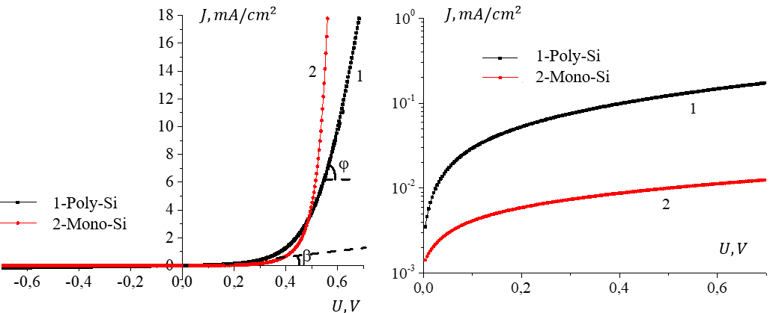
a | b
FIGURE 1. Forward (a) and reverse (b) current–voltage characteristics of industrial polycrystalline Si (1) and monocrystalline Si (2) solar cells with nickel contacts.
Main specifications of the Keithley 2450 source-measure unit: resolution of 6.5 digits; basic accuracy of 0.012%. Voltage: sourcing range from 0.5 µV to 200 V and measurement range from 10 nV to 210 V. Current: sourcing range from 0.5 nA to 1 A and measurement range from 10 fA to 1.05 A. Resistance measurement range from 1 mΩ to 200 MΩ. Measurement speed up to 3130 readings per second with the formation of sweep and data point sequences.
Figure 1 shows the current–voltage characteristics of the solar cells with nickel contacts measured using the Keithley 2450 source-measure unit.
Formation of ohmic contacts. The ohmic contacts were formed using the electroless nickel deposition method [19-21]. This technique does not require thermal treatment at temperatures above 400 °C.
The deposition process is autocatalytic (metallic nickel catalyzes the reduction reaction); therefore, the deposition occurs only on the surface and does not proceed in the bulk of the solution. The silicon surface in an alkaline solution also exhibits catalytic activity.
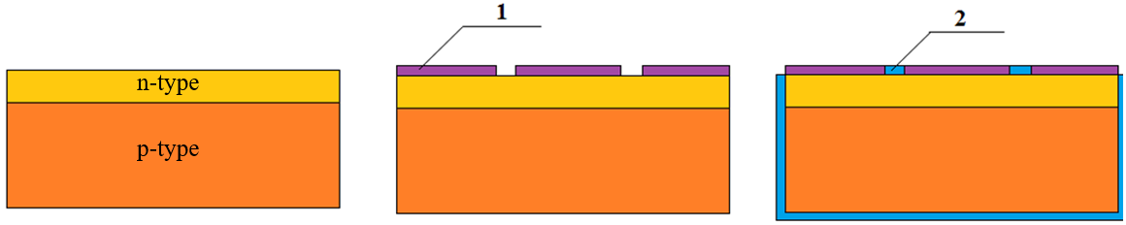
a | b | c

d | e | f
FIGURE 2. Technological stages of forming an ohmic contact based on electroless nickel deposition: (a) initial p–n structure, (b) front-side masking, (c) nickel deposition, (d) masking of front and rear sides, (e) removal of nickel from sidewalls, (f) removal of the protective mask.

The fabrication of ohmic contacts to the solar cells by electroless nickel deposition consists of five technological stages (Fig. 2).
- After the formation of the p–n junction (Fig. 2a), the front surface of the solar cell is protected by an adhesive mask with a slit-shaped opening 0.7–1.0 mm wide (Fig. 2b).
- The specimen is immersed in the electroless nickel-plating bath, the temperature of which is maintained at T = 80–90 °C. The composition of the deposition solution is as follows (g/L): NiCl₂·6H₂O – 21; NaH₂PO₂·H₂O – 24; Na₃C₆H₅O₇·2H₂O – 45; NH₄Cl – 30; aqueous NH₃ (25 wt.%) – 4–5 mL/L. The solution is prepared in a fixed sequence: all chemical reagents except NaH₂PO₂·H₂O are first dissolved in water using an enamel vessel. The solution is then heated to the operating temperature, after which the NaH₂PO₂·H₂O solution is added.
The nickel deposition rate reaches up to 18 µm/h at 90 °C. During the nickel-plating process, the rear and side surfaces of the specimen are completely covered with a metallic nickel layer with a thickness of several micrometers (Fig. 2c).
- The front and rear surfaces of the specimen are then protected with adhesive tape (Fig. 2d).
- To remove the nickel coating from the sidewalls, the specimen is immersed in 50% HNO₃ (Fig. 2e).
- After etching, the protective mask is removed (Fig. 2f).
It is observed that the deposited nickel coating is continuous and free of visible defects over the entire surface (Figs. 3a,b). The uniformity of the coating indicates stable deposition conditions. The adhesion of the nickel layer to the silicon surface was qualitatively evaluated by mechanical scratching with a sharp tool. No peeling or delamination of the coating was detected in the scratched regions, which indicates good adhesion of the electroless nickel layer to the silicon substrate.

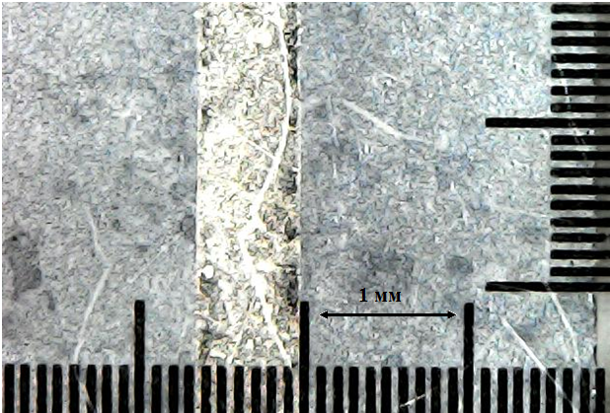  Si  Ni |   Ni  Si
a | b
FIGURE 3. Front (a) and rear (b) surfaces of the specimen after electroless deposition of a metallic nickel layer, obtained using a Digital Microscope (1600× magnification).
Measurement of p–n junction parameters. The parameters of the p–n junctions of the solar cells were measured under illumination from a halogen incandescent lamp at a temperature of approximately 25 °C with an irradiation power density of about 150 mW/cm². The lamp was powered by a stabilized voltage supply. The sample temperature was maintained using a passive water thermostat with an accuracy of ±1 °C. In order to minimize temperature variations during the measurements, the samples were illuminated in a pulsed mode with a period of 15 s and a pulse duration of 1 s.
From the current–voltage characteristics of the solar cells, the open-circuit voltage $U_{oc}$ and the short-circuit current density $J_{sc}$ were determined. The main electrical parameters of the industrial mono- and polycrystalline silicon solar cells are presented in Table 2.
In most cases, the current–voltage characteristic of a solar cell can be expressed in the following form,
$I=I_{0}\left(\exp\left(\frac{q\left(U-IR_{s}\right)}{kT}\right)-1\right)+\frac{U-IR_{s}}{R_{sh}}$ (1)
where $R_{s}$ is the series resistance and $R_{sh}$ is the shunt resistance [12].

TABLE 2. Main parameters of the investigated industrial solar cells with nickel contacts.
Solar cell type | Parameters
Solar cell type | $U_{oc}$, $mV$ | $J_{sc}$, $mA/cm^{2},$
Mono-Si | 580 | 33
Poly-Si | 545 | 28

The forward current–voltage characteristics shown in Fig. 1a were used to determine the series resistance $R_{s}$ by the graphical method based on the cotangent of the slope angle $φ$, where $ctgφ=R_{s}$. With increasing $R_{s}$, the forward branch of the I–V characteristic approaches a linear dependence with $ctgφ=R_{s}$.
The reverse current–voltage characteristics presented in Fig. 1b were employed to evaluate the shunt resistance $R_{sh}$. The influence of $R_{sh}$ was estimated by summing, at equal voltages, the currents determined from the solar cell I–V curve at zero shunt resistance and from a straight line with ctgβ=$R_{sh}$. For an ideal solar cell, $R_{s}=0$ and $R_{sh}→∞$.
For the investigated samples, it is established that $R_{s}\left(poly\right)>R_{s}(mono)$, whereas $R_{sh}\left(poly\right)<R_{sh}(mono)$.
The surface morphology and elemental composition of the samples were studied using an EVO 50 XVP scanning electron microscope (Carl Zeiss) equipped with an INCA Energy 350 microanalysis system (Oxford Instruments). The images were formed using various detection signals, often simultaneously.
The spatial resolution of the microscope is 3 nm at 30 kV in the secondary electron (SE) mode using a W (LaB₆) cathode. The accelerating voltage range is $200-30000 V$. The operating vacuum range is approximately 400 Pa. The magnification range is from $5×$ to $1,000,000×$.
FIGURE 4. Surface of the specimen after electroless deposition of a metallic nickel layer.

Elemental analysis was performed using an energy-dispersive X-ray (EDX) spectrometer with a detection range from boron to uranium and a sensitivity down to 0.1 at.%. The energy-dispersive X-ray spectroscopy (EDX) method is based on the analysis of the energy of characteristic X-ray emission generated by the interaction of the SEM electron beam with the sample material.
The EDX analysis shows that the chemically deposited nickel layer consists mainly of Ni atoms (78–80 at.%) with a phosphorus content of 5–6 at.%.
CONCLUSIONS
A low-temperature electroless deposition technique for the formation of ohmic Ni–P contacts to mono- and polycrystalline silicon solar cells has been developed and experimentally validated. It is established that the deposited Ni–P layers are uniform and continuous, with a nickel content of 78–80 at.% and a phosphorus content of 5–6 at.%.
The fabricated contacts ensure stable current–voltage characteristics of the solar cells under illumination without the use of vacuum equipment or high-temperature annealing. This significantly simplifies the technological procedure and reduces the time required for sample preparation.
The proposed method is intended for rapid laboratory electrical characterization of silicon photovoltaic structures and can be effectively applied in preliminary technological and diagnostic studies.
REFERENCES
- M. K. Bakhadyrkhanov, K. A. Ismailov, and E. Zh. Kosbergenov, Thermal stability of electrical parameters of silicon crystal doped with nickel during growth, Semiconductor Physics, Quantum Electronics & Optoelectronics 25(1), 6–9 (2022). https://doi.org/10.15407/spqeo25.01.006
- M. Iliev, K. A. Ismailov, E. Zh. Kosbergenov, V. B. Odzhaev, V. S. Prosolovich, Yu. N. Yankovsky, Z. T. Kenzhaev, B. O. Isakov, and G. A. Kushiev, The Influence of γ-Irradiation on the Electrophysical Parameters of Nickel-Doped Silicon Grown by the Czochralski Method, Surface Engineering and Applied Electrochemistry 61(6), 854–859 (2025). https://doi.org/10.3103/S1068375525700942
- Z. T. Kenzhaev, Kh. M. Iliev, V. B. Odzhaev, G. Kh. Mavlonov, V. S. Prosolovich, E. Zh. Kosbergenov, B. K. Ismaylov, S. B. Isamov, and Sh. Z. Ollambergenov, The effect of gamma irradiation on the electrophysical parameters of nickel-doped silicon solar cells, Surface Engineering and Applied Electrochemistry 60(6), 851–856 (2024). https://doi.org/10.3103/S1068375524700467
- Kh. M. Iliev, S. V. Koveshnikov, B. O. Isakov, E. Zh. Kosbergenov, G. A. Kushiev, and Z. B. Khudoynazarov, Elemental composition investigation of silicon doped with gallium and antimony atoms, Surface Engineering and Applied Electrochemistry 60(5), 633–639 (2024). https://doi.org/10.3103/S106837552470025X
- N. F. Zikrillaev, S. V. Koveshnikov, L. Trabzon, G. Kh. Mavlonov, B. K. Ismaylov, T. B. Ismailov, and F. E. Urakova, Ferromagnetic properties of silicon doped with manganese atoms, Surface Engineering and Applied Electrochemistry 61(1), 75–80 (2025). https://doi.org/10.3103/S1068375524700571
- N. F. Zikrillayev, G. Kh. Mavlonov, L. Trabzon, S. V. Koveshnikov, Z. T. Kenzhaev, T. B. Ismailov, and Y. A. Abduganiev, Magnetic properties of silicon with paramagnetic impurity atoms, East European Journal of Physics 3, 380–384 (2023). https://doi.org/10.26565/2312-4334-2023-3-40
- G. A. Kushiev, B. O. Isakov, and U. X. Mukhammadjonov, Prospects of obtaining a new material with a hetero-baric structure Ge_{x}Si_{1−x} based on silicon for photoenergy applications, Journal of Nano- and Electronic Physics 16(3), 03003 (2024). https://doi.org/10.21272/jnep.16(3).03003
- N. F. Zikrillaev, A. A. Sattorov, X. F. Zikrillaev, U. Kh. Kurbanova, N. Norkulov, M. M. Shoabdurakhimova, G. A. Kushiev, Y. A. Abduganiev, and N. Abdullaeva, Effect of uniaxial compression on excitation conditions and parameters of low-frequency auto-oscillations of current in compensated silicon, Journal of Nano- and Electronic Physics 17(2), 02014 (2025). https://doi.org/10.21272/jnep.17(2).02014
- N. F. Zikrillaev, F. E. Urakova, A. R. Toshev, G. A. Kushiev, T. B. Ismailov, Y. A. Abduganiev, and N. Norkulov, Physical and magnetic properties of silicon doped with impurity germanium atoms, East European Journal of Physics 1, 184–189 (2025). https://doi.org/10.26565/2312-4334-2025-1-18
- N. F. Zikrillaev, K. S. Ayupov, N. Narkulov, F. E. Urakova, G. A. Kushiev, and O. S. Nematov, Silicon with binary Ge_{x}Si_{1−x} compounds, Surface Engineering and Applied Electrochemistry 60(6), 806–813 (2024). https://doi.org/10.3103/S106837552470039X
- N. F. Zikrillaev, Kh. M. Iliev, G. A. Kushiev, S. B. Isamov, S. V. Koveshnikov, B. A. Abdurakhmanov, and B. O. Isakov, Study of photocells based on Ge_{x}Si_{1−x} structures, Journal of Applied Science and Engineering 29(3), 685–691 (2026). https://doi.org/10.6180/jase.202603_29(3).0019
- N. F. Zikrillaev, M. K. Khakkulov, and B. O. Isakov, Mechanism of the formation of binary compounds between Zn and S impurity atoms in the Si crystal lattice, East European Journal of Physics 4, 177–181 (2023). https://doi.org/10.26565/2312-4334-2023-4-20
- N. F. Zikrillayev, S. B. Isamov, B. O. Isakov, T. Wumaier, Li Wen, J. X. Zhan, and T. Xiayimulati, New technological solution for the tailoring of multilayer silicon-based systems with binary nanoclusters involving elements of Groups III and V, Journal of Nano- and Electronic Physics 16(6), 06024 (2023). https://doi.org/10.21272/jnep.15(6).06024
- Kh. M. Iliev, N. F. Zikrillaev, K. S. Ayupov, B. O. Isakov, B. A. Abdurakhmanov, Z. N. Umarkhodjaeva, and L. I. Isamiddinova, Effect of GaSb compound on silicon band-gap energy, Journal of Nano- and Electronic Physics 16(2), 02004 (2024). https://doi.org/10.21272/jnep.16(2).02004
- X. M. Iliyev, Z. B. Khudoynazarov, B. O. Isakov, M. X. Madjitov, and A. A. Ganiyev, Electrodiffusion of manganese atoms in silicon, East European Journal of Physics 2, 384–387 (2024). https://doi.org/10.26565/2312-4334-2024-2-48
- B. O. Isakov, X. M. Iliyev, Z. B. Khudoynazarov, and G. A. Kushiev, Effective charge of Mn and Ni impurity atoms in silicon under the influence of an external electric field, East European Journal of Physics 2, 215–219 (2025). https://doi.org/10.26565/2312-4334-2025-2-23
- G. H. Mavlonov, Kh. Kh. Uralbaev, B. O. Isakov, Z. N. Umarkhodjaeva, and Sh. I. Hamrokulov, Diffusion distribution of Cr and Mn impurity atoms in silicon, East European Journal of Physics 2, 237–241 (2025). https://doi.org/10.26565/2312-4334-2025-2-27
- X. M. Iliyev, S. B. Isamov, B. O. Isakov, U. X. Qurbonova, and S. A. Abduraxmonov, Surface study of Si doped simultaneously with Ga and Sb, East European Journal of Physics 3, 303–307 (2023). https://doi.org/10.26565/2312-4334-2023-3-29
- Yu. V. Popadinets and D. A. Sidorov, Technology of nickel front metallization of solar cells from low-temperature nickel-plating electrolytes, East European Journal of Advanced Technologies (Applied Physics) 2/5 (56), 9–11 (2012).
- N.F. Zikrillaev et al., J. Nano- Electron. Phys. 17 No 2, 02014 (2025) https://doi.org/10.21272/jnep.17(2).02014
- N.F. Zikrillaev, G.A. Kushiev, Sh.I. Hamrokulov, Y.A. Abduganiev. Optical Properties of GexSi1–x Binary Compounds in Silicon. J. Nano- Electron. Phys. 15 No 3, 03024 (2023) https://doi.org/jnep.15(3).03024M.K.

