Research of the purification of working liquids from contaminated particles in a hydraulic system using a filter developed on a 3D printer
Akbar Zhuraev^{1, a)}, Sardorjon Turdiyev¹, Yuldashev Khusniddin², Bekzod Shavkatov ¹, Eldor Toshmurodov ¹
¹ Navoi State University of Mining and Technologies, Navoi, Uzbekistan
²Almalyk State Technical Institute, Almalyk, Uzbekistan
^{a)} Corresponding author: jurayevakbar@mail.ru
Abstract. This article is devoted to the study of the issue of cleaning working fluids in a hydraulic system from pollutants using a filter manufactured using a 3D printer. The main goal of the research is to increase the efficiency of the hydraulic system, ensure its reliability, and reduce maintenance costs. During the work, filters were manufactured using a 3D printer, their practical effectiveness was tested, and the amount of contamination in the hydraulic oil was assessed on a theoretical and experimental basis. The study also analyzed the operating principle, structure, selection of materials, and technological processes of high-performance filters.

INTRODUCTION

The modern development of the mining industry relies on complex technologies, high-performance equipment, and their effective management systems. In particular, hydraulic systems used in mining play an important role in ensuring the uninterrupted and reliable operation of equipment operating under high pressures and loads in complex operating conditions. In hydraulic systems, working fluids are used as the main energy transfer medium. This directly affects the quality indicators of liquids, in particular, their purity, the efficiency and durability of the entire system [1,2,3-25].

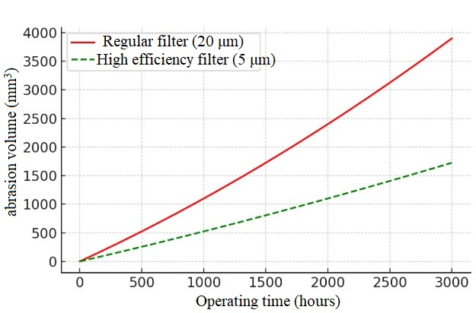
FIGURE 1. Effect of filtration efficiency on corrosion

The development of modern technologies offers innovative approaches to increasing the efficiency of hydraulic systems. One of them is the development of high-precision filters with complex geometric shapes based on 3D printing technology and their application in hydraulic systems. Filters created using 3D printing technology not only provide fine cleaning, but also provide higher efficiency and stability compared to traditional filters. In addition, with the help of a 3D printer, there is the possibility of fast and customized production of filters, which reduces production costs and allows for the creation of customized technical solutions for the equipment used in mining [4,5,6-25].

The purity of the hydraulic fluid is extremely important for the reliable operation of hydraulic systems, since contamination in the form of particles with sizes from 4 to 14 μm can lead to clogging of moving parts, deterioration of lubrication, and rapid wear of equipment. ISO 4406 and GOST 17216-2001 establish cleanliness classes, for example, for new machines - 18/15/12 or 9-10 classes, after 100 hours of operation - 16/13/10 or 8 classes, which corresponds to the number of particles in 1 cm³ of oil [7,8,9-25].
In hydraulic systems, filters serve to prevent wear by capturing solid particles in the oil (Figure 1). Standard systems typically have nominal filter elements of 10-20 microns. However, such filters may not completely capture very small particles < 5 microns. When using high-performance, fine filters (for example, 3-5 micron absolute filters), the liquid becomes much cleaner. Experiments show that during periods of low filtration quality, system depreciation is highest, and with good filtration, depreciation slows down.
The graph below compares the volume of wear accumulated over 3000 hours in two cases using a simple filter and a high-performance fine filter. As can be seen, due to the fine filter, the number of particles is small, and wear is much lower [13-25].
Influence of filtration efficiency on wear. On this graph, the red line shows an increase in wear volume over time when working with a simple filter (about 20 μm nominal), while the green dotted line shows an increase in wear when using a highly effective fine filter (for example, 5 μm). At the end of 3000 hours, approximately 3800 mm3 of material was worn out in a simple filter system, while in a fine filter system this figure is around ~1500 mm³ - that is, less than twice as much. Thus, by improving the filter characteristics, it is possible to significantly slow down the aging process and extend the service life [10,11,12-25].

EXPERIMENTAL RESEARCH
The following equipment is required for conducting the experimental work:
- 3 filter samples (3 samples in Figure 2)
- Hydraulic oil tank - for quality assessment
- Pump (or hydraulic system) - for passing oil through filters
- Pressure gauge - for determining pressure
- Oil receiving tanks - for collecting outgoing oil
- Laboratory equipment - analysis of oil quality after filtration (e.g., microscope, spectrometer)

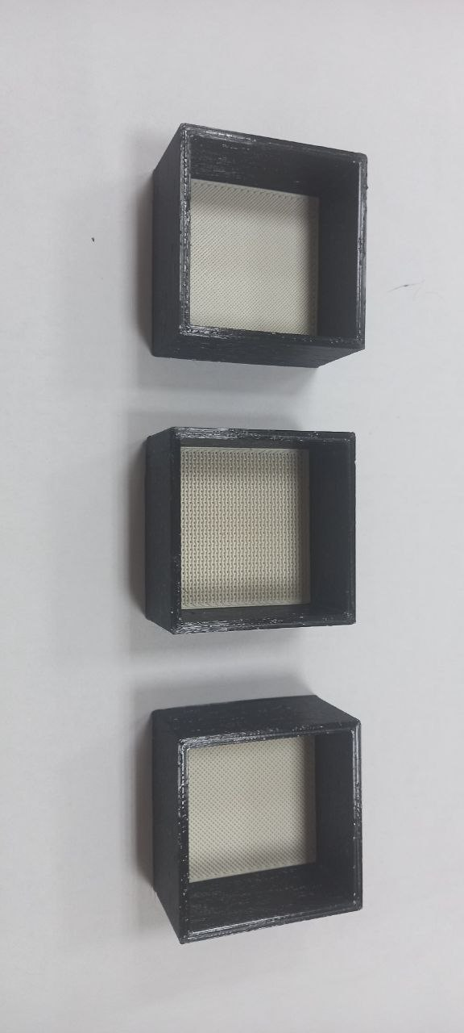
FIGURE 2. Overview of filters with holes of different diameters

The stages of the experiment are carried out in the following order: Experiment 1 - Each filter is tested separately (Figure 3).
When preparing each filter, we install all 3 filters on the device. Hydraulic oil is poured into containers in a specified amount. Through the pump, we transfer the oil to the first filter, control the pressure and flow rate. The oil that has passed filtration is collected in a separate container, and the oil that has passed filtration is collected in a separate container. When assessing oil quality, physical (color, transparency) and chemical (contamination, water, metal residues) analyses are conducted. This process is repeated in the second and third filters, and the filtration efficiency is determined depending on the quality of the oil passing through each filter.
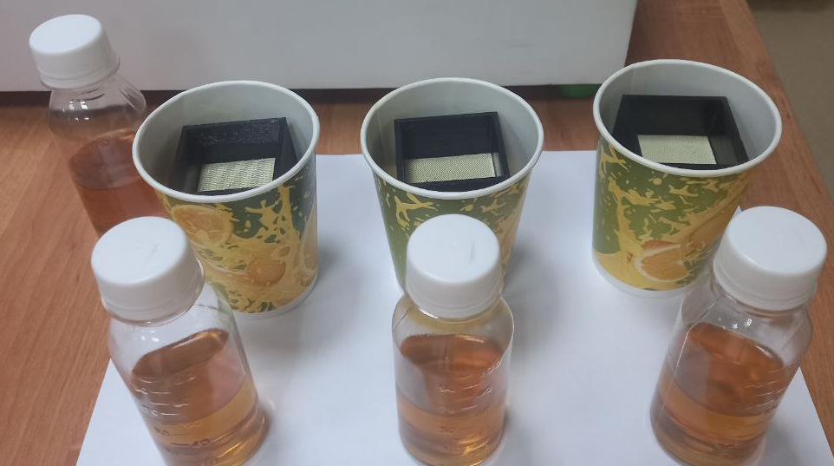
FIGURE 3. Testing of each filter separately during the 1st stage of the experiment

Before conducting the experiment, we will prepare the samples. Samples are:
- unused clean hydraulic oil
- 1 gram of sand particles mixed with hydraulic oil
- Hydraulic oil passed through the filter of sample 1
- Fitted hydraulic oil of sample 2
- Hydraulic oil passed through the filter of sample 3
- Hydraulic oil filtered through 3 samples
We analyze these samples on the Luwatech S41 mobile laboratory device for detecting contaminated particles, shown in Figure 4.
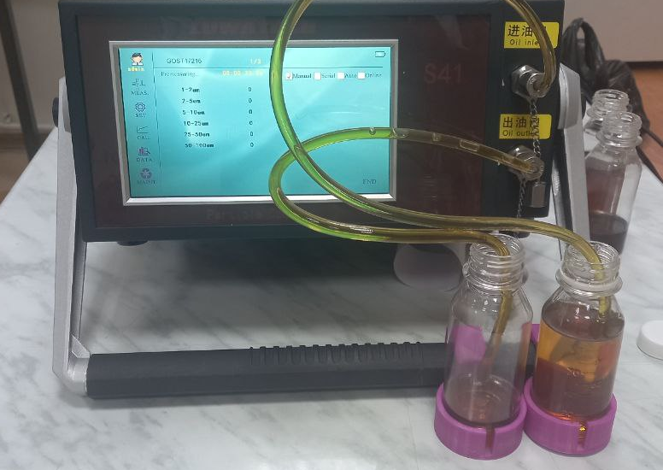
FIGURE 4. Process of analyzing working fluid on a Luwatech S41 mobile laboratory device for detecting contaminated particles

RESEARCH RESULTS
The results of particle analysis of pure hydraulic oil according to GOST 17216 obtained from the Luwatech S41 mobile laboratory unit were analyzed.
In all experiments, the measurement volume is 10.0 mL, and repeated measurements are taken 3 times.
Number of particles by volume (3 measurements) and these results are presented in Table 1 below:
The number of particles is measured according to GOST 17216 (contamination control for hydraulic oils), and there are permissible standards for each range. The basis for determining the purity of hydraulic oil according to GOST 17216 is often the NAS 1638 or ISO 4406 standards.
According to the ISO 4406 standard, the number of particles in 100 ml of oil is given in the following ranges:
≥4 μm (where 2-5 μm and larger)
≥6 μm (5-10 μm and larger)
≥14 μm (10-25 μm and larger).
In accordance with this standard, we will consider the average values based on Table 2 below:

TABLE 1. Clean working fluid purification results from the Luwatech S41 mobile device
Volume range | Measure 1 | Measure 2 | Measure 3 | Average (particles/100 ml)
1-2 μm | 3193 | 2903 | 2,646. | 29140.0
2-5 μm | 4,500 | 4202. | 4175 | 42923.3
5-10 μm | 2231. | 2049 | 1964 | 20813.3
10-25 μm | 1516. | 1286. | 1244. | 13486.7
25-50 μm | 467. | 501. | 406. | 4580.0
50-100 μm | 133. | 114. | 133. | 1266.7

TABLE 2. Average values of pure working fluid based on the standard
Volume range | Average (particles/100 ml)
≥4 μm (2-5 μm +) | 42,923.3
≥6 μm (5-10 μm +) | ~20813.3
≥14 μm (10-25 μm +) | ~13486.7

2-5 μm range: very high particle size (~42923 units/100 mL), which is higher than the requirement for pure oils for pumps and hydraulic systems according to GOST 17216 and ISO 4406. For hydraulic systems, such quantitative indicators usually correspond to category 11-13 (ISO 4406).
5-10 μm and 10-25 μm ranges: the content of particles in these ranges is also high, which indicates the low protection of the oil against abrasive contamination during operation.
25-50 μm and 50-100 μm: these large particle sizes are also significantly present, indicating that the system's large contamination or filtration system is insufficiently effective.
The indicators of particles in the pure oil in the system are high, which exceeds the degree of purification permitted for hydraulic oils according to GOST 17216.
A high number of large particles (≥25 μm) indicates a decrease in the effectiveness of the oil's filtration system or protection from external contamination.
The oil class by particle size (ISO 4406) is assessed as 14/12/11/11/13/14, which indicates a medium or high degree of oil contamination.

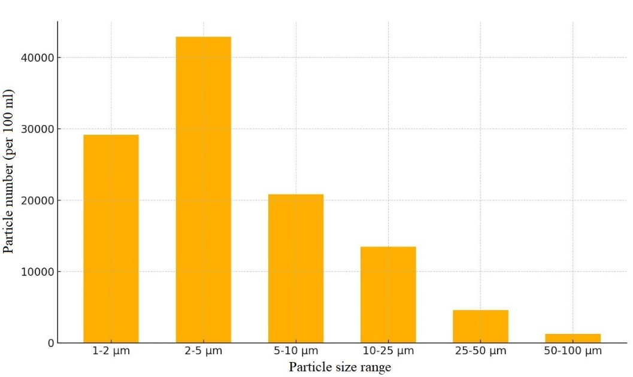
FIGURE 5. Particle content in pure hydraulic oil (average/10ml)

In the graph shown in Fig. 5 above, the average particle content in the hydraulic oil (in 100 ml for each volume range) is shown in Table 2. These results are consistent with the measurement results according to GOST 17216 and visually display the results obtained from the Luwatech S41 mobile laboratory device.
We will analyze the results obtained from the Luwatech S41 laboratory device based on GOST 17216 with the addition of 1 gram of sand to the hydraulic oil according to Table 3.

TABLE 3. Structural results of the purified working fluid obtained in experiment 2 on the Luwatech
S41 mobile device
Volume range | Measure 1 | Measure 2 | Measure 3 | Average (particles/100 ml)
1-2 μm | 9875 | 11566 | 11405 | 109,486.7
2-5 μm | 18976 | 21660 | 21,868 | 208,346.7
5-10 μm | 11805 | 13137 | 13212 | 127180.0
10-25 μm | 6,537. | 7241 | 7285 | 70210.0
25-50 μm | 21.30 | 22.45 | 2147. | 21740.0
50-100 μm | 8698. | 8106 | 7916 | 82400.0

According to GOST 17216 and ISO 4406, the number of particles in hydraulic oil and their volume are the main indicators of system contamination. With the addition of sand, the results are very high, which indicates severe abrasive contamination.
The number of particles is very high, which indicates abrasive contamination caused by the addition of 1 gram of sand.
The number of large particles in the range of 25-50 μm and 50-100 μm (~82400/100 mL) is very large, which indicates inefficient operation of the filters or complete penetration of sand.
According to the ISO 4406 classification, the level of contamination in the system is assessed by the indicator 17/12/14/15/>17, which is classified as highly contaminated oil.
The average number of particles (per 100 ml) when 1 gram of sand is added to hydraulic oil was prepared graphically and is shown in Fig. 6. As can be seen from the graph, after the addition of sand, the numbers in all particle ranges increased sharply, which indicates a significant increase in abrasive contamination in the system.
In our further experimental work, we will use 3 3D printers of various designs, shown in Figure 2 above, to purify the oil mixed with 1 gram of sand from the developed filters and determine their filtration rates.

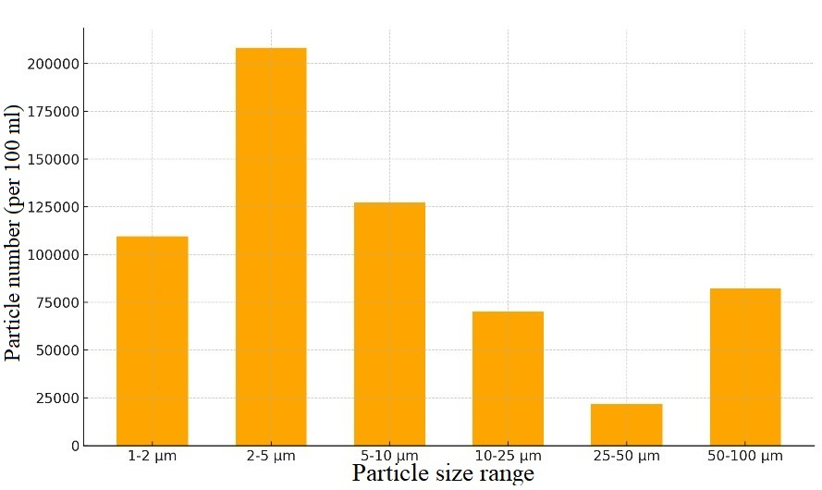
FIGURE 6. The amount of particles mixed with sand in hydraulic oil (average/10ml)

In our 3rd experiment, based on tables 2 and 4, we analyze the particle composition of the filtered hydraulic oil sample of sample 1, obtained from the Luwatech S41 laboratory device according to GOST 17216.

TABLE 4. Structural results of the working fluid purified in the filter of sample 1, obtained on the Luwatech S41 mobile device
Volume range | Measure 1 | Measure 2 | Measure 3 | Average (particles/100 ml)
1-2 μm | 10,533 | 10509 | 11107 | 107,163.3
2-5 μm | 21245 | 21,562 | 24250 | 223523.3
5-10 μm | 9561 | 10816. | 13199 | 111920.0
10-25 μm | 4,454 | 5433 | 6661 | 55160.0
25-50 μm | 913. | 1117 | 1238. | 10893.3
50-100 μm | 333. | 202. | 237. | 2573.3

As a result of filtration, the number of particles significantly decreased, which indicates the effective operation of the filter.
Nevertheless, in the range of ≥4 μm (~223523/100 mL), the indicators exceed the requirements of GOST 17216 and ISO 4406, and the oil still has high contamination.
Filters need to be improved in size and efficiency, especially to reduce the number of large particles (>50 μm).

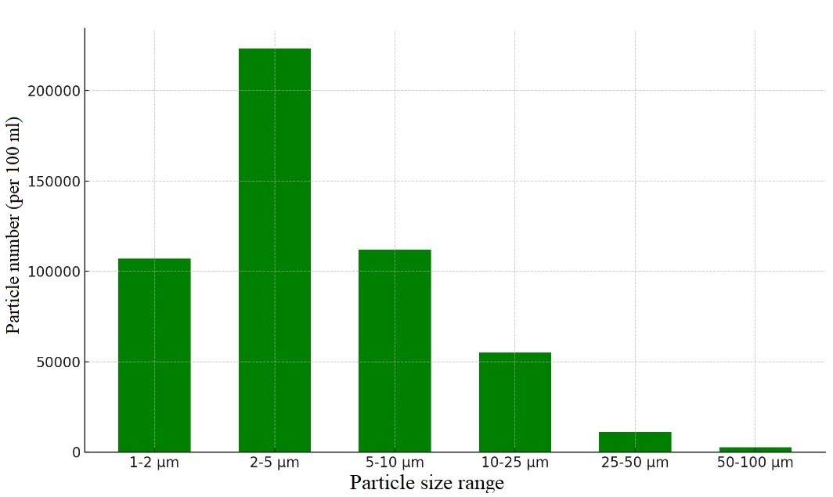
FIGURE 7. 1 - amount of particles in the filtered hydraulic oil (average/10ml)

The number of particles in the filtered hydraulic oil (per 100 ml) was presented graphically. As shown in the graph in Figure 7, after filtration, the number of particles decreased compared to the previous one, but high contamination still remains.
In our 4th experiment, we analyze the particle composition of the filtered hydraulic oil sample in sample 2 according to GOST 17216 and the data obtained from the Luwatech S41 laboratory device based on tables 2 and 5.

TABLE 5. Structural results of the working fluid purified in the filter in sample 2, obtained on the
Luwatech S41 mobile device
Volume range | Measure 1 | Measure 2 | Measure 3 | Average (particles/100 ml)
1-2 μm | 10251 | 9660 | 9446 | 97856.7
2-5 μm | 21 821 | 19240 | 19217 | 200926.7
5-10 μm | 11117 | 8805 | 8807 | 95763.3
10-25 μm | 5485 | 4322 | 4144 | 46503.3
25-50 μm | 977. | 820. | 851. | 8826.7
50-100 μm | 128. | 96. | 88. | 1040.0

These values decreased as a result of filtration, which indicates the filter effectiveness. However, the number of particles is still high, indicating that the filter needs to be strengthened or cleaned in more stages for complete cleaning.
Score according to GOST 17216:
Classification according to ISO 4406 14/12/12/13/14/14, which still does not meet the requirements for pure oil for production conditions. The number of large particles (>50 μm) is significantly reduced (~1040/100 mL), which indicates filtration efficiency. As a result of filtration, the level of contamination decreased, which is a good result.
The number of particles (especially in the ranges of 2-5 μm and 5-10 μm) is still high, which indicates that the system has not completely eliminated contamination. It is recommended to introduce additional filtration stages or strengthen the existing filtration system.

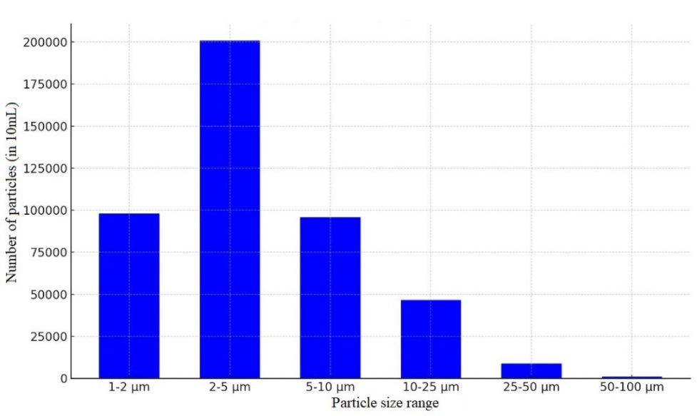
FIGURE 8. 2 - amount of particles in the filtered hydraulic oil (average/10ml)

The number of particles in the filtered hydraulic oil of sample No. 2 (per 100 ml) is presented graphically in Fig. 8. The graph clearly shows that the amount of particles decreased after the filter, but there is still significant contamination.
In our 5th experiment, based on tables 2 and 6, we analyze the particle composition of the filtered hydraulic oil sample of sample 3, obtained from the Luwatech S41 laboratory device according to GOST 17216.

TABLE 6. Structural results of the working fluid purified in the filter of sample 3, obtained on the Luwatech S41 mobile device
Volume range | Measure 1 | Measure 2 | Measure 3 | Average (particles/100 ml)
1-2 μm | 10315 | 10311 | 9265 | 99636.7
2-5 μm | 21329 | 21896 | 18312 | 205123.3
5-10 μm | 10403 | 10976 | 8289 | 98893.3
10-25 μm | 4,906 | 5549 | 3921 | 47920.0
25-50 μm | 804 | 899. | 616 | 7730.0
50-100 μm | 115. | 86. | 66. | 890.0

The filtration effect is clearly visible, as the number of coarse particles has decreased.
In the range of 2-5 μm, there is still high contamination (~205123/100 mL), which indicates the possibility of contamination in the system from pipes, pumps, and external inputs.
Although large particles of 50-100 μm (~890/100 mL) are present, this is significantly reduced compared to previous results.

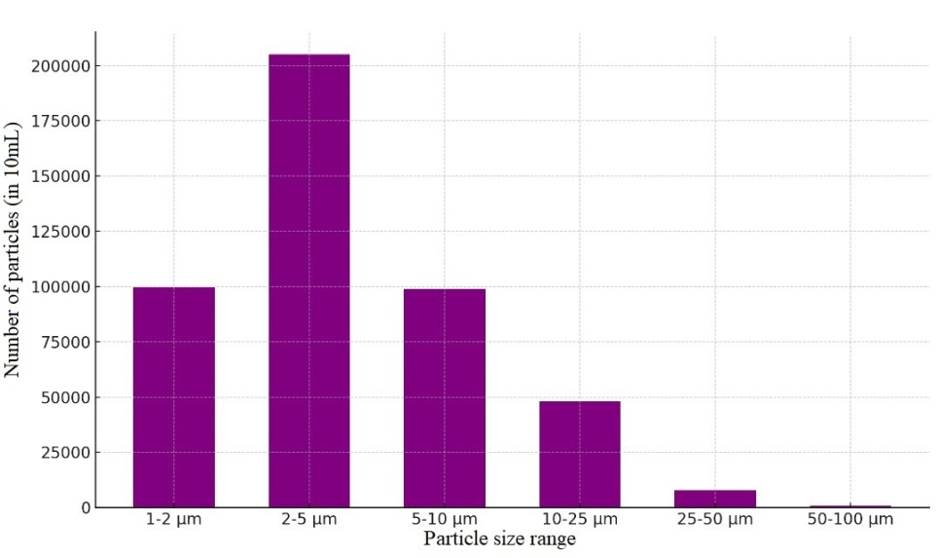
FIGURE 9. 3 - amount of particles in the filtered hydraulic oil (average/10ml)

The number of particles in the filtered hydraulic oil in sample 3 (per 100 mL) is graphically presented in Figure 9, which shows that after filtration, the number of particles decreases, but is still high in the range of 2-5 μm.
We analyze the particle composition of the hydraulic oil sample, which was sequentially passed through a filter of 3 different samples, according to GOST 17216 and the data obtained from the Luwatech S41 laboratory setup, based on tables 2 and 7.

TABLE 7. Structural results of the purified working fluid, sequentially passed through a filter of 3 different samples, obtained on the Luwatech S41 mobile device
Volume range | Measure 1 | Measure 2 | Measure 3 | Average (particles/100 ml)
1-2 μm | 10806 | 11509 | 11920 | 114,116.7
2-5 μm | 21345 | 24,064 | 25153 | 235206.7
5-10 μm | 10340 | 12683 | 14.330 | 124510.0
10-25 μm | 5010 | 6407 | 7102 | 61730.0
25-50 μm | 973. | 1216. | 1084. | 10913.3
50-100 μm | 91. | 95. | 85. | 903.3

As a result of 3-stage filtration, the particle content decreased compared to previous samples, however, in the range of 2-5 μm (~235206/100 mL) and in the range of 5-10 μm (~124510/100 mL) the indicators are still high. Large particles (≥50 μm) (~903/100 mL) are minimal, which indicates the effectiveness of the filter.
In the classification according to GOST 17216 according to ISO 4406 14/12/12/13/14/14, which still does not fully meet the requirements for pure oil for production, but the indicators are better than in previous samples.
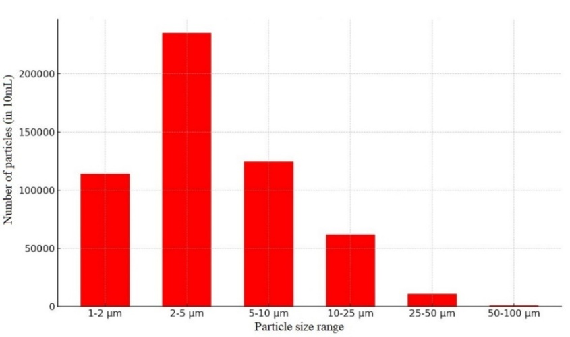
FIGURE 10. Average content of particles in the purified hydraulic oil, sequentially passed through 3-stage filters (average/10ml)

The 3-stage filtration system worked effectively, which contributes to increasing the efficiency of the filter. A high particle size still exists in the ranges of 2-5 μm and 5-10 μm, which requires an additional deep filtration system, improved filter elements. A decrease in the number of coarse particles is a good result, which indicates an improvement in the system.
The number of particles in the hydraulic oil subjected to 3-stage filtration (per 100 ml) is graphically presented in Fig. 10, and as shown in the graph, after the filtration process, the number of coarse particles decreases significantly, but the number of fine particles is still high.
CONCLUSIONS
In the course of the study, it was established that the presence of contaminants (solid particles, water, oxidation products) in the composition of working fluids in hydraulic systems directly affects the technical and economic efficiency of the system, and the possibilities of existing filtration methods were analyzed. The study substantiated such aspects as the negative impact of pollution on the elements of hydraulic systems - accelerated wear of components, a decrease in operational efficiency, an increase in energy consumption, and an increase in the degree of system failure. Based on the standards ISO 4406 and GOST 17216-71, the degree of purity is indicated, which indicates the need for the introduction of constant and effective control systems in hydraulic systems.
The main novelty of the article is the creation of filters of various geometries and high accuracy using a 3D printer and testing their practical effectiveness. Thanks to this innovative approach, adapted technical solutions for hydraulic systems used in mining equipment have been developed. The use of 3D printing technology not only made it possible to clean with high accuracy, but also made it possible to produce filtering modules in a short time, adapting them to individual needs.
During the research, filters were prepared using the CreatBot F430 3D printer, and their surface quality, structure, mechanical strength, and microscopic analysis were carried out. In the experimental setup, the amount of contamination in the hydraulic oil was assessed based on practical tests. The results of microscopic analysis, obtained using the Olypus EX51M microscope, made it possible to determine the decrease in the content of pollutants in the liquid. Based on mathematical models, the wear rate of components and the influence of pollution on the efficiency of the hydraulic system were determined, which served as a scientific basis for improving the system.
According to the research results, filters made on a 3D printer increase the reliability of hydraulic systems, extend the service life of the system, reduce maintenance costs, and also ensure environmental safety. Increased filtration quality reduces the wear rate of hydraulic system elements, which contributes to a reduction in the number of accidents in mining equipment and an increase in operational efficiency.
At the end of the study, it can be concluded that filters made using a 3D printer are one of the promising solutions for increasing the efficiency of mining equipment, reducing maintenance costs, and increasing service life and reliability. The results of the dissertation work include ready-made technical and technological solutions for practical application and serve as a scientific basis for improving the operation of hydraulic systems.

REFERENCES

- Werbinska-Wojciechowska, S.; Rogowski, R. Proactive Maintenance of Pump Systems Operating in the Mining Industry—A Systematic Review. Sensors 2025, 25, 2365. https://doi.org/10.3390/s25082365
- Rakhutin M.G., Giang Quoc Khanh, Krivenko A.E., Tran Van Hiep. Evaluation of the influence of the hydraulic fluid temperature on power loss of the mining hydraulic excavator. Journal of Mining Institute. 2023. Vol. 261, p. 374–383. https://pmi.spmi.ru/pmi/article/view/16193
- Long, M.; Schafrik, S.; Kolapo, P.; Agioutantis, Z.; Sottile, J. Equipment and Operations Automation in Mining: A Review. Machines 2024, 12, 713. https://doi.org/10.3390/machines12100713
- Rîpă, I.C. & Popescu, D. Hydraulic Manifold Blocks Manufactured Using 3D Printing Technology. Bulletin of the Polytechnic Institute of Iași. Machine constructions Section, 70(4), 2024. 117-127. https://doi.org/10.2478/bipcm-2024-0025
- Remache, A.; Pérez-Sánchez, M.; Hidalgo, V.H.; Ramos, H.M.; Sánchez-Romero, F.-J. Towards Sustainability in Hydraulic Machinery Manufacturing by 3D Printing. Processes 2024, 12, 2664. https://doi.org/10.3390/pr12122664
- A. S. Zhuraev, S. A. Turdiyev, S. T. Jurayev, and S.S. Q. Salimova, "Characteristics of packing gland seals in hydraulic systems of quarry excavators and results of comparative analysis of experimental tests," Vibroengineering Procedia, Vol. 54, pp. 252–257, Apr. 2024, https://doi.org/10.21595/vp.2024.24051
- Novak, N.; Trajkovski, A.; Kalin, M.; Majdič, F. Degradation of Hydraulic System due to Wear Particles or Medium Test Dust. Appl. Sci. 2023, 13, 7777. https://doi.org/10.3390/app13137777
- Akbar Zhuraev, Sardorjon Turdiyev; Analyses and studies of working fluid flow in the hydraulic system of hydraulic excavators at the Auminzo-Amantaytau open pit mine. AIP Conf. Proc. 4 November 2025; 3331 (1): 030067. https://doi.org/10.1063/5.0305703
- Sawczuk W, Kołodziejski S, Jüngst M. Test verification of the condition of hydraulic oil of construction machines following the guidelines of ISO 4406 and NAS 1638. Diagnostyka. 2025;26(3):2025310. doi:10.29354/diag/208882.
- Mao, Haiwen, Pibo Ma, and Gaoming Jiang. “Filtration Efficiency Investigation of Mesh Fabrics by Polytetrafluoroethylene Filament with Surface Static Electricity.” The Journal of The Textile Institute 2018. 110 (3): 451–59. doi:10.1080/00405000.2018.1489359.
- Braddock, R. Modelling the Influence of Filter Structure on Efficiency and Pressure Drop in Knitted Filters. 2011. https://doi.org/10.36334/MODSIM.2011.A7.MULLINS
- Mardonov, B., Nurmurodov, T., Abrorov, A., Kadirov, Y., Kovalev, I. Overview of the III International Conference on Geotechnology, Mining and Rational Use of Natural Resources - GeoTech-2023 https://doi.org/10.1051/e3sconf/202341 700001
- Rabatuly M., Myrzathan S.A., Toshov J.B., Nasimov J., Khamzaev A. Views on drilling effectiveness and sampling estimation for solid ore minerals. Integrated Use Of Mineral Raw Materials. №1(336), 2026. https://doi.org/10.31643/2026/6445.01
- Toshov J.B., Rabatuly M., Khaydarov Sh., Kenetayeva A.A., Khamzayev A., Usmonov M., Zheldikbayeva A.T. Methods for Analysis and Improvement of Dynamic Loads on the Steel Wire Rope Holding the Boom of Steel Wire Rope Excavators. Kompleksnoe Ispolzovanie Mineralnogo Syra = Complex Use of Mineral Resources 2026; 339(4):87-96 https://doi.org/10.31643/2026/6445.43
- Zokhidov O.U., Khoshimov O.O., Khalilov Sh.Sh. Experimental analysis of microges installation for existing water flows in industrial plants. III International Conference on Improving Energy Efficiency, Environmental Safety and Sustainable Development in Agriculture (EESTE2023), E3S Web of Conferences. Volume 463. 02023. 2023. https://doi.org/10.1051/e3sconf/202346302023
- Zokhidov O.U., Khoshimov O.O., Sunnatov S.Z. Selection of the type and design of special water turbines based on the nominal parameters of Navoi mine metallurgical combine engineering structures. AIP Conf. Proc. 3331, 050022 (2025). https://doi.org/10.1063/5.0306554
- Khamzaev A.A., Mambetsheripova A., Arislanbek N. Thyristor-based control for high-power and high-voltage synchronous electric drives in ball mill operations/ E3S Web Conf. Volume 498, 2024/ III International Conference on Actual Problems of the Energy Complex: Mining, Production, Transmission, Processing and Environmental Protection (ICAPE2024) DOI: https://doi.org/10.1051/e3sconf/202449801011
- Toshov B.R., Khamzaev A.A. Development of Technical Solutions for the Improvement of the Smooth Starting Method of High Voltage and Powerful Asynchronous Motors/AIP Conference Proceedings 2552, 040018 (2023); https://doi.org/10.1063/5.0116131 Volume 2552, Issue 1; 5 January 2023
- Toshov B.R., Khamzaev A.A., Sadovnikov M.E., Rakhmatov B., Abdurakhmanov U./ Automation measures for mine fan installations/ SPIE 12986, Third International Scientific and Practical Symposium on Materials Science and Technology (MST-III 2023), 129860R (19 January 2024); https://doi.org/10.1117/12.3017728 Third International Scientific and Practical Symposium on Materials Science and Technology (MST-III 2023), 2023, Dushanbe, Tajikistan.
- Toshov B.R., Khamzaev A.A., Namozova Sh.R.Development of a circuit for automatic control of an electric ball mill drive. AIP Conference Proceedings 2552, 040017 (2023) Volume 2552, Issue 1; 5 January 2023. https://doi.org/10.1063/5.0116128
- Boboqulov J., Narzullayev B. Development of a model for diagnosing rotor conditions in the parallel connection of synchronous generators with the network // E3S Web of Conferences. – EDP Sciences, 2024. – Т. 525. – С. 06001. https://doi.org/10.1051/e3sconf/202452506001
- Khasan Murodov, Askarbek Karshibayev, and Shukhrat Abdullayev, Analysis of the process of balanced charging of the battery group with high capacity, E3S Web of Conferences 548, 03012 (2024) https://doi.org/10.1051/e3sconf/202454803012
- Akram Tovbaev, Muxtarxan Ibadullayev and Mohinur Davronova. Study of subharmonic oscillation processes in ferroresonance circuits. E3S Web of Conf. Volume 525, 2024. IV International Conference on Geotechnology, Mining and Rational Use of Natural Resources (GEOTECH-2024). https://doi.org/10.1051/e3sconf/202452503008
- Akram Tovbaev., Islom Togaev., Uktam Usarov.,Gulom Nodirov, Reactive power compensation helps maintain a stable voltage profile across the network, AIP Conf. Proc. 3331, 060014 (2025). https://doi.org/10.1063/5.0307209
- Asliddin Norqulov, Feruz Raximov, Methods for evaluating financial and economic effectiveness of investment projects in the energy sector with time factor considerations, AIP Conf. Proc. 3331, 030070-1–030070-6. https://doi.org/10.1063/5.0306104

