Oprevention of longitudinal tearing of conveyor belts
Lazizjon Ataqulov, Shokhidjon Haydarov, Izzat Rakhmonov ^{a)}, Orifjon Kaxxarov
Navoi State Mining and Technological University, Navoi, Uzbekistan
^{a)} Corresponding author: izzat049428@mail.ru
Abstract. This article analyzes the hazards of longitudinal tears in conveyor belts used in mining operations, caused by external factors. The situation becomes especially critical in the absence of protective systems, as tears can propagate along the length of the belt, allowing transported material to fall onto the lower belt section. This material may then enter between drums, causing further damage to other areas of the belt. As a result, significant time and labor are required for repair or replacement, other conveyor components may fail, and overall system productivity decreases. Various types of equipment for early detection of longitudinal tears are reviewed, including ultrasonic, laser-based, thermal imaging, and mechanical monitoring devices. The importance of timely conveyor shutdown using such systems is substantiated to prevent further damage.
INTRODUCTION
As the depth of open-pit mines increases, it becomes more appropriate to use continuous transport systems for the delivery of minerals over considerable distances. Among continuous transport machines, the belt conveyor stands out for its simple design, operational reliability, and efficiency in transporting rock materials up to 300–400 mm in size. The technical and economic performance indicators of mining enterprises largely depend on the operation and efficiency of their belt conveyors. In major mining operations of our country, such as the fully conveyorized mines belonging to “O‘zbekko‘mir” JSC, and the “Angren” coal open-pit, as well as the “Muruntau” and “Daugiztau” quarries of the Navoi Mining and Metallurgical Combine JSC, the number of belt conveyors is steadily increasing.
Nowadays, the use of many conveyor systems with a slope of is increasing in the expansion of quarries. In a conveyor system, the failure of one conveyor or the failure of one of the components of a conveyor leads to the failure of the entire conveyor system and a decrease in reliability.
Main Part.During the operation of conveyor transport, stoppages occur as a result of belt damage caused not only by rock material but also by foreign objects (often sharp metal), accounting for 53% of downtime. Damage caused by rock material itself accounts for 20%, climatic changes for 7%, changes in the internal structure of the belt for 7%, breakage of roller supports or conveyor frames for 7%, belt abrasion for 3%, and rupture of connected sections of the belt for 3% (Figure 1) [1-10, 19-28].

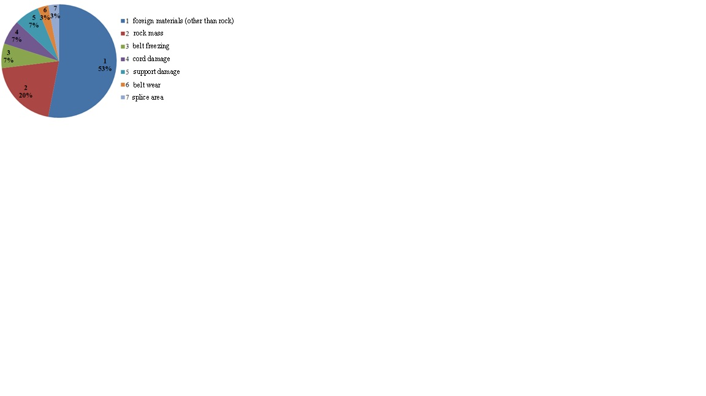
FIGURE 1. Factors causing downtime due to belt damage
Among the stoppages caused by the factors listed above, longitudinal tears of the conveyor belt are considered particularly hazardous. Specifically, the absence of protective and mitigating devices within the conveyor system can result in longitudinal tearing along the entire belt length, enlargement of the damaged area, and the deposition of transported rock material from the torn section onto the lower return belt. This may cause the rock to become lodged between the conveyor drums, leading to additional belt damage, increased labor and time requirements for belt repair or replacement, failure of other conveyor components, and a significant reduction in overall conveyor productivity. The cost of the belt constitutes approximately 40% of the total conveyor system cost, making its replacement or repair a substantial economic burden [10-19].
To detect longitudinal tears in conveyor belts, various monitoring technologies are employed worldwide. These include ultrasonic, laser, thermal imaging, and mechanically operated inspection devices. To prevent longitudinal tearing and mitigate the aforementioned risks, it is essential to stop the conveyor in a timely manner using belt monitoring and control systems. An example of a longitudinally torn belt during operational use is illustrated in Figure 2.
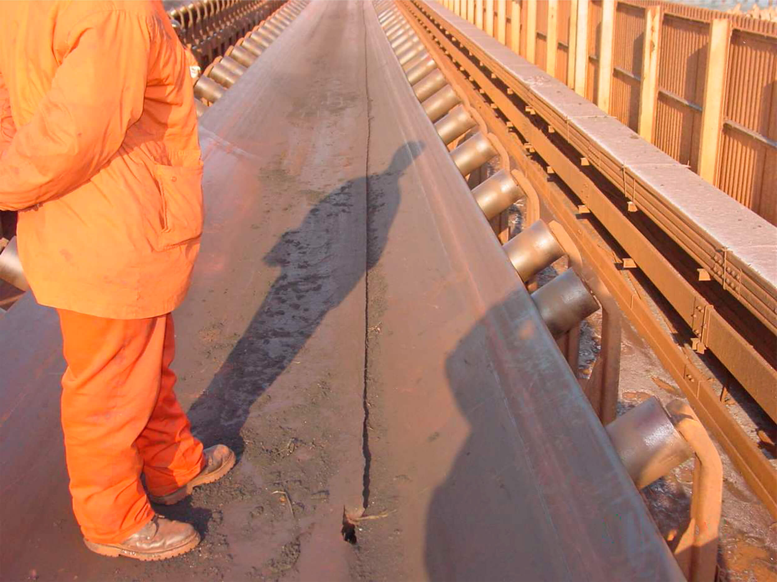
FIGURE 2. Longitudinal Tear in Conveyor Belts

Ultrasonic Sensor Device for Conveyor Belt Monitoring.In the ultrasonic sensor device for monitoring conveyor belts, as shown in Figure 3a, piezoelectric plates are installed on opposite sides of the belt. One plate generates waves across the belt width, while the other plate, located on the opposite side, receives the waves. In Figure 3b, when the belt is longitudinally torn, the waves sent by the transmitting piezoelectric plate cannot pass through the torn section to reach the receiving plate. As a result, the sensor emits a signal sound and stops the conveyor.
a.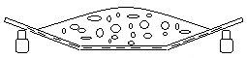 | b 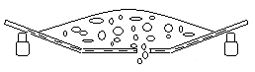
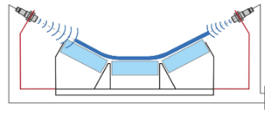 | 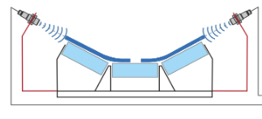
FIGURE 3. Detection of Belt Tear Using an Ultrasonic Sensor
a – Wave propagation across the belt width; b – Longitudinal tear of the belt

In this case, if the belt is longitudinally torn, the second plate will not receive the waves, indicating that the belt has been damaged [2].
The analysis of using laser sensor devices shows that the recommended method is effective for detecting longitudinal cracks wider than 3 mm. That is, before the belt develops a longitudinal tear, the objects causing the damage may first create slight scratches on the belt surface. Signals generated by these scratches are displayed in the monitoring software, and depending on their magnitude, the conveyor can be stopped or allowed to continue operating. Experimental results indicate that the detection accuracy reaches 99.2% (Figure 4) [4,6,7-30].

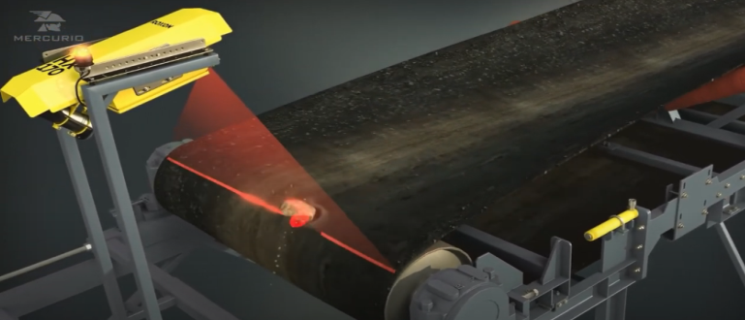
FIGURE 4. Laser Sensor Device

Moreover, compared to image processing methods used to detect longitudinal or transverse tears—which require approximately 18–50 m/s—this method has a significantly shorter identification time of 0.01–0.04 m/s.
A thermal imager is a device designed to measure the temperature of a conveyor belt and the temperature distribution along its surface (Figure 5). The operating principle of the device is based on detecting infrared radiation and converting it into a digital signal, which allows the temperature zones to be displayed on a screen.
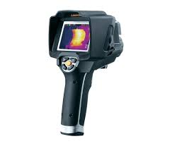
FIGURE 5. General view of the thermal imager

The main components of the device include high-precision lenses, a sensitive matrix that converts infrared radiation into an electrical signal, a processor for processing incoming data, and a display for visualizing the image.
When using mechanically operated monitoring sensors, A. Yu. Zakharov, A. V. Grigoryev, A. G. Zakharova, and several other researchers have proposed a device (shown in Figure 6) designed to detect longitudinal belt tearing and rock spillage from the damaged section [4,5,6].
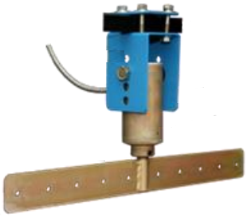
FIGURE 6. Mechanical Device for Monitoring Longitudinal Belt Tears

When a longitudinal tear occurs in the conveyor belt, the rock material spilling from the damaged section accumulates on the lower return belt moving in the opposite direction. This accumulation pushes the mechanical control device, activating the sensor, which then stops the conveyor.
All devices currently used worldwide to detect longitudinal belt tears have their respective advantages and disadvantages. The drawback of ultrasonic sensors is that they activate only when the belt is completely torn through its thickness; in other words, a partial tear does not interrupt wave transmission across the belt width, so the conveyor does not stop until the tear becomes full-depth. Laser sensors, while accurate, are expensive, and their performance decreases in dusty environments. Thermal imaging systems depend on belt surface heating, and due to limited experimental data obtained during operation, their practical reliability is not fully verified [20-32].
Mechanical monitoring devices for detecting longitudinal belt tears are widely used because of their low cost and high reliability. However, in areas near the conveyor drums, the belt’s tension prevents rock spillage even when longitudinal tearing occurs over a certain distance (the tension distance for steel cord belts and for fabric belts is determined using the following formulas, where B is the belt width, m; and L is the conveyor length, m). Therefore, in some cases, this type of device may delay the stopping of the conveyor.
At the mining enterprises belonging to Navoi Mining and Metallurgical Combine JSC (NMMC), the increasing use of conveyor transport systems and the need to prevent or reduce the aforementioned problems make it essential to employ devices that stop the conveyor in the event of longitudinal belt tearing. Furthermore, scientific research is required to select, install, and continuously monitor the performance of these devices to ensure reliable and efficient operation.
Scientific research on this issue is currently being conducted by the management staff of Navoi Mining and Metallurgical Combine JSC (NMMC) and the lecturers of the Department of Mining Electromechanics. Studies have been carried out, in collaboration with personnel from the Continuous Transport Department and the Heap Leaching Plant of the Central Mining Administration, to investigate the performance of mechanical belt tear monitoring devices and thermal imaging systems for detecting longitudinal tears in conveyor belts.
First, a structural diagram of the mechanical monitoring device for detecting longitudinal belt tears was developed (Figure 7). The structural diagram consists of the following components:
1 – conveyor transverse lower frame (existing on the conveyor);2 – limit switch;3 – pin;4 – lever arm;5 – transverse metal plate;6,7 – bushings;8,16 – cotter pins;9 – metal lever;10 – steel plate;11,12 – brackets;13,14,15,17 – bolts and nuts.

a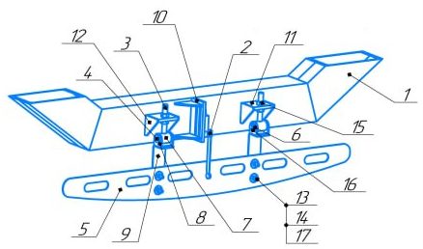 b 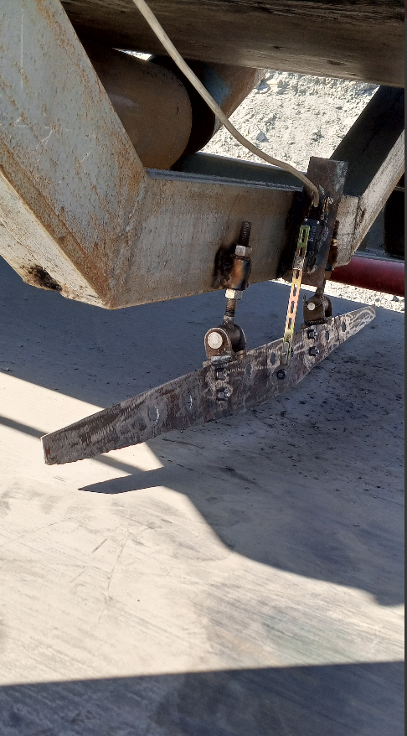

FIGURE 7. Mechanical Device for Monitoring Longitudinal Belt Tears
(a – Structural diagram; b – Developed device)
1 – conveyor transverse frame; 2 – limit switch; 3 – pin; 4 – lever arm; 5 – transverse metal plate; 6,7 – bushings; 8,16 – cotter pins; 9 – metal lever; 10 – steel plate; 11,12 – brackets; 13,14,17 – bolts and nuts; 15 – nut.

At the Muruntau open-pit mine, a belt tear monitoring device was installed on the lower idle branch of the KL-3 belt conveyor at the Continuous Transport Department (CTD) (Figure 7). The steel plate (10) and brackets (11, 12) are welded to the transverse frame (1) of the conveyor. The limit switch (2) is fixed onto the steel plate. A pin (3) is mounted on the brackets, allowing adjustment of the transverse metal plate (5) upward or downward using the nut (15). The lever of the limit switch (2) is positioned vertically and remains in contact with the transverse metal plate (5). When rock material hits the transverse metal plate (5), causing it to deflect at an angle of 15–20 degrees, the limit switch (2) is activated, which ensures the conveyor stops automatically.
Additionally, at the Heap Leaching Plant under the Central Mining Administration of NMMC, an experimental study was conducted using a thermal imaging device to investigate complete longitudinal tearing of a conveyor belt. For this experiment, a fabric belt with a width of B = 1200 mm and a thickness of h = 40 mm was used. The belt was installed on a mobile conveyor (Kuznechik) and set in operation. The conveyor speed was v = 3 m/s, and a sharp-edged piece of metal was used to induce tearing. The sharp metal completely cut through the belt, causing a longitudinal tear, while a thermal imaging device was installed under the lower side of the belt.
The resulting images are shown in Figure 8. In Figure 8a, before the belt was torn, it can be seen that the sharp-edged metal heated up to 160.3 °C, while the belt temperature reached 40.6°C.

a.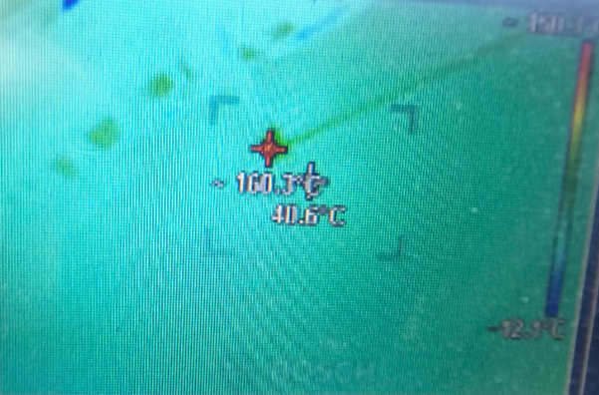 b. 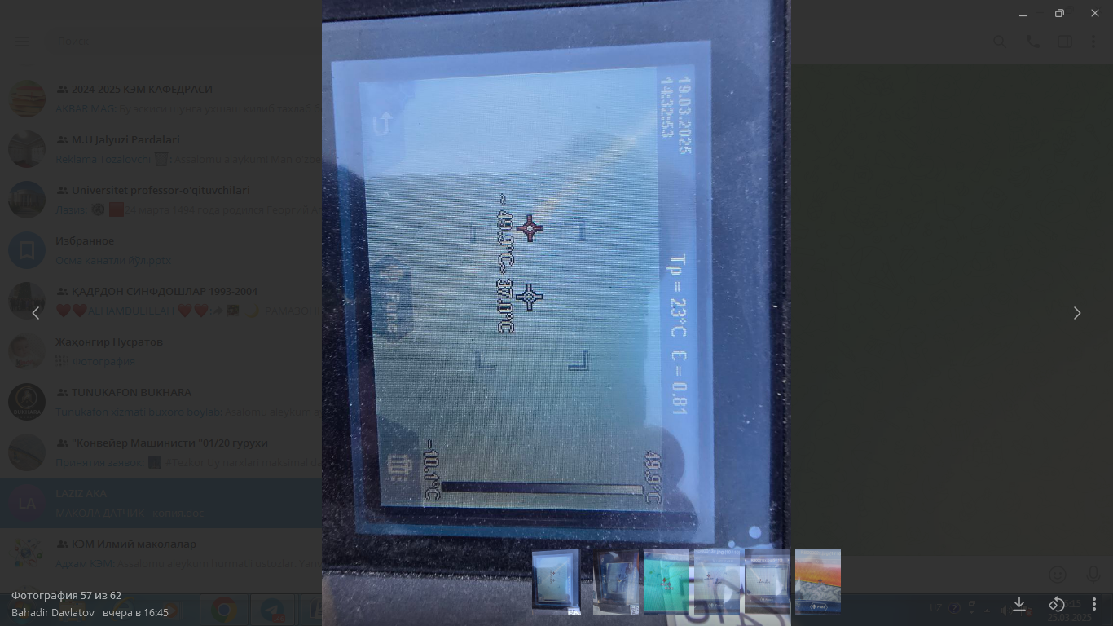
FIGURE 8. Images Obtained from the Thermal Imager
(a – Temperature of the belt and the sharp-edged metal; b – Temperature of the belt and the torn section of the belt)

In the next stage, as a result of the sharp-edged metal completely cutting through the belt, a temperature change occurred along the torn section of the belt, as shown in Figure 8b. The temperature along this line reached 49.9 °C, while the temperature of the remaining belt was 37°C. This indicates that the sharp-edged metal that caused the tear heated up, and the temperature difference between the torn section and the intact belt reached 13 °C.
CONCLUSION
When using the monitoring devices described above to detect longitudinal belt tears, these devices can be distinguished from one another by their quality, low cost, ease of installation, measurement accuracy, and resistance to dust and other external factors. Additionally, the devices should be easy to manufacture and install, should not interfere with the conveyor operation or personnel during maintenance, be inexpensive, and allow for localization. Considering these factors, the mechanically operated monitoring device proved to be effective due to its low cost, dust resistance, potential for local production, and reliable performance.
REFERENCES
- Xianguo L., Lifang S., Zixu M., Can Z., Hangqi J. Laser-based on-line machine vision detection for longitudinal rip of conveyor belt // Optik (Stuttg), 168 (2018), pp. 360-369.
- Blazej R., Jurdziak L., Kirjanow A., Kozlowski T. Evaluation of the quality of steel cord belt splices based on belt examination using magnetic techniques / Wroclaw University of Technology, Machinery Systems Division, 2 Industrial and GeoEconomics Division, Na Grobli 15, 50-421 Wroclaw, Poland // Diagnostyka, Vol. 16, No. 3 (2015), pp. 1-6.
- Yu B., Qiao T., Zhang H., Yan G. Dual band infrared detection method based on mid-infrared and long infrared vision for conveyor belts longitudinal tear // Meas. J. Int. Meas. Confed., 120 (2018), pp. 140-149.
- Zaxarov A.Yu., Yerofeeva N.V. Vibratsiya lentы i rabochie protsessы konveyera // Vestn. Kuzbas. gos. texn. un-ta. 2015. № 6. S. 78-83.
- Zaxarov A.Yu., Yerofeeva N.V. Vibratsiya lentы i rabochie protsessы konveyera // Vestn. Kuzbas. gos. texn. un-ta. 2015. № 6. S. 78-83.
- Atakulov LN, Khaidarov Sh.B., Istablaev F.F., Narzullaev B.Sh. Investigation of an alternative method of connecting rubber cord belts. Achievements, problems and modern trends in the development of the mining and metallurgical complex IX International Scientific and Technical Conference. 2017
- Rabatuly M., Myrzathan S.A., Toshov J.B., Nasimov J., Khamzaev A. Views on drilling effectiveness and sampling estimation for solid ore minerals. Integrated Use of Mineral Raw Materials. №1(336), 2026. https://doi.org/10.31643/2026/6445.01
- Toshov J.B., Rabatuly M., Khaydarov Sh., Kenetayeva A.A., Khamzayev A., Usmonov M., Zheldikbayeva A.T. Methods for Analysis and Improvement of Dynamic Loads on the Steel Wire Rope Holding the Boom of Steel Wire Rope Excavators. Integrated Use of Mineral Raw Materials Complex Use of Mineral Resources 2026; 339(4):87-96 https://doi.org/10.31643/2026/6445.43
- Zokhidov O.U., Khoshimov O.O., Khalilov Sh.Sh. Experimental analysis of microges installation for existing water flows in industrial plants. III International Conference on Improving Energy Efficiency, Environmental Safety and Sustainable Development in Agriculture (EESTE2023), E3S Web of Conferences. volume 463. 02023. 2023. https://doi.org/10.1051/e3sconf/202346302023
- Zokhidov O.U., Khoshimov O.O., Sunnatov S.Z. Selection of the type and design of special water turbines based on the nominal parameters of Navoi mine metallurgical combine engineering structures. AIP Conf. Proc. 3331, 050022 (2025). https://doi.org/10.1063/5.0306554
- Khamzaev A.A., Mambetsheripova A., Arislanbek N. Thyristor-based control for high-power and high-voltage synchronous electric drives in ball mill operations/ E3S Web Conf. Volume 498, 2024/ III International Conference on Actual Problems of the Energy Complex: Mining, Production, Transmission, Processing and Environmental Protection (ICAPE2024) DOI: https://doi.org/10.1051/e3sconf/202449801011
- Toshov B.R., Khamzaev A.A. Development of Technical Solutions for the Improvement of the Smooth Starting Method of High Voltage and Powerful Asynchronous Motors/AIP Conference Proceedings 2552, 040018 (2023); https://doi.org/10.1063/5.0116131 Volume 2552, Issue 1; 5 January 2023
- Toshov B.R., Khamzaev A.A., Sadovnikov M.E., Rakhmatov B., Abdurakhmanov U./ Automation measures for mine fan installations/ SPIE 12986, Third International Scientific and Practical Symposium on Materials Science and Technology (MST-III 2023), 129860R (19 January 2024); doi: 10.1117/12.3017728. Third International Scientific and Practical Symposium on Materials Science and Technology (MST-III 2023), 2023, Dushanbe, Tajikistan.
- Toshov B.R., Khamzaev A.A., Namozova Sh.R.Development of a circuit for automatic control of an electric ball mill drive. AIP Conference Proceedings 2552, 040017 (2023) Volume 2552, Issue 1; 5 January 2023.
- Toirov, O.,Pirmatov, N.,Khalbutaeva, A.,Jumaeva, D.,Khamzaev, A. Method of calculation of the magnetic induction of the stator winding of a spiritual synchronous motor. E3S Web of Conferences., 2023, 401, 04033
- A. S. Zhuraev, S. A. Turdiyev, S. T. Jurayev, and S.S. Q. Salimova, "Characteristics of packing gland seals in hydraulic systems of quarry excavators and results of comparative analysis of experimental tests," Vibroengineering Procedia, Vol. 54, pp. 252–257, Apr. 2024, https://doi.org/10.21595/vp.2024.24051
- Akbar Zhuraev, Sardorjon Turdiyev; Analyses and studies of working fluid flow in the hydraulic system of hydraulic excavators at the Auminzo-Amantaytau open pit mine. AIP Conf. Proc. 4 November 2025; 3331 (1): 030067. https://doi.org/10.1063/5.0305703
- Mislibaev I.T., Makhmudov A.M., Makhmudov Sh.A. Theoretical generalisation of functioning modes and modelling of operational indicators of excavators. // Mining information-analytical bulletin. - 2021. №1. p. 102-110. DOI: 10.25018/0236-1493-2021-1-0-102-110
- Makhmudov Sh, Makhmudov A, Khudojberdiev L, Izzat Rakhmonov, “Criteria for assessing the performance of mining and transport equipment of mining enterprises,” Proc. SPIE 12986, Third International Scientific and Practical Symposium on Materials Science and Technology (MST-III 2023), 129860P (19 January 2024); doi: 10.1117/12.3017722
- Ataqulov L.N., Haydarov Sh.B., Polvonov N.O. Impact forces on side and middle rollers. SPIE 12986, Third International Scientific and Practical Symposium on Materials Science and Technology (MST-III 2023), 129860Q (19 January 2024); doi: 10.1117/12.3017724
- Atakulov L.N., Kakharov S.K., Khaidarov S.B. Selection of optimal jointing method for rubber conveyor belts. Gornyl Zhurnal, 2018. (9), 97-100. DOI:10.17580/gzh.2018.09.16
- Mahmudov A, Musurmanov E, Chorikulov A, Tukhtaev Sh. Justification of the development of the ventilation network and increasing the efficiency of ventilation equipment by controlling themovement of air flow. Third International Scientific and Practical Symposium on Materials Science and Technology (MST-III 2023), Proc. of SPIE Vol. 12986, 1298610. doi: 10.1117/12.3017914
- A.Tovboyev, I.Togayev, I.Uzoqov, G. Nodirov, Use of reactive power sources in improving the quality of electricity, E3S Web of Conferences 417, 03001 (2023) https://doi.org/10.1051/e3sconf/202341703001
- I.Togayev, A.Tovbaev, G. Nodirov, Assessment of the quality of electricity by applying reactive power sources, E3S Web of Conferences, 525, 03004 (2024) https://doi.org/10.1051/e3sconf/202452503004
- G.Boynazarov, A. Tovbaev, U. Usarov, Methology of experimental research of voltage quality in electrical circuit, E3S Web of Conferences 548, 03009 (2024) https://doi.org/10.1051/e3sconf/202454803009
- Ataullayev N.O., Muxammadov B.Q., Idieva A.A., Research of dynamic characteristics of magnetic modulation current converter with negative feedback // International Journal of Advanced Research in Science, Engineering and Technology, India, 2020, November, Vol. 7, Issue 11. – P. 15749-15752. http://www.ijarset.com/volume-7-issue-11.html?utm_source=chatgpt.com
- Bobur Narzullayev; Javokhir Boboqulov, Improving reliability based on diagnostics of the technical condition of electric motor stator gutters, AIP Conf. Proc. 3331, 030032 (2025). https://doi.org/10.1063/5.0305735
- Boboqulov J., Narzullayev B. Development of a model for diagnosing rotor conditions in the parallel connection of synchronous generators with the network // E3S Web of Conferences. – EDP Sciences, 2024. – Т. 525. – С. 06001. https://doi.org/10.1051/e3sconf/202452506001
- Islom Togaev., Akram Tovbaev., Gulom Nodirov, Systematic analysis of reactive power compensation in electric networks is essential for improving electricity quality enhancing system stability, and reducing operational costs, AIP Conf. Proc. 3331, 030099 (2025) https://doi.org/10.1063/5.0305740
- Abdurakhim Taslimov., Farrukh Rakhimov., Feruz Rakhimov., Vaxobiddin Mo’minov, Analysis of the results of sampling the surfaces of sections of rural electric networks, AIP Conf. Proc. 3331, 030041 (2025) https://doi.org/10.1063/5.0305783
- Shirinov S.G., J.S. Olimov, I.Z. Jumayev, M.K. Sayidov Analysis of patterns of electricity consumption in mining and processing enterprises. Vibroeng. Procedia 2024, 54, 308–313. https://doi.org/10.21595/vp.2024.24073
- Jumayev, Z.I., Karshibayev, A.I., Sayidov, M.K., & Shirinov, S.G. Analysis of climate-meteorological and technological factors affecting electricity consumption of mining enterprises. Vibroengineering Procedia, Vol. 54, pp. 293-299 (Apr. 4 2024). https://doi.org/10.21595/vp.2024.24047

