Optimization of the structure and operating conditions of a distribution electrical network using a genetic algorithm
Abduraxim Taslimov ^{1,a)}, Shohrukh Samiev ¹, Asomitdin Fayzullaev¹, Farrukh Rakhimov²
¹ Tashkent state technical university named after Islam Karimov, Tashkent, Uzbekistan
²Navoi State University of Mining and Technologies, Navoiy, Uzbekistan
^{a)} Corresponding author: ataslimov@mail.ru
Abstract. This work examines the optimization of operating conditions in a radial distribution network through the application of a genetic algorithm. The study concentrates on identifying the most effective network nodes for the placement of distributed generation units to enhance voltage levels at substation buses and decrease both active and reactive power losses. A 35 kV distribution system was modeled with different configurations of distributed generation placement. The analysis indicates that the performance of active–adaptive components is strongly dependent on the network’s structural configuration and the magnitude of the local load demand. Simulation outcomes show that installing a distributed generation unit at node 9 yields the most pronounced improvement, resulting in a more uniform voltage profile and a significant reduction in power losses. Overall, the results confirm that genetic algorithm–based optimization is a viable approach for addressing structural and operational challenges in distribution networks.
INTRODUCTION
Most consumers receive electricity through radial distribution networks, which are characterized by a single feeding source - a factor that represents their major limitation. The transmission lines situated closest to the primary step-down substation typically experience the highest loading levels [1]. One approach to relieving these lines and enhancing their transfer capability is to reduce the power drawn from the main grid by introducing local generation units. This encourages the deployment of active-adaptive components within distribution systems, where they serve as key elements for improving network performance. Incorporating distributed generation into a previously passive distribution network effectively transforms it into an active one [2].
The presence of distributed energy resources helps decrease power losses and contributes to maintaining voltage stability at consumer buses in radial distribution systems. The efficiency of active-adaptive elements can be assessed and optimized using various methodological approaches. A significant number of these optimization techniques rely on evolutionary computation tools, such as genetic algorithms, evolutionary strategies, evolutionary programming, differential evolution, and genetic programming [3, 4]. These methods can be used independently or in combination when evaluating the operating states of intelligent power systems.
Although genetic algorithms are widely applied in optimization tasks, they represent only one category within a broader spectrum of possible solution techniques. For many years, optimization problems have traditionally been addressed through two primary strategies: local gradient-based methods and exhaustive search methods, each offering unique strengths and inherent limitations. A hybridization of these two strategies can generate approximate yet progressively improving solutions, where the accuracy increases proportionally with the computation effort. Genetic algorithms inherently combine features of both approaches - iterative sampling resembles the exhaustive search component, while the preferential selection of higher-quality candidates functions similarly to gradient-descent behavior [7].

EXPERIMENTAL RESEARCH
To evaluate and enhance the performance of a 35 kV radial distribution network (Fig. 1), an optimization study was carried out using a genetic algorithm. The analysis focused on integrating distributed generation units at consumer buses to meet the internal power demands of substations while preventing power exchange with neighboring substations. This approach ensures that the existing power-flow pattern remains unchanged, thereby eliminating the need to adjust relay protection settings and preserving the original network configuration [8,9]. The investigated distribution system includes 11 substations (S) with corresponding loads Sn​, 10 transmission lines (W1–W10), a primary supply source (E1), and transformers (T1–T10). Technical parameters of the lines and consumer loads are presented in the accompanying table. For network optimization, the genetic algorithm iteratively evaluated potential nodes for placing distributed generation units [10]. Because each substation has a distinct load profile and distributed generation is intended solely to satisfy the internal demand of the specific substation where it is installed, the resulting improvement strongly depends on both the magnitude of the local load and the structural characteristics of the network.
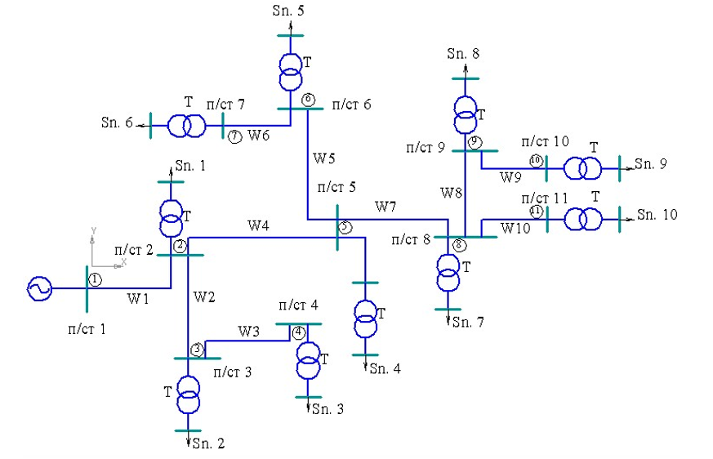

FIGURE 1. Electrical network diagram
TABLE 1. Characteristics of transmission lines and loads
Characteristics of transmission lines |  |  | Load characteristics
Name | Length, km | Conductor type | №, Substation | P, kW | Q, kVAr
W1 | 9 | АС-150/11 | 2 | 1500 | 720
W2 | 4 | АС-120/11 | 3 | 700 | 340
W3 | 4 | АС-120/11 | 4 | 500 | 240
W4 | 9 | АС-150/11 | 5 | 1000 | 480
W5 | 4 | АС-120/11 | 6 | 500 | 240
W6 | 3 | АС-120/11 | 7 | 400 | 190
W7 | 7,5 | АС-120/11 | 8 | 1000 | 480
W8 | 4 | АС-120/11 | 9 | 800 | 380
W9 | 3 | АС-120/11 | 10 | 500 | 240
W10 | 4 | АС-120/11 | 11 | 700 | 340
A genetic algorithm was applied to optimize the operation of the electrical network by evaluating various nodes as potential locations for distributed generation units [11,12]. Because the load profile of each substation is unique and distributed generation is intended solely to meet the internal demand of the corresponding substation, the overall benefit of integration is determined by both the load magnitude and the configuration of the network.
Figure 2 illustrates how voltage levels vary across the network nodes under normal operating conditions and when distributed generation is installed at different points. In the normal mode, voltage gradually declines as the distance from the supply source increases, which stems from rising current levels and the impedance of long distribution lines. Although installing distributed generation at the examined nodes leads to an overall voltage rise, the degree of enhancement depends on how each node is positioned relative to the most heavily loaded sections of the network.
The most pronounced improvement occurs when distributed generation is placed at node 9. In this case, terminal-node voltages become more uniform and approach their nominal values. This effect results from the local compensation of part of the load and reduced current flow through lines W8–W10, which previously caused significant voltage drops. Overall, the analysis confirms that locating distributed generation at node 9 provides the greatest improvement in substation bus voltage levels (Fig. 2).

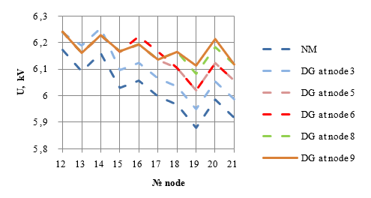
FIGURE 2. Voltage profile changes under normal operating conditions and with distributed generation installed at various network nodes
RESEARCH RESULTS
Figure 3 presents the active and reactive power losses for both the normal operating mode and the scenarios in which distributed generation is placed at selected nodes of the network. The data illustrate how active (ΔP) and reactive (ΔQ) losses vary depending on the location of distributed generation sources. Under normal operating conditions, power losses are the highest, primarily due to the substantial currents flowing through the long feeders and the relatively large reactive component of the overall load.
The installation of distributed generation at nodes 3, 5, and 6 results in only a moderate decrease in losses. This limited effect is attributed to the proximity of these nodes to the main supply point, which prevents significant unloading of the most extended branches of the network. A more pronounced improvement is achieved when distributed generation is placed at node 8, while the lowest values of ΔP and ΔQ are obtained when the source is installed at node 9. This occurs because a unit installed at node 9 compensates the demand of the most distant and heavily loaded sections, sharply reducing the current through lines W8–W10 and thereby minimizing power losses.
Consequently, the configuration with distributed generation located at node 9 yields the smallest active and reactive power losses within the network.

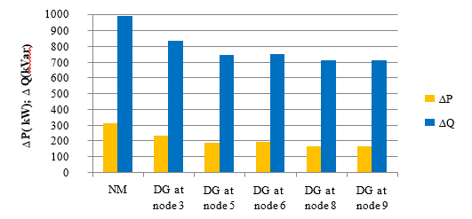
FIGURE 3. Active (P) and reactive (Q) power losses under normal operating conditions and with distributed generation installed at various network nodes
The examination of the graphs clearly indicates that the selection of the node for distributed generation placement plays a critical role in shaping the network’s operating performance. The most effective configuration corresponds to installing distributed generation at node 9, where the voltage profile at terminal nodes improves most substantially and the reduction in active and reactive power losses is greatest. These findings highlight the strong dependence of radial distribution networks on the spatial distribution of local generation sources and validate the applicability of genetic algorithm–based optimization techniques for identifying effective strategies for deploying active-adaptive elements.
CONCLUSIONS
1. Integrating distributed generation (DG) units into the network results in a noticeable improvement in voltage levels at consumer buses. The extent of this improvement is largely determined by the structural characteristics of the network and the distribution of loads across nearby consumers, both of which influence how effectively local generation can support the system.
2. Genetic algorithms (GA) provide an effective tool for determining optimal DG installation points within radial distribution systems. Simulation outcomes reveal that placing DG at node 9 delivers the most substantial enhancement in network performance. This placement leads to the greatest increase in voltage levels and the most pronounced reduction in active and reactive power losses, primarily due to local load compensation and the resulting decrease in current flow through downstream branches.
3. Additional improvements in reducing power losses across the network can be achieved by installing static capacitor banks at consumer buses. Such devices enhance reactive power support, improve voltage stability, and contribute to a more efficient overall operation of the distribution system.
REFERENCES
- Kubarykov Yu.P., Golubeva K.A. Voltage level and loss control in electrical networks with active–adaptive elements // Power Engineering Through the Eyes of Youth: Proceedings of the 6th International Scientific and Technical Conference, November 9–13, 2015, Ivanovo. – In 2 volumes.
- Dolan M.J., Davidson E.M., Kockar I., Ault G.W., McArthur, and S.D.J. Distribution Power Flow Management Utilizing an Online Optimal Power Flow Technique. IEEE Transactions on Power Systems, vol. 27, no. 2, pp. 790-799, May 2012.
- Atia R., Yamada N. Distributed Renewable Generation and Storage System Sizing Based on Smart Dispatch of Microgrids. Energies. 2016, 9, 176. [ R. Atia, and N. Yamada, “Distributed Renewable Generation and Storage System Sizing Based on Smart Dispatch of Microgrids”. Energies. 2016, 9, 176.].
- Guerrero J. M., Vasquez J. C., Matas J., Vicuña L. G., Castilla M. Hierarchical control of droop-controlled AC and DC microgrids-A general approach toward standardization. IEEE Trans. Ind. Electron. 2011, 58, 158–172.
- N. E. Tarasovskaya, G. A. Orazalina, and A. A. Orazbayeva, “Methodical classification of genetic problems by the solution algorithm,” in Proc. Int. Sci.-Prac. Conf. “Modern Society, Education and Science”, 2015, pp. 148–150.
- M. M. Minegaliyeva and I. I. Nabiev, “Study of the influence of population size in a genetic algorithm on the efficiency of solving optimization problems,” in Proc. 4th Int. Youth Sci. Conf. “Generation of the Future: View of Young Scientists – 2015”, 2015, pp. 56–68.
- Taslimov A, Rakhimov F, Nematov L, Markaev N, Bijanov A and Yunusov R. Economic load intervals for selecting 10 kV cable cross sections for agricultural consumers// IOP Conf. Series: Materials Science and Engineering 883 (2020) 012102 IOP Publishing https://doi.org/10.1088/1757-899X/883/1/012102.
- A.D. Taslimov, A.S. Berdishev, A.A. Yuldashev, F.M. Rakhimov. Optimal tendency of selecting cable cross-sections for agricultural electrical networks// Published 1 April 2020Published under licence by IOP Publishing LtdJournal of Physics: Conference Series, Volume 1515, Applied Physics and Cyber-Physical Systems. https://doi.org/10.1088/17426596/1515/2/022056.
- A.D. Taslimov, A.S. Berdishev, M.V. Melikuziyev, F.M. Rakhimov. Method of selecting parameters of cable lines distributive networks 10 kV in uncertainty conditions// E3S Web Conf.Volume 139, 2019 Rudenko International Conference “Methodological problems in reliability study of large energy systems” RSES 2019.
- Kholikhmatov B.B., Samiev Sh.S., Erejepov M.T., Nematov L.A. Modelling of laboratory work in the science "Fundamentals of power supply" using an educational simulator based on a programmed logic controller // E3S Web of Conferences 384. 2023. РР, 01032, 1-3. https://doi.org/10.1051/e3sconf/202338401032.
- A.D. Taslimov, A.S. Berdishev, M.V. Melikuziyev, F.M. Rakhimov. Method of choosing the unification of cable sections of electric network cables under conditions of load development uncertainty // E3S Web Conf.Volume 139, 2019 Rudenko International Conference “Methodological problems in reliability study of large energy systems” RSES 2019.
- Taslimov A D, Rakhmonov I U 2019 Optimization of complex parameters of urban distribution electric networks Journal of Physics: Conference Series 1399. https://doi.org/10.1088/1742-6596/1399/5/055046.
- Rakhimov F, Rakhimov F, Samiev Sh, Abdukhalilov D. Justification of Technical and Economic Effectiveness of Application of 20 kV Voltage in Overhead Electric Networks //AIP Conf. Proc. 3152, 030023 (2024). https://doi.org/10.1063/5.0218921

