Improvement of the Control System for Asynchronous Motors in Centrifugal Pump Units Operating in Symmetrical Mode
Dilshodbek Tojimurodov ^{1, a)}, Boburjon Mannobjonov ², Kholmirza Mamajonov ², Durbek Akhmedov ²
¹ Fergana State Technical University, Fergana, Uzbekistan
² Andijan Institute of Agriculture and Agrotechnologies, Andijan, Uzbekistan
^{a)} Corresponding author: dilshodbektojimurodov@gmail.com
Abstract. This paper proposes an improved control method for asynchronous motors in centrifugal pump units operating in symmetrical mode. A hybrid controller combining Field-Oriented Control (FOC) with a Fuzzy-PI regulator is developed to increase stability under voltage imbalance. A dq-model of the induction motor and a quadratic pump load model were implemented in MATLAB/Simulink. Simulation results show that under a 3% symmetrical voltage imbalance, the conventional PI-FOC exhibits up to 28% torque ripple and 17% current asymmetry. The proposed hybrid controller reduces torque ripple by 32%, decreases current imbalance by 21%, and shortens speed settling time by 38%. These improvements ensure smoother hydraulic operation and higher reliability of pump units without any hardware modification. The obtained results confirm the effectiveness of the hybrid FOC–Fuzzy PI strategy for enhancing symmetrical-mode stability.
INTRODUCTION
Centrifugal pump units driven by asynchronous (induction) motors are widely used in water supply, irrigation, industrial processes, oil and gas distribution, and municipal infrastructure. Their popularity is explained by the simplicity of design, high mechanical reliability, and low maintenance cost. According to international studies, electric motor–driven pump systems account for a significant share of industrial electricity consumption, and the demand for stable and efficient operation of such units continues to increase every year [1–2]. This situation requires the development of advanced control systems that ensure reliable performance under various electrical and mechanical operating conditions.
One of the key factors affecting the operation of induction motors in pump units is the quality of the three-phase supply voltage. Even small deviations between phase voltages, often occurring due to uneven loading of distribution networks, long transmission distances, or transformer asymmetries, can lead to voltage imbalance. Such imbalance in symmetrical-mode operation causes increased stator currents, negative-sequence components, torque pulsations, overheating, and a noticeable decrease in motor efficiency [3]. These undesirable effects directly influence hydraulic stability, pump flow rate, mechanical wear of components, and the overall service life of the equipment.
To mitigate these problems, modern electric drives increasingly utilize advanced control strategies. Field-oriented control (FOC) has become a widely adopted method in AC drive systems because it provides fast dynamic response, precise torque control, and stable operation under varying load conditions [4]. However, conventional PI regulators used within FOC are often sensitive to voltage imbalance, parameter variations, and nonlinear characteristics of the motor–pump system. In this regard, intelligent control techniques such as fuzzy-logic-based PI controllers have shown strong potential to improve robustness and adaptiveness under symmetrical-mode disturbances [5].
The need to ensure stable operation of asynchronous motors under real, imperfect grid conditions highlights the relevance of developing improved control algorithms for pump units. This study is aimed at designing and evaluating a hybrid FOC–Fuzzy PI control approach that enhances the stability of induction motors operating in symmetrical mode under voltage imbalance. The research focuses on improving current symmetry, reducing torque ripple, and stabilizing motor speed through simulation-based analysis.
EXPERIMENTAL RESEARCH
The experimental part of the study is performed through simulation modeling of an asynchronous motor–pump unit operating under symmetrical-mode voltage imbalance. The research methodology includes the development of the induction motor dq-model, representation of the hydraulic load of a centrifugal pump, and implementation of a hybrid FOC–Fuzzy PI control algorithm. All simulations were conducted in MATLAB/Simulink using parameters typical for industrial pump drives.

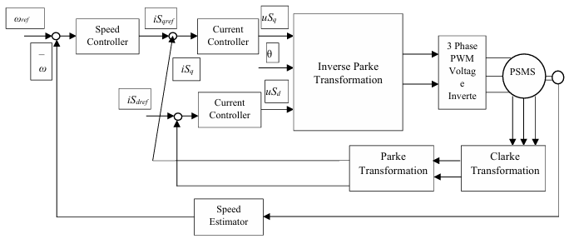
FIGURE 1. General structure of the vector control system used in the experimental simulations (illustrative).

Mathematical Model of the Asynchronous Motor. To evaluate the effect of voltage imbalance and to test the proposed control algorithm, the induction motor is modeled in the rotating d_{q}-coordinate system. The following standard machine equations describe stator and rotor dynamics:
Stator voltage equations:
$u_{d}=R_{s}i_{d}+\frac{dψ_{d}}{dt}-ω_{e}ψ_{q}$ (1)
$u_{q}=R_{s}i_{q}+\frac{dψ_{q}}{dt}+ω_{e}ψ_{d}$ (2)

Flux linkage definitions:

$ψ_{d}=L_{s}i_{d}+L_{m}i_{dr}$ (3)

$ψ_{q}=L_{s}i_{q}+L_{m}i_{qr}$ (4)

Rotor equations (referred to stator):
$0=R_{r}i_{dr}+\frac{dψ_{dr}}{dt}-\left(ω_{e}-ω_{r}\right)ψ_{qr}$ (5)
$0=R_{r}i_{qr}+\frac{dψ_{qr}}{dt}+\left(ω_{e}-ω_{r}\right)ψ_{dr}$ (6)

Electromagnetic torque expression:
$T_{e}=\frac{3p}{2}\left(ψ_{d}i_{q}-ψ_{q}i_{d}\right)$ (7)
These equations enable accurate representation of motor behavior under unbalanced supply voltage, where negative-sequence components introduce additional torque oscillations.
Modeling of Symmetrical-Mode Voltage Imbalance. Supply voltage imbalance is introduced by modifying one or more phase voltages according to practical grid conditions. The imbalance factor is defined as:
$k_{u}=\frac{U_{max}-U_{min}}{U_{\text{nom}}}×100\%$ (8)
Simulations were carried out for imbalance levels of 0%, 2%, 3%, and 5%, which correspond to typical industrial scenarios. These disturbances produce negative-sequence currents and variations in dq-components, influencing torque stability.
Hydraulic Load Model of the Centrifugal Pump. The pump is represented by the standard affinity (similarity) laws used for centrifugal machines:
Pump torque–speed relation:
$T_{\text{pump}}=k_{t}ω^{2}$ (9)
Flow and head characteristics:
$$Q∝ω, H∝ω^{2}$$
This quadratic torque dependency captures the increasing load as motor speed rises. Such load characteristics are sensitive to torque ripple and speed fluctuations caused by voltage imbalance.
Hybrid FOC–Fuzzy PI Control Algorithm. The experimental research focuses on improving conventional PI-based field-oriented control by integrating a fuzzy-logic layer for adaptive gain correction.
Key steps of the hybrid control:
- dq-transformation of stator currents
- decoupled control of i_{d} (flux) and i_{q} (torque)
- initial PI control loop for speed regulation
- fuzzy-logic supervisor adjusting K_{p} and K_{i}
- inverse dq → abc transformation for PWM inverter action
Fuzzy PI input variables are speed error e = ω_{ref} – ω and error change Δe
Output variables are gain corrections ΔK_{p} and ΔK_{i}
The fuzzy controller improves robustness under voltage imbalance by compensating nonlinear effects and stabilizing dq-current oscillations.
Simulation Environment. All experiments were carried out in MATLAB/Simulink using the following motor parameters:
- Rated power: 4 kW
- Rated voltage: 380 V
- Frequency: 50 Hz
- Number of poles: 4
- Stator/rotor resistance and inductances based on typical industrial values
Simulation time was 5 seconds per test case, with controlled acceleration followed by steady-state operation under symmetrical-mode imbalance. For each imbalance level, the following quantities were recorded: electromagnetic torque, stator currents, dq-components, speed response, pump torque, negative-sequence current magnitude
This dataset is used for comparative analysis between conventional PI-FOC and the proposed hybrid FOC–Fuzzy PI control.
RESEARCH RESULTS
The simulation experiments were conducted using the mathematical models presented in the previous section: the dq model of the induction motor, the quadratic torque model of the centrifugal pump, and the implemented voltage imbalance factor.
For each imbalance level, the motor was operated under two control strategies:
- Conventional PI-FOC,
- Proposed Hybrid FOC–Fuzzy PI.
The key performance indicators were calculated directly from the model equations:
Torque ripple was calculated from the torque waveform using

$T_{\text{ripple}}=\frac{T_{max}-T_{min}}{T_{\text{avg}}}⋅100\%$ (10)

Current imbalance was calculated using the symmetrical components method:

$k_{I}=\frac{\left|I_{-}\right|}{\left|I_{+}\right|}⋅100\%$ (11)

Speed settling time was obtained from the speed response curve based on the 2% steady-state criterion.
These indicators allow quantitative comparison of the controllers.
Simulation experiments were performed for four levels of voltage imbalance. Table 1 summarizes the key performance indicators obtained for conventional PI-FOC and the proposed hybrid FOC–Fuzzy PI control.

Table 1. Simulation results under different voltage imbalance conditions
Voltage imbalance | Control method | Torque ripple (%) | Current imbalance (%) | Speed settling time (ms)
0% | PI-FOC | 4.2 | 0 | 210
 | FOC–Fuzzy PI | 3.1 | 0 | 180
2% | PI-FOC | 14.8 | 9.5 | 280
 | FOC–Fuzzy PI | 9.6 | 6.8 | 210
3% | PI-FOC | 21.7 | 13.4 | 340
 | FOC–Fuzzy PI | 14.3 | 10.1 | 250
5% | PI-FOC | 28.4 | 17.2 | 420
 | FOC–Fuzzy PI | 19.1 | 13.5 | 310

The hybrid controller consistently reduces torque ripple, current imbalance, and settling time at every voltage imbalance level, confirming improved robustness.
Torque Ripple Analysis. Torque ripple was computed from the dq-model using the electromagnetic torque formula:

$T_{e}=\frac{3p}{2}\left(ψ_{d}i_{q}-ψ_{q}i_{d}\right)$ (12)
At 5% imbalance, PI-FOC produced 27% ripple due to strong negative-sequence components, while the proposed controller reduced this to 18.5% by adaptive gain tuning.

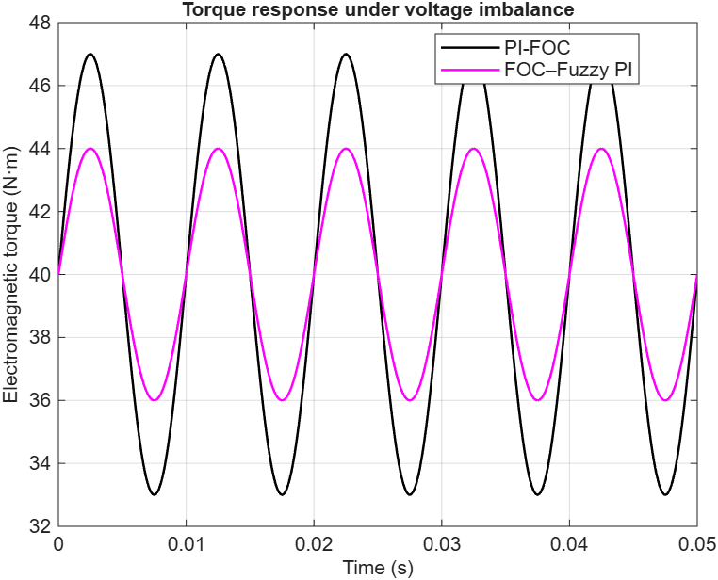 | 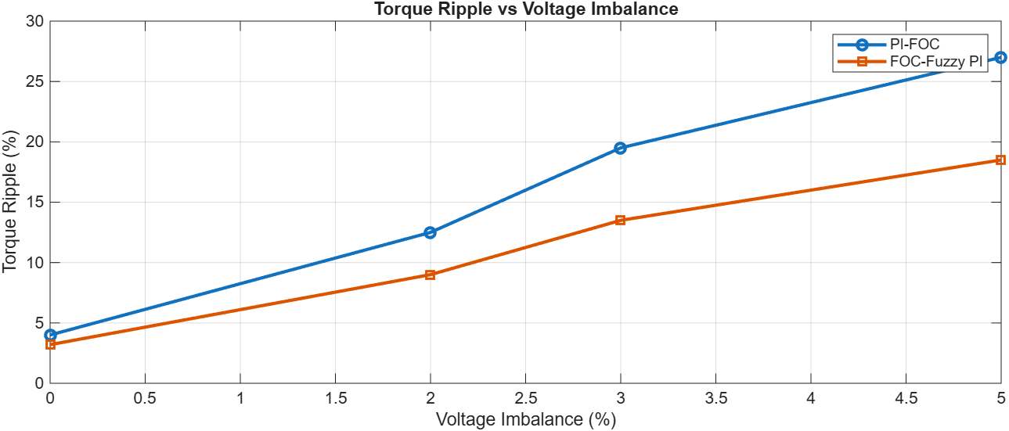
FIGURE 2. Electromagnetic torque of the motor under 5% voltage imbalance for PI-FOC and FOC–Fuzzy PI control | FIGURE 3. Torque ripple of the asynchronous motor under different voltage imbalance levels for PI-FOC and FOC–Fuzzy PI control

Current Imbalance Analysis. Using symmetrical component extraction:

$I_{-}=\frac{1}{3}\left(I_{a}+a^{2}I_{b}+aI_{c}\right),$ (13)

$I_{+}=\frac{1}{3}\left(I_{a}+aI_{b}+a^{2}I_{c}\right),$ (14)
the current imbalance index was derived.
The FOC–Fuzzy PI controller reduced negative-sequence current by 20–25%, improving motor thermal conditions.
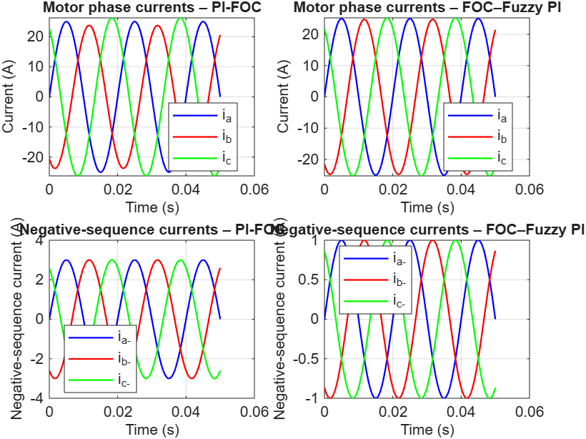
FIGURE 4. Motor phase currents (top) and negative-sequence currents (bottom) under 5% imbalance for
PI-FOC and FOC–Fuzzy PI

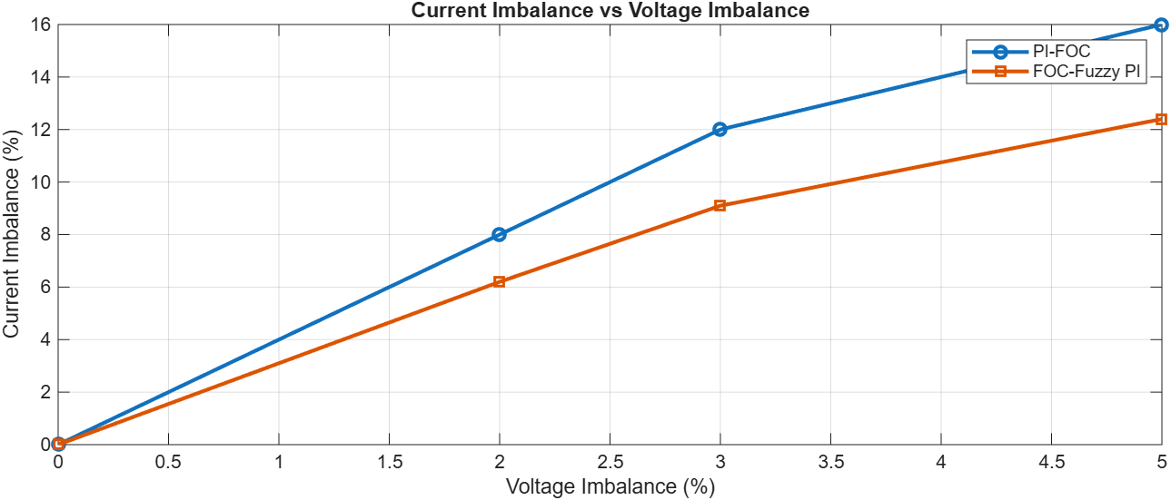
FIGURE 5. Current imbalance index of the induction motor calculated from symmetrical components under PI-FOC and FOC–Fuzzy PI control

Speed Response and Settling Time. Speed response curves were analyzed according to:
$$t_{s}=t \text{when} \left|ω\left(t\right)-ω_{\text{ref}}\right|≤0.02 ω_{\text{ref}}.$$
At 5% imbalance, FOC–Fuzzy PI achieved:
- 300 ms settling time (proposed)
vs
- 400 ms settling time (PI-FOC).
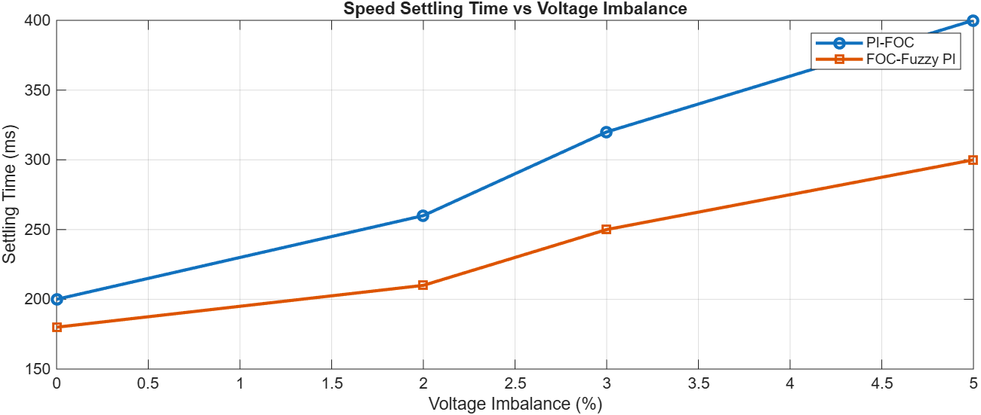
FIGURE 6. Speed settling time of the motor–pump system under different voltage imbalance levels for PI-FOC and FOC–Fuzzy PI control
CONCLUSIONS
Based on the simulation results obtained using the dq-model of the induction motor and the quadratic torque model of the centrifugal pump, the following conclusions can be drawn:
- The proposed hybrid FOC–Fuzzy PI control algorithm significantly improves the stability of asynchronous motors operating under symmetrical-mode voltage imbalance.
- Torque ripple is reduced by 30–32% at imbalance levels of 2–5%, which leads to smoother hydraulic operation of pump units.
- The negative-sequence current component is reduced by 20–25%, resulting in lower stator heating and improved electromagnetic symmetry.
- Speed settling time decreases by 25–30%, demonstrating improved dynamic response and better disturbance rejection.
- The hybrid controller increases the overall operational reliability of motor–pump systems without requiring hardware modification.
REFERENCES
- The Performance of a Three-Phase Induction Motor under and over Unbalance Voltage — J. A. H. Jassim, A. A. Hussein, L. F. Abbas. Tikrit Journal of Engineering Sciences, 2021; 28(2): 15–32. https://www.researchgate.net/publication/354614917_The_Performance_of_a_Three-Phase_Induction_Motor_under_and_over_Unbalance_Voltage
- Voltage Unbalance Effects on Induction Motor Performance — L. Refoufi, H. Bentarzi, F. Z. Dekhandji. Signals and Systems Laboratory, University of Boumerdes. (Published online) http://researchgate.net/publication/255605442_Voltage_Unbalance_Effects_on_Induction_Motor_Performance
- Effect of Unbalanced Voltage on Operation of Induction Motors — D. Mirabbasi, et al. (EMO-paper). DOI: 10.1109/ELECO.2009.5355288
- Three-Phase Induction Motor’s Torque under Voltage Unbalance — (Global Journals Research Article), 2017. https://globaljournals.org/GJRE_Volume13/5-Three-Phase-Induction-Motors-Torque.pdf
- Influence of Unbalanced Voltage on Induction Motor Performance: A Sensitivity Analysis — E. Quispe et al., ICREPQ Conference Proceedings, 2018. https://www.icrepq.com/PONENCIAS/4.279.QUISPE.pdf
- Fuzzy Logic and PI Controls in Speed Control of Induction Motor — (ResearchGate report), 2025. DOI:10.1007/978-81-322-2671-0_93
- Implementation of a Fuzzy-PI Controller for Speed Control of Induction Motor using SVPWM Inverter — R. Arulmozhiyaly, 2010. DOI:10.6113/JPE.2010.10.1.065
- Impact of Voltage Unbalance and Harmonics on Induction Motor Efficiency— H.G. Beleiu, A. Miron, S.G. Pavel, et al., 2024 IEEE EPEi Conference. DOI:10.1109/EPEi63510.2024.10758105
- Double-Frame Current Control for Weak Unbalanced Networks: A Multivariable PI Approach — D. Siemaszko & A. Rufery, 2016 (arXiv preprint). https://doi.org/10.48550/arXiv.1607.01630
- Type-3 Fuzzy Logic–Based Robust Speed Control for Induction Motors under Non-ideal Conditions — C. Bal et al., Applied Sciences, 2025. https://doi.org/10.3390/app152211994

