Study of using Remote Sensing technologies in forestry cadastre and monitoring (in case Uzbekistan)
Nodira Xasanxonova ^{a)}, Ravshan Kalandarov, Lyudmila Ulichkina
Tashkent State University of Economics, Tashkent, Uzbekistan
^{a)} Corresponding author: nxasanxonova@gmail.com
Abstract. The integration of remote sensing (RS) technologies into Uzbekistan's forestry cadastre and monitoring practices represents a major advancement in sustainable forest management. This study examines how RS improves the accuracy, efficiency, and comprehensiveness of the forestry cadastre, which is vital for the effective management, conservation, and restoration of forest resources in Uzbekistan. By utilizing spatial analysis, remote sensing, and data integration, RS technologies offer detailed insights into forest cover, land use changes, and biodiversity, creating a strong foundation for informed decision-making and policy development. The research highlights how RS tools facilitate precise mapping of forest boundaries, monitoring of illegal logging activities, and evaluation of reforestation efforts. Furthermore, the study explores the challenges and opportunities linked to the implementation of RS in Uzbekistan's forestry sector, considering the country’s unique geographical and ecological context. The findings suggest that adopting RS technologies can significantly bolster Uzbekistan's environmental sustainability objectives and enhance the management of its forestry resources.
INTRODUCTION
Forests are essential for preserving biodiversity, supplying economic resources, and preserving ecological balance. Forests are essential to the ecology in Uzbekistan, a nation with a wide variety of landforms, including deserts and mountain ranges. They provide a multitude of ecological functions and support the livelihoods of rural inhabitants [1]. However, deforestation, illicit logging, land degradation, and the effects of climate change present serious obstacles to Uzbekistan's forest resource management and conservation. Modern technical solutions like Remote Sensing (RS) have become more and more important in the fields of forestry cadastre and monitoring in order to address these issues.[2]. RS is a potent tool that combines spatial and non-spatial data, enabling users to meaningfully and thoroughly explore, analyze, and interpret geographic data. RS technologies are used in the forestry setting to map forest tracts, track changes over time, and efficiently manage forest resources [3]. Uzbekistan can strengthen the vital monitoring procedures that support sustainable forest management and its forestry cadastre, an official record that documents the size, worth, and ownership of forest properties, by utilizing RS's capabilities [4].
A forestry cadastre is an integral component of forest management, giving vital information regarding the quantity, location, and status of wooded areas. The precise and current upkeep of a forestry cadastre is essential for sustainable development in the context of Uzbekistan, where forests make up around 8% of the country's total land area [5–7]. The allocation of forest resources, conservation initiatives, and land use planning are just a few of the activities that rely on this cadastre as its fundamental basis. Deforestation and land degradation are major issues in the nation, and it is crucial in monitoring these two phenomena [8–10].
Data collection and analysis in Uzbekistan's forestry cadastre have historically been done by hand. Nevertheless, these techniques are frequently labor-intensive, time-consuming, and prone to mistakes. This procedure might be completely transformed by incorporating RS technology into the forestry cadastre system. RS permits the efficient capture, storage, and analysis of large spatial data, hence facilitating the updating and maintenance of the cadastre. Additionally, RS offers modeling and spatial analysis capabilities, which improve the forest management decision-making process [11–13]. The use of RS technologies significantly enhances monitoring, which is an essential part of forest management. Tracking changes in forest cover, evaluating the effects of human activity, and identifying illegal logging and other types of forest degradation are all included in the monitoring of forest conditions in Uzbekistan. A thorough and complete method of tracking these changes is made possible by integrating RS with remote sensing technologies like satellite imaging and aerial photography. The capacity of RS to handle and analyze data from many sources in a spatially explicit way is a significant benefit of using it in forestry monitoring. As a result, it is possible to track, record, and evaluate changes in forest cover over time, offering important information for conservation and management projects [14–17]. To help identify regions that need immediate attention or intervention, RS can, for example, create time-series maps that show the progress of reforestation or deforestation activities. Additionally, RS technologies make it easier to integrate different datasets, including topography, soil types, climate data, and land use trends. All of these datasets are relevant to understanding the dynamics of forests. Therefore, this comprehensive approach facilitates the creation of focused plans for forest conservation and restoration and allows for a more nuanced understanding of the variables influencing changes in forest cover [18–20]. Although using RS for forestry cadastre and monitoring has many clear advantages, there are drawbacks to its application in Uzbekistan. These difficulties include the need for technological know-how, the accessibility of high-quality geographical data, and the upfront expenses related to setting up RS infrastructure. However, with the right investment in technology transfer and capacity creation, these challenges can be solved. There are numerous chances to improve forest management techniques in Uzbekistan's forestry industry by implementing RS technologies. RS can promote sustainable forest management, aid in biodiversity preservation, and lessen the effects of climate change by improving the precision and effectiveness of forestry cadastre and monitoring systems. With Uzbekistan's continued dedication to environmental sustainability, RS in forestry is expected to play a bigger part in achieving these goals (A of figure 1).
EXPERIMENTAL RESEARCH
The Bustanlik district in the Tashkent region of Uzbekistan serves as the study area for this investigation into the use of RS technologies in forestry cadastre and monitoring (B of figure 1). Located in the western slopes of the Tien Shan Mountains, Bustanlik is known for its diverse terrain, which includes both high-altitude forests and lowland plains [21]. As a result, the district plays a crucial part in Uzbekistan's forest management and protection. The district, which is believed to be 4,900 square kilometers in size, is primarily made up of forested areas.

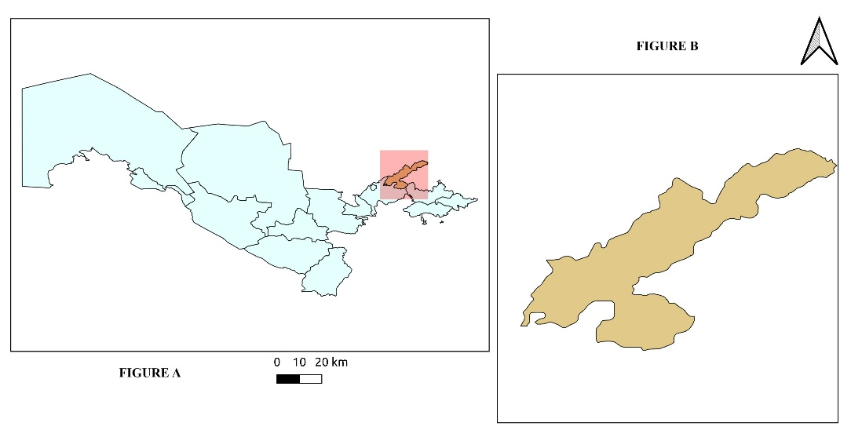
FIGURE 1. Study area: a) use of RS technologies in forestry cadastre and monitoring in The Bustanlik district in the map of Uzbekistan, b) use of RS technologies in forestry cadastre and monitoring in the map of The Bustanlik district

Due to its unique biological characteristics, Bustanlik is an ideal site for researching the application of RS technologies in forestry monitoring and cadastre. The district's forests are essential for controlling the flow of rivers, particularly the Chirchiq, which provides water for nearby hydroelectric generating plants and agricultural irrigation. Furthermore, it is impossible to overestimate the importance of effective forest monitoring and management given the district's increased susceptibility to the effects of climate change [22].
The Landsat 9 Operational Land Imager (OLI) satellite photos are employed in the study as remote sensing data to enhance Uzbekistan's forestry cadastre and monitoring procedures. The Normalized Difference Vegetation Index (NDVI), a popular remote sensing method for evaluating vegetation health, forest cover, and land use changes, is the main subject of the investigation [23].
Data Collection: The ability of Landsat 9 OLI satellite imagery to collect high-quality, multi-spectral data over wide areas led to its selection. This imagery has a spatial resolution of 30 meters. In order to document vegetation changes over time, satellite photos were taken over several seasons. The primary wooded parts of the study area, such as riparian zones and hilly regions, are included in the study area. These areas are where forest dynamics are most noticeable.
Data preprocessing: A number of preprocessing procedures were applied to the unprocessed satellite photos in order to guarantee data accuracy and quality. These procedures included cloud masking to reduce the influence of clouds on the analysis, atmospheric correction to eliminate distortions brought on by atmospheric circumstances, and geometric correction to align the photos with geographic coordinates. The accuracy of the photos' representation of the ground conditions was guaranteed by this preprocessing.
NDVI Analysis: The main method involved calculating the NDVI for each satellite image using the formula:

$NDVI=\frac{NIR-Red}{NIR+Red}$ (1)

Where: Certain spectral bands recorded by the Landsat 9 OLI sensor are represented by the NIR (Near Infrared) and RED bands. Higher NDVI readings indicate denser and healthier vegetation; they range from -1 to +1. The creation of NDVI maps for various time periods made it possible to evaluate the health of the vegetation, changes in the forest cover, and regions of deterioration.[24].
RS Integration: Spatial analysis and visualization were made possible by the integration of the NDVI results into an RS platform. The development of comprehensive forest cadastre maps that pinpointed regions of land degradation, reforestation, and deforestation was made possible by this integration. Monitoring illicit logging operations and evaluating the efficacy of forest management techniques were also made easier by the RS analysis. Ground truth information gathered from field surveys and pre-existing forestry records was used to confirm the precision and dependability of the satellite-based analysis.
A thorough strategy to monitoring and managing Uzbekistan's forest resources was made possible by the integration of RS, NDVI analysis, and Landsat 9 OLI data. This technique yielded important insights for sustainable forest management.
RESEARCH RESULTS
For mapping forest regions, the findings of a study on the land cover changes index for converting RS technologies and satellite photos (particularly Landsat 8.9 OLI) are suggested and assessed. The variations in bare land and woodland could be studied by the index. Because forest and bare land/open land had different spectral responses in all Landsat 8.9 OLI pictures, the NDVI analysis indices were able to distinguish between them with accuracy. The land cover change map from 2013 to 2023 indicates a mixture of forest land change classes. While some areas in the study area experienced significant land cover changes over the ten-year period, large portions of forest and bare land remained unchanged in terms of land use. Some observed land cover changes during this period appeared to be related to agricultural activities (A and B of figure 2).
Important new information about the health, cover, and dynamics of the forest was obtained from the study that used RS technologies in forestry cadastre and monitoring in the Bustanlik district of Uzbekistan. We evaluated forest conditions over time by utilizing NDVI analysis and Landsat 9 OLI satellite images. The NDVI values, which ranged from -0.2 to +0.6, showed both regions undergoing deterioration and areas with dense, healthy vegetation.
High NDVI values (0.3 to 0.6) were concentrated in the upper mountainous regions, according to the RS-based spatial analysis, suggesting healthy forest stands, especially in juniper and walnut woods. The riparian and lower-altitude zones, on the other hand, showed lower NDVI values (below 0.1), indicating increased human impact, land degradation, and deforestation.
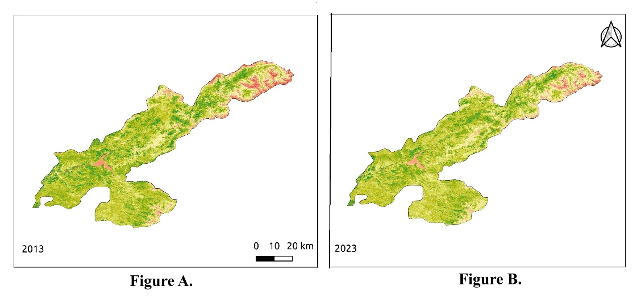
FIGURE 2. The period appeared to be related to agricultural activities: a) some observed land cover changes in 2013, b) some observed land cover changes in 2023

Better forest cadastre management was made possible by the accurate mapping of forest boundaries and the identification of deforested areas made possible by the integration of NDVI with RS. Additionally, hotspots for illicit logging and regions vulnerable to soil erosion were identified, offering important insights for upcoming conservation initiatives.

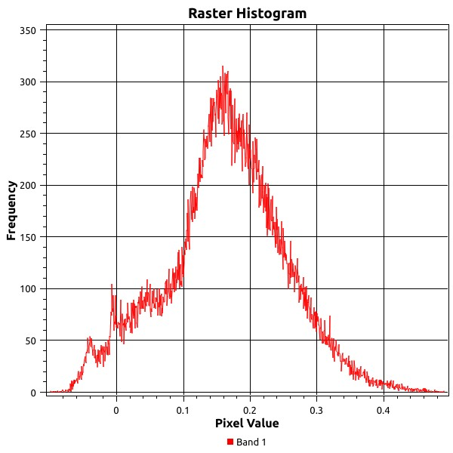
FIGURE 3. Histogram of green indexes of study area
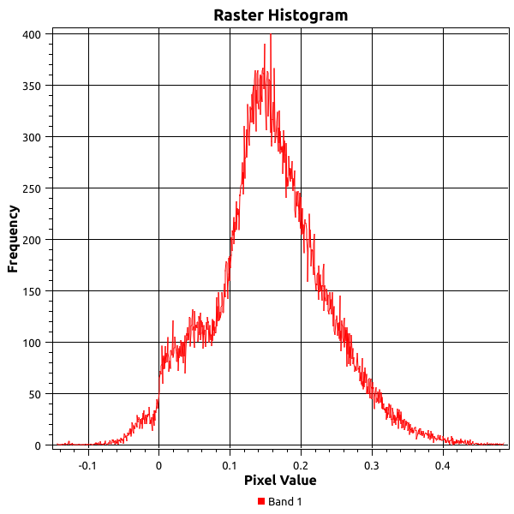
FIGURE 4. Histogram of green indexes of study area
Proceed to examine the histogram that is displayed in the pictures. With a "Frequency" axis ranging from 0 to 400, the indicators (Figure 3,4) are situated in the figure 3. With 400 at the top and none at the bottom, this is comparable to counting the number of bites you take. The "Pixel Value" axis, which ranges from -0.2 to 0.4 and indicates various tastes from bitter to sweet, is represented by the figure 4. A bell-shaped curve in the middle of the data shows a frequency of roughly 350 bites and a peak at a pixel value of 0.1. The part of data where take the most bites is represented by this peak. All things considered, the Bustanlik district's use of RS and remote sensing technologies improved the precision of forestry monitoring, encouraging improved forest management and sustainability in this environmentally delicate area.
CONCLUSIONS
The study, which was carried out in Uzbekistan's Bustanlik district, looks at how RS technologies are used in forestry monitoring and cadastre. The potential of spatial analytic techniques to promote sustainable forest management methods is highlighted by this study. The work shows a very successful method for assessing forest health, detecting deforestation, and tracking land degradation in this ecologically crucial region by combining Landsat 9 OLI satellite images with Normalized Difference Vegetation Index (NDVI) analysis. The use of RS makes it easier to map forested areas accurately, providing in-depth information on changes in vegetation cover and making it possible to identify areas that are at risk from illicit logging and unsustainable land use. Additionally, this methodology facilitates continuous forest resource monitoring, offering a trustworthy way to monitor the advancement of conservation initiatives over time. Since woods are crucial to Bustanlik's water management, biodiversity preservation, and local livelihoods, the use of RS technology has greatly improved the accuracy and effectiveness of forestry cadastre systems. Adopting these technologies would help Uzbek forest managers and policymakers make better decisions, which will support the district's forest resources' long-term sustainability. Bustanlik's effective use of RS technology offers a possible template for comparable forest management programs across the nation.
REFERENCES
- Juliev, M., Pulatov, A., Fuchs, S. & Hübl, J. (2019). Analysis of Land Use Land Cover Change Detection of Bostanlik District, Uzbekistan. Polish Journal of Environmental Studies, 28(5), 3235–3242. https://doi.org/10.15244/pjoes/94216
- M. Asori and P. Adu. (2025). Integrating RUSLE, GIS, and Remote Sensing for Soil Erosion Assessment in Morocco's Raouz Watershed. E3S Web of Conferences. 676. 02011. 10.1051/e3sconf/202567602011.
- Amini, S., Saber, M., Rabiei-Dastjerdi, H., & Homayouni, S. (2022). Urban Land Use and Land Cover Change Analysis Using Random Forest Classification of Landsat Time Series. Remote Sensing, 14(11), 2654. https://doi.org/10.3390/rs14112654
- Al Shogoor, Sattam & Sahwan, Wahib & Hazaymeh, Khaled & Almhadeen, Eman & Schütt, Brigitta. (2022). Evaluating the Impact of the Influx of Syrian Refugees on Land Use/Land Cover Change in Irbid District, Northwestern Jordan. Land. https://doi.org/10.3390/land11030372
5. I. Aslanov, Sustainable Management of Earth Resources and Biodiversity. IOP Conference Series: Earth and Environmental Science 1068, 011001 (2022) https://doi.org/10.1088/1755-1315/1068/1/011001
6. Islomov, S. et al. (2023). Monitoring of Land and Forest Cover Change Dynamics Using Remote Sensing and GIS in Mountains and Foothill of Zaamin, Uzbekistan. In: Beskopylny, A., Shamtsyan, M., Artiukh, V. (eds) XV International Scientific Conference “INTERAGROMASH 2022”. INTERAGROMASH 2022. Lecture Notes in Networks and Systems, vol 575. Springer, Cham. https://doi.org/10.1007/978-3-031-21219-2_212 https://doi.org/10.1007/978-3-031-21432-5
7. UMukhtorov, U., Aslanov, I., Lapasov, J., Eshnazarov, D., Bakhriev, M. (2023). Creating Fertilizer Application Map via Precision Agriculture Using Sentinel-2 Data in Uzbekistan. In: Beskopylny, A., Shamtsyan, M., Artiukh, V. (eds) XV International Scientific Conference “INTERAGROMASH 2022”. INTERAGROMASH 2022. Lecture Notes in Networks and Systems, vol 575. Springer, Cham. https://doi.org/10.1007/978-3-031-21219-2_213
8. Rustam Oymatov, Ilhomjon Musaev, Mukhammad Bakhriev and Guljahon Aminova. Monitoring agricultural land areas using GIS-online program EOS DA: case study of Andijan region E3S Web of Conf., 401 (2023) 02005 https://doi.org/10.1051/e3sconf/202338604008
9. U. Mukhtorov, S. Gapparov, Z. Djumaev, A. Utaev, S. Olloniyozov, and E. Karimov, Assessment of land reclamation status using remote sensing and GIS in territory of Pakhtakor district of Uzbekistan E3S Web of Conf. 401 02002 (2023) https://doi.org/10.1051/e3sconf/202340102002
10. M. Reimov, V. Statov, P. Reymov, N. Mamutov, S. Abdireymov, Y. Khudaybergenov, S. Matchanova, and A. Orazbaev, Evaluation of desertified delta plant communities using spectral indexes and landscape transformation models. E3S Web of Conferences 227, 02006 (2021) https://doi.org/10.1051/e3sconf/202122702006
11. I. Aslanov, I. Jumaniyazov, N. Embergenov, K. Allanazarov, G. Khodjaeva, A. Joldasov, and S. Alimova, Remote Sensing for Land Use Monitoring in the Suburban Areas of Tashkent, Uzbekistan. in XV International Scientific Conference “INTERAGROMASH 2022,” edited by A. Beskopylny, M. Shamtsyan, and V. Artiukh (Springer International Publishing, Cham, 2023), pp. 1899–1907 https://doi.org/10.1007/978-3-031-21219-2_211
12. A. Khurmamatov, O. Ismailov, R. Yusupov, J. Isamatova, and G. Aminova. Study of hydrodynamics of the condensation process in heat exchanger devices E3S Web Conf. 497, 01022 (2024) https://doi.org/10.1051/e3sconf/202449701022
13. R. Oymatov, I. Musaev, M. Bakhriev, and G. Aminova. Monitoring agricultural land areas using GIS-online program EOS DA: case study of Andijan region. E3S Web of Conf. 401, 02005 (2023) https://doi.org/10.1051/e3sconf/202340102005
14. Z. Mamatkulov, E. Safarov, R. Oymatov, I. Abdurahmanov, and M. Rajapbaev. Application of GIS and RS in real time crop monitoring and yield forecasting: a case study of cotton fields in low and high productive farmlands // E3S Web of Conferences 227, 03001 (2021) https://doi.org/10.1051/e3sconf/202122703001
15. R. Oymatov, N. Teshaev, R. Makhsudov, and F. Safarov. Analysis of soil salinity in irrigated agricultural land using remote sensing data: case study of Chinoz district in Uzbekistan. E3S Web of Conf. 401, 02004 (2023) https://doi.org/10.1051/e3sconf/202340102004
16. M. Lehoczky and Z. Abdurakhmonov. Present Software of photogrammetric processing of digital images. E3S Web of Conferences 227, 04001 (2021) https://doi.org/10.1051/e3sconf/202122704001
17. O. Ruzikulova, N. Sabitova, and G. Kholdorova. The role of GIS technology in determining irrigated geosystems. (2021) https://doi.org/10.1051/e3sconf/202122703004
18. M. Khamidov, A. Inamov, U. Islamov, Z. Mamatkulov, and B. Inamov. Determination of irrigation regimes based on geospatial technologies in water scarcity areas. E3S Web Conf. 386, 02001 (2023) https://doi.org/10.1051/e3sconf/202338602001
19. K. Amankulova, N. Farmonov, U. Mukhtorov, and L. Mucsi. Time‑series analysis of Sentinel‑2 satellite images for sunflower yield estimation - Geocarto International 38, 2197509 (2023) https://doi.org/10.1080/10106049.2023.2197509
20. G. Yakubov, K. Mubarakov, I. Abdullaev, and A. Ruziyev. The precise title for this specific DOI isn’t widely indexed online, but it appears as: Creating large‑scale maps for agriculture using remote sensing - E3S Web of Conferences 227, 03002 (2021) https://doi.org/10.1051/e3sconf/202122703002
21. M. Juliev, W. Ng, I. Mondal, D. Begimkulov, L. Gafurova, M. Hakimova, O. Ergasheva, and M. Saidova. Analysis of using GIS and remote sensing - E3S Web Conf. 386, 04010 (2023) https://doi.org/10.1051/e3sconf/202338604010
22. J. Gerts, M. Juliev, and A. Pulatov. Land cover and crop condition monitoring using remote sensing data. GeoScape 14, 62 (2020) https://doi.org/10.2478/geosc-2020-0006
23. M. Usman, R. Liedl, M. A. Shahid, and A. Abbas, Land Use/Land Cover Classification and Its Change Detection Using Multi-Temporal MODIS NDVI Data (Science in China Press, 2015), pp. 1479–1506 https://doi.org/10.1007/s11442-015-1247-y.
24. A. Bannari, D. Morin, F. Bonn, and A. R. Huete. A review of vegetation indices. Remote Sensing Reviews. Remote Sensing Reviews 13, 95 (1995) https://doi.org/10.1080/02757259509532298
25 C. Opp, M. Groll, O. Semenov, L. Shardakova, Y. Kovalevskaya, R. Kulmatov, I. Normatov, and I. Aslanov. Water household changes, climate change, and human impact – reasons for the dusty side of the Aral Sea Syndrome. E3S Web Conf. 575, 04001 (2024) https://doi.org/10.1051/e3sconf/202457504001
26 I. Aslanov, N. Teshaev, Z. Jabbarov, C. Opp, R. Oymatov, Y. Karimov, and G. Henebry. Characterizing land surface dynamics in Aral Sea basin of Uzbekistan using climatic and remote sensing data to project future conditions. E3S Web Conf. 575, 04009 (2024) https://doi.org/10.1051/e3sconf/202457504009
27 J. Som-Ard, C. Atzberger, E. Izquierdo-Verdiguier, F. Vuolo, and M. Immitzer. Remote Sensing Applications in Sugarcane Cultivation: A Review. Remote Sensing. Remote Sensing 13, 1 (2021) https://doi.org/10.3390/rs13204040
28 S. Kumar, N. Radhakrishnan, and S. Mathew. Land Use Change Modelling Using a Markov Model and Remote Sensing. Geomatics, Natural Hazards and Risk, 5, 145-156. Geomatics, Natural Hazards and Risk 5, 145 (2014) https://doi.org/10.1080/19475705.2013.795502

