Monitoring of land cover change dynamics using remote sensing and GIS in mountains and foothill of Parkent for ecosystem services
Gulzada Khalikulova ^{a)}, Shuhrat Tashmatov, Dilafruz Nasirxodjayeva
Tashkent State University of Economics, Tashkent, Uzbekistan
^{a)} Corresponding author: khalikulova78@gmail.com
Abstract. Remote sensing and Geographical Information System (GIS) are the most effective tools in spatial data analysis. Natural resources like land, forest, and water, these techniques have proved a valuable source of information generation as well as in the management and planning purposes. This study aims to suggest possible bare land/open land, agriculture land, and forest land management strategies in mountains and highlands of East Tian-shan based on land cover analysis and the changing pattern observed during the last twenty years. Nowadays human encroachment is taking place for more land for the misuse of pastures. The changes were well observed in the land use and land cover in the study region. A large part of fallow land and open forest were converted into bare land/open land. Geo-informatics and remote sensing techniques give an opportunity to obtain results with low costs, less time consumption, and good accuracy of land cover changing. Continuously capture the Earth’s surface and decision-makers can easily apply satellite imagery to monitor dynamics of change land cover.
INTRODUCTION
Nowadays developing remote sensing technology and Geographic Information Systems (GIS) allow us to analysing and monitoring landscape ecology and spatial analysis approach to address the problem of deforestation. [6]. Monitoring and studying of recent changes in natural resources like land, forest using remote sensing and geo-information technologies have put forward a new dimension and interactive approaches in mapping and analysis. Studying forest resources during the last twenty years, the availability of remote sensing data (Landsat 5TM, Landsat 8OLI). [5]. Land cover changes it embraces, for example, the quantity and type of surface vegetation, water, and soil cover. Land-cover changes fall into a modification class of land-cover. The latter is a change of condition within a land-cover category, such as the thinning of a forest, bare land/open land, and agricultural area composition. [12]. The purpose of the research discussed in this paper was analysing land cover changes and creating map that occurred from 2001 to 2021, using pre-existing land cover map data sets as inputs. This work aimed to assess apparent land cover changes during the observed time frame mainly with respect to forest bare land and agricultural areas. Such information was needed to augment understanding and interpretation of land cover effects on remote sensing analysis [19].
In Central Asia, the work related to land cover change dynamics seen in the works of various researchers. Most researchers work on the land in a micro watershed in the mid-elevation zone of mountain and highland areas. The vegetation cover was altered drastically with inefficient land-use pressure (both human and animal), human activities, and inefficient use of pastures. Geo-informatics and remote sensing analysis of give opportunity to increase machine learning capacity and obtain efficient monitoring land use and land cover changing [11]. Important in any studying any changes of land use creating map also key important of managing to complete mapping capacity may prevent completion of a lands create ecological penalties [20, 25]. Remote sensing data analyse loggers can easily generate and store time and position information of monitoring large areas [18]. Remote sensing data analysis and algorithms can provide managers with essential information for analysing machine learning [15].
Information about land use and monitoring of land resources is essential for correct management planning and management the use land area of such resources.
EXPERIMENTAL RESEARCH
This study area is located on the northern slopes of the East Tian shan ridge. This area an administrative division constitutes the discitis of Parkent Tashkent region of Uzbekistan. (Fig. 1). Preparation of remote sensing images of land cover of remotely sensed data ten years (2011 and 2021). Suggesting some possible measures for the improvement of the area based on the results obtained for land cover changes is the prime aim of this study. The region currently extends between 41º 00' N to 41º 30' N latitude and 69º 51' E to 71º 23' E longitude. The territory of the reserve is a mountain range with a well-expressed zonation: low land, middle and high mountains, located at an altitude of 550 - 3500 m above sea level. The southern part of the reserve occupies the steep slopes of the Chotqal ridge, cut by deep gorges; the western part has a smoother relief with terraces covered with a thick layer of marls and loess-like loams. On the territory of the reserve, three types of juniper grow together: Chotqol, hemispherical and Quraman. Juniper hemispherical forms mixed plantations in the upper part of the slopes with the Turkestan juniper, and in the lower part with the Qurama juniper. The undergrowth layer is represented by shrubs: Chotqal hawthorn, Fedchenko's rose hip, Korolkov's honeysuckle, oblong barberry, multiflower cotoneaster, occasionally Tien Shan mountain ash is found among the rocks. In the reserve, at present, more than 700 species of higher vascular plants from 70 families, 280 genera have been identified, of which 13 species are included in the Red Book of the Republic of Uzbekistan, 48 species are endemics of the western part of the Turkestan ridge. The growth of 216 species of cap fungi - macromycetes - has been noted and studied. More than 20 species of medicinal plants grow here: aconite, colchicum, immortelle and valerian, ziziphora, snakehead, etc.; more than 15 decorative species: veronica, carnation, primrose, tulips, eremurus, crocuses, iris, delphinium, etc.
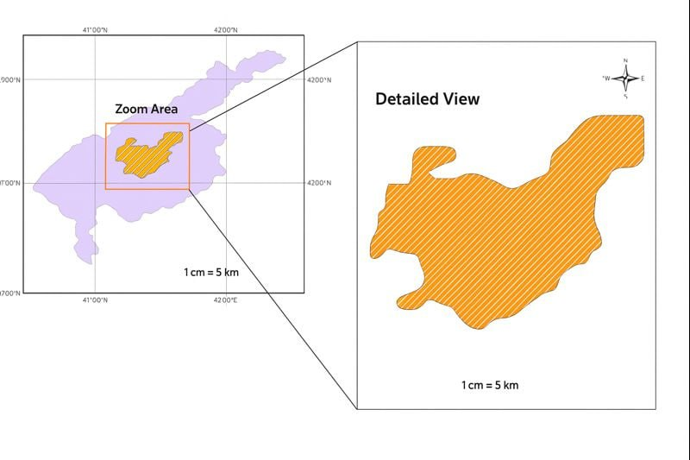
FIGURE 1. Study area Tashkent region and Parkent districts

To achieve additional increases of monitoring land cover changes, the grower deliberately applies approximately of the substance in certain areas of the area to test the correct application of remote sensing [12]. This technology became possible to the development of Geo-informatics, data progress in the land cover of automation of machinery learning, the development of remote sensing data and measuring complexes for collecting information in the land use land cover changes [17], understanding how land use land cover changing analysis [6] and assessing the effects of future land use change and monitoring [9].
For the current research data periods of 2001, 2011, 2021 (Landsat 5 TM thematic mapper and Landsat 8 OLI operational land imager) provided by the USGS (United States Geological Survey) Earth Explorer database system. The spatial resolution of Landsat imageries is the equals 30 m. To analysing of the study area is mountainous and ground data reference for visual interpretation the classification of images used Google Earth Pro. Processing classification steps were completed using the software packages and tools ArcGIS 10.6. The data reprocessing steps included the assignment of the borders, coordinate system, and sub-setting the images based on the polygon of the research area. For Land classification were used supervised classification methods and maximum likelihood algorithm of ArcGIS. Fig.3. Maximum likelihood algorithms are most used and well-known in assessing Landsat satellite imageries [15]. Land classification classes were identified in the study area: bare land cover, forest, waterbodies, agriculture area and built-up areas. For obtaining more accurate land cover classification maps, for every land classes 20 training samples were selected from study area. Fig. 2.
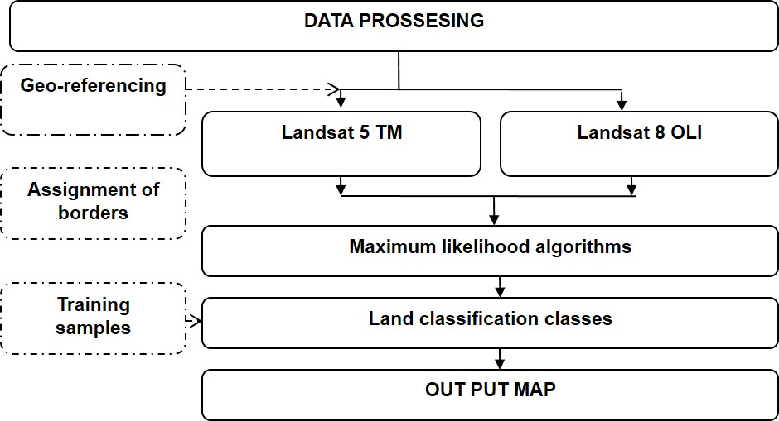
FIGURE 2. Flow chart for adopted methodology
RESEARCH RESULTS
Results of study land use/land cover index for transforming remote sensing data was proposed and evaluated for mapping forest area and bare land/open areas. The index was able to study of changing forest and bare land/open areas with a Maximum likelihood classification. The classification indices could perfectly differentiate between forest and bare land/open land because both of these land types show significantly spectral responses in all Landsat 5 TM+ bands, Landsat8 OLI. The 2011–2021 land cover change map indicates a mix of forest and bare land /open land change classes. Although some of the study area has undergone noteworthy land cove change over the 10-year interval from 2011 to 2021, extensive areas of forest and bare lands were not converted to some other land use. Some of the apparent land cover change during the observation period appeared to be of an agricultural area. Fig.4. In addition, the land cover change map included areas with deforestation, which help to illustrate the dynamic anthropogenic factors of land cover changes in the region during the observed 10-year time frame.
The relief map of the study area is taken from the DEM file from the resource earthdata.nasa.gov. The relief map of the studied area identifies the elevation zones of that area, and in the surface classification it is possible to determine at what altitudes the classification has changed. The results of the analysis show that between 2011 to 2021, forests in the study area, mainly in the area of 1000 m up to 2500 m, decreased and became open lands. (Fig. 3.)
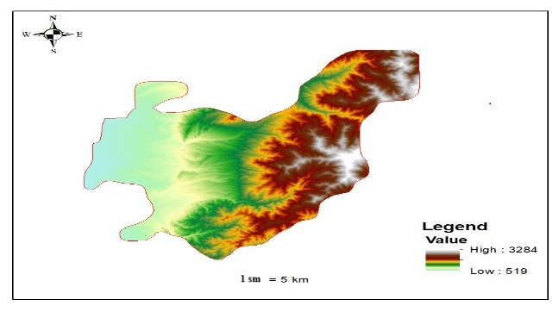
FIGURE 3. Relief map research area

The Land cover changes index is rather a hint at what is currently happening on the land. Maximum likelihood algorithms usage for land analysis: at the beginning, in the middle, and at end of the growing season (summer). Growing of the season, the Maximum likelihood algorithms index helps to understand how the plant and trees has changes over the time (Fig. 4).
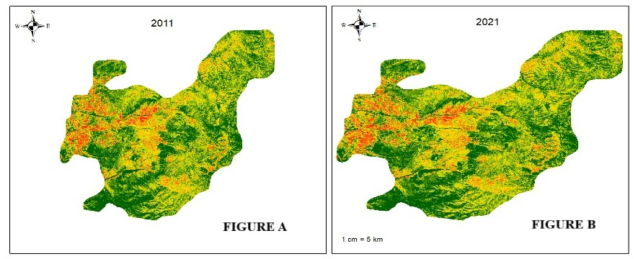
FIGURE 4. Land cover changing map: a) the comparison of classes and accuracy in 2011, b) the comparison of classes and accuracy in 2021

Nevertheless, it should be kept in mind that high Maximum likelihood algorithms identification land cover classes needed to check using google earth pro this area. Land cover categories confirmed variation in the univariate statistical values of radiation heat flux parameters (Fig. 3). Spatial parameters characterized by gradational change in the values of each parameter. Fig 2 maps shows the range of each parameter under study with their average and standard deviation values gave the best results in terms of land cover classification accuracy. A and B of figure 4 show the comparison of classes and accuracy for every land cover classes for classifications. Land cover highlighted relative increase in accuracies for all the land cover categories forest and bare land which show increase and decrease in the classification accuracy.
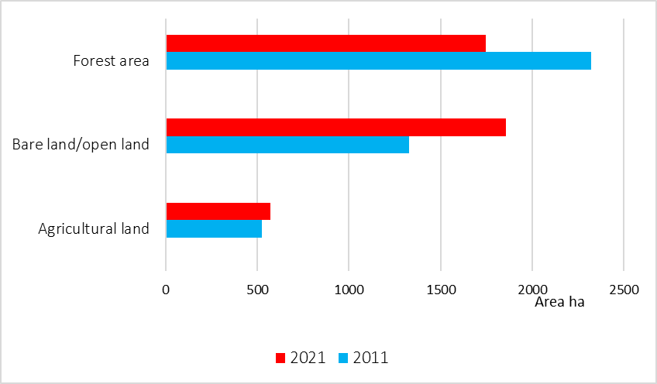
FIGURE 5. Land cover changing of ten-years data (2011-2021).

Ten-years data (2011-2021) have been taken into account to analyse the pattern of land cover changes. For the year 2011, Forest area covered nearly 61 % of the total area of study area. Bare land and open land constituted nearly 28%, agricultural land covered nearly 12% of the area. Year 2011, displayed nearly 32 % share area under the total Bare land and open land an increase in nearly 7 % during the 2011-2011. From 2011 to 2021 changes are significantly Bare land and open land an increase up to 45 % of total area. And forest has decreased from 61 % (2011) to 42% in the year 2021. This shows a decrease of forest are 19% during the last 20th years. Fallow land shows the highest change in the pattern.
CONCLUSIONS
Remote sensing methods with accurate Landsat data and monitoring results can support assessing the further behaviour of land cover monitoring. The achieved results show that within 10 years the land cover changes of the mountains and highlands of Qotqol significantly. As a result of 10 years of inefficient use of pastures in the mountainous and foothill areas of Chotqol, these areas have become open lands. The study area exhibits different land cover changes and that land changes can causes soil erosion, floods, and landslides in future – all of which can turn into hazards once elements are at risk. The land cover changing maps resulting from this study will be further used for landslide susceptibility mapping of study area, which will support the governmental authorities and stakeholders to establish land-use planning for the local government in order to prevent natural hazard losses.
REFERENCES
- Peng, Y., Li, F. D., Xu, N., Kulmatov, R., Gao, K. C., Wang, G. Q., ... & Khasanov, S. (2021). Spatial-temporal variations in drought conditions and their climatic oscillations in Central Asia from 1990 to 2019. https://doi.org/10.13930/j.cnki.cjea.200927
- Mondal, I., Thakur, S., Juliev, M. et al. Spatio-temporal modelling of shoreline migration in Sagar Island, West Bengal, India. J Coast Conserv 24, 50 (2020). https://doi.org/10.1007/s11852-020-00768-2
- K. Khakimova, I. Musaev, A. Khamraliev, Basics of Atlas Mapping Optimization in the Fergana Valley. In E3S Web of Conferences, 227, 02003 (2021). https://doi.org/10.1051/e3sconf/202122702003
- Spruce, J. Bolten, I.N. Mohammed, R. Srinivasan, V. Lakshmi. Mapping Land Use Land Cover Change in the Lower Mekong Basin From 1997 to 2010. Frontiers in Environmental Science, 8, xxxx (2020)R. https://doi.org/10.3389/fenvs.2020.00021
- Kulmatov, A. Taylakov, S. Khasanov. Quantity and quality of groundwater resources distribution along Sirdarya province. Environmental Science and Pollution Research, 28(10), 12245-12255 (2021). https://doi.org/10.1007/s11356-020-11984-w.
- N. Sabitova, O. Ruzikulova, I. Aslanov. Experience in creating a soil-reclamation map of the Zarafshan river valley based on the system analysis of lithodynamic flow structures. In E3S Web of Conferences, 227, 03003 (2021). https://doi.org/10.1051/e3sconf/202122703003
- C. Opp, M. Groll, I. Aslanov, T. Lotz, N. Vereshagina. Aeolian dust deposition in the southern Aral Sea region (Uzbekistan): Ground-based monitoring results from the LUCA project. Quaternary International, 429, 86-99 (2017). https://doi.org/10.1016/j.quaint.2015.12.103
- I. Aslanov, S. Khasanov, Y. Khudaybergenov, M. Groll, Ch. Opp, F. Li, E. Ramirez Del-Valle. Land cover-adjusted index for the former Aral Sea using Landsat images. In E3S Web of Conferences, 227, 02005 (2021). https://doi.org/10.1051/e3sconf/202122702005
- S. Sinha, L.K. Sharma, M. S. Nathawat. Improved Land-use/Land-cover classification of semi-arid deciduous forest landscape using thermal remote sensing. In Egyptian Journal of Remote Sensing and Space Science, 18, 217-233 (2015). https://doi.org/10.1016/j.ejrs.2015.09.005
- I. Musaev, A. Bokiev, M. Botirova. The Value of the Cards in Water Basins with the Installation of Solar Power Plants in Yangiyul District of Tashkent Province of Uzbekistan. In E3S Web of Conferences, 227, 05004 (2021). https://doi.org/10.1051/e3sconf/202122705004
- I. Aslanov, Sh. Kholdorov, Sh Ochilov,. A. Jumanov, Z. Jabbarov, I. Jumaniyazov, N. Namozov. Evaluation of soil salinity level through using Landsat-8 OLI in Central Fergana valley, Uzbekistan. In E3S Web of Conferences, 258, 03012 (2021). https://doi.org/10.1051/e3sconf/202125803012
- I. Aslanov, U. Mukhtorov, R. Mahsudov, U. Makhmudova, S. Alimova, L. Djurayeva,O. Ibragimov. Applying remote sensing techniques to monitor green areas in Tashkent Uzbekistan. In E3S Web of Conferences, 258, 04012 (2021). https://doi.org/10.1051/e3sconf/202125804012
- Sh. Narbaev, S. Abdurahmanov, O. Allanazarov, A. Talgatovna, I. Aslanov. Modernization of telecommunication networks on the basis of studying demographic processes using GIS. In E3S. Web of Conferences, 263, 04055 (2021) https://doi.org/10.1051/e3sconf/202126304055

