Improving the innovation mechanism of the personnel training system in the development of agriculture
Kongratbay Sharipov¹, Khurshid Asatullayev², Umida Zaynitdinova^{2, a)}, Aliboy Ulashov²
¹ Ministry of Higher Education, Science and Innovation of the Republic of Uzbekistan, Tashkent, Uzbekistan
² Tashkent State University of Economics, Tashkent, Uzbekistan
- Corresponding author: Umishka3344@mail.ru
Abstract. In the article, the nature and necessity of training qualified personnel in the innovative development of agriculture and the factors affecting it are scientifically and theoretically researched. The process of improving the scientific and methodological bases of determining the demand for highly qualified and highly educated personnel in agricultural specialties and the efficiency of their activities is brought to a systematic basis. The possibility of applying the positive experiences of the system of training qualified specialists and highly educated personnel for agriculture in foreign countries in our country has been analyzed. Develop conclusions based on the analysis of the current state of the system of providing qualified personnel with higher education in Uzbekistan's agriculture; scientific proposals and practical recommendations on improving the mechanisms of state support and encouragement of the system of training qualified personnel in the agricultural sector have been formulated.
INTRODUCTION
Today, and especially for the future, it is important as a decision-maker, as a decision-maker, to make a correct use of human resources and capital, strength and energy in the introduction of innovations in the world where digital management and systems of communication he is making tools. Not only the economic aspects, but the main purpose of the productive forces of socio-economic development will be important. Today, meeting the demand for agricultural products due to the trend of globalization of the economy and the increase in the population, on the one hand, requires the improvement of product quality and labor productivity based on the introduction of innovations, modern complex computerized programs and techniques, and on the other hand, the response to these processes and requirements It is important to provide highly qualified personnel, especially those with higher education. A number of scientific and research works aimed at providing agriculture with qualified personnel are being carried out in the world. In this sense, according to the Organization for Economic Cooperation and Development (OECD), the proportion of people aged 25 to 34 with higher education is 69.6% in Korea, 61.8% in Canada, 60.7% in Japan, with 56.2%. % in Ireland and 55.6% in Lithuania percentage, Switzerland 51.2%, UK 50.8%, USA 49.4%, France 46.9% and" [3]. According to the World Bank, as a result of the development of the science of genetics, by 2030, agriculture will not only increase the volume of production, but also ensure the organic quality of products and preserve their natural state. To achieve this, it is necessary to provide the field with qualified specialists [2]. Therefore, special attention is paid to the task of providing agriculture with qualified specialists not only for employment, but also for the solution of issues such as the cultivation of organic ecologically clean products and the preservation of the national genetic fund of crops.
In our republic, the organizational and economic foundations of the system of training and supply of qualified specialists and highly educated personnel for agriculture and its various sectors have been developed, and certain results are being achieved with the implementation of comprehensive measures. However, in practice, there are interruptions in science-education-practice integration due to lack of personnel, objective and subjective (related to the human factor) reasons. In this regard, our head of government said: "The goal of making Uzbekistan a developing country can only be achieved through rapid innovation, science and innovation". For this, first of all, it is necessary to educate new generation personnel who will be proactive reformers, who think strategically, and who will be educated and qualified..." [1]. This task is to develop a comprehensive approach to the issue of training and supply of highly qualified and, including, highly educated specialists in agriculture, which requires multi-disciplinary and specialization, including the use of modern methods of stimulating the integration of science - science - education - production. shows the importance of focused research.
EXPERIMENTAL RESEARCH
Methods such as abstract thinking, monographic observation, economic analysis, comparison, expert evaluation were widely used in the research process.
A number of factors such as globalization of the world economy, changes in natural and climatic conditions and the development of real networks based on innovative digital information and technology tools, an increase in the demand for environmentally friendly organic products, especially the degradation of agricultural arable land, in turn, increase the share of complex mental technical and technological labor in the development of society. to ensure the trend and, therefore, make it an objective necessity to radically improve the scientific fields and research areas, the system of training and supply of qualified personnel. The validity of this necessity is also explained by the strategic tasks before each country at the international level, that is, strengthening its food security and internal supply, and the need to solve the issues of external economic and resource dependence at the expense of internal capabilities to the maximum extent. However, the solution to this is directly related not only to indicators such as favorable natural-geographical location, availability of arable land, their productivity and gross yield, levels of provision per capita, but also to the influence of the social capital of society on them. Because, in the socio-economic development of the society, highly educated personnel with high knowledge, skills and qualifications play a special role as the national wealth of the society in the production of products (services), improving their quality and delivering them to consumers, effectively organizing complex mental labor processes.
The development of the above situation and trends brings two important issues to the agenda in the world economy, i.e., firstly, putting legal and economic restrictions on the base of national genetic banks of agricultural products, conducting a protection policy aimed at preventing their genetic distortion in the segments of the world market, and secondly , due to the increasing share of the private sector in agricultural sector research and development in developed countries and the new varieties and technical-technological solutions developed as a result of scientific research are aimed at making a profit by entrepreneurs, attention is being paid to permanent strict control by the state and legal protection as intellectual property. For this reason, the financial resources allocated to education and science in developed countries are increasing year by year and remain in high shares compared to GDP (10% in the USA, 7% in Japan, 8.6% in Korea, 6.4% in Turkey, etc.).
Despite the positive changes in the training, retraining and supply of highly educated personnel and qualified specialists in the agricultural education system in our country in recent years, based on the state order, in our opinion, it is necessary to further strengthen the mechanisms of state support and encouragement of this important sector, and this can be explained by the following circumstances. Including:
- the increasing application of scientific achievements of foreign countries in order to create the potential of personnel with knowledge, skills and experience capable of operating in new forms of economic management;
- increasing interest in attracting private investors to the education system, focusing on training specialists with modern knowledge and skills through the establishment of private educational institutions;
- increasing demand for a narrow range of specialists and their deeper knowledge, scientific-research developments and strengthening of science-practice integration, etc.
RESEARCH RESULTS
Taking into account the above, in our opinion, it is appropriate to rely on special approaches in the establishment of private higher education institutions as one of the directions of state support for the system of training and retraining of highly educated personnel in the agricultural sector. Already, in recent years, foreign private higher education institutions or their branches have been established in our country's HEIs. Therefore, the "PMP" (plus-minus+plus) model, which is widely used in foreign countries, is important in assessing the effectiveness of investments made in the state support of the system of training qualified specialists with higher education in the agricultural sector.
However, in this model, the effect of investment and support levers introduced by the state or private sector in the field of education is assessed as a natural situation, and the effectiveness of the results is not evaluated during this period. Therefore, in this regard, the incompatibility of the interests of the parties, the effect of relations not being noticeable in a short time or turning into a short-term practice, causes the following negative situations to occur between employees with scientific potential and employers. Because the education, knowledge, skills, experience and scientific development of a scientific worker are his intellectual wealth, and it will be effective only if he is materially (or morally) interested in spending it. Therefore, it is appropriate to introduce one of the following methods of state regulation and stimulation of the above situations with the use of economic levers, that is:
- providing scientific-practical advice and support to the local agricultural specialists, transferring services such as their training and retraining to the private sector, developing sources and mechanisms for its financing;
- formation of the composition of working groups consisting of experienced, scientific potential personnel in the cross-section of industries and creation of an incentive system of their financing;
- by focusing on the financing of issues such as estimates developed for the commercialization or implementation of scientific research results and retraining in project documents, teaching and promotion of the use of scientific results, etc.
It is known that the effectiveness of educational institutions in providing agricultural sectors with qualified personnel is one of the important indicators. From this point of view, the analysis of the number of higher education institutions (HEIs) engaged in the provision of highly educated personnel in the agricultural sector in our republic and their indicators of training specialists in the period from 2017 to 2021 shows that in 2021 there will be a total of 102 HEIs in the republic, of which 10 or 9.8 percent are directly engaged in training of highly educated personnel for agriculture. This indicator was 6 (7.8%) in 2017, 7 (8.1%) in 2018 and 9 (9.5%) by 2019. That is, in recent years, their number has increased by 4 or 66.6 percent (Table 1).

TABLE 1. Dynamics of change in the number of educational institutions training higher educated
personnel in our republic
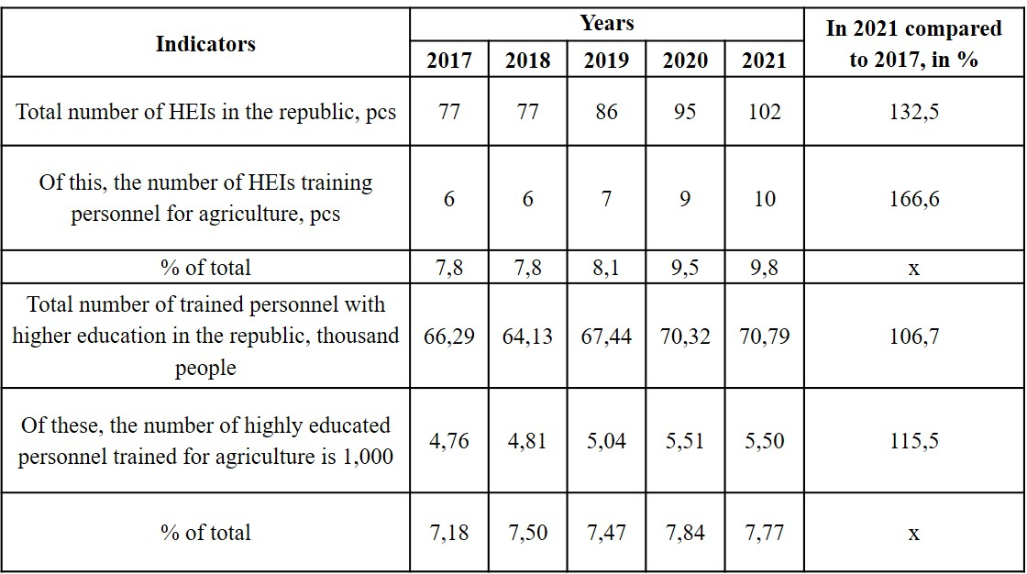
* Compiled by the authors
During the research, social questionnaires were conducted in several districts of the region to study problems such as the knowledge of agricultural workers, their response to modern students, and their lack of interest. When evaluating the level of knowledge of highly educated personnel, 32% of respondents believe that their knowledge in using modern technologies and methods is lacking, while 24% of respondents believe that the level of knowledge of highly educated personnel is not compatible with practice. 22 percent of the respondents who believe that a narrow range of personnel does not meet the requirements due to the fact that practice is far ahead of education and consists of a combination of several directions, and 14 percent of respondents who believe that the level of knowledge of the trained personnel is medium and sufficient for practical work.
In our conclusion, it is suitable to center on the most headings of state back for agrarian instructive educate, such as expanding the level of scope of understudies, retraining and progressing the qualifications of pros within the field, progressing and modernizing the level of fabric and specialized back of the instructive framework, developing the integration of instruction, science and hone.
After all, the development of special economic methods for government support and the solution of administrative and financial problems through their effective implementation indicate the real and importance of the reforms that are being carried out today for the development of the educational system. Given the nature of the digital economy.
That is, in recent years, the introduction of specific economic mechanisms in the legal and regulatory documents issued to support various sectors of the economy, including the education sector, and their legal acts (such as a plan of measures, a road map, programs, an implementation scheme) an effective co-op practice is in place. This helps the decision to be implemented quickly and to have an effective character. Therefore, in the process of research, the ways of improving the mechanisms of the state promotion of the system of personnel training and qualification improvement in the agricultural sector were substantiated.
It should be noted that the development of the economy today mainly requires the improvement of the organizational-production and economic relations of the system of exchange of new knowledge and experiences between economic subjects and various organizations through the wide introduction of innovative techniques and information and communication tools. Therefore, in the dissertation, the importance and advantages of introducing the outstaffing service, which has been widely used in developed foreign countries for many years and has passed the life test, into the system of training and supply of personnel in agriculture were scientifically and practically justified.
Already, this outstaffing service and the activity of the entity (agency, firm) that implements it were initially tested in European countries, and are being gradually introduced in the CIS countries after 2010. In our country, this type of service has now found its place in small business, and according to our proposal, it is appropriate to introduce it in agriculture as well. Therefore, in order to provide agricultural enterprises and organizations with highly qualified, up-to-date knowledge and experienced personnel, ways and methods of state promotion of the development of outstaffing services have been developed.
Digitization of the economy and organization of smart agriculture through the effective introduction of innovative technologies into practice requires, first of all, training of competitive qualified personnel that meets today's demands. This is the "Center for testing and introduction of modern forms of education in agriculture", which includes functionally interrelated entities and tasks in order to train, retrain and improve the skills of students who have studied and graduated from HEIs based on the current requirements in practice. We believe that it is appropriate to organize (Figure 1).
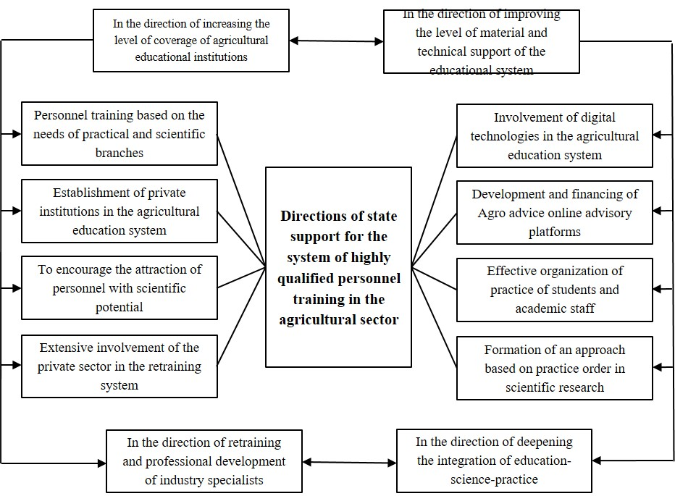
FIGURE 1. Organizational structure of the center for testing and introducing modern forms
of education in agriculture*
* Compiled by the authors
This center conducts its exercises in participation with agrarian generation substances, agroclusters, cooperatives, agrofirms and logical investigate establishing by testing the cutting edge shapes, advances and strategies of instruction presented in nearby and outside HEIs and private instructive teach, and putting into hone those that meet the prerequisites of the time is locked in. This framework, in turn, makes wide openings for the imaginative improvement of horticulture, counting within the setting of the advanced economy.
In the current conditions, when new mechanisms for financing innovative developments are being introduced, in our opinion, the Ministry of Innovative Development should play an important role in the commercialization of scientific research results that serve to form modern knowledge and skills of agricultural workers, as a leading body that coordinates scientific research and implements a unified state policy.
The financial incentive of the scientific worker at the expense of the funds of the "Fund for the support of innovative development and innovative ideas" established under the Ministry should be carried out in the form of a one-time payment equal to the amount of commercialization, exempted from all taxes and mandatory fees. This procedure will be an incentive for the scientific worker to put his research results into practice, convey them to agricultural workers, improve their skills, and teach technological aspects related to the use of innovations.
The condition of the material and technical base of higher education institutions has a direct impact on the ability of the trained highly qualified personnel to adapt to the new form of agrarian entrepreneurship, modern methods and tools. However, the lack of financial capacity to continuously provide educational institutions with modern devices and training equipment requires new economic approaches to the field. That is why, in our opinion, it is necessary to focus on attracting private entrepreneurs working in agriculture or whose activities are related to agriculture to educational institutions on the basis of public-private partnership, and to develop methods of encouraging them with economic incentives.
Based on the experience of developed countries in this matter and the agrarian reforms implemented in our country, we believe that private sector agrarian educational institutions, for example, should be given credit benefits in the amount of 50 percent of the refinancing rate (including the bank margin) for equipping private sector agrarian educational institutions with digital technologies 100 times the amount of the basic calculation rate. can be encouraged through.
Attention to the development of the digital economy, the adoption of a state program related to it, and the urgency of its implementation in the context of the pandemic caused a sharp increase in the level of use of digital technologies among product manufacturers and service providers. Significant results have been achieved, especially in areas such as distance learning courses, seminars, counseling and skills training. In the future, it is desirable to pay special attention to the development of the system of retraining of personnel, to increase the knowledge and skills of product producers through distance education, especially through online consulting services. For this, it is necessary to encourage scientific employees who have developed online consultation platforms and who have managed to gather more than 5 thousand listeners to the platform on the basis of a 100 percent salary increase.
CONCLUSIONS
In our opinion, in the process of training highly educated personnel and highly qualified specialists, first of all, the cognitive ability and potential of a particular person, i.e., making the right conclusions and decisions based on his perception of the surrounding things, reality, events and information, pre-imagining and analyzing them, and putting them into practice special consideration should be given to implementation capabilities, talent and experience:
1. Training of qualified and knowledgeable specialists in various professional and functional specialties in agriculture, organization and development of outstaffing services and forms of outstaffing specialized in providing organizations and enterprises with them, organizational and financial support and encouragement of their economic relations with other consumer entities by the state It is desirable to put the mechanisms into practice.
2. In our republic today, the manager of the farm is usually one person and he, relying on his long-term experience, undertakes several tasks, such as organizing production, managing the farm, growing and selling products. For this reason, there is a constant demand for highly qualified hired personnel. As of January 1, 2020, 38.1% of farm managers are agronomists, 19.4% are economists, 9.4% are engineers, 7.4% are zootechnical-veterinarians, 4.3% are lawyers, and 21.4% have other specialties. However, 54.5% of them are specialists not directly related to agricultural production.
3. The aim is to establish a "Center for Testing and Implementation of Modern Forms of Education in Agriculture" that includes functionally interrelated subjects and tasks in order to prepare, retrain and improve the skills of students who have studied and graduated from higher education institutions based on the current requirements in practice. according to. This center, in cooperation with agricultural production entities, agroclusters, cooperatives, agrofirms and research institutes, is engaged in testing the modern forms of education, technologies and methods introduced in local and foreign HEIs and private educational institutions, and putting them into practice that meet the requirements of the time. This system, in turn, creates wide opportunities for the innovative development of agriculture, including in the context of the digital economy.
4. A social survey was conducted to study problems such as knowledge, education, skills, ability to respond to modern students and unwillingness of personnel in regional farms. In particular, does this current system always correspond to the interests of workers or not? It should be noted that the question is the main problem. In this regard, 42% of the respondents consider monthly payment in cash acceptable, while 30% said that payment in cash or kind is not important. In general, it is necessary to solve the problems of improving the financial potential and working conditions of the enterprises employing highly educated personnel and qualified workers, paying wages at the level of demand and providing material incentives.
5. In our country, it is necessary to further strengthen the mechanisms of state support for training, retraining and supply of highly educated personnel, qualified specialists in the agrarian education system based on the order of the state. This can be explained by the following circumstances: a) the increasing application of scientific achievements of foreign countries in order to create the potential of educated and qualified personnel capable of operating in new forms of economic management; b) attracting private investors to the education system, special attention is being paid to the training of specialist personnel with modern knowledge and skills through the establishment of private educational institutions; v) increased demand for specialisms, scientific-research developments and science-practice integration, etc.
6. According to the econometric model of forecasting the number of specialists related to agriculture, among other things, the demand for qualified personnel in agriculture of Kashkadarya region is equal to 3196 people in 2025, and this indicator is 1332 people (41.7%) compared to 2011 or 622 compared to 2020. means more people (19.5%). This includes the formation of modern fields and professions such as "network marketing", "droning dispatcher", "online and virtual sales management", "automated agricultural machinery operator", "intellectual property evaluation" in accordance with the current global rapid development period and related to the digitalization of the network in the future. is also one of the main reasons.
REFERENCES
- Address of the President of the Republic of Uzbekistan to the Oliy Majlis, January 25 (2020), available at https://uza.uz
- Food and Agriculture Organization of the United Nations (FAO), The role of FAO in genetic resources, available at http://www.fao.org/genetic-resources/en/
- Organization for Economic Cooperation and Development (OECD), OECD Data, available at https://data.oecd.org/chart/5Hc6
- V. V. Ukhobotov, Agricultural workers and their reproduction, Niva of the Volga Region 2(11), (2009).
- E. A. Levchenko, Regulation of the labor market for agricultural management personnel, Bulletin of the Kursk State Agricultural Academy 1, (2009).
- V. V. Pchelkina, Strategy for training personnel for agriculture, Bulletin of Chuvash University, (2005).
- A. V. Prodivlyanova, Personnel training system for agriculture, News of the Orenburg State Agrarian University: Economics and Management 4(30), (2007).
- T. V. Eliseeva, Motivation for attracting qualified personnel to agriculture, Economics and Management 4(30), (2007).
- N. I. Proka, The influence of the agri-food market on the formation of personnel in agriculture, Bulletin of Orel State Agrarian University 6(09), (2015).
- L. M. Nazarchuk, Improving the system of training personnel for agriculture, VESTNIK GGTU named after P.O. Sukhoi 3–4, (2001).
- A. N. Chekavinsky, Training and retention of personnel in agriculture: problems and solutions, Dairy Bulletin 3(23), (2016).
- U. P. Umurzokov, Alternativeization of agricultural production costs based on the assessment of agricultural resources, Cotton and Grain Farming 2, (1998).
- T. Kh. Farmanov, The main directions of establishment and development of farms in the Republic of Uzbekistan, Doctoral dissertation, Tashkent (2006).
- N. S. Khushmatov and T. Fayzullaeva, Factors of economic coordination of livestock development, Agriculture of Uzbekistan 7, (2012).
- H. Turaboeva, Training of high-level economic personnel in the conditions of the knowledge economy and improvement of its financing, Economy and Innovative Technologies 4, (2018).
- O. Kakhorov, Factors affecting the process of training and management of economist personnel in the higher education system, Business Expert 2, (2017).
- J. T. Yoldoshev, The role of business funds in financing the personnel training system, Economy and Innovative Technologies 3, (2012).
- A. A. Makhmudov, International practice of managing the financing system in higher education institutions, Economy and Innovative Technologies 1, (2015).
- Sh. A. Rasulov, Public and private sector cooperation in higher education, Economy and Innovative Technologies 2, (2015).
- B. Tursunov, Export competitiveness: theory and practice, International Finance and Accounting 3, 27 (2020).

