Perspectives for the development of personnel training for the modern energy sector
Sharofjon Babaev^{1,a)}, Mirdodojon Babaev¹, Alisher Farmanov¹, Javokhir Boboqulov^{1,2}
¹ Navoi State Mining and Technology University, Navoi, Uzbekistan
²Termez State University of Engineering and Agrotechnology, Termez, Uzbekistan
^{a)} Corresponding author: babayevmirdodojon@mail.ru
Abstract. The article discusses modern approaches to personnel training for the energy industry with an emphasis on occupational safety and industrial safety issues. Traditional and practice-oriented learning models are analyzed, including dual programs, simulator training, and the integration of safety modules into educational courses. The research data reflecting the impact of the quality of training on reducing the number of staff errors and improving the reliability of technological processes are presented. The key problems of the existing training system have been identified, including the lack of a practical base, the obsolescence of programs and the influence of the human factor. The development prospects associated with the strengthening of practical training, the modernization of training centers and the formation of a culture of safe behavior have been identified. The results confirm that improving the training of specialists is an essential condition for improving the safety and efficiency of modern energy.
INTRODUCTION
The modern energy industry is a complex and multilevel system, the sustainable operation of which depends on the functioning of all sectors of the economy and social infrastructure. The electric power industry ensures the continuity of production processes, transport systems, communications, medicine, education and the household environment. With the rapid development of industry, urban growth and increased energy consumption, the importance of stable and safe energy supply is only increasing. Therefore, the issues of training qualified specialists for the energy sector are becoming strategic and are considered not just as an educational task, but as the basis of national security [1-6].
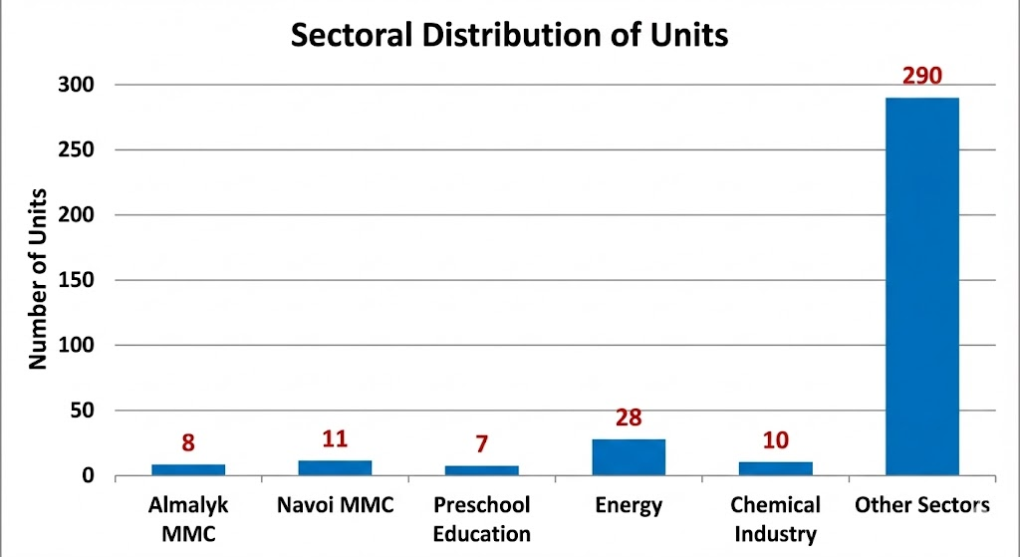
FIGURE 1. Statistics of occupational accidents by sector (first 10 months of 2025, data from the Labour Inspectorate of the Republic of Uzbekistan)
The energy industry has been undergoing a profound technological transformation in recent decades: modern control systems are being introduced, new types of energy facilities are being built, equipment is being improved, and the level of process automation is increasing. However, the increasing complexity of technology automatically increases the demands on staff. Specialists should not only possess technical knowledge, but also understand the nature of the risks associated with the operation of complex power plants. It is the human factor that remains one of the key causes of accidents and disruptions in the industry [7-12].
During the reporting period (January-October 2025), 28 accidents were recorded in the energy sector. This is the highest indicator among all relevant departments and organizations of the Republic of Uzbekistan. Therefore, the quality of personnel training directly affects the efficiency, reliability and safety of energy facilities. A special role in the training of future power engineers is played by the formation of competencies in the field of occupational safety and health. The energy sector belongs to the zone of increased danger: work with high voltages, currents, thermal loads, rotating mechanisms, gas and steam installations requires high discipline, responsibility and strict compliance with regulations. The slightest violation can lead to serious consequences, from equipment failure to serious personal injury. Therefore, safety should not be a separate discipline in the educational program, but the foundation of the entire training of specialists [13,14].
A modern education system should provide students not only with knowledge of technical processes, but also with a stable culture of safe behavior. This includes an understanding of regulatory requirements, skills in analyzing industrial risks, the ability to act in non-standard and emergency situations, as well as the ability to make decisions that prevent dangerous conditions. In practice, this means the need to integrate occupational safety issues into all stages of training - from theoretical courses to laboratory work, practical training at enterprises and final certification.

EXPERIMENTAL RESEARCH
The training of specialists for the energy industry is based on a combination of fundamental knowledge, practical experience, and industry safety standards. Universities remain the core of this system, where future engineers study the principles of energy system operation, equipment design, diagnostic methods, and the basics of industrial safety [15]. University programs develop students’ ability to analyze complex technological processes and make well-grounded decisions in production environments.
Universities provide training for specialists who constitute a key segment of operational personnel. The training here is practice-oriented: performing routine operations, monitoring equipment, and following instructions on occupational safety and accident prevention. When educational institutions maintain strong partnerships with industrial enterprises, students are able to gain applied skills that are in demand at real energy facilities. In recent years, the dual education system has become especially important, as it combines theoretical instruction with extended industrial practice. At the university, energy students undergo internships at boiler houses, thermal networks, and energy installations. In practice, they learn to work with equipment, monitor operating modes, perform basic maintenance operations, and apply occupational safety requirements in real conditions. This approach improves the quality of training and speeds up the adaptation of young specialists at enterprises.
Special attention must be paid to the training of operational personnel-machinists, operators, and dispatchers working at high-risk facilities. Specialized simulators and training systems are used for this purpose, modeling the operation of power units, control systems, and emergency situations. This is especially important for nuclear and thermal power plants, where the accuracy of personnel actions determines the safety of the entire facility. Simulator-based training helps develop professional thinking, rapid response skills, and the ability to act strictly according to regulations.
The experience of personnel training in the energy sector is based on the integration of academic education, practice-oriented instruction, and mandatory simulator training. This comprehensive approach makes it possible to prepare specialists who are ready to work safely, efficiently, and in accordance with modern industry requirements.
The modern system of personnel training for the energy sector is built around the principle of “safety as the core of professional competence.” This means that the training technology and the structure of educational programs are designed to develop sustainable knowledge, skills, and behavioral models that enable a specialist to work without risk to themselves, equipment, or the surrounding environment.
One of the key methodologies remains the modular approach, in which safety-related modules are integrated into all disciplines rather than existing as separate courses. This structure allows theoretical knowledge to be connected with practical situations: while studying electrical engineering, students simultaneously analyze typical industrial risks and ways to prevent equipment overheating or personnel errors that could lead to accidents. Such interdisciplinary training is emphasized in the works of leading scholars, where safety is considered a “cross-cutting competence” of energy specialists.
The situational learning method also holds great importance in the industry. It is based on analyzing real production cases, including failures, incidents, and regulatory violations. Students examine the causes of events, evaluate personnel actions, and propose optimal solutions. This method helps develop a responsible mindset and teaches students to identify risks before they cause accidents. The application of situational analysis also highlights the importance of preparing for “non-standard and high-stress work conditions” [16].
Equally significant is the regulatory-practical approach, widely used in both training centers and industrial enterprises. Its essence lies in repeated execution of operations-from equipment startup to the preparation of work permits—with strict adherence to occupational safety instructions. This methodology is especially effective for training personnel performing critical and potentially hazardous tasks. Regularly repeating procedures and strictly following established regulations help reduce the impact of human error during work at heights and other hazardous tasks [2]. Another important aspect of this methodology is the ongoing assessment and verification of employees’ knowledge. In the energy sector, personnel are granted access to perform work only after multiple confirmations of their qualifications, reflecting the sector’s high standards for safety. The staff regularly undergoes testing, briefings, internships and targeted knowledge tests. This practice reflects the industry's approach to continuous professional development and competence maintenance [17].
Modern training methodologies combine theoretical consistency, analysis of practical situations, strict work regulations and regular knowledge testing. The central element of all these approaches is safety - not as a separate discipline, but as the fundamental basis of the professional culture of an energy industry specialist.
Despite the development of educational programs and the introduction of practice-oriented methods, the system for training specialists in the energy sector faces a number of serious problems. Many of these are directly related to ensuring safety and the quality of professional training [18].
One of the key challenges remains the mismatch between curricula and real production conditions. A significant portion of educational materials still relies on outdated examples of equipment and technologies, while actual enterprises use more modern diagnostic, automation, and safety controlsystems. The need to update curricula and improve training effectiveness depends on the continuous revision of teaching methods and educational models [19].

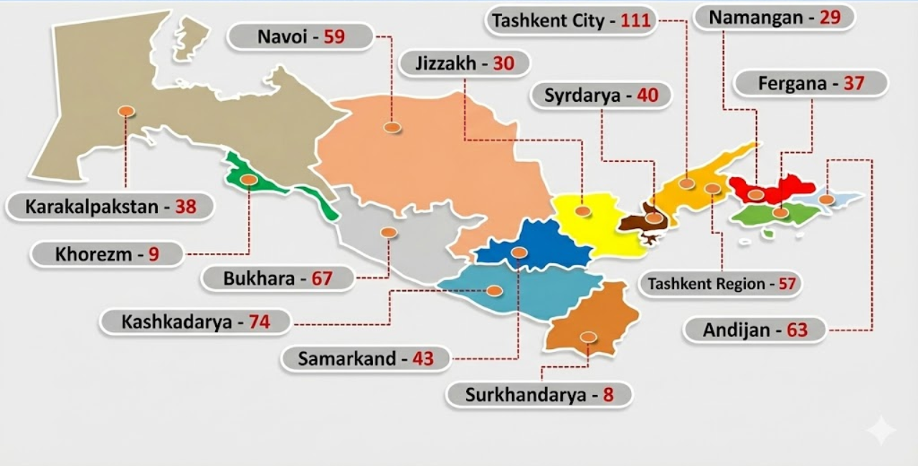
FIGURE 2. Breakdown of accidents by region
The human factor remains a major cause of industrial incidents. When insufficient attention is given to workers’ psychological resilience, their training in high-pressure situations, and the cultivation of discipline, mistakes can occur that increase the risk of accidents. Figure 1 presents data on accidents in the regions of the Republic for the first ten months of 2025 (data from the Labour Inspectorate of the Republic of Uzbekistan). Without cultivating a culture of safe behavior, even a well-prepared specialist can make critical mistakes [20].
A serious problem is the lack of practical training, especially in the field of occupational health and safety. Although the dual education system is gradually developing, access to modern simulators, laboratories, and active production facilities remains limited. This results in young specialists knowing safety requirements in theory but struggling to apply them in real conditions. The problem is further compounded by the fact that enterprises are not always ready to allocate resources for trainee training, particularly at high-risk facilities.
Another challenge is the shortage of personnel in the field of occupational safety and industrial security. Safety specialists are in demand, but the influx of young professionals is insufficient - the profession is considered complex, responsible, and requires constant skill development. The sector faces a “lack of personnel reserve” and insufficient motivation among young specialists to work in the energy sector [21].
Many educational institutions still face the problem of outdated equipment. Training laboratories do not always meet the technical standards of energy enterprises. The absence of training models, modern protective systems, automated control panels, or emergency scenario simulators limits the possibilities for high-quality practical training. This problem is particularly noticeable in technical colleges and universities that train primary operators for regulated operations.
The personnel training system in the energy sector faces a complex set of systemic challenges: from the gap between curricula and production realities to shortages of equipment and qualified personnel. Solving these problems requires coordinated efforts from training centers, universities, and enterprises themselves, as the safety of the sector directly depends on the quality of professional training.
Modern energy industry imposes increasingly high requirements on the qualifications of specialists, which determines the directions for further development of the personnel training system. The central task is to create an educational environment that not only transfers knowledge but also promotes the sustainable development of a culture of safe behavior and professional responsibility. One of the promising directions is the deeper integration of occupational safety into all stages of professional education. This includes not only separate disciplines but also the redesign of curricula so that safety requirements are embedded in every practical module and every production task. Such an approach aligns with conclusions on the necessity of forming an “inseparable link between technological literacy and safe working methods”. Another important development direction is the expansion of the dual training system. With sufficient support from enterprises, this model allows students to access modern workplaces, undergo extended internships, work with real equipment, and acquire skills for safe behavior in real production conditions. Strengthening cooperation between educational institutions and energy companies can improve training quality and reduce the adaptation period for young specialists in the workplace.

FIGURE 3. Comparative analysis of professional competence growth during the implementation of a comprehensive training system
The development of specialized training centers is also a promising direction. These centers can utilize full-scale models, process simulators, and emergency situation simulation stands—everything that allows personnel to practice actions under conditions as close as possible to real ones. Such centers provide the most reliable formation of professional skills when performing hazardous tasks [22].
Retraining and advanced training of current personnel also play a crucial role. The energy sector is rapidly evolving, and specialists need to regularly update their knowledge—from new occupational safety regulations to modern equipment diagnostics methods. A promising direction is the creation of flexible programs that allow employees to combine training with productive work.
Forming a culture of responsibility is vital for improving training quality. This goes beyond simply following instructions: it involves developing in future specialists an understanding of the consequences of their actions, readiness to prevent risks, the ability to act in non-standard conditions, and maintain discipline in the workplace. Safety culture is recognized by many leading researchers as a key factor for reliable enterprise operation.
The prospects for personnel training in the energy sector are associated with the systematic strengthening of practice-oriented learning, expansion of educational and production facilities, updating curricula, and fostering a sustainable culture of safe behavior. These transformations make it possible to provide the industry with qualified specialists capable of working effectively and safely under modern production conditions.
At power plants, similar findings were obtained during practice on operational boiler unit mock-ups. Initial diagnostics showed that approximately 40% of students committed violations of safety requirements; however, after additional practical sessions and corrective training, the majority of them corrected the identified mistakes. This confirms that a practical environment allows timely identification and elimination of gaps in safety knowledge.
Further research focused on analyzing production incidents among young specialists after completing internships. At three boiler plants, the average percentage of violations of regulations and occupational safety rules during the first month of work was 12-15%. After the implementation of a dual education system, extended practical training, and regular repeated simulator sessions, this figure decreased to 8–9%, indicating an improvement in graduates’ readiness to work under real production conditions. Diagram 3 presents the results of the initial assessment of safety requirement violations by young specialists at three control enterprises, according to the conducted studies.

FIGURE 4. Primary diagnostics of the level of violations of safety requirements by young specialists at three control enterprises

Overall, the results of the studies demonstrate that a systematic approach to personnel training - combining theoretical education, extended practical experience, simulator-based training, and the development of a safety culture - significantly reduces the likelihood of errors and improves the quality of work of young specialists. The formation of stable compliance skills is especially important for high-risk facilities, such as nuclear and thermal power plants, where personnel mistakes can have critical consequences.
CONCLUSION
The results of the studies convincingly confirm that the modern system of personnel training has a direct impact on the safety and efficiency of energy facilities. Practice-oriented methods - such as dual training systems, simulator exercises, and emergency situation modeling - significantly enhance specialists’ readiness to work under high-risk conditions. The research demonstrates a reduction in errors and regulatory violations, increased personnel resilience to stressful situations, and improved quality of technological operations. Moreover, regular knowledge assessment, systematic certification, and the integration of occupational safety at all stages of the educational process foster a sustainable safety culture among future employees. This highlights the necessity for further development of practical training forms and modernization of educational and training facilities. Overall, the quality of personnel training remains one of the most effective tools for reducing industrial risks and ensuring the reliability of the energy sector.
REFERENCES
- Rodichev, A. Yu. Models and Methods for Improving the Evacuation Management System of People from High-Rise Buildings. Moscow: Academy of the State Fire Service of the Ministry of Emergency Situations of Russia, 2018. 224 p.
- Todosieychuk, S. P., Onishchenko, Yu. A., Arkhipenko, A. A. Technologies and Results of Field Tests of Means of Rescuing People from Heights. Kyiv: Institute of Fire Safety, 2020. 156 p.
- Telitsyna, A. A. Development of Recommendations for the Implementation of Modern Fire Safety Technologies in High-Rise Buildings. Moscow: MGSU, 2019. 142 p.
- Cheberyak, V. V. Safety of Evacuating People from High-Rise Buildings. Minsk: BNTU, 2017. 198 p.
- Piskun, A. A. Rescue of People from High-Rise Buildings during Fires. Moscow: Academy of the Ministry of Emergency Situations of Russia, 2016. 176 p.
- Boboqulov J., Narzullayev B. Development of a model for diagnosing rotor conditions in the parallel connection of synchronous generators with the network // E3S Web of Conferences. – EDP Sciences, 2024. – Т. 525. – С. 06001. https://doi.org/10.1051/e3sconf/202452506001
- Tursunova, A., Bozorova, S., Ibragimova, K., Bobokulov, J., & Abdullaev, S. (2023). Researching localization of vertical axis wind generators. In E3S Web of Conferences (Vol. 417, p. 03005). EDP Sciences. https://doi.org/10.1051/e3sconf/202341703005
- Numon Niyozov, Anvar Akhmedov, Shukhrat Djurayev, Botir Tukhtamishev, Asliddin Norqulov, Development of a method for forecasting the specific consumption indicator of electric energy, AIP Conf. Proc. 3331, 080008 (2025) https://doi.org/10.1063/5.0305729
- Bakhodir Ramazonov, Shakhzodbek Sayfiev, Khasan Muradov, Mathematical modeling and research of high capacity lead-acid stabilized accumulator battery, AIP Conf. Proc. 3268, 020043 (2025) https://doi.org/10.1063/5.0257860
- Khasan Murodov, Askarbek Karshibayev, and Shukhrat Abdullayev, Analysis of the process of balanced charging of the battery group with high capacity, E3S Web of Conferences 548, 03012 (2024) https://doi.org/10.1051/e3sconf/202454803012
- O.O. Zaripov, S.J. Nimatov, Y.M. Yeralieva, S.O. Zaripova, M.A. Zakirov, D.M. Nomozova, J.T. Akhmedov, Akram Tovbaev. Calculation of the nominal power and еlectrical еnergy of the hydro power plant on an еlectronic calculator. E3S Web Conf. Volume 486, 2024. IX International Conference on Advanced Agritechnologies, Environmental Engineering and Sustainable Development (AGRITECH-IX 2023). https://doi.org/10.1051/e3sconf/202448601027
- Mukhtorkhon Ibadullayev; Shavkat Begmatov; Akram Tovbaev. Subharmonic resonance in three-phase ferroresonant circuits with common magnetic cores. AIP Conf. Proc. 3152, 050019 (2024) https://doi.org/10.1063/5.0218907
- Akram Tovbaev, Muxtarxan Ibadullayev and Mohinur Davronova. Study of subharmonic oscillation processes in ferroresonance circuits. E3S Web of Conf. Volume 525, 2024. IV International Conference on Geotechnology, Mining and Rational Use of Natural Resources (GEOTECH-2024). https://doi.org/10.1051/e3sconf/202452503008
- Narzullayev B. S., Eshmirzaev M. A, Causes of the appearance of current waves in high voltage electric arc furnaces, and methods of their reduction, E3S Web of Conferences. – EDP Sciences, 2023. – Т. 417. – С. 03003. https://doi.org/10.1051/e3sconf/202341703003
- Akram Tovbaev., Islom Togaev., Uktam Usarov.,Gulom Nodirov, Reactive power compensation helps maintain a stable voltage profile across the network, AIP Conf. Proc. 3331, 060014 (2025). https://doi.org/10.1063/5.0307209
- Asliddin Norqulov, Feruz Raximov, Methods for evaluating financial and economic effectiveness of investment projects in the energy sector with time factor considerations, AIP Conf. Proc. 3331, 030070-1–030070-6. https://doi.org/10.1063/5.0306104
- Shukhrat Abdullaev., Ziyodullo Eshmurodov., Islom Togaev, A systematic analysis of the gradual increase in quality indicators of electricity using reactive power sources involves several steps, AIP Conf. Proc. 3331, 040051 (2025). https://doi.org/10.1063/5.0306786
- Turdibekov, K., Sulliev, A., Iskandarova, O., & Boboqulov, J. (2023). Experimental and statistical methods for studying the modes of electric power systems under conditions of uncertainty. In E3S Web of Conferences (Vol. 452, p. 04002). EDP Sciences. https://doi.org/10.1051/e3sconf/202345204002
- Bobur Narzullayev; Javokhir Boboqulov, Improving reliability based on diagnostics of the technical condition of electric motor stator gutters, AIP Conf. Proc. 3331, 030032 (2025). https://doi.org/10.1063/5.0305735
- Abdurakhim Taslimov., Feruz Raximov., Farrukh Rakhimov., Iles Bakhadirov, Optimal parameters and selection criteria for neutral grounding resistors in 20 kv electrical networks, AIP Conf. Proc. 3331, 030048 (2025) https://doi.org/10.1063/5.0306108
- Islom Togaev., Akram Tovbaev., Gulom Nodirov, Systematic analysis of reactive power compensation in electric networks is essential for improving electricity quality enhancing system stability, and reducing operational costs, AIP Conf. Proc. 3331, 030099 (2025) https://doi.org/10.1063/5.0305740
- Abdurakhim Taslimov., Farrukh Rakhimov., Feruz Rakhimov., Vaxobiddin Mo’minov, Analysis of the results of sampling the surfaces of sections of rural electric networks, AIP Conf. Proc. 3331, 030041 (2025) https://doi.org/10.1063/5.0305783

