Study of the Asymmetric Form of Shell Stability Loss of a Feed Cylinder under Axial Compression
Xakimjonov Avazbek^{1,a)}, Mirzaev Otabek², Urakuv Nuriddin¹, Abdimajidov Farrux¹
¹Termez State university of Engineering and Agrotechnologies Termez, Uzbekistan
²Karshi State Technical university Karshi Uzbekistan
^{a)} Corresponding author: hakimjonov.avazbek99@gmail.com
Abstract. The article examines the asymmetric form of buckling in a chevron-type feeding cylinder shell under axial compression. A dynamic analysis of the radial, circumferential, and longitudinal displacements of the shell of the composite feeding cylinder used in pneumomechanical spinning machines is presented. The drawings of the composite feeding cylinder with an elastic shell are discussed in relation to the machine dynamics. To address these problems, Euler’s equations for variational problems are employed. The changes in the curvature of the transverse sections of the composite feeding cylinder shell are investigated. The main components of the deformation of the feeding cylinder shell element are presented in detail.
INTRODUCTION
It is known that the shell is analyzed as a highly statically indeterminate system. As the primary statically admissible system, a stress state corresponding to a conventional thin-walled shell with a non-deformable cross-sectional contour is considered in detail. From the theory of rod analysis and the mechanics of materials, the reader should be aware that the complexity or simplicity of resolving static indeterminacy largely depends on the successful choice of redundant unknowns. The combination of an energy method with an appropriate selection of functional unknowns can significantly simplify the solution of the problem, allow a wider class of shells to be covered, and eliminate a number of assumptions [1].
The discretization of the feeding ribbon depends not only on the geometric parameters of the needles of the combing drum but also on the adjustment parameters of the discretization unit as a whole [2]. To obtain high-quality yarn, the elastic modulus of the rubber shell of the feeding cylinder is recommended [3]. The feeding cylinder of the spinning device has external splines in the form of ridges and grooves parallel to the cylinder axis, and the outer surfaces of the ridges are ribbed [4]. Classical displacement equations are used to describe the motion of the shell [5,6].The question of the number and meaning of boundary conditions in shell theory, as in plate theory, still lacks a satisfactory explanation despite numerous studies on this topic [7]. The development of methods for calculating structural elements within the framework of plate theory remains one of the relevant and challenging problems in the mechanics of deformable solids [8].
In chamber-type pneumomechanical spinning machines, single-zone twisting is carried out, which is not combined with winding [9]. Elongation plays a significant role in yarn processing technology, since yarn is first stretched to a certain value and only then do stresses arise [10]. Deformation, strength, vibrations, and static and dynamic stability of thin-walled structural elements in the form of closed circular cylindrical shells are the subject of numerous studies. The increasing interest in them is due to their use as primary load-bearing structural components in aviation, missile, and space engineering, underwater devices, tunnel structures, reservoirs, and the housings of modern power systems [11]. In thick fillers, transverse shear and through-thickness compression are taken into account, and displacement variation is assumed to be linear along the transverse coordinate [12]. The process of transport service must be aimed at continuously meeting the transportation needs of consumers [13].

EXPERIMENTAL RESEARCH
This structural system is analyzed under axial compression to determine the asymmetric buckling mode of the cylindrical shell
1. Variational approach and Euler’s equation
To investigate the deformation and stability behavior of the shell, a variational formulation based on the Euler equation was used. This equation is derived from the principle of least action (minimum potential energy) and is widely applied in shell mechanics.
The radial displacement of the shell is assumed in the form:
$ω=ϕ\left(х\right)cosnφ$ where: (1)
- $ϕ\left(х\right)$ is the unknown function along the shell length,
- $n=2,3,4,…..-$corresponds to the circumferential wave number.
Using this representation, all accompanying displacements—circumferential $υ$, axial $u$ —as well as strains and internal forces ($ε_{х}, χ_{φ}, m_{φ},m_{х}, σ_{х}, q$) are expressed as functions of $ϕ\left(х\right)$ and its derivatives.
2. Energy Method
The total potential energy of the system is defined as:
$U=\int_{0}^{L}{Bdx}$ (2)
where the strain energy density BBB (neglecting shear deformation) is:
$B=\oint{[\frac{1}{2}σ_{φ}δ_{шев}ε_{φ}+\frac{1}{2}m_{х}χ_{х}- σ_{кр}δ_{c}\frac{1}{2}(\frac{dω}{dx})^{2}]ds}$ (3)
Applying the Euler–Lagrange equation to the functional yields a fourth-order homogeneous differential equation describing the shell deformation:
$B=[\frac{1}{2}Eδ_{шев}(\frac{ ω}{R})^{2}+\frac{1}{2}D_{с}(\frac{d^{2}ω}{dx^{2}})^{2}- σ_{кр}δ_{c}\frac{1}{2}(\frac{dω}{dx})^{2}]2πR$ (4)
RESEARCH RESULTS
The analysis of the parameters of the composite chevron-type feeding cylinder shell shows that, under axial compression, the loss of stability does not occur in a symmetric form, but rather in an asymmetric one. This phenomenon is mathematically associated with the complex interaction between the geometry, the rubber material of the shell, and the stress state of the composite feeding cylinder.

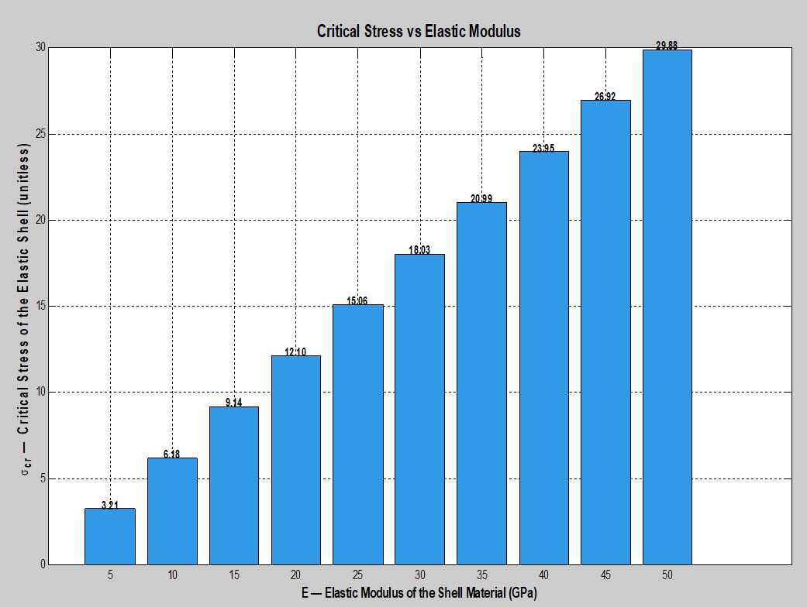
FIGURE 2. Dependence of the critical stress σₙᵣ of the elastic shell of the composite feeding cylinder on its elastic modulus E.

It should be particularly emphasized that the significant radial and longitudinal displacements of the composite feeding cylinder, as well as the presence of bending moments and shear forces, highlight the critical importance of considering asymmetric modes in engineering design calculations. This is necessary to prevent structural failure and to ensure the reliability of the feeding cylinder shell in machine-building applications.
Its graphical function as a function of time is shown in Fig. 2
Let us analyze the factorial and resultant parameters obtained from the theoretical experiments. The numerical values of several parameters required for accurate representation are given in Table 1.

TABLE 1. The analysis of factorial and resultant parameters obtained from the theoretical experiments.
№ | Notation | Name of Parameters | Numerical Values or Their Boundary Limits
1 | $$σ_{кр}$$ | Critical stress of the composite feeding cylinder shell | $$28\frac{N}{{mm}^{2}}$$
2 | $$δ_{c}$$ | Equivalent wall thickness of the shell | $$3mm$$
3 | $$D_{с}$$ | Bending stiffness (per unit length) of the cross-section of the shell element of the composite feed cylinder | $$12N{mm}^{2}$$
4 | $$δ_{шев}$$ | Equivalent thickness of the chevron part of the shell | $$4mm$$
5 | $$E$$ | Elastic modulus of the material of the shell of the feed cylinder | $$40\frac{N}{{mm}^{2}}$$
6 | $$R$$ | Radius of the shell of the composite feed cylinder | $$5mm$$
7 | $$ω$$ | Radial displacements of the shell of the composite feed cylinder | $$0.82mm$$
8 | $$L$$ | Length of the shell of the composite feed cylinder | $$21mm$$
9 | $$m$$ | Natural number of the shell at the point of its stability loss | $$2$$
10 | $$q$$ | Shear forces of the shell of the composite feed cylinder | $$12.1$$
11 | $$σ_{φ}$$ | Hoop stresses of the shell of the composite feed cylinder | $$6.4\frac{N}{{mm}^{2}}$$
12 | $$μ$$ | Poisson's ratio | $$0.3$$
13 | $$m_{φ}$$ | Circumferential bending moments | $$2.8\frac{Nmm}{mm}$$
14 | $$χ_{х}$$ | Change in curvature of elements along the generatrices of the shell of the feed cylinder | $$-0.12{mm}^{-1}$$
15 | $$u$$ | Longitudinal displacements of the shell of the feed cylinder | $$-4.45mm$$
16 | $$υ$$ | Circumferential displacements of the shell of the feed cylinder | $$-0.09mm$$
17 | $$σ_{х}$$ | Normal stresses of the shell of the feed cylinder | $$-0.56\frac{N}{{mm}^{2}}$$
18 | $$F_{a}$$ | Amplitude values as a function of ϕ(x) | $$12 N$$
19 | $$n$$ | Natural number | $$2$$
20 | $$x=L$$ | Length of the shell of the composite feed cylinder | $$21mm$$
21 | $$φ$$ | Angle measured from the vertical axis of the composite feed cylinder | $${1.2}^{0}$$
22 | $$ε_{х}$$ | Axial relative strain of the shell of the feed cylinder | $$-0.2$$
23 | $$χ_{φ}$$ | Curvatures of the cross-sections of the shell of the composite feed cylinder | $$0.62{mm}^{-1}$$

CONCLUSION
The mechanical stability and reliability of the shell of the composite chevron-type feeding cylinder installed in the feeding zone of rotor spinning machines primarily depend on the elastic modulus (E) of the rubber material. As the value of E increases, the critical stress σₖᵣ increases linearly, which indicates an enhanced ability of the feeding cylinder structure to resist buckling. Selecting rubber materials with higher elastic moduli significantly improves the stability limit of the feeding cylinder without increasing its mass or the thickness of the elastic shell.
This is particularly important in textile and mechanical engineering industries, where both weight and operational reliability are critical factors. Moreover, a higher value of σₖᵣ contributes to increasing the safety margin of the feeding cylinder shell, thereby improving the operational safety of the feeding zone and extending its service life. Thus, when designing shell-type cylindrical structures, it is advisable to choose rubber materials with higher elastic moduli. From an engineering standpoint, the elastic modulus of the rubber shell material of the feeding cylinder should be selected as E = 40 N/mm². This value is determined based on the radial displacement of the composite feeding cylinder shell, which equals ω = 0.82 mm. Given that the operational clearance between the walls of the feeding zone and the cylinders ranges from 0.95 mm to 1 mm, the condition ω = 0.82 mm < 1 mm must be satisfied to ensure proper functioning of the composite chevron-type feeding cylinder. Therefore, selecting rubber materials with an elastic modulus of E = 40 N/mm² makes it possible to produce high-quality yarn that meets the required technological parameters.
REFERENCES
- Aripova, Sh.N., Matismailov, S.L., et al. Features of the design and operation of a pneumo-mechanical spinning machine. Universum: Technical Sciences, Electronic Scientific Journal, 2021, 4(85). URL: https://7universum.com/ru/tech/archive/item/11501 (accessed: 24.04.2021).
- Djuraev, A.D., Urakov, N.A., Mirzaev, O.A., Almardonov, O.M., Usmanov, Kh.S. Analysis of the load of the feeding cylinder in the feed unit of spinning machines. Universum: Technical Sciences, Electronic Scientific Journal, 2021, 12(93). URL: https://7universum.com/ru/tech/archive/item/12672
- Grigolyuk, E.I., Selezov, I.T. Non-classical theories of vibrations of rods, plates, and shells. Results of Science and Technology. Mechanics of Solid Deformable Bodies, Vol. 5. Moscow, 1973. 272 p.
- Hamroyev, O., Togaev, J., Keldiyorov, R.N. Installation for testing the ability of oil-oxidizing microorganisms. E3S Web Conf., 417, 02015 (2023). DOI: https://doi.org/10.1051/e3sconf/202341702015
- Kan, S.N. Structural Mechanics of Shells. Moscow: Mashinostroenie, 2016. Pp. 197-212.
- Matismailov, S.L., Aripova, Sh.R., Kobilzhanova, Yu.R. Study of the possibility of producing pneumo-mechanical yarn from cotton waste. Universum: Technical Sciences, Electronic Scientific Journal, 2023, 12(117). URL: https://7universum.com/ru/tech/archive/item/16525
- Mirzakabilov, N.Kh. Methods for calculating vibrations of viscoelastic multilayer (three-layer) plates. Universum: Technical Sciences, Electronic Scientific Journal, 2024, 7(124). URL: https://7universum.com/ru/tech/archive/item/18008
- Mirzaev, O.A., Uzakov, Z.Z., Uzakov, Z.U., Kilicheva, D.I., Shomuratov, B.X. Stability of feeding cylinder shell under torsion in pneumo-mechanical spinning machines. E3S Web Conf., 392, 01049 (2023). DOI: https://doi.org/10.1051/e3sconf/202339201049
- Mirzaev, O.A., Uzakov, Z.U., Uzakov, Z.Z., Boyirov, Z.R., Botirova, B.T. The power required to maintain the forced oscillations of a composite feed cylinder of spinning machines. In: Third International Scientific and Practical Symposium on Materials Science and Technology (MST-III 2023), 12986, 202-210 (2024).
- Starovoitov, E.I., Leonenko, D.V., Pleskachevskiy, Yu.M. Vibrations of three-layer cylindrical shells in Winkler elastic medium at resonance. Mechanics of Machines, Mechanisms and Materials, 2013, №4(25), special issue, pp. 70-73. ISSN 19950470.
- Leizerovich, G.S., Seregin, S.V. Free vibrations of circular cylindrical shells with attached small concentrated mass. Applied Mechanics and Technical Physics, 2016, Vol. 57, No. 5, pp. 90-96.
- Urakov, N.A., Zhumanazarova, S.Sh., Mirzaev, O.A. Optimization of the parameters of the loader in the discrete zone of a pneumo-mechanical spinning machine. Scientific Journal "Mechanics and Technology", №2(15), 2024, pp. 47-54.
- Uzakov, Z.Z., Mirzaev, O.A. Theoretical discussion of the composite feeding cylinder under torsion in spinning machines. Universum: Technical Sciences, Electronic Scientific Journal, 2024, 6(123). URL: https://7universum.com/ru/tech/archive/item/17716

