Current trends in ensuring the reliability and quality of power transmission using cable and conductor systems
Victoria Tsypkina ^{1,2, a)}, Vera Ivanova¹, Dilfuza Kurbanbayeva¹, Umidakhon Mamadalieva ¹, Sarbinaz Pirnazarova ¹
¹ Tashkent state technical university named after Islam Karimov, Tashkent, Uzbekistan
²Termez State University of Engineering and Agrotechnology, Termez, Uzbekistan
^{a)} Corresponding author: viktoriya.tsipkina@gmail.com
Abstract. The article discusses issues related to improving the energy efficiency of cable lines in modern operating conditions and the growing loads arising from their operation in providing high-quality electrical energy to the national economy of the Republic of Uzbekistan. The main areas addressed by manufacturers of cabling and wiring products for the introduction of new types are presented. The main tasks are considered, the solution of which will ensure that finished cable products comply with modern technical regulations; take into account various operational factors in conditions of increased mechanical loads, temperature fluctuations, and the influence of aggressive environments; develop designs for heat-resistant, fire-resistant, and low-smoke cables with reduced toxicity during combustion. Priority areas are considered that will allow for increasing the efficiency of operating cable lines, including: the intellectualization of cable systems through the introduction of sensor elements and diagnostic modules; developing new requirements for cable products in the process of the energy transition to renewable energy sources; introducing cable systems that operate under conditions of electromagnetic compatibility; introducing new cable designs and new materials.
INTRODUCTION
The electric power sector occupies a special place in the cabling and wiring products (CWPs) market, where the primary burden falls on cables supplying power to various economic facilities. The reliability of all power supply systems is a key element in ensuring the stability and efficiency of industrial and social facilities, including internal building networks. This issue is particularly relevant all over the world (Table 1), in the current conditions and the growing requirements of modern technological processes, where sustainable power supply to industrial enterprises allows optimizing production operations in accordance with the dynamics and specifics of products being manufactured.
TABLE 1. Information on the GDP structure by country in 2023 [1]
Country, 2023 | Agriculture,  % of GDP | Industry,  % of GDP | Services,  % of GDP
USA | 1 | 19 | 80
EU | 2 | 27 | 71
Russia | 4 | 40 | 56
China | 8 | 38 | 54
India | 18 | 34 | 48

Given the constant changes in equipment characteristics and stricter requirements for finished products, there is an increasing need to improve the reliability of power supply systems. At the same time, cabling and wiring products (CWPs) are a crucial element of power transmission and distribution systems, ensuring the efficient transfer of electricity from power sources to consumers.
Ensuring the growth of cable industry production directly depends on the pace of development and the needs of various economic sectors. To fulfill the tasks set in the cable industry, the following priority areas are currently relevant, focused on the introduction of new types of CWPs, namely: strict compliance with modern technical regulations; ensuring consideration of various factors related to cable operation under conditions of increased mechanical loads, temperature fluctuations and the influence of aggressive environments; the creation of heat-resistant, flame-resistant and low-smoke cables with reduced toxicity during combustion, which are becoming priority areas.
Increasing attention is being paid to the intellectualization of cable systems (CS) — the use of sensor elements and diagnostic modules that allow real-time monitoring of insulation conditions, current and voltage parameters, defects and excess temperatures. Such solutions can significantly reduce the risk of failures, increase safety and extend the service life of electrical networks.
The energy transition, driven by the development of renewable energy sources (RES), offers significant opportunities to increase the efficiency of the Republic's existing power system, which also imposes new requirements on cabling and wiring products. Cables that are resistant to UV radiation, moisture, mechanical and climatic influences are needed to integrate wind, solar and hybrid installations. In addition, increased flexibility and reduced weight of cables are becoming critical for use in mobile and distributed energy systems.
Thus, ensuring the quality and reliability of the CWPs is not only a technical compliance task, but also a strategic direction that affects the sustainability of the entire energy infrastructure in the context of global technological changes throughout the national economic sector of our Republic [1-5].
General information. It should be noted that the service life of typical cable products, during which the preservation of their operational characteristics is guaranteed, is about 25 years. After this period, cable lines (CLs) require replacement with modern cables and wires that meet new technical and environmental requirements. The increased requirements for the CWPs are due to the specific features of the latest equipment with which the cable products interact.
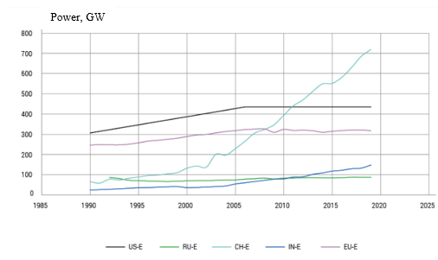
FIGURE 1. Change in the total capacity of final electricity consumption for the USA (US), China (CH), Russia (RU), the European Union (EU) and India (IN) for the period 1990-2019, GW

Special attention in modern conditions is paid to the electromagnetic compatibility (EMC) of cable products (CPs) used in power transmission lines. Compliance with the established EMC standards is the most important criterion for ensuring stable operation not only of the line itself, but also of the surrounding technological equipment (installed in close proximity) subject to the possible effects of emerging electromagnetic interference.
Against the background of a steady shortage of energy capacities and a continuous increase in electricity consumption (Fig. 1), especially in the countries of the European Union, where the projected annual growth is about 1.5% [1, 2], the problem of improving the reliability and efficiency of power transmission systems is becoming increasingly relevant.
Currently, more than half of the existing cable lines (CLs) have reached their service life and require replacement. In order to compensate for the shortage of energy supply, new generating facilities are being built and main power transmission lines are being expanded, in the construction of which non-insulated phase conductors are widely used.
As a result, high operational requirements are imposed on modern cable products: minimal specific losses, increased tensile strength, vibration resistance, resistance to extreme wind and ice loads, as well as corrosion resistance in various climatic zones.
An analysis of the current state of the cable market in the Republic of Uzbekistan indicates that a significant part of the available cable products does not fully meet the listed criteria, which leads to emergencies at the energy infrastructure facilities of our country. In this regard, enterprises serving the energy sector incur significant financial losses associated with repairing damage to lines and the cost of promptly restoring their operability, often in difficult climatic conditions (from +60 °C to -25 °C), with hurricane-force winds, lack of transport accessibility and power supply. One of the critical factors remains the vulnerability of overhead power transmission lines (OPTL) to lightning strikes. Products with effective protection against lightning surges are becoming a competitive advantage in the market, providing a higher level of operational reliability.
The experience of operating medium-voltage distribution networks (from 5 to 30 kV) in countries such as the United Kingdom, Germany, the Netherlands and the Scandinavian countries demonstrates the effectiveness of switching to underground cable lines, including high-voltage class. This area has been actively developed as part of the modernization of energy networks aimed at reducing losses, improving the safety and stability of power supply systems.

EXPERIMENTAL RESEARCH
Many leading manufacturers of cable products, together with organizations operating energy networks, are implementing comprehensive projects to improve the design of power cable products. Their special attention is paid to the development of new types of cross-linked polyethylene (XLPE) used as an insulating material: flame-retardant compounds are being created, the quality of sheaths is being improved, and moisture-proofing technologies are being introduced. All these solutions contribute to a reduction in the total cost of both installation and operation of high-voltage and ultra-high-voltage cable lines based on XLPE.
High-temperature superconductivity cables (HTSC) deserve special attention as an innovative approach to modernizing power transmission systems. These cables represent a promising alternative to traditional copper and aluminum systems, especially in high-current power transmission environments. A distinctive feature of HTS cables (Fig.2) is their ability to transport 3-5 times more energy than conventional counterparts, while providing a significant reduction in specific losses in the transmission area — up to 7-10%. This, in turn, allows not only to optimize the operation of energy systems, but also helps to reduce greenhouse gas emissions, which meets the current requirements of environmental sustainability [3, 4].

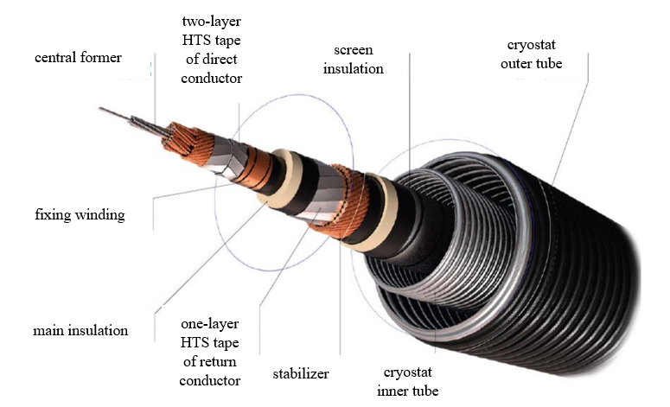
FIGURE 2. Superconducting cable: HTS cable

The use of such cables also makes it possible to transmit electricity at lower voltage levels, reducing the need to install transformer substations, which positively affects the cost of infrastructure projects and network reliability. Non-flammable liquid nitrogen is used as the cooling medium in HTS cables, which eliminates the risk of ignition or explosion in case of short circuits and overloads, unlike traditional oil-filled cable systems.
The development and implementation of superconducting technologies are actively promoted by leading companies in the field of electrical engineering, including Sumitomo Electric Industries, Intermagnetics General Corporation (Japan), and American Superconductor Corporation (AMSC) [4]. Significant progress in this area has been achieved through the introduction of rare earth elements, in particular holmium, into the coating structure of superconducting layers, which has improved the characteristics of conductors and increased the temperature range of their operation.
Despite the fact that copper and aluminum remain the main materials used in traditional cable conductors, research is increasingly underway to find new conductive materials capable of providing additional competitive advantages to cable products. Priority areas include composite conductors, carbon nanostructures, and graphene-based materials, which open up opportunities for creating lightweight, durable, and energy-efficient solutions in the electrical industry.

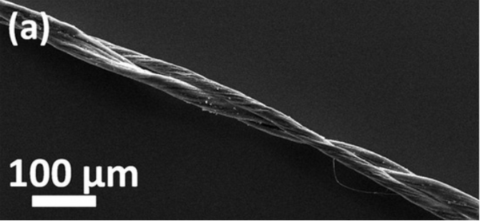
FIGURE 3. A sample of a quantum nanotube wire (pictured) capable of carrying a current density of
104~105 A/cm²

One of the most promising directions in improving the design of power cables is the introduction of cable conductors based on pure carbon nanotubes, the so-called quantum wires. These nanostructures have outstanding electrical characteristics: their conductivity exceeds that of copper by approximately 10 times, while the mass is only about one-sixth of the mass of a traditional copper conductor. This combination of high conductivity and lightness makes carbon nanotubes particularly attractive for the development of energy-efficient and compact next-generation cable systems.
The need to develop alternative conductors is also due to the current situation in the global copper market, which is characterized by a steady increase in the cost of raw materials and a limited resource base. In this context, efforts to create new types of cables acquire strategic importance not only for our Republic, but also for other countries. For example, in the United States, the Hydrocarbon Technologies Laboratory at Rice University has been commissioned to develop a prototype power cable based on carbon nanotubes. The research and development work is being conducted under a contract with NASA and plans to manufacture a 1-meter-long prototype quantum conductor [5].
Also, among the priorities of modern scientific research in the field of materials used in cable technology, a special place is occupied by the development of superconductors capable of operating at temperatures close to room temperature. Achieving stable superconductivity without the need for cryogenic cooling will be a technological breakthrough that significantly simplifies the design of cable systems, reduces operating costs, and expands their scope of application [6].

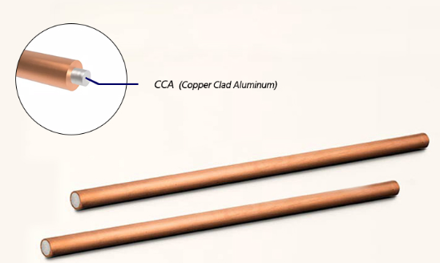
FIGURE 4. Copper clad aluminum (CCA) wire

At the same time, more cost-effective solutions aimed at reducing dependence on scarce copper are being actively explored. One of these options is bimetallic conductors, in particular copper clad aluminum (CCA) wires. These materials are used in both power and high-frequency cable systems, combining mechanical lightness and sufficient electrical conductivity at a lower cost [6]. The use of such conductors (Fig. 4) significantly reduces production costs and facilitates installation, especially in the case of long cable routes.

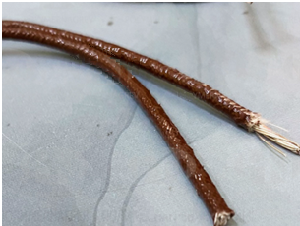
FIGURE 5. Heat-resistant copper-nickel wire

Among modern bimetallic conductors, which are becoming increasingly common, a particularly prominent type is one with a copper-core conductor and a nickel plating (Fig. 5). This design solution makes it possible to ensure high resistance of the cable product to aggressive external factors, including sudden temperature fluctuations, oxidation processes and chemical corrosion. Due to its properties, nickel is used in the composition of wires and cables designed for use in extreme conditions - at high temperatures, in environments with increased corrosion activity, as well as under significant mechanical and thermal loads.
According to a number of industrial surveys [6], more than 10 metric tons of copper are plated with nickel or silver every year worldwide. This indicates a high demand for such solutions from industries related to energy, aerospace technology, petrochemicals and high-temperature industries. The use of nickel-plated conductors makes it possible to significantly extend the service life of cable products, increase their reliability and ensure stable performance in conditions unacceptable for traditional materials.
Another important direction in the development of the cable industry is the introduction of new alloys that can effectively replace traditional conductive materials - copper and aluminum. The development of these alloys is carried out in order to achieve an optimal balance between electrical conductivity, mechanical strength, resistance to external influences and cost-effectiveness.

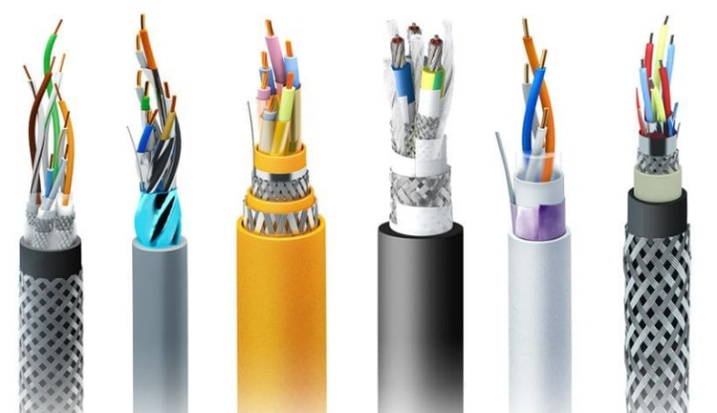

FIGURE 6. Specialized profile wires

One example of such a technological solution is a high-quality copper alloy with increased conductivity, marketed by the American company Phelps Dodge [7]. This material has found wide application in the production of various types of conductors, both for twisted cable structures with variable diameters and for specialized profile wires. Due to its characteristics, the alloy is used in high-load industrial sectors, including aerospace, defense and automotive industries, where increased requirements are placed on reliability, vibration resistance and minimizing the weight of conductors.
The use of such innovative materials expands the possibilities of designing cable products, making it possible to create lighter and more energy-efficient power transmission systems, which is especially important in the context of the rapid development of high-tech industries.
RESEARCH RESULTS
The analysis of modern cabling and wiring products and applied materials has shown that the use of cross-linked polyethylene (XLPE) insulation provides an increase in the allowable operating temperature of power cables up to 90–110 °C, resulting in a 10–15% increase in current-carrying capacity and a reduction in dielectric losses compared to traditional insulation systems.
The application of halogen-free, flame-retardant and low-smoke compounds leads to a significant improvement in fire safety characteristics. In particular, smoke generation is reduced by more than 40%, while the toxicity of combustion products decreases by up to 50%, which is critical for cable operation in enclosed and high-risk facilities.
The comparative assessment of conductor materials demonstrates that bimetallic conductors, including copper clad aluminum (CCA) and copper–nickel designs, allow a reduction in cable weight by 25–40% while maintaining acceptable electrical and mechanical properties. Nickel-plated conductors exhibit enhanced resistance to corrosion and temperature cycling, ensuring an increase in service life under aggressive environmental conditions.
The evaluation of advanced conductive technologies confirms the high potential of high-temperature superconducting (HTS) cables. These systems provide a reduction in transmission losses of up to 7–10% and an increase in power density by 3–5 times compared to conventional copper and aluminum cables, enabling more compact and efficient power transmission solutions.
Experimental studies of carbon nanotube-based conductors indicate the possibility of achieving current densities of 10⁴–10⁵ A/cm² with a significantly lower mass than traditional metallic conductors, which opens prospects for the development of lightweight and energy-efficient cable systems.
The integration of sensor elements and diagnostic modules into cable systems enables real-time monitoring of thermal and electrical parameters, reducing the probability of failures and unplanned outages by 20–30%.
The obtained results confirm that the combined use of advanced insulation materials, innovative conductor designs and intelligent monitoring technologies significantly improves the reliability, energy efficiency and operational stability of modern power cable lines.

CONCLUSIONS
Thus, modern trends in the development of cable products are aimed at comprehensively improving their operational properties. The emphasis is on increasing the strength and flexibility of structures, reducing weight, ensuring resistance to corrosive and chemically aggressive environments, increasing fire resistance and minimizing the release of toxic and corrosive products during combustion. Along with this, radiation resistance and compliance with electromagnetic compatibility (EMC) requirements play an important role. The solution to these challenges is reflected in the growing number of innovative developments demonstrating a steady positive trend in the market of cabling and wiring products.
REFERENCES
- Analysis of energy consumption of leading countries on the eve of global changes in the modern world, Energy Policy, available at: https://energypolicy.ru/analiz-energopotrebleniya-vedushhih-stran-nakanune-globalnyh-izmenenij-sovremennogo-mira/energetika/2023/12/13/(accessed 2023).
- P. Bulteel, “Competitive competition,” Power Engineering International 2, (2005).
- High-temperature superconducting cable, Uncomtech, available at: https://www.uncomtech.ru/page/8/vysokotemperaturnyi-sverxprovodyashhii-kabel
- P. Radbourne, “Undergrounding utility power cables,” Wire and Cable Technology International 1, (2005).
- Carbon nanotubes ready for use in electronics, Habr, available at: https://habr.com/ru/articles/129083/
- “American Superconductor Corporation reports advance in its HTS wire,” Wire Journal International 1, (2005).
- A. Gibson, “The economics of copper-clad aluminum bimetallic cables,” Wire and Cable Technology International 3, (2005).
- V. Tsypkina and V. Ivanova, “Modeling of a resource-saving method of drawing,” E3S Web of Conferences 139, 01073 (2019). https://doi.org/10.1051/e3sconf/201913901073
- D. B. Madrakhimov, V. P. Ivanova, and V. V. Tsypkina, “Improving the reliability of cable lines operation in hot climates,” E3S Web of Conferences 216, 01151 (2020). https://doi.org/10.1051/e3sconf/202021601151
- O. Toirov, V. Ivanova, V. Tsypkina, D. Jumaeva, and D. Abdullaeva, “Improvement of the multifilament wire lager for cable production,” E3S Web of Conferences 411, 01041 (2023). https://doi.org/10.1051/e3sconf/202341101041
- V. P. Ivanova and V. V. Tsypkina, “Improving the reliability of power supply to active consumers by improving the technology for manufacturing cable product,” E3S Web of Conferences 216, 01152 (2020). https://doi.org/10.1051/e3sconf/202021601152

