Improving the energy efficiency of technological equipment in cable manufacturing through the utilization of waste heat
Vera Ivanova¹, Victoria Tsypkina ^{1,3, a)}, Mikhail Kozlitin², Aybek Turabekov¹, Humoyun Muminov¹
¹Tashkent state technical university named after Islam Karimov, Tashkent, Uzbekistan
² Branch of the Moscow Power Engineering Institute Research University in Tashkent, Uzbekistan
³Termez State University of Engineering and Agrotechnology, Termez, Uzbekistan
^{a)} Corresponding author: viktoriya.tsipkina@gmail.com
Abstract. The article discusses the possibility of utilizing waste (excess) thermal energy generated by the technological equipment of industrial enterprises during their operation when performing a given technology. The object of scientific research is high-energy-consuming cable technological equipment: induction furnace, extrusion line. The issue of improving the energy efficiency of cable machines involved in the technology of manufacturing finished cable products is a highly energy-intensive production process, since the following technological operations are performed: the production of copper wire rod, contact annealing of drawn wire, and the application of insulation and sheathing to the cable conductor or cable core require a large amount of thermal energy, which is released into the environment as “waste” energy. A method for utilizing waste thermal energy and converting it into electrical energy has been proposed. The use of thermogenerators for this purpose will allow the utilization of excess thermal radiation from technological installations, which will reduce heat losses and increase the overall energy efficiency of the production process. This thermal energy is essentially recoverable for the operation of the electromechanical system of any cable unit that has a strong thermal background from the operation of its components and mechanisms.
INTRODUCTION
Many technological operations in the manufacturing process of cabling and wiring products (CWPs) are carried out due to the operation of cable equipment with significant energy consumption aimed at generating thermal energy. The most energy-intensive technological operations of cable production include: the manufacture of copper and aluminum billets (wire rods), the application of insulation and an external cable protection cover. The implementation of the above technologies is carried out by cable machines (CMs), which have induction and resistive heating systems in their design.
Currently, the main task being solved by modern cable production is to increase the energy efficiency of the production and technological process of CWPs manufacturing. One of the promising areas contributing to the achievement of this goal is the introduction of technologies using alternative energy sources. The search for solutions in this area is focused on ensuring the generation of electrical energy in environmentally friendly and resource-saving ways.

EXPERIMENTAL RESEARCH
One of the promising energy sources capable of meeting the requirements of modern energy-intensive cable industries is a thermoelectric power source (TEPS). The principle of its operation is based on the high sensitivity of thermoelectric elements to various sources of heat flow. This technology enables the efficient use of even minor temperature fluctuations, giving thermoelectric generators significant advantages over alternative installations, which are less effective in conditions of low-temperature difference.
The direct conversion of thermal energy into electrical energy was first discovered in 1822 by the German physicist Thomas Seebeck. The effect he described has found widespread application in modern technical and technological units that utilize the conversion of heat flow into electrical energy using thermoelectric generators (TEGs). The operating principle of TEGs is based on the direct conversion of thermal energy into electrical energy due to a system of semiconductor thermocouples having a serial or parallel connection.
The initial source of thermal energy, within the framework of the technical solution under consideration, are cable machines (CMs): induction melting furnaces and extrusion equipment, which are equipped with built-in heat sources with an operating temperature range from 400 °C to 1500 °C.
RESEARCH RESULTS
As a solution to the issue of increasing the efficiency of CMs, it is necessary to use thermoelectric power sources (TEPSs) integrated into operating systems that will allow the disposal of excess thermal radiation, which has a negative impact on nearby technological equipment, maintenance personnel and the environment.
The TEPS or thermogenerator (TG) is a module with a number of significant advantages over similar units: noiselessness, compactness, the possibility of free installation in any spatial position, ease of operation, relative affordability and high reliability in operation.
The amount of electrical energy generated by thermoelectric converters (TECs) may be sufficient to provide power to auxiliary equipment located on cable lines, such as pumping and fan installations, lighting elements and other systems with a low level of power consumption.
The possibility of using various elements – TGs, capable of generating electric current due to thermal energy is based on the principle of the thermoelectric effect, which occurs both during heat transfer between conductors having different temperatures (the Peltier effect, discovered by the French physicist Jean Charles Athanase Peltier in 1834), and the effect that occurs during cooling or heating of the junction of two different metals (the Seebeck effect, established by the German physicist Thomas Johann Seebeck in 1821).

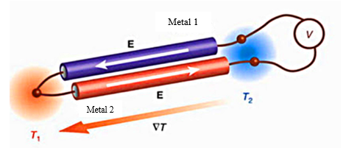
FIGURE 1. Thermocouple. Operating principle: 1 – measuring device; 2, 3 – thermoelectrodes; Т1,
Т2 - temperature of hot and cold junctions of the thermocouple

The operation of these units is based on the principle of the thermocouple (Fig. 1), which uses thermoelectric effects that are opposite in physical essence, ensuring high efficiency in converting thermal energy into electrical energy.

RESEARCH RESULTS
The development of a system that ensures the joint operation of TG and CM without disrupting the technological process in the established operating modes is a complex but highly relevant task, which is based on the operation of components and mechanisms of cable units with significant heat generation, which until now has not been utilized, but rather dissipated into the environment.
The use of TG as an additional module to CM opens up the possibility of a significant increase in the efficiency of technological equipment due to the targeted use of thermal radiation from heating units. The energy generated in this way can be used, for example, to charge battery power sources and devices servicing auxiliary equipment.
The potential of using TG as a renewable energy source in heat-intensive cable equipment was studied on an experimental facility (Fig. 2).

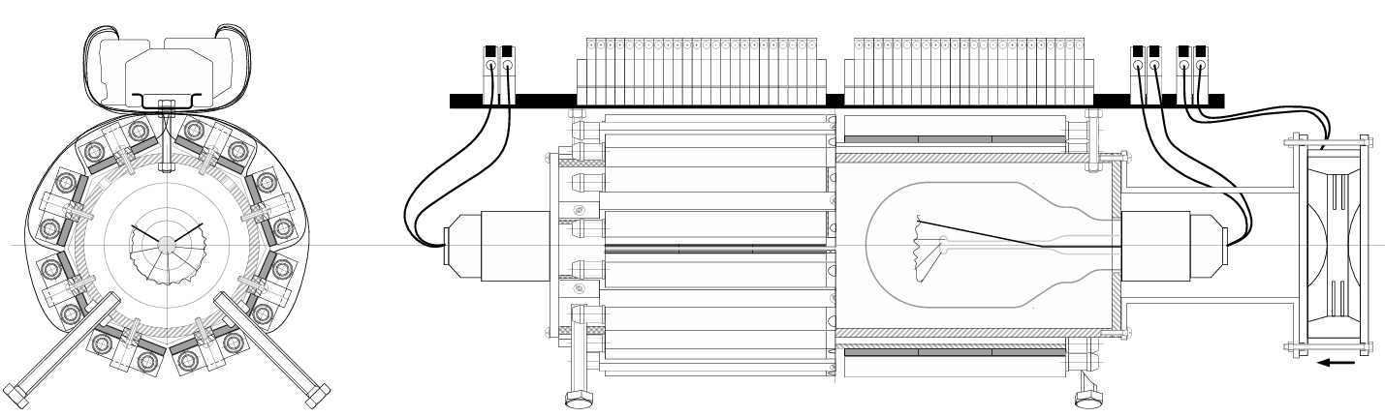
FIGURE 2. Experimental facility

The facility design has been developed on the basis of preliminary thermotechnical calculations and includes an electric furnace with resistive heating and a TG system mounted on the outer surface of the working chamber body. The temperature regime of the facility ranged from room temperature to 150 °C. The experimental dependence obtained (Figs. 3, 4) demonstrates the possibility of generating secondary electrical voltage due to the heat flow emanating from the working chamber.
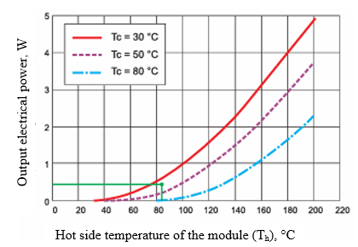
FIGURE 3. Dependence of the TG output electrical power on the hot side temperature of the module

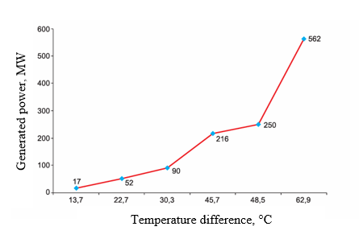
FIGURE 4. Results of the laboratory facility experiment
The experimental studies carried out, the results of which are shown in Figs. 3, 4 and in Tables 1 and 2, have confirmed the feasibility of using the TEG as an additional module for converting excess thermal energy into electrical energy.

TABLE 1. Experimental results obtained at the laboratory facility
No. | T_{hot}, °C | T_{cold}, °C | Temperature difference | R_{heating}, rated, Ohm | U_{heating}, B | I_{heating}, mА | P_{heating}, mW | R_{heating,} calculated,  Ohm
1 | 91,2 | 43 | 48,2 | 6,2 | 1,21 | 199,9 | 241,9 | 6,1
2 | 91,6 | 43,1 | 48,5 | 6,5 | 1,27 | 194 | 246,4 | 6,5
3 | 91,6 | 43,1 | 48,5 | 7 | 1,33 | 187,9 | 249,9 | 7,1
4 | 91,8 | 43,3 | 48,5 | 7,3 | 1,35 | 182,6 | 246,5 | 7,4
5 | 91,7 | 43,4 | 48,3 | 7,5 | 1,35 | 180,6 | 243,8 | 7,5
6 | 91,9 | 43,6 | 48,3 | 8 | 1,38 | 176 | 242,9 | 7,8
7 | 91,9 | 43,4 | 48,5 | 8,5 | 1,41 | 169,9 | 239,6 | 8,3

TABLE 2. Experimental results to determine the efficiency of the generated power during operation of the laboratory facility
No. | T_{hot}, °C | T_{cold}, °C | U, B | I, mА | P, mW
1 | 43,1 | 29,4 | 0,33 | 50,2 | 17
2 | 55 | 32,3 | 0,58 | 89,3 | 52
3 | 66 | 35,7 | 0,77 | 117 | 90
4 | 85,5 | 39,8 | 1,19 | 181,5 | 216
5 | 91,6 | 43,1 | 1,33 | 187,9 | 250
6 | 114,7 | 51,8 | 2,01 | 280 | 562

As part of the study, a simulation model of the extruder's thermal regime was also developed, including key heat-generating elements: an induction furnace, an extruder, a forming die and a divider. The model simulated technologies reflecting the operation of the CM's heat-generating elements: a thermal radiation zone consisting of an induction furnace, an extruder, a forming die and a divider in the set modes, enabling an assessment of the heat recovery potential in conditions close to the real production process. The TG was part of an additional module in the CM's operating system, the main functional load of which was the ability to convert thermal energy into electrical energy.
CONCLUSIONS
Based on the experimental data obtained (Tables 1 and 2) [1], it can be concluded that the use of TG in cable equipment is feasible. This is due to the fact that the operating temperatures of this equipment significantly exceed the temperature conditions of the laboratory facility, opening up prospects for increasing the output electrical power. The obtained results confirm the need for further research in this area.
REFERENCES
- V. Tsypkina and V. Ivanova, “Modeling of a resource-saving method of drawing,” E3S Web of Conferences 139, 01073 (2019). https://doi.org/10.1051/e3sconf/201913901073
- D. B. Madrakhimov, V. P. Ivanova, and V. V. Tsypkina, “Improving the reliability of cable lines operation in hot climates,” E3S Web of Conferences 216, 01151 (2020). https://doi.org/10.1051/e3sconf/202021601151
- O. Toirov, V. Ivanova, V. Tsypkina, D. Jumaeva, and D. Abdullaeva, “Improvement of the multifilament wire lager for cable production,” E3S Web of Conferences 411, 01041 (2023). https://doi.org/10.1051/e3sconf/202341101041
- V. P. Ivanova and V. V. Tsypkina, “Improving the reliability of power supply to active consumers by improving the technology for manufacturing cable product,” E3S Web of Conferences 216, 01152 (2020). https://doi.org/10.1051/e3sconf/202021601152

