Qualitative Analysis of Increasing the Dynamic Stability of autonomous inverters by connecting cut-off valves
Shukhrat Umarov ^{a)}, Abror Pulatov, Murat Tulyaganov, Islambek Abdullabekov, Murat Shamiyev, Ubaydulla Boqijonov, Saidamir Oripov
Tashkent state technical university named after Islam Karimov, Tashkent, Uzbekistan
^{a)} Corresponding author: shumarov1951@mail.ru
Abstract. The article presents the results of a qualitative analysis of circuits of autonomous current and voltage inverters with cut-off valves; the influence of the charge value of the switching capacitor in parallel and series equivalent circuits on the restoration of the switching properties of the thyristors of the inverter power circuit is studied. It is shown that due to the energy periodically accumulated in the inductive elements of the load, the voltage on the switching capacitor in the cut-off state is greater than in a conventional parallel autonomous current inverter. This circumstance ensures an increase in the switching stability of the inverter and therefore the circuit of an autonomous current inverter with cut-off valves is operational in valve converters for variable-frequency electric drives and remains operational during sudden load surges and short circuits, since the voltage value on the switching capacitor does not depend on the load voltage value those. the charge on the switching capacitor is maintained even when the load voltage sharply decreases between switching the thyristors of the power circuit.
INTRODUCTION
In the world, special attention is paid to solving the problems of developing power semiconductor converter technology based on current converters that are widely used in various industrial fields, their rational use with high accuracy of maintaining energy parameters, increasing operational reliability and increasing service life. Currently, in developed countries, "... more than 60% of the electricity generated passes through semiconductor converters. When using power electronics systems to a world-class level, it will be possible to save 12-15% of the electricity generated". In this regard, issues related to improving the energy efficiency of valve converters based on current converters for various purposes designed to provide the required power supply regime for energy facilities with increased requirements for the quality of energy consumed and reliability of energy resources are relevant [1-6].
The description of the modes of operation of the AСI implies the need to have a load with a resulting capacitive impedance, which facilitates instantaneous switching of the current in the load. For this purpose, a compensating capacitor is connected in parallel to the L, R load. This combination in the AСI is considered as its load. The corresponding algorithms for switching the thyristors of the automatic control system with a given frequency facilitate the conversion of the continuous current of the power source into the alternating current of the load and the voltage of the compensating capacitor [7-11].
It should be noted that the presence of parallel capacitance in the case of operation on the engine [2] leads to the occurrence, in certain modes, of capacitor self-excitation of the engine, causing the phenomenon of self-swinging. As a result, oscillations of the angle of recovery of the commutating properties of the thyristors - δ appear and the switching failure occurs.
The prospects for solving this issue led to the need to reduce the value of switching capacitances when regulating the output frequency over wide limits, by creating an automatic heat sink with cut-off valves (CV) [12-16].
The introduction of cut-off valves into the circuit results in the fact that in each time interval between the transmission of unlocking pulses to the control electrodes of the valves, the capacitors are disconnected from the load and the power source for some time. This circumstance allows to maintain the highest voltage appearing on it between commutations on C_{k}, making $U_{c }(t)$ independent of $U_{H }(t)$. As a result, the AСI with СD and СT have the ability to maintain the dynamic stability of the inverter with increasing load current.
The development and practical implementation of each next generation of power semiconductor devices, in turn, led to the qualitative development of converter devices with a corresponding increase in their power and expansion of their fields of application, as well as significant development of their research and design methods.
METHOD
As is known, in quasi-steady-state mode, capacitors of the power circuit of an autonomous current inverter (ACI) are the only energy sources to compensate for the reactive power of the load and restore the locking properties of thyristors, i.e. there is a balance of reactive energy [18-22].
$Q_{с}=Q_{н}+Q_{δ}$ (1)
where: Q_{δ} - is the reactive power to restore the valve;
Q_{н}- is the reactive power of the load.
As can be seen from Fig. 1. and 2, the voltage on the capacitors in the circuit of an autonomous current inverter (ACI) without cut-off valves has a shape close to a sine wave, and in circuits with CV – close to a trapezoid. The smaller the trapezoid front, the smaller the capacitance of the capacitors, i.e., with a decrease in the capacitance value, the load voltage is enriched with higher harmonics. The formation of additional higher harmonics in the output voltage curve of the CV circuits affects the redistribution of energy Q_{с} between Q_{н} and Q_{δ} in such a way that Q_{н} increases and the power Q_{с} decreases [23-25].

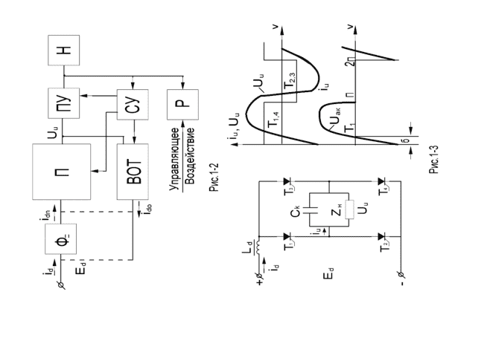
а) b)
FIGURE 1. Scheme (a) and time diagrams (b) of a single-phase ACI

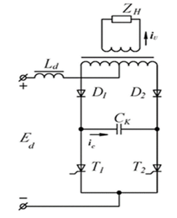 | 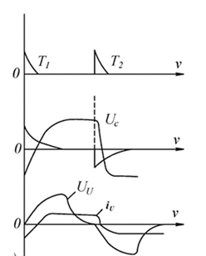
a) | b)
FIGURE 2. Scheme (a) and time diagrams (b) of a single-phase ACI with CV
Let us consider in more detail the operation of ACI with CV in quasi-steady-state mode using the example of a single-phase bridge circuit (Fig. 1) [25-27].
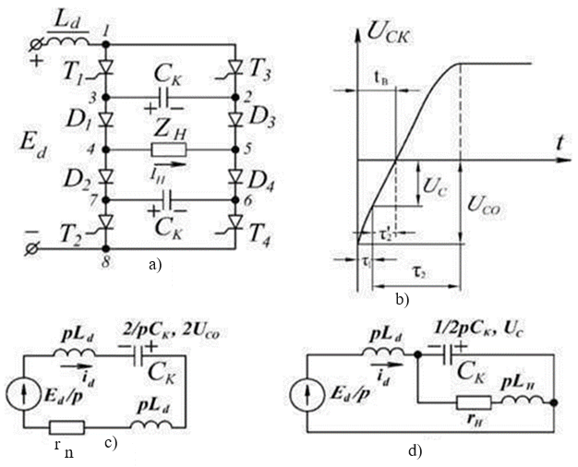
FIGURE 3. ACI with CV: circuit (a); time diagram of the capacitor voltage (b); replacement circuits (c, d).

Suppose at the moment t = 0 the current passed through $L_{d}-T_{1}-D_{1}-Z_{(p)}-D_{4}-T_{4}$ and the capacitors had a voltage $U_{cо}$. At the moment t = 0 the thyristors Т₃, Т₂ are switched on from the control system. Under the action of a reverse voltage of $U_{cо}$, Т₁, Т₄ are instantly locked, but diodes $D_{2}$, $D_{3}$ are not switched on. This happens because we always have $\left|U_{cо}\right|>\left|U_{н}(0)\right|$| in circuits with CV, and the next pair of cut-off diodes can open only after eliminating this inequality as a result of capacitor discharge.
The discharge occurs along the contour (in numbers): 1-2-3-4-5-6-7-8 and corresponds to the replacement circuit (Fig. 3, c) in the form of a sequential L, C circuit. At the moment $t=τ_{1}$ we have
$U_{c}\left(τ_{1}\right)=U_{н}\left(τ_{1}\right)$. (1)
In this case, diodes $D_{2}$, $D_{3}$ are opened and in the interval$τ_{2}$ , the current in the load and the voltage on the capacitors change sign. At the moment$t_{В}=τ_{1}+τ_{2}^{'}$ when the voltage $U_{c}\left(t\right)=0$, the interval for restoring the locking properties $T_{1},$ Т₄ ends.
Let us consider the effect of the charge of the Sc in parallel and serial substitution circuits on the interval t_B and the establishment of the voltage U_{co}. To do this, instead of diodes $D_{1}÷D_{4}$, cut-off thyristors (CT) $T_{1}^{'}÷T_{4}^{'}$, are installed, and the possibility is used to delay the supply of control pulses to $T_{2}^{'} , T_{3}^{'}$ relative to the moment t = 0 and set the interval of existence of the first substitution circuit ($τ_{11}$) within the required value, for example:
$τ_{1}<τ_{11}<\left(τ_{1}+τ_{2}\right)$. (2)
For the case of replacing cut-off diodes with thyristors, under the simplifying assumption $i_{d}(t)=I_{d}=const$, the following system of calculation expressions can be obtained for a single-phase ACI with cut-off thyristors:
$$U_{11}^{'}=r_{н}I_{d}$$
$$τ_{2}=\frac{\left[π-arctg\left(\frac{Ω_{1}}{Ϭ_{1}}\right)\right]}{Ω_{1}}$$
$$U_{11}=r_{н}I_{d}+\frac{\left[2Ω_{1}L_{H}I_{d}∙exp⁡(-Ϭ_{1}τ_{2})\right]}{\sin{Ω_{1}}τ_{2}}τ_{1}=C\left(\frac{U_{11}}{I_{d}-r_{н}}\right)$$
where: (3)
$$Ϭ_{1}=\frac{r_{н}}{2L_{H}} ; Ω_{1}={\left[\frac{1}{\left(2L_{H}C\right)-Ϭ_{1}^{2}}\right]}^{\frac{1}{2}}.$$
$$U_{11}=\left|U_{C0}\right|=\left|u_{C}\left(τ_{1}+τ_{2}\right)\right|$$
$U_{11}^{'}=u_{C}\left(τ_{1}\right)=u_{н}\left(τ_{1}\right)=u_{н}(0)$
Here, ${ τ}_{1}$ is characterized as the moment of transition from a serial to a parallel recharge circuit of a switching capacitor С_{k}.
Suppose the switching on of the cut-off thyristors is delayed relative to the moment t=0 until $u_{C}\left(τ_{11}\right)=0$. is obtained. Then, in the interval $τ_{11}$, a sequential replacement circuit of the charge С_{k} operates. If you enter the interval$τ_{21}$ for a parallel circuit, then you can write the inequality:
$τ_{11}$+ $τ_{21}$≠ $τ_{1}$+ $τ_{2}$
Under the above assumptions, the system of calculation ratios for ACI with cut-off thyristors has the form:

${ U}_{11}^{1}$ = 0 ,
${ τ}_{21}=\frac{п}{2Ω_{1}}$ ,
${ U}_{11}= r_{H }I_{d}$ + $2Ω_{1}L_{H}I_{d}*$ exp (-$Ϭ_{1} τ_{21}$) , (4)
$τ_{11}=C*$ $U_{11}$/ $I_{d}$ .

In the circuit with cut-off thyristors$t_{B1}$ = $τ_{11},$ and in the circuit with cut-off diodes${ t}_{B}$ = $τ_{1}+ τ_{2 }^{'}$Obviously, in the latter case, it is necessary to have the expression $U_{c}$ (t) on the recharge interval in a parallel circuit, and then the value of $τ_{2 }^{'}$' is found from the solution of the equation:
$U_{c}$($τ_{2 }^{'}$)= 0. (5)
Thus, the following features can be noted in the ACI schemes:
a) due to the energy periodically accumulated in the inductive elements of the load and$L_{d}$, the voltage on the $C_{к}$in the cut-off state is greater than in a conventional parallel ACI at the time of commutation;
b) the form of voltage at $C$ and at load is not the same, $U_{c} \left(t\right)≠ U_{H} (t)$. In particular, $U_{CO}$ does not depend on the frequency of ACI operation when it decreases, and therefore the ACI circuit with СV is operable for a frequency electric drive [25-27];
c) since $U_{c}$ (t) does not depend on $U_{H }(t)$, the charge on $C_{к}$ is preserved even with a sharp decrease in $U_{H} (t)$ between switching thyristors, that is, with sudden load surges and short circuit. This property can be used to provide switching during overloads and short circuit;
d) the introduction of cut-off thyristors makes it possible to change the ratio of recharge durations $C_{к}$ in serial and parallel circuits with load and the value $U_{co}$. Regulation $τ_{11}$ makes little difference to the time allowed for power thyristors to recover.
ACI circuits with СT on the switching interval consist, as it were, of two independent circuits: connecting $C_{к}$and connecting the load. However, the complete independence of the $C_{к}$ and load connection circuits is achieved only in the ACI circuit with DC, in which only a pulse of the C_{k} recharge current flows through the switching circuit (C_{k} plus thyristor). The single-phase version of ACI with CT in Fig. 4 has the same half-cycle substitution schemes as ACI with CD in Fig. 3 and the same lifetime of these substitution circuits as ACI with CT, provided that $τ_{11}$ is the delay in switching on the next power thyristor relative to the time of switching on the previous switching thyristor.
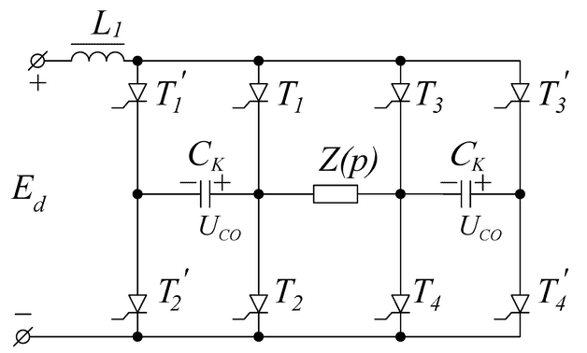
FIGURE 4. Single-phase ACI circuit with CT

Compensation of the reactivity of the load in the AСI is carried out due to the reactive current valves and the capacitance of the filter connected to the power source $E_{d}$ or due to inter-phase interactions. It will be shown below that the separation of the $L_{к}$. From the $C_{к}$ circuit is possible in a single-phase AСI only in the presence of CV.
Let's consider the operation of a single-phase bridge circuit of an ACI with an CV (Fig. 5).
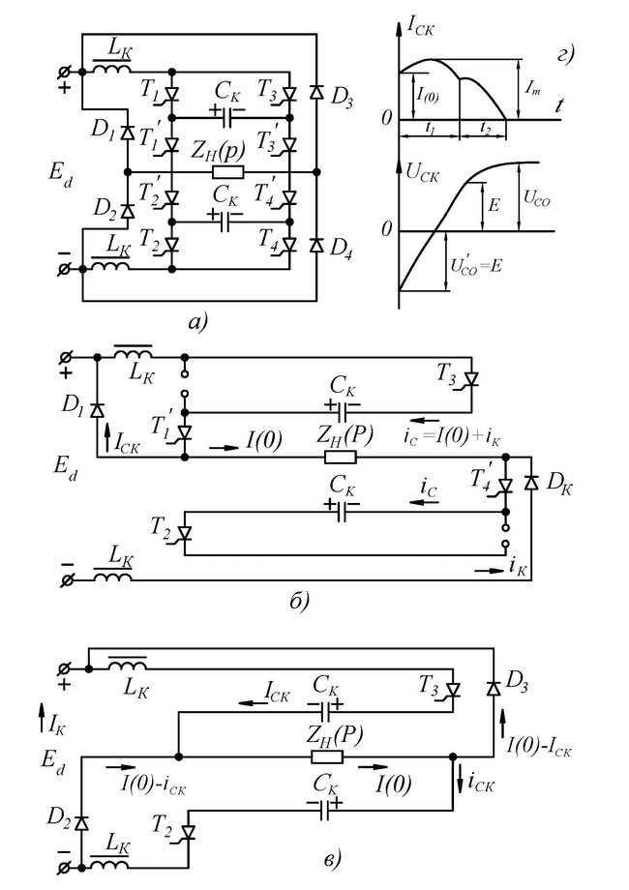
- b)

c)
FIGURE 5. The scheme of a single-phase bridge ACI with CV: a) circuit; b) time diagrams; c) switching circuit through D₁, D_{к}

RESULTS

Let all elements be ideal; before the next inclusion of the pair Т₃, Т₂, there is $U_{co}^{1}$ = $E_{d}$; the load is active – inductive with a large time constant. Then, after switching on Т₃,Т₂, oscillatory recharge circuits $C_{к}$ are formed, completely equivalent to the circuits with two-stage switching in the ACI (Fig.5, b). The recharge is oscillatory and therefore on (Fig.5, d) the recharge current $i_{ск}$ has the shape of a dome above the initial value of the load current$i$(0). From the moment t₁, the current $C_{к}$ is insufficient to supply the load and the load current tends to close through $D_{3}, D_{2}$ and the source (Fig. 5, c), and the voltage $U_{H}$ changes the polarity abruptly.
In the replacement circuit (Fig. 5, c) capacitors $C_{к}$ from $U_{c} \left(t_{1}\right)= E_{d}$ are recharged in the interval $t_{2}$to $U_{co}= E_{d}+i\left(0\right)\sqrt{L_{к}} /С_{к}$ due to the energy stored at the moment t = $t_{1}$in the inductance$L_{к}.$. Next, you can turn on the thyristors$T_{3}^{1}$ , $T_{2}^{1}$ at the moment of the $i_{H}$ current drop to zero or at t > $t_{1}$with a wide pulse, as in conventional ACI. Repeated switching in the scheme under consideration, as can be seen, will lead to an increase in $U_{co}$,, which is limited only by natural or artificially introduced losses into the scheme.
Programming the obtained analytical expressions and making up the algorithm of the process paths, the mathematical model was obtained. The mathematical model was used to calculate the transients and to plot the time diagrams of the currents and voltages to be expected, as shown in Fig. 6, a. Fig. 6, b shows the time diagrams of currents and voltages obtained by simulation. As can be seen from the presented diagrams, the time diagrams of currents and voltages at start-up of the autonomous inverter have a good agreement within 4-6%.
a)

b)
Figure 6. Time diagrams of currents and voltages at start-up:
a) analytical modelling; b) simulation modelling
CONCLUSIONS
Cutting-off diodes allow you to save$U_{co}= E_{d}$ from the end of any switching to the beginning of the next one and ensure overload operation if it was taken into account when calculating $С_{к}$with $U_{co}$ = $E_{d}$. In particular, this approach is successfully applicable in the presence of filters, which have an input resistance not equal to zero at the load efficiency.
The use of cut-off valves in autonomous current (ACI) and voltage inverters (AVI) allows you to save the greatest voltage appearing on it between the switches on $С_{к}$ making $U_{c }(t)$ independent of $U_{H }(t)$. The resulting useful properties of CD and CT are used equally in both ACI and AVI. They were listed when reviewing the CV in the ACI. However, there is a property of schemes with CD belonging only to ACI. This is the $U_{co}$ > $E_{d}$ inequality, which increases with increasing load current and is caused by the transfer of energy to $С_{к}$ from $L_{H}$ and $L_{d}$ at the switching interval. As a result, ACI with CD and CT have the ability to maintain switching stability with increasing load current. AVI with CT and AVI with CD schemes have similar properties.
REFERENCES
1. Chen H., Wang X., Liu, C., Pulatov A., Musolino A. Design of a Three-Phase High Torque Density Modular Linear Rotary Switched Reluctance Launcher IEEE Transactions on Plasma Science Open source preview, 2025, 53(10), pp 2653–2661
2. Liu J., Chen H., Pulatov A.A., Nguyen V.T., Li, X. Fault-Tolerant Control Method for Inter-Turn Short Circuit Faults of Switched Reluctance Linear Motors in Rail Transit. IEEE Transactions on Transportation Electrification Open-source preview, 2025.
3. Mirisaev A., Pulatov A., Muminov K. Improving the Energy Efficiency of Power Supply Systems and Electrical Equipment of Induction Plants of Metallurgical Enterprises AIP Conference Proceedings Open source preview, 2024, 3152(1), 030004
4. Mirisaev A., Pulatov A., Shamiev M. The Impact of the Operation of Electric Drives on the Reliability and Energy Efficiency of Power Supply Systems of Industrial Enterprises. AIP Conference Proceedings Open source preview, 2024, 3152(1), 030005. https://doi.org/10.1063/5.0218881
5. Farrukh Akbarov; Rustam Kabulov; Anvar Alimov; Erkin Abduraimov; Dildora Nasirova. Dependence of output parameters of photovoltaic module based on CIGS solar cells on external temperatures. AIP Conf. Proc. 3331, 040046 (2025). https://doi.org/10.1063/5.0305885
6. Anvar Alimov; Kudrat Abidov; Erkin Abduraimov; Farrukh Akbarov; Humoyun Muminov. Generalized model of nonlinear inductance and its parameters. AIP Conf. Proc. 3331, 040035 (2025). https://doi.org/10.1063/5.03058832.
7. Pirmatov, N., Bekishev, A.,Kurbanov, N.,Saodullaev, A.,Saimbetov , Z. Increasing the efficiency and survivability of synchronous machines with biaxial excitation when operating in transient processes. Proceedings of the AIP conference. Volume 3152, Issue 1, June 17, 2024, https://doi.org/10.1063/5.0218824
8. Bekishev, A.,Kurbanov, N.,Zainieva , O.,Saimbetov , Z.,Saodullaev, A. Comparative analysis of the survivability of synchronous machines in asynchronous mode without excitation. Proceedings of the AIP conference. Volume 3152, Issue 1, June 17, 2024, https://doi.org/10.1063/5.0218806.
9. A. Bekishev, A. E. Norboev, U. A. Khudoynazarov, N. A. Kurbanov and O. A. Yunusov. Autonomous mode and parallel operation of an asynchronous generator with an electrical network. E 3 S Conference Network. Volume 524, 2024. VII International Conference on Current Issues of the Energy Complex and Environmental Protection (APEC-VII-2024).https://doi.org/10.1051/e3sconf/202452401009
10. Allabergen Bekishev, Nurali Pirmatov, Dilfuza Kurbanbayeva, Najmiddin Kurbanov, Oliyakhon Zaynieva, Obidkhan Yunusov, Utkir Khudoynazarov, Zinatdin Saimbetov.Achievement of maximum power levels at different wind speeds from wind turners with asynchronous double-way feed generator. AIP Conf. Proc. 3331, 030011 (2025).https://doi.org/10.1063/5.0305765
11. Allabergen Bekishev, Gulzoda Mustafakulova, Aziza Khalbutayeva, Jasurbek Nizamov. Modeling of reactive power compensation of the electric arc steelmaking furnace DSP-100 UMK at JSC Uzmetkombinat. AIP Conf. Proc. 3331, 030069 (2025).https://doi.org/10.1063/5.0305769
12. Egorov A.N., Semenov A.S., Fedorov O.V. Practical experience of using the POWER FLEX 7000 device in the mining industry// NSTU Publishing House.- 2017, No. 4, pp.86-93.
13. Lazarev G. High-voltage converters for frequency-controlled electric drive //Electrical Engineering News, 2019, №5(119). – Pp.1-15.
14. Egorov A.N., Semenov A.S., Fedorov O.V. Practical experience of using the POWER FLEX 7000 device in the mining industry// NSTU Publishing House.- 2017, No.4, pp.86-93.
15. Tomashevsky D.N. Autonomous inverters. A study guide. Yekaterinburg: Ural Publishing House. Unita, 2019. – 120 p.
16. Zhu, S., Liu, K., Qin, L. et al.: ‘Global assessment of the asymptotic stability of three-phase inverters with saturation’, electron energy analysis., 2018, 11, (9), pp. 1556-1565
17. Shukhrat Umarov, Murot Tulyaganov. Peculiarities of simulation of steady modes of valve converters with periodic power circuit structure. III International Scientific and Technical Conference “Actual Issues of Power Supply Systems” (ICAIPSS2023). AIP Conf. Proc. 3152, 050004-1–050004-7; https://doi.org/10.1063/5.0218869
18. Murot Tulyaganov, Shukhrat Umarov. Improving the energy and operational efficiency of an asynchronous electric drive. III International Scientific and Technical Conference “Actual Issues of Power Supply Systems” (ICAIPSS2023); https://doi.org/10.1063/5.0218876
19. Hao Chen, Yongqiang Liu, Fan Yang, Wang Xing Xing, Zefu Tan, Li Cai, Antonio Musolino, Qian Huang, Yong Qi, Yokub Tairov, Murat Shamiyev. Research on Temperature Rise and Cooling System Optimization Design of Switched Reluctance Machine. July 2025 Protection and Control of Modern Power Systems 10(4):72-88, https://doi.org/10.23919/PCMP.2024.000092
20. Liu J.; Chen H.; Wang X.; Gu J.; Shamiyev M.; Pulatov A.O.; Wheeler P.; Torkaman H.; Musolino A.; Gorbounov Y. A Novel Adaptive Force Ripple Suppressing Method for Double-Sided Switched Reluctance Linear Motor. IEEE Transactions on Transportation Electrification, 2025, https://doi.org/10.1109/tte.2025.3609443
21. Shukhrat Umarov, Murat Tulyaganov, Saidamir Oripov, Ubaydulla Boqijonov. Using a modified Laplace transform to simulate valve converters with periodic topology Available to Purchase. IV international scientific and technical conference “Actual issues of power supply systems”: ICAIPSS 2024 . -Volume 3331, Issue 1 4 November 2025, https://doi.org/10.1063/5.0305792
22. Murot Tulyaganov, Shukhrat Umarov, Islombek Abdullabekov, Shakhnoza Adilova. Optimization of modes of an asynchronous electric drive taken into account thermal transient processes. IV international scientific and technical conference “Actual issues of power supply systems”: ICAIPSS 2024. Tashkent, Uzbekistan Article Contents. -Volume 3331, Issue 1 4 November 2025, https://doi.org/10.1063/5.0305786
23. Islombek Abdullabekov, Murakam Mirsaidov, Shukhrat Umarov, Murot Tulyaganov, Saidamirkhon Oripov. Optimizing energy efficiency in water pumping stations: A case study of the Chilonzor water distribution facility. IV international scientific and technical conference “Actual issues of power supply systems”: ICAIPSS 2024. Tashkent, Uzbekistan. -Volume 3331, Issue 1 4 November 2025, https://doi.org/10.1063/5.0305780
24. Alexandr D. Petrushin, Murot Tulyaganov. Optimal Control of the Switched Reluctance Motor of High-Speed Rail Transport with an On-Board Energy Source. 2024 International Conference on Industrial Engineering, Applications and Manufacturing (ICIEAM). -2024, https://doi:10.1109/icieam60818.2024.10553741
25. Murot Tulyaganov, Shukhrat Umarov. Improving the energy and operational efficiency of an asynchronous electric drive. Conference “Actual Issues of Power Supply Systems” (1CA1PSS2023) AIP Conf. Proc. 3152, 050004-1-050004-7; https://doi.org/10.1063/5-0218869 Published under an exclusive license by AIP Publishing. 978-0-7354-4988-6/$30.00. -2024, https://doi.org/10.1063/5.0218876
26. Shukhrat Umarov, Murat Tulyaganov. Peculiarities of Simulation of Steady Modes of Valve Converters with Periodic Power Circuit Structure. AIP Conference Proceedings Conference paper 2024 https://doi:10.1063/5.0218869
27. Shukhrat Umarov, Khushnud Sapaev, Islambek Abdullabekov. The Implicit Formulas of Numerical Integration Digital Models of Nonlinear Transformers. AIP Conf. Proc. 3331, 030105 (2025); https://doi.org/10.1063/5.0305793

