Criteria for selecting the optimal light spectrum for plant cultivation in greenhouse conditions
Yusupov Sharofiddin¹, Qurbonazarov Suhrob^{2, a)}, Babakhova Gulziba³, Igamberdiyev Abdumannon², Sheraliev Doston²
¹“Tashkent Institute of Irrigation and Agricultural Mechanization Engineers” National Research University, Tashkent, Uzbekistan
² Termez state university of engineering and agrotechnologies, Termez, Uzbekistan
³Karakalpak State University named after Berdakh, Nukus, Uzbekistan
^{a)} Corresponding author: sukhrob.qurbonazarov@mail.ru
Abstract. This study investigates the best light spectrum for artificial plant growing, focusing on LED lighting technology. By comparing natural sunshine to artificial light sources and evaluating the absorption spectra of essential plant pigments, the study suggests that red (660 nm) and blue (450 nm) wavelengths are the most effective for photosynthesis. The paper also looks at the limits of previous models, such as McCree's action spectrum, in light of recent spectral efficiency data. According to study, plants develop well when exposed to a balanced blend of red, blue, and green light, which is quite similar to sunlight. Furthermore, it has been discovered that during specific growth stages, ultraviolet and far-red wavelengths serve complementary but potentially helpful functions
INTRODUCTION
Theoretically, all lamps are the same, but their practical applications vary widely. First, pick lamps with aluminum casings. The lamp's housing ought to be heavy and substantial. The second is that high-quality LEDs are necessary. They must be of extraordinary quality and possess a certain spectrum. Red, blue, and green are the colors that work best for plants. Stated differently, the lamp's LEDs must be red, blue, and green. If the LED ratio is appropriate, the plants will feel comfortable. The blue hue is actually essential to the plant's visual appeal, even though it alters the fruiting season. So there must be red. Red, on the other hand, is vital to the plant and marks the beginning of the fruiting and flowering season. Furthermore, the color green is only required to facilitate plant work for our eyes. Red, green, and blue should normally make up 20–30% of the total. The plant will then develop in a comfortable way. The color temperature of such a lamp should be approximately 4200 Kelvin.
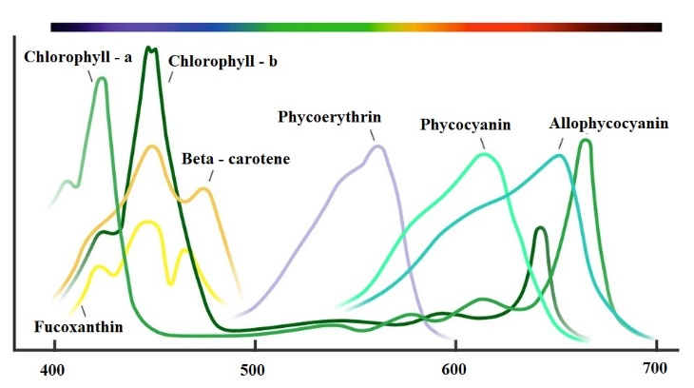
FIGURE 1. The absorption spectra of the main plant pigments are displayed

EXPERIMENTAL RESEARCH
Plants contain a variety of pigments that sense color. [1] This picture shows the primary pigments [2]. It is evident that the absorption spectrum of these pigments spans from 400 to 700 nanometers [3,4]. The main ones, though, are pigments that also absorb ultraviolet and infrared light. More precisely, the far red infrared spectrum heats the leaf immersed in the water, which is why it primarily affects us. [5] The sun is, of course, the best color for plants. This is true, but the question arises when we wish to cultivate plants in artificial settings, such as a greenhouse, a windowsill, or a completely indoor space that isn’t exposed to sunlight. [6,7]
LED-based lamps, sodium lamps, and other gas-discharge lamps come in a wide range of colors, including bicolor, full spectrum, and white [8]. I will therefore go into more detail in this article. [9] What is the best light to use? The pigment absorption spectrum data makes it evident at first glance that the lamp's spectrum should coincide with these absorption peaks [11]. This isn’t entirely true, though.This method of creating lamps to measure spectral radiation has been stimulating minds ever since Timiryazevo and this absorption spectrum of the average leaf were derived. The spectral efficiency of photosynthesis was calculated using the absorption spectrum of the photosynthetic pigments chlorophyll and carotenoids, which is line one [13].
This includes data from McCree and other scientists of the time. Considering all of this, a standard was even developed in the 1980s that said the radiation spectrum of the lamp should be the same as the spectrum of photosynthesis efficiency. [14,15] Subsequent studies, however, have demonstrated that this is still incorrect. Because McCree radiation was applied to plants that had distinct spectra, or those that glowed red in different ways. For both green and blue, they looked at the rate of photosynthesis separately. They shone with every light wavelength to observe the effects of each one.

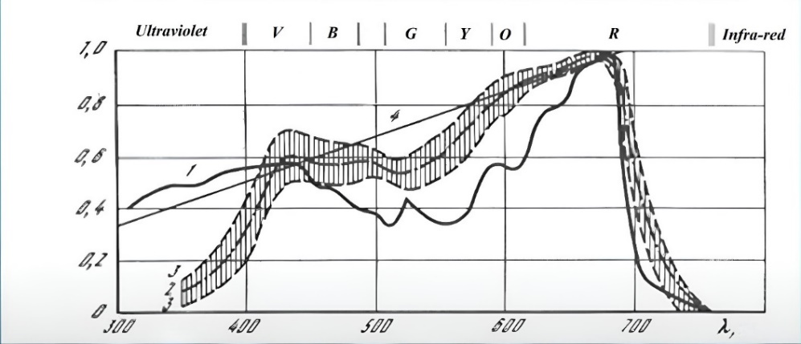
FIGURE 2. Spectral photosynthetic efficiency of optical radiation

However, it is fundamentally inaccurate to say that these effects occurred at a relatively small illumination, or irradiance. The second mistake is that the absorption spectra of pigments in different solutions are detected using a spectrophotometer. However, the leaf absorbs light energy differently on average than the sum of the absorption of these pigments extracted by some solution because the solvent and the extraction process both affect the absorption spectra in different solvents, and because the pigments are in compounds and surrounded by other elements in the leaf [16].
This method of assessing pigments' spectrum efficiency is therefore not entirely accurate; they gradually moved away from it, and this criterion remained in use during those years before being discontinued. Last but not least, scientists have shown that the leaf absorbs light between 400 and 700 nanometers, making it incorrect to assess its efficacy based on specific pigments like chlorophyll carotenoids [10]. Additionally, linking it to these carotenoids and chlorophyll absorption peaks and selecting LEDs specifically for these peaks is not entirely correct.
RESEARCH RESULTS
This picture shows how different colors influence the processes that occur in plants that affect their vital functions. No wavelength-specific binding is present. This range is displayed here, and despite the table's extreme conditionality, certain impacts are visible. They are found in certain plants and can be used to create lamps or to make some that currently exist.
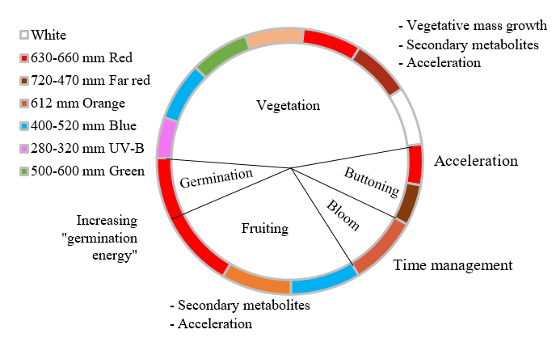
FIGURE 3. The main effects stimulated by different flowers throughout the plant life cycle

Let’s now examine the sun radiation spectrum. It is true that solar radiation has a broad and constant spectrum. Additionally, the plant has evolved to withstand this type of radiation. We can observe that the sun's upper portion is cloudless and clear. We have almost equal amounts of red, green, and blue. And down below is the sun’s spectrum during overcast conditions.

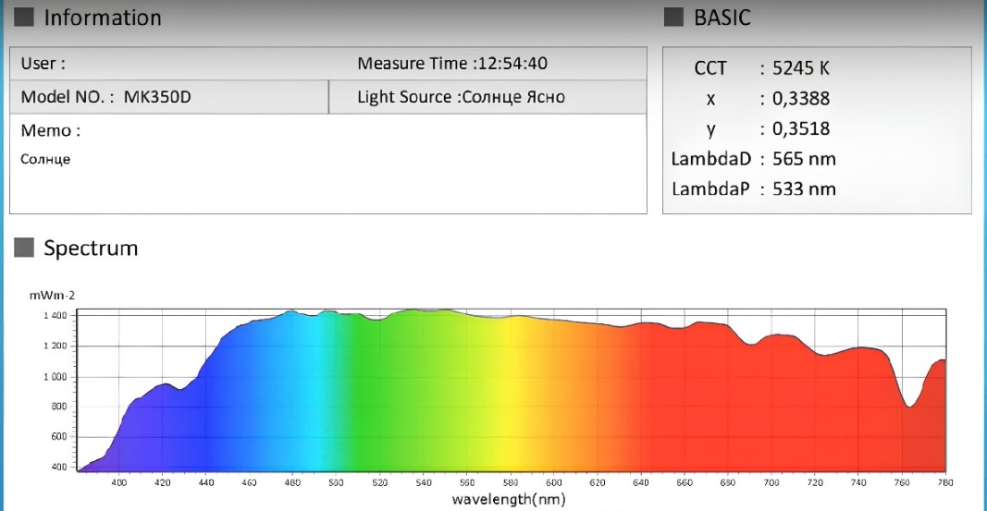
FIGURE 4. The light spectrum of the sun on a sunny day

More blue is produced, less red. That being said, if you examine the percentage ratio.
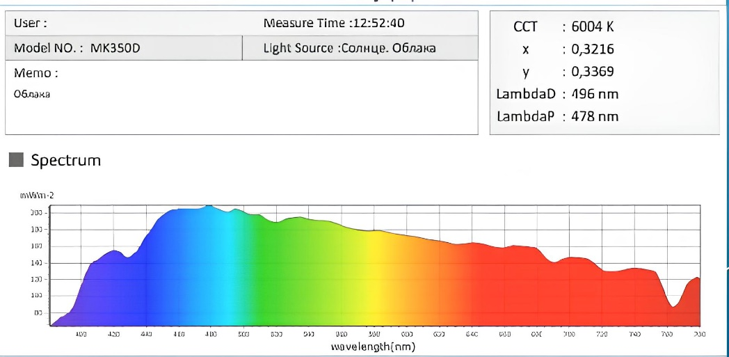
FIGURE 5. Sunlight spectrum on a cloudy day

We keep the proportions so that red is about 30%, green is between 26% and 28%, and blue is always about 20%. At the same time, far red is around 20% and ultraviolet light is no more than 1%.

TABLE 1. Percentage ratio of radiation in different parts of the spectrum
 | Sun | Cloudy | Sunny % | Cloudy %
Blue | 452,2 | 68,51 | 18,8 | 22,2
Green | 647,8 | 85,6 | 26,9 | 27,7
Red | 721,9 | 86,6 | 30,0 | 2781
Ultraviolet | 31,67 | 5,382 | 1,3 | 1,7
Far red | 553,7 | 62,15 | 23,0 | 20,1
 | 2407 | 308,7

This can theoretically serve as a reference for choosing artificial LED light sources and spectrum ratios. For instance, most plant species will probably grow under such a lamp if it is made with such ratios; they won’t experience any significant alterations related to an inaccurate spectrum and an inadequate ratio of various ranges there. Consequently, this can serve as a foundation, and these percentage ratios can be modified based on the kind of plant and the desired outcome. Simply growing green mass is one thing; producing fruit is another; and promoting additional effects, like reddening red lettuce, is a third objective.
CONCLUSIONS
You can alter these ratios for the same dill, parsley, and other basils to increase various volatile aromatic components.
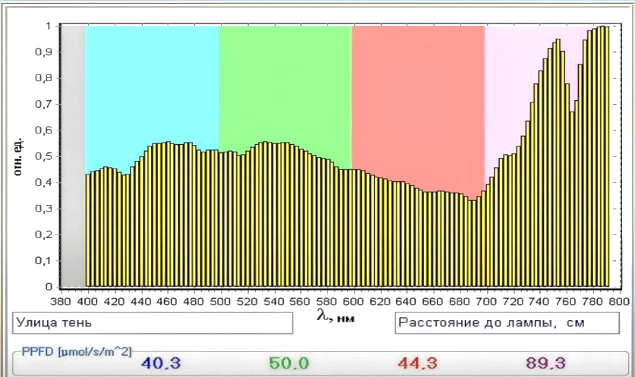
FIGURE 6. Spectral composition of radiation in the shade of trees
Here is another spectrum of solar radiation that we can observe in the shade of trees. The greenery allows a significant portion of the light to reach us. This red light extends from 700 to 800 nanometers and beyond. For instance, if you grow on a windowsill, your window will look out onto the tree-rich yard. Therefore, the plants will extend to escape the shade so that your seedlings do not stretch to the far red. The process known as phytochrome reactions is activated.
Which make it easier for the plant to avoid the shade when it occurs. In the shade of other trees there begins to stretch to look for light, to prevent this, it is enough to add blue, green and red to the windowsill so that the spectrum is more even and your plant will not stretch [12].
The radiation efficiency of a few Cree LEDs is shown below. These are all useful tools for simulating the sun's spectrum. Selecting LEDs that will accomplish the task efficiently is an additional step. It is evident from this graph that red LEDs with a wavelength of 660 nanometers—not to be confused with 630 nanometers—are our most efficient. Its efficiency is around half that of the original.

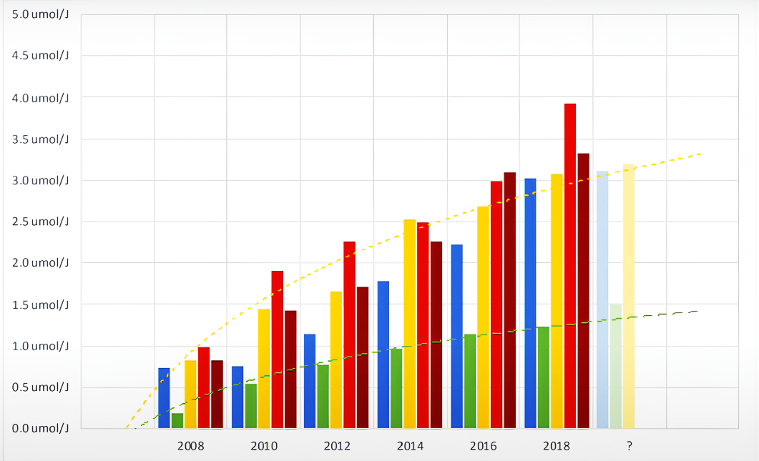
FIGURE 7. Emission efficiency of LEDs
The Cree LEDs have the following emission efficiency:
Blue (450 nm) – 3 μmol/J; Red (660 nm) – 3.8 μmol/J;
Far red (730 nm) – 3.3 μmol/J; White (4000 K) – 3.3 μmol/J.

Next, we have far red in efficiency, but I want to point out right once that they cost a lot more. These are Cree LEDs; other brands' efficiency may vary, but generally speaking, these ratios will be maintained as efficiency improves. The color temperature of these white LEDs is 4000 Kelvin. The efficiency of a different color temperature is almost the same. However, the highest photon flux on LEDs is 4000 Kelvin. This illustrates how green LEDs are twice as inefficient. As a result, using them in lamp design is unfeasible. I would also like to say the same regarding ultraviolet, yellow LEDs, and other colors. They are all somewhat inefficient, with the exception of those mentioned above. It turns out that when creating lamps, it is beneficial for us to employ only red, blue, white, and maybe far red. Naturally, distant red will be unnecessary for you if, as I previously stated, you have a window sill with tree shadows.
REFERENCES
- Sh. B. Yusupov. Growing sweet pepper plants based on effective electrical technology Journal of Sustainable Agriculture 2(14) (2022)
- A.S. Berdiyshev, T.M. Bayzakov, Sh.B. Yusupov, Bulletin of Science of the Kazakh Agrotechnical Research University named after. S.Seifullina 1(116) (2023)
- T.M. Bayzakov, R.F. Yunusov, Sh.B. Yusupov, IOP Conf. Ser.: Earth Environ. Sci. 1231 012065 (2023). https://www.doi.org/10.1088/1755-1315/1231/1/012065
- А. Muhammadiev, T.M. Bayzakov, Sh.B. Yusupov, Bulletin of Science of the Kazakh Agrotechnical Research University named after. S. Seifullina (interdisciplinary) 3(118), 340-347 (2023)
- Sh.B. Yusupov, D. Diniqulov, M. Mamutov, AIP Conf. Proc. 2612, 050042 (2023). https://doi.org/10.1063/5.0116514
- Mingjie Shao, Wenke Liu, Lingyan Zha, Chengbo Zhou, Yubin Zhang, Horticulture, Environment and biotechnology 61, 989-997 (2020). https://www.doi.org/10.1007/s13580-020-00285-z
- Sharofiddin Yusupov, Rustem Yunusov, Ilxom Xolmirzaev, IOP Conf. Series: Earth and Environmental Science 1231 012065 (2023)
- V.A. Sineshchekov, Int. J. Mol. Sci. 24(9) 8139 (2023). https://doi.org/10.3390/ijms24098139
- Sharofiddin B. Yusupov, Suhrob E. Qurbonazarov*, Zinatdin J. Saymbetov, and Rinat K. Kenesbayev - Ways to increase the efficiency of growing products in greenhouses E3S Web of Conferences 548, 01034 AGRITECH-X 2024 (2024) https://doi.org/10.1051/e3sconf/202454801034
- Mingjie Shao, Wenke Liu, Lingyan Zha, Chengbo Zhou, Yubin Zhang, Baoshi Li, Scientia Horticulturae 268 109366 (2020). https://doi.org/10.1016/j.scienta.2020.109366
- Linsheng Wu, Yongguang Zhang, Zhaoying Zhang, Xiaokang Zhang, Yunfei Wu, Jing Chen, Remote Sensing of Environment 304(1) 114043 (2024). https://doi.org/10.1016/j.rse.2024.114043
- Fan Ding, Yiqing Zhou, Yue He, Yuanyuan Liang, Peilan Luo, Wenli Zhou, Jilin Zhang, Liping Yu, Zhongxian Qiu, Shixun Lian, Inorg. Chem. 62(7), 3141-3152 (2023). https://doi.org/10.1021/acs.inorgchem.2c04022
- Ren Chen, Zhenwei Wang, Wenke Liu, Yuteng Ding, Qishuan Zhang, Shurong Wang, Plants 12(24), 4147 (2023). https://doi.org/10.3390/plants12244147
- Y. Liu, N. Cao, X. Shi, F. Meng, Y. Zhou, H. Wang, Q. Yang, Agronomy 13(7), 1910 (2023). https://doi.org/10.3390/agronomy13071910
- Y. Park, E.S. Runkle, PLoS ONE 18(2) e0281996 (2023). https://doi.org/10.1371/journal.pone.0281996
- In Tae Jang, Jae Hwan Lee, Eun Ji Shin, and Sang Yong Nam, J. People Plants Environ 26(4) 335-349 (2023). https://doi.org/10.11628/ksppe.2023.26.4.335
- S. F. Amirov and B. Kh. Khushbokov, “Transformers with multicoil cores for control systems,” Innovation-2006: Proc. Int. Sci.-Pract. Conf., vol. 2, pp. 670–673, Tashkent, Oct. 2006.
- S. F. Amirov and B. Kh. Khushbokov, “Current sensors with multicoil cores,” Innovative Technologies in Management, Education, and Industry “ASTINTECH-2007”, vol. 2, pp. 76–78, Astrakhan, 2007.
- S. F. Amirov, B. Kh. Khushbokov, J. F. Kadyrov, and N. E. Balgaev, “Current transformers for operation in transient modes,” Proc. Sci.-Pract. Conf. “From the Legendary Turksib to the Strategic Trans-Eurasian Railway”, vol. 2, pp. 51–55, Almaty, May 2006.
- S. F. Amirov, B. Kh. Khushbokov, and Y. Yu. Shoimov, “Remote converters of high currents with multicoil cores,” Vestnik TashIIT, no. 1, pp. 162–169, Tashkent, 2006.
- S. F. Amirov, Y. Yu. Shoimov, and N. N. Ochilov, “Wide-range electromagnetic converters of large DC currents,” Resource-Saving Technologies in Railway Transport: Proc. Republican Sci.-Tech. Conf., pp. 40–43, Tashkent, 2006.
- S. F. Amirov, B. Kh. Khushbokov, and Y. Yu. Shoimov, “Remote converters of high currents with multicoil cores,” Vestnik TashIIT, no. 1, pp. 162–169, Tashkent, 2006.
- Patent RUz No. 03316, Multi-turn Contactless AC Potentiometer, S. F. Amirov, K. Kh. Turdibekov, Y. Yu. Shoimov, Kh. A. Sattarov, B. Kh. Khushbokov, Official Bulletin, no. 3, 2007.
- S. Makhmutkhanov, Y. Ochilov, H. Nurov, and S. Kurbonazarov, “Increasing the environmental cleanness of industrial enterprises,” in AIP Conference Proceedings, AIP Publishing, 2024, p. 060012. Accessed: Oct. 06, 2025. [Online]. Available: https://doi.org/10.1063/5.0219213
- N. Niyozov, B. Khushbokov, G. E. Saidova, and I. Bakhadirov, “Energy efficiency of concrete work technology,” in AIP Conference Proceedings, AIP Publishing, 2024, p. 030025. Accessed: Oct. 06, 2025. [Online]. Available: https://doi.org/10.1063/5.0218841
- B. Khushbokov, K. Khakimov, J. Kodirov, and F. Khursanov, “Increasing the quality of receiving current through the current receiver by improving the fixator,” in AIP Conference Proceedings, AIP Publishing, 2024, p. 020006. Accessed: Oct. 06, 2025. [Online]. Available: https://doi.org/10.1063/5.0197788
- B. H. Khushbokov, M. R. Shaymanov, D. I. Safarov, I. T. Karabayev, and U. X. Abdimurodov, “Wide-range current transformers with non-contact regulation,” ACADEMICIA: An International Multidisciplinary Research Journal, vol. 11, no. 3, pp. 295–300, 2021, https://doi.org/10.5958/2249-7137.2021.00634.0
- B. U. Dzhumaevich, Khushbokov Bakhtiyor Khudoymurodovich, Khudaynazarov Salimjon Khushbokovich, and Omonov Fakhriddin, “Comparative analysis of modern current converters,” Open Journal of Science and Technology, vol. 4, no. 3, pp. 98–104, Dec. 2021, https://doi.org/10.31580/ojst.v4i3.1685.
- Nuritdin Khalilov; Doston Sheraliev, Sobir Eshmuradov, “Analysis and experimental study of a three-phase auto-parametric voltage stabilizer with a ferroresonant structure” AIP Conf. Proc. 3152, 040033 (2024) https://doi.org/10.1063/5.0219924
- Nuritdin Khalilov, Nematjon Qurbanov, Qahramon Jabborov, Doston Sheraliev, Sobir Eshmuradov, “Autoparametric single-phase to three-phase converter of phase number and frequency tripler with stable output voltage” AIP Conf. Proc. 3331, 070016 (2025) https://doi.org/10.1063/5.0305730

