Wide-range contactless adjustable current sensors of new design
Bakhtiyor Khushbokov, Suhrob Qurbonazarov^{a)}, Jumanazar Kodirov, Ilxom Xolmirzaev, Sobir Eshmuradov, Komil Abdirasulov
Termez state university of engineering and agrotechnologies, Termez, Uzbekistan
^{a)} Corresponding author: sukhrob.qurbonazarov@mail.ru
Abstract. A number of wide-range current sensor (CS) designs have been developed and analyzed to improve the accuracy and stability of current measurements in control and monitoring systems [1, 2]. The analysis of their operating principles revealed that conventional sensors with adjustable windings have low reliability due to the presence of sliding contacts, which cause mechanical wear and instability. To overcome these limitations, a new wide-range contactless current sensor configuration has been proposed. The sensor is based on an Archimedean spiral-shaped core made of diamagnetic and non-conductive material [3, 4]. The core is equipped with a primary winding, a movable magnetic conductor with a secondary winding, and a ferromagnetic fluid that enhances magnetic coupling. The vertical orientation of the spiral and its rotational adjustment ensure a smooth variation of the conversion ratio without breaking the primary circuit. This constructive solution prevents ferromagnetic fluid leakage and provides stable operation even during short-term power interruptions. The proposed design improves measurement precision, magnetic stability, and operational reliability compared to traditional sensors. Therefore, the developed contactless current sensor can be effectively applied in modern automated control and diagnostic systems that require high measurement accuracy and long-term stability [5].
INTRODUCTION
A number of design concepts for wide-range current sensors (CS) have been developed [1], [2], [3] to meet the increasing demands of modern control and monitoring systems. The analysis of their operation shows that sensors with continuously adjustable windings demonstrate low reliability due to the use of sliding contacts [4], [5]. These contacts, over time, lead to instability and measurement [9] errors.
It is well known that continuous adjustment of winding turns enables a wide measurement range, but the use of sliding contacts significantly decreases reliability [6], [7]. To overcome this limitation, this paper proposes a new type of wide-range current sensor with a contactless control mechanism [8]. The goal of this design is to eliminate mechanical contact and ensure a smooth, reliable adjustment of the conversion range [15].
It is known that by continuously adjusting the number of winding turns, it is possible to control the sensitivity of a wide range of current sensors [10], [11]. However, the presence of sliding contacts in such solutions reduces the overall reliability of the device [12]. Therefore, this study proposes a new design solution that allows contactless control of the measurement range [13], [16]. Figure 1 illustrates the developed wide-range current sensor [17].

EXPERIMENTAL RESEARCH
The proposed current sensor (CS) consists of a hollow fixed core (1) with a spiral made of insulating material wound around it [1], [7], [8]. The primary winding (2) is wound in a specific order on the core [9], [10]. The movable magnetic core made of ferromagnetic material (3) can rotate around the central axis (4). This movement is achieved using a rod (5) [11]. The signal is transmitted to the low-voltage winding (6), which is located in the empty cavity of the ferromagnetic conductor [12]. Additionally, the device contains a ferromagnetic fluid (7) that partially fills the hollow tube (1), which surrounds the movable core (3) [13]. The number of turns in the primary winding increases from the center of the core to its end for each unit of rotation angle of the movable core [14]. This sensor is classified as low-power and features air gaps [15], [16].
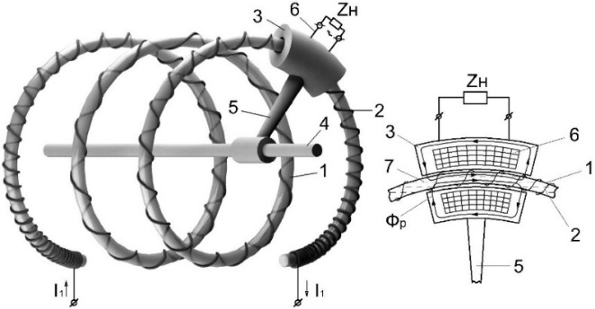
1) | 2)
FIGURE 1. Structural diagram of a wide-range current sensor (CS)

The operating principle of a broadband current sensor (CS) is as follows [17]. Ferromagnetic fluid under the influence of electromagnetic force accumulates due to the effect of magnetic fields. The ferromagnetic fluid gathers in parts of the hollow tube beneath the moving magnetic core [18]. When a moving magnetic conductor is moved in the direction of a spiral, the ferromagnetic fluid also moves accordingly [19]. The use of spiral hollow cores significantly conserves materials and results in low mass [20], [21].
The total magnetic resistance in the working magnetic flux path is determined by the following expression [22]:
$R_{μΣ}=\frac{l_{μp}}{μ_{p}∙μ_{0}∙S_{μp}}+\frac{l_{μp}}{μ_{s}∙μ_{0}∙S_{μs}}+\frac{l_{μδ}}{μ_{0}∙S_{μδ}}$ (1)
where:
$l_{μδ}=2\left(δ+δ_{C}\right)$ – total nonmagnetic gap in the path of the working magnetic flux;
$δ$ – Air gap. Located between the driving magnetic core 3 and the spiral-shaped core (1);
$δ_{C}$ – thickness of the hollow spiral core 1;
$μ_{0}=4π∙{10}^{-7} [Gn/m]$ – magnetic constant;
$μ_{p},μ_{s}$ – magnetic permeability of steel and ferromagnetic fluid, respectively;
$S_{μp}, S_{μs},S_{μδ}$ - respectively in the path of the moving magnetic conductor, ferromagnetic fluid, and the working magnetic flux of the gap.
The primary current creates an EMF:
$U_{μ1}=I_{1}w_{2}=I_{1}kα$ (2)
where:
$w_{2}=kα$ – the number of turns in the winding intended for measurement per each full rotation of the moving magnetic circuit;
$k$- proportionality coefficient
RESEARCH RESULTS
The described current sensor (TC) is designed to change relatively small current values [1], [3], [6]. The technology of adjusting the measurement range (multi-range capability) is implemented by rotating the movable magnetic circuit without disconnecting the main circuit, that is, without changing the number of turns in the main circuit [7], [8]. Such a solution is especially important in systems where power supply interruptions are unacceptable [9], [18].
If the ferromagnetic circuit is disconnected, the liquid leaves the region where the windings [10] are located. As a result, after restoring the primary current, the sensor operates without the presence of ferromagnetic fluid, which leads to significant errors in the measurement process [11], [12]. Therefore, in this study, the task of increasing the stability of the current sensor was put forward [13]. The solution to the problem lies in the fact that in the developed wide-range current sensor, the core with a spiral-shaped cavity is made of diamagnetic and non-conductive material [14]. A primary winding is connected to this core according to the required functional law [15]. The sensor has a movable magnetic core with a secondary circuit winding, which encloses part of a hollow core containing ferromagnetic fluid [16], [17]. The sensor core is positioned in a spiral resembling an Archimedes spiral and can rotate [18]. The movable core is mounted on a vertical rod [19].
Using a vertically positioned Archimedes spiral increases the stability of the devices [20]. In this current sensor, the vertically moving magnetic core encloses part of the hollow core filled with fluid [21].
In this device, as the Archimedes spiral rotates, the ferromagnetic fluid is held in the lower part of the hollow spiral according to physical laws [22]. This part is enclosed by the measuring magnetic circuit [23].
The current sensor maintains stable characteristics when the electrical network is disconnected or restarted [19]. Because the ferromagnetic fluid always sits in the lower part of the Archimedean spiral and when the network operating mode is disrupted, it does not flow into the unnecessary part of the spiral, while the driving core moves only along the vertical rod [24].
Figure 2 shows the proposed current sensor [8].
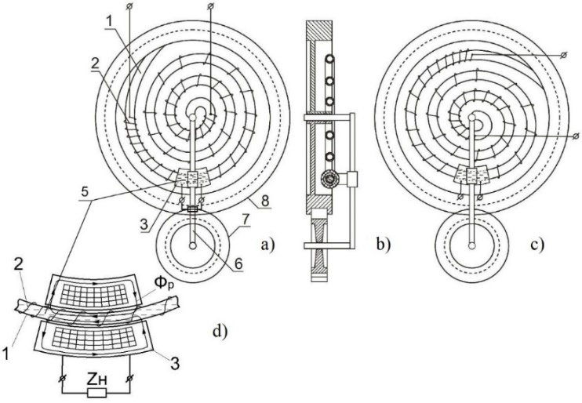
FIGURE 2. Developed wide-range current sensor: (a) front view, (b) side view, (c) spiral core at 90°, (d) movable magnetic core (cross-section)

This device is constructed in the form of a vertically arranged Archimedes spiral (1) made of an insulating pipe, on which the primary windings (2) are wound according to a certain law [10], on this core [11] a driving magnetic core (3) (has a secondary winding) is mounted, which covers the filled (with ferromagnetic fluid) part of the core (5).
The driving part (3) of this sensor moves up and down along the vertical rod (6) [12]. And the rotation of the spiral allows the auxiliary gear. (7 and 8) [13].Such a design solution simplifies the sensor's movement mechanism, increases measurement accuracy, and eliminates the leakage of ferromagnetic fluid [14].
A movable magnetic core 3 performs the function of forming a magnetic flux [15]. It has the shape of a hollow cylinder, the curved axis of which coincides with the axis of the wire wound around the hollow core 1 [16]. This magnetic core covers only one part of core 1, i.e., the part where primary winding 2 is located [17]. Therefore, the operating principle of the proposed current sensor (TS) does not fundamentally differ from previous analogues, but its design solution increases the level of accuracy and reliability [18], [19], [20].
As a result of this mechanical and electromagnetic interaction, the output signal of the current sensor changes proportionally to the core rotation angle [24]. Thus, the measurement range of the CS is expanded by means of mechanical contactless control, which significantly increases the reliability of the device [1], [7].
CONCLUSIONS
In conclusion, it can be said that the rigid arrangement of the hollow spiral in the proposed device, with the ability to rotate around a vertical axis designed in the form of an Archimedes spiral, provides a number of advantages.
Firstly, such a constructive solution prevents the leakage of ferromagnetic fluid from under the moving magnetic conductor, which ensures the mechanical stability of the system.
Secondly, the current sensor (TC) maintains its specified operating mode even in cases of short-term power outages and restoration.
As a result, the proposed design significantly increases the stability, reliability, and measurement accuracy of the TS operation and allows for a wide range of measurements based on the principle of contactless control.
REFERENCES
- S. F. Amirov and B. Kh. Khushbokov, “Transformers with multicoil cores for control systems,” Innovation-2006: Proc. Int. Sci.-Pract. Conf., vol. 2, pp. 670–673, Tashkent, Oct. 2006.
- S. F. Amirov and B. Kh. Khushbokov, “Current sensors with multicoil cores,” Innovative Technologies in Management, Education, and Industry “ASTINTECH-2007”, vol. 2, pp. 76–78, Astrakhan, 2007.
- S. F. Amirov, B. Kh. Khushbokov, J. F. Kadyrov, and N. E. Balgaev, “Current transformers for operation in transient modes,” Proc. Sci.-Pract. Conf. “From the Legendary Turksib to the Strategic Trans-Eurasian Railway”, vol. 2, pp. 51–55, Almaty, May 2006.
- S. F. Amirov, B. Kh. Khushbokov, and Y. Yu. Shoimov, “Remote converters of high currents with multicoil cores,” Vestnik TashIIT, no. 1, pp. 162–169, Tashkent, 2006.
- S. F. Amirov, Y. Yu. Shoimov, and N. N. Ochilov, “Wide-range electromagnetic converters of large DC currents,” Resource-Saving Technologies in Railway Transport: Proc. Republican Sci.-Tech. Conf., pp. 40–43, Tashkent, 2006.
- S. F. Amirov, B. Kh. Khushbokov, and Y. Yu. Shoimov, “Remote converters of high currents with multicoil cores,” Vestnik TashIIT, no. 1, pp. 162–169, Tashkent, 2006.
- Yu. A. Andreev and G. V. Abramzon, Current Converters for Measurements without Circuit Breaks, Leningrad: Energiya, 1979.
- E. G. Atamalyan, Instruments and Methods for Measuring Electrical Quantities, Moscow: Drofa, 2005.
- Yu. V. Afanasyev, N. M. Adonyev, V. M. Kibel, I. M. Sirota, and B. S. Stogniy, Current Transformers, Leningrad: Energoatomizdat, 1989.
- USSR Author’s Certificate No. 135789, Cl. 74 v, 8/04, Bulletin of Inventions, No. 3, 1961.
- USSR Author’s Certificate No. 211638, Cl. 71 d, 54, 21e, 32, GOIR 17/20, Bulletin of Inventions, No. 8, 1968.
- A. M. Golovanova and A. V. Kravtsov, Theoretical Foundations of Electrical Engineering: Electrical Measurements, Moscow: MGAU, 2006.
- A. L. Gurtovtsev, V. V. Bordaev, and V. I. Chizhonok, “0.4 kV current measuring transformers: testing, selection, application,” News of Electrical Engineering, no. 1(25), no. 2(26), pp. 66–71, 91–94, 2004.
- Yu. N. Kochemasov and Yu. B. Kolegaev, “Comparative analysis of magnetic field sensor characteristics,” Sensors and Systems, no. 4, pp. 33–34, Moscow, 2001.
- Patent RUz No. 03316, Multi-turn Contactless AC Potentiometer, S. F. Amirov, K. Kh. Turdibekov, Y. Yu. Shoimov, Kh. A. Sattarov, B. Kh. Khushbokov, Official Bulletin, no. 3, 2007.
- A. M. Plakhtiyev, Contactless Ferromagnetic Converters with Distributed Magnetic Parameters for Control and Monitoring Systems, Doct. Tech. Sci. Dissertation Abstract, Tashkent State Technical University, 2009.
- M. A. Rozenblat, “New achievements and directions in the development of magnetic sensors,” Instruments and Control Systems, no. 9, pp. 42–50, Moscow, 1996.
- M. A. Shabad, Current Transformers in Relay Protection Circuits, Moscow: EnergoProgress, 1998.
- Sh. B. Yusupov, S. E. Qurbonazarov, Z. J. Saymbetov, and R. K. Kenesbayev, “Ways to increase the efficiency of growing products in greenhouses,” E3S Web of Conferences, vol. 548, p. 01034, 2024, https://doi.org/10.1051/e3sconf/202454801034
- S. Makhmutkhanov, Y. Ochilov, H. Nurov, and S. Kurbonazarov, “Increasing the environmental cleanness of industrial enterprises,” in AIP Conference Proceedings, AIP Publishing, 2024, p. 060012. Accessed: Oct. 06, 2025. [Online]. Available: https://doi.org/10.1063/5.0219213
- N. Niyozov, B. Khushbokov, G. E. Saidova, and I. Bakhadirov, “Energy efficiency of concrete work technology,” in AIP Conference Proceedings, AIP Publishing, 2024, p. 030025. Accessed: Oct. 06, 2025. [Online]. Available: https://doi.org/10.1063/5.0218841
- B. Khushbokov, K. Khakimov, J. Kodirov, and F. Khursanov, “Increasing the quality of receiving current through the current receiver by improving the fixator,” in AIP Conference Proceedings, AIP Publishing, 2024, p. 020006. Accessed: Oct. 06, 2025. [Online]. Available: https://doi.org/10.1063/5.0197788
- B. H. Khushbokov, M. R. Shaymanov, D. I. Safarov, I. T. Karabayev, and U. X. Abdimurodov, “Wide-range current transformers with non-contact regulation,” ACADEMICIA: An International Multidisciplinary Research Journal, vol. 11, no. 3, pp. 295–300, 2021, https://doi.org/10.5958/2249-7137.2021.00634.0
- U. Dzhumaevich, Khushbokov Bakhtiyor Khudoymurodovich, Khudaynazarov Salimjon Khushbokovich, and Omonov Fakhriddin, “Comparative analysis of modern current converters,” Open Journal of Science and Technology, vol. 4, no. 3, pp. 98–104, Dec. 2021, https://doi.org/10.31580/ojst.v4i3.1685.
- Nuritdin Khalilov; Doston Sheraliev, Sobir Eshmuradov, “Analysis and experimental study of a three-phase auto-parametric voltage stabilizer with a ferroresonant structure” AIP Conf. Proc. 3152, 040033 (2024) https://doi.org/10.1063/5.0219924
- Nuritdin Khalilov, Nematjon Qurbanov, Qahramon Jabborov, Doston Sheraliev, Sobir Eshmuradov, “Autoparametric single-phase to three-phase converter of phase number and frequency tripler with stable output voltage” AIP Conf. Proc. 3331, 070016 (2025) https://doi.org/10.1063/5.0305730

