Improving Energy Efficiency through the use of Energy-Saving Technological Equipment
Xakim Muratov ¹, Fozildjon Xoshimov ^{3,1}, Kamoliddin Kаdirov¹, Alijon Kushev¹, Xulkaroy Yusupaliyeva^{1,a}, Alisher Tukhtashev²
¹The institute of energy problems of the academy of Sciences of the Republic of Uzbekistan, Tashkent, Uzbekistan
²Fergana State Technical University, Fergana, Uzbekistan
³Tаshkеnt stаtе tесhniсаl univеrsity nаmеd аftеr Islаm Kаrimоv, Tаshkеnt, Uzbеkistаn
^{a)} Corresponding author: shayumovaz@mail.ru
Abstract. This article explores methods for achieving energy efficiency in industrial enterprises through the implementation of modern energy-saving technological equipment. It highlights the replacement of existing, outdated equipment with advanced energy-efficient alternatives and analyzes the differences in energy performance between them. The operating mode of modern energy-efficient equipment should be selected with consideration for efficiency, resource savings, and safety. Selecting the optimal operating mode helps extend the service life of the equipment, reduce maintenance costs, and enable significant energy savings. Ensuring that technological equipment operates under the correct mode supports efficient production processes and facilitates increased productivity. Consequently, production costs are reduced, and the competitiveness of the final product is enhanced.
INTRODUCTION
Energy-saving technological equipment refers to a set of machines, mechanisms, and tools designed to handle, process, and form various materials during the production process. These types of equipment are capable of operating under different modes depending on their operational characteristics and specific functional requirements.
In the first mode, known as continuous operation, the equipment operates without interruption or with minimal downtime. This mode is typically used in sectors such as large conveyor lines, power plants, and oil refineries.
The second mode, or continuous-cyclic operation, involves equipment functioning for a specific period followed by short breaks. This mode is commonly applied in the textile and food processing industries.
The third mode, called cyclic (intermittent) operation, involves equipment that runs during specific time intervals, then stops and restarts in a new cycle. This pattern is typical in enterprises with presses, metalworking machines, and lifting mechanisms.
The fourth mode is known as short-term operation, where equipment functions for a brief duration followed by extended periods of inactivity. This mode is characteristic of laboratory instruments, testing devices, and other specialized units [1–3].
The implementation of energy-saving technological equipment in industrial enterprises provides greater opportunities to achieve operational efficiency. Analyzing the operational modes of such equipment reveals various influencing factors that impact efficiency. For instance, the level of load—whether the equipment operates under heavy or light conditions significantly affects its performance. In material processing, characteristics such as material strength, elasticity, and other physical properties play a critical role. Environmental conditions, including temperature, humidity, and durability, must also be considered when determining the most suitable operating mode. While continuous operation typically demands higher energy consumption, cyclic modes may offer better economic efficiency.
In industrial applications, selecting the optimal operating mode for energy-saving equipment is crucial. This mode should be determined with a focus on maximizing efficiency, conserving resources, and ensuring safety. Choosing an appropriate mode can extend equipment lifespan, reduce maintenance costs, and enable significant energy savings. Proper operation ensures a more effective production process, promotes higher productivity,reduces the cost of manufactured goods, and enhances product competitiveness in the market.
Increasing production efficiency and improving product quality rely heavily on applying optimal operational modes tailored to the equipment. Key criteria for selecting such modes include load optimization: extended operation under full load may accelerate wear, while underloaded conditions may lead to reduced efficiency. Therefore, it is essential to ensure balanced load distribution and maintain equilibrium in the production schedule.
To enhance energy efficiency, equipment must be operated under energy-saving conditions for example, by using variable-speed electric motors and ensuring that power supply is automatically shut off during idle times. Moreover, optimizing the operational modes of technological equipment in industrial settings requires precise monitoring of parameters such as temperature, pressure, and speed to ensure quality and reliability. This can be achieved through the use of automated control systems capable of real-time monitoring and adjustment.
The overarching goal of adapting modern energy-saving technological equipment to the conditions of the Republic is to improve energy infrastructure, increase energy efficiency, and reduce environmental impact. Achieving this goal requires addressing the following tasks:
- conducting a thorough analysis of existing technologies to enable the practical implementation of new solutions;
- comparing available technologies during decision-making and accounting for their performance differences;
- adopting the latest innovative energy-efficient technologies as a mandatory requirement.

EXPERIMENTAL RESEARCH
In recent years, the demand for electricity in the light industry sector of the Republic has been steadily increasing. Today, Uzbekistan's textile industry produces goods that meet international standards and can compete in terms of quality with those of leading global manufacturers.
To improve efficiency, the development of mathematical models for energy-saving technological equipment relies on key performance indicators obtained from statistical data recorded during standard operational conditions or determined through experimental measurements.
Based on the aforementioned approach, mathematical models are derived to estimate the energy consumption corresponding to the volume of products manufactured during the accounting period.
$W=W_{EC}+e_{1}П_{1}+e_{2}П_{2}+…+e_{n}П_{n} kvt*hour$ (1)
Here, - the volume of a specific type of product manufactured during the calculation (accounting) period;
- baseline (fixed) energy consumption that is independent of production efficiency;
- the specific electricity consumption for each type of product
- types of manufactured products.
The specific electricity consumption is calculated using the following equation:
(2)
The mathematical model of total electricity consumption can be expressed in the form of a house:
(3)
Based on the obtained model of electricity consumption, the value of the comparative electricity consumption of the gross product corresponding to 1000 soums is determined according to the following expression:
(4)
It should be noted that the obtained calculation results may vary to some extent due to the implementation of organizational and technical measures at the enterprise, as well as the influence of various operational and technological factors on the model parameters.
To identify the patterns of change in energy performance indicators, the following aspects must be determined through the analysis of statistical data:
seasonal variations in the consumption of energy resources and the quality of components such as raw materials, semi-finished products, and technological elements (compressed air, water, gas, electricity);
changes in energy performance depending on the enterprise’s operating schedule during different times of the day and months of the year;
consumption of energy resources during equipment maintenance periods.
The mathematical models for absolute and specific electricity consumption are developed using statistical methods. In particular, correlation equations are applied to construct these models [3].
The mathematical expressions for the specific and absolute electricity consumption are as follows::
$W=W_{0}+\overline{ω}*П,$ kvt*hour (5)
$d=\frac{W_{0}}{П}+\overline{ω} kvt*hour$ (6)
Here, и - Therefore, it is a constant component of the absolute and relative consumption of electrical energy.
Based on the developed models, it is possible to determine the specific electricity consumption for any selected operating mode of the enterprise. Moreover, the quantitative evaluation of the electrical capacity of products can be carried out under both normal and low-load operating conditions.
In order to improve the methods for analyzing and forecasting electricity performance indicators across individual processes and the entire enterprise, and to consolidate and enhance the accuracy and adaptability of electricity consumption norms, the following recommendations are proposed:
utilize the proposed calculation methods and mathematical models to conduct short- and medium-term forecasts of electricity consumption;
in energy consumption calculations, take into account the energy intensity and quantity ratio of different product types, the seasonality of electricity consumption levels, and the operating modes of ventilation and humidification systems;
develop the enterprise's energy performance characteristics based on the actual and total volume of products manufactured.
All indicators related to the consumer must be considered when evaluating energy consumption, including the production schedule. For example, in a light industry enterprise, if the required raw materials are not delivered on time or due to other similar reasons, electricity consumption may increase significantly.
A method has been proposed to determine the excess electricity consumption for a single idle-operating unit in a light industry enterprise. This method is based on the equipment’s energy performance characteristics.:
(7)
According to the adopted method, the analysis and calculations are carried out with respect to a specified conditional product, and the required conditional calculated quantity for ensuring production is determined using the following expression:
$n_{p}^{'}=(W_{p}-W_{o}/(P_{в}^{'}t)$ (8)
Here, – calculated value of electricity consumption;
– conditionally consumed power;
– The power consumed by a machine that produces a given product;
– working time during the billing period;
– constant organizer of electricity consumption determined as a result of measurements (for ventilation, water supply, lighting, etc.).
The effective operating power under actual productivity and electricity consumption conditions is determined using the following expression:
(9)
Specific additional electricity consumption due to idle operation:
(10)
Here, .
For light industry enterprises, the specific electricity consumption of a single fully operational technological unit ranges between 0.24 and 0.36 kWh. Analysis of the data using the proposed method shows that the total electricity consumption during idle operation accounts for approximately 5–10% of the enterprise’s overall electricity usage in the production process.
This applies, first of all, to autonomous electric generators operating according to the laws of rotation frequency change (ω), frequency (f) and voltage (U) in certain ranges.
RESEARCH RESULTS
To enhance energy efficiency, the installation of modern energy-saving technological equipment becomes a necessary recommendation. In this regard, it is essential to transfer advanced energy-efficient equipment produced in developed countries such as Turkey, Germany, China, Sweden, and others to light industry enterprises across the Republic. Leading manufacturers that provide such equipment include Rieter, Savio, Truetzschler, Marzoli, Murata, Toyota, Saurer, Pai Lung, Wellknit, and others. The installation of modern technological equipment enables more rational and economical use of energy resources, thereby increasing overall energy efficiency.
At present, many light industry enterprises in the Republic still operate outdated technological equipment that is not energy efficient. For these consumers, the adoption of energy-saving technological equipment can significantly improve performance efficiency.
Table 1 presents the comparative energy efficiency characteristics of replacing existing outdated equipment with modern energy-saving technological equipment in light industry enterprises.

TABLE 1. Comparative energy efficiency characteristics of replacing existing outdated equipment with modern energy-saving technological equipment
Technical indicators | Old-fashioned technological equipment |  |  | Modern energy-efficient technological equipment
Technical indicators | Pai lung | Wellknit | Orizo | Hanma | Hengyi | Huixing
Product production, kg/hour | 20 | 22 | 10 | 35 | 25 | 15
Installed power, kW | 6,5 | 4,5 | 4,5 | 5,5 | 3,7 | 3,7
Consumption power, kW*hour | 5,7 | 4,2 | 4,1 | 5,1 | 3,3 | 3,2
Speed, rad/min | 15-22 | 17-45 | 16-30 | 16-30 | 15-35 | 16-30
Comparative consumption of electricity, kW*hour/kg | 0,28 | 0,19 | 0,41 | 0,14 | 0,13 | 0,21

The analysis of the technical and economic indicators of these circular knitting machines, along with the results of replacing them with modern energy-efficient technological equipment, shows that the specific electricity consumption of outdated machines can be up to 41% higher compared to modern energy-saving knitting machines.
Figure 1 illustrates outdated models of circular knitting machines. These machines were installed during the initial commissioning of the enterprise (approximately after the year 1991), and a significant portion of them are currently in need of repair.

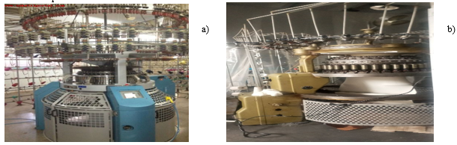
FIGURE 1. Old Pai lung (a) and Orizo (b) brand circular knitting fabric machines with low energy efficiency

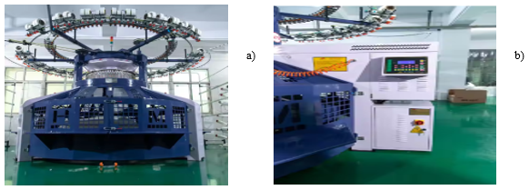
FIGURE 2. Modern Hanma (a) and Hengyi (b) brand circular knitting fabric machines with high energy-efficientciency

Numerous new textile enterprises are being commissioned across the Republic. It is recommended that these facilities be equipped with modern energy-efficient machinery produced in leading industrialized countries (Figure 2).
The obtained energy characteristics and mathematical models of key energy-efficient technological equipment serve to determine the optimal operating mode of the equipment and to reduce the specific electricity consumption per unit of manufactured product.
To determine energy capacity coefficients, a linear equation method and the electrical energy classification of all manufactured product types can be used. In this case, products are grouped according to their equivalent energy capacity levels.
Figures 3-5 presents a graph generated by a comparative analysis program that tracks daily electricity consumption patterns of outdated and modern energy-efficient technological equipment.

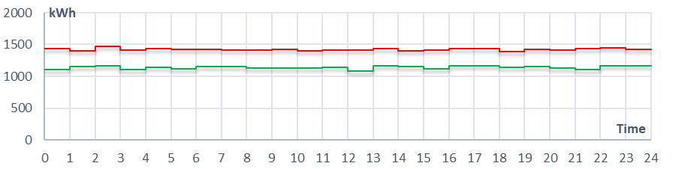
FIGURE 3. Daily electricity consumption monitoring of Pai Lung (red) and Hanma (green) circular knitting fabric technological equipment

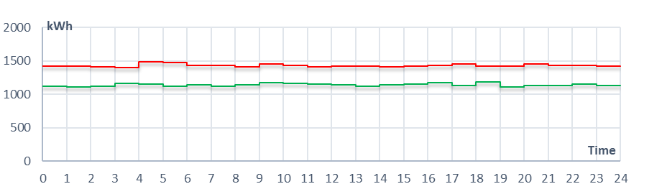
FIGURE 4. Daily electricity consumption monitoring of Wellknit (red) and Hengyi (green) circular knitting fabric technological equipment
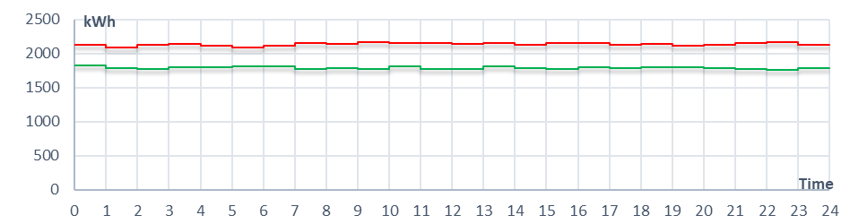
FIGURE 5. Daily electricity consumption monitoring of Orizo (red) and Huixing (green) circular knitting fabric technological equipment
Pai lung
Hanma
Welknit
Hengyi
Orizo
Huixing

To assess the energy efficiency gap between outdated and modern energy-saving technological equipment, it is necessary to develop a specific algorithm. This algorithm must evaluate the efficiency of electricity usage, consider production characteristics, and calculate relevant energy performance indicators. Based on electricity consumption scenarios, an algorithm has been developed to improve energy efficiency (see Figure 6).

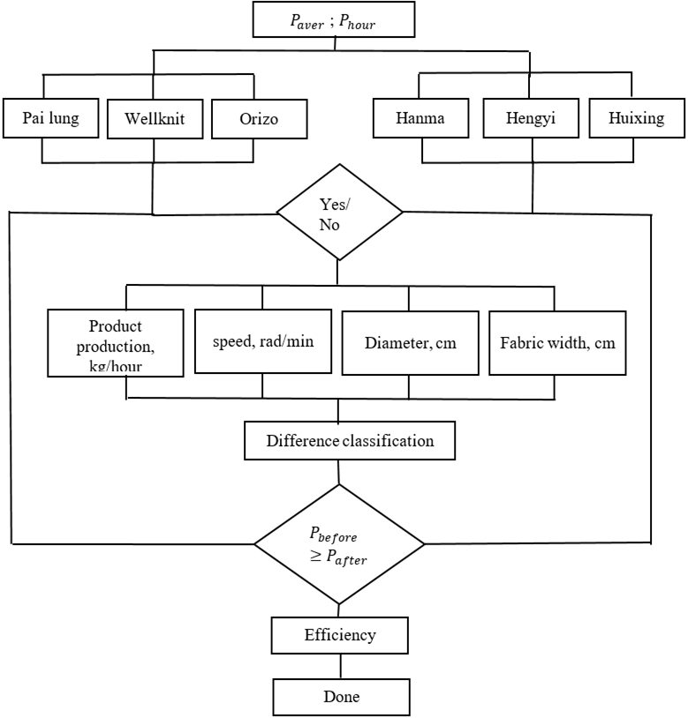
FIGURE 6. Improving energy efficiency based on the comparison between outdated and modern energy-efficient technological equipment
With the help of the proposed algorithm, it is possible to assess the potential for enhancing energy efficiency through the implementation of energy-saving technological equipment by comparing outdated and modern machines.
Using the developed algorithm, a methodology was established for implementing energy efficiency improvements in light industry enterprises of the Republic by comparing the differences between outdated and modern energy-efficient technological equipment.
CONCLUSIONS
Based on the study of electricity consumption modes tailored to the technological characteristics of each production process, opportunities for energy savings were identified and the patterns of change in energy-related parameters were analyzed. As a result, an energy-saving management technology was developed, which incorporates a set of methods and algorithms aimed at reducing the specific energy consumption per unit of produced goods.
An analysis of the current efforts to improve energy efficiency in textile industry enterprises equipped with modern energy-saving technological equipment reveals that the specific electricity consumption of outdated equipment is, on average, 41% higher than that of modern energy-efficient machines.
Experimental studies conducted at enterprises using energy-efficient technological equipment have produced the most reliable results in assessing electricity consumption indicators, as they take into account all relevant parameters observed during actual operational conditions.
REFERENCES
- F.A. Hashimov Optimizing the use of energy resources in textile industry T., 2005, 250 pages
- Hoshimov F.A, Yusupaliyeva X.U. //Analysis of energy efficiency of textile industry enterprises// Fergana Polytechnic Institute. Scientific and technical magazine 2022. Volume 26. No. 4 Page: 130-136
- Hoshimov F.A, Yusupalieva Kh.U., Kadirov I.N. Methods for forecasting electricity consumption at textile industry enterprises // Innovative Technologies 2022/3(47) issue. pp. 32-39
- N.Niyozov. Analysis of methods for forecasting electricity consumption at industrial enterprises // Journal “Problems of energy and resource conservation”. Tashkent, 2020. -№3-4.214-218 p
- F.A.Xoshimov, K.SH.Kadirov, A.P.Kushev, Kh.U.Yusupaliyeva // Technological process and laws of change of energy consumption parameters of spinning enterprises // E3S Web of Conferences 497, 01013 (2024) ICECAE 2024 https://doi.org/10.1051/e3sconf/202449701013.
- Hoshimov F.A., Kadirov K.Sh. Standardization of energy resources at enterprises processing agricultural products with modern technological equipment. – “PUBLISH HIGH FUTURE”. Tashkent. 2024 g. S. 105
- F.A.Hoshimov, K.Sh.Kadirov, H.U.Yusupalieva Standardization of energy resource consumption per unit of manufactured products in the spinning production of the textile industry // Energy and energy resources // Energy and resource saving problems 2024 y. special issue (No. 85), pp. 246-255.
- F.A.Hoshimov, K.Sh.Kadirov Possibilities of eliminating loads on the electric power system using time-based tariffs // Ministry of Higher Education, Science and Innovations of the Republic of Uzbekistan, Fergana Polytechnic Institute, Scientific and Technical Journal, Fergana-2024, Vol. 28, No. 1, pp. 178-183.
- K.Sh.Kadirov, Kh.U.Yusupalieva The state of electricity consumption in the republican power system // Scientific and technical journal of the development of science and technology // Bukhara Engineering and Technology Institute. 2024. No. 4, pp. 202-207.
- F.A.Hoshimov, K.Sh.Kadirov, H.U.Yusupalieva General problems of the power supply system reliability and energy efficiency improvement // Nukus 2024 y. pp. 6-9.
- Kh.M. Muradov, K.SH. Kadirov, APKushev, KHUYusupaliyeva // Increase efficiency at the expense of changing the working mode using time-differentiated tariffs // E3S Web of Conferences 563, 01011 (2024) ICESTE 2024 https://doi.org/10.1051/e3sconf/202456301011.
- Kh.M.Muradov, K.SH.Kadirov, A.P.Kushev Specification of the system application for the different tariffs during the consumption time of electricity by industrial enterprises // E3S Web of Conferences 304, 01006 (2021) https://doi.org/10.1051/e3sconf/202130401006 ICECAE 2021
- Kh.M.Muradov, A.J.Isakov, K.SH.Kadirov, A.P.Kushev Characteristics of application of different time rates for electricity consumed in industrial enterprises // E3S Web of Conferences 401, 05049 (2023) CONMECHYDRO – 2023, https://doi.org/10.1051/e3sconf/202340105049
- Kh.M.Muradov, A.Isakov, K.SH.Kadirov, A.P.Kushev Investments reduction on developing the generating capacity with differentiated electricity tariffs // E3S Web of Conferences 402, 05019 (2023) Trance Siberia 2023, https://doi.org/10.1051/e3sconf/202340205019
- Kh.M.Muradov, K.SH.Kadirov, A.Kushev Possibilities of applying time-classified tariffs in "smoothing" the loading graph of the electric energy system // E3S Web of Conferences 434, 01008 (2023) https://doi.org/10.1051/e3sconf/202343401008 ICECAE 2023
- Kh.M.Muradov, K.SH.Kadirov, A.P.Kushev Possibilities of managing electricity consumption through the application of time-classified tariffs // E3S Web of Conferences 434, 01009 (2023) https://doi.org/10.1051/e3sconf/202343401009 ICECAE 2023
- Kh.M.Muradov, A.J.Isakov, K.SH.Kadirov, A.P.Kushev Applying different time enterprises rates for electricity consumption industrial and its impact on the energy system // E3S Web of Conferences 452, 04004 (2023) IPFA 2023 https://doi.org/10.1051/e3sconf/202345204004

