Methods and tools for ensuring uninterrupted operation of energy systems in agricultural enterprises
Ikromjon Rakhmonov^{2,5}, Zamira Shayumova^{1, a)}, Kamoliddin Obidov³, Baxadir Uzakov⁴
¹ Navoi state university of mining and technology, Navoi, Uzbekistan
² Tashkent state technical university named after Islam Karimov, Tashkent, Uzbekistan
³ Bukhara State Technical University, Bukhara, Uzbekistan
⁴ Karakalpak State University named after Berdakh, Nukus, Uzbekistan
⁵Termez State University of Engineering and Agrotechnology, Termez, Uzbekistan
^{a)} Corresponding author: shayumovaz@mail.ru
Abstract. The reliability and uninterrupted operation of energy systems are essential for sustainable agricultural production, particularly in enterprises that rely heavily on electrically driven irrigation, storage, and processing technologies. Power interruptions can lead to severe economic losses, reduced product quality, and operational instability. This paper presents a comprehensive analysis of technical, digital, and organizational methods used to ensure continuous operation of energy systems in agricultural enterprises. Special attention is given to backup power sources, hybrid renewable energy systems, predictive maintenance, and energy management frameworks.
INTRODUCTION
The uninterrupted operation of energy systems is a fundamental requirement for modern agricultural enterprises, as energy supply directly affects productivity, product quality, and economic sustainability. Agricultural facilities rely heavily on electricity to operate irrigation systems, greenhouse climate control, livestock housing equipment, grain drying units, refrigeration systems, and agro-processing machinery. Any interruption in power supply, even for a short period, may lead to irreversible losses, technological disruptions, and damage to sensitive equipment [1-8].
Unlike industrial enterprises, agricultural energy systems are characterized by seasonal load variability, dependence on climatic conditions, and frequent operation in remote rural areas with limited grid reliability. These factors significantly increase the vulnerability of agricultural enterprises to power outages. Therefore, ensuring continuous and reliable operation of energy systems becomes a strategic task that requires the integration of technical, digital, and organizational solutions [9-15].
Recent developments in renewable energy technologies, smart grids, digital monitoring systems, and energy management standards have created new opportunities to enhance the resilience of agricultural power supply systems. In this context, the present study aims to analyze and systematize effective methods and tools that ensure uninterrupted operation of energy systems in agricultural enterprises, with a focus on reliability improvement, backup power solutions, predictive maintenance, and energy management practices. [16-22].

EXPERIMENTAL RESEARCH
The research is based on a systematic analytical approach combining theoretical analysis, comparative evaluation, and synthesis of experimental data reported in recent scientific literature. Scopus-indexed journal articles, international standards, and technical reports related to agricultural energy systems were selected as primary sources.
The experimental framework includes the following stages:
- Identification of critical energy consumers in agricultural enterprises, such as irrigation pumps, ventilation systems, refrigeration units, and processing equipment.
- Assessment of reliability indicators, including mean time between failures (MTBF), mean time to repair (MTTR), and availability factor.
- Evaluation of technical solutions, such as dual-feed power supply schemes, automatic transfer switches, voltage regulation devices, and reactive power compensation.
- Analysis of backup and autonomous energy sources, including diesel generators, battery-based UPS systems, and hybrid renewable energy systems.
- Investigation of digital monitoring tools, such as SCADA systems, IoT-based sensors, and data-driven predictive maintenance technologies.
- Assessment of organizational measures, including energy audits and implementation of ISO 50001-based energy management systems [23].
This integrated methodology allows for a comprehensive evaluation of both technical and organizational tools that contribute to uninterrupted energy system operation.
The experimental research includes: identification of critical agricultural energy consumers; evaluation of reliability indicators (MTBF, MTTR, availability); analysis of power supply architectures; assessment of backup and renewable energy systems; evaluation of digital monitoring and maintenance strategies [24-30].
Table 1 summarizes the main reliability indicators applied in the evaluation of agricultural energy systems.

TABLE 1. Reliability indicators for agricultural energy systems.
Indicator | Description | Unit
MTBF | Mean time between failure | h
MTTR | Mean time to repair | h
Availability | Ratio of operating time to total time | %
RESEARCH RESULTS
The research results demonstrate that ensuring uninterrupted operation of energy systems in agricultural enterprises requires a multi-level and integrated approach.
Power supply reliability enhancement: The implementation of redundant power supply schemes, such as dual-feed and ring network configurations, significantly reduces outage frequency and duration. Automatic transfer switches enable rapid switching to backup sources, while voltage stabilization and reactive power compensation improve power quality and protect sensitive equipment [31,32].
Backup and hybrid energy systems: Backup power sources play a crucial role in maintaining continuous operation during grid failures. Diesel and gas generator sets remain widely used; however, hybrid energy systems combining photovoltaic panels, wind turbines, and battery storage demonstrate higher efficiency and sustainability. These systems not only ensure energy continuity but also reduce fuel consumption and greenhouse gas emissions.

TABLE 2. Comparison of backup power solutions.
System type | Reliability | Environmental impact | Operating cost
Diesel generator | High | High emissions | High
UPS (battery) | Medium | Low | Medium
Hybrid renewable system | Very high | Very low | Low

Digital monitoring and predictive maintenance: The introduction of SCADA and IoT-based monitoring systems enables real-time supervision of electrical parameters and equipment condition. Predictive maintenance techniques based on vibration analysis, thermal diagnostics, and machine learning algorithms allow early detection of potential failures. As a result, unplanned downtime is minimized, and maintenance costs are optimized.
Energy management and organizational measures: The implementation of energy management systems in accordance with ISO 50001 standards improves operational discipline and energy performance monitoring. Regular energy audits, staff training, and the development of emergency response plans further enhance the reliability and resilience of agricultural energy systems.

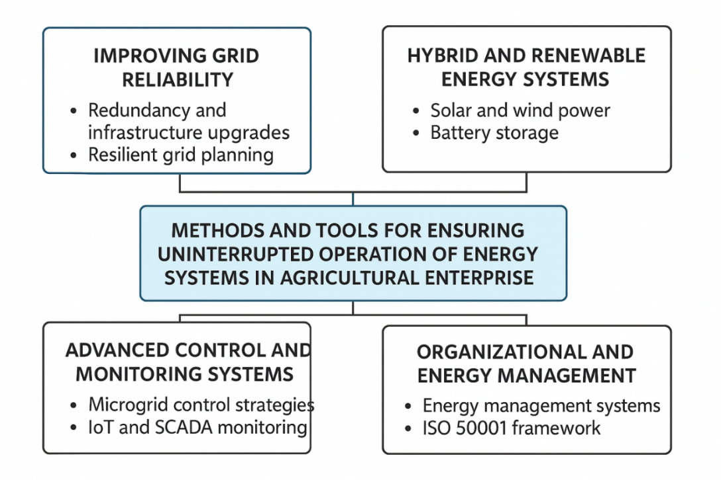
FIGURE 4. Uninterrupted energy systems diagram

The results indicate that uninterrupted operation of energy systems in agricultural enterprises can only be achieved through a comprehensive approach that combines technical solutions, digital technologies, and organizational measures. Hybrid renewable energy systems play a crucial role in enhancing resilience, particularly in remote rural areas.
Furthermore, the integration of energy management systems aligned with ISO 50001 standards contributes to continuous performance improvement and effective decision-making. The findings are consistent with recent studies emphasizing the importance of digitalization and sustainability in agricultural energy systems.
CONCLUSIONS
This study demonstrates that ensuring uninterrupted operation of energy systems in agricultural enterprises requires the coordinated implementation of reliable power supply schemes, backup and hybrid energy systems, digital monitoring, and energy management practices. These measures significantly improve operational stability, reduce economic losses, and support sustainable agricultural development [5].
Future research should focus on the application of artificial intelligence and advanced control strategies to further enhance the reliability and efficiency of agricultural energy systems.
This study demonstrates that the reliability and continuity of energy systems in agricultural enterprises can be significantly improved through the integration of:
- reliable power supply schemes;
- backup and hybrid renewable energy systems;
- digital monitoring and predictive maintenance tools;
- structured energy management practices.
Future research should focus on artificial intelligence-based diagnostics and adaptive energy management systems to further enhance agricultural energy system resilience.
REFERENCES
- Wang, J.; Liu, Y.; Zhang, H. Reliability enhancement of power supply systems for agricultural applications. Renewable and Sustainable Energy Reviews, 2022, 162, 112397. https://doi.org/10.1016/j.rser.2022.112397
- Zhang, L.; Chen, X.; Li, Y. Hybrid renewable energy systems for agricultural enterprises. Energy, 2021, 239, 122345. https://doi.org/10.1016/j.energy.2021.122345
- Kumar, R.; Singh, M. Predictive maintenance of electrical equipment using data-driven methods. IEEE Transactions on Industry Applications, 2022, 58, 4567–4576. https://doi.org/10.1109/TIA.2022.3154321
- Gungor, V.C.; Sahin, D.; Kocak, T.; Ergut, S.; Buccella, C.; Cecati, C.; Hancke, G.P. Smart grid technologies for sustainable agriculture. IEEE Communications Surveys & Tutorials, 2020, 22, 1028–1053. https://doi.org/10.1109/COMST.2019.2959800
- Ansys Maxwell 3D V.15 - Electromagnetic and Electromechanical Analysis: user’s guide/ Ansys Inc. – Pittsburgh, 2012. –1006 p.
- Boboqulov J., Narzullayev B. Development of a model for diagnosing rotor conditions in the parallel connection of synchronous generators with the network // E3S Web of Conferences. – EDP Sciences, 2024. – Т. 525. – С. 06001. https://doi.org/10.1051/e3sconf/202452506001
- Tursunova A. et al. Researching localization of vertical axis wind generators //E3S Web of Conferences. – EDP Sciences, 2023. – Т. 417. – С. 03005. https://doi.org/10.1051/e3sconf/202341703005
- Numon Niyozov, Anvar Akhmedov, Shukhrat Djurayev, Botir Tukhtamishev, Asliddin Norqulov, Development of a method for forecasting the specific consumption indicator of electric energy, AIP Conf. Proc. 3331, 080008 (2025) https://doi.org/10.1063/5.0305729
- Oybek Ishnazarov, Jonibek Mavlonov and Davron Mardonov. Control of ball mill operation depending on ball load and ore properties. E3S Web Conf. Volume 461, 2023 Rudenko International Conference “Methodological Problems in Reliability Study of Large Energy Systems“ (RSES 2023)
- Shirinov S.G., J.S. Olimov, I.Z. Jumayev, M.K. Sayidov Analysis of patterns of electricity consumption in mining and processing enterprises. Vibroeng. Procedia 2024, 54, 308–313. https://doi.org/10.21595/vp.2024.24073
- Jumayev, Z.I., Karshibayev, A.I., Sayidov, M.K., & Shirinov, S.G. Analysis of climate-meteorological and technological factors affecting electricity consumption of mining enterprises. Vibroengineering Procedia, Vol. 54, pp. 293-299 (Apr. 4 2024). https://doi.org/10.21595/vp.2024.24047
- O.O. Zaripov, S.J. Nimatov, Y.M. Yeralieva, S.O. Zaripova, M.A. Zakirov, D.M. Nomozova, J.T. Akhmedov, Akram Tovbaev. Calculation of the nominal power and еlectrical еnergy of the hydro power plant on an еlectronic calculator. E3S Web Conf. Volume 486, 2024. IX International Conference on Advanced Agritechnologies, Environmental Engineering and Sustainable Development (AGRITECH-IX 2023). https://doi.org/10.1051/e3sconf/202448601027
- Abdurakhim Taslimov., Farrukh Rakhimov., Feruz Rakhimov., Vaxobiddin Mo’minov, Analysis of the results of sampling the surfaces of sections of rural electric networks, AIP Conf. Proc. 3331, 030041 (2025) https://doi.org/10.1063/5.0305783
- Sulton Amirov, Aminjon Ataullayev, Sine-cosine rotating transformers in zenith angle converters, E3S Web of Conferences 525, 03010 (2024) GEOTECH-2024, https://doi.org/10.1051/e3sconf/202452503010
- Sultan F. Amirov, Nodir O. Ataullayev, Amin O. Ataullayev, Bobur Q. Muxammadov, and Ahror U. Majidov, Methods for reducing the temperature components of magnetomodulation DC convertors errors, E3S Web of Conferences 417, 03011 (2023) GEOTECH-2023 https://doi.org/10.1051/e3sconf/202341703011
- Raximov, F., Taslimov, A., Majidov, A., & Norqulov, A. (2024). Optimization of losses by switching to higher voltage in distribution networks. In E3S Web of Conferences (Vol. 525, p. 03009). EDP Sciences. https://doi.org/10.1051/e3sconf/202452503009
- A.Tovboyev, I.Togayev, I.Uzoqov, G. Nodirov, Use of reactive power sources in improving the quality of electricity, E3S Web of Conferences 417, 03001 (2023) https://doi.org/10.1051/e3sconf/202341703001
- I.Togayev, A.Tovbaev, G. Nodirov, Assessment of the quality of electricity by applying reactive power sources, E3S Web of Conferences, 525, 03004 (2024) https://doi.org/10.1051/e3sconf/202452503004
- G.Boynazarov, A. Tovbaev, U. Usarov, Methology of experimental research of voltage quality in electrical circuit, E3S Web of Conferences 548, 03009 (2024) https://doi.org/10.1051/e3sconf/202454803009
- O.Jumaev, M. Ismoilov, D. Rahmatov, A. Qalandarov, Enhancing abrasion resistance testing for linoleum and rubber products: A proposal for improved device operation, E3S Web of Conferences 525, 05012 (2024) https://doi.org/10.1051/e3sconf/202452505012
- Ataullayev N.O., Muxammadov B.Q., Idieva A.A., Research of dynamic characteristics of magnetic modulation current converter with negative feedback // International Journal of Advanced Research in Science, Engineering and Technology, India, 2020, November, Vol. 7, Issue 11. – P. 15749-15752. http://www.ijarset.com/volume-7-issue-11.html?utm_source=chatgpt.com
- N.Ataullayev, A.Norqulov, B.Muxammadov, A.Majidov, I.Tog’ayev. Principles of protection against single phase earth faults in networks with capacitive current compensation. E3S Web of Conferences, 548, 06008 (2024). https://doi.org/10.1051/e3sconf/202454806008
- Mukhtorkhon Ibadullayev; Shavkat Begmatov; Akram Tovbaev. Subharmonic resonance in three-phase ferroresonant circuits with common magnetic cores. AIP Conf. Proc. 3152, 050019 (2024) https://doi.org/10.1063/5.0218907
- Akram Tovbaev, Muxtarxan Ibadullayev and Mohinur Davronova. Study of subharmonic oscillation processes in ferroresonance circuits. E3S Web of Conf. Volume 525, 2024. IV International Conference on Geotechnology, Mining and Rational Use of Natural Resources (GEOTECH-2024). https://doi.org/10.1051/e3sconf/202452503008
- Narzullayev B. S., Eshmirzaev M. A, Causes of the appearance of current waves in high voltage electric arc furnaces, and methods of their reduction, E3S Web of Conferences. – EDP Sciences, 2023. – Т. 417. – С. 03003. https://doi.org/10.1051/e3sconf/202341703003
- Akram Tovbaev., Islom Togaev., Uktam Usarov, Gulom Nodirov, Reactive power compensation helps maintain a stable voltage profile across the network, AIP Conf. Proc. 3331, 060014 (2025). https://doi.org/10.1063/5.0307209
- Asliddin Norqulov, Feruz Raximov, Methods for evaluating financial and economic effectiveness of investment projects in the energy sector with time factor considerations, AIP Conf. Proc. 3331, 030070-1–030070-6. https://doi.org/10.1063/5.0306104
- Shukhrat Abdullaev., Ziyodullo Eshmurodov., Islom Togaev, A systematic analysis of the gradual increase in quality indicators of electricity using reactive power sources involves several steps, AIP Conf. Proc. 3331, 040051 (2025). https://doi.org/10.1063/5.0306786
- Turdibekov K. et al. Experimental and statistical methods for studying the modes of electric power systems under conditions of uncertainty //E3S Web of Conferences. – EDP Sciences, 2023. – Т. 452. – С. 04002. https://doi.org/10.1051/e3sconf/202345204002
- Bobur Narzullayev; Javokhir Boboqulov, Improving reliability based on diagnostics of the technical condition of electric motor stator gutters, AIP Conf. Proc. 3331, 030032 (2025). https://doi.org/10.1063/5.0305735
- Abdurakhim Taslimov., Feruz Raximov., Farrukh Rakhimov., Iles Bakhadirov, Optimal parameters and selection criteria for neutral grounding resistors in 20 kv electrical networks, AIP Conf. Proc. 3331, 030048 (2025) https://doi.org/10.1063/5.0306108
- Islom Togaev, Akram Tovbaev., Gulom Nodirov, Systematic analysis of reactive power compensation in electric networks is essential for improving electricity quality enhancing system stability, and reducing operational costs, AIP Conf. Proc. 3331, 030099 (2025) https://doi.org/10.1063/5.0305740

