Determination of amino acid composition in bryndza samples pressed and shaped using vibrational and conventional methods
Jasur Safarov^{1,a)}, Shakhnoza Sultanova^{1,2}, Qobil Mukhiddinov¹, Fakhriddin Khabibov³, Zulfiya Ergasheva¹
¹Tashkent state technical university named after Islam Karimov, Tashkent, Uzbekistan
²Deputy Mayor of Tashkent, Tashkent, Uzbekistan
³ Bukhara state technical university, Bukhara, Uzbekistan
^{a)} Corresponding author: jasursafarov@yahoo.com
Abstract. This study investigates the amino acid composition of bryndza samples produced using vibrational and conventional pressing and shaping methods. The research aims to compare how different processing techniques influence the qualitative and quantitative profiles of amino acids in the final product. Amino acids were identified and quantified using high-performance liquid chromatography (HPLC), enabling accurate separation and detection of essential and non-essential components. The obtained results provide insight into the biochemical changes occurring during vibrational versus traditional pressing and offer valuable information for improving cheese processing technologies and enhancing nutritional quality.
INTRODUCTION
Bryndza is a traditional soft cheese widely consumed in many regions and valued for its distinctive flavor, nutritional richness, and functional properties. The quality of bryndza largely depends on its production technology, particularly the pressing and shaping stages, which influence moisture content, texture formation, and biochemical composition. In recent years, innovative processing techniques such as vibrational pressing have been introduced to improve product uniformity, reduce processing time, and potentially enhance nutritional characteristics. Despite these technological advances, limited scientific data exist regarding how vibrational processing affects the amino acid profile of bryndza compared to the conventional method.
Amino acids play an essential role in determining the nutritional value and sensory attributes of cheese. They are formed through proteolytic reactions during production and ripening, and their concentrations may vary depending on processing conditions. High-performance liquid chromatography (HPLC) offers a precise analytical tool for identifying and quantifying amino acids in dairy products, enabling detailed characterization of biochemical changes. Therefore, evaluating the amino acid composition of bryndza produced under vibrational and traditional pressing conditions is crucial for understanding the influence of technological modifications on product quality and for optimizing processing strategies in cheese manufacturing.

EXPERIMENTAL RESEARCH
Amino acids are known as the building blocks of proteins and play a role in numerous biological processes within the human body. They are organic compounds essential for the body’s protein synthesis. Each amino acid has a unique structure that enables it to contribute to vital physiological functions. These structures ensure the formation of proteins according to the instructions encoded in DNA. Therefore, amino acids are crucial for the body’s growth, repair, and overall maintenance of health [1-2].
Amino acids formed as a result of protein breakdown can be utilized for various functions depending on the body’s needs. They are especially involved in essential processes such as cellular renewal, tissue repair, and hormone production. For these processes to continue in a healthy manner, the body must receive a constant supply of amino acids. A deficiency of amino acids may disrupt these pathways and lead to various health problems [3].
There are 20 amino acids present in the human body, and they are classified into two main groups: essential and non-essential amino acids. Essential amino acids cannot be synthesized by the body and therefore must be obtained from external sources, primarily through food. Non-essential amino acids, on the other hand, can be synthesized endogenously. Both groups are vital for proper bodily functions, and obtaining them through a balanced diet is of great importance [4-5].
Essential amino acids are those that cannot be produced by the body and thus must be acquired exclusively through dietary intake. These amino acids are supplied to the body through the consumption of foods such as red meat, fish, poultry, and eggs. Some essential amino acids and their functions are listed below:
Isoleucine: Essential for hemoglobin synthesis, which is the oxygen-binding molecule in red blood cells. In addition to its role in muscle metabolism, isoleucine contributes to immune system function and the maintenance of energy balance.
Histidine: Involved in the synthesis of histamine, a biologically important compound for brain function. It supports tissue repair and the production of blood cells, and plays a significant role in digestion, immune responses, sleep regulation, and reproductive functions.
Lysine: Plays an important role in immune system activity, energy metabolism, and hormone production. Lysine is essential for bone strength, muscle growth, and the regulation of enzymes and antibodies.
Leucine: One of the most abundant amino acids in proteins. It is involved in the production of growth hormones and in the growth and maintenance of muscle and bone tissues. Leucine also contributes to wound healing and the regulation of blood glucose levels, and plays a role in maintaining nitrogen balance in adults.
Methionine: Necessary for the absorption and metabolism of the mineral selenium and zinc. It actively participates in detoxification reactions, tissue metabolism, and tissue growth, thereby positively influencing skin and hair health.
Threonine: Plays a key role in immune function and lipid metabolism, and contributes to improved digestion. Threonine is a structural component of elastin, tooth enamel, and collagen, making it essential for healthy skin and teeth.
Tryptophan: Involved in serotonin synthesis and the maintenance of nitrogen balance. Through these functions, it directly influences mood regulation and sleep patterns.
Valine: Important for muscle metabolism, tissue repair, and regeneration. Valine also helps maintain mental calmness and supports concentration and cognitive focus.
Phenylalanine: Serves as a precursor for key neurotransmitters, including norepinephrine, dopamine, and epinephrine. It is also involved in the synthesis of non-essential amino acids and plays a structural role in enzymes and proteins.
Non-essential amino acids are amino acids that can be synthesized independently by the human body. These include conditionally essential amino acids. Under conditions such as trauma, stress, or disease, the body’s demand for amino acids increases. In such situations, the organism may not be able to synthesize certain amino acids in sufficient amounts. Therefore, some amino acids that are normally classified as non-essential are referred to as semi-essential or conditionally essential amino acids. These include glutamine, arginine, cysteine, tyrosine, proline, serine, and glycine. In particular, arginine is considered an essential amino acid under severe pathological conditions such as cancer and trauma.
Isolation of free amino acids: Precipitation from the aqueous extract of proteins and peptides was carried out in centrifuge tubes. For this purpose, 1 ml of the analyzed sample was mixed with 1 ml (exact volume) of 20% trichloroacetic acid (TCA). After 10 minutes, the resulting precipitate was separated by centrifugation at 8000 rpm for 15 minutes. Subsequently, 0.1 ml of the supernatant was collected and dried by lyophilization [6-7].
The hydrolysate was evaporated, and the resulting dry residue was dissolved in a triethylamine-acetonitrile-water mixture (1:7:1) and dried again. This procedure was repeated twice to neutralize residual acid. Amino acid phenylthiocarbamyl (PTC) derivatives were obtained through reaction with phenylisothiocyanate according to the method of Steven A. and Cohen Daviel [8-12].
Identification of amino acid derivatives was performed using high-performance liquid chromatography (HPLC).
High-performance liquid chromatography (HPLC) conditions:
- Chromatograph: Agilent Technologies 1200
- Detector: DAD (diode array detector)
- Column: Discovery HS C18, 75 × 4.6 mm
- Mobile phase A: 0.14 M CH₃COONa + 0.05% triethylamine (TEA), pH 6.4
- Mobile phase B: CH₃CN
- Flow rate: 1.2 ml/min
- Detection wavelength: 269 nm
Gradient program (%B/min): 1-6% / 0-2.5 min, 6-30% / 2.51-40 min, 30-60% / 40.1-45 min, 60-60% / 45.1-50 min, 60-0% / 50.1-55 min [8, 13].
RESEARCH RESULTS
Based on experimental studies, the amino acid composition of the produced brynza cheese was investigated at the Institute of Bioorganic Chemistry named after Academician A.S. Sodiqov of the Academy of Sciences of the Republic of Uzbekistan.
Table 1 presents the laboratory analysis results of amino acids in cheese samples produced using vibrational and conventional methods. Each sample was prepared for analysis according to the following scheme:

TABLE 1. Amino acid composition of brynza cheese pressed and shaped using vibrational and conventional methods
№ | Names of amino acids | Sample 1 | Sample 2 | Sample 3 | Sample 4
№ | Names of amino acids | Concentration, mg/g
1. | Aspartic acid | 0,322 | 0,398 | 0,090 | 0,049
2. | Glutamic acid | 0,189 | 0,229 | 0,050 | 0,055
3. | Serine | 0,177 | 0,094 | 0,318 | 0,284
4. | Glycine | 0,045 | 0,471 | 0,058 | 0,049
5. | Asparagine | 0,436 | 0,552 | 0,113 | 0,102
6. | Glutamine | 0,182 | 0,279 | 0,239 | 0,378
7. | Cysteine | 0,033 | 0,407 | 0,381 | 0,308
8. | Threonine | 0,277 | 0,056 | 0,066 | 0,031
9. | Arginine | 0,214 | 0,444 | 0,104 | 0,043
10. | Alanine | 0,034 | 0,018 | 0,044 | 0,019
11. | Proline | 0,119 | 0,081 | 0,073 | 0,090
12. | Tyrosine | 0,406 | 0,208 | 0,071 | 0,061
13. | Valine | 0,250 | 0,496 | 0,054 | 0,017
14. | Methionine | 0,063 | 0,041 | 0,041 | 0,029
15. | Histidine | 0,045 | 0,036 | 0,121 | 0,133
16. | Isoleucine | 0,055 | 0,074 | 0,052 | 0,031
17. | Leucine | 0,017 | 0,037 | 0,165 | 0,073
18. | Tryptophan | 0,464 | 0,893 | 0,040 | 0,111
19. | Phenylalanine | 0,422 | 0,068 | 0,097 | 0,016
20. | Lysine | 0,427 | 0,031 | 0,045 | 0,019
Total |  | 4,177 | 4,914 | 2,222 | 1,899

№ 1-cheese sample pressed and shaped by the conventional method (salted);
№ 2-cheese sample pressed and shaped under the influence of a vibrational device (salted) (ultrasound-based method proposed by the author);
№ 3-cheese sample pressed and shaped by the conventional method (unsalted);
№ 4-cheese sample pressed and shaped under the influence of a vibrational device (unsalted).
The moisture content of cheese has a direct effect on its density. The denser the cheese, the more stable its amino acid composition. Conversely, in products with a high moisture content, microbial activity intensifies, which may lead to the degradation of amino acids. When pressing is carried out using a vibrational device, the reduction of moisture content in the product is accelerated, the processing time is shortened, and conditions are created for obtaining a high-quality product, as demonstrated by sample №. 2 [14-15].
Amino acids in brynza is the most important biochemical event occurring during the production and ripening of brynza, which, through the degradation of milk proteins, contributes to the formation of peptides and free amino acids responsible for the typical aroma of brynza and its nutritional value.
From the state of the art of the introductory section, it emerges that the course of the proteolytic process, and consequently the free amino acid profile of the final product, is a function of various factors linked to the cheese processing stages, including environmental factors (such as temperature, pH, humidity) that are able to influence the enzymatic activity of the resident microflora. Subsequently, possible differences in the free amino acid profile were explored on the basis of seasonality (months of production) and altimetry (mountains, hills and plains), correlating these factors also with the sensory characteristics (e.g. taste, aroma and colour) and centesimal composition (protein, lipid, moisture and salt content) of the samples analysed [15-16].
Compared to the other samples, the content and proportion of essential amino acids showed the highest values. Table 3.10 above presents data on the concentrations of 20 different amino acids in four cheese samples. The results indicate that Sample 2, produced using the method proposed by the author, can be considered the highest-quality product, as it contains higher levels of amino acids [17].
During vibrational oscillation, a high level of interparticle friction occurs within the brynza matrix. As a result, friction between fat, protein, and water molecules increases, leading to enhanced moisture release and an increase in product density. When pressing was carried out using the vibrational device, the density reached 1.15, whereas in the case of conventional pressing, the product retained a relatively higher moisture content, reaching 52% [18].

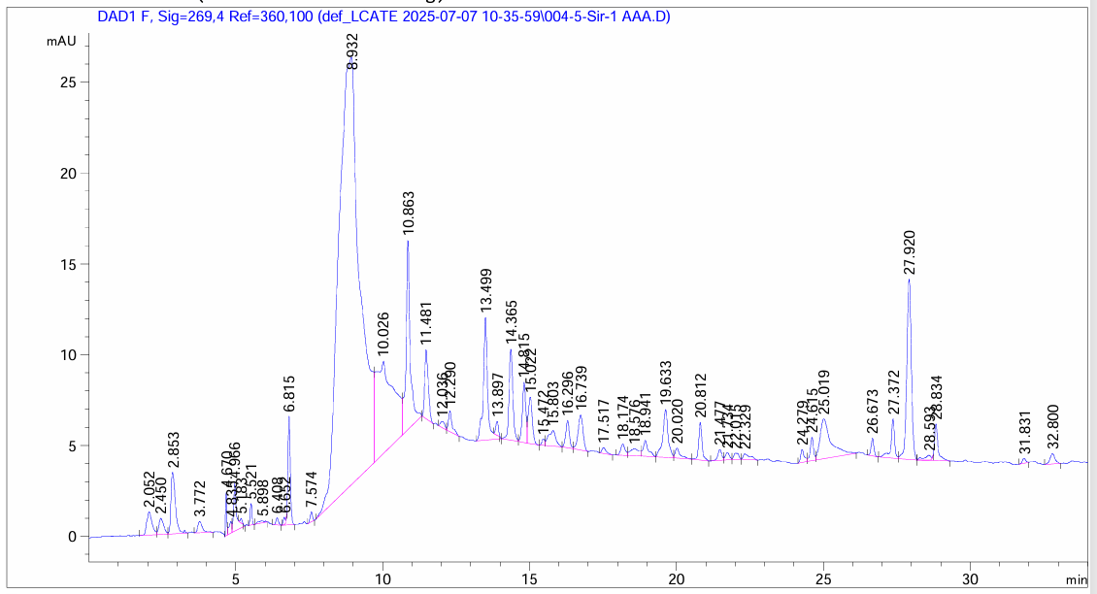
FIGURE 1. Chromatogram of the salted brynza sample pressed and shaped using the conventional method

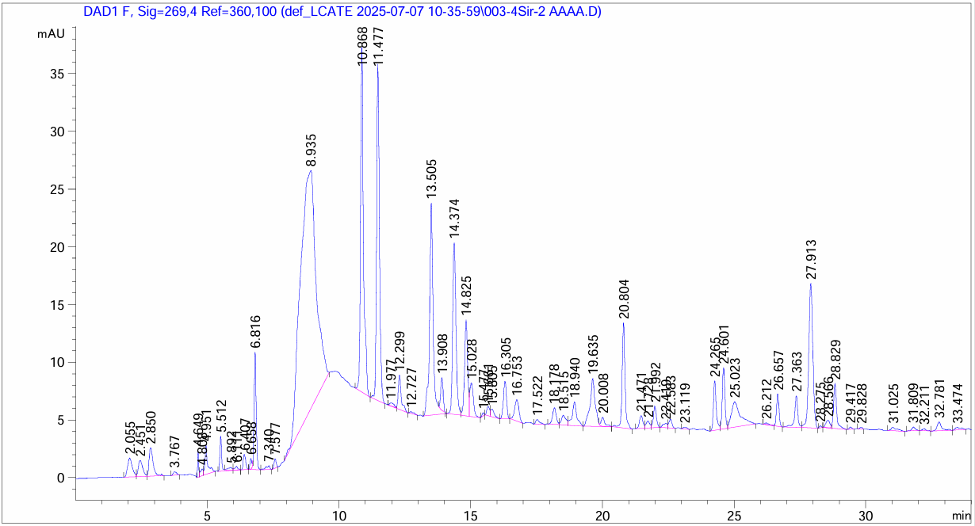
FIGURE 2. Chromatogram of the salted brynza sample pressed and shaped under the influence of a vibrational device
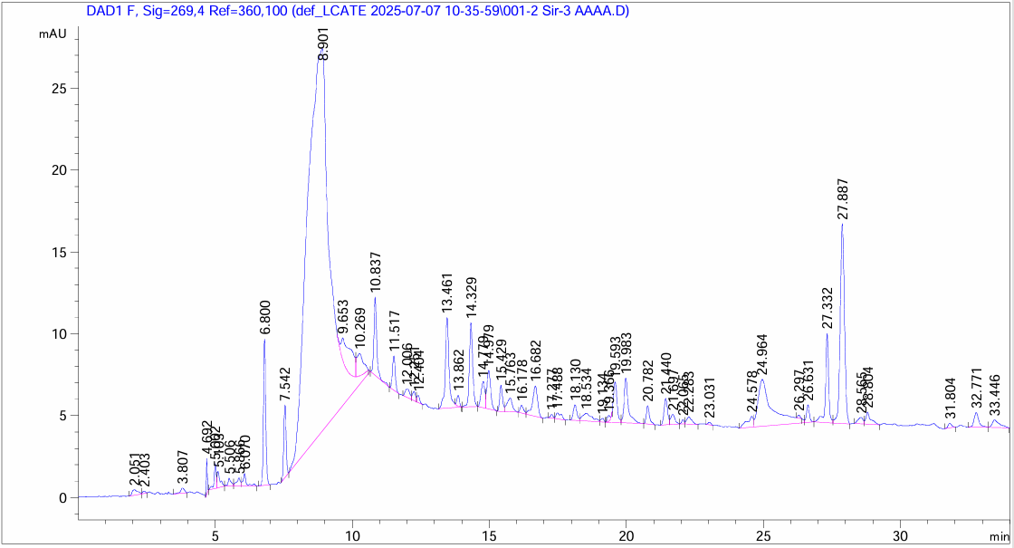
FIGURE 3. Chromatogram of the unsalted brynza sample pressed and shaped using the conventional method

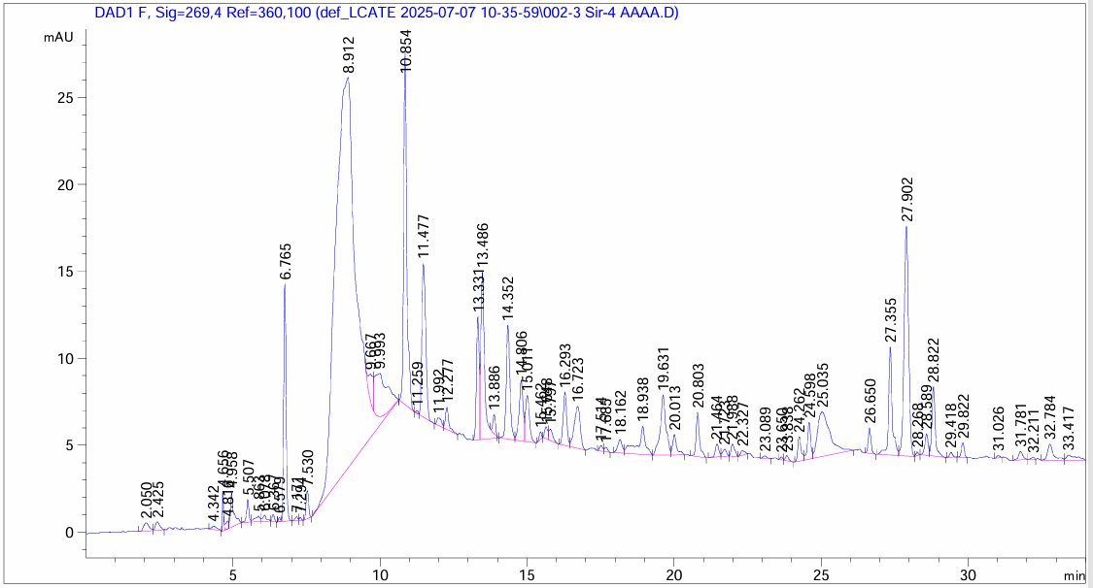
FIGURE 4. Chromatogram of the unsalted brynza sample pressed and shaped under the influence of a vibrational device

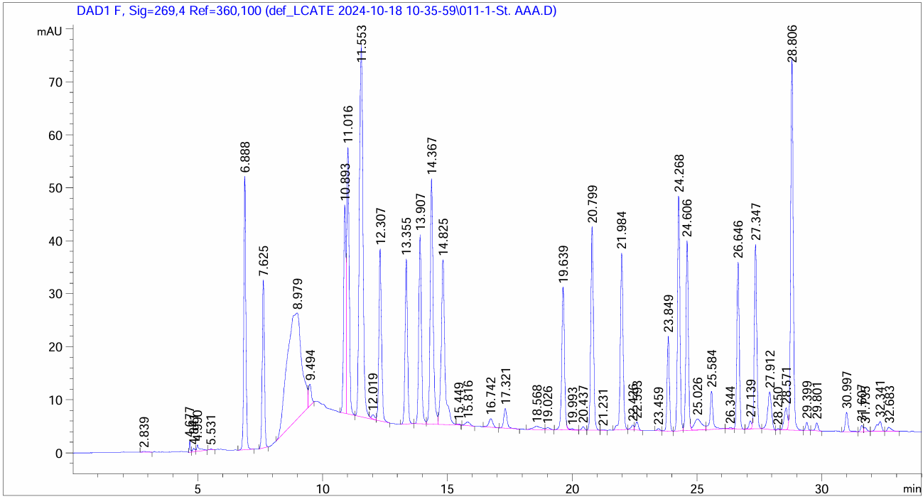
FIGURE 5. Standard chromatogram of the brynza product
The cheese pressing and shaping processes were carried out using four different sample variants. Figures 1, 2, 3, and 4 present the chromatograms of cheese samples prepared under laboratory conditions. Figure 5 shows the chromatogram of the standard cheese product. According to the results, the amino acid composition of Sample No. 2 (salted), which was pressed and shaped using a vibrational device (the method proposed by the author), is as follows: Glutamic acid-0.229, Glycine-0.471, Asparagine-0.552, Valine-0.496, Tryptophan-0.893.
The process of amino acids in brynza is influenced by different elements, especially pH and temperature in the processing stages, which are able to influence the enzymes and lactic acid bacteria involved in this proteolytic activity.
In particular, temperature affects the enzymatic action of microbial populations, especially for cooked cheeses such as Parmigiano Reggiano. In fact, after cooking, due to the high temperature and the large size of the wheel, a decreasing temperature gradient is established from the inside to the outside of the cheese mass, which has a significant effect on the intensity and specificity of proteolysis during ripening; furthermore, temperature is fundamental for activating the endogenous milk enzymes that contribute to the proteolytic process [19-20].
With regard to pH, it too affects enzyme activity, since if it is excessively acid it can lead to denaturation of the enzymes by inactivating them; in addition, it influences the viability of the lactic acid bacteria and the consequent lysis that results in the release of endogenous proteolytic enzymes and can determine a greater or lesser action of the enzymes that make up the rennet [21].
It has recently been studied in cheeses such as Cheddar, how the salt and fat content also influence the production of free amino acids; in particular, salt, by influencing the viability of the microorganisms, determines greater or lesser cell lysis and consequent release of endogenous proteolytic enzymes. In contrast, it has been observed that in the presence of a high fat content, this leads to a reduction in the proteolytic process and the formation of free amino acids [21-22].
CONCLUSIONS
The amino acid composition of brynza cheese was determined using chromatographic analysis, and a comprehensive investigation of four different brynza samples was conducted. The results clearly demonstrate that the technology developed by the author (Sample No. 2), based on vibrational pressing and shaping, provides significant advantages over the conventional methods. Chromatographic data confirmed that the concentration of amino acids in Sample No. 2 was consistently higher than in the other samples.
This improvement can be attributed to the intensified interparticle interactions and enhanced moisture removal induced by vibrational treatment, which led to increased product density and greater stability of the protein matrix. As a consequence, the preservation and accumulation of amino acids were more pronounced in the vibrationally processed brynza. Therefore, the proposed technology not only improves the physicochemical properties of the product but also enhances its nutritional value. On the basis of the obtained experimental and analytical results, it can be concluded that vibrational pressing represents an effective and scientifically justified approach for producing high-quality brynza with an improved amino acid profile.
REFERENCES
1. J.Safarov, Sh.Sultanova, Z.Ergasheva, Y.Cahyana, A.Aït-Kaddour, M.Najafli, Q.Mukhiddinov Development of dry matter content of the main components of whey // AIP Conf. Proc. 2025 y, pp. 030026-1 - 030026-5. https://doi.org/10.1063/5.0306195.
2. Safarov J.E., Sultanova Sh.A., Dadayev G.T., Samandarov D.I. Method for the primary processing of silkworm cocoons (Bombyx mori). // International Journal of Innovative Technology and Exploring Engineering (Scopus). Volume-9, Issue-1, November, 2019. Р.4562-4565. DOI: 10.35940/ijitee.A5089.119119
3. Sultanova Sh., Safarov J., Usenov A., Raxmanova T. Definitions of useful energy and temperature at the outlet of solar collectors. // E3S Web of Conferences: Rudenko International Conference “Methodological problems in reliability study of large energy systems” (RSES 2020). Vol. 216, 2020. P.1-5. doi.org/10.1051/e3sconf/202021601094.
4. Sh.Sultanova, Q.Mukhiddinov, J.Safarov, D.Alimova, A.Hassoun, M.Nasirova, Z.Ergasheva, B.Jumaev Determination of some characteristics of traditional cheese and evaluatıon of evaluated cheese to food safety // AIP Conf. Proc. 2025 y, pp. 030028-1 - 030028-7 https://doi.org/10.1063/5.0306235.
5. A.Nuraliyev, I.Jalolov, M.Peysenov, A.Adxamov, S.Rismukhamedov, R.Karimov. Improving and Increasing the Efficiency of the Industrial Gas Waste Cleaning Electrical Filter Device. AIP Conference Proceedings, 3331(1), 040040, (2025), https://doi.org/10.1063/5.0305751
6. Usenov A.B., Sultanova Sh.A., Safarov J.E., Azimov A.T. Experimental-statistic modelling of temperature dependence of solubility in the extraction of ocimum basilicum plants. // International conference AEGIS-2021 «Agricultural Engineering and Green Infrastructure Solutions». IOP Conf. Series: Earth and Environmental Science 868 (2021) 012047. P.1-5. doi:10.1088/1755-1315/868/1/012047
7. Mukhiddinov Q.A., Rakhimov A.M., Safarov Dj., A Aït-Kaddour., Sultonova Sh. Investigation of the process of molding, pressing and salting hard and soft cheeses. // IOP Conference Series: Earth and Environmental Science AEGIS 2022. C 2-10. doi.org/ 10.1088/1755-1315/1076/1/012060.
8. Matmurodov, F., Yunusov, B., Khakimov, J., Daminov, O., Gapurov, B. Mathematical Modeling and Numerical Determination of Kinetic and Power Parameters of Loaded Power Mechanisms of a Combined Machine. AIP Conference Proceedings, 2432, 040013, (2022), https://doi.org/ 10.1063/5.0090304
9. Renewable Energy and CO2 Emissions in Upper-Middle Income Transition Countries. Gulchekhra Allaeva, Gulchekhra Yusupkhodjaeva, Avazbek Sadikov, Abdusalom Umarov. International Journal of Energy Economics and Policy, 2025, 15(6), 195-201.
10. Gulchekhra Allaeva, Gulchekhra Yusupkhodjaeva, Kamola Mukhitdinova, Methodology for calculating sustainable development of fec enterprises based on consolidated integral indices. AIP Conf. Proc. 3331, 030006 (2025) https://doi.org/10.1063/5.0308133
11. Gulchekhra Yusupkhodjaeva, Gulchekhra Allaeva, Kamola Mukhitdinova, Sustainable development of transport enterprises in the context of the formation of the digital economy. AIP Conf. Proc. 3331, 030087 (2025) https://doi.org/10.1063/5.0306872
12. Kamala Mukhitdinova, Gulchekhra Yusupkhodjaeva, Gulchekhra Allaeva, Econometric modeling of investment potential of industrial enterprisess. AIP Conf. Proc. 3331, 050026 (2025) https://doi.org/10.1063/5.0308123
13. Ergasheva Z.K., Safarov J.E., Sultanova Sh.A. Mathematical modelling of inulin drying and extraction processes. 2022 E3S Web of Conferences ISSN 25550403 Doi 10.1051/e3sconf/202340103047
14. Sultanova Sh.A., Safarov J.E., Usenov A.B., Muminova D. Analysis of the design of ultrasonic electronic generators. // Journal of Physics: Conference Series. International Conference "High-tech and Innovations in Research and Manufacturing" (HIRM 2021). 2176 (2022) 012007. doi:10.1088/1742-6596/2176/1/012007
15. M.Sadullaev, E.Usmanov, R.Karimov, D.Xushvaktov, D.Xalmanov, Y.Shoyimov, D.Khimmataliev. Mathematical Models and Calculation of Elements of Developed Schemes of Contactless Devices. AIP Conference Proceedings, 3331(1), 040043, (2025), https://doi.org/10.1063/5.0305748
16. Ergasheva Z.K., Sultanov S.A., Saparov J.E. Analysis of dairy whey food functional modules based on resource-saving technologies. 2023 IOP Conference Series: Earth and Environmental Science 1231(1),012042 doi 10.1088/1755-1315/1231/1/012042
17. Mukhiddinov Q., Alimova D.K., Safarov J., Sultonova Sh., A Aït-Kaddour. Determination of Protein content in Cheese Products. // IOP Conference Series: Earth and Environmental Science. AEGIS 2021 C. 3-5. doi.org/10.1088/1755-1315/868/1/012046.
18. Zulpanov Sh.U., Samandarov D.I., Dadayev G.T., Sultonova S.A., Safarov J.E. Research of the influence of mulberry silkworm cocoon structure on drying kinetics. // IOP Conf. Series: Earth and Environmental Science (AEGIS-2022). 1076 (2022) 012059. Р.1-6. doi:10.1088/1755-1315/1076/1/012059
19. E.Yuldashev, M.Yuldasheva, A.Togayev, J.Abdullayev, R.Karimov. Energy efficiency research of conveyor transport. AIP Conference Proceedings, 3331(1), 040030, (2025), https://doi.org/10.1063/5.0305742
20. Ergasheva Z.K., Rakhmanova T.T., Abhijit Tarawade, Sultonova Sh.A., Safarov J.E. Investigation of the drying process of moist materials under convective heat input conditions. AEGIS-2022 IOP Conf. Series: Earth and Environmental Science 1076 (2022) 012058 IOP Publishing doi:10.1088/1755-1315/1076/1/012058
21. Tarawade A., Samandarov D.I., Azimov T.Dj., Sultanova Sh.A., Safarov J.E. Theoretical and experimental study of the drying process of mulberry fruits by infrared radiation. // IOP Conf. Series: Earth and Environmental Science (ETESD). 1112 (2022) 012098. P.1-9. doi:10.1088/1755-1315/1112/1/012098
22. Dadaev Gani, Sultanova Shakhnoza, Safarov Jasur, Mukhiddinov Qobiljon. Calculation of the drying process of dietary materials in solar dryers. // E3S Web of Conferences 434, 01035 (2023. doi.org/10.1051/e3sconf/202343401035.

