Mathematical modelling of water harvesting technology from atmospheric air
Jasur Safarov^{1,a)}, Shakhnoza Sultanova^{1,2}, Doston Samandarov¹, Azamat Usenov¹, Muslum Huseynli¹, Qobil Mukhiddinov¹, Shakhzod Dustqobilov¹
¹ Tashkent state technical university named after Islam Karimov, Tashkent, Uzbekistan
²Tashkent City Administration, Tashkent, Uzbekistan
^{a)} Corresponding author: jasursafarov@yahoo.com
Abstract. The aim of this study is to mathematically model the process of water harvesting using atmospheric water vapour and to evaluate the efficiency of air water generator (AWG) systems based on heat and mass transfer equations. The model analyses air flow, moisture distribution and condensation processes using computational fluid dynamics (CFD) together with the Magnus-Teten, Clausius-Clapeyron and adsorption equations. The results showed that air temperature, relative humidity, and condenser temperature strongly influence water collection capacity. CFD simulations made it possible to determine condensation zones and establish optimal operating parameters for AWG unit.
INTRODUCTION
Water is considered the most abundant resource on Earth. It covers more than 70% of the planet's surface. However, we humans, as a species, are facing a dire crisis. Climate change, global conflicts and population growth are seriously damaging water supplies in many regions of the world. A quarter of the world's population needs clean drinking water. As the world's population approaches eight billion, all attention is focused on developing technologies that will help solve this problem before it is too late. Water scarcity is not a new phenomenon, but many countries, especially in the southern hemisphere, are experiencing severe droughts and floods as a result of climate change, which is leading to the contamination of water sources [1-3].
According to the Food and Agriculture Organisation of the United Nations, more than 50% of the world's population – four billion people – experience water shortages at least once a month, and by 2025, 1.8 billion people are expected to live in completely arid countries or regions [4, 5].
According to the World Health Organisation (WHO), more than 2 billion people worldwide live with water mixed with sewage. A single sip of water can infect them with diseases such as cholera and typhoid fever, resulting in approximately 500,000 deaths each year. Energy efficiency is a way to obtain clean water without the need for traditional water infrastructure, making it an attractive option in remote areas [6-8].
According to a report by Global Market Insights, the atmospheric water production market, estimated at $3.4 billion in 2022, is expected to reach $13.5 billion by 2032. There are two main methods of obtaining atmospheric water. The first is condensation cooling, in which humid air is converted into water droplets. The second is a system in which hygroscopic materials absorb moisture from the air, and the absorbed moisture is converted into water by heating [9-11].
MATERIALS AND METHODS
An air water generator (AWG) is a system that collects water vapour from the air through condensation or adsorption/absorption and converts it into drinking water. The efficiency of this technology depends on the amount of moisture in the atmosphere and the air temperature. For example, in areas with an air temperature of 30-40 °C and relative humidity of 40–80 %, these devices work very efficiently [12].
Water vapour is present in the air, and to convert it into a liquid state, the vapour must be cooled below the dew point [13-16].
The main stages of the process of obtaining water from air:
• air intake – the device draws in air using a fan;
• cooling (condensation) – the air is cooled to 10-15 °C using a cooler or Peltier element;
• vapour condensation – water vapour in the air is converted into liquid water;
• filtration and mineralisation – water passes through a filter and mineral additives to improve its drinking quality.
Calculation model (analytical analysis). If the air temperature $T_{a}$ and relative humidity φ are known, the amount of water in the air is determined as follows [17-24]:
$ρ_{v}=ϕ∙\frac{6.112∙e^{\frac{17.62{∙T}_{a}}{243.12+T_{a}}}∙2.1674}{273.15+T_{a}}$ (1)
here $ρ_{v}$ is water vapor density in the air (g/m³).
When the condenser temperature is $T_{с}$, the maximum water density when the air is cooled to:
$ρ_{v,sat}(T_{с})$ (2)
Amount of condensate (i.e., water to be collected):
$m_{cond}=ρ_{v}-ρ_{v,sat}(T_{с})$ (3)
Sample calculation: $T_{a}=35$℃; $ϕ=0.4$; $T_{с}=12$℃; $ρ_{v}≈15.1$g/m³; $ρ_{v,sat}(T_{с})≈10.7$ g/m³;
$Condensat≈4.4 1$g/m³.
This means that 4.4 grams of water can be extracted from each cubic meter of air.
TABLE 1. Factors affecting efficiency
Factor | Effect | Note
Air temperature | When T+, humidity increases. | At 40 °C, the amount of water is 2-3 times higher.
Relative humidity | Efficiency is high at 50-80%. | It is very difficult to obtain water in dry weather (<30%)
Condenser temperature | The lower it is, the more water there is. | However, energy consumption increases
Air flow rate | A balance is needed. | At a very low speed, there will be insufficient air, and condensation will not take place very quickly.
Unit surface | A large area means a large body of water. | If the capacitor area is 10 m², the efficiency is much higher.

Types of water intake [21].
1. Condensation (based on cooling):
• cooling the air using a compressor and condenser;
• internal temperature ≈10-15 °C;
• effective, but energy-intensive (0.3-0.5 kWh/liter).
2. Adsorption (silica gel/zeolite):
• absorbs moisture at night and collects water during the day, releasing it under the influence of solar heat;
• no electricity required, but quiet.
3. Hybrid systems:
• condensation + acceleration of vapour droplets using ultrasound or vibration;
CFD models are used to optimise such systems.
TABLE 2. CFD (Computational Fluid Dynamics) Parameters used in modeling
Parameters | Designation | Range | Note
Air temperature | $$T_{air}$$ | 30-45 °C | Incoming air
Relative humidity | $$ϕ$$ | 30-80% | Atmospheric conditions
Air velocity | $$v$$ | 1-5 м/с | Fan flow rate
Capacitor temperature | $$T_{с}$$ | 10-15 °C | Cooling panel
Condensation of velocity | $$\dot{m}$$ | г/м²·с | CFD results
Moisture diffusion | $$D$$ | 2.6×10⁻⁵ м²/с | Mass transfer coefficient
TABLE 3. Energy efficiency
Equipment type | Energy consumption (kWh/liter) | Note
Condensation (compressor) | 0.3-0.6 | Requires electricity
Elemental coat | 0.6-1.0 | For small unit
Solar hybrid (sun + adsorption) | 0.05-0.2 | Effective on sunny days
Ultrasound system | 0.1-0.3 | Innovative type

TABLE 4. Dependence of unit efficiency on weather conditions
Temperature (°C) | Relative moisture (%) | Water intake from 1 m³ of air (g)
20 | 40 | 5-6
25 | 60 | 15-20
30 | 80 | 25-35

For example, at an ambient temperature of 30 °C and relative humidity of 80%, a 1-tonne atmospheric water harvesting unit can produce approximately 200-300 liters of condensed water per day.
CFD (computational fluid dynamics) modelling was performed to visualise the physical behaviour of air flow and moisture condensation processes.
Ambient air temperature range considered:
• 20-30 °C (typical operating conditions);
• 30-45 °C (arid and desert climatic conditions).
Relative humidity levels investigated:
• 40%, 60% and 80%;
• higher relative humidity directly increases condensation efficiency.
Air flow velocities analysed (m/s):
• 0.5 m/s (low flow);
• 1-2 m/s (moderate flow conditions);
• 3-5 m/s (typical for high-power systems);
Condenser surface temperature:
• maintained in the range of 10-15 °C.
Modelling results include:
• air flow direction represented by vector fields;
• temperature gradients illustrating heat transfer distribution;
• moisture condensation areas defined by isosurfaces or droplet formation zones.
RESULTS AND DISCUSSION
If the air temperature range is: 30-45 °C (desert/dry conditions), relative humidity (%): 40% (high humidity - high condensation efficiency), air velocity (m/s): 1-2 m/s (average speed), cooling surface temperature (condenser): 10-15 °C.
Absolute humidity (g/m³) was calculated using the Magnus-Tetens formula. Steam in excess of saturation for the capacitor surface was taken as "condensate," i.e. [25]:
$Condensate (g/m³)=max(0, ρ_{v,inlet}-ρ_{v,sat}(T_{cond}))$ (4)
Calculations were performed for the conditions $T_{in}=30-45$ °C (integer), RH=40%, $T_{cond}=10, 12, 15$ °C. Transition to airflow for integration:
$m³/day=velocity (m/s)×intake_area (m²)×86400$ s/day.
In this research work, two typical $intake_areas$ were adopted: $small=0.1$ m² (mobile), $large=1.0$ m² (kilovatt or industrial module).
When the condensate (g/m³):
$T_{in}\left(RH=40\%\right)$ (5)
• at 10 °C, from each m³ of air in the range of 30–45 °C, ≈2.7→16.7 g/m³ can be obtained (varies depending on whether it is 30 °C or 45 °C);
• when the condenser is at 12 °C and 15 °C, the quantity decreases respectively (in cases where $T_{cond}$ is lower, efficiency is observed to be higher).
Figure 1 shows a decrease in the temperature gradient in the air flow from 45 °C to 30 °C. It was found that as the air approaches the condenser surface, the temperature drops rapidly and the condensation process is activated. The increase in the gradient reflects intense heat exchange and the beginning of water droplet formation.
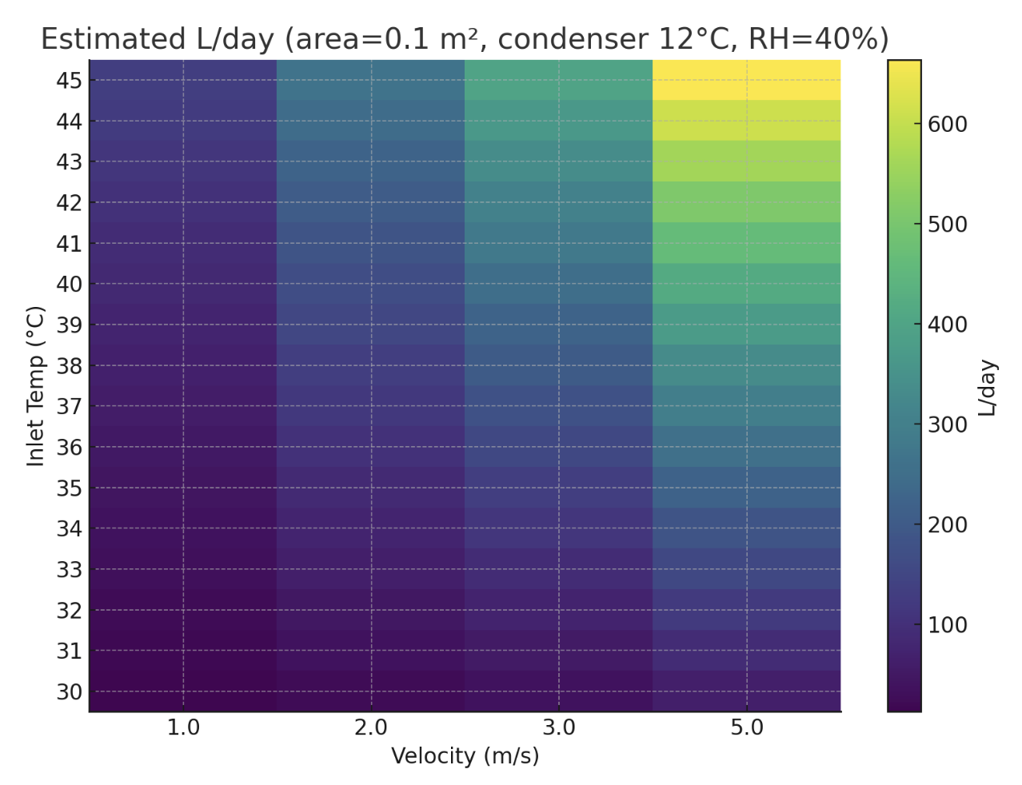
FIGURE 1. Temperature gradient (heat distribution)

Liter/day examples (area=0.1 m² and 1.0 m²):
In this case, under conditions of area=0.1 m², $v=1$ m/s, $T_{in}=35$ °C, $T_{cond}=12$ °C;
We obtain:
$m^{3}/day ≈1.0×0.1×86400≈8640$ m³/day.
• condensate ≈ 7.78 g/m³ ($T_{in}=35$, $RH 40\%$, $T_{cond}=12$ °C).
Including:
$L/day≈7.78×8640/1000≈67.2$ L/day.
With a large size (area=1.0 m²) and v=3-5 m/s, it is possible to obtain examples from several hundred liters/day to several thousand liters/day (the graph is given in the form of a "heatmap") [26].
Figure 2 illustrates the spatial variation of temperature as air moves within the range of 30-45 °C. As the air approaches the condenser, the heat flow decreases and the cold zone expands. This indicates a reduction in turbulence and an increase in condensation efficiency. The directed airflow ensures energy-efficient operation of the AWG system.
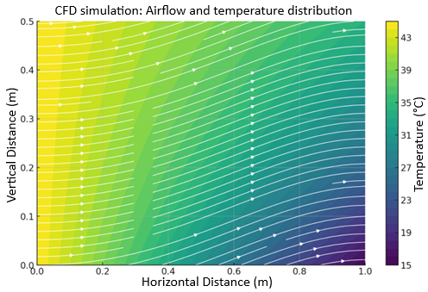
FIGURE 2. Airflow and temperature distribution (decrease from 45 °C to 30 °C)

Figure 3 shows a local increase in air humidity to values above 40%. This is due to the vapour approaching saturation in the condenser area and an increased likelihood of droplet formation. The humidity gradient precisely determines the intensification of mass transfer and the optimal zone for water accumulation.
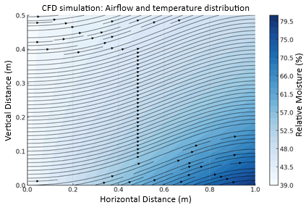
FIGURE 3. Moisture distribution (increases above 40%, i.e., increases the probability of condensation)

Figure 4 shows a three-dimensional model of multidimensional temperature dynamics during air movement. Hot air has a high value at the inlet and cools rapidly in the condenser zone. The spatially uniform temperature drop confirms the correctness of the AWG device geometry and the conformity of the heat transfer model to real conditions.
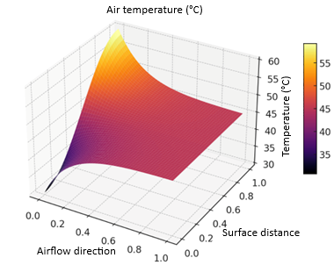
FIGURE 4. CFD simulation results in 3D format: changes in air temperature (between 30-45°C)

Figure 5 shows the distribution of moisture in the air flow in volumetric format. A sharp decrease in moisture concentration near the condenser indicates the activity of the process of converting vapour into droplets. The movement of moisture from the upper points to the lower zone indicates stable operation of the mass transfer mechanism.
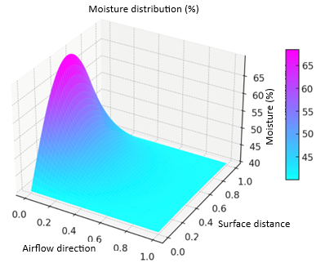
FIGURE 5. CFD simulation results in 3D format: moisture distribution (%)

The overall results show that the relationship between the temperature gradient, moisture distribution, and air flow determines the water consumption efficiency of the AWG system. CFD analysis made it possible to identify condensation zones and select the optimal cooling temperature and air flow velocity. The developed model provides a solid foundation for the energy-efficient design of the AWG unit [27-29].
CONCLUSIONS
The technology of extracting water from the air has become an effective tool in combating the global problem of water scarcity. The use of this technology, with its increased energy efficiency, operational reliability and convenience, is highly relevant. Thanks to the creation of new materials and designs that take into account the impact on the environment, as well as the implementation of measures to support this technology, the technology of obtaining water from the air can become a reliable source of water for millions of people living in regions of the world experiencing water shortages.
REFERENCES
1. Alenezi A., Jung H.H., Alabaiadly Y. Experimental and Numerical Analysis of an Atmospheric Water Harvester Using a Thermoelectric Cooler. Atmosphere (2023) 14(2): 276. https://doi.10.3390/atmos14020276
2. Safarov J., Khujakulov A., Sultanova Sh., Khujakulov U., Sunil Verma. Research on energy efficient kinetics of drying raw material. // E3S Web of Conferences: RSES (2020) 216: 1–5. https://doi.org/10.1051/e3sconf/202021601093
3. Kim H., Rao S.R., Kapustin E.A., Zhao L., Yang S., Yaghi O.M., Wang E.N. Adsorption-based atmospheric water harvesting device for arid climates. Nature communications (2018) 9(1): 1–8. https://doi.10.1038/s41467-018-03162-7
4. Ajiwiguna T.A. et al. Design, simulation, and optimization of portable atmospheric water generator using vapor compression refrigeration system. Journal of Physics Conference Series (2023) 2673(1): 012001. https://doi.10.1088/1742-6596/2673/1/012001
5. Ishmuradov Sh., Hamroev R. Disc rotary plough for agriculture mechanization. E3S Web of Conferences (2024) 548: 08017. https://doi:10.1051/e3sconf/202454808017.
6. Elashmawy M., Alshammari F. Atmospheric water harvesting from low humid regions using tubular solar still powered by a parabolic concentrator system. Journal of Cleaner Production (2020) 256: 120329. https://doi.10.1016/j.jclepro.2020.120329
7. Aravind K. Investigation of the technological advancements and future prospects of atmospheric water generator systems. Journal of Student Research (2023) 12(3): 195.
8. Rismaya R., Pramudantoro T.P., Khakim N. Analysis of the effect of different temperature settings on condensate water production in mini freezer pre-coolers. Prosiding Industrial Research Workshop and National Seminar (2023) 14(1): 453–457.
9. Sultanova Sh., Safarov J., Usenov A., Raxmanova T. Definitions of useful energy and temperature at the outlet of solar collectors. E3S Web of Conferences: Rudenko International Conference. Methodological problems in reliability study of large energy systems (2020) 216: 1–5. doi.org/10.1051/e3sconf/202021601094
10. Muratçobanoğlu B., Mandev E., Ceviz M.A., Manay E., Afshari F., CFD Simulation and Experimental Analysis of Cooling Performance for Thermoelectric Cooler with Liquid Cooling Heat Sink. Journal of Thermal Analysis and Calorimetry (2024) 149(1): 359–377. https://doi.10.1007/s10973-023-12415-w
11. Alhurmuzi M. et al. Investigation of silica gel performance on potable water harvesting from ambient air using a rotatable apparatus with a solar tracking system. Desalination and Water Treatment (2023) 304: 12–24. https://doi.10.5004/dwt.2023.32772
12. Saparov Dj.E., Sultonova S.A., Guven E.С., Samandarov D.I., Rakhimov A.M. Theoretical study of characteristics and mathematical model of convective drying of foods. RSES 2023. E3S Web of Conferences (2023) 461 (01057): 1–5. https://doi.org/10.1051/e3sconf/202346101057
13. Shan H., Li C.,Chen Z. et al. Exceptionalwaterproductionyieldenabled by batch-processed portable water harvester in semi-arid climate. Nat Commun. (2022) 13(1): 5406. https://doi.10.1038/s41467-022-33147-9
14. Kandeal A.W., Joseph A., Elsharkawy M., Elkadeem M.R., Hamada M.A., Khalil A., Moustapha M.E., Sharshir S.W. Research progress on recent technologies of water harvesting from atmospheric air: A detailed review. Sustainable Energy Technologies and Assessments (2022) 52: 102000. https://doi.10.1016/j.seta.2022.102000
15. Ishmuratov K., Abduraxmanov A. Justifications of chain drive efficiency. AIP Conference Proceedings (2024) 3184 (1): 020002. https://doi:10.1063/5.0212156
16. Ali A.S.M., Hegab H.M., Almarzooqi F., Jaoude M.A., Hasan S., Banat F. Carbon composites for efficient solar-driven atmospheric water harvesting. Journal of Environmental Chemical Engineering (2024) 12(5): 113319. https://doi.10.1016/j.jece.2024.113319
17. Tarawade A., Samandarov D.I., Azimov T.Dj., Sultanova Sh.A., Safarov J.E. Theoretical and experimental study of the drying process of mulberry fruits by infrared radiation. IOP Conf. Series: Earth and Environmental Science (2022) 1112 (012098): 1–9. https://doi:10.1088/1755-1315/1112/1/012098
18. Runze D., Qingfen M., Hui L., Gaoping W., Wei Y., Guangfu C., Yifan C. Experimental investigations on a portable atmospheric water generator for maritime rescue. Journal of Water Reuse and Desalination (2020) 10(1): 30–44. https://doi:10.2166/wrd.2020.048
19. Kobilov N., Khamidov B., Rakhmatov K., Daminov O., Ganieva S., Shukurov A., Kodirov S., Omonov S. Development of effective chemicals for drilling fluid based on local and raw materials of Uzbekistan. AIP Conference Proceedings (2025) 3304: 040077. https://doi.org/10.1063/5.0269403
20. Liu S., He W., Hu D., Lv S., Chen D., Wu X., Xu F., Li S. Experimental analysis of a portable atmospheric water generator by thermoelectric cooling method. Energy Procedia (2017) 142: 1609-1614. https://doi.org/10.1016/j.egypro.2017.12.538
21. Kumar P.M., Arunthathi S., Prasanth S.J., Aswin T., Antony A.A., Daniel D., Babu P.N. Investigation on a desiccant based solar water recuperator for generating water from atmospheric air. Materials Today: Proceedings (2021) 45: 7881–7884. https://doi.org/10.1016/j.matpr.2020.12.506
22. Gulchekhra Allaeva, Fiscal instruments of taxation improvement as a factor of sustainable development of enterprises of the fuel and energy sector. In E3S Web of Conferences 216, 01173 (2020) https://doi.org/10.1051/e3sconf/202021601173
23. Gulchekhra Allaeva, Priority directions of development “Uzbekneftegas” jsc in the conditions of globalization of the world economy. In E3S Web of Conferences 139, 01008 (2019) https://doi.org/10.1051/e3sconf/201913901008
24. Ravshan Xusainov, Otabek Begmullaev, Problems of ensuring the electricity supply system in Uzbekistan. In AIP Conference Proceedings. 3331, 030002 (2025) https://doi.org/10.1063/5.0305927
25. Safarov J., Sultanova Sh., Dadayev G.T., Zulponov Sh.U. Influence of the structure of coolant flows on the temperature profile by phases in a water heating dryer. IOP Conf. Series: Materials Science and Engineering. Dynamics of Technical Systems (2021) 1029 (012019): 1–11. https://doi:10.1088/1757-899X/1029/1/012019
26. Ahamed P.U. et al. Performance analysis of atmospheric water extraction by refrigerator cum air conditioner. International Journal of Advanced Research in Science, Communication and Technology (IJARSCT) (2023) 3(3): 318–339. https://doi:10.48175/IJARSCT-14341
27. Sadullaev M., Usmanov E., Karimov R., Xushvaktov D., Xalmanov D., Shoyimov Y., Khimmataliev D. Mathematical models and calculation of elements of developed schemes of contactless devices. AIP Conference Proceedings (2025) 3331(1): 040043. https://doi.org/10.1063/5.0305748
28. Djafar Z., Arman A.A., Sakka A., Mustofa M.F., Klara S., Rauf N., Piarah W.H. Atmospheric water harvesting using thermoelectric cooling technology. International Journal of Design & Nature and Ecodynamics (2023) 18(4): 1011–1016. https://doi.org/10.18280/ijdne.180430
29. Sultanova Sh.A., Artikov A.A., Masharipova Z.A., Abhijit Tarawade, Safarov J.E. Results of experiments conducted in a helio water heating convective drying plant. International conference AEGIS-2021 «Agricultural Engineering and Green Infrastructure Solutions». IOP Conf. Series: Earth and Environmental Science (2021) 868 (012045): 1–6. doi:10.1088/1755-1315/868/1/012045

