Mathematical modelling of the heat transfer process in a drying unit
Jasur Safarov^{1,a)}, Shakhnoza Sultanova^{1,2}, Doston Samandarov¹, Azamat Usenov¹, Mavluda Nasirova¹, Abdurakhmon Mirkomilov³, Javohir Eshmamatov¹, Dilnoza Dushanova¹
¹Tashkent state technical university named after Islam Karimov, Tashkent, Uzbekistan
²Tashkent City Administration, Tashkent, Uzbekistan
³Tashkent institute of chemical technology, Tashkent, Uzbekistan
^{a)} Corresponding author: jasursafarov@yahoo.com
Abstract. This study theoretically examines the convective drying process of pumpkin products under different operational conditions, including air velocities of 0.5, 0.7, and 1.0 m/s, temperatures of 45, 55, and 65 °C, and initial moisture levels of 40%, 60%, and 80%. Regression analysis is applied to theoretical drying data to evaluate statistical indicators such as R², χ², and SE, enabling the identification of the most suitable mathematical model for describing the convective drying behavior. The results show that the Midilli model provides the most stable and accurate fit across all examined moisture conditions, demonstrating higher R² values and lower χ² and SE indices. Based on these findings, scientific recommendations are proposed for applying the Midilli model to optimize the drying efficiency of pumpkin products in convective systems.
INTRODUCTION
Diffusion process is important in food drying. Ambient velocity, temperature and humidity are interrelated with the diffusion coefficient. In general, when we analyzed pumpkin drying, we observed the change of temperature per unit of time and the change of humidity per unit of time. We turned to mathematical modeling to analyze experiments, express relationships and reveal the essence of the process. As we know, a mathematical model is an abstract model used to mathematically explain a system that explains a certain phenomenon and process through mathematical formulas and relationships [1-3].
Research works have been carried out to obtain theoretical parameters for drying pumpkin products. Air velocity (0,5 m/s, 0,7 m/s, 1.0 m/s), drying air temperature (45 °C, 55 °C, 65 °C) and product relative humidity (40%, 60% and 80%) were taken from the variables in the calculations. In this application, the drying conditions were considered constant and the analyses were performed numerically. In the analyses performed for different drying air velocities, the drying temperature was assumed to be 55 °C [4-6].
MATERIALS AND METHODS
To theoretically analyze the convective drying of pumpkin and select the most adequate model describing the change in moisture content over time, five commonly used thin-layer drying models were used: the Lewis, Henderson, and Pabis models, the two-term model, the Wang and Singh models, and Midilli model. The equations for these models are presented in Table 1 [7-12].
here W is the humidity coefficient; k, k₀, k1 are the drying constant; b is the coefficients; n is the drying constant.
To test the adequacy of the models to the experimental data and to determine the optimal parameters of the drying process, the Statistika 6.0 program was used. Using this program, the main statistical indicators were calculated: drying coefficients (a, b, k, k₀, k₁, n), the determination coefficient (R²), the standard error (SE), and the χ² (chi-square) criterion using formulas (1) and (2) [13-15].
TABLE 1. Constants and coefficients of drying models
№ | Model names | Equation
1 | Lewis | $$W=exp(-kt)$$
2 | Henderson and Pabis | $$W=aexp(-kt)$$
3 | Binominal Model | $$W=aexp\left(-k_{0}t\right)+bexp\left(-k_{1}t\right)$$
4 | Wang and Singh | $$W=1+at+bt^{2}$$
5 | Midilli | $$W=aexp(-kt^{n})+bt$$

$SE=\sqrt{\frac{\sum_{i=1}^{N}{{\left(W_{exp.}-W_{calc.}\right)}^{2}}}{N-z}}$ (1)
${}^{2}=\frac{\sum_{i=1}^{N}{{\left(W_{exp.}-W_{calc.}\right)}^{2}}}{N-z}$ (2)
here is the dimensionless humidity coefficient obtained as a result of experiments $W_{exp.}$ and $W_{calc.}$ and estimated using the program. $N$ is the number of data read in the experiment depending on time and $z$ is the number of coefficients.
When selecting the most suitable model, the following criteria were taken into account: the value of the coefficient of determination $R^{2}$ should be as close to 1 as possible, and the values of $SE$ and ${}^{2}$ should be minimal, close to 0. These indicators allow us to assess the degree of conformity of the model with the experimental data and select the model that most accurately describes the convective drying process [16-18].
$R^{2}=\frac{\sum_{i=1}^{N}{{\left(W_{exp.}-W_{calc.}\right)}^{2}}}{\sum_{i=1}^{N}{{\left(W_{exp.}-{\overline{W}}_{exp.}\right)}^{2}}}$ (3)
Thus, the obtained data were processed using regression analysis methods with $R^{2}$, ${}^{2}$ and $SE$ indicators. Based on these, the most adequate model was selected, which accurately describes the convective drying process [19-27].
RESULTS AND DISCUSSION
Figure 1 shows the relationship between drying air velocity and drying time. Figure 2 shows the change in internal product temperature over time at different drying air velocities. It was observed that the temperature in the centre of the product increased with increasing air velocity and the amount of moisture decreased with time.

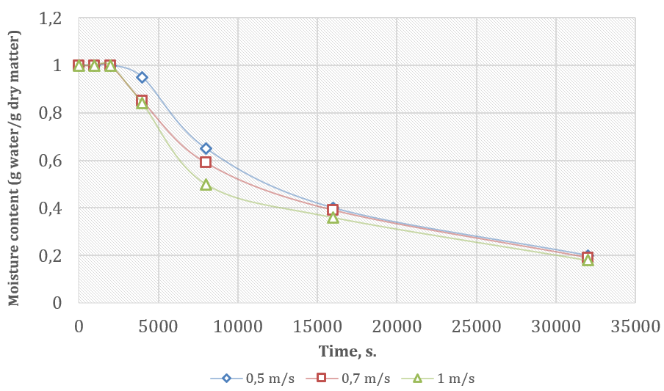 | 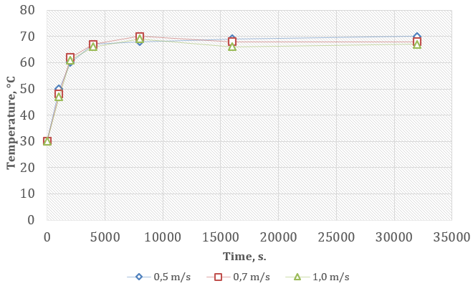
FIGURE 1. Dimensionless moisture change with time at different drying air speeds | FIGURE 2. Variation of product internal temperature over time at different drying air speeds

In the analyzes conducted for different drying air temperatures, the drying air velocity was assumed to be 1.0 m/s. Fig. 3 shows the variation of dimensionless product moisture with time at different drying air temperatures.
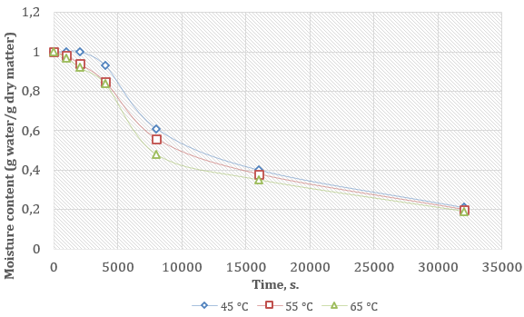
FIGURE 3. Changes in moisture content with time at different drying temperatures

Figure 4 shows the variation of temperature inside the product with time at different drying air temperatures. As the air temperature increases, the temperature in the center of the product increases over time, while the moisture content decreases. In the analyses performed for different values of product moisture content, the drying air velocity is 1 m/s and the temperature is 55 °C.
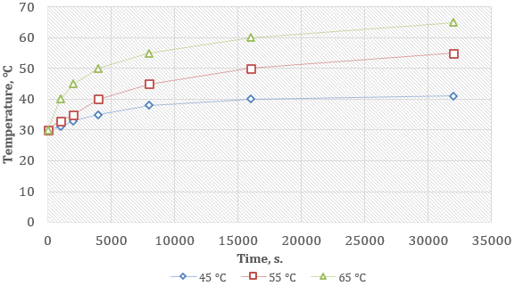
FIGURE 4. Variation of product temperature with time at different drying temperatures

Figure 5 shows the change in product moisture content over time in materials with different initial product moisture contents.
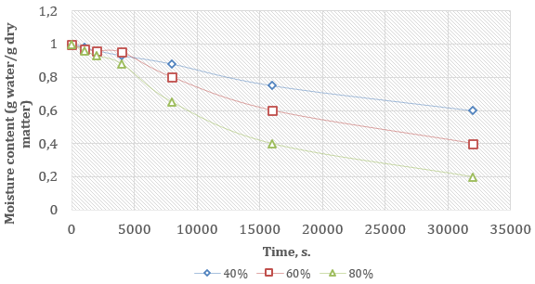
FIGURE 5. Moisture change over time in material with different values of initial product moisture

Figure 6 shows the variation of temperature inside the product over time in material with different initial product moisture content. It was observed that the temperature in the centre of the product did not change with time, while the moisture content decreased with increasing initial product moisture content.
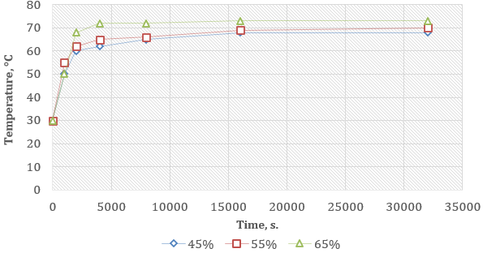
FIGURE 6. Internal temperature variation over time in materials with different initial product moisture contents

In addition, dimensionless moisture data obtained from different parameters were put into drying models and coefficients obtained by regression method were found [28]. The velocity data of 0,5 m/s, 0,7 m/s, 1.0 m/s are placed in drying models and the results are summarised in Tables 2-10. The constants obtained for 0.5 m/s velocity, R², SE and χ² values of 0.99, 0.0170 and 0.0003 are given in Table 2 respectively.

TABLE 2. Values of statistical parameters of drying models at 0.5 m/s
Model/ Coefficient | a | b | k | k₀ | k₁ | n | R² | SE | χ²
Lewis |  |  | 2,40×10⁻⁵ |  |  |  | 0,97 | 0,0592 | 0,0035
Henderson and Pabis | 1,053 |  | 2,62×10⁻⁵ |  |  |  | 0,98 | 0,0499 | 0,0025
Two-member model | 0,529 | 0,523 |  | 2,62×10⁻⁵ | 2,62×10⁻⁵ |  | 0,97 | 0,0590 | 0,0035
Wang and Singh | –2,02×10⁻⁵ | 9,49×10⁻¹¹ |  |  |  |  | 0,99 | 0,0360 | 0,0009
Midilli | 1,001 | –3,23×10⁻⁹ | 3,45×10⁻⁷ |  |  | 1,41 | 0,99 | 0,0170 | 0,0003
a, b, k, k₀, k₁, n- drying coefficients.

The constants, values of R², CO and x² obtained for a velocity of 0.7 m/s are given in Table 3, 0.99, 0.0127 and 0.0002 respectively.
TABLE 3. Values of statistical parameters of drying models for 0.7 m/s
Model/ Coefficient | a | b | k | k₀ | k₁ | n | R² | SE | χ²
Lewis |  |  | 2,58×10⁻⁵ |  |  |  | 0,98 | 0,0545 | 0,0030
Henderson and Pabis | 1,056 |  | 2,83×10⁻⁵ |  |  |  | 0,98 | 0,0421 | 0,0018
Two-member model | 0,531 | 0,524 |  | 2,83×10⁻⁵ | 2,83×10⁻⁵ |  | 0,98 | 0,0498 | 0,0025
Wang and Singh | –2,12×10⁻⁵ | 1,03×10⁻¹⁰ |  |  |  |  | 0,99 | 0,0294 | 0,0009
Midilli | 1,014 | –2,69×10⁻⁹ | 8,19×10⁻⁷ |  |  | 1,33 | 0,99 | 0,0127 | 0,0002

The constants, R², SE and χ² values obtained for a velocity of 1,0 m/s are given in Table 4 respectively 0.99, 0.0179 and 0.0003. From these results, it was seen that the model with R² value closest to one and SE and χ² values closest to 0 was the Midilli model. In the study carried out for different speeds, it was observed that the pony model best described the drying behaviour.
TABLE 4. Values of statistical parameters of drying models for 1.0 m/s
Model/ Coefficient | a | b | k | k₀ | k₁ | n | R² | SE | χ²
Lewis |  |  | 2,76×10⁻⁵ |  |  |  | 0,98 | 0,0462 | 0,0021
Henderson and Pabis | 1,051 |  | 3,02×10⁻⁵ |  |  |  | 0,99 | 0,0331 | 0,0011
Two-member model | 0,528 | 0,522 |  | 3,02×10⁻⁵ | 3,02×10⁻⁵ |  | 0,99 | 0,0392 | 0,0015
Wang and Singh | –2,16×10⁻⁵ | 1,07×10⁻¹⁰ |  |  |  |  | 0,99 | 0,0371 | 0,0014
Midilli | 1,022 | –5,41×10⁻⁹ | 1,50×10⁻⁶ |  |  | 1,22 | 0,99 | 0,0179 | 0,0003
The air temperature data for drying temperatures of 45 °C, 55 °C, 65 °C are placed in different drying models and the results are summarised in Tables 5-7. The constants, R², SE and χ² values obtained for 45 °C temperature of 0.99, 0.0132 and 0.0002 respectively are given in Table 5.

TABLE 5. Values of statistical parameters of drying models for 45 °C
Model/ Coefficient | a | b | k | k₀ | k₁ | n | R² | SE | χ²
Lewis |  |  | 2,41×10⁻⁵ |  |  |  | 0,97 | 0,0604 | 0,0037
Henderson and Pabis | 1,058 |  | 2,66×10⁻⁵ |  |  |  | 0,98 | 0,0481 | 0,0023
Two-member model | 0,532 | 0,525 |  | 2,66×10⁻⁵ | 2,66×10⁻⁵ |  | 0,97 | 0,0569 | 0,0032
Wang and Singh | -2,05×10⁻⁵ | 9,71×10⁻¹¹ |  |  |  |  | 0,99 | 0,0295 | 0,0009
Midilli | 1,013 | 4,51×10⁻⁹ | 3,92×10⁻⁷ |  |  | 1,40 | 0,99 | 0,0132 | 0,0002

The constants, values of R², SE and χ², obtained for a temperature of 55 °C 0.99, 0.0123 and 0.0002, respectively, are given in Table 6.

TABLE 6. Values of statistical parameters of drying models for 55 °C
Model/ Coefficient | a | b | k | k₀ | k₁ | n | R² | SE | χ²
Lewis |  |  | 2,60×10⁻⁵ |  |  |  | 0,98 | 0,0502 | 0,0025
Henderson and Pabis | 1,047 |  | 2,82×10⁻⁵ |  |  |  | 0,98 | 0,0412 | 0,0017
Two-member model | 0,526 | 0,520 |  | 2,82×10⁻⁵ | 2,82×10⁻⁵ |  | 0,98 | 0,0487 | 0,0024
Wang and Singh | -2,09×10⁻⁵ | 1,01×10⁻¹⁰ |  |  |  |  | 0,99 | 0,0276 | 0,0008
Midilli | 1,006 | 4,36×10⁻⁹ | 8,42×10⁻⁷ |  |  | 1,33 | 0,99 | 0,0123 | 0,0002

The constants, values of R², SE and χ², obtained for temperature 65 °C 0.99, 0.0188 and 0.0004 respectively are given in Table 7. From these results, it was seen that the model with R² value closest to one and SE and χ² values closest to 0 was the Midilli model. In a study conducted for different temperatures, it was observed that the Midilli model best represented drying.

TABLE 7. Values of statistical parameters of drying models for 65 °C
Model/ Coefficient | a | b | k | k₀ | k₁ | n | R² | SE | χ²
Lewis |  |  | 2,78×10⁻⁵ |  |  |  | 0,98 | 0,0460 | 0,0021
Henderson and Pabis | 1,045 |  | 3,01×10⁻⁵ |  |  |  | 0,99 | 0,0366 | 0,0013
Two-member model | 0,525 | 0,520 |  | 3,01×10⁻⁵ | 3,01×10⁻⁵ |  | 0,98 | 0,0433 | 0,0019
Wang and Singh | -2,15×10⁻⁵ | 1,06×10⁻¹⁰ |  |  |  |  | 0,99 | 0,0379 | 0,0014
Midilli | 1,01 | 2,02×10⁻⁸ | 1,79×10⁻⁶ |  |  | 1,27 | 0,99 | 0,0188 | 0,0004

These initial moisture content values of 40%, 60%, 80% are placed in different drying models and the results are given in Tables 8, 9 and 10. The constants, values of R², SE and χ² obtained for moisture content of 40% , are given in Table 8 as 0.99, 0.0155 and 0.0002 respectively.

TABLE 8. Values of statistical parameters of drying models for moisture content of 40%
Model/ Coefficient | a | b | k | k₀ | k₁ | n | R² | SE | χ²
Lewis |  |  | 2,62×10⁻⁵ |  |  |  | 0,98 | 0,0466 | 0,0022
Henderson and Pabis | 1,032 |  | 2,77×10⁻⁵ |  |  |  | 0,98 | 0,0439 | 0,0019
Two-member model | 0,515 | 0,510 |  | 2,77×10⁻⁵ | 2,77×10⁻⁵ |  | 0,98 | 0,0520 | 0,0027
Wang and Singh | -2,05×10⁻⁵ | 9,91×10⁻¹¹ |  |  |  |  | 0,99 | 0,0214 | 0,0005
Midilli | 0,98 | -3,58×10⁻⁸ | 5,72×10⁻⁷ |  |  | 1,36 | 0,99 | 0,0155 | 0,0002

The constants, values of R², SE and χ² obtained for moisture content of 60% are given in Table 9 as 0.99, 0.0160 and 0.0003 respectively.
TABLE 9. Values of statistical parameters of drying models for 60% moisture content
Model/ Coefficient | a | b | k | k₀ | k₁ | n | R² | SE | χ²
Lewis |  |  | 2,58×10⁻⁵ |  |  |  | 0,98 | 0,0488 | 0,0024
Henderson and Pabis | 1,043 |  | 2,78×10⁻⁵ |  |  |  | 0,98 | 0,0415 | 0,0017
Two-member model | 0,525 | 0,511 |  | 2,78×10⁻⁵ | 2,78×10⁻⁵ |  | 0,98 | 0,0491 | 0,0024
Wang and Singh | -2,07×10⁻⁵ | 9,99×10⁻¹¹ |  |  |  |  | 0,99 | 0,0288 | 0,0008
Midilli | 1,00 | -7,00×10⁻⁹ | 8,76×10⁻⁷ |  |  | 1,33 | 0,99 | 0,0160 | 0,0003

The constants, R², SE and χ² values obtained for 80% moisture content of 0.99, 0.0143 and 0.0002 are given in Table 10 respectively.

TABLE 10. Values of statistical parameters of drying models for 80% moisture content
Model/ Coefficient | a | b | k | k₀ | k₁ | n | R² | SE | χ²
Lewis |  |  | 2,55×10⁻⁵ |  |  |  | 0,98 | 0,0498 | 0,0025
Henderson and Pabis | 1,045 |  | 2,76×10⁻⁵ |  |  |  | 0,98 | 0,0415 | 0,0017
Two-member model | 0,525 | 0,520 |  | 2,76×10⁻⁵ | 2,76×10⁻⁵ |  | 0,98 | 0,0491 | 0,0024
Wang and Singh | -2,06×10⁻⁵ | 9,92×10⁻¹¹ |  |  |  |  | 0,99 | 0,0297 | 0,0009
Midilli | 1,00 | 5,56×10⁻⁹ | 8,10×10⁻⁷ |  |  | 1,33 | 0,99 | 0,0143 | 0,0002

From these results, it was seen that the model with R² value closest to one and SE and χ² values closest to 0 was the Midilli model. In the study carried out for different values of initial moisture content, it was observed that the Midilli model best represents drying.
CONCLUSIONS
1. The research showed that increasing the temperature and speed of the drying air (from 0.5 to 1.0 m/s and from 45 to 65 °C) significantly reduces the duration of the drying process.
2. Regression analysis of the dimensionless moisture coefficient showed that the Midilli model best describes the drying kinetics for various combinations of parameters (speed, temperature, humidity).
3. Optimisation of drying modes prevents material deformation and preserves the vitamin and nutritional value of the product.
4. Using a drying unit model allows the duration of the process to be predicted and the specified humidity and temperature parameters to be achieved, saving time, energy and production costs.
5. Mathematical modelling has proven its effectiveness as a tool for preliminary analysis of the drying process, allowing financial losses to be minimised and control of the technological process to be improved.
6. Analysis of multiphase moisture flow in porous material showed that the most intense evaporation occurs in samples with a square cross-section, which is important for optimising the shape of the product when designing drying installations.
7. The results obtained confirmed the consistency of theoretical and experimental data, which proves the reliability of the proposed model.
8. The developed mathematical model allows determining the distribution of temperature and humidity inside and around the product over time, as well as designing the structural dimensions of the dryer taking into account the specified technological parameters.
9. The research results are of practical importance for industrial application and create a basis for further scientific developments in the field of energy-efficient drying technologies.
REFERENCES
1. Murkovic M., Mülleder U., Neunteufl H. Carotenoid content in different varieties of pumpkins. Journal of Food Composition and Analysis (2002) 15(6): 633–638. https://doi: 10.1006/jfca.2002.1052
2. Sultanova Sh., Safarov J., Usenov A., Samandarov D., Azimov T. Ultrasonic extraction and determination of flavonoids. XVII International scientific-technical conference “Dynamics of technical systems” (DTS-2021). AIP Conference Proceedings (2023) 2507: 050005. https://doi.org/10.1063/5.0110524
3. Küçük H., Akbulut U., Midilli A. Single-layer drying modeling of pumpkin (Cucurbita Maxima). Turkish journal of electromechanics and energy (2022) 7(3): 110–119.
4. Juraeva G., Mamasolieva M., Maxmudova N. Mathematical modeling of the theory of salt and salt dust. IOP Conference Series: Earth and Environmental Science (2022) 1112(1): 012134. https://doi:10.1088/1755-1315/1112/1/012134
5. Chottamom P., Kongmanee R., Manklang C., Soponronnarit S. Effect of osmotic treatment on drying kinetics and antioxidant properties of dried mulberry. Drying Technology (2012) 30(1): 80–87. https://doi: 10.1080/07373937.2011.625461
6. Sultanova Sh.A., Safarov J.E., Usenov A.B., Muminova D. Analysis of the design of ultrasonic electronic generators. // Journal of Physics: Conference Series. International Conference "High-tech and Innovations in Research and Manufacturing" (2022) 2176: 012007. https://doi:10.1088/1742-6596/2176/1/012007
7. Dyshlyuk L., Babich O., Prosekov A., Ivanova S., Pavsky V., Yang Y. In vivo study of medical and biological properties of functional bakery products with the addition of pumpkin flour. Bioactive Carbohydrates and Dietary Fibre (2017) 12: 20–24. https://doi:10.1016/j.bcdf.2017.09.001
8. Agrawal S.G., Methekar R.N. Mathematical model for heat and mass transfer during convective drying of pumpkin. Food and Bioproducts Processing (2017) 101: 68–73. https://doi:10.1016/j.fbp.2016.10.005
9. Kalogirou S. Solar water heating in Cyprus: Current status of technology and problems. Renewable Energy (1997) 10(1): 107–112. https://doi:10.1016/0960-1481(96)00019-5
10. Doymaz I. The kinetics of forced convective air-drying of pumpkin slices. Journal of Food Engineering (2007) 79(1): 243-248. https://doi:10.1016/j.jfoodeng.2006.01.049
11. Nakagawa K., Ochiai T. A mathematical model of multi-dimensional freeze-drying for food products. Journal of Food Engineering, 2015, Vol. 161. pp. 55-67. https://doi.org/10.1016/j.jfoodeng.2015.03.033
12. Safarov J.E., Sultanova Sh.A., Dadayev G.T., Samandarov D.I. Method for the primary processing of silkworm cocoons (Bombyx mori). International journal of innovative technology and exploring engineering (2019) 9(1): 4562-4565. https://doi:10.35940/ijitee.A5089.119119
13. Tunde-Akintunde T.Y., Ogunlakin G.O. Mathematical modeling of drying of pretreated and untreated pumpkin. Journal of Food Science and Technology (2013) 50(4): 705-713. https://doi:10.1007/s13197-011-0392-2
Ponasenko A.S., Saparov D.E., Sultonova S.A., Samandarov D.I., Azimov A.T. Theoretical study and mathematical calculations of the pumpkin drying process. IOP Conference Series: Earth and Environmental Science (2023) 1231(1): 012040. https://doi:10.1088/1755-1315/1231/1/012040
14. Madhankumar S.et al. Drying kinetics, mathematical modelling and colour analysis of an indirect solar dryer with latent heat storage unit for cucumber drying. Solar Energy (2025) 292: 113431. https://doi.org/10.1016/j.solener.2025.113431.
15. Usenov A.B., Sultanova Sh.A., Safarov J.E., Azimov A.T. Experimental-statistic modelling of temperature dependence of solubility in the extraction of ocimum basilicum plants. International conference AEGIS-2021 «Agricultural Engineering and Green Infrastructure Solutions». IOP Conf. Series: Earth and Environmental Science (2021) 868: 012047. https://doi:10.1088/1755-1315/868/1/012047
16. Umerov F., Asanov S., Daminov O., Komiljonov U., Avazov I. Energy savings in public transport: Estimating the impact of regenerative braking in electric buses in public transport of Tashkent. AIP Conf. Proc. (2025) 3331: 030080. https://doi.org/10.1063/5.0306144
17. Nettari Ch., Boubekri A., Benseddik A., Bouhoun S., Daoud D., Badji A., Hasrane I. Design and performance evaluation of an innovative medium-scale solar dryer with heat recovery based-latent heat storage: Experimental and mathematical analysis of tomato drying. Journal of Energy Storage (2024) 88: 111559. https://doi.org/10.1016/j.est.2024.111559.
18. Zulpanov Sh.U., Samandarov D.I., Dadayev G.T., Sultonova S.A., Safarov J.E. Research of the influence of mulberry silkworm cocoon structure on drying kinetics. IOP Conf. Series: Earth and Environmental Science (2022) 1076: 012059. https://doi:10.1088/1755-1315/1076/1/012059
19. Schenck S., Barrios S., Ferrari A., Lema P., Goñi S.M. Macroscopic modelling and parameter estimation of blueberries freeze-drying. Food and Bioproducts Processing (2025) 152: 191-206. https://doi.org/10.1016/j.fbp.2025.05.007.
20. Sadullaev M., Usmanov E., Karimov R., Xushvaktov D., Tairova N., Yusubaliev A. Review of Literature Sources and Internet Materials on Contactless Devices for Reactive Power Compensation. AIP Conference Proceedings (2025) 3331(1): 040041. https://doi.org/10.1063/5.0305878
21. Chao G. et al. Modeling and experimental research of heat and mass transfer during the freeze-drying of porcine aorta considering radially-layered tissue properties. Frontiers in Heat and Mass Transfer (2025) 23(5): 1621-1637. https://doi.org/10.32604/fhmt.2025.072268.
22. Wang F. et al. Numerical simulation and experimental verification of the effect by hot air drying on heat and mass transfer of Camellia oleifera seed. Food and Bioproducts Processing (2025) 153: 304–314. https://doi.org/10.1016/j.fbp.2025.07.004.
23. Yan W.M., Zhou Y.Sh., Qin M., Chen B.L., Li Ch.H. Coupled heat transfer and temperature uniformity analysis in vacuum microwave drying of pineapple. Applied Thermal Engineering (2025) 282: 28837. https://doi.org/10.1016/j.applthermaleng.2025.128837.
24. Otabek Begmullaev, Saidaxon Nabieva, Shakhnoza Mirsaidova, Classification of energy efficiency policies and their implementation Available to Purchase. In AIP Conference Proceedings. 3331, 030053 (2025) https://doi.org/10.1063/5.0305929
25. Otabek, A., Otabek, B. Alternative energy and its place in ensuring the energy balance of the Republic of Uzbekistan. In AIP Conference Proceedings, 2023, 2552, 050030 https://doi.org/10.1063/5.0117633
26. Akhmedov, O., Begmullaev, O. The ways ensuring energy balance in Uzbekistan. In E3S Web of Conferences 216, 01137 (2020), https://doi.org/10.1051/e3sconf/202021601137
27. Santos Y.C. et al. Heat and mass transfer in fluidized bed drying of acai agricultural biomass waste. Fuel (2025) 399: 135547. https://doi.org/10.1016/j.fuel.2025.135547.
28. Safarov J.E., Sultanova Sh.A., Dadayev G.T., Samandarov D.I. Method for drying fruits of rose hips. International journal of innovative technology and exploring engineering 2019 9(1): 3765-3768. https://doi: 10.35940/ijitee.A4716.119119

