Features of metal hydrides for hydrogen storage
Muhammad-Sultanxan Payzullakhanov^{1, 2}, Odilkhuzha Parpiev^{1, a)}, Mirutkir Sulaymonov^{1,4} Fayzulla Ernazarov^{1,4}, Olim Ruzimuradov^{1,3}
¹ Institute of Materials Science of the Academy of Sciences of the Republic of Uzbekistan, Tashkent, Chingiz Aytmatov street 2, Uzbekistan
² Fergana State University, Fergana, Uzbekistan
³ Turin Polytechnic University in Tashkent, Tashkent, Uzbekistan
⁴Tashkent State Transport University, Tashkent, Uzbekistan
^{a)} Corresponding author: fayz@bk.ru
Abstract. This article investigates the hydrogen storage characteristics of several metals and metal hydrides, including aluminum–nickel alloys, titanium, magnesium, and lithium. Experimental hydrogenation was carried out under elevated temperatures and pressures using a high-temperature reactor. It was found that aluminum–nickel alloys did not exhibit hydrogen absorption under the tested conditions. Titanium powders demonstrated hydrogen uptake up to 3.8 wt.% at 12 atm and 700 °C, approaching the theoretical value for TiH₂. Lithium hydride showed the highest hydrogen storage capacity, reaching 12.5 wt.% at 700 °C and 12 atm. The results indicate that achieving hydrogen absorption levels above 6 wt.% requires high temperatures and elevated hydrogen pressures. Metal hydrides therefore remain promising materials for safe and efficient hydrogen storage applications.
INTRODUCTION
Over the past decades, hydrogen has been widely considered a promising energy carrier due to its high gravimetric energy density and environmentally friendly combustion products. However, the large-scale application of hydrogen energy is significantly constrained by challenges associated with its storage and transportation. Conventional storage methods rely on compressing hydrogen gas to pressures up to 700 bar, which requires heavy, expensive tanks and poses serious safety risks. Therefore, alternative hydrogen storage technologies are actively being explored.
One of the most promising approaches is hydrogen storage in the form of metal hydrides. In such systems, hydrogen is chemically bound within the crystal lattice of metals or alloys, allowing storage at relatively low pressures while achieving high volumetric hydrogen densities. Metal-hydride-based storage systems can reach volumetric hydrogen densities of up to 150 kg/m³, which significantly exceeds that of compressed hydrogen at 700 bar. In addition, these systems offer enhanced safety, reversible hydrogen absorption and desorption, and the possibility of precise control over operating parameters [1-5].

EXPERIMENTAL RESEARCH
In this work, hydrogenation experiments were carried out using aluminum, titanium, magnesium and lithium samples in bulk and powdered forms. Prior to hydrogenation, the samples were dried at 200 °C to remove moisture and volatile impurities. The experiments were conducted in a stainless-steel high-temperature reactor capable of operating at temperatures up to 700 °C and hydrogen pressures up to 15 atm.
Before heating, the reactor chamber was purged with hydrogen to eliminate residual air. After purging, hydrogen was introduced to the required pressure level, and the samples were heated according to a predetermined temperature program. After completion of the hydrogenation process, the reactor was cooled either slowly or rapidly, depending on the experimental conditions.
Phase composition of the samples was analyzed by X-ray diffraction using a PANalytical Empyrean diffractometer with Cu Kα radiation in the 2θ range of 20–60°. The microstructural features of the samples were studied by scanning electron microscopy using JEOL JSM-6510 and HITACHI FLEXSEM 100 microscopes.
RESEARCH RESULTS
We carried out experiments on the hydrogenation of aluminum, titanium, magnesium, and lithium. The hydrogenation process was conducted in a stainless-steel reactor equipped with a high-temperature attachment. The samples were pre-dried at 200 °C, weighed, and then placed into the reactor.

.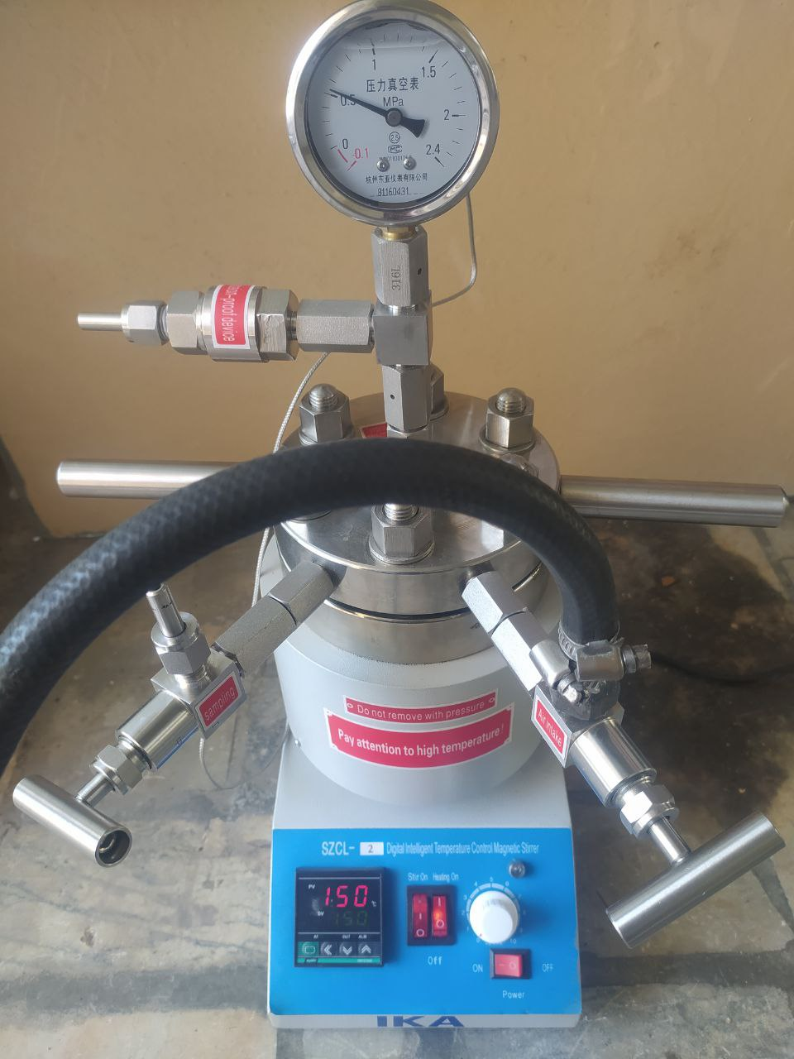
FIGURE 1. Photo of the container - high-temperature reactor

The hydrogen absorption behavior of aluminum–nickel alloys, titanium, magnesium and lithium was investigated at temperatures ranging from 150 to 700 °C and hydrogen pressures of 10–15 atm. Aluminum–nickel alloy samples did not exhibit measurable hydrogen absorption under any of the tested conditions. Magnesium samples absorbed hydrogen up to 1.5 wt.%.
Titanium powders demonstrated significant hydrogen uptake, reaching 3.8 wt.% at 12 atm and 700 °C, which is close to the theoretical hydrogen capacity of titanium dihydride. Lithium samples showed the highest hydrogen absorption capacity among all investigated materials. At 700 °C and 12 atm, the hydrogen content in lithium reached 12.5 wt.%.
Metal hydride formation occurs through adsorption of molecular hydrogen on the metal surface, dissociation into atomic hydrogen, and diffusion of hydrogen atoms into the metal lattice. At elevated temperatures, lithium hydride decomposes according to the reaction 2LiH → 2Li + H₂. When lithium hydride reacts with water, lithium hydroxide and hydrogen gas are formed, releasing a significant amount of hydrogen.
CONCLUSIONS
The conducted experimental studies confirm that metal hydrides are promising materials for hydrogen storage applications. Lithium exhibited the highest hydrogen storage capacity, while titanium showed stable and reversible hydrogen absorption close to its theoretical limit. Aluminum–nickel alloys were found to be unsuitable for hydrogen storage under the investigated conditions. The results demonstrate that achieving high hydrogen storage capacities requires elevated temperatures and hydrogen pressures. These findings support further research and development of metal-hydride-based hydrogen storage systems for future energy technologies.
REFERENCES

- MS Paizullakhanov, OR Parpiev, ZZ Shermatov, EZ Nodirmatov, et.all., Hydrogen Storage on Porous Absorbers with a Zeolite Composition, Applied Solar Energy 60 (4), 604-608
- . Blinov D. V., Borzenko V. I., Bezdudny A. V., Kuleshov N. V. Promising Metal Hydride Technologies for Hydrogen Storage and Purification. Izvestiya Vysshikh Uchebnykh Zavedeniy. Energetika. 2021. No. 23(2). Pp. 149–160. https://doi.org/10.30724/1998-9903-2021-23-2-149-160
- Abdellatif M. Sadeq, Raad Z. Homod, Ahmed Kadhim Hussein, et.all., Hydrogen energy systems: Technologies, trends, and future prospects. Science of the Total Environment 939 (2024) 173622. https://doi.org/10.1016/j.scitotenv.2024.173622
- K.S. Nivedhitha, T. Beena, N.R. Banapurmath, et.all., Advances in hydrogen storage with metal hydrides: Mechanisms, materials, and challenges. International Journal of Hydrogen Energy 61 (2024) 1259–1273. https://doi.org/10.1016/j.ijhydene.2024.02.335
- M. Lototskyy, V. Yartys, B. Pollet et al., Metal hydride hydrogen storage and compression systems for energy storage technologies. International Journal of Hydrogen Energy, 46 (2021) 34419–https://doi.org/10.1016/j.ijhydene.2021.08.090

