Structural and Spectral Factors of Gold and Other Mineralization in the Boboshil Prospective Area (Southern Nurata Mountains)
Kholida Tursinbayeva ^{a)}, Farhod Chulliyev, Marjona Ergashova, Mirzokhid Khasanov
University of Geological Sciences, Tashkent, Uzbekistan
^{a)} Corresponding author: xolidatursinbayeva110@gmail.com
Abstract. This research focuses on the structural and spectral factors controlling gold and associated mineralization within the Boboshil prospective field, located in the Southern Nurata Mountains of Uzbekistan. The study integrates remote sensing (RS) data interpretation, geological mapping, and spectral analysis of ASTER and Landsat imagery to identify hydrothermal alteration zones and potential ore-bearing structures. Using band ratio techniques and mineral indices (such as Alunite–Kaolinite–Pyrophyllite, Carbonate–Chlorite–Epidote, and Amphibole–MgOH), the spatial distribution of alteration minerals was mapped and correlated with known tectonic and intrusive features. The results reveal a close genetic relationship between hydrothermal alteration, structural deformation, and magmatic processes that have influenced gold mineralization in the study area. The integrated analysis of spectral signatures, geological mapping, and field verification confirms that alteration halos and bleaching zones are associated with contact-metasomatic and hydrothermal-metasomatic processes, indicating high potential for gold and polymetallic mineralization in the Boboshil area.
INTRODUCTION
Remote sensing technologies have become an essential tool in modern geological mapping and mineral exploration. The continuous development of high-resolution satellite sensors and image processing techniques has significantly improved the detection and characterization of hydrothermal alteration zones and lithological units. Among these sensors, the Advanced Spaceborne Thermal Emission and Reflection Radiometer (ASTER) has proven particularly effective due to its multispectral capability and high spatial resolution, allowing for detailed discrimination of surface mineralogy and alteration patterns. The use of spectral unmixing and image enhancement techniques has further advanced the interpretation of remotely sensed data for mineral exploration. Demonstrated that partial unmixing of hyperspectral data can successfully isolate and map mineralogical target signatures, providing valuable insights into alteration mineral assemblages. Developed the “Crosta technique,” a principal component analysis (PCA)-based approach for enhancing alteration anomalies in multispectral imagery, which remains widely used in mineral prospectivity studies. For instance, within the Central Kyzylkum region, the ore-bearing zones are spatially and genetically associated with hydrothermal alteration and kaolinitization processes. The geological and structural framework of the area is distinctly reflected in the geophysical fields, exhibiting a well-defined correlation with the identified alteration zones and mineralization patterns. [1-8]
MATERIALS AND METHODS
Research Objective and Approach. The study aimed to identify and map lithological types and hydrothermal alteration zones associated with mineralization within the Boboshil prospective area. The research integrated geological, geochemical, and remote sensing (RS) data using a combined approach of field spectral measurements and satellite-based spectral analysis. The methodological workflow included:
(1) field data collection and spectral calibration;
(2) satellite data preprocessing and spectral enhancement;
(3) mineral index calculation and classification; and
(4) validation through ground-truth and laboratory analyses [4,5]
Remote Sensing Data and Preprocessing
Multispectral satellite imagery from ASTER (Advanced Spaceborne Thermal Emission and Reflection Radiometer, VNIR–SWIR ranges) and Landsat-8 OLI (Operational Land Imager) was utilized. Cloud-free Level 1T/2 scenes were selected based on low atmospheric water vapor conditions.
Standard preprocessing steps included:
Radiometric and atmospheric correction to convert raw digital numbers to surface reflectance;
Geometric correction and co-registration using topographic maps and GPS/GNSS control points (accuracy ≤3–5 m);
Masking of clouds, shadows, and water bodies;
Resolution harmonization between VNIR (15 m) and SWIR (30 m) data to a unified working grid;
Spectral convolution, where field continuous spectra were resampled using ASTER spectral response functions to ensure direct comparability with satellite bands [1,2].
Spectral transformations such as Principal Component Analysis (PCA), Minimum Noise Fraction (MNF), and band ratioing were applied to enhance geological and mineralogical features while reducing noise.[3]
Field Spectral Measurements and Sample Collection
Fieldwork was carried out to obtain representative spectral curves of major lithological units. Measurements were conducted using a field spectroradiometer covering the visible–near and short-wave infrared ranges, with a Spectralon white reference panel used for calibration before each measurement series.[4]
At each site, 10–15 spectral readings were recorded and averaged to minimize variability. Shadows, surface moisture, and glare were carefully avoided. Coordinates, time, and environmental conditions (solar elevation, cloud cover, surface state) were documented for each observation.
Outliers and noisy spectra were excluded. The resulting spectral curves were filtered and smoothed as necessary without distorting diagnostic absorption features, normalized within the 0.4–2.5 µm range, and analyzed for characteristic bands indicative of carbonates, clays, and iron-bearing minerals.
Spectral Indices and Mineral Mapping
To delineate hydrothermal alteration zones, several diagnostic indices derived from ASTER bands were computed using band-math operations in ENVI:
Carbonate–Chlorite–Epidote Index (CCE): (Band 7 + Band 9) / Band 8;
Epidote–Amphibole–Chlorite Index (EAC): (Band 6 + Band 9) + (Band 7 + Band 8);
Amphibole–MgOH Index (AM): (Band 6 + Band 9) / Band 8;
Alunite–Kaolinite–Pyrophyllite Index (AKP): (Band 4 + Band 6) / Band 5.
These indices served as proxies for hydrothermal and metasomatic alteration processes and were spatially correlated with structural and lithological maps [6,7]
Spectral Matching and Supervised Classification
To establish quantitative links between field and satellite data, spectral matching algorithms such as Spectral Angle Mapper (SAM) and Spectral Information Divergence (SID) were applied.
Field-verified spectral signatures were used to define training polygons representing lithological and alteration classes.
Supervised classification using Support Vector Machine (SVM) and Random Forest (RF) algorithms was implemented on VNIR–SWIR ASTER data. Post-classification refinement included morphological and modal filtering to remove noise and improve boundary coherence.[8]
Structural Analysis
Structural features (faults, fractures, and ring structures) were delineated using both visual interpretation and semi-automated lineament extraction techniques. Edge-detection filters (Sobel and Kirsch) and shaded-relief transformations were used to enhance linear and circular features.[6]
Lineament density maps were analyzed to reveal structural controls on hydrothermal alteration zones.
Validation and Accuracy Assessment
An independent validation dataset was compiled from field checkpoints and laboratory-confirmed rock samples. Accuracy metrics, including error matrix, overall accuracy (OA), Kappa coefficient (κ), and class-specific user’s and producer’s accuracies, were calculated.
Expert geological evaluation of classified boundaries was performed considering geomorphological context and reference outcrops.[5]
Data Integration and Output Products
The final outputs included:
A thematic lithological and alteration map showing carbonate, terrigenous, clay, sand–clay, Quaternary, and hydrothermal alteration zones;
GIS-ready datasets (classified rasters, vector boundaries, and metadata files);
Documentation of QA/QC logs, calibration data, and preprocessing records.
All datasets were integrated within a GIS environment for visualization, analysis, and further geochemical correlation.
Quality Control
All measurements were performed under stable illumination with minimal atmospheric interference. ASTER scenes with low water vapor content were prioritized. Data quality was monitored through calibration records, outlier rejection protocols, and consistency checks across instruments and datasets.
RESULTS AND DISCUSSION
Structural Features and Tectonic Setting
The Boboshil prospective area, located within the Southern Nurata Mountains, is characterized by a complex geological framework consisting of Paleozoic metamorphic and magmatic rocks. The area is dissected by numerous faults, folds, and ring structures, which have significantly influenced the localization of mineralization.
Remote sensing data revealed dominant NW–SE and NE–SW trending fault systems, with ring-shaped and arcuate structures superimposed on them. These features are interpreted as zones of intensive hydrothermal alteration and deformation, which correspond spatially to gold-bearing and polymetallic mineralization zones identified during fieldwork.
The lineament density map generated using Sobel and Kirsch edge-detection filters indicates higher structural intensity near the Boboshil, Boshtut, and Boshmachit sites, suggesting a strong tectonic control over mineral deposition.[7]
Spectral Characteristics of Alteration Zones
Spectral analysis of ASTER data provided valuable insights into the distribution of alteration minerals associated with gold mineralization.
Key results include:
Carbonate–Chlorite–Epidote zones [(7+9)/8 index] were identified mainly along tectonic faults, representing hydrothermal metasomatic processes. These zones coincide with intrusive contacts and metasomatic halos visible on geological maps.[6]
Epidote–Amphibole–Chlorite assemblages [(6+9) +(7+8)] are closely related to regional shear zones and hydrothermal conduits. These mineral associations indicate the propylitic alteration stage, typically found in the outer zones of gold-bearing systems.[8]
Amphibole–MgOH zones [(6+9)/8 index] correspond to metamorphic aureoles around intrusive bodies, confirming the contact-metasomatic nature of the processes.
Alunite–Kaolinite–Pyrophyllite zones [(4+6)/5 index] were detected in the southwestern and central parts of the study area, indicating advanced argillic alteration typical of high-sulfidation epithermal environments.[5]
The combination of these indices provides a reliable criterion for delineating potentially mineralized zones. The spectral results show a clear correlation between hydrothermal alterations and structural zones of deformation, which are the primary pathways for ore-bearing fluids.
Integration with Geological and Geochemical Data
The integration of remote sensing results with field geological and laboratory data confirmed the genetic relationship between hydrothermal and magmatic processes. Areas of rock bleaching, detected primarily in ASTER band 7 (2.23–2.28 µm), coincide with contact-metamorphic zones and show elevated concentrations of gold, silver, and rare-earth elements in sample analyses.[6]
Field observations revealed that carbonaceous quartzites and mica-quartz schists of the Middle Cambrian–Lower Ordovician age underwent intense thermal alteration near intrusive bodies, leading to partial combustion of carbon and visible rock lightening. These zones are interpreted as ore-bearing halos, marking areas of potential mineralization.
Identification of Promising Areas
Based on the integration of spectral, structural, and field data, several prospective zones were delineated within the Boboshil area:
Boboshil Block – characterized by carbonate-chlorite-epidote alteration with strong structural control and elevated gold anomalies;
Boshtut Site – dominated by alunite-kaolinite-pyrophyllite alterations, suggesting near-surface epithermal mineralization;
Boshmachit Zone – marked by amphibole-MgOH signatures and metasomatic halos near intrusive contacts.

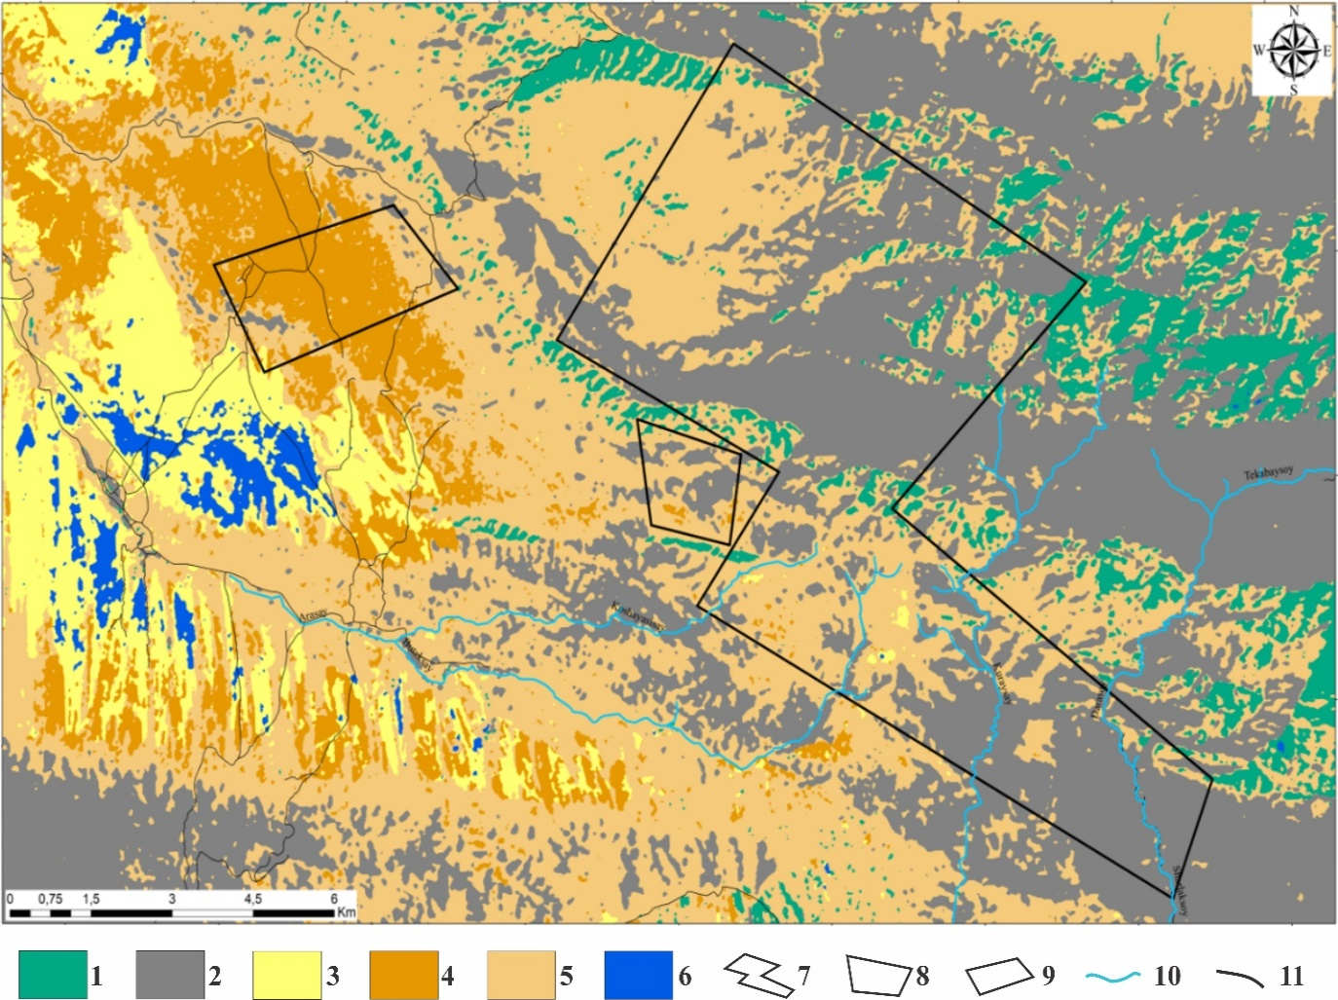
FIGURE 1. The map is based on the reference classification of spectral measurements of rocks in the Boboshil area
Legend: Classes of supervised classification: 1-Carbonate rock; 2-Terrigenous rock; 3-Clay rock; 4-Sand–clay rock; 5-Quaternary rock; 6-Saline soils; Survey outlines: 7-Boboshil; 8-Boshut; 9-Toshmachit; Other symbols: 10-Rivers; 11-Roads

Prospective zones: The integration of spectral, geological, and field data enabled the identification of three main prospective areas - Boboshil, Boshtut, and Boshmachit - which display the strongest correlation between alteration, structure, and geochemical anomalies.
Thus, the results demonstrate the effectiveness of combining remote sensing, spectral analysis, and field geology in identifying potential gold-bearing zones. These findings provide a scientific basis for future detailed exploration and resource evaluation in the Southern Nurata region [7].

CONCLUSIONS
This study demonstrates the effectiveness of an integrated approach combining remote sensing data, spectral analysis, and structural interpretation for identifying gold and associated mineralization in the Boboshil prospective area of the Southern Nurata Mountains. The use of ASTER multispectral imagery, together with band ratio techniques and mineral indices, enabled reliable mapping of hydrothermal alteration zones related to ore-forming processes. [1,4,5]
The results indicate a strong spatial and genetic relationship between hydrothermal alteration, tectonic structures, and magmatic activity. Carbonate–chlorite–epidote and epidote–amphibole–chlorite assemblages are mainly controlled by regional fault systems and intrusive contacts, reflecting propylitic and contact-metasomatic alteration stages. In contrast, alunite–kaolinite–pyrophyllite assemblages mark advanced argillic alteration zones, which are typical indicators of epithermal mineralization environments.
Structural analysis revealed that NW–SE and NE–SW trending faults, as well as ring and arcuate structures, play a key role in controlling fluid migration pathways and the localization of gold mineralization. These findings are consistent with regional geological and geophysical models proposed for the Central Kyzylkum and Southern Tien Shan regions. [6,7,8]
The integration of spectral results with field observations and geochemical data confirms that bleaching zones and metasomatic halos around intrusive bodies represent promising targets for further exploration. Based on the combined spectral, structural, and geological criteria, the Boboshil, Boshtut, and Boshmachit zones are identified as the most перспектив areas for gold and polymetallic mineralization.
Overall, the proposed methodological framework provides a reliable and cost-effective tool for preliminary mineral prospectivity assessment and can be successfully applied to similar geological settings within Uzbekistan and other orogenic gold provinces.
REFERENCES
- M. Abrams, “The Advanced Spaceborne Thermal Emission and Reflection Radiometer (ASTER): Data products for the high spatial resolution imager on NASA’s Terra platform,” Int. J. Remote Sens. 21(5), 847–859 (2000).
- J. W. Boardman, F. A. Kruse, and R. O. Green, “Mapping target signatures via partial unmixing of AVIRIS data,” in Summaries of the Fifth Annual JPL Airborne Earth Science Workshop, JPL Publication 95–1, Vol. 1 (Jet Propulsion Laboratory, Pasadena, CA, 1995), pp. 23–26.
- A.P. Crosta and J. M. Moore, “Enhancement of Landsat Thematic Mapper imagery for residual soil mapping in SW Minas Gerais State, Brazil: A prospecting case history in greenstone belt terrain,” in Proceedings of the Seventh ERIM Thematic Conference: Remote Sensing for Exploration Geology (ERIM, Ann Arbor, MI, 1989), pp. 1173–1187.
- R. P. Gupta, Remote Sensing Geology, 3rd ed. (Springer, Berlin, 2017).
- F. F. Sabins, “Remote sensing for mineral exploration,” Ore Geol. Rev. 14(3–4), 157–183 (1999).
- A.B. Goipov, Sh. I. Akhmadov, A. V. Tevelev, Z. M. Musakhonov, and R. I. Mirsayapov, “Application of innovative methods of spectral and structural interpretation to solving geological problems and searching for deposits (case study of the Auminzatau–Beltau ore district, Republic of Uzbekistan),” Moscow Univ. Geol. Bull. 79(6), 798–809 (2024).
- B. Goipov, Sh. I. Akhmadov, and V. R. Yusupov, “Characteristics of geophysical fields and geophysical indicators of mineralization in the Bo‘kantov Mountains, Southern Tien Shan,” ANAS Trans., Earth Sci. 2, 77–91 (2024).
- B. Goipov, A. U. Ashurov, and D. Kh. Atabaev, “Interpretation of airborne electrical prospecting data in the search for gold ore objects and geodynamic zoning of the Bukantau Mountains (Southern Tien Shan),” J. Geophys. Res. 1, 79–97 (2025).

