Multiscale analysis of nanocellulose: structural, adsorption and sensory properties
Shohzodbek Rashidov ^{a)}, Elmurod Egamberdiev, Sadritdin Turabdjanov, Doston Shomurodov, Fakhriddin Umarov
Tashkent state technical university named after Islam Karimov, Tashkent, Uzbekistan
^{a)} Corresponding author: Shoh.rashidov2103@gmail.com
Abstract. This paper presents an extensive study of nanocellulose obtained from Miscanthus and Broussonetia papery using a combined chemomechanical method. The following analytical methods were used for a comprehensive evaluation of the synthesized samples' properties: dynamic light scattering (DLS), IR spectroscopy, McBain adsorption analysis, and quartz crystal microbalance (QCM) gas sensing. Five nanocellulose samples obtained under different hydrolysis conditions were compared. The influence of morphology, particle size distribution, porosity, and specific surface area on the sorption and sensory activity of the materials was established. Samples 4.1-6 and 4.1-9 demonstrated the highest sensitivity to CO₂, which allows them to be considered as promising materials for the development of environmental sensors and membrane systems. The presented results expand scientific understanding of the relationship between the structure and functional properties of nanocellulose and open up new areas of biopolymer application in engineering and environmental applications.
INTRODUCTION
Nanocellulose is one of the most promising biopolymer nanostructures due to its combination of high mechanical strength, developed surface area, biocompatibility, chemical modifiability, and environmental safety. This unique combination of properties has led to its use in membrane technologies, sensorics, packaging materials, biomedicine, sorbents, and composites [1, 2].
Development of nanocellulose production methods includes acid hydrolysis, mechanical defibrillation, enzymatic treatment, TEMPO oxidation, and hybrid approaches [3]. However, to date, there is no universal method for simultaneously controlling the morphology, surface properties, and adsorption behavior of nanocellulose. Furthermore, the material's properties depend significantly on the starting plant material, degree of crystallinity, mechanochemical treatment, and hydrolysis conditions [5].
Of particular interest is the production of nanocellulose from unconventional sources, such as Miscanthus and Broussonetia papyracea. Both plants are characterized by high yields, rapid growth, resistance to climatic conditions, and high cellulose content, making them attractive candidates for green biomaterial production [4].
Comprehensive characterization of nanocellulose is an important step in the development of technologies for its practical application. DLS methods allow us to determine particle size distribution, IR spectroscopy allows us to determine structure and functional groups, adsorption methods allow us to determine surface characteristics, while QCM sensors are becoming a modern tool for assessing the gas sensitivity of biopolymers.
The goal of this study is to obtain nanocellulose from plant materials using a combined method and conduct a multi-level study of its structural, adsorption, and sensory properties to determine the optimal sample.

EXPERIMENTAL RESEARCH
Feedstock and nanocellulose production. Miscanthus and Broussonetia papery cellulose were used as feedstock materials. Nanocellulose was produced using a combined method involving chemical treatment and mechanical destruction, allowing for the production of nanoscale particles [6,7]. The samples obtained under various conditions of the combined method were tested using multi-level analyses such as dynamic light scattering (DLS) [8], IR spectroscopy, McBain adsorption analysis, and QCM sensor analysis.
Particle size was determined using DLS. Colloidal solutions of five nanocellulose samples were prepared for analysis: 3.1-6, 3.1-9, 4.1-6, 4.1-9, and 5.1. The following parameters were measured: r – hydrodynamic radius (nm); G(r) – prevalence; C(r) – nanocellulose concentration [9].
IR spectra were recorded in the range of 400–4000 cm⁻¹. Peaks characteristic of cellulose structures were interpreted.
Adsorption behavior in aqueous and benzene media was studied. The following parameters were determined: absorption volume (mol/kg), specific surface area (m²/g), micropore and mesopore volume, and pore radius.
The samples were tested for sensitivity to carbon dioxide. The frequency response of a quartz resonator was evaluated.
RESEARCH RESULTS
In the Dynamic Light Scattering (DLS) analysis, the size of cellulose nanoparticles was examined depending on their concentration in the colloidal solution. In sample 3.1-6, nanocellulose at a concentration of 5.784 shows the highest distribution intensity, while the nanoparticle size is 5.12 nm.

FIGURE 1. Sample № 3.1-6. r(nm) is the particle size, G(r) is the degree of prevalence, C(r) is the concentration of nanocellulose in the solution
In sample 3.1-9, nanocellulose at a concentration of 3.761 shows the highest distribution intensity, while the nanoparticle size is 4 nm. This demonstrates that the majority of the obtained solution consists of nanocellulose with a size of about 4 nm.
In sample 4.1-6, nanocellulose at a concentration of 4.537 shows the highest distribution intensity, while the nanoparticle size is 4 nm. This indicates that the majority of the obtained solution consists of nanocellulose with a size of about 4 nm.

FIGURE 2. Sample № 3.1-9. r(nm) is the particle size, G(r) is the degree of prevalence, C(r) is the concentration of nanocellulose in the solution

FIGURE 3. Sample № 4.1-6. r(nm) is the particle size, G(r) is the degree of prevalence, C(r) is the concentration of nanocellulose in the solution
In sample 4.1-9, nanocellulose at a concentration of 3.784 shows the highest distribution intensity, while the nanoparticle size is 2.5 nm. This demonstrates that the majority of the obtained solution consists of nanocellulose with a size of about 2.5 nm.
In sample 5.1, nanocellulose at a concentration of 3.445 shows the highest distribution intensity, while the nanoparticle size is 2.88 nm. This indicates that the majority of the obtained solution consists of nanocellulose with a size of about 2.88 nm.

FIGURE 4. Sample № 4.1-9. r(nm) is the particle size, G(r) is the degree of prevalence, C(r) is the concentration of nanocellulose in the solution

FIGURE 5. Sample № 5.1. r(nm) is the particle size, G(r) is the degree of prevalence, C(r) is the concentration of nanocellulose in the solution
The IR spectrum of nanocellulose of all samples 3.1-6, 4.1-6 and 4.1-9, 3.1-9 and 5.1 shows characteristic absorption bands corresponding to the main functional groups present in the cellulose structure.

TABLE 1. The following table can be compiled from the peak diagram to visualize the IR spectroscopy response (in cm⁻¹)
№ | Wavenumber (cm⁻¹) | Intensity | Possible purpose
1 | 704.5 | 0.592 | C–H bending vibrations, possible residual impurities, or C–O vibrations from amorphous regions.
2 | 725.0 | 0.609 | C–O–C vibrations in β-glycosidic bonds.
3 | 842.4 | 0.267 | Characteristic peak of β-1,4-glycosidic bonds in cellulose.
4 | 1107.0 | 0.235 | C–O–C stretching in the glucopyranose ring.
5 | 1345.6 | 0.941 | C–H vibrations (deformational in CH₂ groups)
6 | 1408.9 | 0.859 | C–H bending vibrations (in CH₂ groups).
7 | 1623.3 | 0.728 | O–H stretching vibrations of adsorbed water.
8 | 3276.3 | 0.638 | O–H stretching (hydroxyl groups).
9 | 3390.0 | 0.771 | O–H stretching (broad peak – hydrogen bonding).

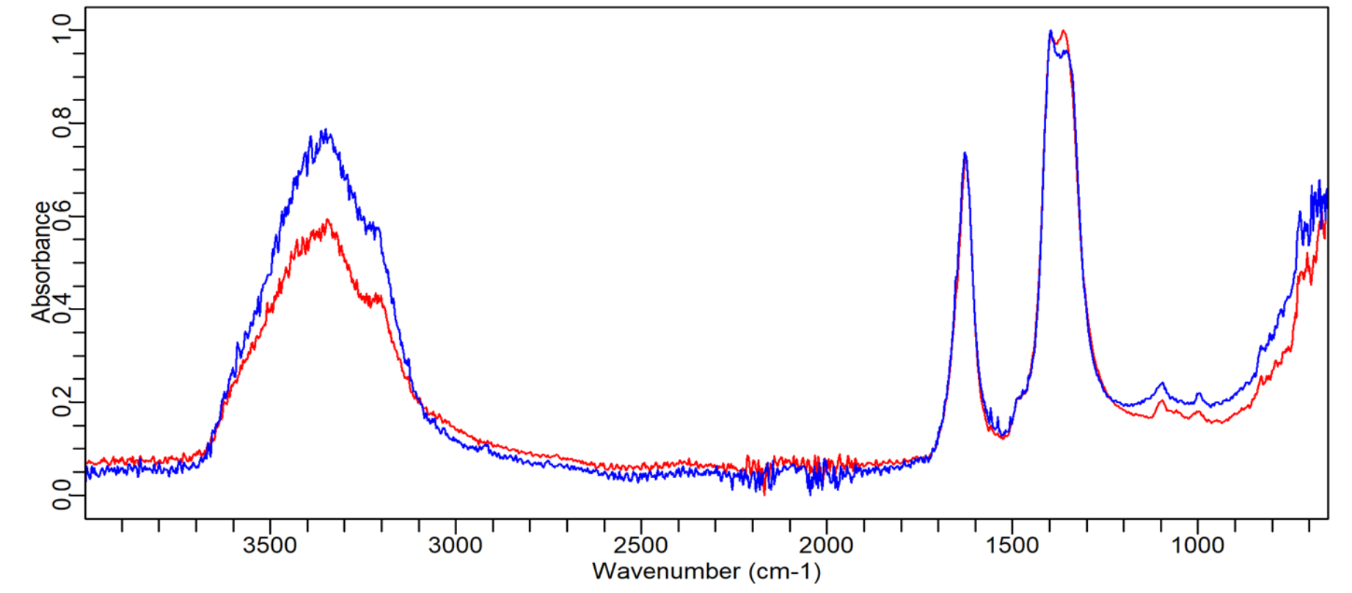
FIGURE 6. IR spectroscopy of samples 3.1-6, 4.1-6, 4.1-9:
3.1-6 – red peaks, 4.1-6 and 4.1-9 – blue peaks
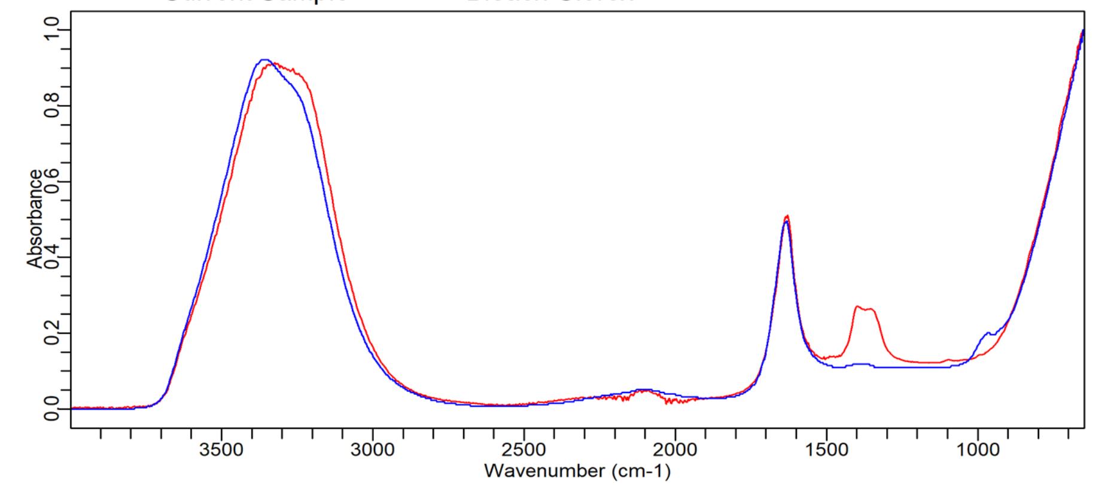
FIGURE 7. IR spectroscopy of samples 3.1-9, 5.1:
3.1-9 – red peaks, 5.1 – blue peaks
Each sample was tested for adsorption properties using the McBain method. Among all the samples, sample 4.1-6 showed good results in adsorption tests in an aqueous solution, while in a benzene solution, sample 5.1 demonstrated promising results.

FIGURE 8. Performance of sample 4.1-6 in the adsorption properties analysis using the McBain method
in an aqueous solution.

FIGURE 9. Performance of sample 5.1 in the adsorption properties analysis using the McBain method in a benzene solution.
Sample 4.1-6 showed the following adsorption values in an aqueous solution: single-pore capacity of 0.782 mol/kg, specific surface area of 188.26 m²/g, micropore volume of 0.1865572, mesopore volume of 0.1, and pore radius of 29.9 Å. Sample 5.1 showed the following adsorption values in a benzene solution: single-pore capacity of 0.905 mol/kg, specific surface area of 58.82 m²/g, micropore volume of 0.0676196, mesopore volume of 0.04, and pore radius of 39.9 Å.
The graphs show the time-dependent changes in quartz crystal microbalance (QCM) frequency during cyclic switching of the gas environment between nitrogen (N₂) and carbon dioxide (CO₂). The gas supply periods are indicated by color shading:
green — N₂ flow (inert environment),
orange — CO₂ flow (active adsorption environment).
Each curve reflects the dynamics of CO₂ sorption/desorption by the nanocellulose coating. Upon CO₂ exposure, a significant decrease in the resonance frequency (Δf) is observed, indicating:
- adsorption of CO₂ molecules on the surface and internal nanostructural regions of the nanocellulose;
- an increase in the mass of the sensor layer;
- rapid establishment of sorption equilibrium.
Returning to N₂ results in partial frequency recovery due to CO₂ desorption. The observed repeatability of the cycles confirms the stability, reproducibility, and absence of degradation of the nanocellulose layer.
Comparison of the samples shows that sensors of the 3.1–6 / 3.1–9 series demonstrate moderate Δf amplitudes upon CO₂ exposure, whereas sensors 4.1–6 / 4.1–9 exhibit significantly deeper frequency drops, indicating higher sorption capacity and a more developed nanostructure of the coating.
Thus, the data demonstrate that the chemical modification and structure of the nanocellulose layers determine the QCM sensor’s sensitivity to CO₂.
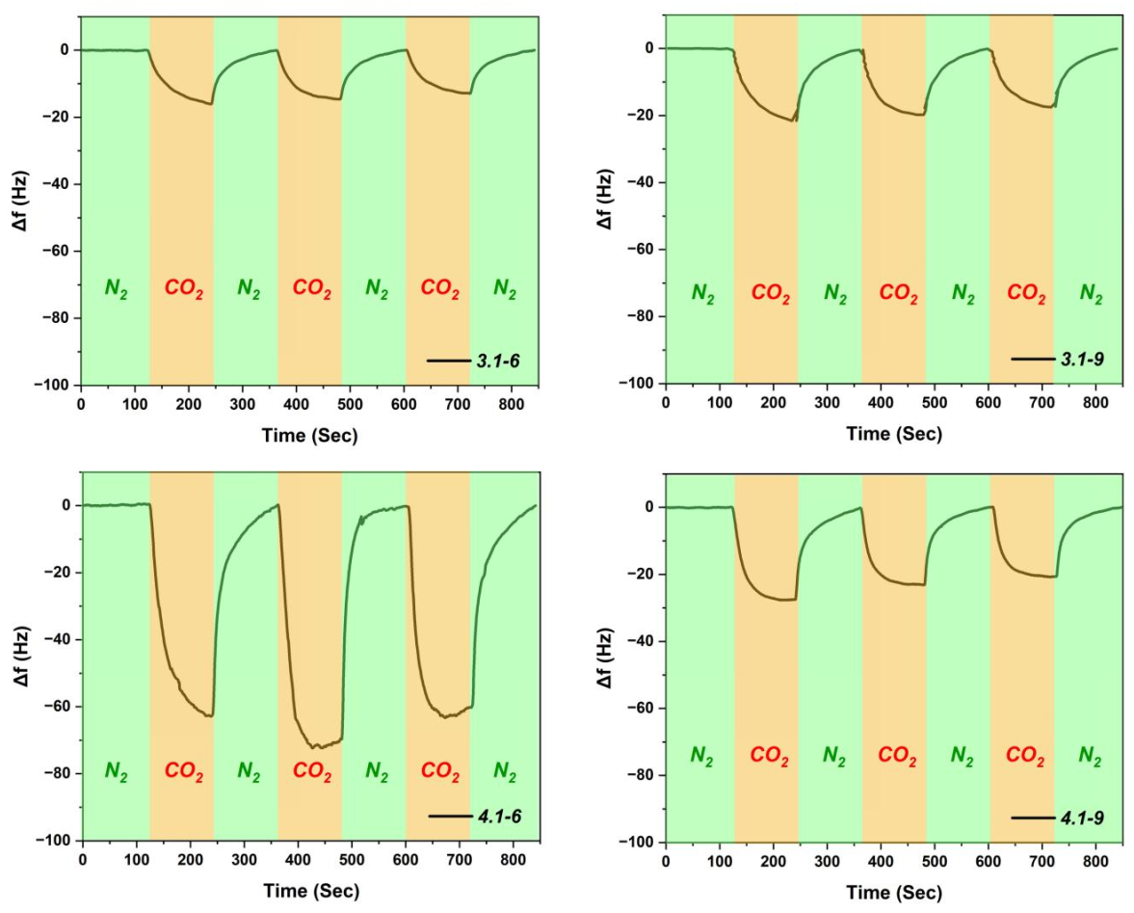
FIGURE 10. QCM sensory testing indicators
Thus, the data demonstrate that the chemical modification and structure of the nanocellulose layers determine the QCM sensor’s sensitivity to CO₂.
CONCLUSIONS
In the course of the study, nanocellulose was obtained from Miscanthus and Broussonetia papyrifera using a combined chemical–mechanical method, and a comprehensive multi-level characterization was performed using DLS, IR spectroscopy, McBain adsorption analysis, and QCM sensor testing. The results confirm that varying the conditions of hydrolysis and mechanical treatment allows targeted modification of the morphology, size characteristics, and surface properties of nanocellulose, which directly affects its adsorption and sensor activity.
DLS analysis showed that the studied samples contain nanoparticles in the 2.5–5 nm range, with samples 4.1-6 and 4.1-9 exhibiting the smallest average particle size and the narrowest distribution, indicating a high degree of defibrillation. IR spectroscopy confirmed the preservation of cellulose-specific functional groups and the absence of foreign impurities, demonstrating the correctness of the production technology.
Adsorption analysis revealed significant differences between the samples: sample 4.1-6 showed maximum adsorption in an aqueous environment and the most developed specific surface area, while sample 5.1 exhibited the highest sorption in a benzene environment, indicating differences in microporous structure and surface energetics. Sensor testing using QCM showed that samples 4.1-6 and 4.1-9 possess high sensitivity to carbon dioxide, providing the deepest frequency response and good reproducibility of adsorption–desorption cycles.
Thus, it was established that the structural parameters, specific surface area, and porosity of nanocellulose directly determine its adsorption and sensor properties. Samples 4.1-6 and 4.1-9 can be considered optimal for the development of gas-sensitive coatings and CO₂ environmental sensors, and they also show promise for membrane and adsorption technologies. The obtained results expand scientific understanding of the relationship between nanocellulose morphology and functionality and confirm the potential of Miscanthus and Broussonetia plant materials for creating highly efficient next-generation biomaterials.
REFERENCES
- Habibi, Y., Lucia, L. A., & Rojas, O. J. (2010). Cellulose nanocrystals: Chemistry, self-assembly, and applications. Chemical Reviews, 110(6), 3479–3500.
- Klemm, D., Cranston, E. D., Fischer, D., Gama, M., Kedzior, S. A., Kralisch, D., … & Ribeiro, A. J. (2018). Nanocelluloses: A new family of nature-based materials. Angewandte Chemie International Edition, 57(26), 6843–6868.
- Isogai, A. (2020). Progress in TEMPO-oxidized cellulose nanofibers. Journal of Polymer Science, 58(13), 1861–1871.
- Chandel, A. K., Garlapati, V. K., Singh, A. K., Antunes, F. A., & da Silva, S. S. (2019). The path forward for lignocellulosic biorefineries: Bottlenecks, solutions, and perspective on commercialization. Bioresource Technology, 278, 362–372.
- Siro, I., & Plackett, D. (2010). Microfibrillated cellulose and new nanocomposite materials: A review. Cellulose, 17(3), 459–494.
- Hoeng, F., Denneulin, A., Bras, J. (2016). Neuromorphic and sensing applications of nanocellulose. Sensors, 17(1), 104–121.
- Sh.А. Rashidov, E.А. Egamberdiev, S.M. Turabdjanov. Obtaining nanocellulose by a combined method ISBN 978-985-897-285-1. 2025. pp. 280.
- Egamberdiyev, E. A., Turabdjanov, S., Azimov, D., Igamkulova, N., & Mengliev, S. (2025). Environmental and mechanical performance of modified cement-based composites. Procedia Environmental Science, Engineering and Management, 12, 261–267.
- Duschanova, Z. A., Egamberdiyev, E. A., Turabdjanov, S., & co-authors. (2024). Nanostructured additives for improving cement composite properties. Journal of Nanostructures, 14, 789–797. https://doi.org/10.22052/JNS.2023.03.020
- Egamberdiev, E., Umarova, M., & Azimov, D. (2024). Eco-efficient binders modified with industrial waste. E3S Web of Conferences, 497, 03031. https://doi.org/10.1051/e3sconf/202449703031
- Egamberdiev, E., Turabdjanov, S., & Mengliev, S. (2024). Physical and mechanical behavior of composite binders with modifiers. E3S Web of Conferences, 497, 02026. https://doi.org/10.1051/e3sconf/202449702026
- Egamberdiyev, E. A., Turabdjanov, S., Azimov, D., Igamkulova, N., & Mengliev, S. (2025). Sustainable construction materials based on modified cement systems. Procedia Environmental Science, Engineering and Management, 12(1), 261–267.
- Akhmatovna, A. M., Elmurod, E., Gulzat, O., Sabokhat, S., & Inomjon, M. (2025). Nanostructured modifiers and their effect on cement composite performance. Journal of Nanostructures, 15(3), 1041–1049. https://doi.org/10.22052/JNS.2025.03.021

