Methodology for applying pedagogical and virtual modeling technologies in the training of professionally competent specialists
Sevara Turaeva ¹^{,a)}, Farxodjon Parmankulov¹, Gulmira Pardaeva², Aziza Akmalova³, Sulaymonova Dilnoza⁴
¹ Belarusian-Uzbekistan Institute of Intersectoral Practical Technical Qualifications in Tashkent, Tashkent, Uzbekistan
² University of information technology and management, Karshi, Uzbekistan
³ National University of Uzbekistan named after Mirzo Ulugbek, Tashkent, Uzbekistan
⁴ Karshi State Technical University, Karshi, Uzbekistan
^{a)} Corresponding author: sevara08.90@mail.ru
Abstract. This study presents an integrated instructional methodology that combines pedagogical technologies with virtual modeling tools to enhance the professional competencies of pre-service physics teachers. The proposed approach is grounded in a competence-oriented framework and incorporates problem-based learning, interactive instructional strategies, project-based activities, and the systematic use of virtual laboratories and 2D/3D simulation environments. Digital modeling tools such as PhET, Algodoo, Labster, and Blender were employed to support conceptual understanding, experimental reasoning, and modeling skills development. The research adopted a quasi-experimental design and was conducted at two higher education institutions, involving pre-service physics teachers assigned to experimental and control groups. The experimental group was instructed using the integrated pedagogical–virtual modeling methodology, while the control group followed traditional instructional practices. Data were collected through theoretical knowledge assessments, rubric-based evaluation of practical skills, and analysis of students’ modeling portfolios. The effectiveness of the methodology was examined using comparative analysis of pre- and post-instruction outcomes. The findings demonstrate that the integrated use of pedagogical technologies and virtual modeling tools leads to substantial improvements in professional competence, conceptual understanding, practical experimentation skills, and modeling-based analytical thinking. The results confirm that the functional integration of instructional strategies with digital simulation environments enhances learning effectiveness and supports the development of technologically and pedagogically competent future physics teachers. The study contributes a validated methodological framework that can be applied in higher education institutions to modernize physics teacher education and strengthen competence-based training.
INTRODUCTION
In contemporary higher education, the preparation of professionally competent specialists has become one of the central priorities of educational reforms. The rapid advancement of digital technologies, virtual environments, and modeling tools is transforming the content, structure, and methods of teaching and learning. In particular, the training of pre-service physics teachers requires the integration of theoretical knowledge with practical application, the visualization of complex physical processes, and the development of students’ technological competencies and scientific reasoning skills.
Virtual laboratories, 2D/3D simulation tools, and modeling platforms such as PhET, Algodoo, Labster, and Blender provide opportunities to enhance students’ investigative abilities, analyze phenomena in depth, and explore physical processes in realistic and interactive environments [18]. When these tools are combined with pedagogical technologies — including problem-based learning, interactive methods, project-based approaches, and integrative instructional models — the learning process becomes significantly more effective and engaging [5].
Although recent educational reforms in Uzbekistan emphasize the implementation of innovative methods and digital resources in higher education, there remains a lack of systematically developed methodologies that integrate pedagogical technologies with virtual modeling to enhance professional competence. In particular, comprehensive methodological approaches aimed at fostering pre-service physics teachers’ professional, pedagogical, and technological competencies are still insufficiently explored.
Therefore, this study aims to develop, implement, and experimentally evaluate a methodology based on the integrated application of pedagogical technologies and virtual modeling tools. The novelty of the research lies in proposing a competence-oriented instructional model that integrates modern simulation platforms, 3D modeling tools, and digital resources with various stages of the didactic process in physics education.
In contrast to existing studies that examine pedagogical technologies or virtual modeling tools separately, this research offers an empirically validated integrated pedagogical–virtual modeling methodology that aligns instructional strategies with 2D/3D simulations and virtual laboratories to support competence-based training. The originality of the proposed approach lies in its systematic structure and experimental verification within real higher education settings, demonstrating its effectiveness in preparing professionally competent pre-service physics teachers.
LITERATURE REVIEW
A broad range of international and regional studies has examined the integration of pedagogical technologies and virtual modeling tools in the preparation of professionally competent specialists. The competency-based approach [9; 12] is recognized as one of the key methodological foundations of contemporary higher education, emphasizing the development of not only theoretical knowledge but also practical skills, communication abilities, problem-solving, and technological literacy among students.
Numerous studies have demonstrated the effectiveness of virtual laboratories and simulation platforms in physics education. For example, PhET simulations [15] significantly enhance conceptual understanding, foster student engagement, and improve motivation by visualizing abstract physical processes. Algodoo provides an interactive environment for modeling mechanical phenomena and has been shown to support creative thinking and experimental reasoning [13]. Labster virtual labs allow students to explore molecular and microscopic processes in safe, cost-effective, and repeatable conditions [7].
Research on the use of 3D modeling tools—particularly Blender—has expanded in recent years. Blender’s capabilities for visualizing physical systems in three dimensions, simulating object dynamics, and modeling particle interactions make it an effective instructional tool in STEM education [10].
Regional studies have also explored the use of pedagogical technologies [16;11], the integration of multimedia and digital resources in teaching [14], and the role of virtual laboratories in science education [8]. However, the literature indicates a significant gap regarding comprehensive methodologies that systematically integrate pedagogical technologies with 2D/3D modeling tools to enhance professional competence.
Thus, while existing research highlights the individual benefits of virtual modeling tools, there is limited work on developing an integrative methodology that combines these tools with pedagogical technologies to effectively support the professional development of pre-service physics teachers.
RESEARCH METHODOLOGY
The methodology of this study was designed to evaluate the effectiveness of integrating pedagogical technologies with virtual modeling tools in the preparation of professionally competent specialists. A quasi-experimental research design was employed and conducted at two higher education institutions in Uzbekistan, involving a total of 104 pre-service physics teacher students. Participants were randomly assigned to experimental and control groups in equal numbers.
The research consisted of three major phases: pre-testing, instructional intervention, and post-testing. Initially, the professional competence levels of both groups were assessed using diagnostic instruments. During the 14-week intervention phase, the experimental group received instruction based on an integrated methodology combining problem-based learning, project-based learning, and interactive teaching methods with 2D/3D simulations created through PhET, Algodoo, Labster, and Blender. The instructional process focused on strengthening theoretical understanding, enhancing practical skills, and developing modeling competencies through specially designed competence-oriented learning tasks. The control group continued with traditional instructional methods.
Data collection included a professional competence index, a 40-item theoretical knowledge test, a rubric-based assessment of practical skills, and an analysis of students’ modeling portfolios. The reliability and content validity of the diagnostic instruments were ensured through expert review by physics education specialists and pilot testing prior to the main experimental implementation. Statistical processing of the results was carried out using mean scores, standard deviations, and Student’s t-test to determine the significance of differences between groups, with the significance threshold set at p < 0.01. Ethical considerations were strictly observed throughout the study, with informed consent obtained from all participants and full confidentiality ensured.
Model Description and Rationale. In the course of the research, an integrated pedagogical–virtual modeling framework was developed to enhance the competencies of pre-service physics teachers (Figure 1). The model consists of five core components and ensures the functional integration of pedagogical technologies with digital modeling tools [17].

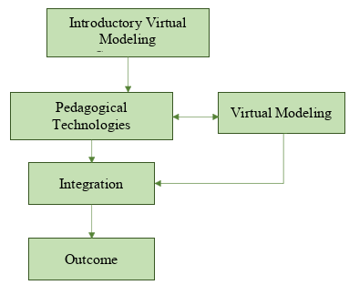
FIGURE 1. Integrated Pedagogical-Virtual Modeling Framework

I. The Introductory Component. This component involves identifying methodological objectives based on an assessment of students’ initial preparedness, existing competency indicators, and diagnostic results related to expected learning outcomes [1].
II. The Pedagogical Technologies Component. This part establishes the didactic basis of the instructional process through problem-based learning, interactive methods, group activities, and practice-oriented tasks [20].
III. The Virtual Modeling Component. This component provides visual and interactive analysis of physical processes using 2D simulations, 3D models, and virtual laboratory environments. As part of the research, the specially designed platform “Virtual Developments for Enhancing Creative Thinking in Physics” was used to develop students’ modeling competencies. The platform includes interactive 2D/3D simulations, virtual laboratory tasks, and visually enriched models of physical phenomena [2; 6].
These virtual modeling tools enhanced pre-service teachers’ spatial reasoning, algorithmic process analysis, and physics-based model construction skills. In particular, the interactive 3D simulation illustrating the operational stages of the Carnot engine played a significant role in improving students’ conceptual understanding of thermodynamic processes (Figure 2).
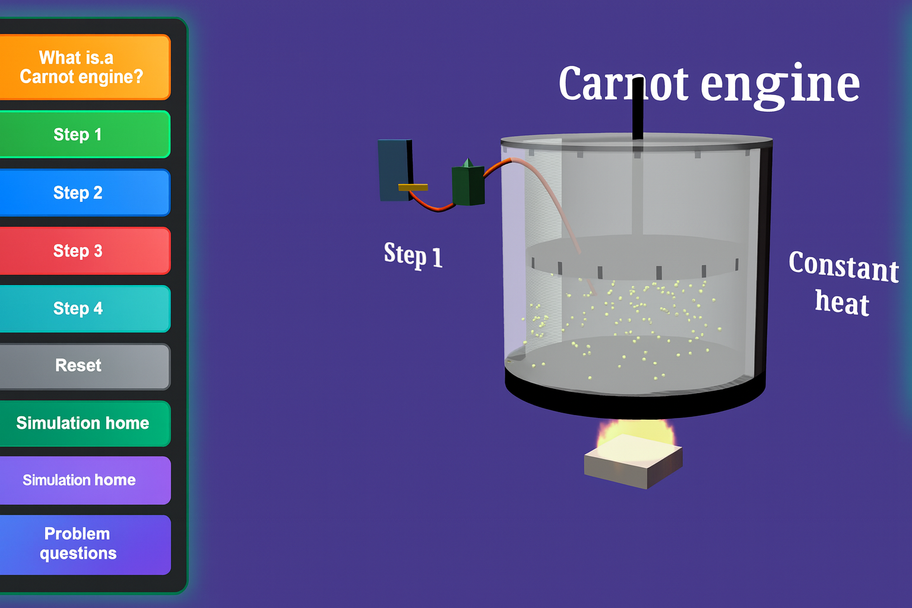
FIGURE 2. Example of a virtual simulation developed within the platform “Virtual Developments for Enhancing Creative Thinking in Physics.” The figure illustrates the operational stages of a Carnot engine using interactive 2D/3D animations.

IV. The Integration Component. This component ensures the functional merging of pedagogical methods with virtual modeling tools. Problem-based learning is combined with 3D simulations, interactive teaching strategies with 2D models, while experimental approaches are integrated with virtual laboratory activities [3; 4].
V. The Outcome Component. The model concludes with the development of professional competencies, the formation of analytical thinking based on modeling, and the emergence of a pre-service teacher capable of effectively explaining physical phenomena [5; 19].
RESULTS
The results of the quasi-experimental study revealed statistically significant improvements in the professional competencies of pre-service physics teachers who were instructed using the integrated pedagogical–virtual modeling methodology.
1. Professional Competence Index. The pre-test results indicated no statistically significant difference between the experimental and control groups (p > 0.05), confirming initial homogeneity. However, post-test measurements demonstrated a substantial increase in the competence scores of the experimental group.

TABLE 1. Comparison of professional competence indicators of experimental and control groups
Group | Pre-test  M ± SD | Post-test  M ± SD | Δ Growth | t-value | p-value
Experimental  (n = 52) | 42.6 ± 6.8 | 78.4 ± 7.1 | +35.8 | 12.47 | p < 0.01
Control  (n = 52) | 43.1 ± 7.2 | 56.3 ± 6.5 | +13.2 | 4.28 | p < 0.01

As shown in Table 1, the experimental group demonstrated a substantially higher increase in professional competence compared to the control group. The growth in competence indicators in the experimental group was more than twice that of the control group.
2. Theoretical Knowledge Test (40 items). A t-test of the post-test scores showed a strong statistically significant difference:
Experimental group: M = 33.2, SD = 3.4
Control group: M = 26.8, SD = 4.1
t = 8.95, p < 0.01
This indicates that integrating virtual modeling tools (PhET, Algodoo, Labster, Blender) with pedagogical technologies significantly enhanced conceptual understanding.
3. Practical Skills Assessment. A rubric-based analysis demonstrated considerable improvement in the ability of students to:
- conduct virtual experiments,
- build 2D/3D models,
- interpret simulation data,
- describe physical processes through evidence-based explanations.
Mean rubric score (max 10):
Experimental: 8.7 ± 0.9
Control: 6.1 ± 1.2
t = 10.21, p < 0.01
4. Modeling Competence (Portfolio Analysis). Students in the experimental group successfully developed more complex and scientifically grounded modeling projects, including:
- simulations of oscillatory motion,
- 3D visualization of electromagnetic processes,
- virtual laboratory reconstructions of classical experiments.
Portfolio quality scoring also showed a significant difference (p < 0.01), confirming that integrated instruction contributes to the formation of higher-order modeling skills.
The quantitative results of the experimental study are presented in Figure 3, which compares the professional competence scores of the control and experimental groups.

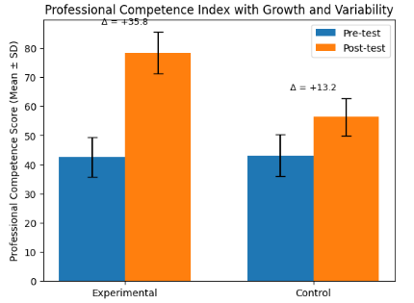
FIGURE 3. Professional competence scores before and after the intervention

Overall Result. The integrated model had a strong positive effect on:
- professional competence formation,
- theoretical knowledge acquisition,
- practical and experimental skills,
- modeling-based analytical thinking.
These findings empirically validate the effectiveness of combining pedagogical technologies with virtual modeling environments in the preparation of professionally competent specialists.
DISCUSSION
The findings of the study demonstrate that the integrated use of pedagogical technologies and virtual modeling significantly enhances the professional competencies of pre-service physics teachers. These results align with previous research. For example, Finkelstein et al. showed that virtual simulations improve conceptual understanding in physics, while Zacharia and Olympiou reported that virtual experimentation can be as effective as physical experimentation in fostering learning outcomes.
1. Advantages of the Integrated Approach. The effectiveness of the proposed instructional model can be attributed to several key factors:
a) Synergy between problem-based and interactive methods with 2D/3D modeling. Problem-based learning fosters active inquiry and analytical thinking, whereas simulations provide visual and dynamic representations of physical processes. This supports the conclusions of Sahin, who found that problem-based learning contributes to deeper conceptual understanding in physics.
b) Virtual laboratories’ capacity to develop experiment-related competencies. In this study, virtual labs based on Labster and Algodoo enabled students to acquire skills equivalent to real laboratory experiments, but in a safer and more efficient environment. This corresponds with the findings of de Jong, Linn, and Zacharia, who emphasized the pedagogical value of virtual laboratories in visualizing complex scientific phenomena.
c) Enhanced analytical and creative thinking through 3D modeling using Blender. The process of constructing 3D models requires students to apply theoretical knowledge, algorithmic reasoning, and creativity. This aligns with Baser and Durmuş, who found that 3D modeling environments significantly improve conceptual understanding in physics education.
2. Theoretical Justification of the Empirical Results. The results showed that the experimental group exhibited:
- a significant increase in the professional competence index,
- substantial improvement in practical skills, and
- meaningful gains in theoretical knowledge
compared to the control group.
These outcomes support the Technological Pedagogical Content Knowledge (TPACK) framework [17], suggesting that the productive combination of pedagogical, technological, and content-related knowledge leads to more effective teacher preparation.
3. Theoretical Significance of the Study. This research strengthens the theoretical foundations of technology-enhanced physics education by:
- proposing an integrated pedagogical–virtual modeling framework,
- identifying mechanisms for developing modeling competencies, and
- justifying the methodological use of digital tools in teacher preparation.
The model provides a structured methodological basis for improving the quality of physics teacher education.
4. Practical Significance. The practical outcomes of the study include:
- guidelines for implementing an integrated instructional approach in higher education institutions,
- a set of modeling-based virtual laboratory activities,
- project-based learning tasks focused on digital modeling, and
- a framework applicable to teacher training curricula.
These outputs can directly support curriculum developers, methodologists, and teacher educators.
5. Limitations. Several limitations should be acknowledged:
- The study was conducted at only two universities in Uzbekistan.
- The experiment spanned 14 weeks; long-term retention was not examined.
- Some students had limited prior experience with modeling tools, potentially influencing their learning progression.
Future studies should expand the sample size, explore long-term effects, and examine the application of the model across different subject domains.
CONCLUSION
This study developed and empirically validated an integrated methodology that combines pedagogical technologies with virtual modeling tools to enhance the professional competencies of pre-service physics teachers. The findings clearly demonstrate that the integration of 2D and 3D simulations, virtual laboratories, and interactive teaching strategies significantly strengthens students’ theoretical understanding. Furthermore, modeling-oriented tasks foster deeper analytical engagement, improve experimental reasoning, and support students in explaining complex physical processes through structured problem situations.
The positive learning dynamics observed throughout the experiment indicate that the functional alignment of pedagogical methods with virtual modeling tools plays a crucial role in increasing instructional effectiveness. The intentional combination of problem-based learning with 3D simulations, interactive strategies with 2D models, and experimental approaches with virtual laboratory environments contributed to the formation of more stable conceptual understanding among students. These outcomes highlight the theoretical relevance and practical value of the proposed integrated model.
The results also confirm that virtual modeling competence has become an essential component of modern teacher education in physics. The implementation of the integrated framework nurtures inquiry-oriented thinking, supports the development of research skills, and contributes to the comprehensive professional preparation of future teachers. Promising directions for future research include expanding the model with AR/VR technologies, enriching virtual laboratory environments with more advanced processes, and conducting longitudinal studies to evaluate sustained competency development.
REFERENCES
- Bernard.R.M., Borokhovski.E., Tamim.R. A meta-analysis of blended learning and technology integration in higher education. Journal of Computing in Higher Education, (2020). 32(3), 1–23.
- De Jong.T., Linn.M.C., Zacharia.Z.C. Physical and virtual laboratories in science and engineering education. Science, (2013). 340(6130), 305–308.
- Finkelstein.N.D., Adams.W.K., Keller.C.J., Kohl.P.B., Perkins.K.K., Podolefsky.N.S., Reid.S., LeMaster.R. When learning about the real world is better done virtually: A study using PhET simulations. Physical Review Special Topics – Physics Education Research, (2005). 1(1), 010103.
- Zacharia.Z.C., Olympiou.G. Physical versus virtual manipulative experimentation in physics learning. Research in Science Education, (2011). 41(4), 579–602.
- Kebritchi.M., Hirumi.A., Bai.H. The effects of modern educational technologies on teaching and learning. Computers and Education, (2017). 103, 1–14.
- Smetana.L.K., Bell.R.L. Computer simulations to support science instruction and learning. Science Educator, (2012). 20(3), 23–28.
- Bonde.M.T., Makransky.G., Wandall.J., Larsen.M.V., Morsing.M., Jarmer.H., Sommer.M.O. Improving biotechnology education through gamified laboratory simulations. Nature Biotechnology, (2014). 32(7), 694–697.
- Ergashev.S. Didactic possibilities of using virtual laboratories in physics education. Journal of Physics Education, (2022). 14(2), 55–63.
- Hutmacher.W. Key competencies for Europe. Council of Europe Publishing. 1997.
- Kent.T. Using Blender for STEM education: Enhancing visualization and simulation in physics learning. International Journal of Educational Technology, (2020). 17(1), 45–59.
- Nishonov.B. Theoretical foundations of applying innovative pedagogical technologies in higher education. Tashkent State Pedagogical University Press. 2021.
- OECD. OECD Learning Compass 2030: Competencies for the future. OECD Publishing. 2019.
- Sibilla.F., Zappi.D. Enhancing students’ understanding of mechanics using Algodoo simulations. European Journal of Physics Education, 2018. 9(3), 10–18.
- Tojiyev.U. Effectiveness of digital learning tools: Use of multimedia resources in the educational process. Uzbek Journal of Education, 2020. 25(1), 32–40.
- Wieman.C., Perkins.K. Transforming physics education. Physics Today, 2005. 58(11), 36–41.
- Yoldoshev.J. Pedagogical technologies and their role in the educational process. Journal of Higher Education, 2019. 6(3), 15–22.
- Mishra.P., Koehler.M.J. Technological Pedagogical Content Knowledge: A framework for teacher knowledge. Teachers College Record, 2006. 108(6), 1017–1054.
- Baser.M., Durmuş.S. Effectiveness of 3D modeling environments on students’ conceptual understanding in physics education. International Journal of Science and Mathematics Education, 2021. 19, 89–110.
- Wu.H.K., Lee.S.W.Y., Chang.H.Y., Liang.J.C. Current status, opportunities, and challenges of augmented reality in education. Computers and Education, 2013. 62, 41–49.
- Sahin.M. The impact of problem-based learning on student knowledge in physics. Journal of Science Education and Technology, 2010. 19(6), 551–556.

