Simulation and structural analysis of fiber-reinforced concrete beam using ANSYS
Abdurasul Martazaev ^{a)}, Ravshanbek Mavlonov, Odiljon Fozilov, Sohiba Numonova
Namangan state technical university, Namangan, Uzbekistan
^{a)} Corresponding author: abdurasul.mas@gmail.com
Abstract. The paper is a numerical examination of the reinforced concrete (RC) and fiber-reinforced concrete (FRC) beams, conducted through ANSYS on the finite element method (FEM). The study aims at assessing the effects of the polypropylene fiber content (0.1, 0.2 0.3 percent) and the length of the fibers (30mm) on the mechanical behaviour, stress distributions, deformations properties and the potential load bearing capacity of the beams during the bending loads. The nonlinear SOLID65 element was used to model the concrete, and LINK8 elements were used to represent the discrete fiber of polypropylene in order to represent the realistic fiber-matrix interaction and stress transfer mechanisms. The outcomes of the simulation demonstrate that tensile zone deformation, crack resistance, and ultimate strength of FRC beams are much higher than they are in conventional RC beams. The addition of fiber contributed to a 13÷16 percentage point improvement in the load-bearing capacity, greater control of cracks, and lower levels of deflection when subjected to a similar amount of load. The relative deformations of reinforcement and concrete were studied closely and proved the possibility of dispersed polypropylene fibres to slow down the crack propagation and enhance the structural performance under flexural loading.
INTRODUCTION
Fiber-reinforced concrete (FRC) is now considered as one of the most sophisticated and popular construction materials as it is characterized by better mechanical properties, such as a higher tensile strength, ductility, toughness, and crack resistance [1]. The incorporation of fiber into the concrete matrix, unlike standard reinforced concrete, may undergo brittle failure due to high stresses or tension dominated environments, delay the crack propagation and promote the overall structural performance [2]. In common practice, they are steel, polypropylene, and basalt, and these have been sporadically studied in the past research (Almohammed F. and Thakur M. S.; Y. Wang Y. et al., 2025) [3, 4]. It is important to have accurate analysis of structural elements of FRC especially beams in order to design safe and effective concrete structures. Although experimental studies can be very informative, they tend to be time consuming, expensive and inefficient in shaping the complex material behavior when subjected to different load conditions [5]. Thus, the use of numerical simulation techniques, in particular, finite element analysis (FEA), has become instrumental in the prediction of the mechanical behavior of fiber-reinforced concrete elements. FEA enables engineers and researchers to examine nonlinear reactions of materials, crack formation and development, deflection designs and ability of loads to be carried out in realistic service environments [6]. ANSYS among the existing FEA software has high functionality in modeling complicated structural systems including the impact of fiber reinforcement, heterogeneity of concrete, and nonlinear [7].
The recent research has proved the success of FEA in the case of FRC structural members. An example of this is a very recent study by Rio J. et al. 2023 that used a nonlinear global resistance approach to design hybrid glass fiber-reinforced polymer (GFRP) and steel fiber-reinforced concrete beam, where FEA results are shown to be able to accurately predict flexural behaviour and load-bearing capacity of beam hybrid systems [8]. S. Razzakov et al. are another recent study, which integrated experimental analysis with FEA to evaluate flexural behaviour of steel fiber-reinforced recycled-aggregate concrete beams, comparing crack development, load-deflection response and ultimate strength results that can be used to validate numerical modelling strategies to sustainable concrete composites. Likewise, a finite element analysis of flexural members of fiber reinforced concrete-steel using ANSYS was conducted in 2024 which showed that ANSYS had the ability to model the nonlinear stress-strain behaviour, crack propagation and failure mechanism under bending loads [9, 10, 11].
The current paper is dedicated to simulation and structural analysis of beam with fiber-reinforced concrete in ANSYS to determine the influence of fiber content and type on the mechanical behavior of beam with different loading conditions. This study aims to offer more insights into the behavior of cracks, deformation and load-bearing capacity through the development of the right numerical model, which will in the end help in designing concrete structure more efficiently and safely [12, 13]. The results of the current research are relevant to the development of knowledge about the structural behavior of the FRC and provide a reasonable suggestion to use the best of the fiber-reinforced concrete in the contemporary construction.

EXPERIMENTAL RESEARCH
According to the outcomes of experiment testing, concrete and fiber-reinforced concrete (FRC) materials were modeled as a simulative model of the mechanical behavior of the beam under a load. In the case of reinforced concrete beam, the SOLID65 element in ANSYS was used to model the concrete material. The SOLID65 element particularly works with three dimensional solid materials like concrete and it can also capture nonlinear material behavior. It can be used to simulate cracking, progressive failure, and deformations, including the mechanical properties of both compression and tension of concrete. This allows proper modeling of the structural performance of concrete when subjected to bending and tensile forces. The fiber model herein of polypropylene fibers that were reinforced with fiber-reinforced concrete was in the form of discrete reinforcing elements modeled by the LINK8 element. The fibers were joined together with the help of nodes installed into the concrete matrix so that the bond between the fibers and the concrete of the surrounding area was perfect. SOLID65 element was used to model the concrete matrix in 3D and the fibers were incorporated in 3D by means of nodal connections, so that they can simultaneously transmit stresses and deformations, just like the concrete. The fibers had mechanical properties that were determined as elastic modulus, tensile and compressive strength, and elastic-plastic behavior. The fibers were dispersed randomly in the concrete matrix and in ANSYS, the angles of orientation and the positions of the fiber within the space were explicitly set to recreate realistic fibre dispersion. The method of modeling allows to consider in details the interaction of fibers with concrete, finding out the efficiency of reinforcement, the control of cracks, and the general performance of beams based on fiber-reinforced concrete.
During the simulation process, reinforced concrete and fiber-reinforced concrete beams were modeled with cross-sectional dimensions of 100 × 200 × 1200 mm. These dimensions were selected in accordance with standard laboratory conditions and were used as the basic geometry for the 3D modeling of the beams. The general view of the modeled beam is shown in Figure 1.
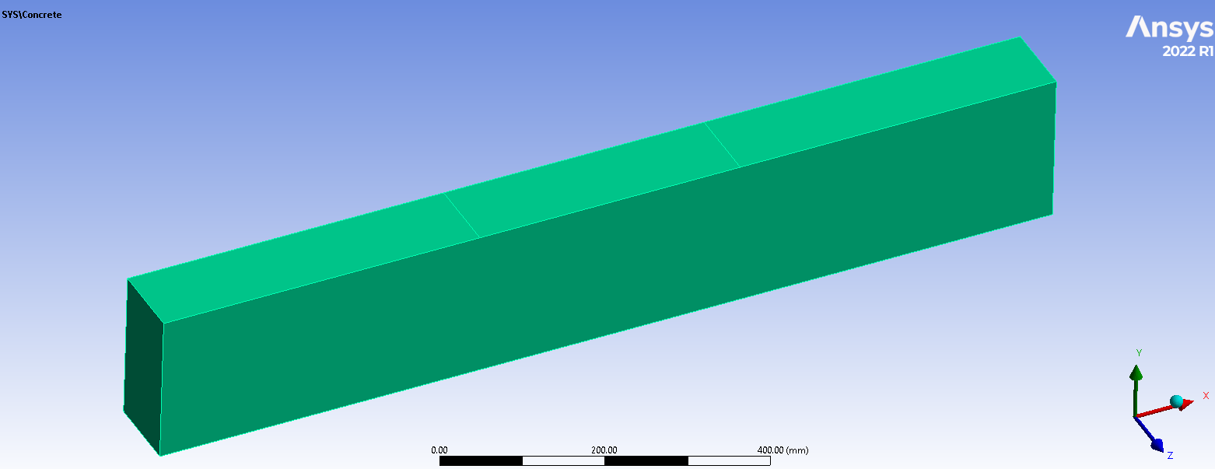
FIGURE 1. The general view of the beam

In the numerical models, polypropylene fibers with a length of 30 mm were incorporated into the concrete matrix to represent fiber-reinforced concrete beams. The fibers were added in varying volume fractions of 0.1%, 0.2%, and 0.3%, corresponding to different reinforcement levels. Each fiber was modeled as a discrete element within the 3D concrete matrix, ensuring proper interaction and stress transfer between the fibers and the surrounding concrete. This approach allowed for a systematic investigation of the influence of fiber content on the mechanical performance of the beams, including crack propagation, load-bearing capacity, and deformation behavior. By simulating multiple fiber concentrations, the study provides insights into the optimal fiber dosage for enhancing structural performance while maintaining material workability and uniform fiber distribution. An overview of the modeled polypropylene fibers is shown in Figure 2.
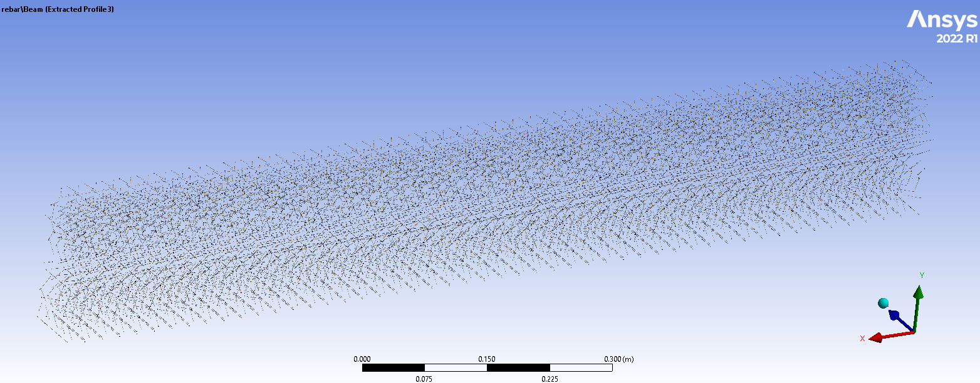
FIGURE 2. General view of modeled polypropylene fibers
RESEARCH RESULTS
A detailed numerical modeling of the ANSYS program was done in order to get a wide range of results concerning the stress-strain behavior of ordinary reinforced concrete beam and fiber-reinforced concrete beam. The simulations gave the information on the stresses and relative deformations of the longitudinal reinforcement, the stress distribution within the compression and tension zones of the beam cross-sections. Besides that, the overall deformation fields, the vertical deflections along the beam span, the areas susceptible to cracks, and the overall load-bearing capacity and strength profile of the investigated sample beams were determined with the assistance of the modeling.
The tensile portion of the beam had a relative deformation of the reinforcement that was maximum and was ɛ_{с}=235.05·10⁻⁵. The relative deformation in the tensile working reinforcement was ɛ_{c}=277.12·10⁻⁵, when the destructive load on the fiber-reinforced concrete beam with dispersion reinforcement of 0.1% polypropylene fibers length of 30 mm in the concrete reached 85÷90% normal cross-section, relative deformation in the working reinforcement of the samples with dispersion reinforcement of 0.2% was ɛ_{c}=269.10·10⁻⁵and relative deformation in the working reinforcement of the samples with Figure 3 indicates the normal section deformations of a reinforced concrete beam in relative terms.
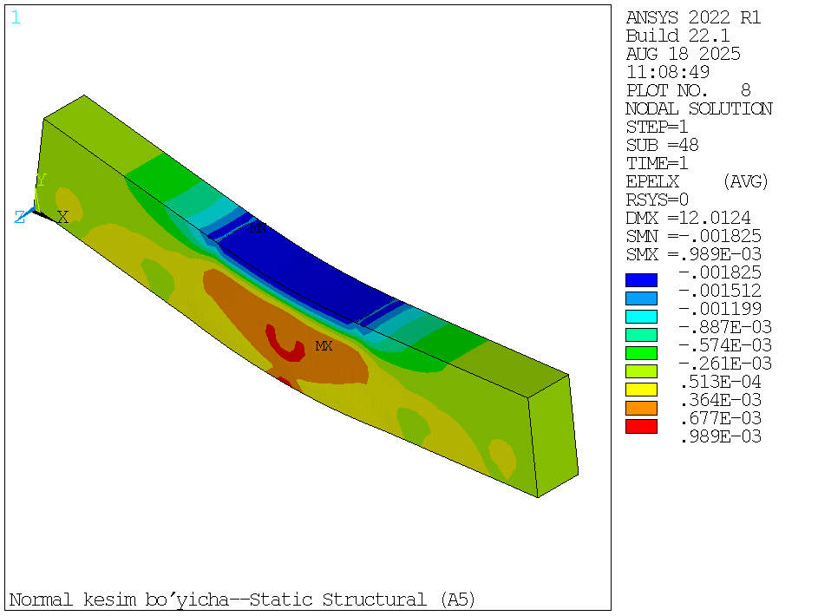
FIGURE 3. Appearance of relative deformation along the normal section in a reinforced concrete beam
The relative deformation of the concrete in the tensile section of the fiber-reinforced concrete beam of 0.1% polypropylene fiber length of 30 mm dispersive reinforcement was ɛ_{fbt}=128.81⁻⁵ at the tensile section when the destructive load of the beam was 80÷90% and the relative deformation of the concrete in the compression part of the fiber-reinforced concrete beam was ɛ_{fb}=36.91⁻⁵. In the tensile section of the fiber-reinforced concrete beam and polypropylene fibers dispersion reinforcement of 0.2 percentage with length of 30 mm, relative deformation of the concrete in the compression zone of the fiber-reinforced concrete beam was ɛ_{fbt}=132.41⁻⁵ and the maximum relative deformation of the concrete in compression zone of the fiber-reinforced concrete beam was ɛ_{fb}=44.91⁻⁵. The relative deformation of the concrete in tensile part of the fiber-reinforced concrete beam was ɛ_{fbt}=136.11⁻⁵, and the maximum relative deformation of the concrete in compression part of the fiber-reinforced concrete beam was ɛ_{fb}=28.61⁻⁵, in the tensile part of the fiber-reinforced concrete beam with a dispersion reinforcement of 0.3% polypropylene fibers with a length of 30 mm. Relative deformation on normal section of a fiber reinforced concrete beam is indicated in fig.4.
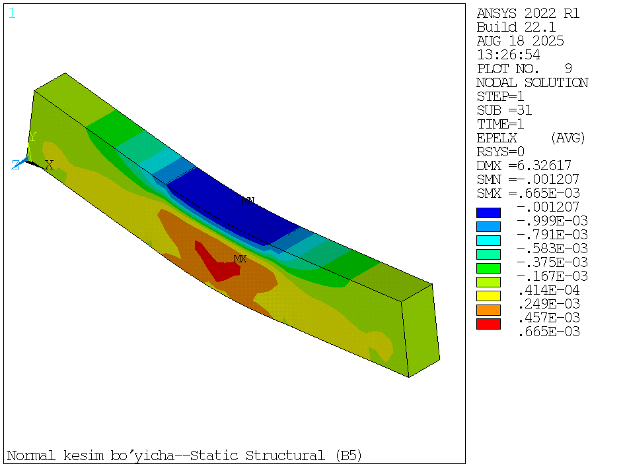
FIGURE 4. Appearance of relative deformation along the normal section in a fiber reinforced concrete beam
The outcome of the examination of the deflections in beams under load indicates that the values of deflections rose in a linear way at the initial values of the loads. As soon as the tensile zone reinforcement was at the yield point, the values of deflection started to rise steeply. The deflection was 0.42 mm when the value of the breaking force along the normal section was 40 % and the deflection was 12.01 mm when the breaking force was 73.49 kN in a conventional reinforced concrete beam. In introducing polypropylene fibers with a length of 10 mm into the concrete in proportion of 0.1, the deflection in the sample when the value of the breaking force along the normal section was 40 %, when 0.2, it was 0.3 and when 0.3 it was 0.40 mm.
As the value of the breaking force was highest in samples with 0.1% fiber in the normal section, deflection was highest there, 16.60 mm, in samples with 0.2 percent fiber was 14.52 mm, and in samples with 0.3% fiber was 15.02 mm. In a fiber-reinforced beam of concrete, which was eventually reinforced with 30 mm long polypropylene fibers sparsely placed in the beam and wherein the force of breaking was found to be 40% at the normal section, the displacement was within the range of 0.36 to 0.41 mm. It was 15.9 mm at the maximum breaking force in the normal section. Figure 5 shows the strength properties of fiber reinforced concrete beams.
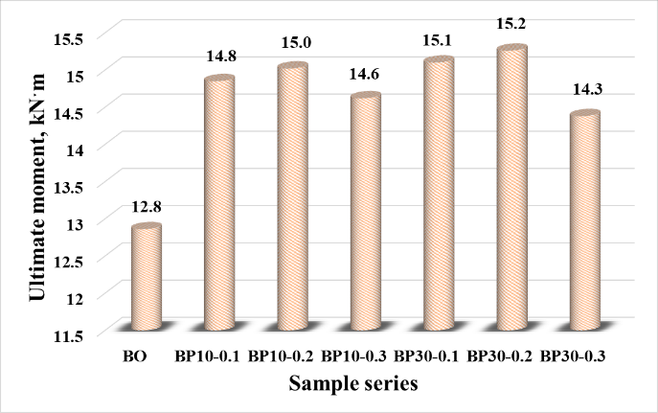
FIGURE 5. Strength characteristics of fiber-reinforced concrete beams
Stresses and crack limitation were found to be the results of the study, indicating that polypropylene fibers can absorb stresses and the normal section of the destructive moment of the fiber-reinforced concrete. The length and proportion of the fibers were also very essential in providing maximum strength of the concrete.
CONCLUSIONS
1. New scientific findings were made on the stresses and relative deformations in reinforced concrete and fiber reinforced concrete beam reinforcement, compressive and tensile parts of beams stresses, total deformations, deflections, and strengths of sample beams through modeling, which was used in the ANSYS program.
2. Based on the obtained result in ANSYS program, it was discovered that the addition of dispersed reinforcement in concrete by adding 30 mm long fibers in 0.1, 0.2, 0.3% increases the strength of fiber-reinforced concrete beams by 13÷16% and the strength of ordinary reinforced concrete beams.
3. They were found out to be a linear one in the initial values of the loads on the deflections of the fiber-reinforced concrete and reinforced concrete beams, and the deflection of the reinforced concrete beam is higher than the deflection of the fiber-reinforced concrete beam when the loads are suddenly increasing due to the uniform loads on them.
REFERENCES
- A. Martazaev and S. Khakimov, “Dispersed reinforcement with basalt fibers and strength of fiber-reinforced concrete beams,” AIP Conf. Proc., vol. 3256, p. 030011, 2025, https://doi.org/10.1063/5.0266797
- R. Mavlonov and S. Razzakov, “Numerical modeling of combined reinforcement concrete beam,” E3S Web Conf., vol. 401, p. 03007, 2023, https://doi.org/10.1051/e3sconf/202340103007
- F. Almohammed and M. S. Thakur, “Forecasting compressive strength of concrete with basalt and polypropylene fiber by using ANN, RF and RT models,” Asian J. Civ. Eng., vol. 25, no. 2, pp. 1671–1690, 2024. https://doi.org/10.1007/s42107-023-00870-4
- Y. Wang et al., “Strength characteristics of polypropylene fiber-modified rubber foamed concrete,” Buildings, vol. 15, no. 10, p. 1663, 2025, https://doi.org/10.3390/buildings15101663
- Y. Chen et al., “Durability properties of macro-polypropylene fiber reinforced self-compacting concrete,” Materials, vol. 17, no. 2, p. 284, https://doi.org/10.3390/ma17020284
- E. Najaf and H. Abbasi, “Impact resistance and mechanical properties of fiber‐reinforced concrete using string and fibrillated polypropylene fibers in a hybrid form,” Struct. Concr., vol. 24, no. 1, pp. 1282–1295, 2023, https://doi.org/10.1002/suco.202200019
- S. Gong et al., “Effect of polypropylene fiber and nano-silica on the compressive strength and frost resistance of recycled brick aggregate concrete,” Nanotechnol. Rev., vol. 12, no. 1, p. 20230174, 2023, https://doi.org/10.1515/ntrev-2023-0174
- “Investigating the influence of polypropylene and steel fibers on the mechanical properties of UHPFRC,” Matéria (Rio J.), vol. 29, no. 4, 2024, doi:10.1590/1517-7076-RMAT-2024-0708. https://doi.org/10.1590/1517-7076-RMAT-2024-0708
- S. Razzakov and A. Martazaev, “Mechanical properties of concrete reinforced with basalt fibers,” E3S Web Conf., vol. 401, p. 05003, 2023, https://doi.org/10.1051/e3sconf/202340105003
- R. Mavlonov, S. Razzakov, and S. Numanova, “Stress-strain state of combined steel-FRP reinforced concrete beams,” E3S Web Conf., vol. 452, p. 06022, 2023, https://doi.org/10.1051/e3sconf/202345206022
- E. S. George, R. Hari, and M. K. Madhavan, “Performance assessment of blended self-compacting concrete with ferrochrome slag as fine aggregate using functional ANOVA,” J. Build. Eng., vol. 89, p. 109390, 2024, https://doi.org/10.1016/j.jobe.2024.109390
- A. Martazaev, M. Orzimatova, and M. Xamdamova, “Determination of optimum quantity of silica fume for high-performance concrete,” AIP Conf. Proc., vol. 3256, p. 030012, 2025, https://doi.org/10.1063/5.0266799
- Y. Nouri, M. A. Ghanbari, and P. Fakharian, “An integrated optimization and ANOVA approach for reinforcing concrete beams with glass fiber polymer,” Decis. Anal. J., vol. 11, p. 100479, 2024, https://doi.org/10.1016/j.dajour.2024.100479

