Decision-Oriented Optimization in Hybrid Renewable Energy Systems: Systematic Review of Methods and Future Potential

Ibragim Askarov ¹, Mirjalol Muminjonov ¹, Dilnoza Xojimatova¹, Roziya Nazirtashov ², Mаrhаbо Xоlmаtоvа ³, Makhliyo Makhmudova¹, Nargiza Atakulova^{1,a)}
¹ Andijan State University, Andijan, Uzbekistan
² Fergana Medical Institute of Public Health, Fergana, Uzbekistan
³ Fergana State University, Andijan, Uzbekistan
^{a)} Corresponding author: nargizaatakulova456@gmail.com
Abstract. Though Hybrid Renewable Energy Systems play an important role in the Sustainable Energy Transition, their designing and functioning pose many optimization challenges when considering different components, stochastic resources, as well as multiple objectives. The systematic review consolidates the HRES optimization problem space and points out key research gaps. We recommend that future studies should focus on interdisciplinary collaboration, standardized social/resilience metrics, scalable and trustworthy AI and validation frameworks to unlock the potential of HRESs.
INTRODUCTION
One of the key drivers of such impacts is the innovation of sustainable energy system [1] which in turn has promoted the innovation of HRESs. Such systems integrating multiple renewable resources (including solar, wind, and biomass) with storage and normal backup generating plants provide a feasible strategy to control the sporadic system renewable potential of individual renewables in conjunction with the reliable and economical performance of the whole system as a whole [2]. As one of the pressing challenges related to the design and implementation HRES, its complicatedness means that complexity in nature (number of components and stochastic energy sources, multiplicity of operational objectives and targets) poses as an optimization challenge [3]. The optimization of an HRES does not include the simple choice of the component but instead entails fine detailing the optimization of size, configuration, and operation strategy to balance the conflicting economic, technical, environmental and social conditions [4]. The aim of this review therefore is to draw on and deepen the wide-ranging HRES optimisation literature. It starts with an initial assumption: the physical and logical structures that comprise problem space provide the foundations for a shared mathematical formulation where language is used to perform comparative work. Thus, as this part deconstructs the problem into its defining aspect which is architectures, decision variables, objectives, constraints, it will outline a comprehensive overview of the current status quo in the field and then the types of challenges going ahead.

EXPERIMENTAL RESEARCH
While energy safety and decarbonization of energy systems is high on the agenda, the new focus on energy security has established HRES as the front-runner. But the mass introduction of variable renewables (VRE) at a global scale creates large overall systemic risks that threaten stability and reliability of modern power grids. These challenges shouldn’t be seen as technical hurdles, but instead, they represent basic strategic obstacles that must be overcome for a successful energy transition. The main risk is the threat to the grid stability and the increased vulnerability of blackouts. To stabilise the frequency, most conventional power systems depend on the rotational inertia of huge synchronous generators (e.g., coal or gas plants). Thus, this stored kinetic energy naturally resists a change in frequency given the supply–demand imbalance and allows the operator time to react [5]. Solar and wind are among the VRE sources that connect to the grid using power electronic inverters and lack this physical inertia. With higher penetration of VRE, systemic inertia decreases, contributing to the susceptibility of the grid to disturbances [6]. If power is out of a device suddenly, out of an entire network, or because of load variation, a much faster Rate of Change of Frequency (RoCoF) rate will occur and protection mechanisms might be triggered causing cascading failures which may lead to a massive blackout [7]. Such a dynamic has been recognized as one of its most serious challenges, as contemporary power systems were not built to run with this low inertia.
Optimization of HRES is not possible to be carried out away from the political and economic arena; it situates the practice in a dynamic global geopolitical environment. The energy transition creates an acute shift in resource dependency; the geopolitics of coal, oil and gas are replaced by new sources of vulnerability associated with supply chains for critical minerals. The technologies at the core of HRES photovoltaic panels, wind turbines and batteries rely on elements including lithium, cobalt, nickel and rare earth elements. These minerals are extracted and processed in very specific countries [10]. For instance, the DR Congo produced 70% of the world’s cobalt in 2022 and China processed the majority of the world’s rare earths, lithium, and cobalt [11]. This concentration also leads to new strategic dependencies and supply chain choke points, which can be subject to disruption by trade disputes, political instability, or resource access as a political weapon [12]. Geopolitical tensions can disrupt the supply chain causing price fluctuations and a shortage of components essential to energy production. This phenomena, known as “greenflation,” reflects the inflationary burden on resource prices for energy transition projects, which could threaten their economic sustainability. Without consideration of the possibility of price shocks due to geopolitical events, optimization models based on stable yet predictable capital costs inputs for some components can produce false, misleading results. Thus, a genuinely robust optimization must take into account both supply chain diversity and geopolitical risk as key considerations. In addition, the growing digitalization and interconnectedness of modern energy systems also pose threats to security. Smart grids and decentralized HRES’s – even though they have the advantages of improved efficiency, they also open up many attack surfaces for cyberattacks by both state and non-state actors that are seeking to cause significant disruption to critical infrastructure [14]. Both global supply chain threats have combined with digital security threats have also accelerated strategic energy independence drive. Nationally, this leads to investment in domestic manufacturing, which ultimately means funding for domestic manufacturing and multiple types of energy investments. Local level, it drives the design of resilient, islandable microgrids able to sustain power for the critical installations when the grid is outages or other similar types of disruptions are experienced. This indicates that optimization goals are expanding beyond cost reduction and are now inclusive of metrics of resilience and energy security that can be measured, which are directly impacted by the geopolitical situation that has implications globally.
RESEARCH RESULTS
A systematic study of academic literature was conducted to identify and select relevant literature, according to the PRISMA 2020 standard (Figure 1) [15], and in the following subsection, the process developed is discussed. Based on the results of this study, we developed a systematic analysis covering all relevant papers used in the course analysis literature. It includes the formulation of a comprehensive search strategy, the establishment of well-defined inclusion and exclusion criteria, and the study selection procedure documented in a PRISMA flow diagram. Designing the Systematic Search Strategy. A systematic search strategy was created to identify relevant academic articles that focused on the optimization of Hybrid Renewable Energy Systems. To conduct this search plan, we decided the choice of specific academic databases and designed powerful search queries that would cover the whole relevant body of data. Databases Searched: The electronic databases that are prominent for their provision of the engineering, energy, and environmental sciences material were searched. This general structure was used differentially and was adjusted for the specific syntax and search capabilities of each database, as shown in Table 1. Articles published in the English language were only included in the search. While allowing for the discovery of trends (the search period was used to capture recent changes), to cover both the search period 1 Jan 2014 to 15 July 2025 (the end date represents the latest available information in the date on which the search was performed). Results. The HRES optimization problem is mostly constrained decision-making under uncertainty [16]. The key to achieving desired outcomes is the choice of the best approach for the system components and operating rules, on the basis of the physical restrictions of the equipment, the uncertain characteristics of renewable energy resources, and electricity demand [17]. The nature and computational complexity of this optimization task are fundamentally determined by the architecture of the system itself, both physically and logically. Figures 1–2 display articles that are categorized based on funding sponsor, country/territory, and subject area, respectively (Figure 2).
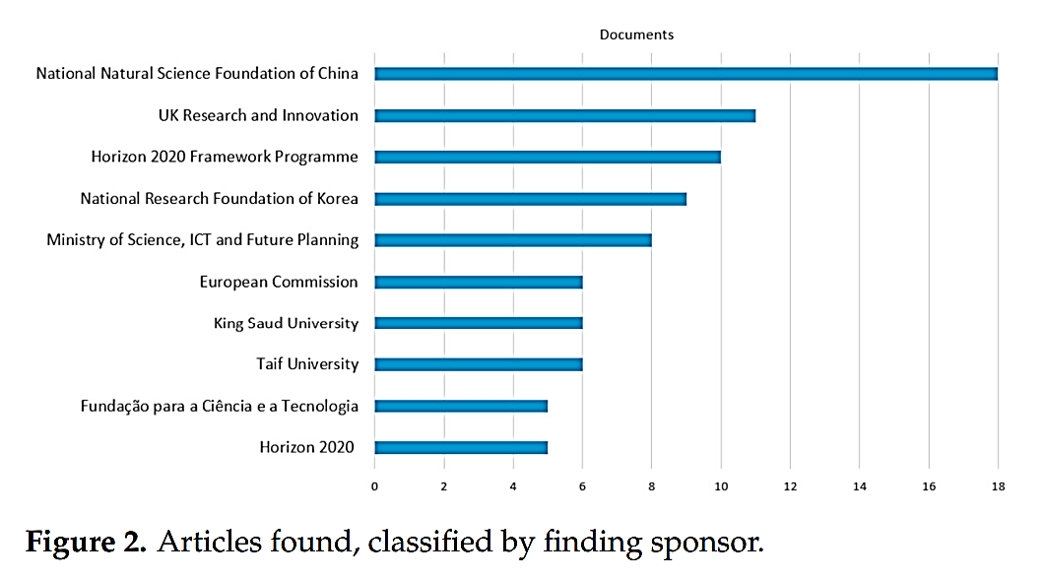
FIGURE 1. Articles found, classified by finding sponsor.

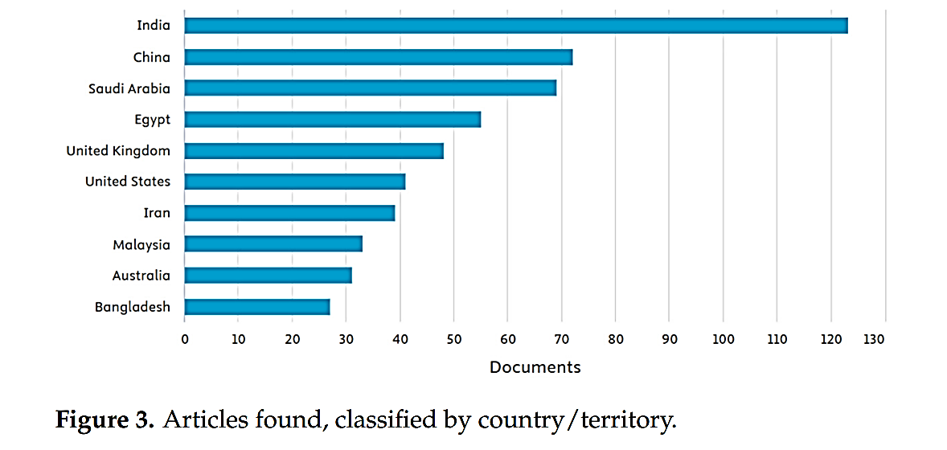
FIGURE 2. Articles found, classified by country/territory

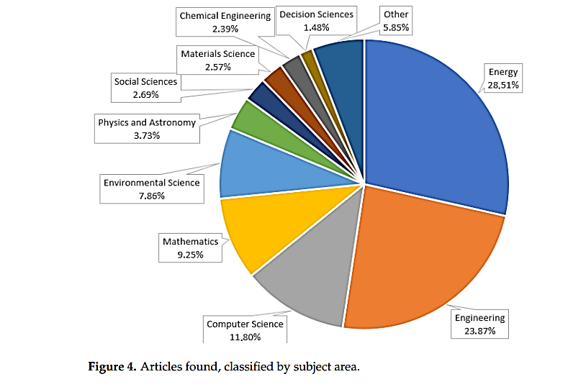
FIGURE 3. Articles found, classified by subject area.

HRES architecture determines patterns of energy flow and relationship between components and thus, it is the construction of the optimization model. Choosing a specific architecture introduces particular constraints and variables that will need to be considered [18]. Thus, knowledge of these architectural choices is the first step in forming an adequate optimization problem.
CONCLUSIONS
This systematic review in 2015–mid-2025 synthesises new research on optimizing Hybrid Renewable Energy Systems (HRESs). Rather than single-objective economic or technical analysis, research has evolved into multi-objective optimization (MOO) frameworks that explicitly encompass trade-offs between economic, technical, environmental, social, and resilience criteria. Over recent years, Pareto-front methods (e.g., NSGA-II, MOPSO) have been accepted for support for design decisions. However, metaheuristic algorithms (GA, PSO, NSGA-II, MOPSO and recent swarm variants) remain popular in HRES because, as we see it, HRES problems are nonlinear and mixed-integer. Now hybrid approaches are deployed to improve convergence and local refinement, combining metaheuristics with classical solvers, or surrogate/ML models. Artificial neural networks (ANNs) and other ML tools have been extensively adopted for forecasting (solar, wind, load) and surrogate modeling to minimize computational cost. Deep reinforcement learning (DRL) and adaptive AI-based EMS methods for operational control are also developing, although very much in their research and proof-of-concept phase. GHG emissions and other environmental measures have become commonplace, whereas social measures (employment, social acceptance and equity) and resilience metrics (VoR, SAIDI/SAIFI, restoration rates) are becoming more integrated, albeit frequently inconsistently delineated. Furthermore, the models even now include hydrogen storage, V2G as well as multi-vector coupling (heat, transport, gas) and long-duration storage, drastically expanding the dimensionality of decision making and the requirement for high-quality component simulation. Resource and demand uncertainty is handled through stochastic, robust and distributionally robust optimization, supported by scenario reduction and surrogate models. Nevertheless, both scarcity of data and computational effort continue to be significant barriers to broad scale, real-time operations. HOMER and other accessible tools are common for feasibility studies, but in comparison, lack the scale necessary for advanced MOO and EMS applications. As a result, most researchers utilize custom implementation in MATLAB/Python. Reproducibility problems stem from proprietary datasets, variable reporting of algorithmic characteristics, and a lack of standardized benchmarks. Its main deployment limitations include computational scalability, explainability and trust in AI controllers, lack of high-fidelity degradation models (for batteries, electrolyzers, fuel cells) and the perennial “valley of death” between simulation outputs and bankable, field-validated projects. This review is also limited in scope. The search was limited to three major English language databases (Scopus, IEEE Xplore, Web of Science) and might therefore be subject to language and regional bias. This review advocates for the need to incorporate social and geopolitical aspects in quantitative optimization frameworks, but the majority of the existing works are qualitative. Meaning translating constructs like “social acceptance” or geopolitical risks into mathematically tractable objectives or boundaries is a challenge across various areas of research. A systematic review, then, may take an idea in the field in a snapshot, since technological innovation (AI algorithms, battery chemistry, SMR design) and policy development are driving change at an unprecedented pace. It is probable that new findings were introduced during the paper's publication window. Furthermore, the peer-reviewed research tends to focus on new algorithms, while the industrial practice, project finance documentation, regulatory case studies, and engineering good practice, including the ones used to achieve bankability and large-scale implementation are largely downplayed in academic literature.
REFERENCES
- Giedraityte, A.; Rimkevicius, S.; Marciukaitis, M.; Radziukynas, V.; Bakas, R. Hybrid Renewable Energy Systems—A Review of Optimization Approaches and Future Challenges. Appl. Sci. 2025, 15, 1744. [CrossRef]
- Thirunavukkarasu, M.; Sawle, Y. A Comparative Study of the Optimal Sizing and Management of Off-Grid Solar/Wind/Diesel and Battery Energy Systems for Remote Areas. Front. Energy Res. 2021, 9, 752043. [CrossRef]
- Bamisile, O.; Cai, D.; Adun, H.; Dagsi, M.; Ukwuoma, C.C.; Huang, Q.; Johnson, N.; Bamisile, O. Towards Renewables Development: Review of Optimization Techniques for Energy Storage and Hybrid Renewable Energy Systems. Heliyon 2024, 10, e37482. [CrossRef] [PubMed]
- Ajiboye, O.K.; Ochiengbu, C.V.; Ofosu, E.A.; Gyamfi, S. A Review of Hybrid Renewable Energies Optimisation: Design, Methodologies, and Criteria. Int. J. Sustain. Energy 2023, 42, 648–684. [CrossRef]
- Mehigan, L.; Al Kez, D.; Collins, S.; Foley, A.; Ó Gallachóir, B.; Deane, P. Renewables in the European Power System and the Impact on System Rotational Inertia. Energy 2020, 203, 117776. [CrossRef]
- Ali, J.S.; Qiblawey, Y.; Alassi, A.; Massoud, A.M.; Muyene, S.M.; Abu-Rub, H. Power System Stability with High Penetration of Renewable Energy Sources: Challenges, Assessment, and Mitigation Strategies. IEEE Access 2025, 13, 39912–39934. [CrossRef]
- Fotis, G.; Maris, T.I.; Mladenov, V. Risks, Obstacles and Challenges of the Electrical Energy Transition in Europe: Greece as a Case Study. Sustainability 2025, 17, 5325. [CrossRef]
- Zaheb, H.; Ahmadi, M.; Rahmany, N.A.; Danish, M.S.S.; Fedayi, H.; Yona, A. Optimal Grid Flexibility Assessment for Integration of Variable Renewable-Based Electricity Generation. Sustainability 2023, 15, 15032. [CrossRef]
- Hinrichs-Rahlwes, R. Renewable Energy for Climate Protection and Energy Security: Lessons Learned from the European Green Deal and REPowerEU. In Transition Towards a Carbon Free Future; Springer: Cham, Switzerland, 2024; pp. 245–257.
- The Geopolitics of the Global Energy Transition; Hafner, M., Tagliapietra, S., Eds.; Springer International Publishing: Cham, Switzerland, 2020; Volume 73, ISBN 978-3-030-39065-5.
- Gulley, A.L. One Hundred Years of Cobalt Production in the Democratic Republic of the Congo. Resour. Policy 2022, 79, 103007. [CrossRef]
- Islam, M.M.; Mariev, O.; Sohag, K. International Mineral Trade—Cleaner Energy Transformation Nexus: How Decomposed Mineral Prices and Geopolitical Events Act? Energy Strategy Rev. 2025, 59, 101699. [CrossRef]
- Betterelli, L.; Furceri, D.; Pisano, L.; Pizzuto, P. Greenflation: Empirical Evidence Using Macro, Regional and Sectoral Data. Eur. Econ. Rev. 2025, 174, 104983. [CrossRef]
- Chen, J.; Yan, J.; Kemmegne, A.; Kassouf, M.; Debbabi, M. Cybersecurity of Distributed Energy Resource Systems in the Smart Grid: A Survey. Appl. Energy 2025, 383, 125364. [CrossRef]
- Page, M.J.; McKenzie, J.E.; Bossuyt, P.M.; Boutron, I.; Hoffmann, T.C.; Mulrow, C.D.; Shamseer, L.; Tetzlaff, J.M.; Akl, E.A.; Brennan, S.E.; et al. The PRISMA 2020 Statement: An Updated Guideline for Reporting Systematic Reviews. BMJ 2021, 372, n71. [CrossRef] [PubMed]
- Rezk, H.; Mukhametzyanov, I.Z.; Al-Dhaifallah, M.; Ziedan, H.A. Optimal Selection of Hybrid Renewable Energy System Using Multi-Criteria Decision-Making Algorithms. CMC–Comput. Mater. Contin. 2021, 68, 2001–2027. [CrossRef]
- Ahmad, S.; Ullah, I.; Jamil, F.; Kim, D. Toward the Optimal Operation of Hybrid Renewable Energy Resources in Microgrids. Energies 2020, 13, 5482. [CrossRef]
- Singh, R.; Bansal, R.C. Review of HRESs Based on Storage Options, System Architecture and Optimisation Criteria and Methodologies. IET Renew. Power Gener. 2018, 12, 747–760. [CrossRef]

