Improving Mechanical Power Monitoring of Rotating Mechanisms Under Unstable Loads
Rustam Baratov¹, Murodjon Begmatov^{1,a)}, Mashrab Abdullayev², Botir Xushboqov³, Jumanazar Kodirov³
¹ “Tashkent institute of irrigation and agricultural mechanization engineers” National Research University, Tashkent, Uzbekistan
² Urgench state university, Urgench, Uzbekistan.
³ Termez State University of Engineering and Agrotechnologies, Termez, Uzbekistan
^{a)} Corresponding author: murod05071991@mail.ru
Abstract. Real-time mechanical power measurement of agricultural tractor rotating mechanisms, particularly the power take-off (PTO), is affected by unstable loads and dynamic operating conditions. The purpose of this study is to improve the accuracy of mechanical power monitoring under such conditions. The dynamic behavior of the PTO was analyzed experimentally, and the limitations of conventional power measurement methods based on instantaneous torque and angular velocity were investigated. It was found that mechanical oscillations of the power take-off shaft, transmission, and engine, together with sensor response mismatches, phase shifts, and digital signal processing delays, lead to significant dynamic measurement errors. To address these limitations, an electromagnetic angular acceleration sensor is proposed and evaluated. The results demonstrate that the proposed approach enables more reliable real-time mechanical power measurement under unstable loading conditions, increases measurement accuracy and sensitivity, and provides a basis for predicting emergency operating states and implementing predictive maintenance strategies.
INTRODUCTION
In recent years, the increasing global demand for food has contributed to a substantial rise in food prices. Addressing this challenge necessitates, first, a reduction in the cost of energy resources utilized in food production, as well as the accelerated adoption of energy-efficient agricultural machinery. In this context, the Republic of Uzbekistan has implemented the Agricultural Development Strategy for the period 2020–2030 [1]. The strategy underscores the importance of deploying high-performance modern agricultural machinery and equipment to support the intensive and sustainable development of the agricultural sector.
According to studies reported in the technical literature, approximately 40–45% of the power generated by modern tractor engines is consumed by onboard systems [2-3].
A portion of the tractor’s power is expended to overcome inertial forces during acceleration. However, most agricultural operations are typically performed under steady-state operating conditions [2-5]. Under steady-state conditions, the tractor’s inertial forces and angular acceleration are zero. However, variations in field topography and soil resistance result in non-uniform tractor motion. Consequently, angular acceleration represents a key parameter in the assessment of tractor power[6-8].
According to [2], increasing travel speed reduces the penetration depth of plows operated by tillage tractors. Uniform plowing depth is therefore a key performance indicator, as it provides consistent conditions for crop development and maturation.
RELATED RESEARCH WORKS
Recent research has focused on the development of angular acceleration sensors for measurement the actual power transmitted by agricultural tractors to external implements. For agricultural tractors, the power and torque at the power take-off (PTO) shaft represent key technical characteristics, as they directly influence tractor performance and cost. Consequently, a variety of angular acceleration sensor designs based on different operating principles has been proposed for the measurement of power and torque [9-13].
Non-contact methods for measurement angular acceleration have been developed, among which electromagnetic angular acceleration sensors are widely used [14]. Such sensors typically consist of excitation and measurement coils, a stator and a rotor, an inductive angular sensor, and a spring. To extend the service life of the device, the spring is integrated into the stator excitation coil. In addition, the rotor comprises two toothed rings that mechanically couple the stator and rotor [14].
The primary limitation of this design is its low reliability, resulting from manufacturing complexity and the presence of a toothed rotating element. A related angular acceleration sensor based on the transformer principle employs a П-shaped magnetic core with a wound coil, while the rotor is positioned opposite the stator poles. The rotor coils are interconnected, with one stator coil driven by a high-frequency generator and the other connected to a recording unit [15].
This type of angular acceleration sensor has a relatively complex design and requires a stable power supply. In the capacitive sensor proposed by Yu. I. Getman, Kogan, and L. B. Masandilov, variations in angular velocity cause deformation of an elastic element, thereby changing the relative rotation between the inertial disk and the shaft and altering the spacing between capacitor plates. The resulting change in capacitance produces a variation in the output voltage frequency [16].
One of the primary limitations of this sensor is the sensitivity of its capacitance to environmental factors. Accurate capacitance measurements require consideration of the dielectric properties of the surrounding medium. M. F. Zaripov and N. U. Mallin developed sensors based on the induction principle. These sensors operate by detecting changes in the electromotive force in the output circuit, which occur when angular acceleration causes displacement of the inertial mass and alters the number of turns in the measurement coil [17].
However, due to the nonlinearity of its static characteristics, this sensor exhibits low measurement accuracy. In addition, angular acceleration sensors operating on the electromagnetic principle have been developed [18].These sensors typically comprise a magnetic core, an inertial mass mounted on the core, and excitation and measurement coils. Their operation is based on the displacement of the inertial mass under angular acceleration, which induces an electromotive force in the measurement coil.
Limitations of this sensor is that the inertial mass is composed of two different materials, which causes the center of mass to shift from the geometric center. This displacement, in turn, results in measurement errors.
S. A. Orlov, L. A. Zavinovsky, and A. I. Skalon proposed the use of an angular accelerometer for measurement angular acceleration. In their design, the inertial mass oscillates about the sensitivity axis in response to angular acceleration. The input motion produces temporary modulation of the output signal, and feedback within the sensor is implemented via a comparator [19].
The complexity of the angular accelerometer design, combined with changes in the properties of its permanent magnet due to temperature rise, contributes to increased measurement errors.
In liquid-rotor-based angular acceleration sensors, the electrical conductivity and viscosity of the working fluid play a critical role [20]. The sensor’s detector element comprises a dielectric cylinder, within which metal electrodes are positioned diametrically opposite each other. Excitation coils are arranged above and below the electrodes, perpendicular to their plane, while the annular gap is filled with the working fluid. An electrical signal, proportional to angular acceleration, is transmitted through the fluid to the electrodes and then to the measurement device, producing an output signal corresponding to angular acceleration. In sensors operating on the electrokinetic principle, a liquid medium is also employed, where a potential difference arises because of electrokinetic effects [21].
However, the primary limitation of liquid-based sensors is that the working fluid does not immediately return to its equilibrium state. In inductive-type angular acceleration sensors, the viscosity of the ferromagnetic fluid has been observed to vary with the current [21]. In these sensors, angular acceleration is converted into changes in the inductance of a coil. Measurement errors caused by mechanical play prevent the rotating magnetic core from maintaining fully synchronous rotation.
In this type of sensor, angular acceleration causes the movable casing of the sensitive element to deflect by a certain angle, resulting in a change in the sensor’s differential capacitance [22-23]. When the balance of the alternating-current bridge is disturbed, the resulting signal is processed by the sensor electronics and applied to the bridge coils, with the voltage adjusted according to the load resistance Rn​. The construction of this sensor is relatively complex, comprising numerous small components. Furthermore, the flexible elements are temperature-dependent, which may lead to measurement errors.
Another study utilized measurements of torque and angular velocity to determine tractor power [25]. In this approach, the device resembles a vehicle disc brake system, with a load artificially applied to the power take-off (PTO) shaft while torque and angular velocity are measured. Tractor power is subsequently calculated using the following formula:

$P=\frac{2πNT}{60000}$, (1)

where, N - is the rotational speed of the shaft, and T - is torque.
However, this device cannot be employed during actual tractor operation due to its large size and the hazardous nature of the braking process. A torque sensor based on the slip-ring principle is mounted directly on the power take-off (PTO) shaft [25-27]. A specialized dynamometer is used to calibrate and evaluate its performance, while dedicated software tools facilitate data acquisition and processing. Nevertheless, the sensor’s measurement error increases under excessive load, and during prolonged operation, its temperature can rise to as high as 90⁰C.
MATERIALS AND METHODS
Below in Fig. 1 the design of the electromagnetic sensor developed by the author is presented [24].
The angular acceleration sensor comprises an O-shaped magnetic circuit (1) with a circular cross-section segment (3) formed on a magnetic rod (2), which serves as the axis for mounting the inertial mass (4). The inertial mass is fabricated from a soft magnetic material and is divided into four sectors. When subjected to angular acceleration, the magnetic flux path between the magnetic circuit limbs is altered, resulting in a change in the magnetic reluctance of the annular inertial mass, which is given by

$R_{μk}=\frac{l_{μ}}{μ_{0}∙S}=K_{2}\left(1-cos4α\right),$ (2)

wher, $К_{2}=\frac{1}{μ_{0}∙S}$ -​ is a coefficient that depends on the geometric dimensions of the inertial mass, α is the angular displacement of the inertial mass, $μ_{0}-$is the magnetic constant, $l_{μ}$- is the length of the magnetic flux path (m), and S is the cross-sectional area of the inertial mass (m²).

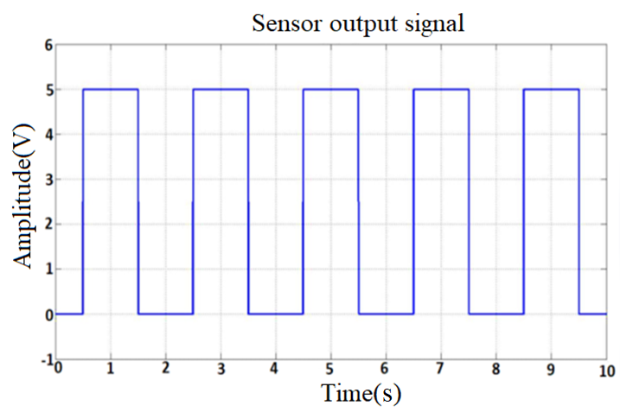  (a) | 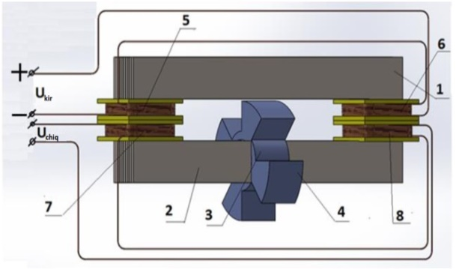  (b)
FIGURE 1. Electromagnetic angular acceleration sensor: a) sensor output signal; b) general view of the sensor

Based on this law governing the variation of magnetic reluctance R_{μ}​, a pulse signal was obtained at the output using digital filtering, as shown in Fig.1a. Fig.1 b presents the new design of the angular acceleration sensor.
The magnetic circuits of the proposed electromagnetic sensor were investigated using analytical approaches and numerical finite element methods (FEM). Fig.2 a illustrates the equivalent magnetic circuit of the electromagnetic angular sensor, while Fig.2 b presents the magnetic flux leakage and edge effects in the air gap.
As a result of the analytical analysis, an expression for the magnetic flux passing through the measuring coil was derived:
$Ф_{\sum{ }}=\frac{U_{μ_{1}}+U_{μ_{2}}}{R_{μ_{a}}+R_{μ_{1}}+2\left(R_{μ_{δ}}+R_{μ_{i.m}}\right)}$ , (3)
where, Uμ₁ and Uμ₂ denote the magnetic voltages (magnetomotive force - MMF) of the first and second magnetic circuits, respectively (A).
An analysis of the magnetic circuits, together with the derived equations and characteristics, shows that the static characteristics are significantly nonlinear due to the air gap, flux leakage, and edge effects. To obtain a linear static characteristic, a finite element model of the electromagnetic sensor magnetic circuit was developed. Based on this model, it was found that an air gap length of 5 mm provides a linear static characteristic for measurement the angular acceleration of rotating mechanisms.

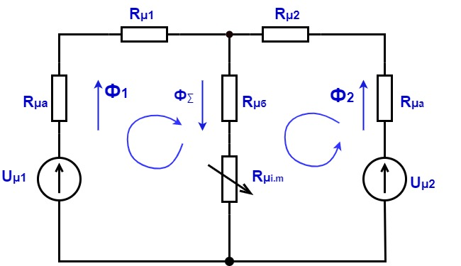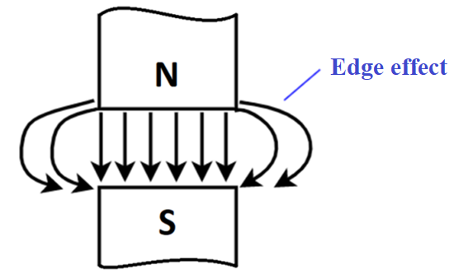
- b)
FIGURE 2. Equivalent circuit diagram of the magnetic circuit of the electromagnetic angular acceleration sensor (a) and the edge effect (b).

FEM models of the magnetic circuits are presented in Figure 3, (a). Using this model, the magnetic flux density, magnetic field intensity, magnetic flux, and other relevant parameters can be obtained at any point within the magnetic circuit(see fig.3, (b)).

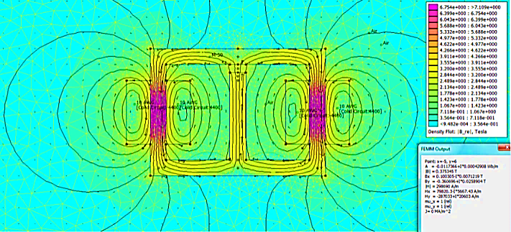
(a)
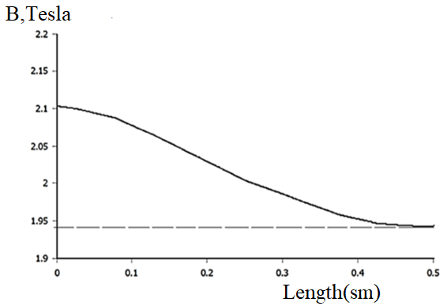
(b)
FIGURE 3. Magnetic circuit models obtained using FEM (a) and graph of magnetic flux density dependence on the air gap length (b)

Another factor that significantly influences the accuracy of measurement the angular acceleration of the tractor's power take-off (PTO) shaft is the noise generated by vibrations of agricultural tractors. The measurement circuit of the electromagnetic sensor, designed to effectively suppress such noise, is analyzed, and the corresponding expression for its input circuit is given as follows:
$${\underline{U}}_{input}={\underline{U}}_{L}+{\underline{U}}_{R}=L\frac{di}{dt}+i∙R=L∙I_{m}\frac{d\left(e^{j\left(ωt+φ_{i}\right)}\right)}{di}+R∙I_{m}e^{j\left(ωt+φ_{i}\right)}=$$
$$=jωL∙I_{m}∙e^{j\left(ωt+φ_{i}\right)}+R∙I_{m}∙e^{j\left(ωt+φ_{i}\right)}=I_{m}∙e^{j\left(ωt+φ_{i}\right)}\left(R+jωL\right)=$$
$=I_{m}∙e^{j\left(ωt+φ_{i}\right)}(R+jX_{L})$ (4)

Then the output voltage of the circuit is equal to:
${\underline{U}}_{output}=\underline{I}∙R=\frac{{\underline{U}}_{input}}{R+jωL}∙R={\underline{U}}_{input}∙\frac{1}{1+jω\frac{L}{R}}=\underline{U}∙K(f)$ , (5)
where, $K_{t.c}=\frac{1}{1+jω\frac{L}{R}}$ - this is referred to as the transmission coefficient of the circuit.
The equasion (5) derived above fully describes the frequency response of the integrating circuit. In this equasion, its magnitude is given as follows, representing the amplitude-frequency response (AFR) of the integrating circuit comprising an inductance:
$\left|K(f)\right|=\frac{1}{\sqrt{1+{\left(2πf∙\frac{L}{R}\right)}^{2}}}$ . (6)
The phase - frequency response (PFR) of the integrating circuit is determined by the phase of expression (5) and is given as follows:
$φ\left(f\right)=-arctg\left(2πf∙\frac{L}{R}\right)=-arctg(2πf∙τ)$ . (7)
If we define R/2πL=f₁ in expression (6), then K(f) can be written as:
$K\left(f\right)=\frac{1}{1+j\frac{f}{f_{1}}}$ . (8)
or its modulus is equal to:
$\left|K(f)\right|=\frac{1}{\sqrt{1+{\left(\frac{f}{f_{1}}\right)}^{2}}}$ , (9)
where, $f_{1}=\frac{R}{2πL}$ – cuttoff frequency.

To effectively suppress low - frequency noise (20 - 30 Hz) caused by vibrations during mechanical power measurements in agricultural tractors, the amplitude - frequency response (AFR) and phase - frequency response (PFR) characteristics of the developed electromagnetic sensor were investigated. The results are presented in Figure 4, a and b.
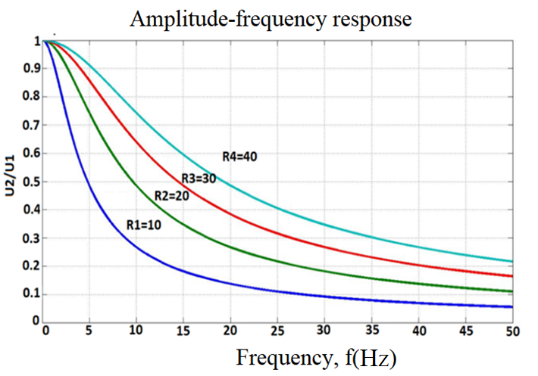  a) | 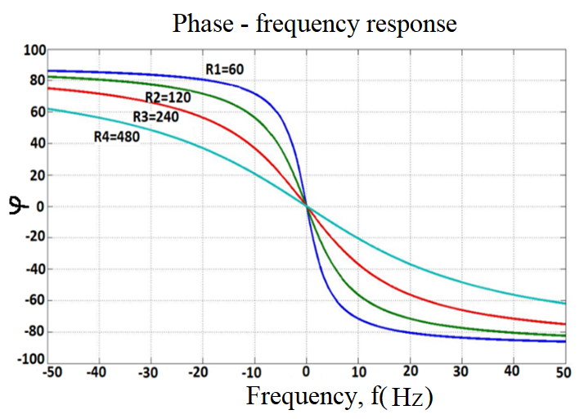  b)
FIGURE 4. Amplitude-frequency (a) and phase - frequency (b) responses of the electromagnetic angular acceleration sensor

When the input signal frequency is much lower than the cutoff frequency, i.e. $f≪f_{с1}$​, the magnitude of the transfer function satisfies$\left|K_{1}(f)\right|<1$. At $f=f_{с1} , \left|K_{1}(f)\right|=\frac{1}{\sqrt{2}}$​ ​. For f ≫ fc₁, ∣K₁(f)∣ reaches its maximum value K_{1max} ​; therefore, the circuit passes signals with frequencies above fc₁​.
At high input signal frequencies, the gain of the RL integrating circuit becomes very small, resulting in a strongly attenuated output signal.
The input signal is transmitted almost completely up to the cutoff frequency fc₁​. Additionally, no appreciable phase shift occurs at high frequencies.
CONCLUSIONS
The results of this study indicate that the rotating mechanisms of agricultural tractors, particularly the PTO, operate under continuously dynamic conditions characterized by unstable loading, sharp variations in torque and angular velocity, and persistent low-frequency vibrations. It was established that conventional methods for measuring torque and angular velocity to determine mechanical power on the PTO are affected by significant dynamic errors caused by mechanical oscillations in the power take-off shaft, transmission, and engine, which reduce the stability of sensor readings. Furthermore, real-time power measurements based on instantaneous torque and angular velocity are compromised by sensor response mismatches, phase shifts, system inertia, digital filtering delays, and computational time lags. Consequently, the application of an electromagnetic angular acceleration sensor enables reliable monitoring of mechanical power under unstable operating conditions, enhances measurement accuracy and sensitivity, supports the prediction of emergency states, and facilitates predictive maintenance.
REFERENCES
1. “PF-5853, dated 23.10.2019. *On the approval of the strategy for the development of agriculture of the Republic of Uzbekistan for 2020–2030.*” Accessed: Apr. 16, 2024. [Online]. Available: [https://lex.uz/docs/-4567334](https://lex.uz/docs/-4567334) .
2. Z. S. Sharipov, P. T. Berdimuratov, and B. B. Xakimov. Diagnostics and Technical Service of Machines and Tractor Aggregates, pp. 1–184, 2021.
3. A. K. Igamberdiev, S. Aliqulov. Operation and Technical Service of Tractors and Agricultural Machines. учебное пособие (Textbook). Tashkent: TIQXMMI, 2020, 228 pp.
4. Kutkov, G.M., 2004. Tractors and automobiles: theory and operation. Kolos, Moscow, 376 p.
5. Zangiev, V.A., Tishchenko, V.F., 2013. Dynamics of agricultural machines. KolosS, Moscow, 320 p.
6. Goering, C.E., Hansen, A.C., Schueller, J.K., 2014. Engine and tractor power. 4th ed. ASABE, St. Joseph, MI, 384 p.
7. Grisso, R.D., Perumpral, J.V., Vaughan, D.H., Roberson, G.T., Pitman, R.M., 2004.
Predicting tractor fuel consumption. Applied Engineering in Agriculture, 20(5), pp. 553–561.
8. Liljedahl, J.B., Turnquist, P.K., Smith, D.W., Hoki, M., 1996. Tractors and their power units. 4th ed. John Wiley & Sons, Hoboken, NJ, 404 p.
9. M.I.Borisov, S.A.Vlyadkin/Angular accelerometer for bench microvibration testing of high-precision guidance and stabilization system,” vol. 2, no. 13, 2016.
10. A. S. Chernysheva, “*Angular Acceleration Sensor,*” pp. 176–183, 2013.
11. S. Nitriles, “C1 C1 C1,” vol. 40, no. 2, pp. 267–268, 1975.
12. R. Baratov and A. Mustafoqulov, “Model of field robot manipulators and sensor for measuring angular displacement of its rotating parts,” E3S Web Conf., vol. 401, p. 04006, Jul. 2023, doi: 10.1051/E3SCONF/202340104006.
13. R. Baratov and A. Mustafoqulov, “Smart angular displacement sensor for agricultural field robot manipulators,” E3S Web Conf., vol. 386, p. 03008, May 2023, doi: 10.1051/E3SCONF/202338603008.
14. Patent SU №387287. Contactless Angular Acceleration Sensor / E.G. Shvetsov, V.V. Moskvin, L.M. Perikov, Yu.N. Kozmin, A.I. Molchanov, V.Sh. Nabutovsky, and Yu.M. Yukhanov // Bulletin No. 27, 21.06.1973.
15. Patent №714286. Angular Acceleration Sensor / V.N. Glushenkov and I.A. Musin // Bulletin No. 5, 05.02.1980.
16. “Device for Measuring Angular Accelerations. Soviet Patent 1983 SU 1035523 A1. Invention under IPC G01P15/125,*” Accessed: Apr. 16, 2024. [Online]. Available: [https://patenton.ru/patent/SU1035523A1](https://patenton.ru/patent/SU1035523A1)
17. Patent SU №1793384. Angular Acceleration Sensor / R.K. Azimov and N.U. Mallin // Bulletin No. 5, 07.02.1993.
18. R. Baratov, K. Sattarov, M. Begmatov, A. Mustafoqulov, and F. Kucharov, “Determination of key features and errors of rotary mechanisms measuring accelerators,” Int. J. Adv. Logist. Transp. Eng., vol. 3, no. 3, pp. 12–20, Aug. 2022, doi: 10.52167/2790-5829-2022-3-3-12-20.
19. Patent №2399915. Angular accelerometre/ A.S.Orlov, L.A. Zavinovskij, S.A. Anatolij// 20.09.2010 Bull. 26.
20. “RU2469337C1 - Angular acceleration sensor with liquid rotor - Google Patents.” Accessed: May 07, 2022. [Online]. Available: https://patents.google.com/patent/RU2469337C1/en
21. “Electrokinetic angular acceleration sensor. Russian patent RU 2018851 C1 published in 1994. Invention WIPO IPC.” Accessed: Apr. 18, 2024. [Online]. Available: https://patenton.ru/patent/RU2018851C1/en
22. K. Sattarov, Inductive angular acceleration sensor for automatic speed control system of train traffic. "European Journal of Molecular & Clinical Medicine"344-354, 2020.
23. A. N. Shipunov, A. A. Gavrilov, and E. N. Gavrilova, “*Balancing of the Integrated Angular Acceleration Sensor,*” *Proceedings of the Nizhny Novgorod State Technical University named after R.E. Alekseev,* vol. 2, no. 87, pp. 302–308, 2011.
24. Patent IAP7827. Angular Acceleration Sensor / R.J. Baratov, M.T. Begmatov // Bulletin No. 10, 2024.
25. M. Minyawi, “A Stationery Loading Unit for Measuring Farm Tractors Power in PTO,” J. Soil Sci. Agric. Eng., vol. 8, no. 2, pp. 73–76, 2017, doi: 10.21608/jssae.2017.37094.
26. J. B. W. Roeber, S. K. Pitla, R. M. Hoy, J. D. Luck, and M. F. Kocher, “Tractor power take-off torque measurement and data acquisition system,” Appl. Eng. Agric., vol. 33, no. 5, pp. 679–686, 2017, doi: 10.13031/aea.11994.
27. R. Baratov, M. Begmatov, A. Mustafoqulov, F. Kucharov, and E. Sabirov, “Study on the methods of measuring power of the rotating mechanisms,” E3S Web Conf., vol. 434, pp. 1–7, 2023, doi: 10.1051/e3sconf/202343401014.

