Improving the power electrical systems of shunting locomotives through modernization
Otabek Ergashev ^{a)}, Bahodir Kulmanov
Tashkent State Transport University, Tashkent, Uzbekistan
^{a)} Corresponding author: otabekergashev9637877@gmail.com
Abstract. In the modern world, due to competition with electric locomotives and global requirements, the requirements for the technical and aesthetic condition of TEM2 series diesel locomotives are constantly increasing. In particular, due to the inefficiency of creating electric traction shunting locomotives, the requirements for shunting locomotives are not decreasing, and their removal from inventory is not planned. In addition, the timely delivery of national economic cargo largely depends on the timely delivery and removal of wagons at railway stations. Therefore, maintaining shunting locomotives in good technical condition is an important task of locomotive depots. However, due to the reduction in the production of shunting diesel locomotives of the TEM-2 series, new parts and units for these diesel locomotives require a lot of effort and resources.
INTRODUCTION
Modernization of power electrical installations of shunting locomotives is a process of updating existing power systems of shunting locomotives based on modern technologies and increasing their energy efficiency. Shunting locomotives (TEM2, CHME3, TGM4) are usually equipped with DC power systems, the purpose of which is to modernize them:
• Reduction of fuel and electricity consumption;
• Increase traction power and reliability;
• Automation of engine, generator, and control systems;
• Reduction of maintenance costs;
• Compliance with environmental requirements (low emissions and low noise levels).
Below are the main directions and technical content of this process. In particular, two-machine units of the MVT25-9U and MVG25-11U2 types play a very important role in exciting the main generator of DC electrical machines and supplying the battery. Due to the obsolescence of diesel locomotives of this series and the import of two-machine units, timely elimination of the malfunction is not always possible. Therefore, in order to ensure freight and passenger transportation, it is necessary to provide them with main and shunting locomotives. To improve the technical condition, as well as to eliminate locomotive downtime during scheduled maintenance, it is necessary to modernize the two-machine unit A706, installed on the TE10M series locomotives, and install it on the TEM-2 series locomotives. The two-machine units of the TE10M series locomotives of the A706 brand are more reliable and, due to the exclusion of these locomotives from the inventory, are cheaper. Several scientists have worked on the modernization of locomotive power electrical installations, in particular, such researchers as N. G. Visin, B. T. Vlasenko, A. I. Kiyko, A. A. Yegorov conducted an analysis of robotic systems for protecting traction engines in electric locomotives from external and internal short circuits [1]. We conducted research on the modernization and improvement of operational efficiency of electrical installations in the power supply of diesel locomotives [2].

EXPERIMENTAL RESEARCH
In TEM2 and TEM1 locomotives, an automatic power regulation system for the traction generator was used. For this purpose, a special exciter is used, which has a longitudinally cut polar design (Fig. 1, a). Each of the three main poles of the exciter consists of a core made of electrical steel, which is divided lengthwise into two parts - unsaturated (US) and saturated (S) - by means of a brass intermediate gasket. Two coils (large) are mounted on the core. The parallel excitation winding SH1 - SH2 is made of insulated wire and covers both parts of the core. The differential winding 01-02 is made of copper strips and covers only the saturated part of the core [3]. (Fig.1).
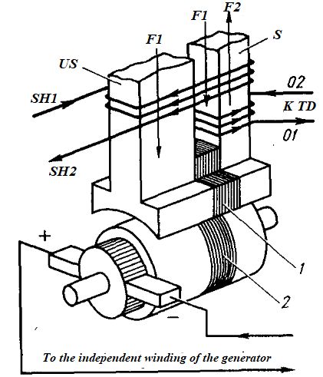  - diagram of the generation of electromotive force (EMF) in the excitation armature winding | 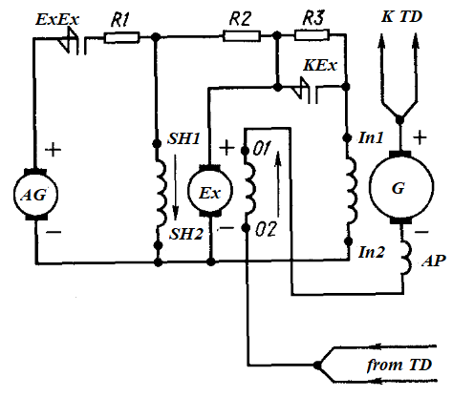  b) pre-modernization power circuit;
FIGURE 1. Automatic power regulation of the traction generator.
(F1 and F2 - magnetic fluxes in the parallel excitation winding SH1-SH2 and the differential excitation winding 01-02 of the exciter, respectively); US and S - saturated and unsaturated parts of the exciter poles; 1 and 2 - diamagnetic gaskets;
The parallel excitation winding SH1 - SH2 (Fig. 1, b) receives power from both the auxiliary generator (AG) and the main exciter (Ex). The main part of the current is supplied to this winding through an auxiliary generator, the voltage of which is maintained constant.
The resistance of resistor R1, connected to this circuit, changes only when the control arm (the controller's main handle) is moved from one position to another. Consequently, when the state of the controller does not change (i.e., when the resistance R1 is at a certain value), the magnetic flux F1, created by the parallel excitation coil, practically does not change [3-6].
The differential winding 01-02 is connected in series with the winding of the additional poles of the exciter, i.e., the entire load current passes through it. The direction of current in this winding does not coincide with the direction of current in the parallel excitation winding. Therefore, the magnetic flux F2 of the differential winding is directed opposite to the magnetic flux F1 of the parallel excitation winding (the directions of the magnetic fluxes are indicated by arrows in Figure 1, a and b).
Since the magnetic flux F2 of the differential winding is proportional to the load current, the resultant (total) magnetic flux generated by the saturated pole varies widely depending on the change in the load current. As is known from electrical engineering, the electromotive force (EMF) of a traction generator is determined by the following formula [7-10]:
$E=C_{E}Fn$ (1)

where $C_{E}$ is the value of the constant coefficient, depending on the design of the machine;
F - magnetic flux of the generator;
n - armature rotation frequency.
In the exciter armature winding, two electromotive forces (EMF) are generated by the split poles - $E_{1}$ (due to the magnetic flux created by the saturated part of the pole) and $E_{2}$ (due to the magnetic flux created by the unsaturated part of the pole). The total EMF of the exciter is the algebraic sum of these two EMFs [11-13]:

${E=E}_{1}+E_{2}$ (2)

From expression (1), it can be seen that at a certain position of the locomotive controller (i.e., with a constant rotation frequency of the exciter armature), the EMF induced in the armature winding depends only on the magnitude of the magnetic flux. Therefore, any change in the load leads to a significant change in the EMF $E_{2}$, while the EMF $E_{1}$ remains practically unchanged.
If the locomotive begins to move along a heavier profile of the track, this causes an increase in the current in the traction electric motors. As the load current increases, the resultant magnetic flux created by the saturated part of the poles decreases, resulting in a decrease in the EMF $E_{2}$. With a further increase in current, a situation arises where the magnetic fluxes in both windings equalize (in this case, the EMF $E_{2}$= 0) [14].
If the load current increases even further, the resultant magnetic flux changes direction, i.e., the saturated part of the pole changes the magnetization polarity and the direction of the EMF $E_{2}$ turns in the opposite direction. This leads to a decrease in the total EMF of the exciter. With an increase in load current, the total EMF of the exciter and the voltage at its output decrease. As a result, the current transmitted from the exciter plus to the independent excitation winding In1-In2 of the traction generator also decreases. This reduces the magnetic flux, EMF, and voltage of the generator.
Thus, the voltage of the traction generator decreases almost simultaneously inversely proportional to the increase in the load current, i.e., the generated power remains approximately constant. With a decrease in load, the demagnetizing effect of the differential winding weakens, as a result of which the excitation voltage increases, the excitation current increases, and the electromotive force and voltage of the traction generator increase [15-17].
It should be noted that the diamagnetic gasket 2 between the armature core has a high magnetic resistance, which prevents the magnetic flux F2 of the differential winding from passing through the armature cores, the unsaturated part of the pole, and the frame. Otherwise, this would have disrupted the power regulation process of the traction generator.
RESEARCH RESULTS
Let us consider the operation of the power circuit diagram of shunting diesel locomotives before the modernization of the power system. For modernization, 4 stands were prepared for aligning the locomotive frame base under the bolts (Fig. 2).
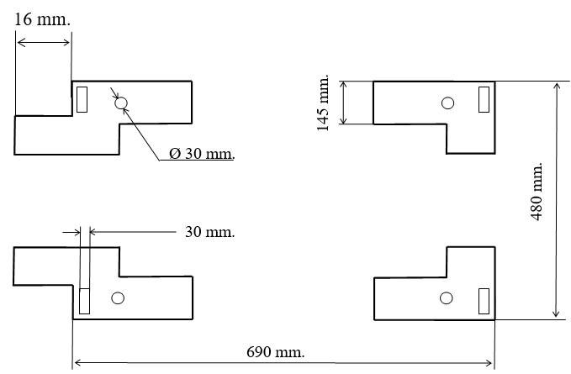  - schematic diagram for installing the unit | 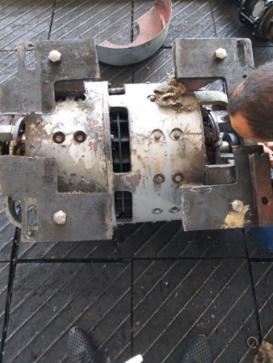  - configuration process
FIGURE 2. Process of modernization of the two-machine unit A-706.

The unit itself is fixed on the supports, and the position of the unit is adjusted by longitudinal cutting. To correct the operation of the unit, the following changes are made to the electrical part. MVT25-9U and MVG25-11U2 have an excitation differential winding for determining the generator current and outputting it to the operator's console, while two-machine units do not have such a winding. Therefore, in this modernized version, shunts 01 and 02 are connected to each other to determine the generator current. To determine the magnitude of the generator current value, we remove outputs In1, In2 from the stabilizing winding of the main pole of the excitation part A706 and connect it to the auxiliary pole of the main generator with the SHA2 shunt. The kiloommeter on the driver's remote receives a signal from the shunt. This modernization is directly aimed at improving the technical condition of shunting locomotives, reducing their downtime during scheduled maintenance, and increasing train traffic safety.
For measuring the current and voltage at the generator output, shunts (SHA2, SHA3, SHA4) and ammeters and voltmeters were used. Measurements were taken at the locomotive driver's controller positions from 0 to 8. The electrical connections between the auxiliary generator, exciter, and main generator (through wires 91, 95, and 96) operated under supervision. Therefore, the article can be expanded as follows. The experiment was conducted using the modernized electrical system of the TEM2 diesel locomotive. For measurements, voltmeters and ammeters were connected to the generator output, and voltage and current values were recorded at all 8 positions of the locomotive driver's controller. In each measurement state, the load condition of the diesel-generator unit was monitored.
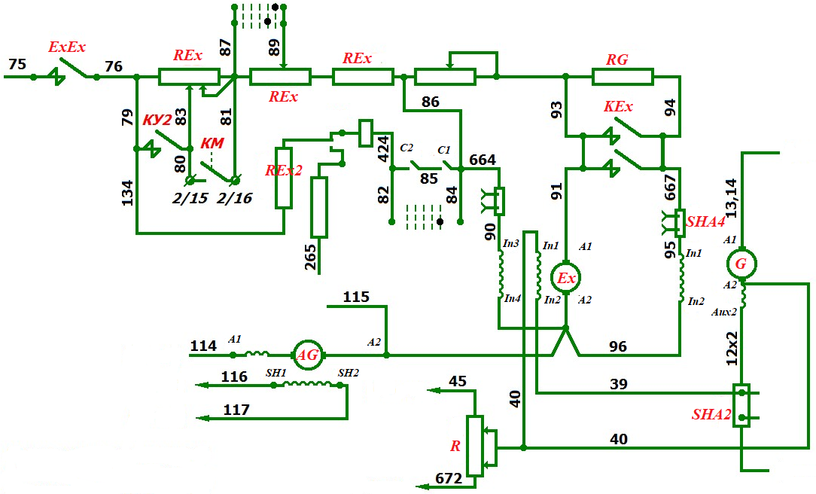
FIGURE 3. Power circuit diagram of the TEM-2 diesel locomotive after modernization

The voltage of the traction generator decreases almost simultaneously inversely proportional to the increase in the load current, i.e., the generated power remains approximately constant. With a decrease in load, the demagnetizing effect of the differential winding weakens, as a result of which the excitation voltage increases, the excitation current increases, and the electromotive force and voltage of the traction generator increase. It should be noted that the diamagnetic gasket 2 between the armature core has a high magnetic resistance, which prevents the magnetic flux Φ2 of the differential winding from passing through the armature cores, the unsaturated part of the pole, and the frame. Otherwise, this would have disrupted the power regulation process of the traction generator. The traction characteristic of the traction generator depends on the power indicators. With an increase in the load on the traction electric motors of the shunting locomotive, an increase in the load on the diesel generator device also occurs. This negatively affects the service life of the devices. Therefore, to maintain constant power in traction motors, it is necessary to ensure a decrease in current strength with increasing voltage. The main function of the two-machine unit of the TEM-2 diesel locomotive is to provide the external characteristics of the traction generator through its exciter (Table 1).

TABLE 1. External characteristics of the GP-300 traction generator
Status of the train driver's assistant | Generator current at the specified condition, A | Generator voltage at the specified condition, V
0 | 2870 | 270
1 | 2620 | 300
2 | 2400 | 325
3 | 2180 | 360
4 | 1960 | 400
5 | 1740 | 450
6 | 1520 | 520
7 | 1300 | 600
8 | 1080 | 720
Based on the 8 positions of the TEM2 locomotive's engine controller, we will construct the external characteristic curve of the traction generator (Figure 4).
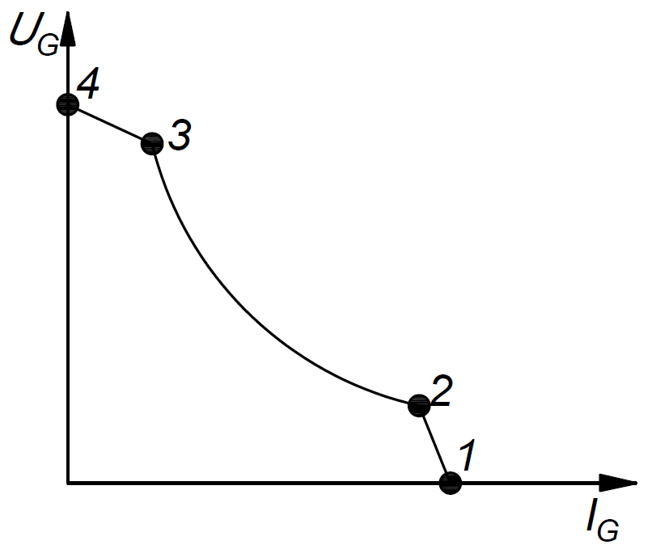
FIGURE 4. External characteristic of the traction generator

Fig. 4 shows the boundary external characteristic of the traction generator, i.e., the dependence of the voltage at the generator output on the load current is graphically represented for position 8 of the controller. It includes three areas:
• zone 1-2 - this is the area of current limitation of generator power (this zone is observed when the locomotive starts moving);
• zone 2-3 - as a result of the exciter operation, the voltage decreases in a hyperbolic form and represents the region of most efficient use of diesel power;
• zone 3-4 - is determined by the voltage limit of the generator power.
In order to ensure the external characteristics of the traction generator, an increase in its reliability was ensured through the modernization of its intermediate electrical devices.
CONCLUSIONS
The research results obtained on the modernization of this two-machine unit of the A706 model and its subsequent installation on diesel locomotives of the TEM-2 series are aimed directly at improving the technical condition of diesel locomotives, reducing downtime during repairs, and increasing the safety of train traffic.
In addition, in particular, improving the reliability of the operation of locomotive units and assemblies significantly increases the reliability of the locomotive as a whole. As a result of the practical application of the research results, the following changes were achieved in the technical parameters of the TEM-2 shunting locomotive:
1. The tension moment increases by 10-15%.
2. Fuel consumption is reduced by 15-25%.
3. The maintenance interval is extended by 1,5-2 times.

TABLE 2. External characteristics of the GP-300 traction generator
Indicator | Before modernization | After modernization | Difference
Decrease in voltage as load increases | 15–20 % | 8–10 % | 1.8x Improvement
Fuel consumption | 100 % | 75–85 % | 15-25% decrease
Torque | 100 % | 110–115 % | Increase by 10-15%
Service interval | 1x | 1,5–2x | Elongated

Prior to modernization, the external characteristic of the GP-300 generator was linear or steeply declining. In the unmodernized system, the traction generator would lose up to 15-20% of its voltage when the load increased. After modernization, thanks to the A706 unit and the additional shunt system, voltage stability was improved, resulting in a slower rate of voltage drop as the load increased. Consequently, in the modernized system, this voltage loss decreased to 8-10%. This ensured a more stable voltage maintenance in the generator's external characteristic.
Due to the availability of spare parts for the A-706 type two-machine unit, it significantly reduces time and money spent on repairs.
REFERENCES
- N. G. Visin, B. T. Vlasenko, A. I. Kiyko, V. V. Kovalyov (DIIT). Increasing the efficiency of the protection scheme of traction engines from external and internal short circuits during recuperative braking on DE1 electric locomotives. - 2023. 115-119.
- N. G. Visin, B. T. Vlasenko, A. I. Kiyko, A. A. Yegorov (DIIT). Modernization of the power diagram of the DE1 electric locomotive. - 2023. 43-50.
- Z.X. Notik. Electrical diagrams of TEM2 and TEM1 diesel locomotives. Moscow – Transport 1980.
- Runov Yu. A. Research of electromagnetic transient processes in traction motors of electric rolling stock // Proceedings of the Central Research Institute of MPS "VNIIJT." - M.: Transport, 1974. - Issue. 516. - P. 78-92;
- Zakharchenko, N. A. Rotanov, E. V. Gorchakov, P. N. Shlyaxto.: Rolling Stock of Electric Railways. Traction Machines and Transformers / D. D. - M.: Transport, 1968. - P. 104-108.
- Voldeck A.I. Electric Machines. - L.: Energy, 1978. - 832 p.
- Ivanov-Smolensky A.V. Electric Machines. In 2 vols. - M.: MEI Publishing House, 2004. - 652 p.
- Ivanov-Smolensky A.V., Abramkin Yu.V., Vlasov A.I., Kuznetsov V.A. Universal method for calculating electromagnetic processes in electrical machines. - M.: Energoatomizdat, 1986. - 217 p.
- Ergashev O.E., Kasimov, O.T., Abduvahobov M.E., Kulmanov B.T., Samatov Sh.T. // Development of a mathematical model for calculating the resistance generated when the rotor rods and rings of auxiliary asynchronous electric motors are made of various materials // Acta of Railway Transport: Current Issues and Innovations. - Тошкент, 2021. - P. 108 - 116.
- I.V. Chernykh. Modeling of electrical devices in MATLAB Sim Power Systems and Simulink. Moscow 2008.
- Kasimov O.T., Ergashev O.E., Namozov S.B., Kulmanov B.T., Keldibekov Z.O., Khusniddinov F.Sh.// "Calculation of the technical condition of short-circuited rotors in auxiliary asynchronous electric locomotive engines." Intellectual Property Agency under the Ministry of Justice of the Republic of Uzbekistan. Certificate of official registration of the computer program. DGU 35097; 13.03.2024.
- O. R. Khamidov, I. S. Kamalov, and O. T. Kasimov, “Diagnosis of traction electric motors of modern rolling stock using artificial intelligence,” AIP Conf. Proc. 2612, 030045 (2023). https// doi:10.1063/5.0125345
- S. Jamilov, O. Ergashev, M. Abduvaxobov, S. Azimov, and S. Abdurasulov, “Improving the temperature resistance of traction electric motors using a microprocessor control system for modern locomotives,” E3S Web Conf. 401, 03030 (2023). https://doi: 10.1051/e3sconf/202340103030
- O. E. Ergashev, M. E. Abduvakhabov, O. R. Khamidov, N. K. Tursunov, and O. T. Toirov, “Increasing the durability of gear transmissions of asynchronous torsion electric motors,” Web of Sci. 3 (10), 1030–1036 (2022).
- O. Ergashev, O. Kasimov, S. Djamilov, S. Azimov, and Z. Keldibekov, “Improvement of diagnostics of traction electrical motors of railway rolling stock,” AIP Conf. Proc. 3045, 050041 (2024). https//doi: 10.1063/5.0197378.
- Shevchenko. V.V., Goryushkin M.I., Lizan I.Ya. Comparison of the characteristics of an asynchronous motor with a short-circuited rotor when replacing the rotor winding material and proposals for their improvement. 2014. 27-34.
- Admenko A.I. Asymmetric Asynchronous Machines. - Kiev: Publishing House of the Academy of Sciences of the USSR, 1962.-212 p.

