Clustering of provincial cities by travel types and its mobility assesment
Fuad Dashdamirov^{1, a)}, Umidulla Abdurrazzokov ², Kamoliddin Ziyayev ², Ulvi Javadlı ¹, Turan Verdiyev ¹
¹ Azerbaijan Technical University, Baku, Azerbaijan
² Tashkent State Transport University, Tashkent, Uzbekistan
^{a)} Corresponding author: fuad.dashdamirov@aztu.edu.az
Abstract. In order to reduce congestion and damage caused by the growth of transport in cities, it is necessary to carefully study the possibilities of increasing public transport and micromobility services (use of bicycles, scooters and mopeds). For this purpose, the data obtained during surveys and monitoring in cities were used to analyze movements in provincial cities. The age categories of private cars used in the cities of Azerbaijan were determined. The share of movements made on foot, by bicycle, by public transport, by private cars and by taxi was determined. The attitude towards service elements in public transport was studied and the adequacy of the infrastructure for micromobility was analyzed. The cities under consideration were clustered according to the priority of the population for movement. The clustering included 38 cities of the Republic of Azerbaijan and 2 cities of the Republic of Uzbekistan. Proposals were put forward for the development of bus using and micromobility in cities.

INTRODUCTUON
An important role in the economic development of the country is the level of development of regional cities. One of the main factors determining the overall level of development of small towns is their transport provision. In many cases, the transport provision of a city is determined by the length of roads per unit area and the population. However, according to modern standards, in addition to the length of roads per unit area and the population, an indicator of the quality of transport provision of the population is the availability of infrastructure for various types of movement and the availability of well-organized public transport. Recently, various documents and regulations have been adopted aimed at ensuring mobility in cities. The document adopted by the European Transport Commission in 2013 to ensure mobility in cities [1] is an important step in this direction.
The population's need for travel in cities is met in various ways. This includes the use of private cars, walking, public transport, bicycles, scooters, mopeds and motor scooters. The most serious problem associated with mobility in recent years has been the growth of density and traffic jams on the roads, as well as damage to the environment as a result of the increase in the number of vehicles.
The population growth in modern cities is accompanied by a rapid increase in the number of private cars. This is typical for both large and medium-sized and small cities. The increase in the number of cars, along with the formation of traffic jams in cities, has led to a sharp increase in the noise level and the amount of harmful substances emitted into the environment. Therefore, the problem of sustainable urban mobility has recently become relevant. There are settlements where administrative measures are taken to reduce the use of private cars. However, this approach may not always be an adequate solution. As an alternative, the most recommended measures are improving the quality of passenger service to increase the use of public transport, stimulating micromobility and creating the appropriate infrastructure for it. Given the specifics of cities, solutions for ensuring sustainable mobility may vary. This is due to the geographical conditions of the territory, employment of the population, age composition of residents, purposes of travel, location of centers of attraction, etc.

LITERARURE REVIEW
For effective mobility management, it is important to study the travel patterns of people. Typically, this data is collected through various forms of surveys. The work by Semanjski and Gautama presents information on modern methods for studying human mobility and discusses their application in smart city management [2]. The possibilities of location-based primary data collection methods are considered. The main research gaps in this area are analyzed.
The growing number of private car owners worldwide has made the use of public transport one of the main solutions for creating a sustainable urban transport system. The road networks of many cities have reached their capacity limits. The attractiveness and quality of public transport for passengers are related not only to the number and congestion of stops, but also to their accessibility and lost time. Branish et al. took into account various criteria when developing a master plan for a small city, determined the distances and times for passengers to get off at stops, and commented on the difficulties encountered in the actual analysis of the results [3].
Despite the low mobility of the population in small cities, it should be noted that the population prefers private cars. Although the development of a sustainable urban mobility system has received special attention in large cities, the solution to this problem in small cities is only beginning. Raska and Major, drawing attention to the fact that the vast majority of the population of Norway lives in small cities, note that the use of international schemes for assessing the sustainability of public transport is impractical [4].
Legislation or standards of countries do not determine the size and population of cities in which public transport should be introduced. Gnap et al. analyzed the work of public transport in 71 provincial cities and found that public transport operates in 21 cities [5]. In their study of regions in Poland, the Czech Republic and Slovakia, the authors took the population of cities with a population of more than 10,000 people as one of the main criteria. In this paper, a methodology based on multi-criteria analysis was proposed to assess the importance of introducing public urban transport.
Urban public transport should have a high quality of service in order to meet the needs of different passengers from different spectrums. In the work of Nana et al., the most influential factors in assessing passenger satisfaction in the city of Wolaita Sodo were studied [6]. For this purpose, surveys were conducted at bus stations with randomly selected passengers. Statistical analysis was performed using SPSS 22 to process the results. As a result of the study, it was determined that the most important factor influencing passenger satisfaction is the travel system, followed by comfort and travel time. The analysis of variance of demographic variables on passenger satisfaction shows that gender, age and marital status of passengers are statistically insignificant in predicting passenger satisfaction.
Arbabi et al., conducting a study on the example of cities in England and Wales, propose to combine the allometric model of the city with the hierarchical clustering method [7]. The authors note that recently more attention has been paid to local, especially intracity mobility, than to intercity transportation. This indicates the importance of short-distance transportation in the overall transport system and the need to pay attention to intracity mobility in small cities.
Farrell et al. showed that sustainable transport measures in small towns reduce the distance travelled by vehicles and reduce emissions of harmful gases (CO2) into the environment [8]. The study assessed the benefits of switching from using personal transport to walking and cycling. The study showed that most car trips are made over distances of less than 6 km.
Public transport in cities is considered the most effective means of ensuring population mobility. To ensure unimpeded movement of public transport on the streets, it is necessary to give it priority at signalized intersections. Kotsianova substantiated the effectiveness of the priority system through two-way data exchange between vehicles and traffic lights in cities with a population of about 50,000 people [9]. It was found that the use of the proposed system at signalized intersections reduces time losses by up to 75%, and the time spent on the road - by up to 12%.
Fiden studied existing public transport routes in the Polish city of Brzezow and determined their impact on the mobility of the city's population.
Amoroso et al. developed a survey-based methodology for bus route networks for small and medium-sized cities [11]. For this purpose, a multi-agent objective function was used and the interests of the parties were taken into account. The proposed model allowed to create an optimal bus route network with a reduction in travel time.
The creation of an environmentally sustainable transport system in cities is considered one of the main requirements. The use of transport systems with an appropriate structure and modern technologies is the basis for the environmental sustainability of the transport system. In his studies conducted in the city of Xanthi, Lanticou found that the solution to transport problems in small cities is possible through walking and cycling in residential areas [12].
In recent decades, the bicycle has taken its place as an alternative urban transport in many cities around the world. Although the popularization of cycling occupies a special place in ensuring mobility in modern cities, the use of this type of transport is not high enough. Dimter et al. studied the level and prospects of compliance with the urban mobility plan in the Croatian city of Osijek, where the total length of bicycle paths is 40 km [13].
Increased popularity of cycling can contribute to the development of sustainable mobility. This requires promoting and incentivizing cycling in cities, creating and expanding the network of bicycle paths and bicycle sharing facilities. Carmine and Forciniti studied attitudes towards cycling in the small southern Italian city of Rende [14]. They sought to determine under what conditions residents would be willing to use bicycles.
The results of a survey of cyclists in the city of Thessaloniki regarding their satisfaction with their mobility showed that the most statistically significant problems were insufficient safety and insufficient integration of the city's bicycle infrastructure [15]. In the city of Barcelona, ​​micromobility, which involves the shared use of bicycles, scooters and scooters, was investigated by interviewing 902 people. It has been found that owners of personal bicycles, scooters and mopeds prefer to travel by bicycle [16]. Surveys conducted among bicycle users in Warsaw and Tbilisi assessed their motivation and attitude towards the infrastructure [17]. Research conducted in the city of Valencia on the topic of micromobility showed that many users do not know the rules to follow [18].
Based on the results of a survey conducted in public places, including public transport stops in Saudi Arabia, the decisive factors influencing the use of bicycles as a means of transportation to bus transport were analyzed [19]. Based on the results of the study, the authors identify individual socio-demographic factors and infrastructure issues that hinder the use of bicycles as a means of transportation to bus transport and provide recommendations for improving the infrastructure for cycling.
The creation of each infrastructure brings with it new challenges. Gticar et al. [August 20] propose a method for creating an innovative security system to address the security issues of bicycle infrastructure, especially bicycle theft, to ensure its normal operation. For this purpose, they propose using non-fungible tokens and blockchain technology.

Metodology
Surveys and monitoring were conducted to determine the current state of residents mobility of provincial cities and their opinions on travel. The age composition of the cars used in the surveys conducted in the cities of the Republic of Azerbaijan was determined.
As a result of the surveys, the distribution of residents' movements in 38 cities of the Republic of Azerbaijan and 2 cities of the Republic of Uzbekistan was determined, and clustering of cities by travel types was carried out. The number of clusters and cities included in these clusters was determined, and comments were given on the preferred travel types in the clusters.
The number of bicycle owners and users in cities, the attitude of residents to the provided public transport services were studied. The main shortcomings in the operation of bus transport were identified. Opportunities for increasing the use of bicycles and the measures that need to be taken for this were determined.

Age composition of vehicles and their impact on the environment
As in central cities, the number of cars in provincial towns is growing, and although traffic jams are already observed in short periods, it is not difficult to predict that this process will gradually accelerate. Therefore before taking measures to ensure mobility, it is necessary to conduct serious monitoring of the transport system, the provided transport services and transport infrastructure, as well as to find out the opinion of the population regarding the transport infrastructure and the level of transport service. The age composition of vehicles was determined by surveys conducted among residents in regional cities of the Republic of Azerbaijan (Figure 1).
As can be seen from Figure 1, the age of vehicles in the surveyed cities is mainly from 10 to 20 years and more. The share of cars older than 20 years is 36.9%.
The amount of damage caused to the environment by vehicles varies depending on the type of engine and year of manufacture. As a result of studies conducted in Poland, depending on the age, mileage and type of engine, it was found that the amount of nitrogen and carbon oxide emissions emitted by cars with a mileage of 86,000 to 317,000 km is significantly lower than that of cars with a mileage of up to 86,000 km [21]. For example, the amount of CO2 emissions from cars with a mileage of less than 86,000 km was 182% lower. The increase in the amount of harmful substances emitted into the environment with the increase in the service life of motor vehicles is also confirmed by measurements taken in various cities [22].

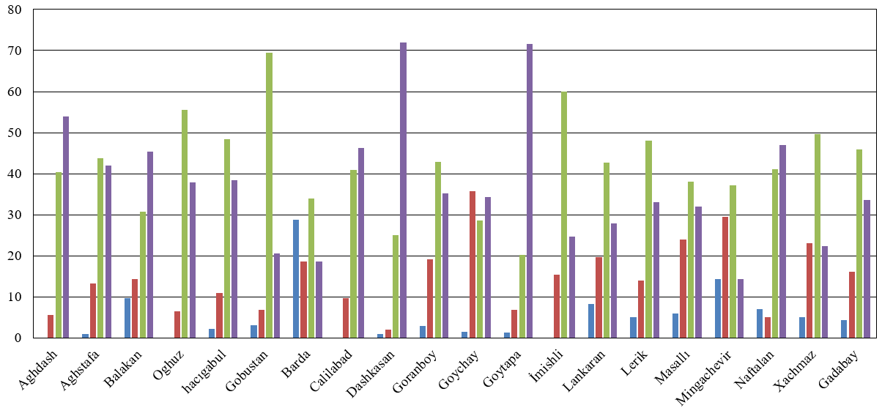
a)
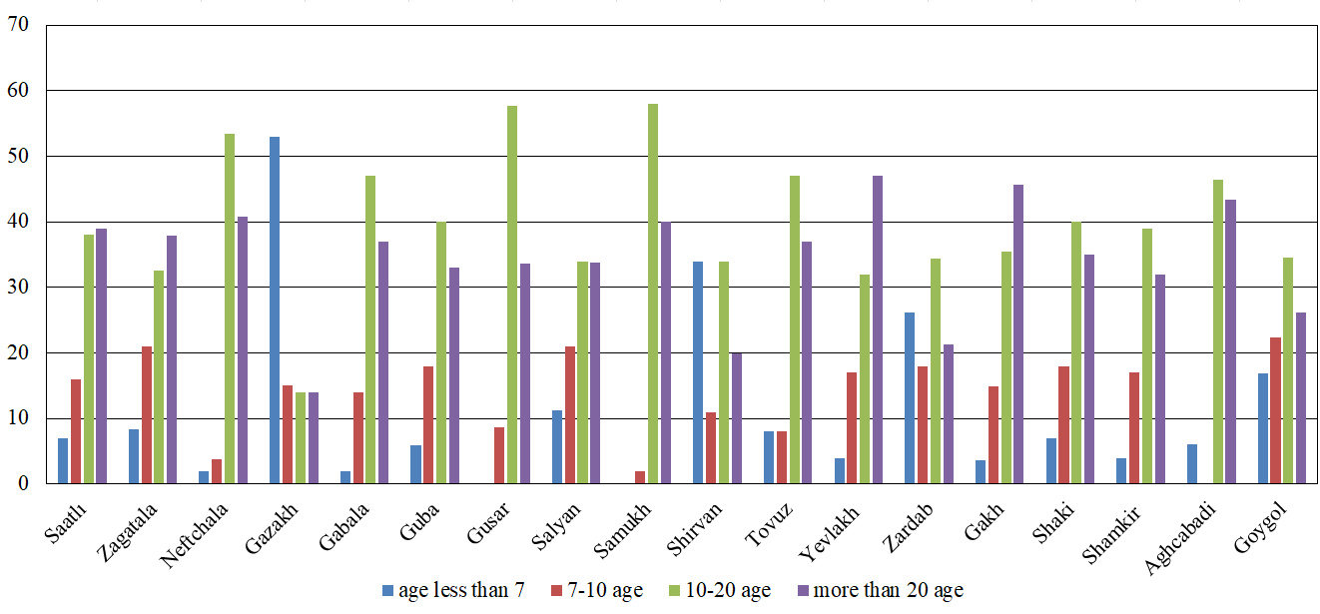
b)
Figure 1. Distribution of vehicles in the cities of the Republic of Azerbaijan by year of operation; a) northern cities, b) southeren cities

Reducing the environmental damage caused by the growing number of cars and their ageing can be achieved by developing alternative travel types, especially micromobility. This requires studying the distribution of travel typess and transport infrastructure in cities.

CLUSTERING CITIES BY TRAVEL TYPES BASED ON SURVEY RESULTS
Based on surveys and monitoring conducted in 38 regional cities of the Republic of Azerbaijan and 2 regional cities of the Republic of Uzbekistan, it was found that in most of these cities buses serve as public transport. The population carries out other transportation on foot, by bicycle, by private car and taxi. There are practically no scooter and moped users in the cities under study. The questionnaires used in the surveys included questions about the technical condition of buses serving the population on routes, the condition of stopping points and the infrastructure for using bicycles. The survey was conducted among 400 respondents in each city. The main problems arising in urban mobility, transport infrastructure and the relief of cities were studied through monitoring.
The values ​​​​determined as a result of the study of the distribution of travel types are presented in Table 1.
TABLE 1. Distribution of movements in regional cities of the Republics of Azerbaijan and Uzbekistan
City | Walk | Bus | Taxi | Own car | Bicycle
Zardab | 45.61% | 25.18% | 10.69% | 15.20% | 6.65%
Salyan | 10.54% | 56.21% | 26.93% | 14.29% | 5.00%
Barda | 17.58% | 62.71% | 33.25% | 16.86% | 2.61%
Samukh | 60.50% | 3.25% | 14.50% | 19.75% | 3.50%
Qabala | 21.38% | 4.16% | 40.73% | 31.42% | 4.91%
Qazax | 13.33% | 62.00% | 17.00% | 25.00% | 1.00%
Neftchala | 38.52% | 22.22% | 14.10% | 31.85% | 1.00%
Lerik | 32.00% | 0.00% | 44.00% | 23.31% | 0.69%
İmishli | 35.71% | 2.71% | 40.39% | 21.43% | 2.71%
Goranboy | 14.42% | 52.00% | 38.00% | 25.00% | 1.00%
Goytapa | 10.63% | 47.80% | 38.60% | 13.70% | 0.00%
Dashkasan | 36.41% | 1.25% | 36.66% | 26.68% | 0.25%
Jalilabad | 45.21% | 35.40% | 34.40% | 26.40% | 2.80%
Aghstafa | 40.86% | 31.50% | 14.04% | 20.11% | 1.71%
Aghdash | 53.35% | 33.50% | 8.20% | 22.10% | 2.50%
Zagatala | 25.94% | 55.00% | 54.00% | 28.00% | 3.00%
Saatli | 19.70% | 8.00% | 60.00% | 28.00% | 4.00%
Gobustan | 50.00% | 0.00% | 14.00% | 35.00% | 1.00%
Oghuz | 8.37% | 64.00% | 29.00% | 30.00% | 1.25%
Hajıgabul | 43.83% | 18.00% | 25.00% | 26.00% | 5.00%
Gadabay | 18.45% | 51.00% | 55.00% | 33.00% | 1.00%
Balakan | 14.25% | 62.25% | 26.25% | 28.00% | 4.75%
Aghjabadi | 31.33% | 12.44% | 47.00% | 40.22% | 3.00%
Goygol | 33.10% | 48.72% | 19.58% | 23.08% | 1.00%
Lankaran | 20.85% | 56.65% | 19.31% | 12.88% | 0.86%
Guba | 28.64% | 43.68% | 15.75% | 24.82% | 1.00%
Shaki | 10.38% | 63.92% | 5.42% | 29.25% | 1.00%
Shamkir | 39.16% | 41.00% | 24.71% | 25.00% | 1.00%
Khachmaz | 35.78% | 35.31% | 5.92% | 33.89% | 2.00%
Yevlakh | 46.30% | 40.00% | 27.83% | 16.51% | 5.00%
Gusar | 18.57% | 51.31% | 18.76% | 28.50% | 2.85%
Bilasuvar | 22.95% | 51.21% | 23.56% | 18.90% | 0.71%
Masalli | 20.28% | 48.00% | 21.00% | 21.50% | 1.65%
Mingachevir | 36.17% | 65.25% | 6.62% | 21.00% | 0.71%
Naftalan | 54.50% | 34.36% | 9.95% | 27.00% | 1.00%
Shirvan | 45.23% | 49.32% | 10.45% | 16.14% | 1.00%
Tovuz | 18.76% | 47.74% | 17.10% | 29.93% | 1.00%
Goychay | 19.39% | 68.46% | 8.88% | 17.29% | 0.93%
Navoi | 25.00% | 42.00% | 0.19 | 28.00% | 2.00%
Karmana | 31.00% | 52.00% | 0.17 | 25.00% | 2.00%

Based on the values presented in Table 1, the number of clusters for population clustering by movement in provincial cities of the Republic of Azerbaijan and Uzbekistan was determined. The results of the distribution of cities by clusters are presented in Table 2.
TABLE 2. Distribution of cities by mobility cluster
CLUSTER | Cities
1 | Samukh, Neftchala, Lerik, İmishli, Dashkasan, Gobustan, Hajıgabul
2 | Zardab, Jalilabad, Aghstafa, Aghdash, Goygol, Lankaran, Guba, Shamkir, Khachmaz, Yevlakh, Bilasuvar, Masalli, Mingachevir, Naftalan, Shirvan, Goychay, Karmana
3 | Qabala, Saatli, Aghjabadi
4 | Salyan, Barda, Qazakh, Goranboy, Goytapa, Zagatala, Oghuz, Gadabay, Balakan, Shaki, Gusar Tovuz, Navoi

The results of recalculation of cluster centroids after recalculation are presented in Table 3.
TABLE 3. Average proportion of residents travel types by clusters as a result of provincial cities clustering
CLUSTER | Walk | Bus | Taxi | Own car | Bicycle
1 | 0.4242 | 0.0678 | 0.2695 | 0.2629 | 0.0202
2 | 0.3638 | 0.4468 | 0.1631 | 0.2158 | 0.0191
3 | 0.2414 | 0.0820 | 0.4924 | 0.3321 | 0.0397
4 | 0.1586 | 0.5523 | 0.2994 | 0.2535 | 0.0204

Figure 2 shows the distribution of travels for each cluster graphically.

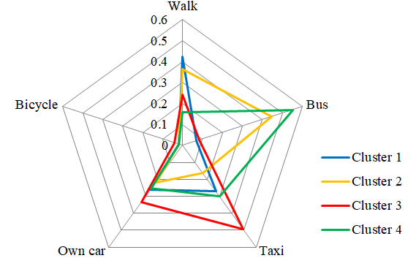
Figure 2. Distribution of travel types by clustersistribution

After interpretation the provincial cities under consideration can be characterized as follows:
- Cluster 1: Cities with pedestrian, own car and taxi travels.
- Cluster 2: Cities with a high share of walking and bus travel.
- Cluster 3: Cities with a predominance of private car and taxi travels.
- Cluster 4: Cities with bus and car travels.
As can be seen, the share of bus transport use is high in clusters 2 and 4, which include a larger number of cities. At the same time, the share of walking is high in 17 cities included in cluster 2, and the share of private car use is high in 13 cities included in cluster 4.

DISCUSSION
It is necessary to create or improve the appropriate infrastructure to replace car and taxi trips in cities with bus and bicycle trips. During monitoring and surveys, the shares and nature of bus trips, the frequency of their use, the number of bicycle owners and users were determined and analyzed. Directions for action to improve the functioning of the proposed types of travel were determined.

ASSESSMENT OF THE BUSES USE FREQUENCY AND BUS ROUTES SERVİCE
When clustering cities by type of transport, it was taken into account that city residents use several types of transport. That is, one and the same resident sometimes travels by two or more types. It was found that users of bus transport also do not always use this type of transport regularly. Therefore, to determine the frequency of use of bus transport, the corresponding questions were included in the questionnaires. The distribution of residents' answers to the question about the frequency of use of buses is shown in Figure 3.

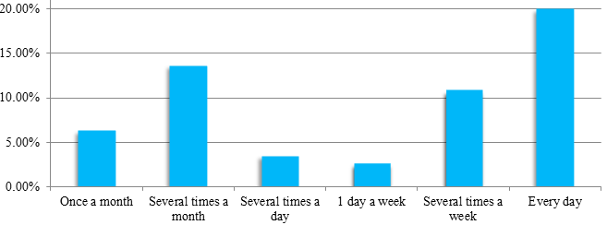
FIgure 3. Distribution of bus usage frequency among residents across all cities considered

As can be seen from Figure 3, not all passengers regularly use bus routes. This is due to some dissatisfaction of city residents with the services of bus routes. The distribution of city residents' answers to questions about the shortcomings of bus routes is presented in Figure 4.

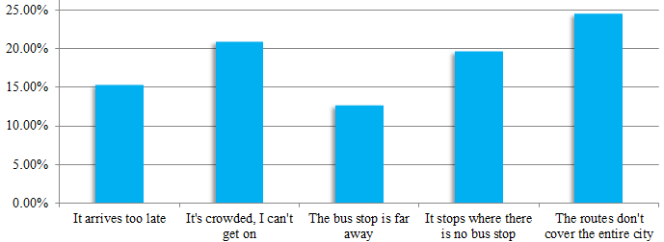
FIgure 4. Sharing opinions of city residents about shortcomings in bus routes

The results of the assessment of buses and bus routes by residents of 40 surveyed cities are presented in Figure 5.

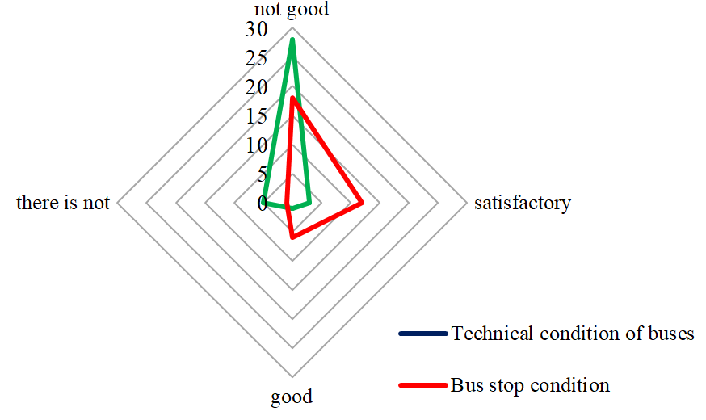
Figure 5. Results of respondents' assessment of the technical condition of buses and bus stops in the surveyed cities

As can be seen from Figure 5, the technical condition of buses in most cities is unsatisfactory. The technical condition of bus stops is unsatisfactory in more than half of the surveyed cities. Thus, to increase the attractiveness of bus transport in the provincial cities under consideration, the following measures must be taken:

- Use buses in good technical condition.
- Improve the technical condition of stops
- Ensure coverage of the urban area by the route network.
- Adapt the capacity and schedule of buses to the needs of passengers.

ASSESSMENT THE PROSPECTS OF MİCROMOBİLİTY
As can be seen from table 1 and table 3, cycling does not have a high share in any of the cities.
According to the results of surveys conducted in regional cities of the Azerbaijan and Uzbekistan Republics, the number of bicycle owners significantly exceeds the number of people using them as a means of transportation. Some bicycle owners do not use bicycles or cannot use them as a means of daily transportation. The distribution of reasons given by residents who do not use bicycles as a means of transportation is presented in Figure 6.

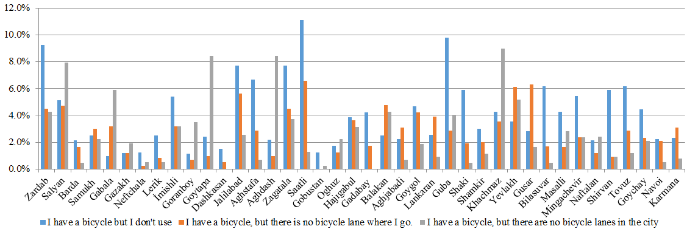
FIgure 6. Level and reasons for non-use of bicycles by owners for urban travel

As can be seen from Figure 3, the low share of bicycle use in cities is also associated with the lack of infrastructure. This is also evidenced by the results of monitoring the transport infrastructure of cities (Figure 7).

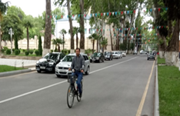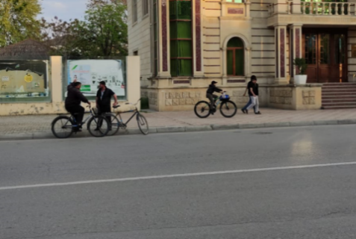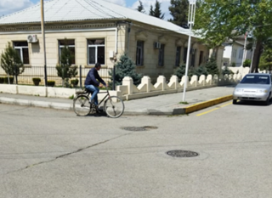
FIgure 7. Images obtained during monitoring of bicycle infrastructure in cities

In some cities, due to their geographical location, the streets are steep and narrow. However, the vast majority of the cities under consideration are located on flat terrain, and monitoring in the cities also shows that they have suitable road infrastructure for the creation of a network of bicycle paths. Therefore, in order to increase micromobility through the use of bicycles, it is advisable to take the following measures:
- • Identifying streets convinient for bicycles use
- • Creating a network of bicycle paths that will allow people to travel around the city by bicycle
- • Taking measures to ensure safety on bicycle paths

CONCLUSION
The main types of transport preferred by the population in the provincial cities under consideration are walking, buses, private cars, taxis and bicycles. Clustering of cities by types of transport based on the data obtained from surveys and monitoring conducted in 40 cities allows us to identify 4 main types of cities.
The share of private car and taxi use in cities is quite high. However, most cars are 10-20 years old or more. This is unsatisfactory from the point of view of environmental safety in cities and necessitates the expansion of public transport and micromobility.
The use of buses in the cities under consideration is higher. However, the work of bus transport does not fully satisfy residents. The shortcomings are mainly related to the technical condition of buses and stops, as well as the organization of work on the routes. It is necessary to work in this direction to increase the attractiveness of bus transport in provincial cities.
There is a difference between the number of bicycle owners and users in cities. It has been established that many bicycle owners do not prefer to travel by bicycle due to the lack of appropriate infrastructure for cyclists. Analysis of transport infrastructure shows that in most cities it is possible to create a road network for cyclists.

Acknowledgments
The authors of the article express their gratitude to the students and teachers of the Azerbaijan Technical University and the Tashkent State Transport University who took part in collecting field data, as well as in the preparation of the Urban Mobility Plan in the cities of the Republic of Azerbaijan and transport master plans in the cities of Uzbekistan.

References
- A concept for sustainable urban mobility plans to the communication from the commission to the european parliament, the council, the european economic and social committee and the committee of the regions. (Brussels, 2013).
- I. Semanjski and S. Gautama. Sensing Human Activity for Smart Cities’ Mobility Management. “Title of Chapter,” in Smart Cities Technologies, edited by Ivan Nunes Da Silva and Rogerio Andrade Flauzino. (inTech, 2018). pp. 2-26
- M. Braniš, M. Šulík, J. Takacs, T. Schlosser. Analysis of public transport services with various criteria. Slovak Journal of Civil Engineering. Vol. 28, No. 4, 23-28. (2020).
- S. Rasca and J.H. Major. “Applicability of Existing Public Transport Sustainability Indicators to Norwegian Small Cities and Towns” in Smart Cities Symposium (Prague, Chech Republic, 2021), pp 1-6.
- J. Gnap, J. Kupčuljaková, Ľ. Černický, G. Dydkowski. The transport service of small towns. Komunikacie 23(1). pp. A21-A31 (2021).
- N. Frehiwot, M.Sudhakar, A. Alemayehu, M. Senapathy. Commuters’ Perception Using Public Transport Services and Its Impact on Passenger Satisfaction: The Case of Sodo Town, Wolaita Zone, Southern Ethiopia. Shanlax International Journal of Management, vol. 10, no. 2, pp. 9–32. (2022).
- H. Arbabi, M. Mayfield, Ph. McCann. On the Development Logic of City‐Regions: Inter‐ Versus Intra‐City Mobility in England and Wales. Spatial Economic Analysis, 14 (3). pp. 301-320. (2019).
- S. Farrell, D. McNamara, B. Caulfield. Estimating the Potential Success of Sustainable Transport Measures for a Small Town. Journal of the Transportation Research Board, 2163, Washington, D.C., pp. 97–102. (2010).
- A. Kociánová. “Benefits of public transport priority at traffic signals: small town experience” in 18th International Multidisciplinary Scientific GeoConference SGEM 2018, Conference proceedings, Volume 18 Issue 6.3, (Albena, Bulgaria, 2018) pp 729-736.
- Ł Fiedeń. Accessibility of Brzozów by public transport on a local, regional and national scale. Urban Development Issue, 53, 37-46 (2017).
- S. Amoroso, M. Migliore, M. Catalano, F. Galatioto. A demand-based methodology for planning the bus network of a small or medium town. European Transport \ Trasporti Europei, 44, 41-56. (2010).
- K. Lantitsoua, V. Profillidisa and G. Kollaros. “Sustainable mobility in small towns like Xanthi” in 3 rd Conference on Sustainable Urban Mobility, 3rd CSUM 2016, (Volos, Greece. 26-27 May 2016), pp.
- S. Dimter, D. Stober, M. Zagvozda. “Strategic Planning of Cycling Infrastructure Towards Sustainable City Mobility - Case Study Osijek, Croatia” in WMCAUS 2018 IOP Conf. Series: Materials Science and Engineering 471 IOP Publishing (2019), pp. 2-11
- D.C. Festa and C. Forciniti. Attitude towards Bike Use in Rende, a Small Town in South Italy. Sustainability 11, 2703, 1-15, (2019).
- K. Ketikidis, A. Papagiannakis, S. Basbas. Identifying and Modeling the Factors That Affect Bicycle Users’ Satisfaction. Sustainability 15, 13666, 1-20, (2023).
- O. Roig‑Costa, O. Marquet, A. Arranz‑López, C. Miralles‑Guasch, V. Van Acker. Understanding multimodal mobility patterns of micromobility users in urban environments: insights from Barcelona. Transportation. 1-25 (2024).
- G. Kikoria, Z. Sanikidze, M. Sikora, S. Gelashvili. What Factors Affect Bicycle Commuting? An Empirical Analysis in Tbilisi and Warsaw. Folia Oeconomica Stetinensia 24(1), 88-104, (2024)
- A.S. Fonseca-Cabrera, D. Llopis-Castelló, A.M. Pérez-Zuriaga, A. García. Assessing Micromobility Users’ Knowledgeof Regulations: Valencia (Spain) Case Study. Safety, 11(2), 36, 1-18, (2025).
- M.A. Al-Rashid, S. Alarabi. Promoting the Use of Bicycles for Transportation and Access to Bus Stations in Riyadh, Saudi Arabia. Sustainability 17, 1921, 1-17, (2025).
- S. Griˇcar, C.Stipanovi, T.Baldigara, Sustainable Daily Mobility andBikeSecurity. Sustainability 17, 6262. 1-20, (2025).
- P. Pryciński, J.Pielecha, J.Korzeb, R.Jachimowski and P.Pielecha. Impact of Vehicle Aging and Mileage on Air Pollution Emissions. Energies, 18(4), 939, 1-20, (2025).
- S. Caserini, C. Pastorello, P. Gaifami, L. Ntziachristos, Impact of the dropping activity with vehicle age on air pollutant emissions, Atmospheric Pollution Research, Volume 4, Issue 3, pp. 282-289, (2013).

