Failure analysis of large tires of dip trucks in the conditions of the MURUNTAU mine
Akhmadjon Anvarjonov^{1, a)}, Umidbek Yusupov¹, Mashrab Isroilov ²
¹ Tashkent state transport university, Tashkent, Uzbekistan
² Navoi Mining and Metallurgical Combine (NMMC) JSC, Navoi, Uzbekistan
^{a)} Corresponding author: aha199603@gmail.com
Abstract. The article presents an analysis of failures of large-size tires of quarry dump trucks in the Muruntau mine conditions using the Failure Mode and Effects Analysis (FMEA) method. The aim of the study is to identify the most critical factors influencing the actual TKHF indicator, assess the risk level based on the integral RPN indicator, and develop measures to improve tire reliability and reduce operating costs. The statistical database includes data on write-offs of tires of sizes 50/80R57, 40.00R57, 37.00R57, and 33.00R51 for 2024 and the first half of 2025. The FMEA analysis results showed that the highest priority risk is associated with tread/carcass separation (RPN = 315), caused by thermal overload and exceeding the TKHF. Mechanical damage (RPN=288) and tread wear (RPN=135) also significantly impact tire life. Based on the analysis, practical recommendations are proposed for reducing the actual TKPH value, increasing tire life, and improving the condition of access roads.
INTRODUCTION
To create competitive designs for large-size tires worldwide, it is crucial to develop methods for reliably assessing their strength and thermal characteristics, implement new technologies that meet modern requirements, improve design methods, and systematically conduct research aimed at increasing resource conservation during dump truck operation. In this area, particular priority is given to research aimed at continuously monitoring the technical condition of dump trucks and tire parameters, as well as at efficiently using their resources through the correct selection of tires taking into account local terrain [1, 2].
The problem of premature failure of large-size tires is one of the most widely studied in global practice, as it directly impacts the reliability, safety, and operating costs of quarry dump trucks. Research centers in various countries and major tire manufacturers are studying this issue from design, thermodynamic, and operational perspectives [1, 12]. The Michelin Earthmover R&D research team (P. Langeron, J.-M. Delebarre) developed key theoretical models of thermal stress, the TKPH parameter, and the impact of temperature processes on tire core layers. Bridgestone Mining Solutions scientists (T. Mishima, J. O'Callaghan) conducted an in-depth study of structural failure mechanisms such as cord ply delamination, belt edge cracking, and tire deformation. Goodyear specialists (R. Olson, D. Jones) made significant contributions to tire fatigue failure and cord break diagnostics [2, 10, 13].
Komatsu and Caterpillar engineers (S. Garza, N. Tanaka) identified the impact of quarry road profile, load distribution, high speed, and real-time temperature on tire life reduction. Australian and Canadian research schools (P. Knights, J. Dill) have developed models of heat accumulation and belt delamination occurring during quarry deepening [4, 9].
Internationally, tire failure causes are classified into four main groups: thermomechanical, structural, operational, and external factors. This classification is reflected in Michelin and Bridgestone standards.
Analysis shows that the key factors in tire failure are a combination of high load, speed, and temperature, as well as poor quarry road quality and improper tire inflation pressure. Current trends are focused on predicting failures using TPMS, KODA, and MineStar real-time tire monitoring systems.
Increasing tire efficiency is achieved by reducing damage and extending tire service life, which reduces costs and downtime, increases equipment utilization, and improves operating economics.
Tire selection must comply with current legislation and be coordinated with vehicle and tire manufacturers, taking into account tire size, load index, speed rating, design, and other parameters. Operating conditions must also be considered, including road surface abrasiveness, the likelihood of mechanical damage, wear rate, and other factors affecting tire service life and performance. Incorrect selection of tread pattern or rubber compound can significantly reduce tire life and equipment performance [3, 5, 8].
Tires are selected based on the following key criteria:
– compliance with the recommended tire size and design for a specific type of vehicle;
– maximum load and permissible speed (in accordance with the load index and speed index);
– performance characteristics, including the TKPH value and average transport distance per hour;
– operating conditions (road surface abrasiveness, temperature conditions, likelihood of cuts and punctures);
– the specific nature of the transport operations (speed, braking frequency, route gradients, etc.).
Proper tire selection, taking into account the above factors, ensures operational safety, extends tire service life, and improves the efficiency of mining dump trucks [4, 6, 7].
In global and domestic practice, the impact of such factors is often assessed in a disjointed manner, which complicates the development of comprehensive preventive measures. The FMEA (Failure Mode and Effects Analysis) method allows for the classification of tire failure modes, prioritizing risks based on the integrated RPN (Risk Priority Number) indicator, and identifying critical areas with the greatest impact on service life, thereby facilitating their reduction. The use of FMEA in studying the tire life of mining dump trucks allows not only for a quantitative assessment of these factors but also for the development of targeted recommendations for reducing the actual TKPH value and increasing tire service life.
Research Materials and Methods Conducting an FMEA failure analysis of large-size tires on quarry dump trucks, assessing the impact of these factors on the actual TKPH, is a relevant scientific and practical task aimed at improving the reliability of industrial vehicles and reducing operating costs in the mining industry. To identify critical factors and develop measures to minimize them, an FMEA failure analysis was conducted based on tire write-off statistics at the Muruntau quarry for 2024 (Table 1) and the first six months of 2025.

TABLE 1. Analysis of the mileage of dump trucks in the Muruntau quarry for the period from 01.01 to 31.12.2024
№ | Model | Size | Number of technic | Number of written-off tires | Average mileage, km. | Mechanical damage |  | Detachment |  | Wear
 |  |  |  |  |  | Number of tires | Average mileage, km | Number of tires | Average mileage, km | Number of tires | Average mileage, km
1 | KOMATSU 860E-1K | 50/80R57 (1200/90R57) | 10 | 42 | 28 243 | 15 | 26 047 | 17 | 22 617 | 10 | 41 102
2 | KOMATSU 830E-1AC | 40.00R57 (46/90R57) | 11 | 845 | 49 903 | 246 | 48 855 | 160 | 35 033 | 439 | 61 877
2 | САТ-793D | 40.00R57 (46/90R57) | 38
2 | BelAZ-75310 | 40.00R57 (46/90R57) | 46
2 | BelAZ-75307 | 40.00R57 (46/90R57) | 6
3 | САТ-789D | 37.00R57 | 10 | 43 | 66 795 | 5 | 60 510 | 25 | 51 100 | 13 | 99 410
4 | BelAZ-7513 | 33.00R51 | 28 | 289 | 47 758 | 100 | 41 672 | 54 | 37 511 | 135 | 56 364
Total |  |  | 149 | 1219 | 49244 | 366  (30%) | 46732 | 256  (21%) | 36678 | 597  (49%) | 60817

The statistical base of the study covered data on the operation of large-size tires of sizes 50/80R57, 40.00R57, 37.00R57 and 33.00R51 installed on dump trucks of the KOMATSU, CAT and BelAZ brands. In 2024, 1,219 large-size tires were written off with an average mileage of 49,244 km, while the failure structure included mechanical damage - 366 units (30%, average mileage of 46,732 km), tread/carcass separation - 256 units (21%, 36,678 km) and tread wear - 597 units (49%, 60,817 km). In the first six months of 2025, 998 large-size tires were written off, 480 of which (48%) were premature failures, while there was an increase in the proportion of mechanical damage to 59% and a decrease in the proportion of delaminations to 11% against the background of an increase in average mileage to 56,011 km (Figs. 1 and 2).
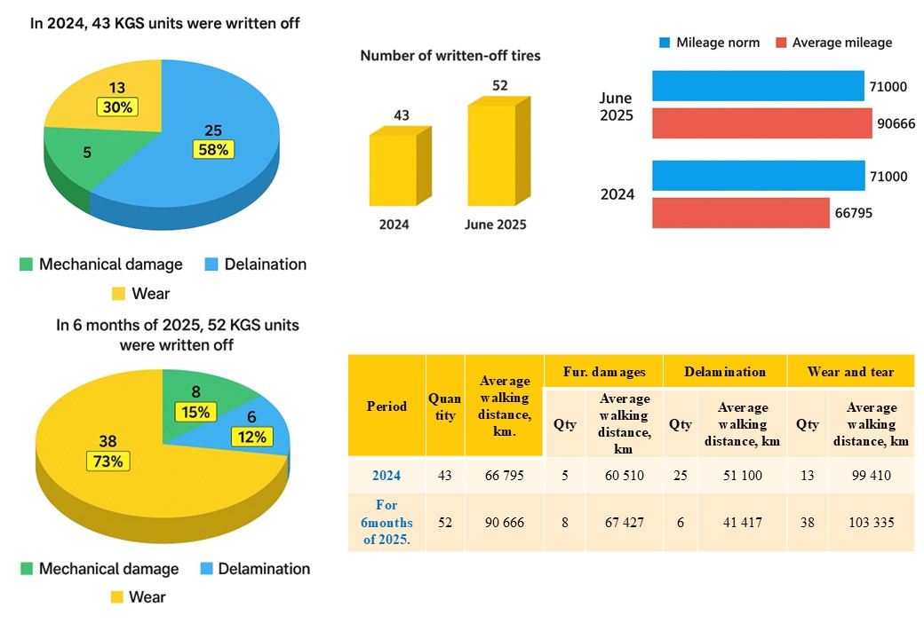
FIGURE. 1. Analysis of the mileage of the KGS tires of size 37.00R57

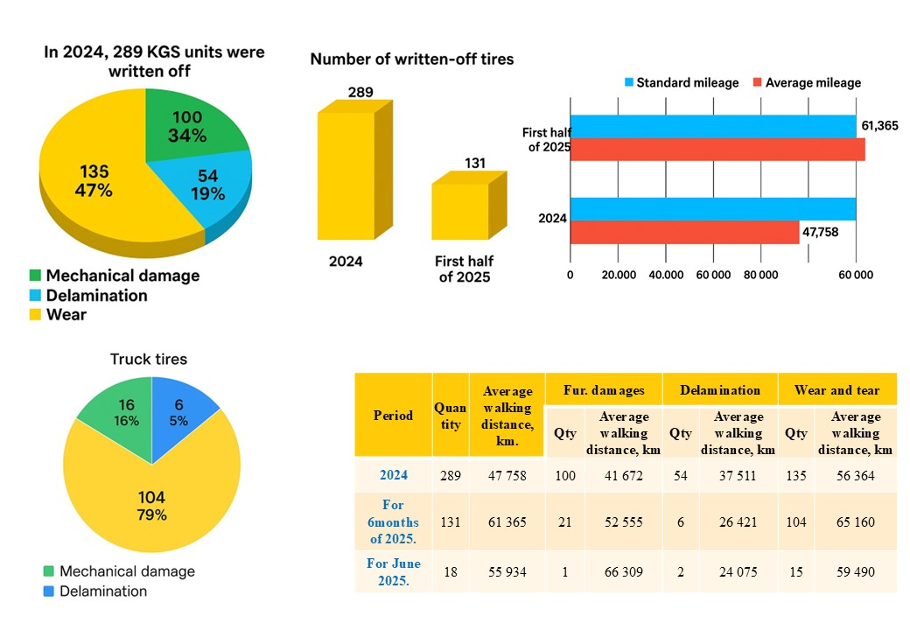
FIGURE. 2. Analysis of the mileage of the KGS tires of size 33.00R51

The research utilized experimental testing, mathematical statistics, expert assessment, and analytical methods such as Failure Modes and Effects Analysis (FMEA) and Fault Tree Analysis (FTA) to identify potential tire failures, assess their consequences, and develop preventative measures.
The aim of the study is to comprehensively assess the causes of premature failure of large-size tires on quarry dump trucks at the Muruntau mine using FMEA and FTA methods.
The study's scientific novelty lies in the following: the classification of premature failure causes for large-size tires was refined using engineering analysis in the form of a cause-and-effect tree (FTA), grouping failures into three main types: natural wear, mechanical damage, and thermal damage.
Results. The FMEA methodology provided for each type of failure the determination of the severity of the consequences (S), the probability of occurrence (O), the probability of timely detection of a defect (D), and the calculation of the risk priority number (RPN) as the product of S × O × D (Table 2).

TABLE 2. Results of FMEA analysis using the risk priority number method
№ | Type of refusal | Main reasons (factors) | S | O | D | RPN | Impact on TKPH | Recommendations
1 | Tread/carcass separation | Exceeding the permissible TKPH value, tire overheating (>85°C), high speed on steep slopes, long haul, low pressure, load imbalance | 9 | 5 | 7 | 315 | A sharp reduction in service life (by 25–40%), frequent failures up to 40 thousand km | Introduce dynamic speed limits based on temperature and slope; online monitoring of TKPH and pressure; selection of mixtures with increased TKPH
2 | Mechanical damage | Stones and sharp edges on the road, impacts at high speeds, incorrect pressure, overloaded axles | 8 | 6 | 6 | 288 | Reduction in service life by 10–25%, increase in TKPH value due to rolling resistance | Preventive grading, sectional speed monitoring, impact load telemetry, pre-trip pressure monitoring
3 | Tread wear | Incorrect selection of compound for temperature and speed, high abrasive action, non-compliance with pressure, lack of rotation | 5 | 9 | 3 | 135 | The TKPH value increases at high speeds, but the resource generally corresponds to the calculated one | Tire rotation based on mileage, pressure monitoring, tread pattern optimization for site conditions
As a result of establishing the causes of premature failure of large-size tires, in order to facilitate and simplify the analysis for tire engineers, an improved classification of the causes of premature failure of large-size tires was developed, based on engineering analysis in the form of a cause-and-effect tree (FTA) with grouping of failures into three main types: tire wear, mechanical damage and thermal damage, shown in Fig. 3.
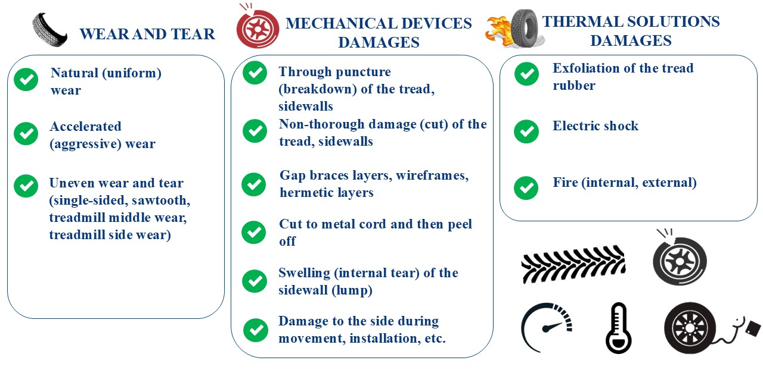
FIGURE. 3. Improved classification of failure causes of large-size tires in quarry operation
1. Tire wear. This group includes processes of degradation of performance properties that occur both as a result of natural aging and under the influence of adverse operating conditions. The following forms of wear are distinguished [6]:
- Natural wear — a gradual decrease in tread thickness within the standard service life;
- Accelerated wear — manifested by intense abrasion of the tire's working surface under the influence of increased loads, non-standard pressure, or an aggressive environment;
- Uneven wear — manifested as one-sided, sawtooth wear, as well as localized wear in the central or lateral zones of the tread, caused by incorrect wheel alignment, imbalance, or systematic deviation from recommended operating conditions.
2. Mechanical damage. This is the result of short-term or prolonged exposure to external forces that exceed the values ​​permissible for the tire design. The main types of mechanical defects include:
- Through damage (punctures, breaks) of the tread or sidewall;
- Non-through damage (cuts of varying depths) with possible loss of seal;
- Ruptures in breaker plies, cords, and innerliners;
- Deep cuts down to the metal cord, accompanied by secondary delamination of structural elements;
- Sidewall bulges (bulges) caused by internal carcass tears;
- Damage to the bead area caused by careless transportation, installation/dismantling, or contact with sharp objects.
3. Thermal damage. Occurs as a result of abnormal thermal exposure, which can compromise the integrity of the rubber-cord structure. The main forms of thermal failure are:
- Separation of the tread rubber caused by overheating due to prolonged driving with low tire pressure or excessive loads;
- Localized damage due to electric shock (e.g., due to improper operation of quarry equipment);
- internal or external combustion of a tire is usually the result of prolonged exposure to high temperatures, mechanical damage or chemical reactions.
DISCUSSIONS
The results of the FMEA and FTA tire failure analysis performed at the Muruntau quarry yield the following conclusions:
1. The highest priority risk according to RPN is tread/carcass separation (315), which is associated with thermal overload of the tires and exceeding the calculated TKHF value.
2. Mechanical damage (RPN = 288) increased in 2025: its share increased to 59%, indicating the need for improved road conditions and speed control.
3. Tread wear (RPN = 135) is a lower priority but requires systematic rotation and optimization of tire selection.
4. An analysis by size revealed that the 50/80R57 tire has the lowest mileage (average mileage of 27,000–28,000 km, compared to the standard of 45,000 km), while the 37.00R57 has the highest mileage (average mileage up to 90,000 km).
5. An analysis of the factors leading to premature tire failure allows us not only to identify typical defects and the conditions under which they occur, but also to formulate sound technical and organizational solutions aimed at increasing reliability, extending service life, and ensuring safe tire operation.
Based on the findings, the following recommendations have been developed to reduce the failure rate of large-size tires and optimize the actual TKPH value in Muruntau conditions:
1. Implement a real-time TKPH monitoring system with automatic driver notification.
2. Develop high-speed route maps taking into account slopes and air temperature.
3. Organize regular grading and condition monitoring of utility roads.
4. Use TPMS with temperature and pressure sensors on each wheel.
5. Conduct route analysis with a damage map to plan pavement repairs.
6. Develop seasonal tire pressure regulations taking into account temperature conditions.

CONCLUSION
1. For the first time, a risk prioritization nomenclature (RPN) FMEA analysis of large-size tire failures was conducted for the Muruntau quarry. This analysis identified and quantified thermal overload and exceeding the calculated TKPH value as key factors for tread/carcass separations. An increase in the proportion of mechanical damage to 59% was established, and tire lifespans were determined, providing a basis for optimizing operating modes and adjusting the methodology for calculating the actual TKPH value.
2. The practical significance of the study lies in the ability to quickly identify critical factors leading to premature tire failures and develop effective measures to reduce the actual TKPH value and increase the lifespan of large-size tires.
3. The contribution of the study lies in adapting the FMEA method to the Muruntau quarry conditions and determining risk priorities (RPN), which enables optimization of operating modes and improvement of the reliability of quarry vehicles.
4. Additional analysis using FMEA and FTA methods provides the basis for developing an automated tire failure risk monitoring system for quarries. Implementation of the proposed measures can reduce the rate of premature tire write-offs and improve the operational efficiency of process vehicles.
5. Implementation of the developed recommendations revealed that premature tire failures at the Central Mining District quarries decreased by 16%, and their average service life increased by 4.56%, confirming the effectiveness of the proposed approach.
REFERENCE
- Michelin Earthmover Product Catalog. — Michelin Mining Solutions, 2022. p. 47.
- Goryunov S.V. Development of a methodology for predicting the durability of large-size tires of quarry dump trucks: Diss. ... Cand.Tech.Sci. - M .: Kemerovo, 2021. - 124 p.
- Topalidi V.A., Israilov M.E. Determination of the actual TKHF indicator of large-size tires in quarry conditions // Automotive industry. - 2024. No. 8. - pp. 12 - 15.
- Fundamental and applied science: state and development trends: Monograph / Abdirakhmonov Zh.A. et al. - Petrozavodsk: MCNP "New Science", 2023. - 545 p. : ill. - Collective authors. DOI 10.46916/06032023-1-978-5-00174-887-8.
- Bridgestone off-road tires reference book. 2014. 97 p.
- Alimova, Z., Tursunov, S., Khikmatov, R., & Pulatov, S. (2025). Evaluating motor oil quality in heavily loaded quarry vehicle engines. 030041. https://doi.org/10.1063/5.0269618
- Choriev, J. A., Faizullaev, E. Z., Khakimov, S. K., & Rakhmanov, A. S. (2025). The Impact of the Number of Street Intersections on Traffic Safety in Karshi City (pp. 227–231). https://doi.org/10.1007/978-3-031-83595-7_37
- Fayzullayev, E., Khakimov, S., Rakhmonov, A., Rajapova, S., & Abdurazzakova, D. (2025). Correct choice of parameters of runaway truck ramp on the mountain roads is factor in saving people’s lives. 030013. https://doi.org/10.1063/5.0267594
- Ikromov, A. (2025). Development of new efficient materials for machine-building parts and units of trucks. 060010. https://doi.org/10.1063/5.0266737
- Israilov, M., Mukhitdinov, A., Yusupov, U., & Anvarjonov, A. (2025). Analysis of the method for calculating the actual indicator ton kilometer per hour of large tires and its disadvantages. 060039. https://doi.org/10.1063/5.0266854
- Kapski, D., Semchenkov, S., Gamulsky, I., Ikromov, A., Omarov, J., & Abruev, S. (2024). Assessment measures developed to improve quality of route transport Polotsk and Novopolotsk. E3S Web of Conferences, 515, 03003. https://doi.org/10.1051/e3sconf/202451503003
- Kapski, D., Semchenkov, S., Korolchuk, M., & Abdurazzokov, U. (2024). Identification of key route indicators to compare different modes of transport. BIO Web of Conferences, 145, 03017. https://doi.org/10.1051/bioconf/202414503017
- Kapski, D., Semchenkov, S., Korolchuk, M., & Ikromov, A. (2024). Improving the efficiency of route passenger transport systems by using recovered energy. E3S Web of Conferences, 592, 07001. https://doi.org/10.1051/e3sconf/202459207001
- Kapsky, D., Abdurazzokov, U., & Ziyaev, K. (2025). Measures to improve operation of passenger transport and urban mobility. 060021. https://doi.org/10.1063/5.0266810
- Khalilova, G. Kh., Choriyeva, M. Sh., Samatov, R. G., Abdurazzokov, U. A., & Urunov, D. A. (2025). AI Integration in Smart Car Parking Stations (pp. 125–133). https://doi.org/10.1007/978-3-031-88846-5_15
- Khalmukhamedov, A., & Anvarjonov, A. (2024). Specific features of improving automobile road complex of the Republic of Uzbekistan. E3S Web of Conferences, 515, 01016. https://doi.org/10.1051/e3sconf/202451501016
- Khalmukhamedov, A. S., Samatov, R. G., Islamov, E. B., & Narziyev, J. Sh. (2025). Assessment of the Highway Network of International Importance of the Republic of Uzbekistan (pp. 189–196). https://doi.org/10.1007/978-3-031-99028-1_21
- Khalmukhamedov, A., Samatov, R., & Rajapova, S. (2024). Prospects for the use of an automatic system for weight and dimensional control of vehicles in the Republic of Uzbekistan. 050031. https://doi.org/10.1063/5.0197415
- Kuvondik, U., Yusupov, U., Zilola, R., & Mashrab, I. (2025). Improvement of the classification of causes for the decommissioning of large-size tires. Vibroengineering Procedia, 58, 291–299. https://doi.org/10.21595/vp.2025.24964
- Larin, O. N., Kapski, P. D., Kapski, D. v., Ziyaev, K. Z., & Abdurazzokov, U. A. (2025). Supply Chain Resilience: A Hierarchical Strategic Planning Model (pp. 61–69). https://doi.org/10.1007/978-3-031-99028-1_8
- Makhmudov, G. (2024). Development of methods for calculating thermal conductivity of gas condensates-alternative motor fuels. E3S Web of Conferences, 515, 03002. https://doi.org/10.1051/e3sconf/202451503002
- Mikhaltsevich, M., & Ziyaev, K. (2024). Modeling the braking process for motorcycle with ABS. E3S Web of Conferences, 592, 07002. https://doi.org/10.1051/e3sconf/202459207002
- Petrovich, B. V., & Ugli, A. A. A. (2025). Analysis of static load on a tire in quarry operating conditions. 030017. https://doi.org/10.1063/5.0266786
- Sattivaldiyev, B., Ochilov, A., Xushvaktov, S., & Shavkatov, K. (2025). Influence of high altitude operating conditions on vehicle fuel economy. 060020. https://doi.org/10.1063/5.0267034
- Skirkovsky, S. V., Kapsky, D. V., Sattivaldiyev, B., Makhmudov, G. N., & Abdurakhimov, L. Kh. (2025). Eco-efficient and environmentally sustainable prioritization of urban passenger transport movement. E3S Web of Conferences, 646, 00051. https://doi.org/10.1051/e3sconf/202564600051
- Tursunbaev, B. H., Fayzullaev, E. Z., Akbarov, N. A., & Nigmatov, H. (2023). A new methodology for evaluating the efficiency of complex machine mechanisms. 040098. https://doi.org/10.1063/5.0145575
- Tursunov, S. R., Khikmatov, R. S., & Khusanov, S. N.-U. (2024). Increasing the efficiency of the use of mining transport due to increasing the periodicity of maintenance time. 050021. https://doi.org/10.1063/5.0197547
- Xikmatov, R., & Urinbaev, Q. (2025). Assessment of influence of final drive ratio on fuel economy of car abstract. 060022. https://doi.org/10.1063/5.0267040
- Yusupov, U., Urinbaev, K., Boykov, V., & Israilov, M. (2025). Optimizing TKPH for Large-Sized Tires in Quarry Conditions (pp. 381–391). https://doi.org/10.1007/978-3-031-95649-2_33
- Zebo, A., Sherali, T., Ravshan, K., Ravshanjon, A., & Kamola, K. (2025). Research of the quality of motor oils working in engines of mining transport equipment. 060023. https://doi.org/10.1063/5.0267065
- Ziyaev, K., Vokhidov, D., Shavkatov, K., Khadiyeva, G., & Yangiyeva, I. (2025). Influence of traffic light management on traffic capacity of Urban highways. 060038. https://doi.org/10.1063/5.0266822

