Thermodynamic analysis of biomass pyrolysis vapor-gas mixtures: Implications for condenser design
Xamidilla Almardanov^{1,a)}, Bakhrom Sherkulov¹, Azim Ruzikulov², Shaxlo Ulasheva¹, Madadjon Uktamov³, Shukurullo Alikulov³, Utkir Urishev ⁴
¹ Karshi State Technical University, Karshi, Uzbekistan
²Karshi State University, Karshi, Uzbekistan
³Shahrisabz State Pedagogical Institute, Shahrisabz, Uzbekistan
⁴Namangan State Technical University, Namangan, Uzbekistan
^{a)} Corresponding author: urisheva80@mail.ru
Abstract. This study investigates the thermodynamic properties of a multicomponent vapor-gas mixture generated during the pyrolysis of lignocellulosic biomass. The mixture comprises typical pyrolysis products, including hydrogen, carbon monoxide, carbon dioxide, methyl radicals, light hydrocarbons, and water vapor. The non-ideal behavior of the gas mixture under elevated temperatures and pressures was modeled using the Peng–Robinson equation of state, with numerical simulations performed in the Aspen Plus environment. The analysis covered a temperature range of 373 K to 473 K and steam molar fractions of 5%–25%. The results revealed that an increase in temperature led to a decrease in density and thermal expansion coefficient, along with an increase in specific heat capacity, thermal conductivity, and acoustic velocity. A higher steam content reduced the viscosity and density while enhancing the heat capacity and sound speed, owing to the distinctive thermophysical properties of water vapor. The Brokaw method and kinetic theory were employed to calculate the viscosity and thermal conductivity, respectively, accounting for molecular interactions and polarity within the mixture. These findings offer valuable insights into the design and optimization of heat exchangers and reactor systems used in biomass pyrolysis, enabling more efficient and predictive engineering applications in renewable energy technologies.
INTRODUCTION
There has been a significant surge in interest regarding various renewable energy sources aimed at decarbonizing society. Plant biomass, including agricultural residues, emerges as a promising alternative to fossil fuels [1,2]. Consequently, the thermochemical conversion of biomass into biofuels and other compounds has garnered substantial attention from the research community [3].
Thermochemical biomass conversion encompasses processes that utilize elevated temperatures to transform biomass into more valuable product streams. Pyrolysis is a specific thermochemical conversion process conducted in the absence of oxygen. During pyrolysis, the biomass structure undergoes thermal decomposition, resulting in the formation of char (solid fraction), bio-oil (condensed vapors), and permanent gas (non-condensable gases under atmospheric conditions). The yield and composition of these products are influenced by various factors, including the pyrolysis heating rate, temperature, residence time, technology, and biomass characteristics [4,5].
Initially, during the heating of the solid fuel particle, water undergoes evaporation in the drying stage, which typically persists until approximately 100 °C. Subsequently, there is a gradual release of volatile compounds as the temperature increases, marking the primary pyrolysis stage, which extends up to approximately 500 °C. The release of volatile substances constitutes the principal phase of the pyrolysis process, wherein the large molecules of the organic matrix of biomass particles decompose into primary volatiles, including both condensable and permanent gases, as well as primary coal. This process is accompanied by a significant reduction in the weight of the initial solid biomass particles [6].
Biomass primarily consists of three components: cellulose (30–60%), hemicellulose (20–35%), and lignin (15–30%), each of which decomposes at distinct temperatures during the thermochemical conversion process [7]. The thermal degradation of the carbonyl and carboxyl functional groups within these lignocellulosic components leads to the formation of a vapor-gas mixture containing CO₂, the cleavage of C and CO bonds resulting in CO formation, and the rupture of CH and aromatic groups producing H₂ [8].

EXPERIMENTAL RESEARCH
Determining the thermodynamic properties of a flue gas mixture is crucial for the modeling and engineering analysis of biomass pyrolysis processes. This gas mixture, generated during the thermochemical decomposition of organic materials, constitutes a complex multicomponent system. It comprises water vapor, volatile organic compounds, and gases such as CO, CO₂, CH₄, and H₂. The behavior of this medium is governed by its physicochemical properties, which are significantly affected by temperature, pressure, and composition.
Accurate determination of parameters such as density, heat capacity, viscosity, and thermal conductivity is essential for the precise resolution of the mass, momentum, and energy conservation equations. These parameters influence the temperature distribution, pressure, flow velocity, and the intensity of heat and mass transfer processes within the reactor. Specifically, understanding heat capacity and thermal conductivity is crucial for evaluating heating inertia and the uniformity of the temperature field. Conversely, density and viscosity are instrumental in determining flow resistance and pressure distribution.
Moreover, it is essential to calculate the enthalpy and internal energy of the mixture to evaluate the heat balance and energy efficiency of the system. These thermodynamic properties are crucial for predicting phase transitions, such as the condensation of volatile fractions, which significantly influence the operation of heat exchange and condensation systems. Without this data, the reliable design of pyrolysis reactors, heat exchangers, separators, and other critical equipment components is unattainable.
The primary constituents of the steam-gas mixture produced during the pyrolysis of vegetable biomass include H₂, H₂O, CO, CO₂, CH₄, C₂H₄, and C₃H₆ [9]. By considering the molar mass and fraction of each component, we determined the average molar mass of the vapor-gas mixture and the average specific gas constant [10].

TABLE 1. Composition of the vapor-gas mixture
Components | Molar mass, g/mol | Mole Fraction | Specific gas constant, J/kg·K)
H₂ | 2,016 | 0,2 | 4125
CH₄ | 16,04 | 0,1 | 519
CO₂ | 44,01 | 0,15 | 189
C₂H₄ | 28,05 | 0,03 | 297
H₂O | 18,02 | 0,2 | 461
C₃H₆ | 42,08 | 0,04 | 198
CO | 28,01 | 0,2 | 297
C₅H₁₂ | 72,15 | 0,018 | 115,23
C₂H₆ | 30,07 | 0,018 | 277
C₆H₆ | 78,11 | 0,012 | 106,44
C₄H₈ | 56,11 | 0,012 | 148,17
C₂H₂ | 26,04 | 0,01 | 319,28
C₃H₈ | 44,1 | 0,01 | 188,53

The average molar mass of the gas mixture was determined using the following formula [10]:
$$M_{m}=\sum{\left(X_{i}∙M_{i}\right)=24,49 (\frac{g}{mol})}$$ | (1)
where: $X_{i}$is the molar fraction of the i-th component and $M_{i}$ is the molar mass of the i-th component.
The mean specific gas constant ($R_{m}$) was calculated using the formula [10]:
$$R_{m}=\frac{R}{M_{m}}=\frac{8,314}{0,02449}=339,6 (\frac{J}{kg·К})$$ | (2)
where: $R$- universal gas constant.
To ascertain the density of the vapor-gas mixture (ρ), we employed the equation of state for an ideal gas [10]:
$ρ=\frac{P}{R_{sp}∙T}$ (3)
where: P is the pressure (Pa), T is the temperature (K), $R_{m}-$specific gas constant (J/(kg·K)).
Utilizing the average specific gas constant, we determined the density of the vapor-gas mixture (Figure 1) at various temperatures of the steam-gas mixture, specifically within the range of 100 to 200 °C, and at a condenser pressure of 5 bar, as observed in laboratory experiments. The illustration presents a two-dimensional matrix that delineates the density distribution of the steam-gas mixture, measured in kg/m³, as a function of temperature (ranging from 100 °C to 200 °C) and pressure (ranging from 1.0 to 5.0 bar). These calculated data were obtained within a context relevant to the operational conditions of pyrolysis and thermochemical reactors. This is pertinent because these conditions may facilitate the production and transport of a steam-gas phase comprising water vapor and pyrolysis products.
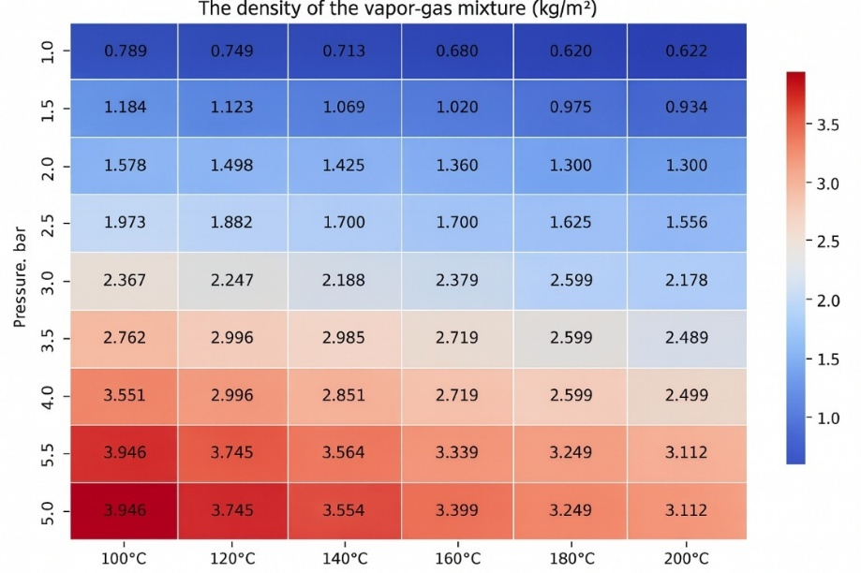
FIGURE 1. Density of the vapor-gas mixture at different temperatures and pressures

Density is a fundamental property that defines the mass of a vapor-gas mixture per unit volume. This parameter plays a crucial role in the calculation of mass flow rates, inertial forces, and gravitational separation. Furthermore, it is an essential component of the equations governing mass and momentum conservation. Variations in density due to changes in temperature and pressure must be considered during the design phase of pipelines and reaction vessels.
A predictable monotonic relationship was identified among density, pressure, and temperature. When the temperature was held constant, an increase in pressure led to an almost linear increase in density. For instance, at 200 °C, the density increased from 0.622 kg/m³ at 1 bar to 3.112 kg/m³ at 5 bar.
At a constant pressure, an increase in temperature leads to a decrease in density. This phenomenon is consistent with Boyle-Mariotte's law and reflects the typical behavior of both ideal and real gases.
The color gradient, ranging from dark blue (indicating low density) to dark red (denoting high density), offers a visual depiction of the variations in the thermophysical properties of the medium. The highest densities were recorded at the lowest temperatures and highest pressures, reaching up to 3.946 kg/m³ at 100 °C and 5 bar. Conversely, the lowest densities were observed at 200 °C and 1 bar, measuring 0.622 kg/m³.
The data table is applicable to a variety of scenarios, including the execution of thermohydraulic calculations, the assessment of volumetric heat capacity, the design of heat exchangers, and the determination of phase transition conditions within pyrolysis plants.
Utilizing the computed data, the Aspen Plus software was employed to determine the thermodynamic properties of the vapor-gas mixture emitted during the pyrolysis of plant biomass. To accomplish this, it is essential to establish a thermodynamic system for the steam-gas mixture using the requisite component values (Table 1).
The steam gas mixture resulting from biomass pyrolysis comprises H₂, CO, CO₂, H₂O, and various hydrocarbons (CH₄, C₂H₄, C₆H₆, etc.), rendering the calculation of its properties a complex endeavor. The Peng Robinson (PR) model is the most appropriate framework for describing the behavior of such a mixture. Unlike the ideal gas model, the PR model accounts for van der Waals forces between molecules, which are crucial for gases containing polar components such as CO, CO₂, and H₂O. Water vapor and CO₂ possess significant dipole moments that influence their behavior, particularly at moderate and high pressures. The presence of condensable components (H₂O, C₆H₆, C₅H₁₂, etc.) is noteworthy at low heat-exchange temperatures, where some vapors may condense. The PR model provides a more accurate description of gas behavior at medium and high pressures and predicts the compressibility coefficient (Z) with greater precision than alternative models [11,12].
The kinetic theory method was selected to calculate the thermal conductivity of a vapor-gas mixture due to its foundation in the molecular-kinetic theory of gases, which accounts for molecular collisions. This consideration is particularly crucial for multicomponent gas mixtures, such as pyrolysis products. The method is more appropriate for real gases across a broad spectrum of temperatures and pressures. Given that our vapor-gas mixture comprises water vapor and hydrocarbons, the kinetic theory method yields more precise results in modeling heat transfer [13].
The Brokaw method is widely regarded as the optimal approach for calculating the viscosity of gas mixtures, as it accounts for molecular polarity, intermolecular forces, and quantum mechanical effects. This consideration is particularly crucial for mixtures containing polar components, such as CO, H₂O, and CO₂. The method is applicable to multicomponent mixtures, including both light gases (H₂, CH₄) and heavy hydrocarbons (C₂H₄, C₆H₆, C₅H₁₂, etc.). The Brokaw method employs a generalized averaging technique that not only considers the proportion of components but also their interactions within the mixture, resulting in more accurate outcomes compared to the simple Smith rule (logarithmic mean). Given that the vapor-gas mixture from biomass pyrolysis contains components at elevated temperatures (up to 500 °C), the Brokaw method has demonstrated superior accuracy under high-temperature conditions compared to other correlations, such as Wilke or Chapman-Enskog [14].
RESEARCH RESULTS
In calculating the thermodynamic properties of a steam-gas mixture, it is imperative to consider the mass fraction of water. This consideration is crucial because, during the pyrolysis of various plant biomasses with differing moisture levels, the thermodynamic properties are influenced by the process temperature. The mass fraction of water in the steam-gas mixture is directly correlated with the moisture content of the plant biomass. Accordingly, we calculated the thermodynamic properties of the steam-gas mixture at varying mass fractions of water, specifically within the range of 0.05 to 0.25, based on the optimal humidity range (Figure 2), as investigated by researchers [15].
To determine the percentage of moisture at the molar fraction of water, we employed the following formula for the mass fraction of water [16]:
$$w_{H_{2}O}=\frac{X_{H_{2}O}∙M_{H_{2}O}}{\sum{(X_{i}∙}M_{i})}$$ | (4)
where: $w_{H_{2}O}-$mass fraction of water (humidity); $X_{H_{2}O}-$ molar fraction of water; $M_{H_{2}O}-$molar mass of water; $M_{i}-$ molar mass of all components of the mixture.
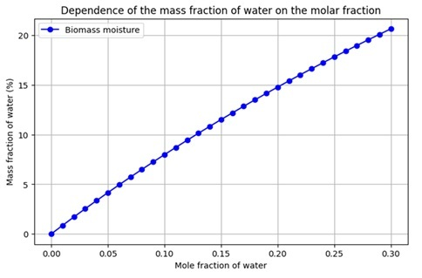
FIGURE 2. Dependence of the mass fraction of water on the molar fraction.

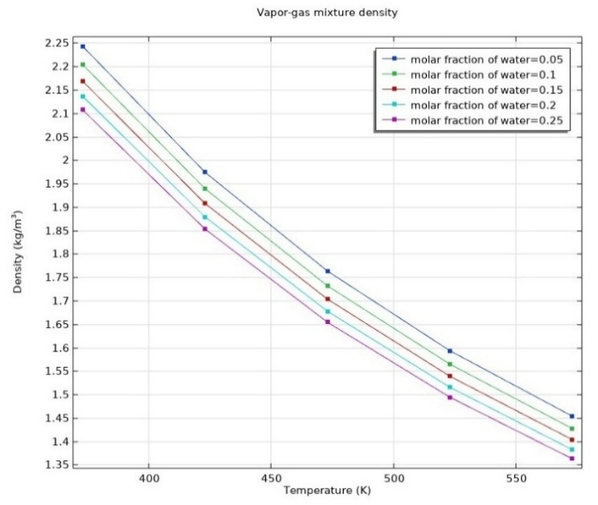 | 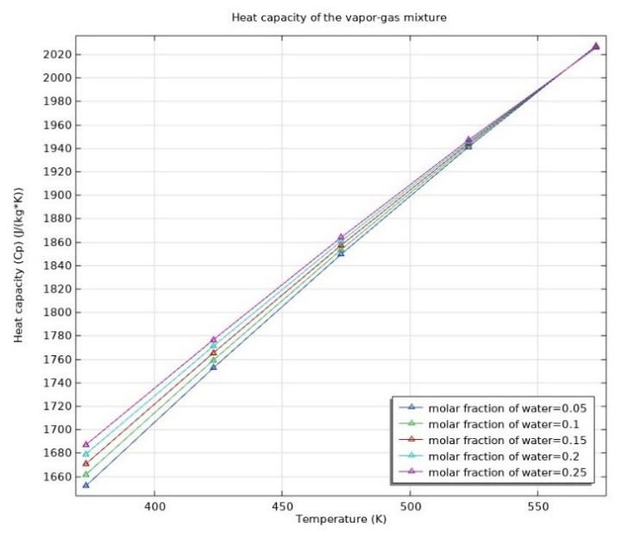
FIGURE 3. Vapor-gas mixture density. | FIGURE 4. Heat capacity of the vapor-gas mixture.

An increase in temperature results in a reduction in the density (ρ) of the mixture across all cases presented (Figure 3). Similarly, an increase in the molar fraction of water contributes to a decrease in density, attributable to the lower molar mass of water vapor relative to other components of the mixture. The graph depicting the density of the vapor-gas mixture illustrates a consistent decline in density, aligning with the equation of state for an ideal gas. These findings facilitate the evaluation of the impact of temperature and humidity on the density of the combined-cycle mixture, which is crucial for optimizing heat exchange processes in pyrolysis plants.
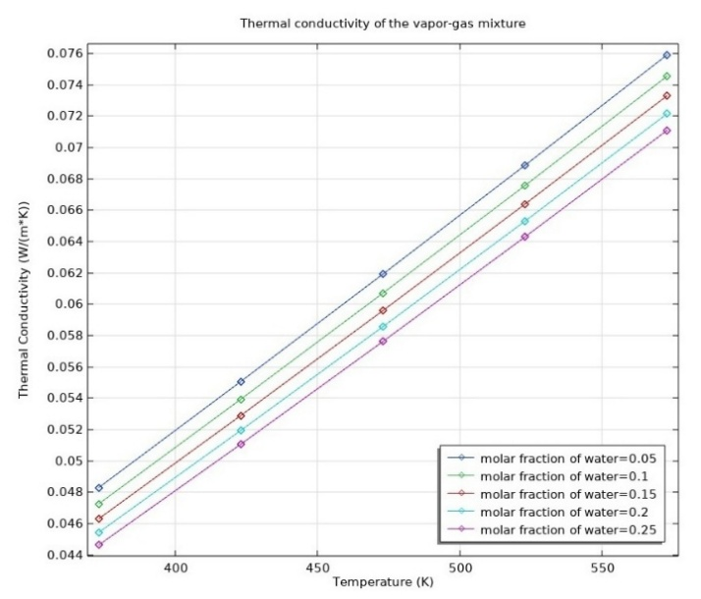 | 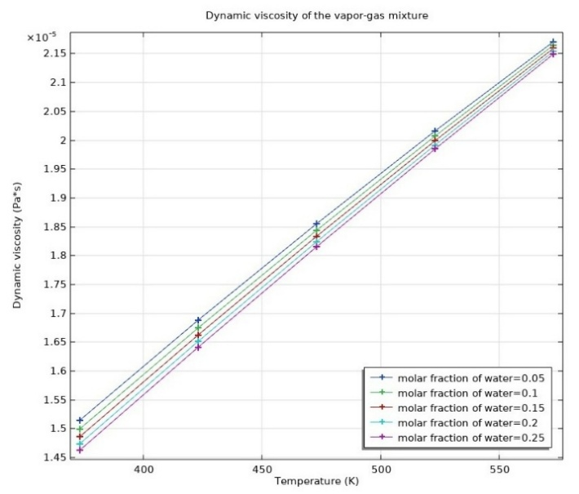
FIGURE 5. Thermal conductivity of the vapor-gas mixture. | FIGURE 6. Dynamic viscosity of the vapor-gas mixture.

As the temperature increases, the heat capacity (cₚ) of the vapor-gas mixture also rises. This phenomenon can be attributed to the enhanced kinetic energy of the molecules and the alteration in the heat capacity of the individual components within the mixture (Figure 4). An increase in the molar fraction of water in the steam-gas mixture results in an elevated specific heat capacity, owing to the relatively high heat capacity of water vapor compared to other components in the mixture. The graph illustrates an almost linear relationship between heat capacity and temperature across all considered molar fractions of water. These findings are significant for the modeling of pyrolysis processes, as heat capacity influences the heat balance within the system and the efficiency of heat exchange in the condenser-heat exchanger of the pyrolysis plant.
The specific heat capacity (cₚ) quantifies a mixture's capacity to store thermal energy. A higher cₚ signifies that a greater amount of heat is required to elevate the mixture's temperature, which is crucial for calculating energy expenditures in heating and pyrolysis reactions. This parameter is integral to the energy equation, determining the thermal inertia of a system.
The thermal conductivity of the vapor-gas mixture exhibits an increase with rising temperature, attributable to the enhanced average molecular velocity and their consequent capacity for energy transfer (Figure 5). Conversely, an increase in the molar fraction of water within the steam-gas mixture results in a reduction of its thermal conductivity. This phenomenon is explained by the fact that the thermal conductivity of water vapor is lower than that of most constituent gases in the steam-gas mixture. The observed relationships are predominantly linear, thereby facilitating the application of approximation methods to predict thermal conductivity across a specified temperature range.
Thermal conductivity (λ) represents the capacity of a vapor-gas to conduct heat in the absence of macroscopic material movement. This property is crucial for determining temperature distributions within reactors and the walls of heat exchange components. A reduction in thermal conductivity can lead to temperature gradients and uneven heating across a layer, whereas an increased value aids in stabilizing the thermal regime.
The dynamic viscosity (μ) of the vapor-gas mixture increases with rising temperature, which is attributed to enhanced intermolecular interactions and an increase in the average kinetic energy of the molecules (Figure 6). An increase in the molar fraction of water results in a decrease in the dynamic viscosity of the mixture. This phenomenon occurs because water vapor exhibits lower viscosity compared to other gases present in the steam gas. The plots demonstrated an almost linear increase in viscosity with temperature, corroborating the applicability of linear models for predicting the viscosity characteristics of the mixture within the studied range.
The dynamic viscosity (μ) measures the internal friction of a fluid, particularly in the context of a vapor-gas mixture traversing a porous medium. It is a critical component of Darcy's law and, consequently, affects hydraulic resistance. An increase in viscosity complicates filtration processes and may result in a pressure drop. Conversely, a decrease in viscosity facilitates more efficient passage through the material.
The ratio of specific heat capacities decreases with increasing temperature, as illustrated in Figure 7. This phenomenon occurs because the isochoric heat capacity increases at a faster rate than the isobaric heat capacity, resulting in a reduction of their ratio. Additionally, as the water vapor content in the mixture rises, the ratio increases at the same temperature. This is attributable to the higher heat capacity of water vapor compared to other components in the vapor-gas mixture. Regardless of the molar fraction of water, the curves exhibit similar shapes and are parallel, indicating a systematic alteration in the thermodynamic properties of the mixture. The ratio of specific heat is a critical parameter in the calculation of thermodynamic processes such as expansion, contraction, and heat transfer.
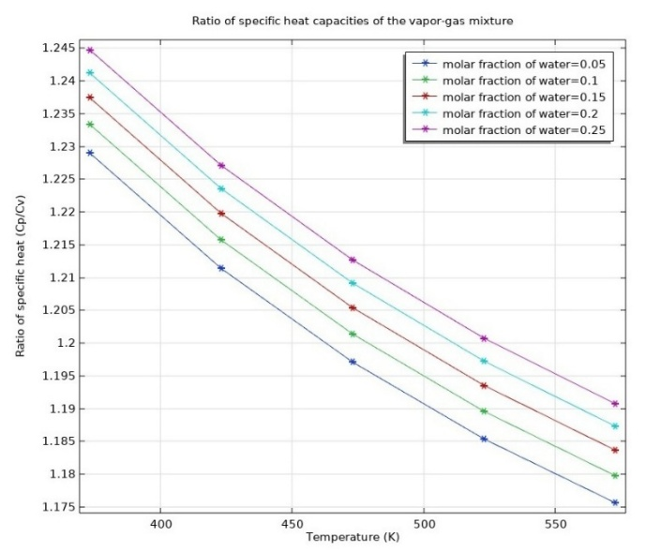 | 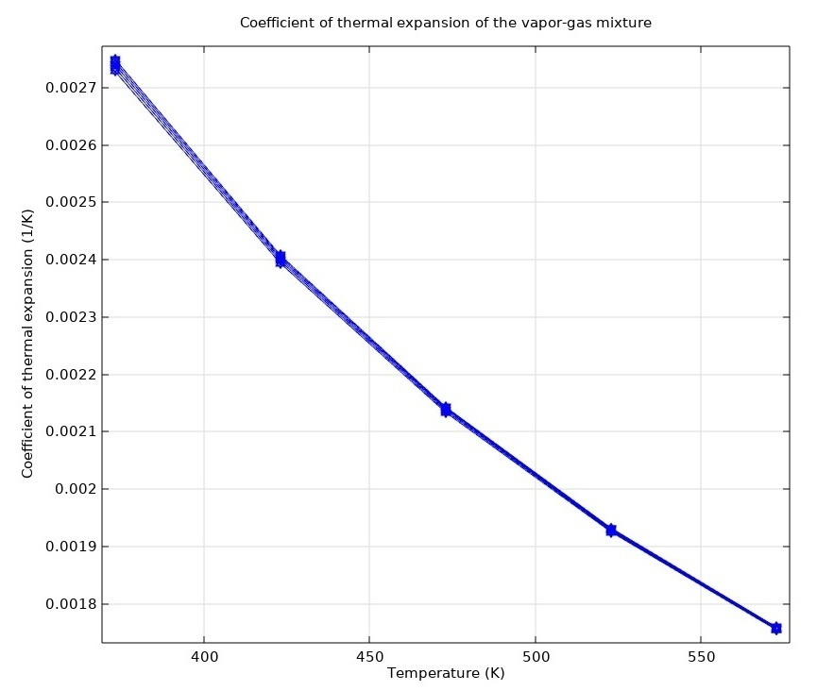
FIGURE 7. Ratio of specific heat capacities of the vapor-gas mixture. | FIGURE 8. Coefficient of thermal expansion of the vapor-gas mixture.

The coefficient of thermal expansion (β) exhibits a decrease as temperature increases (Figure 8). This phenomenon can be attributed to the less pronounced change in the density of the vapor-gas mixture with rising temperature. The curve illustrates an exponential decline in the coefficient of thermal expansion with increasing temperature, suggesting a complex interplay between the molecular forces within the mixture and the effects of temperature. At lower temperatures (<350 K), the coefficient of thermal expansion is higher, indicating a more pronounced increase in the volume of the mixture upon heating. Conversely, at higher temperatures (>500 K), the coefficient approaches constancy, signifying a diminished impact of thermal expansion.
The coefficient of thermal expansion (β) measures the extent to which the volume of a gas changes in response to variations in temperature. This parameter is crucial for modeling natural convection phenomena, assessing thermal deformations, and evaluating the stability of flows within vertical reactors. A larger β enhances the motion driven by thermal buoyancy, potentially affecting the development of the reaction front.
The velocity of sound (a) within the vapor-gas mixture exhibits an increase with rising temperature (Figure 9). This phenomenon is attributed to the augmentation of the average kinetic energy of the molecules, which facilitates the propagation of sound waves. Furthermore, as the molecular fraction of water increases, the velocity of sound correspondingly rises. This is due to the fact that water vapor possesses a higher speed of sound compared to the other gases present in the mixture. The relationship between sound velocity and temperature is nearly linear, thereby simplifying the prediction of the acoustic properties of the mixture under varying operational conditions. Understanding the speed of sound in this medium is crucial for diagnosing processes in heat exchange systems and for the acoustic monitoring of vapor-gas streams.
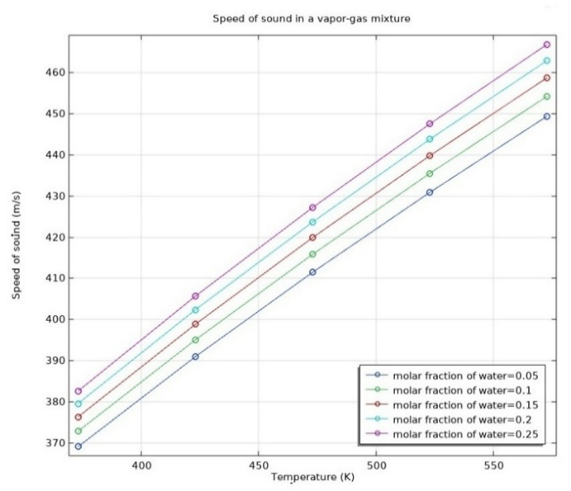
FIGURE 9. Speed of sound in a vapor-gas mixture.

The speed of sound (a) in a vapor-gas mixture is a critical parameter when analyzing high-velocity or compressible flows. Such conditions are exemplified in scenarios like jet nozzles or situations involving sudden pressure fluctuations. Additionally, it is essential to ensure the stability of numerical schemes utilized in Computational Fluid Dynamics (CFD) modeling.
The calculation of the thermodynamic properties of the combined-gas mixture has facilitated the identification of key regularities in its behavior across varying temperatures and water contents. It has been determined that an increase in temperature results in a reduction in the mixture's density, while simultaneously enhancing its heat capacity and thermal conductivity. The Peng-Robinson model has been validated as an effective tool for describing complex multicomponent systems.
The results of these calculations indicate that the composition and temperature of the working mixture significantly influence the processes of heat exchange and condensation, thereby enabling more precise modeling of processes within the condensation heat exchanger of the pyrolysis plant. Analyzing the impact of different temperature regimes on the system's heat transfer efficiency will facilitate the identification of optimal operating conditions for the condenser-heat exchanger.

CONCLUSIONS
A thermodynamic model has been developed to analyze multicomponent vapor-gas mixtures generated during the pyrolysis of biomass. The Peng–Robinson equation of state was utilized for the calculations, providing a comprehensive description of both noncondensable and condensable components across a broad spectrum of temperatures and pressures.
The study demonstrated that the primary properties of the mixture were substantially affected by variations in temperature and moisture content. An increase in temperature results in a reduction in density and the thermal expansion coefficient, while it leads to an enhancement in heat capacity, thermal conductivity, viscosity, and the speed of sound. These relationships are either linear or nearly linear, rendering them amenable to approximation and numerical modeling.
The molar fraction of water has been found to systematically influence the thermodynamic properties of the mixture. An increase in water vapor content results in an enhancement of heat capacity and sound speed, while concurrently leading to a reduction in density, viscosity, and thermal conductivity. This phenomenon can be attributed to the relatively low molar mass and distinctive physical properties of H₂O.
The transport properties, specifically thermal conductivity and viscosity, were determined utilizing the kinetic theory and the Brokaw model. These methodologies have demonstrated accuracy in characterizing the multicomponent and polar mixtures present in pyrolysis products. The application of these methods accounts for molecular interactions that influence heat and mass transfer.
The results of the calculations affirm the model's applicability for engineering analysis and the optimization of heat transfer processes within pyrolysis plant equipment, particularly in condenser-heat exchangers. Correlations have been established that facilitate the prediction of heat exchange efficiency based on the composition and temperature of the mixture.
The proposed approach enables the integration of thermodynamic characteristics into multiphysics reactor models, resulting in a more precise evaluation of operational parameters and enhanced energy efficiency of the plants. These findings can be utilized for scaling up, conducting parametric studies, and automating the control of pyrolysis processes.
REFERENCES
- D. Gielen, D. et al. Methodology Background Document: Development of a Decarbonisation Pathway for the Global Energy System to 2050. A Country-By-Country Analysis for the G20 Based on IRENA's REmap and Renewable Energy Benefits Programmes. (2017) https://cisp.cachefly.net/assets/articles/attachments/68267_irena_remap_decarbonisation_pathway_methodology_2017.pdf
- Mamatkulova S. et al. Modeling and Analysis of the Kinetics of the Pyrolysis Process of Biomass with Influence Raw Material Composition on Comsol Multiphysics. 2024 4th International Conference on Technological Advancements in Computational Sciences (ICTACS), Tashkent, Uzbekistan. (2024) pp. 1315-1318, DOI:10.1109/ICTACS62700.2024.10840876
- Ronsse, F., Nachenius, R., & Prins, W. Carbonization of biomass. In A. Pandey, T. Bashkar, M. Stöcker, & R. K. Sukumaran (Eds.), Recent advances in thermochemical conversion of biomass (2015), pp. 293–324. https://doi.org/10.1016/B978-0-444-63289-0.00011-9
- Uzakov G. et al. Simulation of a tubular pyrolysis reactor using Comsol multiphysics software. In International Scientific and Practical Conference Digital and Information Technologies in Economics and Management, pp. 131-142. Cham: Springer Nature Switzerland. DOI:10.1007/978-3-031-55349-3_11.
- P. Basu. Biomass Gasification and Pyrolysis: Practical Design and theory. Published by Elsevier Inc. (2010) ISBN 978-0-12-374988-8. https://www.rexresearch1.com/WoodGasifierLibrary/BiomassGasificationPyrolysisPracticalDesignTheory.pdf
- L. Zhang, C. C. Xu and P. Champagne. Overview of recent advances in thermo-chemical conversion of biomass, Energy Convers. Manage, (2010) 51, 969–982. DOI:10.1016/j.enconman.2009.11.038
- M. Van de Velden, J. Baeyens, A. Brems, B. Janssens and R. Dewil. Fundamentals, kinetics and endothermicity of the biomass pyrolysis reaction, Renewable Energy, (2010) 35, 232–242. https://2024.sci-hub.st/383/f73dc923c9587f6b77b1294fde23ee86/vandevelden2010.pdf
- Collard, F. X., Blin, J. A review on pyrolysis of biomass constituents: Mechanisms and composition of the products obtained from the conversion of cellulose, hemicelluloses and lignin. Renewable & Sustainable Energy Reviews, (2014) 38, 594–608. https://doi.org/10.1016/j.rser.2014.06.013
- A. C. M. Vilas-Boas et al. Valorisation of residual biomass by pyrolysis: influence of process conditions on products. Sustainable Energy Fuels, (2024), 8, 379-396. DOI:https://doi.org/10.1039/D3SE01216F
- Bulygin Yu.A. Thermodynamics and heat transfer: textbook. Voronezh: Voronezh State Technical University. (2015), 110 p. https://cchgeu.ru/upload/iblock/c1d/up_tit_ngd_01.01.2015.pdf.pdf
- M. Ghanbari. A comparison between Peng-Robinson and Soave-Redlich-Kwong cubic equations of state from modification perspective, Cryogenics, (2017), 84:13-19, DOI:10.1016/j.cryogenics.2017.04.001.
- Toshmamatov, B. (2024). Development of Automation and Control System of Waste Gas Production Process Based on Information Technology. In: Gibadullin, A. (eds) Information Technologies and Intelligent Decision Making Systems. ITIDMS 2023. Communications in Computer and Information Science, vol 2112. Springer, Cham. https://doi.org/10.1007/978-3-031-60318-1_17
- Korotkih A.G. Thermal conductivity of materials: a textbook / Tomsk Polytechnic University. Tomsk: Publishing House of Tomsk Polytechnic University, (2011) 97 p. https://portal.tpu.ru/SHARED/k/KOROTKIKH/educational_work/Tab1/Korotkikh_ucheb_pos.pdf
- K.S. Egorov, L.V. Stepanova. Thermophysical properties of noble gas mixtures with low Prandtl number. Engineering Journal Science and Innovation, (2019), DOI:10.18698/2308-6033-2019-3-1858.
- Uzakov G. et al. Modeling of heat exchange processes in a condenser of a pyrolysis bioenergy plant. In BIO Web of Conferences, (2023), (Vol. 71, p. 02021). EDP Sciences. https://doi.org/10.1051/bioconf/20237102021.
- Kolobova A.V. et al. Dynamic methods of preparation of gas mixtures. Standards. Standard samples. (2024), 20(4):76-88., https://doi.org/10.20915/2077-1177-2024-20-4-76-88.Reymov K.M., Esemuratova Sh.M., Khusanov B.M., Mytnikov A.V. A study of a hybrid type stand-alone 3 kW photovoltaic system of Karakalpak state university // E3S Web of Conferences 384. 2023. РР, 01047, 1-4. https://doi.org/10.1051/e3sconf/202338401047.

