Development of adaptive and intelligent control algorithms for asynchronous electric drives in centrifugal pump units
Usan Berdiyev ¹, Nematjon Samatov ², Xolmirza Mamajonov ^{2,a}
¹ Tashkent State Transport University, Tashkent, Uzbekistan
² Andijan Institute of Agriculture and Agrotechnologies, Andijan, Uzbekistan
^{a)} Corresponding author: mamajonovholmirza93@gmail.com
Abstract. This article provides an in-depth analysis of the effectiveness of various methods for controlling asynchronous electric drives in centrifugal pump units - simple PID, adaptive PID, Fuzzy Logic, GA, and ANFIS. Simulation results showed that the traditional PID cannot adapt to load changes and has poor energy efficiency. Adaptive PID, Fuzzy Logic, and GA methods have been found to be more smooth, flexible, and energy-efficient in control. The highest result was observed in the ANFIS control method, with a significant increase in the accuracy, stability, and energy efficiency of the system. The study shows that intelligent control algorithms are the most optimal and promising solution for pumping systems.
INTRODUCTION
Centrifugal pump units used in industry, utilities, and irrigation systems today are one of the main technological devices that consume a large portion of electrical energy. Their efficiency largely depends on the quality and flexibility of the electric drive system's control. Most existing pumping systems are equipped with simple asynchronous electric motors that operate in static mode at a constant speed. This leads to excessive energy consumption, mechanical wear, and a decrease in the overall efficiency of the system when hydraulic load and flow conditions change [1, 2].
In recent years, extensive research has been conducted on the integration of electric drives with digital automation, sensor networks, and intelligent control systems to increase energy efficiency. In particular, modern methods such as adaptive control, Fuzzy Logic, ANFIS (Adaptive Neuro-Fuzzy Inference System), and genetic algorithms (GA) allow for real-time optimization of the operating mode of electrical drives. Such approaches ensure the system's adaptation to variable loads, reducing electricity consumption by 20–35% .
In the Republic of Uzbekistan, increasing energy efficiency and introducing automated and digital technologies into production have been identified as one of the priority areas of state policy. From this point of view, the development of adaptive and intelligent control algorithms for asynchronous electric drives in centrifugal pump units is of urgent importance not only from a technical, but also from an economic and environmental perspective. The results of this research will serve to rationally use electricity in the water management, industry, and energy sectors, ensure stable system operation, and increase the level of automation [1-2].
METHOD AND MATERIALS
The study used a number of scientific and methodological approaches to adaptive and intelligent control of asynchronous electric drives to increase the energy efficiency of centrifugal pump units.[3-5]
Below is the content of each method.
1. Mathematical modeling method. The centrifugal pump unit is driven by an asynchronous electric drive. The system modeling was based on the electromechanical equations of the engine, the hydraulic characteristics of the pump, and the energy balance [5].
a) Mathematical model of an asynchronous motor
The basic dynamic equations of an asynchronous electric motor are expressed along the d–q axes as follows:

$\left\{\begin{aligned}\frac{dψ_{ds}}{dt}=υ_{ds}-R_{s}i_{ds}+ω_{s}ψ_{qs}, \\ \frac{dψ_{qs}}{dt}=υ_{qs}-R_{s}i_{qs}+ω_{s}ψ_{ds}, \\ \frac{dψ_{dr}}{dt}={-R}_{r}i_{dr}+\left(ω_{s}-ω_{r}\right)ψ_{qr}, \\ \frac{dψ_{dr}}{dt}={-R}_{r}i_{qr}-\left(ω_{s}-ω_{r}\right)ψ_{dr}.\end{aligned}\right.$ (1)
Here: $R_{s}, R_{r}-$ stator and rotor resistances, $ψ_{ds}, ψ_{qs}, ψ_{dr}, ψ_{qr}-$ current connections, $υ_{ds}, υ_{qs}-$ stator voltage components, $ω_{s}, ω_{r}-$ stator and rotor angular velocitie. .
The rotor torque is defined as:
$M_{e}=\frac{3}{2}∙\frac{p}{2}∙\left(ψ_{ds}i_{qs}-ψ_{qs}i_{ds}\right)$ (2)
$p-$ number of pairs of poles.
The mechanical dynamics of the engine are based on Newton's second law:
$J\frac{dω}{dt}=M_{e}-M_{y}-Bω$, (3)
Here: $J-$ moment of inertia, $M_{e}-$ electromagnetic torque, $M_{y}-$ load (pump) torque, $B-$ coefficient of friction.

b) Hydraulic model of the pump unit
The flow-pressure (Q-H) characteristic of a centrifugal pump is experimentally expressed as follows:
$H=H_{0}-aQ^{2},$ (4)
$M_{y}=kQ^{2}.$ (5)
Here: $H_{0}-$ free pressure, $a, k-$ design coefficients of the pump.
c) Energy efficiency and power balance
The relationship between engine power, mechanical power, and efficiency:
$P_{1}=3UIcosφ,$ $P_{2}=M_{e}ω,$ $η=\frac{P_{2}}{P_{1}}$. (6)
To assess energy efficiency, energy consumption is calculated in an integral form over time:
$E=\int_{0}^{t}{P_{1}\left(t\right)dt.}$ (7)
The model determines the dependence of η on load and speed, and determines the optimal $ω_{opt}$ for the energy-efficient operating mode:
$\frac{dη}{dω}=0 → ω=ω_{opt}$. (8)
2. Simulation and computer modeling method. Based on a mathematical model, the working processes of an asynchronous electric drive and a centrifugal pump system were modeled in the Matlab/Simulink environment. Simulation allows for the analysis of control signals, load changes, and energy consumption over time [6, 7].
a) Simulation model structure
The model consists of the following main blocks:
1. Electric motor model - based on differential equations of an asynchronous machine in d-q coordinates.
2. Pump loading model $-M_{L}=kQ^{2}$ connected through the expression.
3. Control unit – based on PID, adaptive PID, Fuzzy and ANFIS algorithms.
4. Energy meter block – determines the integrated power consumption over time.
b) Engine-pump system connection.
The relationship between motor speed and pump flow is expressed in the simulation as follows:
$Q\left(t\right)=C_{Q}∙ω\left(t\right),$ (9)
$M_{L}\left(t\right)=k∙Q^{2}\left(t\right)=k∙C_{Q}^{2}∙ω^{2}\left(t\right),$ (10)
Here: $C_{Q}-$ flow coefficient, $k-$ coefficient of proportionality of the load moment.
c) Control system model (PID): A simple PID control algorithm was introduced into the model in the following mathematical form:
$u\left(t\right)=K_{p}e\left(t\right)+K_{i}\int_{0}^{t}{e\left(τ\right)dτ+K_{d}\frac{de(t)}{dt},}$ (11)
Here: $e\left(t\right)=ω_{ref}-ω\left(t\right)-$ error signal, $K_{p}, K_{i}, K_{d}-$ PID parameters are.
d) Energy analysis in simulation:
The energy consumption for each control algorithm was calculated as follows:
$E_{i}=\int_{0}^{T}{P_{1i}\left(t\right)dt,}$ (12)
and the relative energy efficiency coefficient:
$η_{rel}=\frac{E_{PID}-E_{alg}}{E_{PID}} Χ 100 \%$. (13)
As a result, it is found that adaptive and intelligent control algorithms reduce energy consumption and improve response speed compared to simple PID.
e) Criteria for evaluating simulation results
The following main criteria were used in the model evaluation:
Energy consumption: E — integrated power value;
Error in the installed state: $e_{ss}=\left|ω_{ref}-ω_{st}\right|;$
Response speed: $t_{s}-$ duration of the transient process;
Overspeeding: $M_{p}=\frac{ω_{max}-ω_{ref}}{ω_{ref}}Χ 100 \%$.
3. Adaptive control method: In asynchronous electric drive and centrifugal pump units, simple (static) PID control does not provide sufficient accuracy under conditions of rapid changes in load, pressure, and flow. Therefore, an adaptive control algorithm was developed that adapts to real-time changes in system parameters.[8]
a) Main idea: The adaptive control system has a basic PID structure, but its $K_{p}, K_{i}, K_{d}$ coefficients are automatically updated over time. Based on the system error $e\left(t\right)$and its rate of change, the following adaptation law is introduced:
$u\left(t\right)=K_{p}\left(t\right)e\left(t\right)+K_{i}\int_{0}^{t}{e\left(τ\right)dτ+K_{d}\frac{de(t)}{dt}.}$ (14)
In this $K_{p}(t), K_{i}(t), K_{d}\left(t\right)$ The parameters are updated adaptively through the following expressions.
b) Adaptive rules: A gradient-based adaptation algorithm was used to adapt the PID coefficients:
$\frac{dK_{p}}{dt}=α_{p}e\left(t\right)\frac{de\left(t\right)}{dt}, \frac{dK_{i}}{dt}=α_{i}e\left(t\right), \frac{dK_{d}}{dt}=α_{d}\frac{d^{2}e(t)}{{dt}^{2}} ,$ (15)
Here: $α_{p}, α_{i}, α_{d}-$ positive coefficients that determine the learning rate.
Thus, $K_{p} va K_{d}$​automatically increase when the system error increases, and their value decreases when the error decreases. This approach ensures smooth and fast convergence of the system without excessive oscillations.
c) Energy optimization condition for adaptive PID: To improve the energy efficiency of the system, a criterion for minimizing power consumption through the control signal was introduced:
$J=\int_{0}^{T}{\left[e^{2}\left(t\right)+λu^{2}(t)\right]dt⟶min,}$ (16)
Here: $J-$ objective function, $λ-$ energy and accuracy balance coefficient.
Adaptive algorithm $\frac{dJ}{dK_{p}}=0, \frac{dJ}{dK_{i}}=0, \frac{dJ}{dK_{d}}=0$ finds a set of parameters that satisfy the conditions. As a result, the dynamic response of the control is accelerated and energy consumption is reduced.

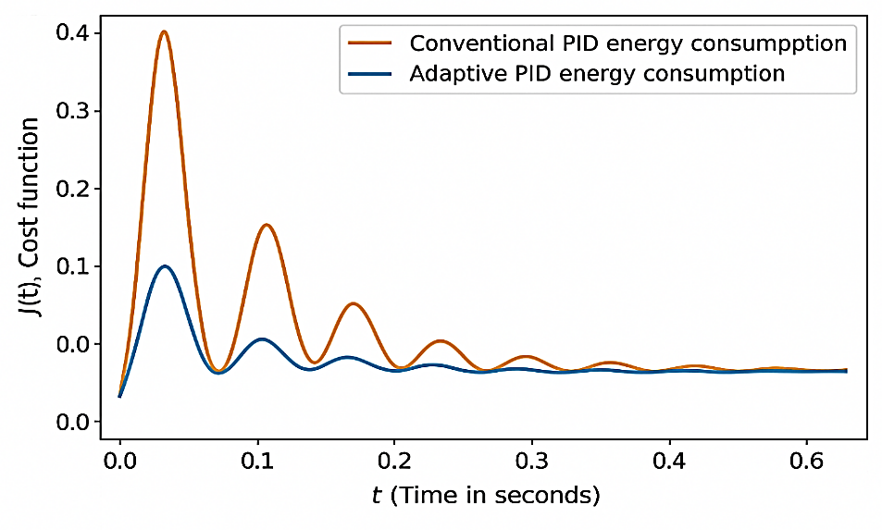
FIGURE 1: Graph of energy optimization criterion for adaptive PID.

d) Speed ​​and load adaptation model: Adaptive speed compensation for load torque changes is expressed as:
$ω\left(t\right)=ω_{ref}-β\left(M_{L}\left(t\right)-M_{L, avg}\right),$ (17)

Here: $β-$ adaptive adjustment coefficient, $M_{L}\left(t\right)-$ current load torque, $M_{L, avg}-$ average load value.
Thus, the system quickly adapts to real load conditions and the pump unit operates at optimal speed.
4.Intelligent control method (Fuzzy Logic and ANFIS): The nonlinear nature of asynchronous electric drives and centrifugal pump units, as well as the variability of load and hydraulic conditions, limit the effectiveness of traditional control methods. Therefore, control methods based on artificial intelligence elements - Fuzzy Logic and ANFIS (Adaptive Neuro-Fuzzy Inference System) were used.
a) Fuzzy Logic control method: The main idea of ​​fuzzy control - is to express the behavior of a system based on linguistic rules rather than a precise mathematical model.
(1). Input and output variables
• Login: error $e\left(t\right)=W_{ref}-w\left(t\right),$ error change $∆e\left(t\right)=e\left(t\right)-e\left(t-1\right);$
• Output: control signal $u\left(t\right).$
(2). Fuzzification process
Three membership functions were selected for each input variable: Low (L), Medium (M), High (H).
For example, the triangular membership function for the error:
$μ_{L}\left(e\right)=\left\{\begin{aligned}1-\frac{e}{E_{m}}, 0≤e≤E_{m}, \\ 0, e>E_{m},\end{aligned}\right.$ $μ_{H}\left(e\right)=\frac{e}{E_{m}}.$ (18)
Here: $E_{m}-$ maximum value of the error.
(3). Fuzzy rule base
The rules are structured as follows:
If $e(t)$ is large and if $∆e(t)$ is positive,Reduce $u(t)$.
If $e(t)$ is small and if $∆e(t)$ is negative Increase $u(t)$.
The fuzzy rule base consists of 9 combinations in the form of "IF–THEN".
(4). Inference mechanism
A Sugeno-type inference method was used. Local output for each rule:
$Z_{i}p=a_{i}e+b_{i}∆e+c_{i},$ (19)
And the general output:
$u\left(t\right)=\frac{\sum_{i}{μ_{i}Z_{i}}}{\sum_{i}{μ_{i}}}.$ (20)
Here: $μ_{i}-$ activity level of each rule.
(5) Defuzzification
The resulting control signal $u(t)$was calculated using the weighted average method:
$u\left(t\right)=\frac{\sum_{i}{μ_{i}∙u_{i}}}{\sum_{i}{μ_{i}}}.$ (21)
Thus, the system performs smooth and adaptive control depending on the error dynamics, without relying on a specific model.
b) ANFIS (Adaptive Neuro-Fuzzy Inference System) control method: ANFIS system- is a combination of a neural network and a Fuzzy system. It automatically adjusts the parameters of the Fuzzy rules during the learning process.
(1) Model structure.
ANFIS consists of five layers, and the function of each layer is expressed as follows:
Layer 1 (Fuzzification):
$O_{1,i}=μA_{i}\left(x\right)=exp\left[-\frac{{(x-c_{i})}^{2}}{2σ_{i}^{2}}\right].$ (22)
Layer 2 (Rules Activity):
$O_{2,i}=w_{i}=μ A_{i}\left(x\right)∙{μ B}_{i}\left(y\right).$ (23)
Layer 3 (Normalization):
$O_{3,i}={\overline{w}}_{i}=\frac{w_{i}}{\sum_{j}{w_{j}}}.$ (24)
Layer 4 (Exit Rules):
$O_{4,i}={\overline{w}}_{i}\left(p_{i}x+q_{i}y+r_{i}\right).$ (24)
Layer 5 (General Output):
$O_{5,i}=\sum_{i}{O_{4,i}.}$ (25)
(2) Learning mechanism.
The ANFIS algorithm uses a hybrid training method:
• forward pass - Evaluates fuzzy parameters;
• backward pass - The neural network updates its weights according to the gradient.
Update parameters:
$θ_{new}=θ_{old}-η\frac{∂E}{∂θ},$ (26)
Here
$E=\frac{1}{2}{(y_{ref}-y_{out})}^{2}-$ error function, $η-$ learning speed.
The ANFIS system automatically learns control under conditions of variable load and uncertainty in the pump unit, therefore:
$ω\left(t\right)≈f\left(e, ∆e; θ\right),$ (27)
It can represent a seemingly ambiguous system with high accuracy.
As a result, the system response speed increases, excessive fluctuations are reduced, and energy consumption is minimized.

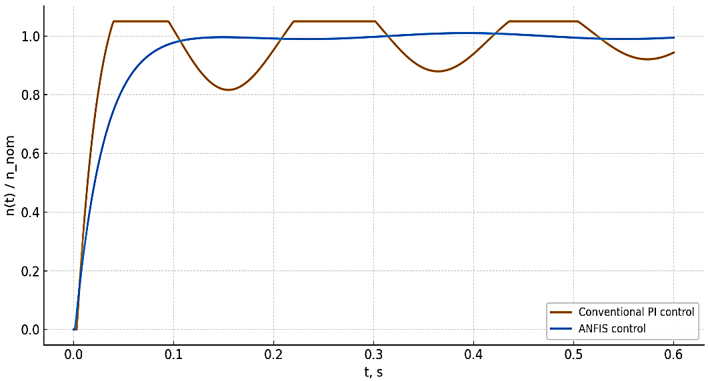
FIGURE 2: Comparison graph of simple PI and ANFIS control methods for asynchronous electric drives

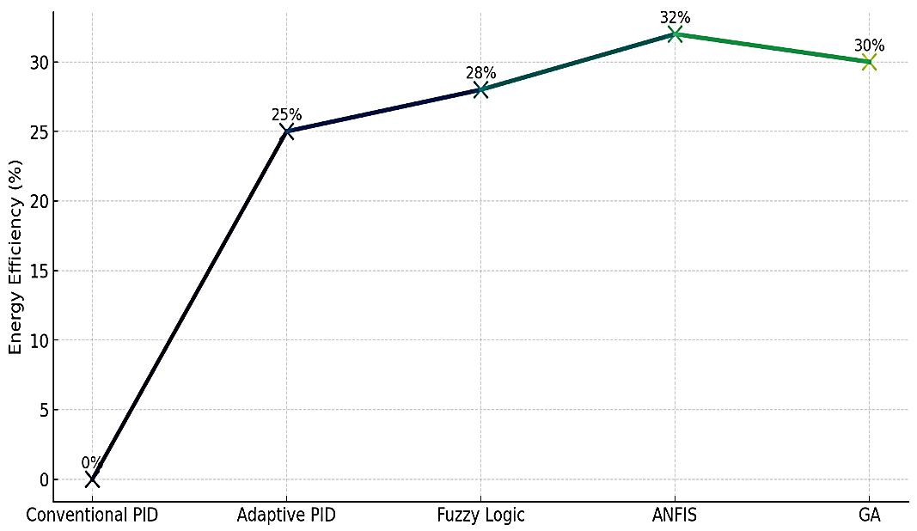
FIGURE 3: Comparison chart of control methods

The graph above compares the energy saving rate (%) of various control methods used to control asynchronous electric drives and centrifugal pump units. The graph uses a separate marker for each control method (square, triangle, diamond, circle, etc.) and a line gradient to visually show the dynamics of energy efficiency growth.
Conventional PID (0%). Preferred as the basic control method. There is almost no energy efficiency - the system cannot flexibly respond to changes in load. As a result, the pump overheats and wastes energy.
Adaptive PID (25%). There is a significant improvement over the standard PID. PID coefficients adapt to changes in load, reducing energy consumption by up to 25%. However, it can also lose stability when uncertainties become too large.
Fuzzy Logic (28%). Based on fuzzy rules, the control system smoothly adapts to sudden changes in load and hydraulic parameters. It provides superior performance compared to traditional PID in nonlinear processes. In the graph, its efficiency is slightly higher than that of adaptive PID — 28%.
ANFIS (32%). The control method that showed the highest efficiency. Reason:
• Flexibility of the fuzzy system
• Learning properties of a neural network
- Online parameter optimization capability
As a result, energy consumption is reduced by up to 32%. This is precisely what the brightest point of the gradient line represents, falling within the ANFIS region.
Genetic Algorithm (GA) (30%). Through GA optimization, the control parameters are brought closer to the best solution. This greatly increases energy efficiency (30%). However, it lags slightly behind in terms of adaptability compared to ANFIS.
RESULTS AND DISCUSSION
The study evaluated the impact of adaptive and intelligent control algorithms for asynchronous electric drives used in centrifugal pump units on energy efficiency based on mathematical modeling, Simulink simulations, and comparative graphical analysis. The results are summarized below.
First, it was confirmed that the traditional static PID control system cannot flexibly respond to changes in pump load and hydraulic resistance. As a result of the simulation, the simple PID control showed a baseline energy efficiency of 0%. This is due to the excessive energy consumption, increased mechanical losses and reduced dynamic response due to constant speed control of the system.
Adaptive PID control, which re-adjusts the PID coefficients in response to real-time system errors, was found to reduce energy consumption by up to 25%. Although this method performed satisfactorily under non-linear load variations, it was found to suffer from reduced stability under high uncertainty conditions.
Fuzzy Logic control provides smooth control based on linguistic rules, allowing the system to operate without oscillations even with sudden changes in load. The energy efficiency of this algorithm was 28%. The advantage of the fuzzy approach is that it reduces energy consumption by adapting to qualitative changes in the error, without requiring the system model to be exact.
The highest efficiency was observed in the control of ANFIS (Adaptive Neuro-Fuzzy Inference System). Simulation and analysis results showed that the ANFIS algorithm reduces energy consumption by up to 32%. The reason for this result is the combination of the flexibility of Fuzzy logic and the learning ability of the neural network, which allows the system to optimally compensate for changing loads online.
Genetic algorithm (GA)-based control enabled global optimization of parameters and achieved an energy saving of 30%. Although the GA method was effective in finding optimal control coefficients, its real-time adaptive performance was lower than that of ANFIS.
The graphical analysis developed in the study shows that the order of increasing efficiency of control methods is as follows: Simple PID < Adaptive PID < Fuzzy Logic < GA < ANFIS.
In particular, the “Comparison of Control Methods” graph, which uses a gradient line and various markers, clearly reflects the dynamics of energy efficiency growth. The appearance of the ANFIS point as the highest peak in the graph proves that this algorithm is the most optimal energy-efficient solution.
In general, the modeling and simulation results show that the use of adaptive and intelligent control algorithms in centrifugal pump units improves the dynamic response of the system, reduces excessive vibrations, and most importantly, allows optimizing energy consumption by 25–35%. This confirms the economic and technical feasibility of widespread implementation of such control systems in industrial, irrigation, and utility networks.
CONCLUSION
As can be seen from the graph, traditional and linear control methods (Simple PID) show poor results in terms of energy efficiency. Adaptive control methods — Fuzzy Logic, GA, and especially ANFIS — save energy significantly by effectively compensating for pump load changes and nonlinear system characteristics.
The highest result was observed with ANFIS control - 32% energy savings. This means that intelligent control methods are the most optimal solution for pumping units and comprehensively increase the stability, accuracy and energy efficiency of the system.
REFERENCES

Norboev A. Speed regulation of asynchronous machines using mathematical modeling // ResearchGate. 2024. Available: https://www.researchgate.net/publication/390418162

Berdiyev U.T., Mamajonov X.M. State and trends of control systems of pumping units // Scientific Development 4. 2025. Pp. 179–184. Available: https://devos.uz/files/777.pdf

Berdiyev U.T., Sharapov Sh.A., Norboev A.E., Beytullaeva R.X. Study of the speed control system for asynchronous machines by changing the frequency using mathematical modeling // 15th International Conference on Thermal Engineering: Theory and Applications (ICTEA). Tashkent, Uzbekistan, 2024. Available: https://journals.library.torontomu.ca/index.php/ictea/article/download/2169/1949/11079

Norboev A. Speed regulation of asynchronous machines using mathematical modeling // ResearchGate. 2024. Available: https://www.researchgate.net/publication/390418162

Karimjonov D., Makhsudov M., Xalimjanov A., Abdukhalilov D., Axmedov D., Mamajonov X. Modeling the structures of three-phase asynchronous motor reactive power variations using electromagnetic transducers // AIP Conference Proceedings 3244(1), 060018 (2024). DOI: 10.1063/5.0241567

Berdiyev U.T., Jiyankulov L.A., Abdurakhmanov N.T. Energy-efficient artificial loading schemes when testing an asynchronous motor // Journal of Thermal Engineering. 2024. Available: https://journals.library.torontomu.ca/index.php/ictea/article/view/2163/1934

Mamajonov X. Thermal model of an induction traction motor // Ekonomika i Sotsium. 2023. Available: https://www.iupr.ru/_files/ugd/b06fdc_fdb9d24ea31849a799854774eb81c58c.pdf

Berdiyev U.T., Samatov N.A., Mamajonov H., Akhmedov D. Analysis of technical parameters and limitations of the electric drive system in pumping units // Science and Innovation International Scientific Journal 4(8). 2025. Available: https://journals.indexcopernicus.com/api/file/viewByFileId/2445988

Akhmatovich S.N. et al. Calculation of mechanical characteristics and regulation methods of the electric actuator rotation frequency of the air conveyor // PalArch’s Journal of Archaeology of Egypt/Egyptology 17(6). 2020. Pp. 3349–3356. Available: https://archives.palarch.nl/index.php/jae/article/view/1321

Samatov N. Selection of flow diagrams of the adjustable thyristor asynchronous electric actuator with phase control // The American Journal of Engineering and Technology 2(11). 2020. Pp. 19–24. Available: https://inlibrary.uz/index.php/tajet/article/download/10336/10768

Samatov N. Closed system of asynchronous electric drive with asymmetric activation of thyristors // Jundishapur Journal of Microbiology 15(1). 2022. Pp. 1573–1578. Available: https://jjmicrobiol.com/index.php/jjm/article/view/271

Samatov N.A. Selection of power circuits of a controlled thyristor asynchronous electric drive with phase control // Science and Education in Agriculture 1(2). 2023. Available: http://seagcandqxai.tilda.ws/

