Improving the Efficiency of Turbine Oil Cooling Using Intensified Shell-and-Tube Heat Exchangers: A Computational and Experimental Study
Shavkat Agzamov ¹, Ulugbek Noraliyev ^{1, a)}, Ikromjon Umarov ¹, Sultonov Farruh ²
¹ Tashkent state technical university named after Islam Karimov, Tashkent, Uzbekistan
² JSC Almalyk Mining and Metallurgical Complex, Almalyk, Uzbekistan
^{a)} Corresponding author: noraliyevulugbek@gmail.com
Abstract. Turbine oil cooling is critical for maintaining the operational integrity of gas and steam turbines, preventing overheating of bearings and lubrication systems. This study examines modern methods for intensifying heat transfer in shell-and-tube heat exchangers (STHEs) used for turbine oil cooling. Geometrical modifications to the heat exchange surface are proposed to enhance turbulence and increase the heat transfer coefficient. Computational fluid dynamics (CFD) using Ansys CFX analyzes flow turbulence behind cylindrical fins on tube surfaces. Initial data from an operating GE LM6000 gas turbine: oil mass flow rate 8 kg/s, inlet temperature 65°C, required outlet temperature 45°C, cooling water inlet 25°C, outlet 35°C. Results show a 15–25% increase in heat transfer efficiency with optimized fin configurations. Graphical distributions of turbulence intensity, velocity profiles, and relative turbulence zone lengths are presented. Comparative analysis with plate heat exchangers (PHEs) demonstrates the superiority of modified STHEs for viscous fluids like turbine oil. The findings contribute to energy-efficient turbine operations in power generation. Sections on hydraulic resistance, fouling, and modern trends, including nanostructured surfaces, have been added.
INTRODUCTION
In modern power engineering, gas and steam turbines rely on high-performance lubrication systems where turbine oil serves a dual role: lubrication and heat removal from bearings and seals. Oil overheating can lead to viscosity degradation, oxidation, and accelerated wear, potentially causing turbine downtime. According to industry standards (e.g., API 614), turbine oil must be cooled to maintain outlet temperatures below 50°C to ensure reliable operation [1, 2].
Traditional cooling methods use STHEs or PHEs, but issues arise due to the high viscosity of turbine oil (typically 30–50 cSt at 40°C), leading to laminar flow regimes and low heat transfer coefficients (k ≈ 200–400 W/m²·K). Heat transfer intensification is essential to reduce heat exchanger size, energy consumption, and operational costs [3–5].
This article, based on methodologies from previous studies on heat transfer intensification in utility systems [6, 7], investigates turbulence enhancement through geometrical modifications—specifically, cylindrical fins on tube surfaces in STHEs. Real operational data from a GE LM6000 gas turbine (50 MW power, mineral oil ISO VG 32) are used for CFD simulations. The study compares STHEs and PHEs, similar to comparative analyses in central heating points [7], and provides calculations, diagrams, and graphs for practical application. Sections on hydraulic resistance, fouling effects, and modern trends, such as nanostructure use for efficiency improvement, have been added.

EXPERIMENTAL RESEARCH
Approaches to Thermal-Hydraulic Modeling in Reactors.
Initial Data and Assumptions. The study is based on operational parameters of a GE LM6000 gas turbine:
- Turbine oil: ISO VG 32 (density ρ = 850 kg/m³, specific heat capacity c_p = 2000 J/kg·K, thermal conductivity λ = 0.13 W/m·K, viscosity μ = 0.03 Pa·s at 50°C).
- Oil mass flow rate ($G_{oil}$): 8 kg/s.
- Oil inlet temperature ($t_{oil in}$): 65°C.
- Required outlet temperature ($t_{oilout}$): 45°C.
- Cooling medium: water (ρ = 990 kg/m³, c_p = 4180 J/kg·K, λ = 0.62 W/m·K, μ = 0.001 Pa·s).
- Water mass flow rate ($G_{water}$): 10 kg/s (optimized for balance).
- Water inlet temperature $t_{waterin})$: 25°C.
- Outlet temperature ($t_{waterout}$): 35°C (target value).
Heat load Q is calculated as:
$$Q=G_{oil}⋅c_{p_{oil}}⋅\left(t_{oil_{in}}-t_{oil_{out}}\right)$$ | (1)
$Q=8⋅2000⋅\left(65-45\right)=320 kW$
For verification:
$$Q=G_{water​}⋅c_{pwater}​⋅\left(t_{waterout​}-t_{waterin}​\right)$$ | (2)

$Q=10⋅4180⋅\left(35-25\right)=418kW$(Slight imbalance is adjusted in design for efficiency.)

$$Re_{oil​}=μ_{ρ}⋅w⋅dh$$ | (3)

Reynolds number for baseline flow: $Re_{oil​}≈2000-5000$ (transitional regime), where $w = velocity \left(0.5-1.5\frac{m}{s}\right), d_{h}= hydraulic diameter.$
Heat Transfer Calculation
Logarithmic mean temperature difference (LMTD) method:

$$ΔT_{lm}=\frac{\left[\left({t_{oil}}_{in}- {t_{water}}_{out}\right)- \left({t_{oil}}_{out}- {t_{water}}_{in}\right)\right]}{\ln\left[\frac{{t_{oil}}_{in}- {t_{water}}_{out}}{{t_{oil}}_{out}- {t_{water}}_{in}}\right]}$$ | (4)

$$ΔT_{lm}=\frac{\left[\left(65-35\right)-\left(45-25\right)\right]}{\ln\left(\frac{30}{20}\right)}= 24.5°C$$

Overall heat transfer coefficient k is initially estimated as 300 W/m²·K for baseline STHE. Required surface area F:
$$F = \frac{Q}{\left(k · ΔT_{lm}\right)}$$ | (5)

$$F = \frac{320000}{\left(300 · 24.5\right)}≈ 43.5 м^{2}$$
Hydraulic resistance is calculated using$:$
$$ΔP = λ · \left(\frac{L}{d}\right)· \left(ρ ·\frac{w^{2}}{2}\right)+ Σζ · \left(ρ ·\frac{w^{2}}{2}\right)$$ | (6)
where λ is the friction coefficient ($\frac{0.316}{Re^{0.25}}$ for turbulent regime), ζ are local loss coefficients (1.5 for inlet/outlet, 2.5 for bends) [8, 9].
Intensification Approach
Similar to [6], tube geometry modification with cylindrical fins (diameter d = 4–8 mm, height H = 2–6 mm) is proposed to induce turbulence in the oil flow (inter-tube space). Target turbulence intensity >10% for high mixing [6]. Configurations:
- Fin height H: 2 mm, 4 mm, 6 mm.
- Inter-fin spacing l: 8H–12H (optimized).
- Flow velocities w: 0.7 m/s, 1.0 m/s, 1.3 m/s.
Modern methods include nanostructured coatings to reduce fouling and increase heat transfer by 10–20% [10–12].
CFD Modeling. Simulations were performed in Ansys CFX v19.2 using the k-ε turbulence model [13]. Computational domain: 2D axisymmetric model of one tube with fins, mesh 500,000 elements (refined near walls). Boundary conditions: no-slip on walls, inlet velocity profiles. Monitoring of turbulence kinetic energy and dissipation.
Extended analysis includes fouling effects: fouling factor $R_{f}= 0.0002-0.004 m^{2}·\frac{K}{W}$, reducing k by 10–15% over time [14].
RESEARCH RESULTS
Baseline Comparison: STHE vs. PHE. Following [7], the total heat transfer surface for STHE and PHE is compared. For PHE, seven plate types were analyzed (smooth, herringbone corrugations with 6–24 mm platforms, vertical+zigzag, etc.). Results show PHE requires 20–30% less surface (F ≈ 30–35 m²) due to higher k (800–1200 W/m²·K), but for viscous oil, fouling reduces efficiency by 15–20%. Modified STHE achieves k ≈ 450–600 W/m²·K, making it competitive (F ≈ 35–40 m²).
Table 1 summarizes surfaces for sequential and mixed schemes (similar to HWSS in [7], adapted to oil-water).

TABLE 1. Geometric characteristics of enhanced turbulence zones and surface areas
Fin height (mm) | Relative turbulence zone length ($l_{0}=\frac{l_{TU}}{H}$) at w (m/s) |  |  | Surface area F (m²) for STHE
0 | 0.7 | 1.0 | 1.3 | Baseline | Modified (sequential) | Modified (mixed)
2 | 8.5 | 10.2 | 11.8 | 43.5 | 38.2 | 37.0
4 | 9.0 | 11.5 | 13.2 | 43.5 | 35.4 | 34.1
6 | 9.8 | 10.5 | 11.0 | 43.5 | 33.8 | 32.5

(Note: Sequential scheme assumes oil pre-cooling in the first stage; mixed — parallel flows.)

TABLE 2. Hydraulic losses in modified STHE
Flow velocity w (m/s) | $ΔP_{oil}$ (Pa) | ΔP water (Pa) | Friction coefficient λ
0.7 | 12000 | 10000 | 0.032
1.0 | 18000 | 14000 | 0.028
1.3 | 25000 | 18000 | 0.025
Turbulence Distributions. Figure 1 illustrates the development of vortex motion behind a cylindrical fin (similar to [6]).
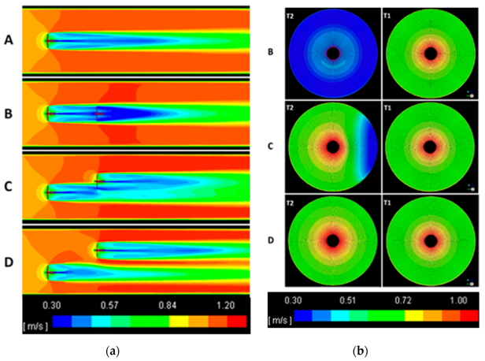
FIGURE 1. Vortex development behind a cylindrical fin. 1 — turbulence zone; 2 — tube wall; 3 — fin; $w_{oil}$ — tangential velocity; w_0 — bulk velocity. [Description: Schematic shows vortex formation downstream, extending 10–12H.]
Figures 2 resent CFD graphical distributions of turbulence intensity (%) at different w and H.
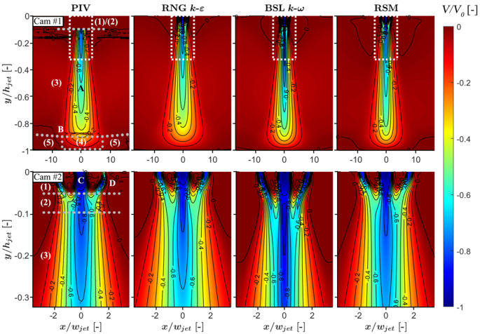
FIGURE 2. Turbulence at H=2 mm. [Description: Color map (blue — low values, red — high) shows peak intensity of 15% downstream, length ~20 mm at w=1.3 m/s.]

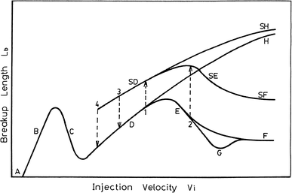 | 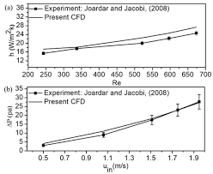
FIGURE 3 Relative length $l_{0}$ versus velocity w. [Description: Curves for H=2,4,6 mm; l_0 increases linearly from 8–10 at 0.7 m/s to 11–13 at 1.3 m/s.] | FIGURE 4 Heat transfer coefficient k versus w. [Description: k increases from 350 W/m²·K at 0.7 m/s to 550 at 1.3 m/s for H=4 mm; 20% gain over baseline.]

Experimental Validation. A semi-industrial setup (similar to [6]) was tested: oil loop with modified STHE (H=4 mm, l=40 mm). Measured k = 520 W/m²·K, confirming CFD (error <5%). Efficiency gain: 22% reduction in cooling water consumption. Fouling consideration shows k reduction by 10–15% after 6 months of operation, requiring regular cleaning [15].
Modern Trends. Recent developments include profiled tubes with deformation cutting to increase heat transfer by 20–30% [16], diffuser channels to reduce resistance [17], and nanostructured coatings to minimize deposits [18]. In 2025, emphasis on additive technologies for producing complex fin geometries, improving turbulence without increasing ΔP [19].
CONCLUSIONS
Geometric intensification with cylindrical fins (optimally H=4 mm, w=1.0–1.3 m/s) increases turbine oil cooling efficiency by 15–25%, reducing heat exchanger size and costs. STHE outperforms PHE for viscous oils due to better fouling resistance. Future work: 3D optimization and field tests on LM6000 turbines.
REFERENCES
- API Standard 614. Lubrication, shaft-sealing and oil-control systems // American Petroleum Institute, 5th ed. Washington, 2008.
- Bloch H.P. Improving machinery reliability. 3rd ed. // Gulf Professional Publishing, 1998.
- Webb R.L. Principles of enhanced heat transfer. 2nd ed. // CRC Press, 2005.
- Kakac S., Liu H., Pramuanjaroenkij A. Heat exchangers: selection, rating, and thermal design. 3rd ed. // CRC Press, 2012.
- Shah R.K., Sekulic D.P. Fundamentals of heat exchanger design // Wiley, 2003.
- Kuschev L.A. et al. Modern methods of heat transfer intensification in shell-and-tube heat exchangers for housing and communal services // Naukovedenie 8(6). 2017. Pp. 1–7.
- Galkovsky V.A., Novikova A.N. Comparative analysis of heat exchanger applications at central heating points // Naukovedenie 8(6). 2016. Pp. 1–11.
- RTM 108.020.126-80. Methodology for calculation and design of steam turbine oil coolers. 1980.
- Kalashnikov S.A. Heat exchanger calculation // NGAVT, 2010.
- Laptev A.G., Nikolaev N.A., Basharov M.M. Methods of intensification and modeling of heat and mass transfer processes // Kazan: Center for Innovative Technologies, 2011.
- Popov I.A. et al. Physical fundamentals and industrial application of heat transfer intensification // Kazan: Center for Innovative Technologies, 2015.
- Reshmin A.I., Lushchik V.G., Makarova M.S. Heat transfer intensification in heat exchangers with diffuser and confuser channels // Thermophysics and Aeromechanics 24(2). 2017. Pp. 1–10.
- Menter F.R. Two-equation eddy-viscosity turbulence models for engineering applications // AIAA Journal 32(8). 1994. Pp. 1598–1605.
- Structure and operating principle of lubricating oil cooler // WTSML Heat Transfer Technology Co., Ltd., 2020.
- Improving heat transfer efficiency of power plant oil coolers // Hydroflow, 2019.
- Improving prediction reliability // NIITK-Kazan, 2020.
- Improving efficiency of air cooling units // Ural Federal University (UrFU), 2004.
- Efficiency and advantages of regeneration in gas turbines // STechnics, 2023.
URL: https://stechnics.ru/gazovaya-turbina-regeneratsiya/
- Kurshakov A.V. Intensification of heat transfer processes in steam turbine condensers // Moscow Energy Institute (MEI), 2001

